Telecommunication  Development Sector |  | 
Regional Preparatory Meeting for WTDC-2010 for Europe
Andorra la Vella, Andorra, 1 - 3 December 2009
 |  | Document RPM-EUR09/10-E
 |  | 17 November 2009
 |  | Original: English
SOURCE: | Ministry of Transport, Information Technology and Communications, Bulgaria
TITLE: | E- Accessibility in Central and Eastern Europe - Internet and DTTV for blind people and people with visual impairment problems
Priority area: Innovative Interactive Applications
The actual situation in accessing Internet or watching TV programmes is very discriminatory towards persons of all ages with acute visual impairment problems. The switch-off of analogue terrestrial television in Europe by 2012 represents both a challenge and an opportunity for extension of access services via DTV. Introduction and deployment of value-added services to existing infrastructures will speed up digital inclusion.
Regional Initiative’s proposal:
- Facilitate the creation of national and regional specialised libraries/databases in order to provide large scale access via Internet for blind people and people with visual impairment problems;
- Set up of pertinent facilities (hardware and software ), training , implementation and execution;
- Promote and foster widespread adoption of access services via Digital Television.
This Regional Initiative Proposal is in line with the Doha Action Plan and Programme 3 on E-Strategies and ICT Applications, Resolution 54 “Information and communication technology applications”, Resolution 20 “Non discriminatory access to modern telecommunication and information technology facilities and services“ and Resolution 50 “Optimal integration of information and communication technologies“.
Innovative interactive information and communication technology, including specialized hardware or software, that simulates the human voice reading of the written information on both computer or TV screen, or alternatively interaction via Braille keyboard, designed to help persons with particular needs to perform daily tasks, has changed the lives of countless individuals of all ages with visual impairments. Towards such innovation objective:
- Appropriate devices are available for students and pupils, who are willing to take courses at normal school close to their homes but not to travel far away to very few specialized schools and carry with them heavy Braille keyboard and manuals.
- Professors and volunteers are willing to scan manuals and books thus creating data bases according to standard curriculum and accordingly teach all kids the same way in the same classroom.
- Parents and relatives are happy because their kids with visual impairments don’t feel special anymore and are connected to the world.
- Employees with visual impairments have extended opportunities to work and employers have a larger choice for their workforce by enabling them to respond to the societal needs in positive manner.
- To travel, have a social life, raise a family, have a career, live independently and productively is possible today for all.
The technology is here today but unfortunately is still very expensive for individuals alone and only large scale use beyond national borders of specialized hardware and software (similar business model as to the introduction and penetration of PCs) could bring prices down, thus creating real social impact, enhanced communication and facilitating the creation of relevant rich content.
One of the main requests from specialized schools, employees and students is access to Internet. Pilot projects are under way in various countries, for example in the “School for the Blind” in Bucharest, Romania (Short description is provided in the Annex 1). This example illustrates substantial part of the approach proposed towards this regional initiative.
Proposed Draft Resolution submitted by the Administrations of Romania and Bulgaria
ANNEX
Pilot project in Bucharest, Romania
The Bucharest School for the Blind is a public school for eligible students who are blind/low-vision pre-school through 8th grade. There is no cost to families for tuition. Founded in 1948, the School awards standard and special diplomas and prepares its graduates for a wide range of professional careers and trades. Each year, over 70% of the graduated students continue their education at colleges, universities and technical training centers.
Status Quo:
The school with 350 students from grade 1 to 8, of which more than 50 students are completely blind benefited from a donation of equipment and facilities, available at the school lab, as follows:
- one computer;
- Internet access;
- one Braille keyboard; and
- one specialized software JAWS with voice synthesizer incorporating 36 languages capability.
One blind students works everyday for 3 hours with said equipment. Of course one set of equipment is not enough. The operation is quite simple. The Braille keyboard is connected with the computer, a visually impaired person will write a text in Braille characters using the Braille keyboard, the software JAWS transforms Braille letters into regular characters that will appear on the computer screen in Latin characters text. E-mail messages can this way be sent via Internet.
To read an e mail or a text that is on the computer screen, the very same software transforms the text in Braille characters and the person with visual impairments can read relevant information by touching the Braille keyboard. Of course, the voice synthesizer can also read the text that appears on the screen, but not too many people like it.
After only one year of operation the responses and the results are incredibly good and encouraging.
Photos 1, 2, 3 below illustrate the set up described:
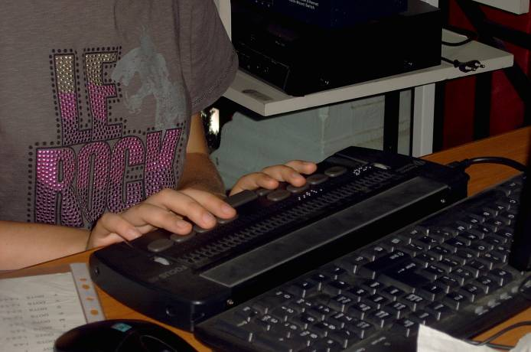 | 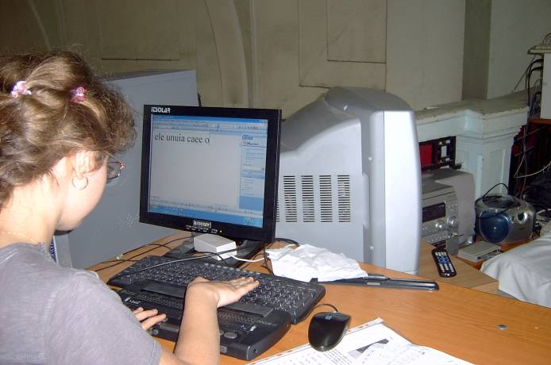 | 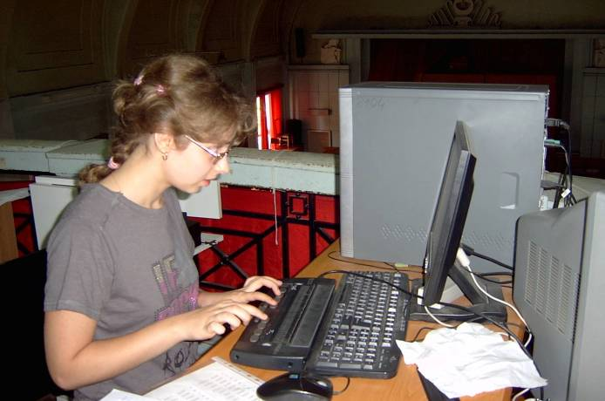
Next Phase
Deployment of 30 workstations system, divided in two groups, supplemented by a VISIO Virtual Environment (VVE) software system and a set of online tools, interoperating systems and processes for interaction intended to facilitate and enhance the learning process and help manage the increasingly complex tasks involved in the classical learning and in the distance learning. In addition, this will facilitate and foster collaboration among communities, often across disciplinary, regional and/or national boundaries. The learning processes that a VVE will support include: resource discovery, data collection, data analysis, simulation, collaboration, communication, publishing, research administration, and project management. Next Phase will foster the creation of a national databases and connections with other schools, businesses, entertainment facilities, travel agencies, banks etc.
Proposed Draft Resolution submitted by The Administrations of Bulgaria and Romania
____________

