电信标准化局 | 

2009年8月10日，日内瓦

文号：  电话：  传真： | 电信标准化局第50号通函补遗1  NGN-GSI/TK  +41 22 730 5126  +41 22 730 5853 | - 致国际电联成员国主管部门
电子  邮件： | tsbngngsi@itu.int | 抄送：  - ITU-T部门成员；  - ITU-T部门准成员；  - ITU-T各研究组正副主席；  - 电信发展局主任；  - 无线电通信局主任

事由： | NGN-GSI（全球标准化举措）活动  2009年9月2-12日，阿根廷马德普拉塔
尊敬的先生/女士：
1 我高兴地通知您，将于2009年9月2-12日在阿根廷马德普拉塔举行的下一次NGN-GSI活动的会址为：
HOTEL HERMITAGE
Av. Colón and Boulevard Marítimo P.P. Ramos 2657 - Mar del Plata
2 本函附件1提供有关酒店住宿的更多信息以及阿根廷甲型H1N1流感的详细情况和标明会址及相关酒店的马德普拉塔的最新地图。

顺致敬意！
电信标准化局主任
马尔科姆•琼森
附件：1件
ANNEX 1
(to Addendum 1 to TSB Circular 50)

Additional practical information
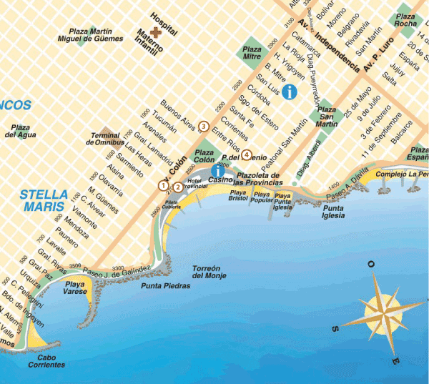

Hotel |  | Category |  | Type of room |  | Rate |  | Remarks
(1) Hotel Hermitage  Av. Colón 1643 and Blvard. Marítimo. P.P. Ramos 2657  Mar del Plata - Argentina  Tel: (54) (0223) 451-9081/86  Fax: (54) (0223) 451-7235  Check-in: 1400 hours  Check-out: 1100 hours  www.hermitagehotel.com.ar  reservas@hermitagehotel.com.ar |  | * * * * * |  | Double or standard single  (with view over the city) |  | USD 150 |  | Includes VAT and buffet breakfast
(2) Apart Hotel Avenida del Mar  Las Heras 2128  Mar del Plata – Argentina  Tel: 54 0223 451-2125  Check-in: 1400 hours  Check-out: 1100 hours  reservas@apart-avenidadelmar.com.ar | * * * * |  | 1 room  (2 persons)  2 rooms  (2 or 3 persons)  3 rooms  ( 4 or 5 persons) |  | USD 74  USD 104  USD 144 |  | Includes VAT and buffet breakfast
(3) Hotel Dos Reyes  Av. Colón 2129  Mar del Plata – Argentina  Tel : 54 0223 491-0383/0037  Check-in: 1400 hours  Check-out: 1100 hours  www.dosreyes.com.ar  info@dosreyes.com.ar | * * * * |  | Single  Double |  | USD 75  USD 85 |  | Includes VAT and buffet breakfast
(4) Argentino Hotel  Belgrano 2225  Mar del Plata – Argentina  Tel/fax : 54 0223 493-0091/2/4  Check-in: 1400 hours  Check-out: 1100 hours  www.argentinohotelmdp.com.ar  info@argentinohotelmdp.com.ar | * * * |  | Single  Double |  | USD 40  USD 55 |  | Includes VAT and buffet breakfast

COMMUNICATION ON HUMAN INFLUENZA A(H1N1)
On the basis of bulletins issued by the Ministry of National Health of the Argentine Republic, the following information is provided to delegates attending the ITU-T KALEIDOSCOPE and NGN-GSI events to be held in Mar del Plata concerning the measures and recommendations being adopted to prevent the spread of human influenza A(H1N1).
Through an intense national campaign, the Ministry of Health has taken the necessary measures to minimize the risks of contagion of the virus, and most cases have been successfully and quickly cured, through simple and safe treatment.
Any additional information that delegates might require can be obtained on the webpage of the Ministry of National Health at: www.msal.gov.ar/.
Recommendations regarding the new human influenza A(H1N1)
What is influenza A(H1N1)?
It is a very contagious acute respiratory infection of viral origin.
How is it transmitted?
• From person to person.
• Through drops of saliva which travel through the air when a person coughs, sneezes or spits.
• It is not transmitted through the consumption of pork or pork derivatives.
What are the symptoms?
• Temperature over 39ºC.
• Cough.
• Sore throat.
• Blocked nose.
• Headache.
• Muscular pains.
How can it be prevented?
• When coughing or sneezing, use a disposal tissue.
• When coughing without a tissue, cover your mouth with your forearm (never with your hands).
• Wash your hands often with soap and water.
• Avoid treating yourself.
• Use of a mask is recommended only if you show symptoms.

________________

