INTERNATIONAL TELECOMMUNICATION UNION |  | Focus Group On  Car Communication
TELECOMMUNICATION  STANDARDIZATION SECTOR  STUDY PERIOD 2009-2012 |  | FG CarCOM-ADM-5
English only
Original: English
 |  | Detroit, 26-27 August 2010
ADMIN DOCUMENT
Source: | FG Chairman
Title: | Invitation to the 3rd Meeting of the Focus Group CarCOM

Invitation to the 3rd Focus Group Meeting to be held
26-27 August 2010 in Detroit
Link to registration & meeting documents
http://www.itu.int/ITU-T/focusgroups/carcom/
Dear Colleagues,
On behalf of the ITU-T Focus Group CarCOM, I have the pleasure of informing you of the arrangements for the above-mentioned meeting hosted by OnStar.
Address of the meeting | General Motors University  2nd floor of the Renaissance Center  GM Headquarters  http://www.gmrencen.com/  Host: OnStar  Jesse Gratke  Acoustic Systems Engineer  OnStar - ASD Core Technologies  Office: +1 (313) 300-5743  Mail: jesse.gratke@onstar.com
mEETING SCHEDULE | The meeting will start on 26 August 2010 at 09.00.  The meeting will end on 27 August 2010 at 13.00.
REGISTRAtion | Please register at the focus group website before 7 August 2010
Documents for the meeting | Please send meeting documents in advance of the meeting to TSB for uploading to the Focus Group website.

Hotel Information | The most convenient place to stay is the Marriott at the Renaissance Center because it is in the same facility. The Ren Cen has all the amenities that anyone would need.  Detroit Marriott at the Renaissance Center  http://www.marriott.com/hotels/travel/dtwdt-detroit-marriott-at-the-renaissance-center/  The Courtyard is another option that is across the street, but a slightly longer walk.  Detroit Courtyard (Across the street, connected by a catwalk)  http://www.marriott.com/hotels/travel/dtwdc-courtyard-detroit-downtown/
How to find the meeting place |  | From Pontiac, Rochester, and the North:  I-75 Southbound to I-375, to Jefferson Avenue Westbound  From Clinton Township, St. Clair Shores, and the East:  I-94 Westbound to I-75 South, to Jefferson Avenue Westbound  From Ann Arbor, Metro Airport, and the West:  I-94 Eastbound to I-75 South, to I-375 to Jefferson Avenue Westbound  From Canada:  Via the Detroit-Windsor Tunnel, turn right at Jefferson Avenue.  Via the Ambassador Bridge, take I-75 North to I-375, to Jefferson Avenue Westbound  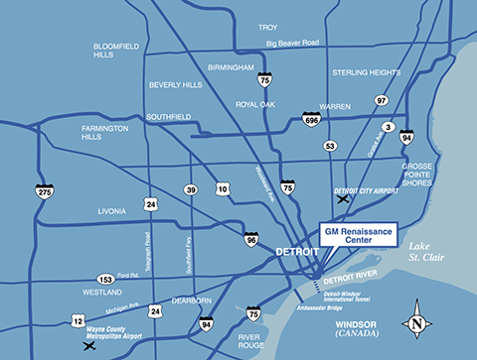
I look forward to seeing you in Detroit,
Yours sincerely
Hans W. Gierlich

