Ginebra, 10 de noviembre de 2006
UNIÓN INTERNACIONAL DE TELECOMUNICACIONES
Oficina de Normalización
de las Telecomunicaciones

Ref:  Tel:  Fax: | Circular TSB 123  NGN-GSI/TK  +41 22 730 5994  +41 22 730 5853 | - A las Administraciones de los Estados Miembros de la Unión
Correo-e: | tsbngngsi@itu.int | Copia:  - A los Miembros del Sector UIT-T;  - A los Asociados del UIT-T;  - Al Presidente y a los Vicepresidentes de todas las Comisiones de Estudio del UIT-T;  - Al Director de la Oficina de Desarrollo de las Telecomunicaciones;  - Al Director de la Oficina de Radiocomunicaciones

Asunto: | Evento de la NGN-GSI  Pekín, R. P. China, 8-12 de enero de 2007

Muy señora mía/Muy señor mío,
1 Tras la celebración de los eventos de la NGN-GSI que tuvieron lugar en 2006 en Ginebra y Kobe, Japón, y con arreglo al acuerdo obtenido durante los dos últimos eventos de la NGN-GSI, celebrados en Ginebra en julio y en octubre - noviembre de 2006, tengo el placer de informarle que el próximo evento de la NGN-GSI se realizará en el Beijing Friendship Hotel, Pekín, República Popular de China, del 8 al 12 de enero de 2007 inclusive, gracias a la amable invitación de la China Communications Standards Association (CCSA).
2 La reunión conjunta de los Grupos de Relator contemplada en el programa del evento de la NGN-GSI empezará a las 09h30 del primer día con la reunión relativa a Estudios técnicos y estratégicos. Los participantes podrán inscribirse desde las 08h30 de ese mismo día. En la página web de la NGN-GSI y en las pantallas del hotel y de cada sala puede consultarse toda la información correspondiente a las salas de reunión.
3 Las reuniones y los debates se celebrarán en inglés.
4 En el anexo 1 adjunto figura un calendario provisional de este evento y ciertas disposiciones logísticas para esta serie de reuniones, tal como acordaron los Relatores y Presidentes correspondientes.
5 Podrá consultarse información actualizada sobre este evento en la página web de la NGN-GSI del UIT-T en: http://www.itu.int/ITU-T/ngn/events/index.asp.
6 El orden del día propuesto de los Grupos de Relator se publicará en la página web creada para esta serie de reuniones, a saber: http://www.itu.int/ITU-T/ngn/events/index.asp.
7 Las contribuciones deben enviarse a la secretaría de la TSB para la NGN-GSI, cuyo correo electrónico es tsbngngsi@itu.int. Teniendo en cuenta que la mayoría de la gente tiene vacaciones de fin de año, se establece excepcionalmente como fecha límite para la presentación de contribuciones el 3 de enero de 2007.
8 En el anexo 2 se facilita información práctica sobre la reunión, el lugar donde se celebrará y el país sede, proporcionada por la organización anfitriona.
9 Para facilitar su asistencia, incluimos un formulario para la reserva de hoteles en el anexo 3 adjunto.
10 Obsérvese que en la reunión se trabajará sin papel, y que los delegados dispondrán de acceso a facilidades LAN inalámbricas. Sírvase traer su tarjeta de acceso inalámbrico. Si no la tuviere, podrá alquilarla en la secretaría de la reunión.
11 Para que la TSB y la organización anfitriona puedan tomar las disposiciones necesarias sobre la organización de este evento, le agradecería que enviara al organizador cuanto antes, a más tardar el 22 de diciembre de 2006, el formulario de inscripción del anexo 4 debidamente rellenado (uno por participante), por fax (+86-10-82053019) o por correo electrónico (NGNGSI_meeting@ccsa.org.cn).
12 Le recordamos que los ciudadanos procedentes de ciertos países necesitan visado para ingresar y permanecer en la R .P. China. Ese visado debe solicitarse y obtenerse en la oficina (Embajada o Consulado) que representa a la R. P. China en su país o, en su defecto, en la más próxima a su país de partida. Tenga en cuenta que la obtención de un visado puede tomar algún tiempo, por lo que le rogamos solicite su carta de invitación cuanto antes.
Se ruega a los participantes que necesiten una carta de invitación y/o una carta que justifique la petición del visado para entrar en que se pongan en contacto con la persona correspondiente en el evento NGN-GSI, cuyos datos son los siguientes:
Sr. Qi Xu
CCSA Standardization Promoting Center
Tel.: +86-10-82050013
Móvil: +86 13466724696
Correo-e: qixu@ptsn.net.cn

Le saluda muy atentamente,
H. Zhao
Director de la Oficina de
Normalización de las Telecomunicaciones

Anexos: 4

ANNEX 1
(to TSB Circular 123)
NGN-GSI time plan
Beijing, China, 8-12 January 2007

Monday | 08/01 | Tuesday | 09/01 | Wednesday | 10/01 | Thursday | 11/01 | Friday | 12/01
AM | PM | AM | PM | AM | PM | AM | PM | AM | PM

TSR | 2/13 | 2/13 | 2/13 | 2/13 | 2/13 | 2/13 | 2/13 | 2/13 | 2/13 | 2/13 | 2/13 | 2/13 | 2/13 | 2/13 | 2/13 | 2/13 | 2/13 | 2/13 | TSR
TSR | 3/13 | 3/13 | 3/13 | 3/13 | 3/13 | 3/13 | 3/13 | 3/13 | 3/13 | 3/13 | 3/13 | 3/13 | 3/13 | 3/13 | 3/13 | 3/13 | 3/13 | 3/13 | TSR
TSR | 4/13 | 4/13 | 4/13 | 4/13 | 4/13 | 4/13 | 4/13 | 4/13 | 4/13 | 4/13 | 4/13 | 4/13 | 4/13 | 4/13 | 4/13 | 4/13 | 4/13 | 4/13 | TSR
TSR | 15/13 | 15/13 | 15/13 | 15/13 | 15/13 | 15/13 | 15/13 | 15/13 | 15/13 | 15/13 | 15/13 | 15/13 | 15/13 | 15/13 | 15/13 | 15/13 | 15/13 | 15/13 | TSR
TSR | 8/13 | 8/13 | 8/13 | 8/13 | 8/13 | 5/11 | 8/13 |  |  | 8/13 |  | 8/13 | 8/13 |  |  | 8/13 | 8/13 | 8/13 | TSR
TSR | 13/13 | 13/13 | 13/13 | 9/13 | 9/13 | 9/13 | 13/13 | 9/13 | 9/13 | 9/13 | 9/13 | 9/13 |  | 9/13 | 9/13 |  |  |  | TSR
TSR | 2/11 | 2/11 | 2/11 | 7/13 | 5/11 | 7/13 | 7/13 | 7/13 | 7/13 |  | 5/11 |  | 7/13 | 7/13 |  |  |  |  | TSR
TSR | 1/13 | 7/13 | 1/13 | 1/13 | 1/13 | 3/11 | 3/11 | 1/13 | 3/11 | 3/11 | 3/11 | 3/11 | 3/11 | 3/11 | 3/11 | 3/11 | 3/11 | 3/11 | TSR
TSR | 8/11 | 5/11 | 8/11 | 7/11 | 7/11 | 7/11 | 1) | 5/11 | 5/11 | 5/11 | 1/13 | 5/11 | 5/11 | 5/11 | 5/11 | 5/11 | 5/11 | 5/11 | TSR

Legend:
TSR: NGN-GSI Technical and Strategy Review Activity
Note 1: Joint Qs.5 & 7/11 meeting

Some arrangements for the NGN-GSI meeting

- The meetings will be run paperless: no paper copies of the documents will be distributed. Meeting documents will be available on http://www.itu.int/ITU-T/ngn/events/index.asp. This page is accessible from the main NGN-GSI webpage http://www.itu.int/ITU-T/ngn/index.phtml.
- Similar to the previous NGN-GSI event in Geneva, the document handling for the NGN-GSI events held as co-located Rapporteur groups meetings (beyond Study Group structure) will be carried out by TSB. Therefore, contributions to this meeting should be sent to the TSB secretariat for NGN-GSI (tsbngngsi@itu.int), with copy to the Rapporteur concerned. Please use the template for the documents available from http://www.itu.int/ITU-T/ngn/events/index.asp.
- The deadline for the submission of contributions is set at 3 January 2007, midnight, Geneva time.
- For this NGN-GSI event a website has been created to give access to the input and output documents via the regular ITU document management system (DMS). As for the previous event, all input and output documents from the various Rapporteur groups for this event will be processed by the TSB, loaded onto the DMS and mirrored onto the FTP area established for this meeting. Mr. Georges Sebek, TSB acting coordinator for the NGN-GSI, is the focal point to carry out this task. His contact details are as follows:
Georges Sebek
TSB/ITU
Place des Nations
CH-1211 Geneva 20
Switzerland
Tel : +41 22 730 5994
Fax : +41 22 730 5853
E-mails : tsbngngsi@itu.int
georges.sebek@itu.int
- Meeting logistics will also be coordinated by TSB. Please contact TSB secretariat for this event at tsbngngsi@itu.int.
- Any requests for information on meetings should be sent to Georges Sebek, TSB acting coordinator for NGN-GSI.
ANNEX 2
(to TSB Circular 123)

Practical Information

- Venue
The Beijing Friendship Hotel (****) Tel: +86-10-68498888
1 Zhongguancun Nandajie, Haidian District, Fax: +86-10-68498866
Beijing, China
For detailed information about Beijing Friendship Hotel, please see:
http://www.bjfriendshiphotel.com/enew.htm
  - How to get there
There are 2 ways to get from the airport to the hotel:
First, a Shuttle Bus from Beijing Capital International Airport to Beijing Friendship Hotel goes every 30 minutes (from 8:00-23:00); the fare is 16 RMB.
Second, you may wish to take a taxi from airport to hotel. Average fare from the airport to the hotel is approximately 120 RMB for a regular taxi but it may cost more depending on traffic during rush hours.
- Entry Notes
Visa requirements
Please contact Mr. Qi Xu (qixu@ptsn.net.cn) should you require an individual invitation letter while obtaining your visa. Your email must include the following information in order to be processed:
- Family name (last name)
- Forename (first name)
- Birth date (month, day, year)
- Passport number, issuing country, issuing date and expiry date
- Gender
- Occupation
- Company name
- Company’s mailing address
- Postal Code
- Country
- Telephone number
- Fax number
- Name of meeting (ITU-T NGN-GSI event)
Letters will only be sent via Express mail upon request. Letters will be sent via fax unless otherwise indicated on the request.
Letters will be processed within 14 days of receiving an email request. If you have not received your letter within 14 days or wish to make changes after receiving a faxed copy, please contact Mr. Qi Xu (qixu@ptsn.net.cn).
In addition, you may be asked for specific documentation showing strong social, economic, and other ties to your home country.
Customs Regulations and Vaccination Requirements
See the above attachment for reference or check this website:
http://www.hlraohe.gov.cn/kajm/crj/xz.htm
Hotel Reservation Procedure
A total of about 100 rooms in the Beijing Friendship Hotel Building NO.4 have been blocked for the participants at preferential rates. The preferential rates will start when the participants arrive at the hotel and be cut off when the meeting closed.
The hotel is pleased to offer you a standard room (single/twin) and a suite (single/twin) in the Building NO.4. The fare for stay in the standard room (single/twin) is US$72 per night (including breakfast), and the fare for the suit (single/twin) is US$127 per night (including breakfast). The fare for the lunch is US$12, and the fare for the lunch and supper will be US$24.
Participants wishing to make reservations should fulfil the reservation form in Annex 3 and send it to the following address: NGNGSI_meeting@ccsa.org.cn (hosting organization focal point for this meeting).
We should be grateful if you would send your reservation as soon as possible, but not later than 20 December 2006.
3. Map directions
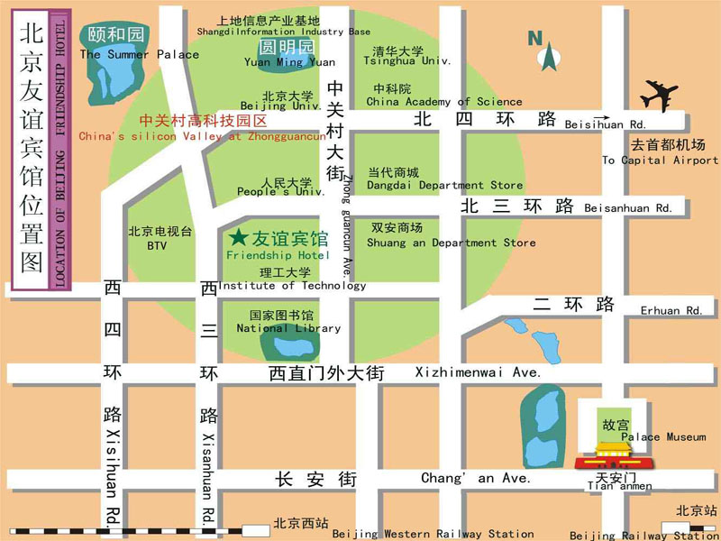
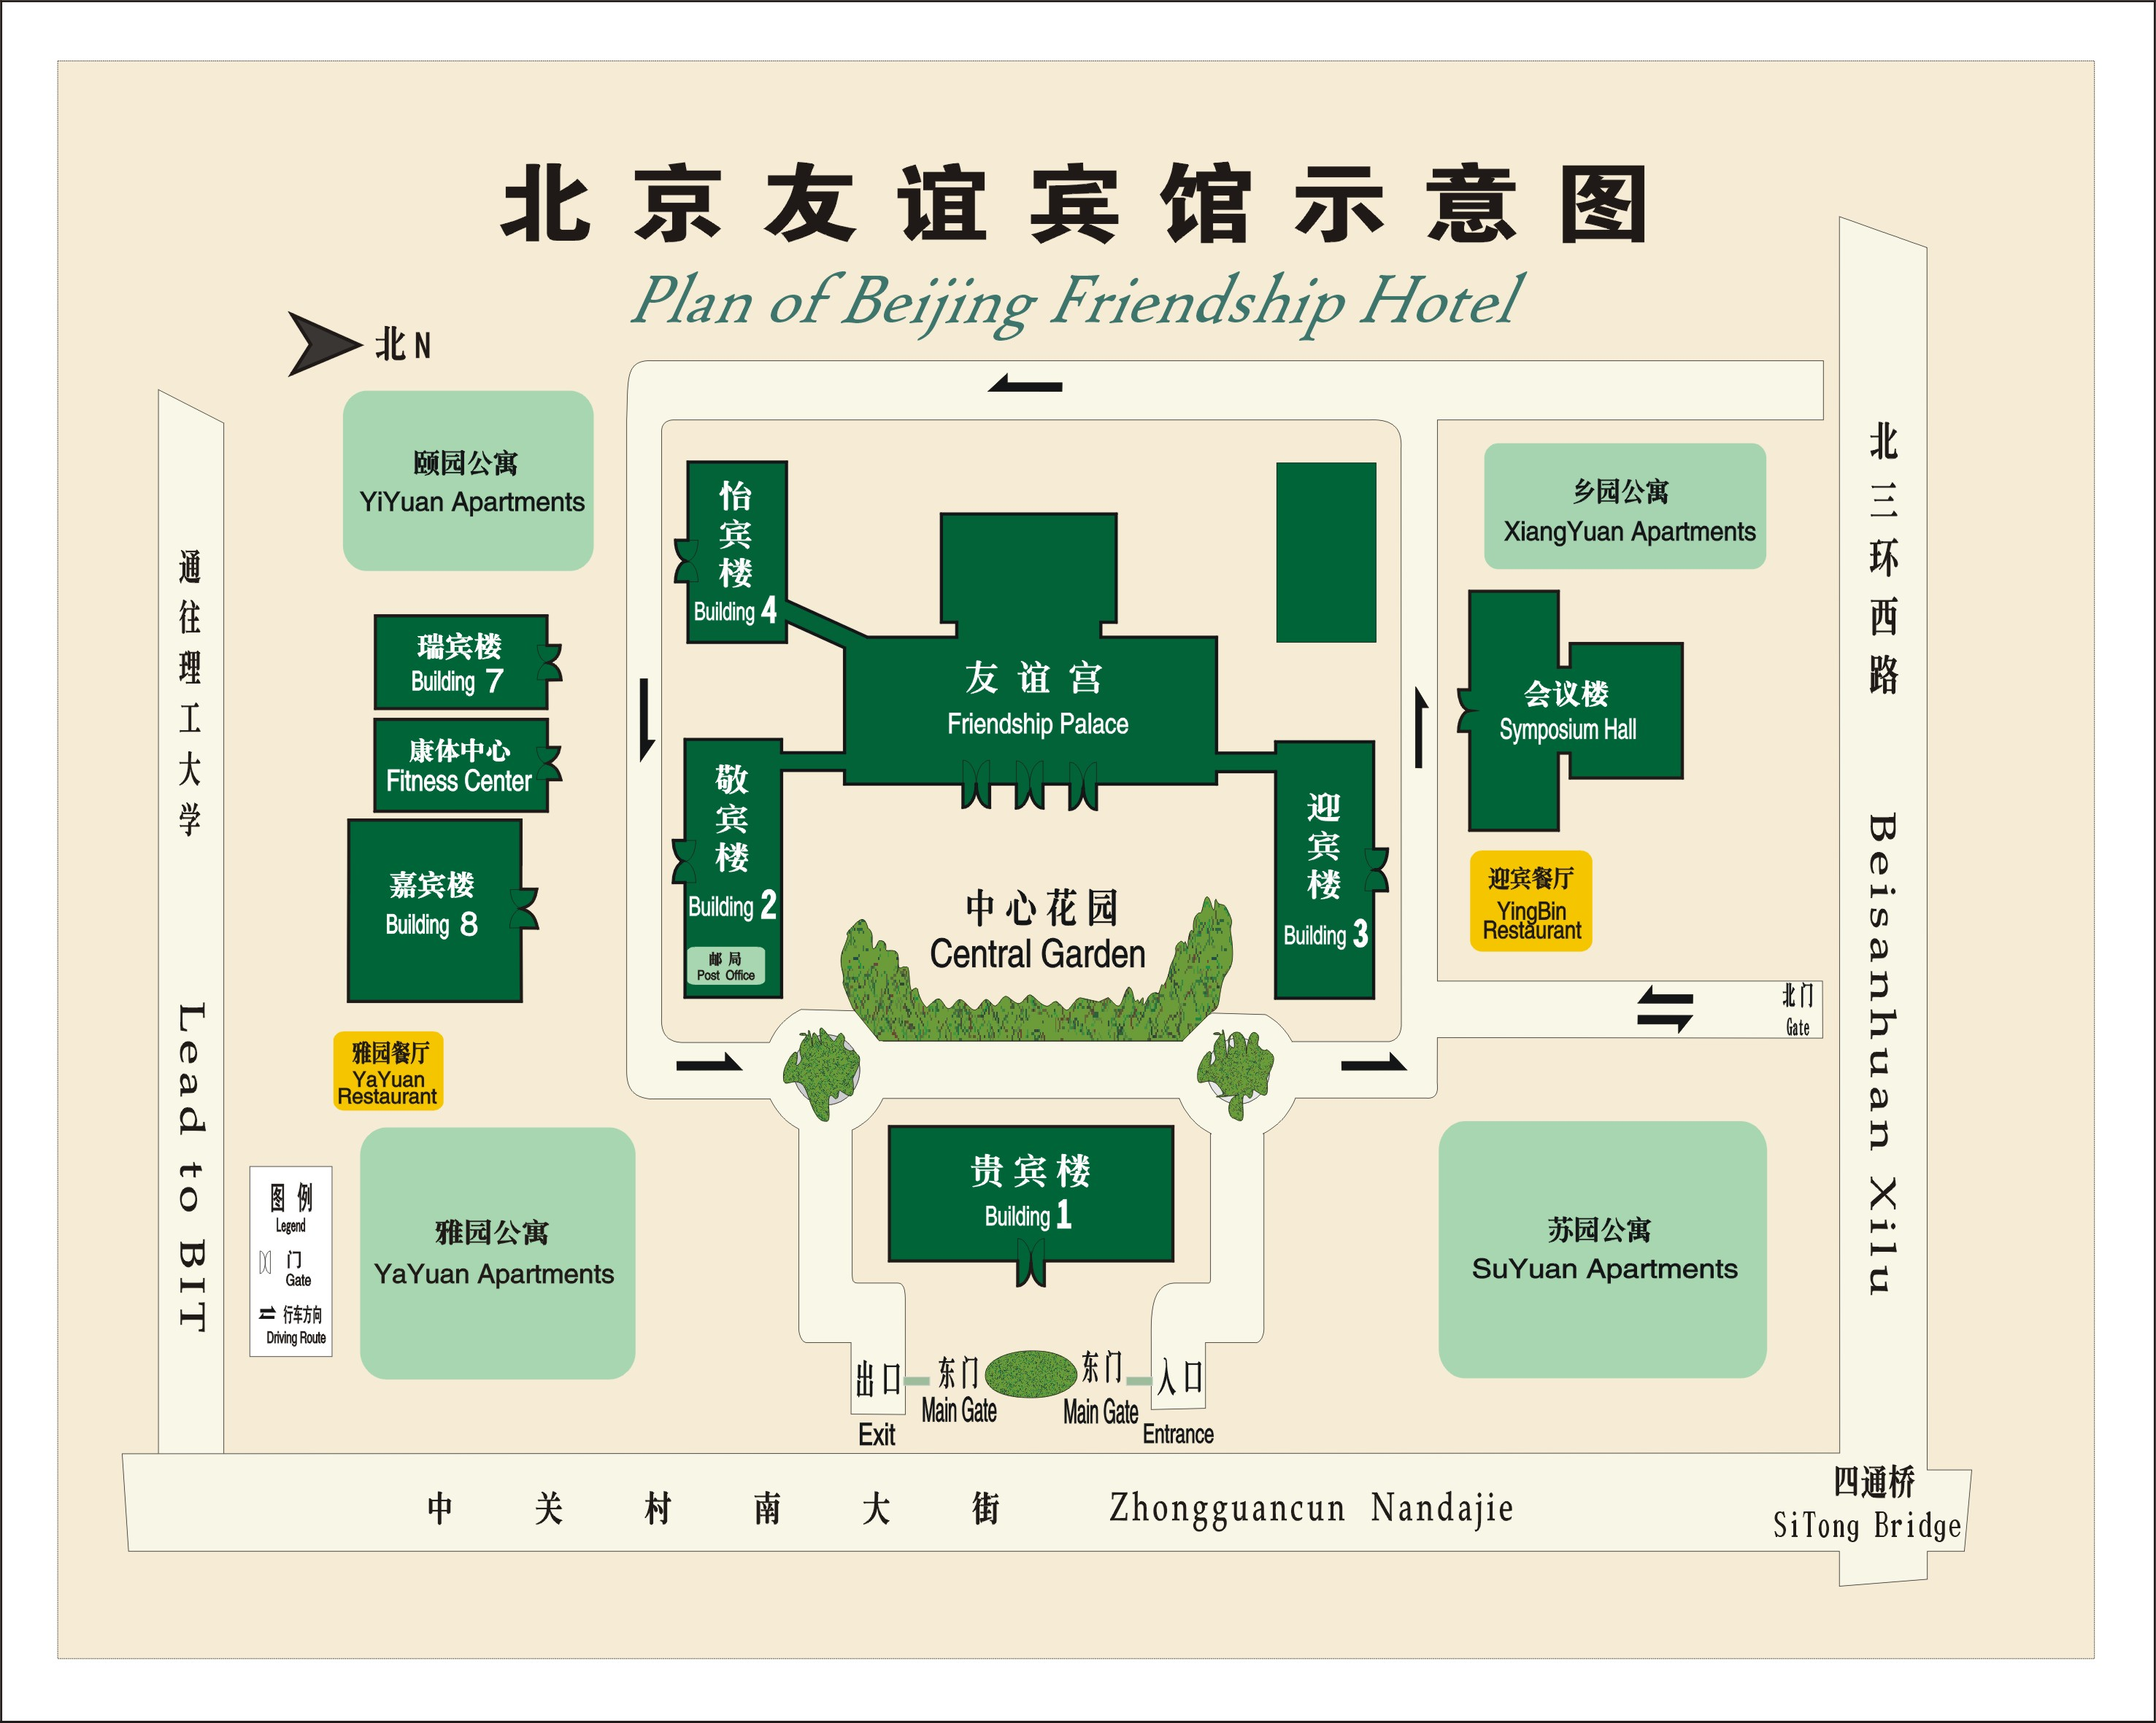
Medical services around the hotel
For medical emergencies, there are two major hospitals around the Beijing Friendship Hotel. They are Peking University Third Hospital and Beijing Haidian Hospital.
Bank services around the hotel
Around the Beijing Friendship Hotel, there are branches of China CITIC Bank and Bank of Beijing. You can go to these for financial business.
4. Miscellaneous
GSM and ACDMA Coverage
There are GSM and CDMA 95/1X coverage in Beijing.
Currency
Local currency RMB Yuan ( ¥ ). The bank and hotel can provide multi-currency service. The currency exchange desk is situated on the 1st floor of Building NO.4, Beijing Friendship Hotel.
Exchange rates
Online spot exchange rates are shown at: http://www.china.org.cn/english/BAT/31.htm
Exchange rate as of 6 November 2006.
US Dollar 100 | 779.42 RMB
Euro 100 | 976.21 RMB

Tipping

Tipping is not necessary.
Time Zone
Central Time Zone (GMT +8 hours, Beijing, Hong Kong).
Climate
Beijing's climate is defined as "continental monsoon". The four seasons are distinctly recognizable. The climate of Beijing in winter is cold and snowy. Average temperature during the January is: -4.6C. Although winter is technically longer, that should not keep you from travelling to Beijing as indoor heating is widely available. Nevertheless, as the indoor/outdoor temperature difference is rather large, travellers should be prepared with warm clothing and a thick coat is recommended for the colder months of the year.
Phone charges
Each delegate is responsible for verifying any toll charges that may be incurred by placing local, long distance and toll-free calls from a guest room.
In-town transport
Taxi rate: Typical minimum charge is RMB ¥10 (covering preliminary 3 kilometers), and extra RMB ¥ 2.0 per additional kilometre.
Subway and City Rail: There are 2 subway lines and 1 city rail in Beijing, as presented in the map below.
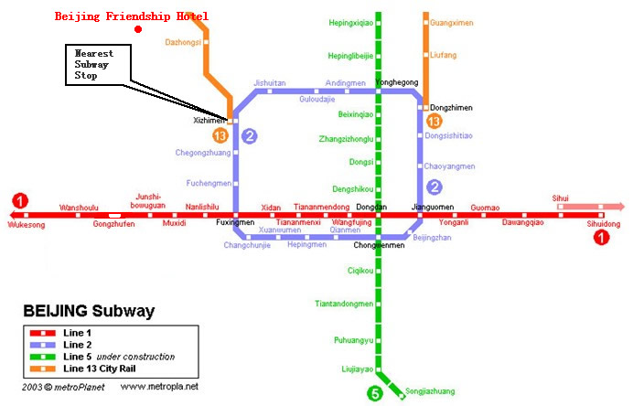
Subway System in Beijing
Currently there are three subway (or city railway) lines running in Beijing, which are line 1, 2, 13.
Line 1: line-style subway; the nearest subway stop to Beijing Friendship Hotel is Xizhimen stop;
Line 2: ring-style subway; running around the Beijing downtown area;
Line 13: sector-style city railway; running at the suburb area in the northern part of Beijing.
Electricity
220 Volt. Please be sure you have the correct adapter. Voltage converters will NOT be provided at the meeting.
The type of electrical socket at the venue of the meeting is type B.

Type B – Oblique flat blades (inverted V-shape) with ground
About Beijing
You are welcome to visit http://www.ebeijing.gov.cn, the official website of Beijing City as well as the 2008 Olympics.
Network
There will be Wireless LAN (802.11) Service in meeting rooms. Please bring your WLAN card, if you have it. WLAN cards can also be rented at the meeting secretariat (there will be a total of 50 WLAN cards available for rent).
Wired Broadband Access to Internet is available in guest rooms, which is charged 50 RMB per day.

ANNEX 3
(to TSB Circular 123)
HOTEL RESERVATION FORM
for NGN-GSI event
(Beijing, 8– 12 January, 2007)
Please complete and return this form to: NGNGSI_meeting@ccsa.org.cn
by 20 December 2006

(Please type or print in block letters and check appropriate items.)
NAME: □ Mr □ Ms.
Last name First name

ORGANIZATION:

ADDRESS: □ Office □ Home _________________

Postal code_ Country
Phone: Fax:

Name of Accompanying Person(s), if any:
□ Mr □ Ms. Last name First name
Flight Schedule: Arriving at (airport) on (date) by (flight number)

HOTEL ACCOMMODATION
Hotel Name | Room Type |  | Period of stay
Beijing Friendship Hotel  (Building NO.4) | Standard Room | Single | Check In:
Beijing Friendship Hotel  (Building NO.4) | Standard Room | Twin | Check In:
Beijing Friendship Hotel  (Building NO.4) | Suite | Single | Check Out:
Beijing Friendship Hotel  (Building NO.4) | Suite | Twin | Nights:

REMITTANCE
- Cash
- □ Credit card: □ VISA □ MasterCard □ Diners Club □ AMEX □ Other ( )
Card number:
Name of card holder: Expiration date: / /
Authorized signature:

ANNEX 4
(to TSB Circular 123)

Registration Form
ITU-T NGN-GSI event
8-12 January 2007, Beijing, P.R. China

Please fill in this form and send it by  22 December 2006 to:  (beyond this date you will be registered on site) | E-Mail: NGNGSI_meeting@ccsa.org.cn  Fax: +86-10-82053019

Title: | Ms. Mr
Last Name:
First Name:
Company:
Mailing address:
Country:
Telephone:
Fax:
Email Address:

_____________

