2006年11月10日，日内瓦
国 际 电 信 联 盟
电信标准化局

文号：  电话：  传真： | 电信标准化局第123号通函  NGN-GSI/TK  +41 22 730 5994  +41 22 730 5853 | - 致国际电联会员国主管部门；
电子  邮件： | tsbngngsi@itu.int | 抄送：  - ITU-T部门成员；  - ITU-T部门准成员；  - ITU-T各研究组正副主席；  - 电信发展局主任；  - 无线电通信局主任

事由： | NGN-GSI 活动  2007年1月8-12日，中华人民共和国，北京

尊敬的先生/女士，
1 作为对2006年在日内瓦和日本神户举行的NGN-GSI活动的跟进，以及根据2006年7月及10月至11月在日内瓦举行的最近两次NGN-GSI活动期间所达成的协议，我很高兴地通知您，应中国通信标准协会（CCSA）的友好邀请，下次NGN-GSI活动将于2007年1月8至12日在中华人民共和国北京市的北京友谊宾馆举行。
2 NGN GSI活动所包含的联合报告人组会议，将于会议第一天的9:30时以技术与战略研究会议作为开始。与会者的注册将于当日8:30时开始。有关会议室的安排将发布在NGN-GSI网站以及酒店入口及各会议室入口处的指示牌上。
3 会议和讨论将用英语进行。
4 本函附件1给出了报告人和有关组主席认可的此次活动时间表草案以及此次系列会议的若干会务安排。
5 关于此次活动的最新情况，请查询ITU-T NGN-GSI网站：http://www.itu.int/ITU-T/ngn/events/index.asp。
6 针对报告人组会议而建议的议程将发布在为此类会议专设的以下网站上： http://www.itu.int/ITU-T/ngn/events/index.asp。
7 文稿应发至电信标准化局（TSB）的NGN-GSI秘书处：tsbngngsi@itu.int。鉴于在此期间许多人将休假过节，故此次文稿的提交截止期限将例外地定为2007年1月3日。
8 附件2是主办方提供的与会议、会址和国家相关的实用信息。
9 附件3为一份酒店预订单，以方便您与会。
10 请注意会议将以无纸化方式进行。会议将为代表提供无线局域网设施。请您自行携带无线网卡，无网卡的代表可在现场向秘书处租用。
11 为使主办方和TSB为此次活动进行必要的安排，我们希望您在2006年12月22日前将附件4中的注册表（每人一份）填好并传真（号码：+86-10-82053019）或电邮（NGNGSI_meeting@ccsa.org.cn）至主办方，以便进行预先注册。
12 在此谨提醒您，一些国家的公民需要获得签证才能入境中华人民共和国并作逗留。签证须向驻贵国的中国代表机构（使馆或领事馆）申请和领取。如贵国无此类机构，则请向驻离出发国最近的此类机构申请并领取。请注意，签证的审批可能需要一些时间，因此请您务必尽快提出邀请函申请。
为入境中国需要邀请函和/或签证辅助函的与会者请与以下NGN-GSI活动的中方联络人联系，其具体联系办法如下：

Mr. Qi Xu
CCSA Standardization Promoting Center
Tel: +86 10 82050013
Mobile: +86 13466724696
Email: qixu@ptsn.net.cn

顺致敬意！
赵厚麟
电信标准化局主任

附件：4件

ANNEX 1
(to TSB Circular 123)
NGN-GSI time plan
Beijing, China, 8-12 January 2007

Monday | 08/01 | Tuesday | 09/01 | Wednesday | 10/01 | Thursday | 11/01 | Friday | 12/01
AM | PM | AM | PM | AM | PM | AM | PM | AM | PM

TSR | 2/13 | 2/13 | 2/13 | 2/13 | 2/13 | 2/13 | 2/13 | 2/13 | 2/13 | 2/13 | 2/13 | 2/13 | 2/13 | 2/13 | 2/13 | 2/13 | 2/13 | 2/13 | TSR
TSR | 3/13 | 3/13 | 3/13 | 3/13 | 3/13 | 3/13 | 3/13 | 3/13 | 3/13 | 3/13 | 3/13 | 3/13 | 3/13 | 3/13 | 3/13 | 3/13 | 3/13 | 3/13 | TSR
TSR | 4/13 | 4/13 | 4/13 | 4/13 | 4/13 | 4/13 | 4/13 | 4/13 | 4/13 | 4/13 | 4/13 | 4/13 | 4/13 | 4/13 | 4/13 | 4/13 | 4/13 | 4/13 | TSR
TSR | 15/13 | 15/13 | 15/13 | 15/13 | 15/13 | 15/13 | 15/13 | 15/13 | 15/13 | 15/13 | 15/13 | 15/13 | 15/13 | 15/13 | 15/13 | 15/13 | 15/13 | 15/13 | TSR
TSR | 8/13 | 8/13 | 8/13 | 8/13 | 8/13 | 5/11 | 8/13 |  |  | 8/13 |  | 8/13 | 8/13 |  |  | 8/13 | 8/13 | 8/13 | TSR
TSR | 13/13 | 13/13 | 13/13 | 9/13 | 9/13 | 9/13 | 13/13 | 9/13 | 9/13 | 9/13 | 9/13 | 9/13 |  | 9/13 | 9/13 |  |  |  | TSR
TSR | 2/11 | 2/11 | 2/11 | 7/13 | 5/11 | 7/13 | 7/13 | 7/13 | 7/13 |  | 5/11 |  | 7/13 | 7/13 |  |  |  |  | TSR
TSR | 1/13 | 7/13 | 1/13 | 1/13 | 1/13 | 3/11 | 3/11 | 1/13 | 3/11 | 3/11 | 3/11 | 3/11 | 3/11 | 3/11 | 3/11 | 3/11 | 3/11 | 3/11 | TSR
TSR | 8/11 | 5/11 | 8/11 | 7/11 | 7/11 | 7/11 | 1) | 5/11 | 5/11 | 5/11 | 1/13 | 5/11 | 5/11 | 5/11 | 5/11 | 5/11 | 5/11 | 5/11 | TSR

Legend:
TSR: NGN-GSI Technical and Strategy Review Activity
Note 1: Joint Qs.5 & 7/11 meeting

Some arrangements for the NGN-GSI meeting

- The meetings will be run paperless: no paper copies of the documents will be distributed. Meeting documents will be available on http://www.itu.int/ITU-T/ngn/events/index.asp. This page is accessible from the main NGN-GSI webpage http://www.itu.int/ITU-T/ngn/index.phtml.
- Similar to the previous NGN-GSI event in Geneva, the document handling for the NGN-GSI events held as co-located Rapporteur groups meetings (beyond Study Group structure) will be carried out by TSB. Therefore, contributions to this meeting should be sent to the TSB secretariat for NGN-GSI (tsbngngsi@itu.int), with copy to the Rapporteur concerned. Please use the template for the documents available from http://www.itu.int/ITU-T/ngn/events/index.asp.
- The deadline for the submission of contributions is set at 3 January 2007, midnight, Geneva time.
- For this NGN-GSI event a website has been created to give access to the input and output documents via the regular ITU document management system (DMS). As for the previous event, all input and output documents from the various Rapporteur groups for this event will be processed by the TSB, loaded onto the DMS and mirrored onto the FTP area established for this meeting. Mr. Georges Sebek, TSB acting coordinator for the NGN-GSI, is the focal point to carry out this task. His contact details are as follows:
Georges Sebek
TSB/ITU
Place des Nations
CH-1211 Geneva 20
Switzerland
Tel : +41 22 730 5994
Fax : +41 22 730 5853
E-mails : tsbngngsi@itu.int
georges.sebek@itu.int
- Meeting logistics will also be coordinated by TSB. Please contact TSB secretariat for this event at tsbngngsi@itu.int.
- Any requests for information on meetings should be sent to Georges Sebek, TSB acting coordinator for NGN-GSI.
ANNEX 2
(to TSB Circular 123)

Practical Information

- Venue
The Beijing Friendship Hotel (****) Tel: +86-10-68498888
1 Zhongguancun Nandajie, Haidian District, Fax: +86-10-68498866
Beijing, China
For detailed information about Beijing Friendship Hotel, please see:
http://www.bjfriendshiphotel.com/enew.htm
  - How to get there
There are 2 ways to get from the airport to the hotel:
First, a Shuttle Bus from Beijing Capital International Airport to Beijing Friendship Hotel goes every 30 minutes (from 8:00-23:00); the fare is 16 RMB.
Second, you may wish to take a taxi from airport to hotel. Average fare from the airport to the hotel is approximately 120 RMB for a regular taxi but it may cost more depending on traffic during rush hours.
- Entry Notes
Visa requirements
Please contact Mr Qi Xu (qixu@ptsn.net.cn) should you require an individual invitation letter while obtaining your visa. Your email must include the following information in order to be processed:
- Family name (last name)
- Forename (first name)
- Birth date (month, day, year)
- Passport number, issuing country, issuing date and expiry date
- Gender
- Occupation
- Company name
- Company’s mailing address
- Postal Code
- Country
- Telephone number
- Fax number
- Name of meeting (ITU-T NGN-GSI event)
Letters will only be sent via Express mail upon request. Letters will be sent via fax unless otherwise indicated on the request.
Letters will be processed within 14 days of receiving an email request. If you have not received your letter within 14 days or wish to make changes after receiving a faxed copy, please contact Mr Qi Xu (qixu@ptsn.net.cn) .
In addition, you may be asked for specific documentation showing strong social, economic, and other ties to your home country.
Customs Regulations and Vaccination Requirements
See the above attachment for reference or check this website:
http://www.hlraohe.gov.cn/kajm/crj/xz.htm
Hotel Reservation Procedure
A total of about 100 rooms in the Beijing Friendship Hotel Building NO.4 have been blocked for the participants at preferential rates. The preferential rates will start when the participants arrive at the hotel and be cut off when the meeting closed.
The hotel is pleased to offer you a standard room (single/twin) and a suite (single/twin) in the Building NO.4. The fare for stay in the standard room (single/twin) is US$72 per night (including breakfast), and the fare for the suit (single/twin) is US$127 per night (including breakfast). The fare for the lunch is US$12, and the fare for the lunch and supper will be US$24.
Participants wishing to make reservations should fulfil the reservation form in Annex 3 and send it to the following address: NGNGSI_meeting@ccsa.org.cn (hosting organization focal point for this meeting).
We should be grateful if you would send your reservation as soon as possible, but not later than 20 December 2006.
3. Map directions
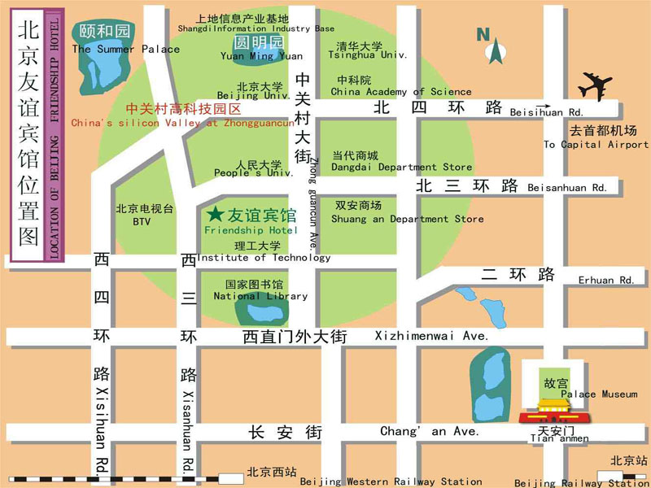
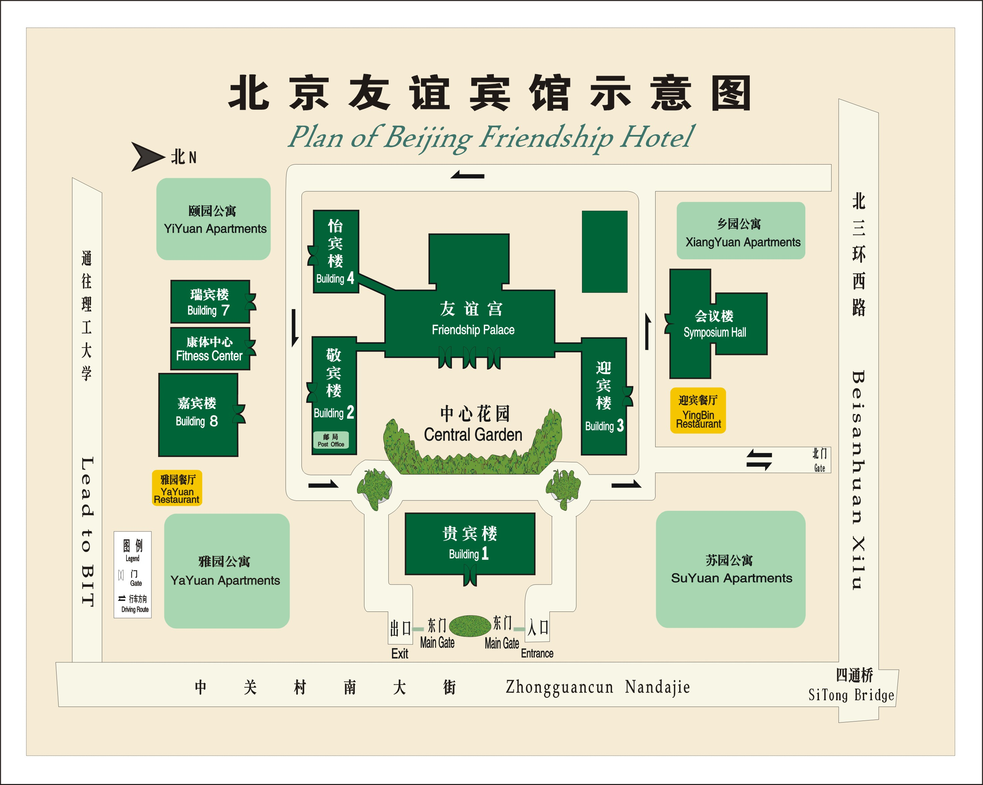
Medical services around the hotel
For medical emergencies, there are two major hospitals around the Beijing Friendship Hotel. They are Peking University Third Hospital and Beijing Haidian Hospital.
Bank services around the hotel
Around the Beijing Friendship Hotel, there are branches of China CITIC Bank and Bank of Beijing. You can go to these for financial business.
4. Miscellaneous
GSM and ACDMA Coverage
There are GSM and CDMA 95/1X coverage in Beijing.
Currency
Local currency RMB Yuan ( ¥ ). The bank and hotel can provide multi-currency service. The currency exchange desk is situated on the 1st floor of Building NO.4, Beijing Friendship Hotel.
Exchange rates
Online spot exchange rates are shown at: http://www.china.org.cn/english/BAT/31.htm
Exchange rate as of 6 November 2006.
US Dollar 100 | 779.42 RMB
Euro 100 | 976.21 RMB

Tipping

Tipping is not necessary.
Time Zone
Central Time Zone (GMT +8 hours, Beijing, Hong Kong).
Climate
Beijing's climate is defined as "continental monsoon". The four seasons are distinctly recognizable. The climate of Beijing in winter is cold and snowy. Average temperature during the January is: -4.6C. Although winter is technically longer, that should not keep you from travelling to Beijing as indoor heating is widely available. Nevertheless, as the indoor/outdoor temperature difference is rather large, travellers should be prepared with warm clothing and a thick coat is recommended for the colder months of the year.
Phone charges
Each delegate is responsible for verifying any toll charges that may be incurred by placing local, long distance and toll-free calls from a guest room.
In-town transport
Taxi rate: Typical minimum charge is RMB ¥10 (covering preliminary 3 kilometers), and extra RMB ¥ 2.0 per additional kilometre.
Subway and City Rail: There are 2 subway lines and 1 city rail in Beijing, as presented in the map below.
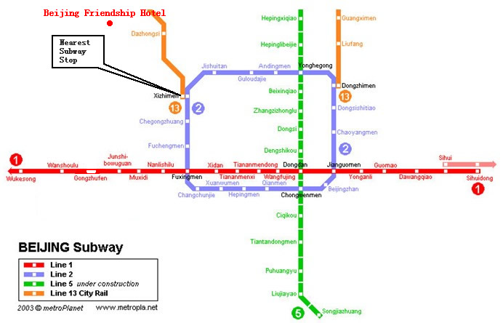
Subway System in Beijing
Currently there are three subway (or city railway) lines running in Beijing, which are line 1, 2, 13.
Line 1: line-style subway; the nearest subway stop to Beijing Friendship Hotel is Xizhimen stop;
Line 2: ring-style subway; running around the Beijing downtown area;
Line 13: sector-style city railway; running at the suburb area in the northern part of Beijing.
Electricity
220 Volt. Please be sure you have the correct adapter. Voltage converters will NOT be provided at the meeting.
The type of electrical socket at the venue of the meeting is type B.

Type B – Oblique flat blades (inverted V-shape) with ground
About Beijing
You are welcome to visit http://www.ebeijing.gov.cn, the official website of Beijing City as well as the 2008 Olympics.
Network
There will be Wireless LAN (802.11) Service in meeting rooms. Please bring your WLAN card, if you have it. WLAN cards can also be rented at the meeting secretariat (there will be a total of 50 WLAN cards available for rent).
Wired Broadband Access to Internet is available in guest rooms, which is charged 50 RMB per day.

ANNEX 3
(to TSB Circular 123)
HOTEL RESERVATION FORM
for NGN-GSI event
(Beijing, 8– 12 January, 2007)
Please complete and return this form to: NGNGSI_meeting@ccsa.org.cn
by 20 December 2006

(Please type or print in block letters and check appropriate items.)
NAME: □ Mr □ Ms.
Last name First name

ORGANIZATION:

ADDRESS: □ Office □ Home _________________

Postal code_ Country
Phone: Fax:

Name of Accompanying Person(s), if any:
□ Mr □ Ms. Last name First name
Flight Schedule: Arriving at (airport) on (date) by (flight number)

HOTEL ACCOMMODATION
Hotel Name | Room Type |  | Period of stay
Beijing Friendship Hotel  (Building NO.4) | Standard Room | Single | Check In:
Beijing Friendship Hotel  (Building NO.4) | Standard Room | Twin | Check In:
Beijing Friendship Hotel  (Building NO.4) | Suite | Single | Check Out:
Beijing Friendship Hotel  (Building NO.4) | Suite | Twin | Nights:

REMITTANCE
- Cash
- □ Credit card: □ VISA □ MasterCard □ Diners Club □ AMEX □ Other ( )
Card number:
Name of card holder: Expiration date: / /
Authorized signature:

ANNEX 4
(to TSB Circular 123)

Registration Form
ITU-T NGN-GSI event
8-12 January 2007, Beijing, P.R. China

Please fill in this form and send it by  22 December 2006 to:  (beyond this date you will be registered on site) | E-Mail: NGNGSI_meeting@ccsa.org.cn  Fax: +86-10-82053019

Title: | Ms. Mr
Last Name:
First Name:
Company:
Mailing address:
Country:
Telephone:
Fax:
Email Address:

_____________

