Международный союз электросвязи  Бюро стандартизации  электросвязи | 

 |  | Женева, 2 декабря 2005 года
Осн.: | Циркуляр 60 БСЭ  TSB Workshops/X.Y. | – Администрациям Государств – Членов Союза  – Членам Сектора МСЭ-Т  – Ассоциированным членам МСЭ-Т
Тел.:  Факс: | +41 22 730 6206  +41 22 730 5853
Эл. почта: | tsbworkshops@itu.int | Копии:  – Председателям и заместителям председателей исследовательских комиссий МСЭ-Т  - Директору Бюро развития электросвязи  - Директору Бюро радиосвязи

Предмет: | Семинар-практикум МСЭ-Т по СПП и их транспортным сетям  Кобе, Япония, 20−21 апреля 2006 года

Уважаемая госпожа,
Уважаемый господин,
1 Хотел бы сообщить вам, что по любезному приглашению компании "The ITU Association of Japan, Inc." семинар-практикум МСЭ-Т на тему "СПП и их транспортные сети" состоится в Международном центре конференций Кобе (МЦКК), Япония, с 20 по 21 апреля 2006 года включительно.
Открытие семинара-практикума состоится в первый день его работы в 09 час. 00 мин. Подробная информация о залах заседаний будет размещена на экранах в МЦКК.
2 Выступления и обсуждение будут проходить на английском языке. Синхронный перевод с английского языка на японский и с японского языка на английский будет обеспечиваться принимающей организацией.
- В семинаре-практикуме могут принять участие Государства − Члены МСЭ, Члены и Ассоциированные члены Сектора, а также любое лицо из страны, являющейся членом МСЭ, которое пожелает внести свой вклад в работу семинара-практикума. К таким лицам относятся также члены международных, региональных и национальных организаций. Участие в семинаре-практикуме является бесплатным, но стипендии не предоставляются.
- В настоящее время в рамках МСЭ-Т и других ОРС ведется активная работа по стандартизации СПП. После успешных результатов, достигнутых Оперативной группой по СПП, и учреждения Глобальной инициативы по стандартизации сетей последующих поколений (ГИС-СПП) в рамках
МСЭ-Т данный семинар-практикум МСЭ-Т будет представлять собой возможность для анализа состояния осуществляемой работы, в особенности в 13-й и 15-й Исследовательских комиссиях, определения существующих и будущих тенденций в области технологии и создания основы для продвижения вперед работы по стандартизации. Данный семинар-практикум позволит проанализировать аспекты СПП, касающиеся архитектуры, функциональных параметров и транспорта, а также рыночные движущие механизмы и задачи. Особое внимание будет уделено сетевым технологиям, стандартам, затрагивающим аспекты СПП, касающиеся архитектуры и функциональных параметров, и аспекты транспортных сетей в поддержку услуг СПП.
- Проект программы семинара-практикума приводится в Приложении 1 к настоящему документу.
6 Обновленная информация о семинаре-практикуме, включая программу, выступления, а также подробные сведения и практическую информацию, предоставленную принимающей стороной, будет размещена на Web-сайте семинара-практикума МСЭ-Т по следующему адресу:
http://www.itu.int/ITU-T/worksem/ngn/200604/index.html.
7 Для вашего удобства в Приложении 2 содержится практическая информация и форма для резервирования гостиницы.
- С тем чтобы БСЭ могло предпринять необходимые действия в отношении организации этого семинара-практикума, были бы признательны вам за предварительную регистрацию путем направления в адрес БСЭ по факсу (+41 22 730 5853), по электронной почте (tsbreg@itu.int) или в онлайновой форме по адресу: http://www.itu.int/ITU-T/worksem/ngn/200604/registration.html в максимально короткий срок, но не позднее пятницы, 7 апреля 2006 года, должным образом заполненную регистрационную форму (по одной на каждого участника), которая содержится в Приложении 3.
Регистрация на месте и вручение электронных пропусков начнутся в четверг, 20 апреля 2006 года, в 08 час. 00 мин. по месту проведения семинара-практикума, где будет выдан действительный электронный пропуск МСЭ для получения доступа на семинар-практикум.
- Напоминаем, что для въезда в Японию и пребывания там гражданам определенных стран необходима виза. Визу следует запрашивать и получать в учреждении (посольстве или консульстве), представляющем Японию в вашей стране, или, если в вашей стране такое учреждение отсутствует, − в ближайшем к стране выезда.
Участникам, которым необходимо получить пригласительное письмо и/или письмо с визовой поддержкой для въезда в Японию, рекомендуется обратиться к представителю семинара-практикума в Японии, подробная информация о котором приводится ниже:
Ms. Hideyo Banishky or Mr. Akihito Yamamoto

Technical Department, The ITU Association of Japan, Inc.

3rd floor Kanda KS Building,
1-8-6 Kaji-cho, Chiyoda-ku, Tokyo 101-0032, Japan
Тел.: +81 3 5207 5722 Факс: +81 3 5207 5731
Эл. почта: hideyo@ituaj.jp
С уважением,
Х. Чжао
Директор Бюро
стандартизации электросвязи

Приложения: 3

ANNEX 1
(to TSB Circular 60)
Advance Program
Workshop on NGN and its Transport Networks
Kobe, Japan, 20 to 21 April 2006
For more details on this workshop and updates to the program, please see the workshop website at the following address: http://www.itu.int/ITU-T/worksem/ngn/200604/index.html

Day 1 - 20 April 2006
9:00-10:30 | SESSION 1: Opening Session  Chairmen: Yoichi MAEDA & Brian MOORE (SG15 and SG13 Chairmen)  Objectives: This session will provide an introduction to the workshop and give an overview of the current developments of NGN related standards. It will also provide experiences of NGN strategic promotion and network deployment experiences in one of the most advanced country on the broadband network services.  Welcome address − Hiroshi MATSUI (President of ITU Association of Japan)  Opening remarks − Houlin ZHAO (TSB Director)  NGN standards overview and the workshop objectives − Chae-sub LEE (FGNGN Chairman)  ITU-T standards overviews on NGN and Its transport networks  SG13 aspects; Brian MOORE (SG13 Chairman)  SG15 aspects; Yoichi MAEDA (SG15 Chairman)  Key note 1; NGN & u-Japan Strategy − Masao MATSUMOTO (Director-General for Technology Policy Coordination of MIC, Japan)  - Key note 2; Broadband service deployment experiences in Japan – Ryuji YAMADA (Senior Executive Vice President of NTT)
10:30-11:00 | COFFEE BREAK
11:00-12:30 | SESSION 2: NGN Architecture and Requirements  Chairman: Naotaka MORITA (SG13 Vice-chairman)  Objectives: This session will review and examine service requirements and capabilities of NGN and its architectural aspects which were developed by NGN related groups such as the FGNGN, TISPAN and OMA. Based on the review and examination of the NGN architecture and requirements, the session will discuss and investigate future issues for the realization of NGN. This investigation will also include discussion on the relationship with transport area like service vs. transport and access vs. core in NGN architecture and requirements.  - Service requirements and capabilities − Marco CARUGI (Nortel Europe)  - Functional Architecture Model of NGN − Dick KNIGHT (BT, UK)  - IMS based NGN Architecture and its application − Anett SCHUELLE (NEC Europe, Germany)  - Further study issues on NGN requirements and architecture − Keith KNIGHTSON (Canada)
12:30-14:00 | LUNCH BREAK
14:00-15:30 | SESSION 3: Network QoS and Control  Chairman: Neal SEITZ (SG13 Vice-chairman)  Objectives: This session will summarize Quality of Service (QoS) and resource control requirements for NGNs, and how those requirements are being addressed in international standards and emerging networks. The session will focus on the "upper layer" controls enabling individual IP packet flows to be established, across IP router networks, among end users and application service providers. It will also explore how upper layer controls may interact with "lower layer" controls enabling aggregate flows to be established, across optical transport networks, among IP router networks operating as OTN clients.  - Resource and Admission Control for NGN − Hui-Lan LU (Lucent, USA)  - NGN QoS Control Architecture and Protocols − Keith MAINWARING (Cisco, USA)  - Optical Transport Network Control and Management − Tobey TRYGAR (Telcordia, USA)  - Capabilities for NGN Operation, Administration, and Maintenance − Dinesh MOHAN (Nortel, Canada)
15:30-16:00 | COFFEE BREAK
16:00-18:00 | SESSION 4: Transport Network Control (ASON, GMPLS and Control plane management  Chairman: Steve TROWBRIDGE (SG15 Vice-chairman)  Objectives: This session will cover the key control plane technologies that are employed in the evolution to intelligent optical and SDH networks which support the transport layers for Next Generation Networks. Presentations topics include: business drivers for control plane deployment; IETF activities on development of the base protocols; and control plane signaling, routing, and management, including an introduction to the relevant standards.  - Business Drivers − Alan McGUIRE (BT, UK)  - IETF - Base Protocols − Adrian FARREL (IETF ccamp co-chair, UK)  - Signaling − Stephen SHEW (Nortel , Canada)  - Routing − Jonathan SADLER (Tellabs, USA)  - Control Plane Management − Kam LAM (Lucent, USA)

Day 2 - 21 April 2006
9:00-10:30 | SESSSION 5: Market Opportunities and Challenges  Chairman: Helmut SCHINK (SG13 Vice-chairman)  Objectives: NGN provides a number of opportunities for various kinds of businesses. Those include service providers, application providers, transport providers in the access and the backbone. It provides mechanisms to offer services to customers, residential end-users, business users or re-sellers.  Challenges arise from a number of sources like competition, cost of implementation, changing marketplaces, complex migration scenarios and regulatory uncertainties.  This session aims to provide a state-of-the-art overview on global trends with a focus to the Asia-Pacific region from the different perspectives.  - Construction of all-IP network and transition plan to NGN, Ultra 3G –Kazuyoshi SAWADA (KDDI Corporation, Japan) (TBC)  - Opportunities and challenges for a global system vendor − John HARPER (Cisco, USA)  - Call server based evolution scenario in China − ZHAO Hui Ling (China Telecom, China)  - Evolution from PSTN to NGN in China − SHEN Yuchao (SCNB, China)
10:30-11:00 | COFFEE BREAK
11:00-12:30 | SESSION 6: Broadband Access (VDSL access, PON access, Cable access and WiMAX)  Chairman: Andrew NUNN (SG15 Vice-chairman)  Objectives: This session will cover some of the access network technologies that are being deployed to support broadband services and which are evolving to support emerging Next Generation Networks. The session will provide an overview of VDSL, Passive Optical Networks, Cable and WiMAX technologies as well as an examination of relevant standards.  - VDSL − Martin SCHENK (Infineon Technology, Germany)  - Passive Optical Networks − Yukio NAKANO (Hitachi, Japan)  - Cable access − Naoyoshi NAKAMURA (NHK, Japan)  - WiMAX − Mitsuo NOHARA (KDDI Corporation, Japan) (TBC)
12:30-14:00 | LUNCH BREAK
14:00-15:30 | SESSION 7: Data over Transport networks (Ethernet/MPLS over Transport and Enhanced Ethernet OAM)  Chairman: Malcolm BETTS (SG15 Q.12 Rapporteur)  Objectives: This session will describe how Ethernet is being deployed in carrier networks today. The session will also describe some of the areas that are currently under active discussion in the IEEE and ITU-T. These enhancements, for example Provider Backbone Bridges and OAM, improve the capabilities and manageability of Ethernet in carrier networks applications.  - Ethernet services over MPLS/VPLS − Maarten VISSERS or Italo BUSI (Alcatel, Belgium) TBC  - IEEE 802.1ah (PBB) and 802.1ag (OAM) − Paul BOTTORFF (Nortel, Canada)  - Ethernet OAM and Protection switching − Hiroshi OHTA (NTT, Japan)  - Next generation Ethernet network application − Alan McGUIRE (BT, UK)
15:30-16:00 | COFFEE BREAK
16:00-17:30 | SESSION 8: Review and Conclusion  Chairmen: Brian MOORE & Yoichi MAEDA (SG13 and SG15 Chairmen)  Objectives: This session will give an overview of the workshop. It will draw the main conclusions and messages from the various sessions of the workshop and in particular identify key issues to be followed up and what new standards may be needed. It will also provide a final opportunity for questions and comments from the workshop participants.  - Main Conclusions  - Messages for further activities by ITU-T  - New Standards Required  Chairmen Conclusion: All Session chairmen will summarize the session discussions and will make proposals for future standardization activities.

ANNEX 2
(to TSB Circular 60)

Practical Information
- Venue
The International Conference Center Kobe Tel: +81 78 302 5200
6-9-1 Minatojima-nakamachi, Chuo-ku, Fax: +81 78 302 6485
Kobe 650-0046, Japan
For detailed information about International Conference Center Kobe (ICCK), please see:
http://www.kcva.or.jp/kcc/icck/e-index.html
- Access to the ICCK
Please see Attachment 1 to Annex 2 for details. Some changes in the operation of public transportation in Kobe are expected when a new domestic airport opens in Kobe in February 2006. Access information will be updated when new information is available.
3. Hotels
3.1 Hotel list
A total of about 300 rooms in 6 hotels around the ICCK have been blocked for the participants at preferential rates for participants. The preferential rates will start on 1 December 2005 and be cut off on 31 March 2006. These hotels are listed in Attachment 2 to Annex 2 and a map indicating their location is also attached.
3.2 Hotel reservations
Participants wishing to make reservations should contact the hotel directly by using the reservation form in Attachment 3 to Annex 2.

4. General information on Japan and Kobe
4.1 Electrical appliances
Japan operates on 100 volts for electrical appliances. The frequency is 60 Hz in western Japan including Kobe and Osaka (50 Hz in eastern Japan including Tokyo). The type of power outlet/connector used in Japan is A type which is two parallel pronged type.
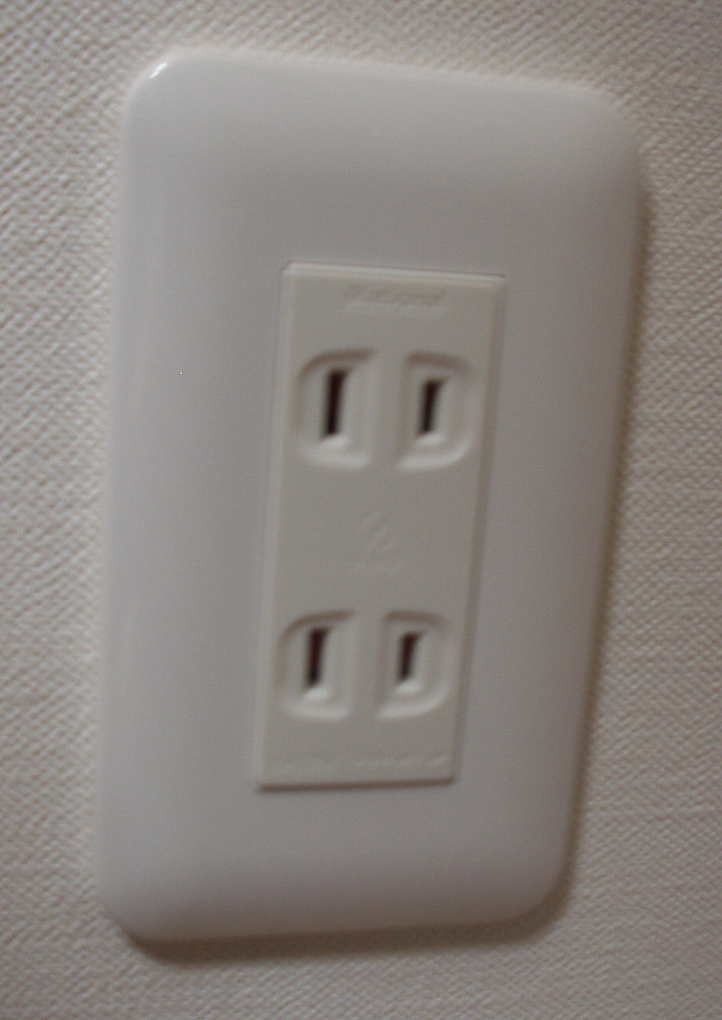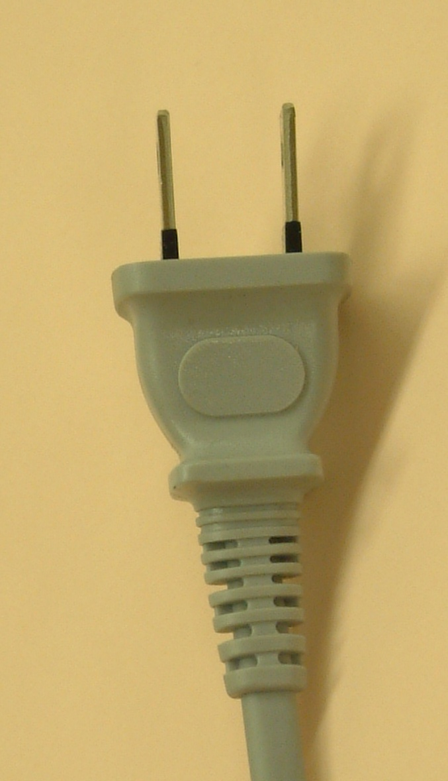
If your appliances operate on a different voltage, please bring your own transformers.
  - Passports and Visas
All foreign visitors entering Japan must have a valid passport. Participants who require a visa should, well in advance, apply for a visa to a Japanese consulate or diplomatic mission in their respective country prior to departure. Participants are also advised to contact their local travel agents or carriers. For more information please visit the web site of the Ministry of Foreign affairs of Japan at: http://www.mofa.go.jp/j_info/visit/visa/index.html.
Participants who need an invitation letter and/or a visa supporting letter for entering Japan are advised to get in touch with the workshop contact person in Japan as indicated in item 6 below.
  - Currency exchange
Only Japanese Yen is accepted at stores and restaurants. Major foreign currencies may be exchanged to Yen at foreign exchange banks and other authorized money exchangers on presentation of your passport. A few local banks’ branches where currency may be exchanged are available around Sannomiya Station.
  - Exchange rates
Online spot exchange rates are shown at: http://www.btm.co.jp/gdocs/kinri/list_j/kinri/kawase.htm. Exchange rate as of 1 December 2005.
US Dollar 1 $ | 116.77
Euro 1 Euro | 133.68

  - Tipping

Tipping is not necessary.
  - Climate
The climate of Kobe in spring is comparatively dry with clear blue skies. Average temperature during the season is:
March | April | May
8.9 C (48.02 F) | 14.7 C (58.46 F) | 19.2 C (66.56 F)

  - City of Kobe
Kobe is a port city with a history of 1,300 years and is now one of the biggest international port cities in Japan, which attracts many people from both home and abroad. The blessing in Kobe is its beautiful mountains and seaside. In downtown, you will see a unique combination of modern and classic, Japanese and exotic cultures. Kobe is the leading city of top mode, fashion and trend. Kobe is also known for its excellent cuisine, especially the Kobe Beef, confectionery, and people’s hospitality. For more information, please visit the following Web site:
http://feel-kobe.jp/english/index.html.
5. Using laptop PC at the meetings7
This meeting will be paper-less. Therefore participants are strongly recommended to bring their laptops. Wireless LAN will be provided in all meeting rooms.

6. Contact persons
If you have any questions, please contact:
Ms. Hideyo Banishky or Mr. Akihito Yamamoto
Technical Department, ITU Association of Japan, Inc.
3rd floor Kanda KS Building, 1-8-6 Kaji-cho, Chiyoda-ku, Tokyo 101-0032, Japan
Tel: +81 3 5207 5722 Fax: +81 3 5207 5731
e-mail: hideyo@ituaj.jp
7. Support
This workshop is kindly supported by the Ministry of Internal Affairs and Communications of Japan, and sponsored by; Nippon Telegraph and Telephone Corporation, FUJITSU LIMITED, Hitachi, Ltd., KDDI Corporation, MITSUBISHI ELECTRIC CORPORATION, NEC Corporation, Oki Electric Industry Co., Ltd., Motorola Japan Ltd., SOFTBANK Group, Softfront, Matsushita Electric Industrial Co., Ltd. (Panasonic), ACCA Networks Co., Ltd., COMMUNICATION LINE PRODUCTS ASSOCIATION OF JAPAN, eAccess Ltd., Ericsson AB, Fuji Xerox Co., Ltd., Japan Cable Television Engineering Association, Japan Cable & Telecommunications Association, NTT Comware Corporation, Support Center for Advanced Telecommunications Technology Research Foundation, The ITU Association of Japan, Inc., The Telecommunication Technology Committee, TOSHIBA CORPORATION and Vodafone.
ATTACHMENT 1 TO ANNEX 2

ACCESS to International Conference Center Kobe

By domestic flight
Fare: \19,100
Travel time: 70 min.
Departure: 3 flights a day
NARITA INT. AIRPORT
KANSAI INT. AIRPORT
By JR limited express train, NARITA EXPRESS
Fare: \2,940
Travel time: 96 min.
Departure time: 7:42 – 21:43
(30 min intervals)

By limousine bus
Fare: \1,800
Travel time: 65 – 75 min.
Departure time: 6:30 – 23:20
(20 min. intervals)

KOBE AIRPORT
(Domestic flight only)
To be opened in Feb 2006
TOKYO STATION
OSAKA INT. AIRPORT

(ITAMI)

By JR bullet train, HIKARI
Fare: \14,270
Travel time: 195min
Departure time: 6:36 – 20:30
(60 min. intervals)

By limousine bus
Fare: \1,020
Travel time: 40 min
Departure time:
From North Terminal: 7:50 – 21:15
From South Terminal: 7:45 – 21:10
(20 min. intervals)
By JR bullet train, NOZOMI
Fare: \14,670
Travel time: 173 min
Departure time: 6:00 – 20:30
(30 min. intervals)

SHINKOBE STATION

By Subway
Fare: \200
Travel time: 5 min
Departure time: 5:26–0:00
(7 min intervals)

SANNOMIYA STATION

By Port Liner
(Shimin Hiroba Sta.)
Fare: \240
Further information will
be provided later
By Port Liner
(Shimin Hiroba Sta.)
Fare: \240
Further information will be provided later

INTERNATIONAL CONFERENCE CENTER KOBE (ICCK)
Attachment 2 TO ANNEX 2
HOTEL LIST (20-27 April 2006, Kobe)
No | Hotel Name | Room Rate^{*1} |  |  |  | ACCESS to ICCK | Address  Phone/Fax
No | Hotel Name | Single  with Bath | Twin  with Bath  (Single Use) |  | Twin  with Bath  (Twin Use) | ACCESS to ICCK | Address  Phone/Fax
No | Hotel Name | Size of Rooms |  |  |  | ACCESS to ICCK | Address  Phone/Fax
1 | Portopia Hotel | ￥11,550  (￥9,550) ^{*2} |  | ￥17,850  (￥15,850) | ￥21,000  (￥17,000) | ･3 min walk to ICCK  ･Every 20 min, free shuttle bus runs from Shinkobe Station and Sannomiya Sation to portopia hotel. | 10-1,6 Chome, Minatojima Nakamachi, Chuo-ku, Kobe  TEL: +81-78-302-1111 FAX: +81-78-302-6877  (www.portopia.co.jp/en/index.html）
1 | Portopia Hotel | (22.4m²) |  | (27.4m² )
2 | Kobe Quality Hotel | ￥7,500  (￥6,500) |  | ￥8,500  (￥7,500) | ￥13,000  (￥11,000) | ･3 min walk to ICCK | 1,6 Chome, Minatojima Nakamachi, Chuo-ku, Kobe  TEL: +81-78-303 5555 FAX: +81-78-303-5560  (www.choicehotels.com/ires/en-EN/hotel/JP044)
2 | Kobe Quality Hotel | (20m² ) |  | (28m²) |  | ･3 min walk to ICCK
3 | Hotel Pearl City Kobe | ￥9,975  (￥8,925) |  | ￥12,600  (￥11,550) | ￥16,800  (￥14,700) | ･5 min walk to ICCK | 5-1, 7 Chome, Minatojima Nakamachi, Chuo-ku, Kobe  TEL: +81-78-303 0100 FAX: +81-78-303-0211  (www.pearlcity.co.jp/kobe/English/jindex.hml)
3 | Hotel Pearl City Kobe | (19m²) |  | (20m²) |  | ･5 min walk to ICCK
4 | Kobe Tokyu Inn | ￥9,000  (￥8,000) |  | ￥12,000  (￥11,000) | ￥16,000  (￥14,000) | ･3 min walk to Sannomiya Sta and 10 min ride (Portliner) to ICCK | 6-1-5, Kumoidori, Chuo-ku, Kobe  TEL: +81-78-291 0109 FAX: +81-78-221-2917
4 | Kobe Tokyu Inn | (15 m² ) |  | (18.4m² ) |  |  | (www.tokyuhotels.co.jp/en/TI/TI_KOBE/index.html)
5 | Sannomiya Terminal Hotel | ￥8,946  (￥8,316) |  | ￥14,212  (￥13,582) | ￥21,702  (￥16,354) | ･10min ride(Portliner) to ICCK | 1-2, 8-chome kumoidori, Chuo-ku,Kobe  TEL: +81-78-291-0001 FAX: +81-78-291-0020
5 | Sannomiya Terminal Hotel | (15m² ) |  | (23m² ) |  |  | (www.sth-hotel.co.jp/e-index.html)
6 | ShinKobe Oriental Hotel | ￥11,550  (￥10,500) |  | ￥15,750  (￥14,700) | ￥18,900  (￥16,800) | ･1min walk to Shin-Kobe Bullet train Station  ･20min ride (Subway & Portliner) to ICCK | 1-chomekitano-cho,chuo-ku,Kobe  TEL: +81-78-291-1121 FAX: +81-78-291-1154  (www.orientalhotel.co.jp/e/index.htm)
6 | ShinKobe Oriental Hotel | (15m² ) |  | (22m² )
Notes: *1 Room rates are the preferential ones for the meeting ITU-T Workshop on NGN and its Transport network in Kobe. Room rates include 10% service charge, 5% tax and breakfast. *2 Room rates without breakfast. **An early reservation is desirable to book a convenient room.*** Positions of each hotel are indicated on attached Hotel MAP.
Map of Hotels in Kobe
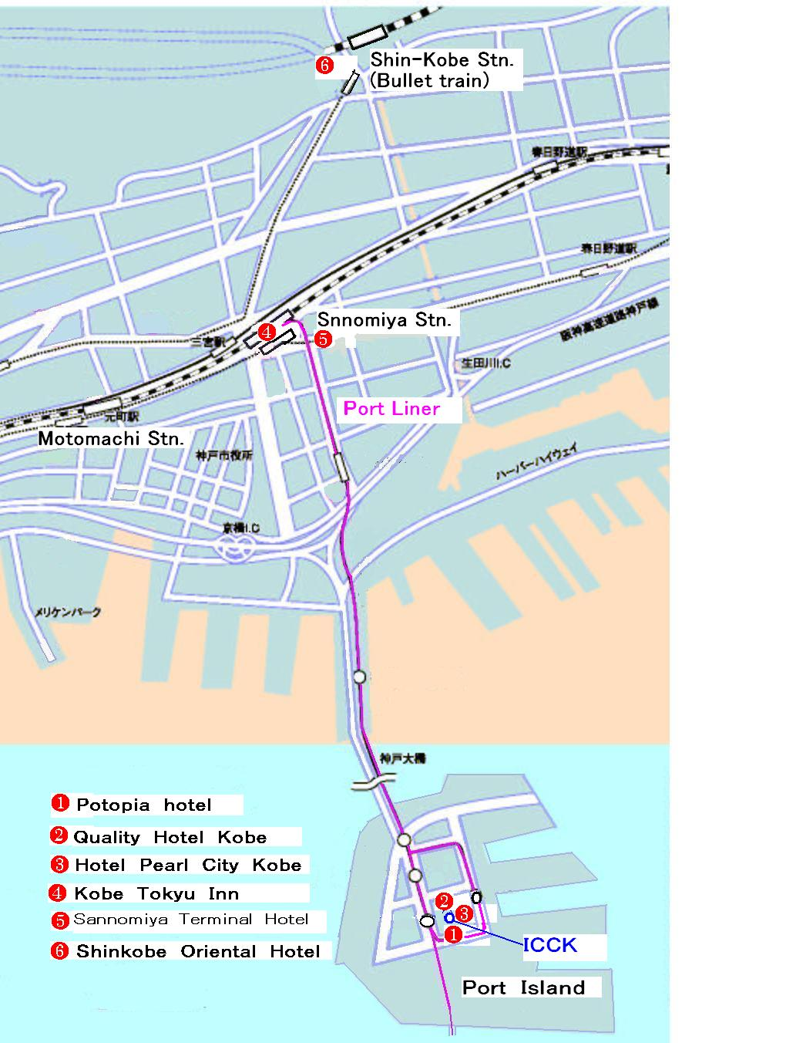

ATTACHMENT 3 TO ANNEX 2

HOTEL RESERVATION FORM for NGN-WS ＆ NGN-GSI
(Kobe, 20 - 27 April, 2006)
Please complete and return this form to one of the hotels below as your preference:
Portopia Hotel: reservation@portopia.co.jp Quality Hotel Kobe: info@choice-hotels.jp
Hotel Pearl City Kobe: kobe@pearlcity.co.jp Kobe Tokyu Inn: kobe109@gold.ocn.ne.jp
Sannomiya Terminal Hotel: info@sth-hotel.co.jp ShinKobe Oriental Hotel: yoyaku@orientalhotel.co.jp
Refer to the attachment 2, each home page or hotel for details

(Please type or print in block letters and check appropriate items.)
NAME: □ Prof. □ Dr. □ Mr. □ Ms.
Last name First name

ORGANIZATION:

ADDRESS: □ Office □ Home

Postal code Country
Phone: Fax:

Name of Accompanying Person(s), if any:
□ Mr. □ Ms. Last name First name _________
Flight Schedule: Arriving at (airport) on (date) by (flight number)

HOTEL ACCOMMODATION
Hotel Name | Room Type | Period of stay
 | Single: | Check In:
 | Twin (single use): | Check Out:
 | Twin (twin use): | Nights:

REMITTANCE
- Cash
- □ Credit card: □ VISA □ MasterCard □ Diners Club □ AMEX □ Other ( )
Card number:
Name of card holder: Expiration date: / /
Authorized signature:

ANNEX 3
(to TSB Circular 60)

ITU-TSB | ITU-T Workshop on NGN and its Transport Networks  Kobe, Japan, 20 to 21 April 2006
REGISTRATION FORM
To be returned to TSB (Fax: +41 22 730 5853 / tsbreg@itu.int ) by Friday 7 April 2006

Mr. Mrs. Ms. Miss |  |  |  | Administration of ITU Member State
____________________________________________  Family Name |  |  |  | ITU Sector Member
 |  |  |  | ITU Associate
____________________________________________  First Name |  |  |  | ITU Associate
 |  |  |  | Non-Member
Name and complete address of Administration or Organization:
______________________________________________ |  |  | Tel.:
______________________________________________
______________________________________________ |  |  | Fax:
_________________________________________ |  |  | E-mail:
Hotel:
 |  |  | Tel.:
Date: ___________________________ | Signature: ______________________________________

