 | INTERNATIONAL TELECOMMUNICATION UNION |  |  |  | COM 19 – C 18 – Rev.1-E
 | TELECOMMUNICATION  STANDARDIZATION SECTOR  STUDY PERIOD 2005-2008 |  |  | April 2007
English only
Original: English
Question(s): |  | 2/19
STUDY GROUP 19 – CONTRIBUTION 18
Source: |  | Korea (Republic of)
Title: |  | Functional Architecture consideration for recommendation MMF (version 1.2)

TSB note: this text has also been published in Study Group 13 as COM 13-C 292

1. Introduction
In the current version of Q.MMF draft, Section 7 “Mobility manager for location management current functional architecture model” is anticipated to describe more structured design considerations, because of lacking a general mobility management concept defined in Q.MMF. We try to clearly define the concept of functional architecture that is appropriate to both Q.MMF (also Q.LMF and Q.HMF) and NGN. Furthermore, we should consider the scenarios of mobility management control functions which are defined in various mobile technologies because of achieving future convergence network.

2. Proposal for the text
7.0 Frame work of mobility manager control functions
Fig. 1 shows the mobility management control functional architecture model. In this figure, we present 3-tier mobility management control functions (MMCF), which can provide a hierarchic framework for Q.MMF, Q.LMF, and Q.HMF. In the access network, access mobility management function (A-MMCF) and local mobility management function (L-MMCF) are considered, while the central mobility management control function (C-MMCF) is considered to be located in the core network. Note that A-MMCF is physically located in an access network, whereas L-MMCF and C-MMCF can be logically configured in any part of a network. In the NGN architecture, the networking is provided in the basis of IP networking. In this recommendation, we consider how IP layer (L3) mobility is provided, and how it inter-works with link layer (L2) mobility, such as mobile networks and wireless internet access networks, and application layer mobility, such as SIP-based IMS.
Mobility management consists of two major functions: location management functions and handover control functions. In addition, mobility management is also capable of proxy functions that can improve the performance, especially of the handover process. Such proxy functions can be implemented mainly at L-MMCF.

When a location management process is initiated, the initial registration process is handled by C-MMCF, which mainly provides information on service authentication and homing address (HMA) assignment. This process is accomplished by interfacing to user profile server (UPS), and address manager such as DHCP. A HMA is a network address that is used for routing correspondence packets to the user or mobile device. In an initial registration, the corresponding A-MMCF grants access authentication through an interface to network attachment controller. Location management is responsible for location registration updates whenever a handover control function reports a change of Location ID. A C-MMCF is responsible for tracking such location updates that is reported from A-MMCF, so that a C-MMCF can provide a complete set of binding information among User ID, HMA, and Location ID. A C-MMCF can provide data path bind information to A-MMCF on handover. Maintaining a complete set of all kinds of binding information at C-MMCF is important to retrieve network access when network problems happen due to routing faults and lost communications.
A handover control process is conducted with access discovery and selection, registration updates, and data path redirection. An A-MMCF is responsible for access discovery-and-selection and HMA-and-location-ID binding for redirection of data packets to the new PoA.
In a large scale network, an L-MMCF can be added to provide scalability, that is, by acting as a proxy of address binding and a cache of C-MMCF database. An L-MMCF can share the load at C-MMCF as it utilizes localized management and control functions, so it can improve handover performance and balance data packet traffic distributions. An L-MMCF will cache UPS entries of active MTs in the access network as well as HMAs, Location IDs, and service authentication information of the MTs.

7.0.1 Central mobility management control function (C-MMCF)

C-MMCFs locate logically in core networks. A core network can have more than one C-MMCF for redundancy. A C-MMCF contains home mobility manager control function (H-MMCF) with User Profile Server (UPS) interface, and visited mobility manager control function (V-MMCF).
H-MMCF provides mobility to Home UE. An UPS is the master user database that contains unique user profiles (UP). C-MMCF has interface to UPS to get the UP. V-MMCF provides mobility to visited UE (from other core network) by peering with the other core network’s C-MMCF. For peering, V-MMCF has to have location information of C-MMCFs of other core networks. A C-MMCF also includes a central location management function (C-LMF) for call set-up and session initiation and a central handover control function (C-HCF) for MM1 type handover. The functional requirement of each management control function is as following:
UPS Interface: C-MMCF may not have UPS but can interface to UPS that is maintained by a service provider. UPS interface can obtain user equipment information of service level agreement (SLA), service agreement, user access type, access technology, and billing ID, identified by a User ID from a serving UPS. This database may be shared with other layer mobility entities, including GPRS, W-CDMA, IEEE802 standard radio access technologies and SIP. The mobility support is not limited to radio access technologies, but also includes wired connection access technologies.
H-MMCF: When a new user enters an access network, the access network establishes an association and the corresponding A-MMCF identifies User ID that is delivered to the H-MMCF with the current location ID. The H-MMCF first looks up UPS to determine if the User ID belongs to its own UPS. When the User ID is found in the UPS, the UE is identified as a home user and the current location ID is recorded in the C-LMF as a homing address (HMA). The user profile of a home user is disclosed to the A-MMCF. When a User ID is not founded from the serving UPS, the H-MMCF forwards such request to V-MMCF.
V-MMCF: If an unidentified User ID is transferred from H-MMCF, V-MMCF forwards the user identification request to H-MMCFs of peering C-MMCFs. When one of peering C-MMCFs reports identification of User ID and provides the User profile, the profile is temporarily stored in a data base whose data structure is similar to an UPS. The User ID and the current location ID is recorded in the C-LMF as a HMA. The user profile of a visited user is disclosed to the A-MMCF. When a User ID is not founded from peering C-MMCFs, the V-MMCF notifies A-MMCF of denial of service to the corresponding user.
C-LMF: Call set-up or session initiation requests from a correspondence user should be forwarded to C-LMF. C-MMCF can retrieve homing address (HMA) for the User ID. If a new location ID is generated for a MT by an A-MMCF, the new Location ID are reported to C-LMF with the corresponding User ID and HMA.
C-HCF: MM1 type handover is managed by C-HCF. A user moved to a core network from another, the C-HCF of the new core network identifies the transferred user profile from the C-HCF of previous core network. In order to reduce a handover lead time, it may first grant to all requests and a denial of service is determined later if the user is identified not to be served in the network.

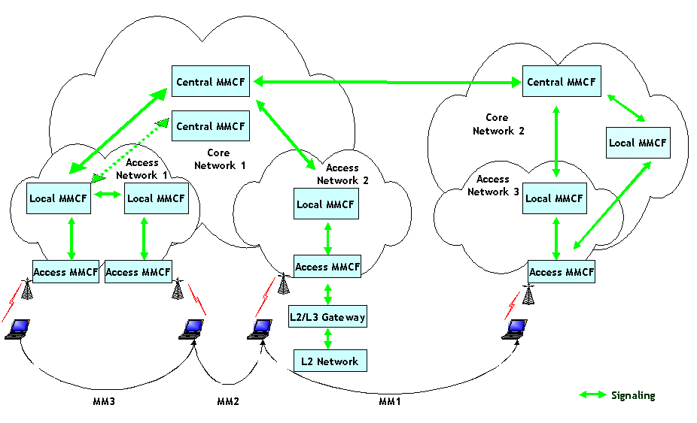
Fig. 1. Mobility management control functional architecture model

7.0.2 Local mobility management control function (L-MMCF)

One or multiple L-MMCFs locate logically in access network or core network. An L-MMCF contains UPS cache function. L-MMCF functions duplicate some of C-MMCF and A-MMCF, making L-MMCF an option for network scalability. An L-MMCF includes C-MMCF data cache, and V-MMCF proxy.

An L-MMCF also have address information of peering C-MMCF so an L-MMCF can communicate with peering C-MMCFs on behalf on its own V-MMCF. In this way, the signaling load of C-MMCF can be distributed to L-MMCF to reduce signaling time and C-MMCF load.

C-MMCF Cache: User profiles of active users within the network copied from C-MMCF database and stored in a short-term database. In MM1 type handovers, user profiles are forwarded to the next access network C-MMCF cache. New information in a C-MMCF cache is duplicated in C-MMCF and A-MMCF.

V-MMCF Proxy: Any signaling from A-MMCF to initiate a V-MMCF process can be intercepted by the V-MMCF proxy. V-MMCF proxy maintains a database of network location of peering C-MMCF, so as to conduct V-MMCF functions at L-MMCF.

Note: Further contributions are anticipated to describe the functional requirement of L-LMF and L-HCF.

7.0.3 Access mobility management control function (A-MMCF)

Several A-MMCFs can be attached to a single L-MMCF or C-MMCF in access network. It associates a mobile station of a user. An A-MMCF discovers a new mobile station and associates it with access association control function (AACF). Also it generates current location ID to attached UE. It reports user ID and current location ID to C-MMCF and L-MMCF.
IP data grams are forwarded by HMAs that are managed by the corresponding A-MMCF, where A-MMCF provides IP datagram tunneling to a user at the instantaneous care-of address (CoA); HMA are assigned in conjunction with an A-MMCF location.
An A-MMCF consists of AACF, A-LMF, A-HCF, and access data transport function (A-DTF). An A-DTF has tunneling capability and routes datagrams from a data tunnel to a point of L2 network attachments.

AACF: AACF discovers a new mobile station and associate it by abstracting L2 network information. AACF first contacts A-HCF to determine if A-HCF is awaiting this mobile station for handover. If so, A-HCF takes over handling of this new mobile station. If not, AACF triggers A-LMF to perform the initial location management procedure for a newly associated user. (i.e., the A-LMF generates the Current location ID and provides mapping of the L2 address.)
A-LMF: The current location ID is reported to L-MMCF and C-MMCF by A-LMF. This process may initiated by AACF for a new location ID or by A-HCF on handover. L2 location information is attained and reported it to L-LMF.
A-HCF: MM2- and MM3-type handovers are controlled by A-HCF. An A-HCF triggers A-LMF for a new current location ID as a result of handover.
A-DTF: IP datagrams are forwarded to A-MMCF in reference to an HMA. An HMA and Location IDs are consistently reported by the C-MMCF so as to bind HMA and Location ID for IP datagram tunneling. An A-DTF typically terminates tunneling from datagrams and maps the destination address with L2 address of UE.

Note: Further Contributions are required to specify the functional requirement of A-DTF.

Appendix A

MMCF functions can utilize currently existing mobile technologies. Such technologies can be classified by network layers and planes. An example of such standard technology components are classified to provide an understanding of how they are related. Figure A summarizes such classifications to provide the frame of reference.

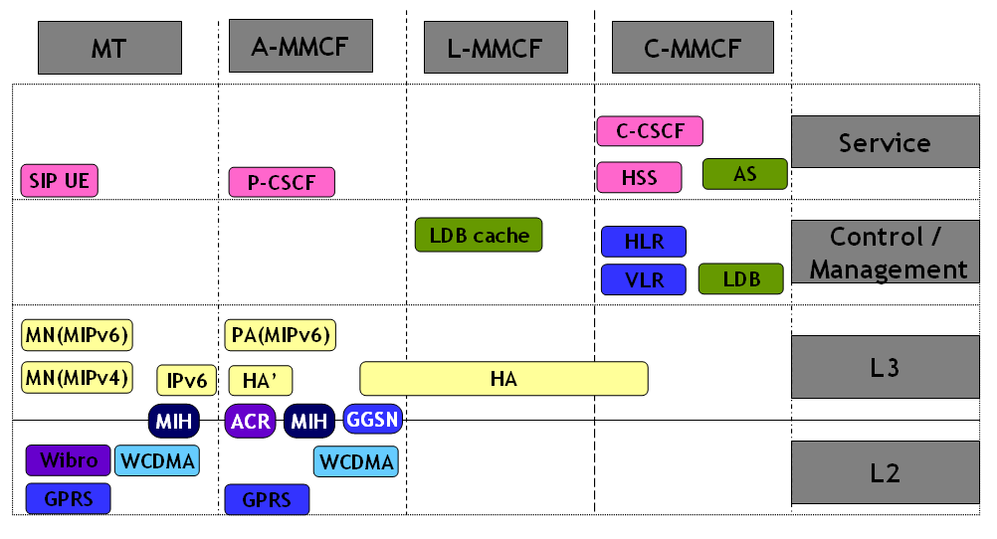
Fig. A. Functional Entities model (further study)
Each color boxes of Fig. A indicates different techniques. Yellow color indicates Mobile IP technique. Blue color indicates GSM technique. Light blue color indicates WCDMA technique. Pink color indicates IMS technique. Navy color indicates MIH technique. Purple color indicates WiBro technique.

Note: For further study
3. Proposal
We propose to adopt the proposed text in Q.MMF.
_______________

