2007年7月27日，日内瓦
国 际 电 信 联 盟
电信标准化局

文号： | 电信标准化局第6/9号集体函
电话：  传真：  电子  邮件： | +41 22 730 6071  +41 22 730 5853  tsbsg9@itu.int | 致国际电联成员国各主管部门、ITU-T部门成员和参加第9研究组工作的  ITU-T部门准成员

事由： | 第9研究组会议  2007年10月29日-11月2日，美国科罗拉多州路易斯维尔

尊敬的先生/女士：
1 应第9研究组（综合宽带有线网络与电视及声音传输）主席的要求，我谨通知您，应有线电视实验室（CableLabs）的盛情邀请，第9研究组将于2007年10月29日至11月2日在美国科罗拉多州路易斯维尔召开会议。
第一天的会议将于09:30开始。与会代表的注册工作从08:30开始。有关会议厅安排的具体信息将在会场公布。
2 会议将仅使用英文进行讨论。
3 会议将为无纸会议。
4 由第9研究组主席与电信标准化局（TSB）磋商后起草的议程草案见本函附件1。
5 由第9研究组主席与电信标准化局磋商后起草的时间表草案见本函附件2。
6 附件3为主办机构提供的实用信息。
7 根据A.1建议书（2006年）的条款，有关该研究组工作的文稿应在会议召开日的至少十个日历日之前、不迟于2007年10月18日提交电信标准化局。电信标准化局收到的文稿将发布在第9研究组的网站上。按照现行规定，可以应要求翻译在会议开始至少两个月前收到的文稿。
欢迎与会代表以第9研究组主页
（http://www.itu.int/ITU-T/studygroups/com09/edh/index.html）提供的网上提交表或电子邮件的方式向以下地址提交文稿：tsbsg9@itu.int。
我们大力提倡您使用已制作出的一套新模版，它们既能够使ITU-T文件的格式保持一致，又可以方便文件制作、提高效率。这些模版可以在ITU-T每个研究组网页中的“指南、工具和模版”（http://www.itu.int/ITU-T/studygroups/templates/index.html）处找到。
为了解决与文稿有关的问题，请在文稿上注明联系人的姓名、传真和电话号码以及电子邮件地址。同样，务请在所有文件的首页注明这些细节。
8 为了便于电信标准化局进行文件制作和会议组织方面的必要安排，我希望您能通过信函、传真（号码：+41 22 730 5853）或电子邮件（tsbreg@itu.int）的方式尽早、但不迟于2007年9月28日将代表贵主管部门、部门成员、部门准成员、区域性和/或国际组织或其它实体出席会议的人员名单发至我处。同时，希望各主管部门注明其代表团团长（如果有副团长，亦盼一并注明）的姓名。填妥的附件4中的报名表（每位与会代表一份）应附于上述名单后。
9 我们在此谨提醒您，一些国家的公民需要获得签证才能入境美国并在此逗留。签证必须向驻贵国的美国代表机构（使馆或领事馆）申请和领取。如果贵国没有此类机构，则请向驻离贵国最近的国家的此类机构申请并领取。需要邀请函和/或签证辅助函的与会者请与美方联系人Christie Poland女士联系，具体方式见附件3第7段。

顺致敬意！
电信标准化局主任
马尔科姆·琼森
附件：4件
ANNEX 1
(to TSB Collective letter 6/9)

Draft Agenda for the Plenary sessions of Study Group 9
(Louisville, Colorado, USA, 29 October -2 November 2007)
1. Welcome and approval of agenda
2. Objectives and Work Plan for this meeting
- Working Groups
3. Allocation of documents and incoming Liaison Statements
4. Feedback on interim activities since last meeting
Rapporteurs' Group meetings and Reports
- Joint Q6/9 and Q9/9 meeting (Aug. 2007)
- Q14/9, VQEG/JRG and MMQA meeting (Sept. 2007)
5. Other Groups/Workshops
- Report on 5th (July 2007) and 6th (Oct. 2007) FG IPTV meetings
- Report on NGN-GSI co-located Rapporteur Groups meeting (Sept. 2007)
- Others
6. Intellectual Property Rights inquiry
7 Approval of a Recommendation under WTSA-04 Resolution 1 (TAP)
8. “Consent” on draft Recommendations proposed for approval in accordance with
Recommendation A.8
9. Proposed revision and deletion of SG 9 Questions
10. Approval of Working Group reports and Outgoing Liaison statements
11. Future Work Programme
12. Approval of outgoing Liaison Statements
13. Date and place of the next meeting
14. Future Interim activities
15. Other
16. Closing
-)-(-
ANNEX 2
(to TSB Collective letter 6/9)
Draft work programme for the meeting of Study Group 9
(Louisville, Colorado, USA, 29 October -2 November 2007)
 | 29 October  Monday |  |  |  | 30 October  Tuesday |  |  |  | 31 October  Wednesday |  |  |  | 1 November  Thursday |  |  |  | 2 November  Friday
 | A.M |  | P.M. |  | A.M. |  | P.M. |  | A.M. |  | P.M. |  | A.M. |  | P.M. |  | A.M. | P.M.
Plenary | X |  |  |  |  |  | X¹ |  |  |  |  |  | X¹ |  |  |  | X | X
WG 1 |  | X | X | X | X | X | X | X | X | X |  |  | X
WG 2 |  |  | X | X |  |  |  |  | X | X |  |  | X
WG 3 |  |  |  |  |  | X | X | X | X | X |  |  | X | X
WG 4 |  |  |  |  | X | X |  |  |  |  |  |  | X
WG 5 |  | X | X | X | X | X | X | X |  | X |  |  | X | X
WG 6 |  |  |  |  |  |  |  |  | X | X |  |  |  |  | X | X
WG 7 |  |  | X | X | X | X | X | X | X | X |  |  |  | X
WG 82 |  |  |  |  |  |  | X | X | X |  |  |  | X
WG 9 |  |  |  |  | X | X | X | X |  |  |  |  |  | X
¹Short Plenary
²Subject to contributions received.
- Tentative Working Group structure:
WG 1 IPCablecom Qs 6/9, 9/9
WG 2 Cable Modems Q. 8/9
WG 3 Network Transport Qs 1/9, 7/9, 12/9
WG 4 Conditional Access, Webcasting Qs 3/9, 11/9
WG 5 Quality Assessment Qs 2/9, 14/9
WG 6 Work Programme, Questions, Liaisons QsAll/9
WG 7 APIs Q. 4/9
WG 8 LSDI Q. 15/9
WG 9 Home Networks, Set-top Box Qs 5, 10/9
- A meeting of the Study Group 9 Management Team will be planned for 28 October 2007
ANNEX 3
(to TSB Collective letter 6/9)
Practical Information
(Louisville, Colorado, USA, 29 October -2 November 2007)
- Venue
Cable Television Laboratories, Inc Tel. +1-303-661-9100
(CableLabs)
858 Coal Creek Circle Fax +1-303-661-9199
Louisville, Colorado USA.
2. Transportation to CableLabs and Hotels nearby:
Denver International Airport (DIA as shown on the map) serves the area in which CableLabs is located. Rental cars are available there and the map in Appendix 1 shows the route from the Denver International Airport (DIA) to CableLabs. However, it is very convenient to use hourly public transportation directly to hotels within walking distance to CableLabs and this may be the most convenient way for most delegates to travel. The location of these hotels is identified in the route map and it is suggested that participants make reservations at one of them. For those desiring to stay in hotels in Boulder, Westminster, or Broomfield, they will find that a rental car would be desirable in order to get from those hotels to CableLabs as public transportation is not directly available for this. A list of hotels and telephone numbers is also given in Appendix 2.
“Boulder Super Shuttle” is the name of the public transportation company providing public transportation from the Denver International Airport. Direct transportation to hotels adjacent to CableLabs and others may be obtained by informing the ticket agent when tickets are purchased. Tickets may be purchased at the airport. The Super Shuttle tickets may be obtained by taking two left turns immediately after taking the escalator up from the train termination which delivers one from the air line arrival gates into the main terminal where baggage claim also is located. Advanced reservations for transportation from DIA to the various Broomfield, Louisville, and Boulder hotels are not accepted. Once your flight arrives at DIA, go directly to the luggage carousel to claim your luggage. Once you have your luggage, go to the Super Shuttle counter to request transportation to your hotel. Super Shuttle will inform you of the next departure time and provide detail on boarding the shuttle. For return transportation from your hotel or CableLabs, you will need to make a reservation with Supper Shuttle. More information regarding the Super Shuttle may found at: http://www.bouldersupershuttle.com/supershuttle/boulder_supershuttle_home.htm.
3. Passports and Visas
All foreign visitors entering the United States (US) must have a valid passport. Visitors from countries whose citizens require a visa should at the earliest time and well in advance of travel apply for a visa at a US Embassy or consulate. The following provides information relating to entry into the U.S.
US ENTRY FOR NONIMMIGRANTS
The US State department issued a detailed update of the current Visa Policy. Click on the link below for complete information.
US State Dept. Visa Policy Update - 3/1/05
For assistance with your visa, visit the following websites:
International Visitors Office site: http://www.nationalacademies.org/visas
Official information on the visa application process: http://travel.state.gov/visa
Visa wait times are available at: http://travel.his.com/visa/tempvisitors_wait.php
4. Climate
The climate in Colorado in the late October – November time frame is usually comparatively dry with clear blue skies, but on occasion precipitation in the form of rain or snow could occur. Monthly Average values are given in the table.
 | October | November
Average Max Temperature | 67°F/19°C | 53°F/12°C
Average Minimum Temperature | 54°F/4°C | 29°F/-2°C
Average Precipitation | 1.3”/3.3cm | 1.2”/3cm
Average Snow Depth | 0” | 1”/2.54cm
5. Altitude
The nominal altitude in the Boulder – Louisville area is about 5300 feet/1615meters. Boulder lies up against the foothills of the Colorado Rocky Mountains, and the continental divide (precipitation falling on one side goes to the Pacific Ocean and the other side to the Atlantic Ocean) is about 20 miles west and rises to over 14000feet/4300meters.
6. Electrical Appliances
Throughout the U.S. electrical appliances operate from 120V, 60Hz. power supplies with plugs as shown below. It is suggested guests bring their own power converters and wall plug adapters to allow use of international appliances. Hotels typically provide irons, ironing boards and hair dryers in the hotel rooms, so there is no need to bring these items with you.
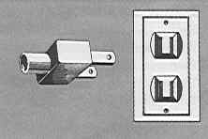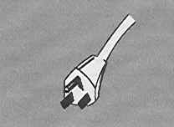
7. Contact Point
If you have any questions about the meeting arrangements, please contact:
Christie Poland; email c.poland@cablelabs.com or telephone +1-303-661-3786
Appendix 1

Map showing route to CableLabs and vicinity from Denver International Airport.
(Hotels adjacent to CableLabs indicated on map)

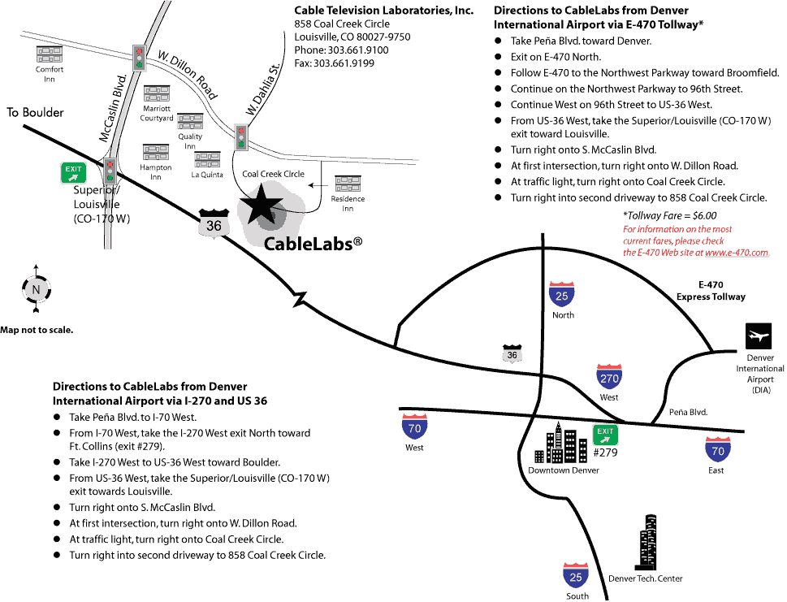

Appendix 2
Hotels
[Distance (miles/kilometers) one-way from Hotel to CableLabs in brackets]
Louisville: Hotels in Louisville are not-full service hotels. They typically offer breakfast and limited room service. However these hotels are in walking distance of CableLabs and a variety of local restaurants, so a rental car is not absolutely necessary.
Residence Inn Marriott  845 Coal Creek Circle  Louisville CO 80027  +1 (303) 665-2661  [.05m/.07km]  Offering a rate of $119 per night for the dates of October 27 – November 2. Please reference “CableLabs ITU Study Group 9 meeting” to secure this special rate. On-line reservations will not be able to honor this special rate – it is necessary to call the hotel directly. Residence Inn Louisville provides an enhanced continental breakfast (several hot and cold items) free of charge to all guests.  http://www.marriott.com/hotels/travel/vborl-residence-inn-boulder-louisville/ | Courtyard Marriott  948 W Dillon Rd  Louisville CO 80027  +1 (303) 604-0007  [.37m/.6km]  Offering a rate of $99 per night for the dates of October 27 – November 2. Please reference “CableLabs ITU Study Group 9 meeting” to secure this special rate. On-line reservations will not be able to honor this special rate – it is necessary to call the hotel directly. Courtyard Marriott offers a hot breakfast buffet daily, at an additional charge per guest.  http://www.marriott.com/hotels/travel/denls-courtyard-boulder-louisville/
Hampton Inn  912 W Dillon Road  Louisville CO 80027  +1 (303) 666-7700  [.19m/.31km] | La Quinta Inn & Suites  902 Dillon Road  Louisville CO 80027  +1 (303) 664-0100  [.15m/.24km]
Quality Inn & Suites  960 W. Dillon Road  Louisville CO 80027  +1 (303) 327-1215  [.35m/.57km] | Comfort Inn  1196 Dillon Road  Louisville CO 80027  +1 (303) 604-0181  [1.08m/1.74km]
Broomfield:
Omni Interlocken Resort  500 Interlocken Blvd  Broomfield CO 80021  +1 (303) 438-6600  [4.43m/7.12km] | Renaissance Boulder Suites Hotel at FlatIron  500 Flatiron Boulevard  Broomfield, CO 80021  +1 (303) 464-8400  [4.07m/6.55km]

Westminster:
The Westin Westminster Hotel
10600 Westminster Blvd
Westminster CO 80020
+1 (303) 410-5000
[8.33m/13.41km]
Boulder:
Boulder Marriott  2660 Canyon Blvd  Boulder CO 80302  +1 (303) 440-8877  [7.7m/12.4km] | Hotel Boulderado  2115 13th Street  Boulder CO 80302  +1 (303) 442-4344  [8.83m/14.21km]
St. Julien Hotel & Spa  900 Walnut Street  Boulder CO 80302  +1 (720) 406-9696  [8.96m/14.42km] | Millennium Harvest House  1345 28th St  Boulder CO 80302-6899  +1 (303) 443-3850  [7.37m/11.85km]
Homewood Suites
4950 Baseline Road
Boulder CO 80303
+1 (303) 499-9922
[5.67m/9.12km]

ANNEX 4
(to TSB Collective letter 6/9)

ITU-TSB | Study Group 9 meeting  (Louisville, Colorado, USA, 29 October -2 November 2007)
REGISTRATION FORM
To be returned to TSB by fax (+41 22 730 5853) or e-mail (tsbreg@itu.int) by 28 September 2007

Mr Mrs Ms Miss |  |  |  |  | _______________________________________________  Country
____________________________________________  Family name |  |  |  |  | ______________________________________________  Name of Administration of Member State*
____________________________________________  First name |  |  |  |  | ______________________________________________  Name of Sector Member / Associate / other
Full address of administration or organization:
______________________________________________ |  |  |  | Tel: _____________________________________________
______________________________________________ |  |  |  | Fax: _____________________________________________
______________________________________________ |  |  |  | E-mail: __________________________________________
*For delegates of Member States: Function at the meeting |  |  |  |  | Hotel or other address in the USA
 |  |  |  |  | Hotel: __________________________________________
(C) Head of delegation |  |  |  |  | Address: ________________________________________
(CA) Deputy head of delegation |  |  |  |  | ___________________________________________
(D) Delegate |  |  |  |  | Tel: ____________________________________________
Important note:
The meeting will be paperless.
Date: ___________________________ | Signature: ______________________________________

For TSB use only
Pigeonhole
____________________

