Geneva, 22 February 2006
INTERNATIONAL TELECOMMUNICATION UNION
Telecommunication
Standardization Bureau

Ref: | TSB Collective-letter 3/5
Tel:  Fax:  E-mail: | +41 22 730 5780  +41 22 730 5853  tsbsg5@itu.int | - To Administrations of Member States of the Union, to ITU-T Sector Members and to ITU-T Associates participating in the work of Study Group 5

Subject: | Meeting of Working Parties 1 and 2 of Study Group 5  Osaka, Japan, 22-26 May 2006

Dear Sir/Madam,
1 At the request of the Chairman of Study Group 5, and in accordance with the decision taken at the last Study Group 5 meeting (12-16 December 2005), I would like to inform you that, at the kind invitation of the Ministry of Internal Affairs and Communications, Japan, Working Parties 1 and 2 of Study Group 5 (Protection against electromagnetic environment effects) are to meet in Osaka, Japan, from 22 to 26 May 2006 inclusive.
The venue of the meeting will be the International House, Osaka, Japan.
The meeting will open at 9³⁰ hours on the first day.
2 The discussions will be held in English.
3 The draft agenda, as prepared by agreement with the Chairmen of Working Parties 1/5 and 2/5, is set out in Annex 1 hereto.
4 The draft timetable, as prepared by the Management Team of Study Group 5, is set out in Annex 2 hereto.
5 Annex 3 gives practical information provided by the host organization. Particular attention is drawn to the hotel booking form, which must be submitted as soon as possible (see Annex 4).
6 Pursuant to the provisions of Recommendation A.1 of WTSA (Florianópolis, 2004), contributions to the work of the study group shall be submitted to the Telecommunication Standardization Bureau (TSB).
a) Contributions received at least two months before the meeting will be published and mailed to the Administrations of Member States of the Union, to ITU-T Sector Members and to ITU-T Associates registered in this study group who have requested paper copies, and will be available on the Study Group 5 website.
b) Contributions received by TSB less than two months but not less than seven working days before the date set for the opening of the meeting shall be published as "delayed contributions", shall be posted to the Study Group 5 website and shall be distributed, upon request only at the beginning of the meeting to only the participants present. Therefore, such contributions must be received by TSB not later than 10 May 2006.
Participants are encouraged to submit contributions by electronic mail to the following address:
tsbsg5@itu.int. Detailed instructions can be found on the ITU-T website.
We strongly encourage you to use the set of templates that has been created to harmonize the appearance of ITU-T documents, while making the production of the documents easier and thus more efficient. These templates are accessible from each ITU-T Study Group web page, under “Guides, Tools and Templates” (http://www.itu.int/ITU-T/studygroups/templates/index.html).
With a view to settling any questions which might arise concerning contributions, the name, the fax and telephone numbers and the e-mail address of the person to be contacted should be indicated on contributions. Accordingly, please give those details on the cover page of all documents.
7 In order to enable TSB to make the necessary arrangements concerning the documentation and organization of the meeting, I should be grateful if you would send me by letter, fax (No.: +41 22 730 5853) or e-mail (tsbreg@itu.int), as soon as possible, but not later than 21 April 2006, the list of people who will be representing your Administration, Sector Member, Associate, regional and/or international organization or other entity. Administrations are requested also to indicate the name of their head of delegation (and deputy-head, if applicable). The registration form in Annex 5, duly completed (one per participant), should be attached to the above-mentioned list.
8 We would remind you that citizens of some countries are required to obtain a visa in order to enter and spend time in Japan. The visa must be requested and obtained from the office (embassy or consulate) representing Japan in your country or, if there is no such office in your country, from the one that is closest to the country of departure.
Participants who need an invitation letter and/or a visa supporting letter for entering Japan are advised to get in touch with the contact person in Japan whose detailed information is as follows:
Mr. Masao MASUGI
NTT corp.
3-9-11 Midori-cho, Musashino-shi
Tokyo 180-8585, Japan
Tel: +81 422 59 2904
Fax: +81 422 59 3314
E-mail: masugi.masao@lab.ntt.co.jp
Yours faithfully,
H. Zhao
Director of the Telecommunication
Standardization Bureau
Annexes: 5
annex 1
(to TSB Collective-letter 3/5)
Draft Agenda for the meeting of Working Parties 1 and 2
of Study Group 5
(Osaka, 22-26 May 2006)
1 Opening of the meeting
2 Adoption of the agenda
3 Document allocation
4 Technical Session on resistibility tests on telecommunication equipment
5 Meetings of Working Parties 1 and 2
5.1 Review of the results of each Question
5.2 Consent on Recommendations in accordance with the rules of
Recommendation A.8
5.3 Approval of Handbooks/informative texts
5.4 Approval of outgoing liaison statements
5.5 Review of the work programme
6 Closure of the meeting

ANNEX 2
(to TSB Collective-letter 3/5)
Draft timetable for the meeting of Working Parties 1 and 2 of Study Group 5
(Osaka, 22-26 May 2006)

 | Morning |  | Afternoon
Monday  22 May | Opening | Working Party 1/5 | Working Party 2/5
Tuesday  23 May | Working Party 1/5  & ad-hoc meetings for WP 2/5 Questions |  | Technical Session
Wednesday  24 May | Working Party 2/5  & ad-hoc meetings for WP 1/5 Questions
Thursday  25 May | Working Party 1/5  & ad-hoc meetings for WP 2/5 Questions |  | Working Party 2/5  & ad-hoc meetings for WP 1/5 Questions
Friday  26 May | Working Party 1/5 |  | Working Party 2/5

annex 3
(to TSB Collective-letter 3/5)
Additional information on the meeting of Working Parties 1 and 2 of Study Group 5
(Osaka, Japan, 22-26 May 2006)

1. Venue of the meeting
International House, Osaka
2-6 Uehommachi, 8-chome, Tennoji-ku,
Osaka 543-0001 JAPAN
Tel: +81 6 6772 5931
Fax: +81 6 6772 7600
E-mail: center@ih-osaka.or.jp
Web: http://www.ih-osaka.or.jp/i.house/index-e.html

About one hour from Kansai international airport by taxi,
Limousine bus, etc. Osaka in Japan
The meeting rooms B (except for 22 May), C & D will be used for ITU-T SG5.

2. Accommodation
Availability is limited, reservations will be reconfirmed on a first-come first-serve basis.
The suggested hotel is:
Miyako Hotel Osaka
6-1-55, Uehommachi(or Uehonmachi), Tennoji-ku, Osaka 543-0001, Japan
Tel: +81 6 6773 1111, Fax: +81 6 6773 3322
Contact via web: https://www2.miyakohotels.ne.jp/e/contact/c_form.html
Web:http://www.miyakohotels.ne.jp/osaka/english/index.html
[5-minutes walk from the International House, Osaka.]
The room rates are
Untill 18 April 2006 JT:
− 12000 Japanese yen per night (one person - standard single room)
− 20000 Japanese yen per night (two person - standard twin room)
[The above prices include breakfast and taxes.]
and after 18 April 2006 JT:
− 17325 Japanese yen per night (one person - standard single room)
− 28875 Japanese yen per night (two persons- standard twin room)
[The above prices include taxes (without breakfast).]

3. Hotel booking
For hotel booking till 18 April 2006 (JT), please fill in the attached "Hotel booking form (Annex 4)" and send it to the following FAX number:
+81 422 59 3314 (Mr. Masao MASUGI, NTT corp., E-mail: masugi.masao@lab.ntt.co.jp)
To avoid troubles, please inform Masugi by e-mail that you have sent the FAX sheet.
If you have some changes to your reservation (such as cancellations) after 18 April 2006 (JT), please contact the hotel directly. (In this case also, please send the information to the above e-mail addresses.) For hotel bookings after18 April 2006 (JT), please contact the hotel directly.
Anyone wishing to stay in other hotels is requested to contact the hotels directly.

4. Transportation
The nearest airport is the Kansai International airport
(KIX, http://www.kansai-airport.or.jp/english/index.htm )

From Kansai International Airport:
- 50 minutes by the direct airport shuttle bus. Please buy the bus ticket for Uehommachi (or Uehonmachi). The bus platform number is seven. It costs 1300 JPN.
- 50 minutes by Nankai Rwy and Kintetsu line (transfer at Namba). The total price is 1190 JPN.
- 50-60 minutes by taxi. The price is approximately 15000 JPN.
(*)Access information can be checked at http://www.kansai-airport.or.jp/english/access/index.htm

Access patterns from the Kansai International airport

The Narita International airport (http://www.narita-airport.jp/en/index.html), which is close to Tokyo, is also available.
From Narita International Airport to Tokyo:
About 1-2 hours by JR and Keisei lines. It costs from 1000 to 4500 JPN, depending on the type of trains.
About 1.5 to 2 hours by the direct airport shuttle bus. It costs 3000 JPN.
(*)Access information can be checked at http://www.narita-airport.jp/en/access/index.html
From Tokyo to Miyako hotel Osaka:
3 hours from JR Tokyo station to JR Shin-Osaka station by JR lines (using Shinkansen express). Then, about 5 min. from JR Shin-Osaka station to JR Osaka station (Umeda station) by JR line [Total cost from Tokyo is about 14000 JPN]. Furthermore, 5 min. to Higashi-Umeda station by walk and then 10 min. to Tanimachi 9-chome station by subway (=Tanimachi line)[230 JPN].
About 1 hour from Tokyo Haneda airport (http://www.tokyo-airport-bldg.co.jp/english/index.html) to Osaka International airport (Itami airport) by air. Then, 3 min. to Hotaruike station by Osaka mono-rail and then 15 min. to Umeda station by Hankyu line (Hankyu Takazuka line). Furthermore, 5 min. from Umeda station to Higashi-umeda station by walk and then 10 min. to Tanimachi 9-chome station by subway (=Tanimachi line).

5. General information

5.1 Electrical appliances
Japan operates on 100 volts for electrical appliances. The frequency is 60 Hz in western Japan including Kobe and Osaka (50 Hz in eastern Japan including Tokyo). The type of power outlet/connector used in Japan is A type which is two parallel pronged type.
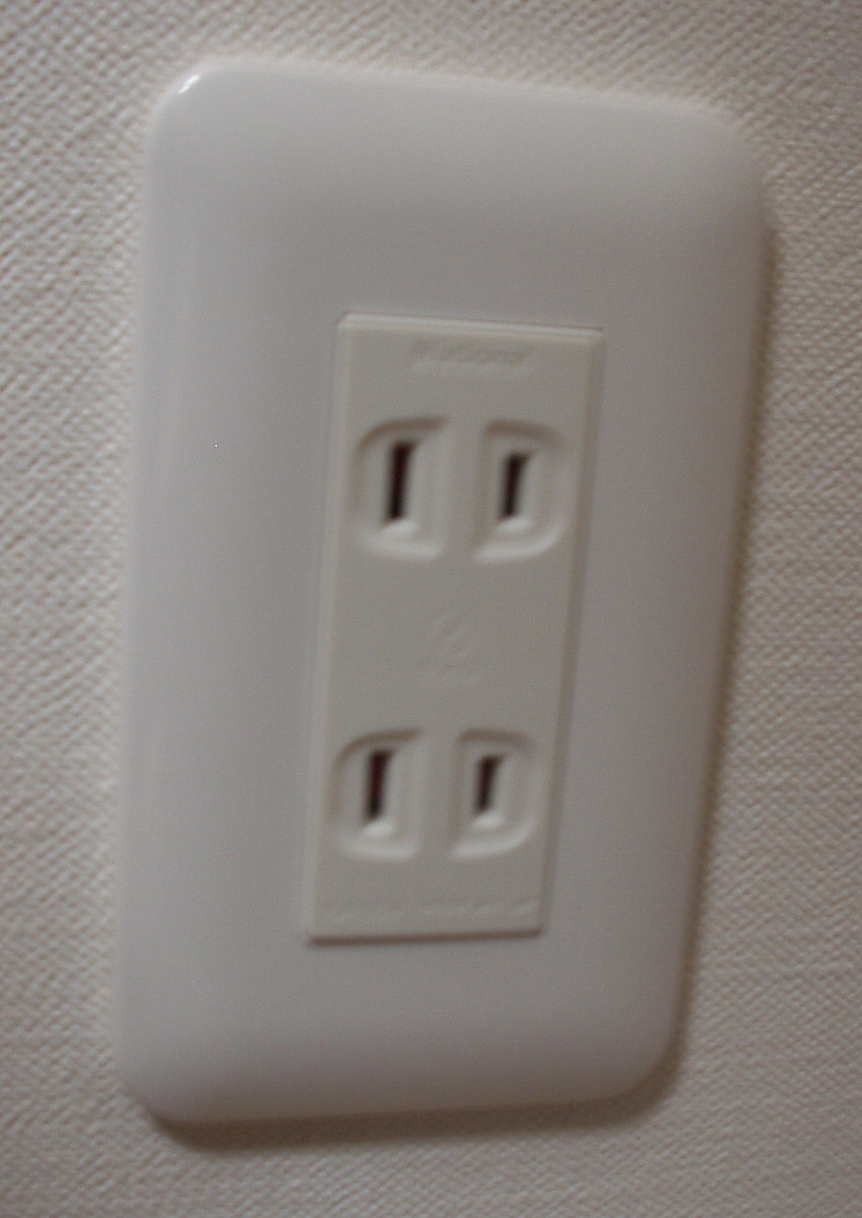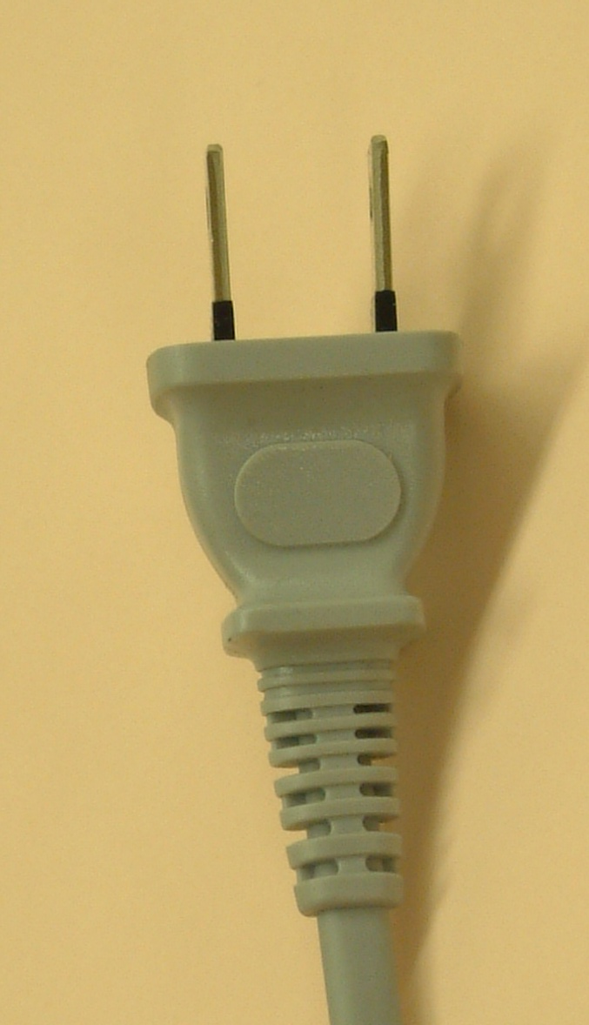
If your appliances operate on a different voltage, please bring your own transformers.

5.2 Passports and Visas
All foreign visitors entering Japan must have a valid passport. Participants who require a visa should, well in advance, apply for a visa to a Japanese consulate or diplomatic mission in their respective country prior to departure. Participants are also advised to contact their local travel agents or carriers. For more information please visit the web site of the Ministry of Foreign affairs of Japan at: http://www.mofa.go.jp/j_info/visit/visa/index.html.
Participants who need an invitation letter and/or a visa supporting letter for entering Japan are advised to get in touch with the contact person in Japan whose detailed information is as follows:
Mr. Masao MASUGI
NTT corp.
3-9-11 Midori-cho, Musashino-shi
Tokyo 180-8585, Japan
Tel: +81 422 59 2904
Fax: +81 422 59 3314
E-mail: masugi.masao@lab.ntt.co.jp

6. Additional information

Location map near meeting spot.

- Visit Japan page: http://www.vjc.jp/
- Sunrise tour (for Osaka, Kyoto & Tokyo): http://www.jtbgmt.com/sunrisetour/
- Osaka tour guide: http://www.tourism.city.osaka.jp/en/index.html
http://www.tourism.city.osaka.jp/ja/index.html
http://www.octb.jp/cb/english/index_e.html
- Kyoto tour guide: http://www.kyotojoho.co.jp/english/index.html
http://raku.city.kyoto.jp/sight.phtml
- Nara tour guide: http://www.pref.nara.jp/nara_e/
- Tokyo tour guide: http://www.tourism.metro.tokyo.jp/english/index.html
http://www.hatobus.com/(Bus tour)
annex 4
(to TSB Collective-letter 3/5)

Meeting of Working Parties 1 and 2 of Study Group 5
(Osaka, Japan, 22-26 May 2006)
HOTEL RESERVATION CONFIRMATION FORM for Miyako Hotel Osaka
This reservation form can be used till 18 April 2006 JPT. to FAX: +81 422 59 3314

Name of the hotel: Miyako Hotel Osaka

Your name and first name:

Name and address of your Company:
Phone #: | Fax #:

E-mail address:

RESERVATION:
12000 JPN per night (one person)  Single room | 20000 JPN per night (two people)  Twin room

The Type of room: Single or Twin ?

If you select the twin room, please describe the name of your partner:

Credit card (as a guarantee of your reservation):

Number:

Expiration date:

ARRIVAL and DEPARTURE
Date of arrival: | Date of departure:
Time of arrival: | Time of departure:

CONFIRMATION:
Date: | Signature:

annex 5
(to TSB Collective-letter 3/5)

 | ITU-TSB | Working Parties 1 and 2 of Study Group 5 Meeting  (Osaka, 22-26 May 2006)
 | REGISTRATION FORM
 | To be returned to TSB (Fax: +41 22 730 5853 / tsbreg@itu.int) by 21 April 2006
 |  |  |  | WP1 | WP2
I participate in the following Working Parties :

Mr. Mrs. Ms. Miss |  |  |  |  | _______________________________________________  Country
____________________________________________  Family Name |  |  |  |  | ______________________________________________  Name of Administration of Member State*
____________________________________________  First Name |  |  |  |  | ______________________________________________  Name of Sector Member / Associate / Other
Complete address of Administration or Organization:
______________________________________________ |  |  |  | Tel: _____________________________________________
______________________________________________ |  |  |  | Fax: _____________________________________________
______________________________________________ |  |  |  | E-mail: __________________________________________
*For delegates of Member States: Function at the meeting |  |  |  |  | Hotel/Address in Osaka
 |  |  |  |  | Hotel: __________________________________________
(C) Head of delegation |  |  |  |  | Address: ________________________________________
(CA) Deputy Head |  |  |  |  | ___________________________________________
(D) Delegate |  |  |  |  | Tel: ____________________________________________
Important Note:
Paper copies of meeting documents will be provided only upon request.
I need paper copies for Delayed Contributions:
I need paper copies for Temporary Documents:
Date: ___________________________ | Signature: ______________________________________
For TSB Secretariat use only
 |  |  |  |  |  | Pigeon-hole

