2006年2月22日，日内瓦
国 际 电 信 联 盟
电信标准化局

文号： | 电信标准化局第3/5号集体函
电话：  传真：  电子  邮件： | +41 22 730 5780  +41 22 730 5853  tsbsg5@itu.int | - 致国际电联会员国各主管部门、ITU-T各部门成员和参加第5研究组工作的ITU-T 部门准成员

事由： | 第5研究组第1和第2工作组的会议  2006年5月22-26日，日本，大阪

尊敬的先生/女士，
1 应第5研究组主席的要求，并根据第5研究组上次会议（2005年12月12-16日）的决定，我谨通知您，应日本总务省的盛情邀请，第5研究组（电磁环境效应的防护）第1和第2工作组的会议将自2006年5月22日至26日在日本大阪召开。
会议地点为日本大阪的国际大厦（International House）。
第一天的会议将于09:30开始。
2 会议讨论将用英文进行。
3 经与第1/5和2/5工作组主席协商起草的议程草案见附件1。
4 由第5研究组管理层起草的时间表草案见附件2。
5 东道主组织提供的有关会议的实用信息见附件3。请特别注意须尽快提交的酒店房间预订表（附件4）。
6 根据世界电信标准化全会（WTSA）A.1建议书（2004年，弗洛里亚诺波利斯）的条款，有关该研究组工作的文稿应提交电信标准化局（TSB）：
a) 在会议召开日至少两个月前收到的文稿将予以出版并将寄至提出接收纸页文件要求的国际电联会员国主管部门、ITU-T部门成员和报名参加该研究组工作的ITU-T 部门准成员，并将及时发布在第 5研究组的网站上。
b) 在会议召开日前两个月以内、但不迟于七个工作日以前收到的文稿将作为“迟到文稿”出版，并将发布在第5研究组的网站上。这些文稿将仅根据要求在会议开始时发给在场的与会者。因此，此类文稿必须在2006年5月10日之前寄达电信标准化局。
欢迎与会者以电子邮件的方式向以下地址提交文稿：tsbsg5@itu.int。详尽指南见ITU-T网站。
我们大力提倡您使用已制作出的一套新模版，它们既能够使ITU-T文件的格式保持一致，又可以方便文件制作、提高效率。这些模版可在每个ITU-T 研究组或电信标准化顾问组（TSAG）的网页中“指南、工具和模版”（http://www.itu.int/ITU-T/studygroups/templates/index.html）处找到。
为了解决与文稿有关的问题，请在文稿上注明联系人的姓名、传真和电话号码以及电子邮件地址。同样，务请在所有文件的首页注明这些细节。
7 为便于电信标准化局进行文件制作和会议组织方面的必要安排，我希望您能通过信函、传真（号码：+41 22 730 5853）或电子邮件（tsbreg@itu.int）的方式尽早、但不迟于2006年4月21日将代表主管部门、部门成员、部门准成员、区域性和/或国际组织或其它实体出席会议的人员名单发至我处。同时，希望各主管部门注明其代表团团长（如果有副团长，亦盼一并注明）的姓名。填妥的附件5中的报名表（每位与会者一份）应附于上述名单后。
8 我们谨在此提醒您，一些国家的公民需要获得签证才能入境日本并进行逗留。签证必须向驻贵国的日本代表机构（使馆或领事馆）申请和领取。如果贵国没有此类机构，则请向驻离贵国最近的国家的此类机构申请并领取。
需要获得邀请函和/或发放签证所需证明方能进入日本的与会者请与日方联系人接触，联系方式如下：
Masao MASUGI先生
NTT corp.（NTT公司）
3-9-11 Midori-cho, Musashino-shi
Tokyo 180-8585, Japan
Tel: +81 422 59 2904
Fax: +81 422 59 3314
E-mail: masugi.masao@lab.ntt.co.jp
顺致敬意！
赵厚麟
电信标准化局主任

附件：5件
annex 1
(to TSB Collective-letter 3/5)
Draft Agenda for the meeting of Working Parties 1 and 2
of Study Group 5
(Osaka, 22-26 May 2006)
1 Opening of the meeting
2 Adoption of the agenda
3 Document allocation
4 Technical Session on resistibility tests on telecommunication equipment
5 Meetings of Working Parties 1 and 2
5.1 Review of the results of each Question
5.2 Consent on Recommendations in accordance with the rules of
Recommendation A.8
5.3 Approval of Handbooks/informative texts
5.4 Approval of outgoing liaison statements
5.5 Review of the work programme
6 Closure of the meeting

ANNEX 2
(to TSB Collective-letter 3/5)
Draft timetable for the meeting of Working Parties 1 and 2 of Study Group 5
(Osaka, 22-26 May 2006)

 | Morning |  | Afternoon
Monday  22 May | Opening | Working Party 1/5 | Working Party 2/5
Tuesday  23 May | Working Party 1/5  & ad-hoc meetings for WP 2/5 Questions |  | Technical Session
Wednesday  24 May | Working Party 2/5  & ad-hoc meetings for WP 1/5 Questions
Thursday  25 May | Working Party 1/5  & ad-hoc meetings for WP 2/5 Questions |  | Working Party 2/5  & ad-hoc meetings for WP 1/5 Questions
Friday  26 May | Working Party 1/5 |  | Working Party 2/5

annex 3
(to TSB Collective-letter 3/5)
Additional information on the meeting of Working Parties 1 and 2 of Study Group 5
(Osaka, Japan, 22-26 May 2006)

1. Venue of the meeting
International House, Osaka
2-6 Uehommachi, 8-chome, Tennoji-ku,
Osaka 543-0001 JAPAN
Tel: +81 6 6772 5931
Fax: +81 6 6772 7600
E-mail: center@ih-osaka.or.jp
Web: http://www.ih-osaka.or.jp/i.house/index-e.html

About one hour from Kansai international airport by taxi,
Limousine bus, etc. Osaka in Japan
The meeting rooms B (except for 22 May), C & D will be used for ITU-T SG5.

2. Accommodation
Availability is limited, reservations will be reconfirmed on a first-come first-serve basis.
The suggested hotel is:
Miyako Hotel Osaka
6-1-55, Uehommachi(or Uehonmachi), Tennoji-ku, Osaka 543-0001, Japan
Tel: +81 6 6773 1111, Fax: +81 6 6773 3322
Contact via web: https://www2.miyakohotels.ne.jp/e/contact/c_form.html
Web:http://www.miyakohotels.ne.jp/osaka/english/index.html
[5-minutes walk from the International House, Osaka.]
The room rates are
Untill 18 April 2006 JT:
− 12000 Japanese yen per night (one person - standard single room)
− 20000 Japanese yen per night (two person - standard twin room)
[The above prices include breakfast and taxes.]
and after 18 April 2006 JT:
− 17325 Japanese yen per night (one person - standard single room)
− 28875 Japanese yen per night (two persons- standard twin room)
[The above prices include taxes (without breakfast).]

3. Hotel booking
For hotel booking till 18 April 2006 (JT), please fill in the attached "Hotel booking form (Annex 4)" and send it to the following FAX number:
+81 422 59 3314 (Mr. Masao MASUGI, NTT corp., E-mail: masugi.masao@lab.ntt.co.jp)
To avoid troubles, please inform Masugi by e-mail that you have sent the FAX sheet.
If you have some changes to your reservation (such as cancellations) after 18 April 2006 (JT), please contact the hotel directly. (In this case also, please send the information to the above e-mail addresses.) For hotel bookings after18 April 2006 (JT), please contact the hotel directly.
Anyone wishing to stay in other hotels is requested to contact the hotels directly.

4. Transportation
The nearest airport is the Kansai International airport
(KIX, http://www.kansai-airport.or.jp/english/index.htm )

From Kansai International Airport:
- 50 minutes by the direct airport shuttle bus. Please buy the bus ticket for Uehommachi (or Uehonmachi). The bus platform number is seven. It costs 1300 JPN.
- 50 minutes by Nankai Rwy and Kintetsu line (transfer at Namba). The total price is 1190 JPN.
- 50-60 minutes by taxi. The price is approximately 15000 JPN.
(*)Access information can be checked at http://www.kansai-airport.or.jp/english/access/index.htm

Access patterns from the Kansai International airport

The Narita International airport (http://www.narita-airport.jp/en/index.html), which is close to Tokyo, is also available.
From Narita International Airport to Tokyo:
About 1-2 hours by JR and Keisei lines. It costs from 1000 to 4500 JPN, depending on the type of trains.
About 1.5 to 2 hours by the direct airport shuttle bus. It costs 3000 JPN.
(*)Access information can be checked at http://www.narita-airport.jp/en/access/index.html
From Tokyo to Miyako hotel Osaka:
3 hours from JR Tokyo station to JR Shin-Osaka station by JR lines (using Shinkansen express). Then, about 5 min. from JR Shin-Osaka station to JR Osaka station (Umeda station) by JR line [Total cost from Tokyo is about 14000 JPN]. Furthermore, 5 min. to Higashi-Umeda station by walk and then 10 min. to Tanimachi 9-chome station by subway (=Tanimachi line)[230 JPN].
About 1 hour from Tokyo Haneda airport (http://www.tokyo-airport-bldg.co.jp/english/index.html) to Osaka International airport (Itami airport) by air. Then, 3 min. to Hotaruike station by Osaka mono-rail and then 15 min. to Umeda station by Hankyu line (Hankyu Takazuka line). Furthermore, 5 min. from Umeda station to Higashi-umeda station by walk and then 10 min. to Tanimachi 9-chome station by subway (=Tanimachi line).

5. General information

5.1 Electrical appliances
Japan operates on 100 volts for electrical appliances. The frequency is 60 Hz in western Japan including Kobe and Osaka (50 Hz in eastern Japan including Tokyo). The type of power outlet/connector used in Japan is A type which is two parallel pronged type.
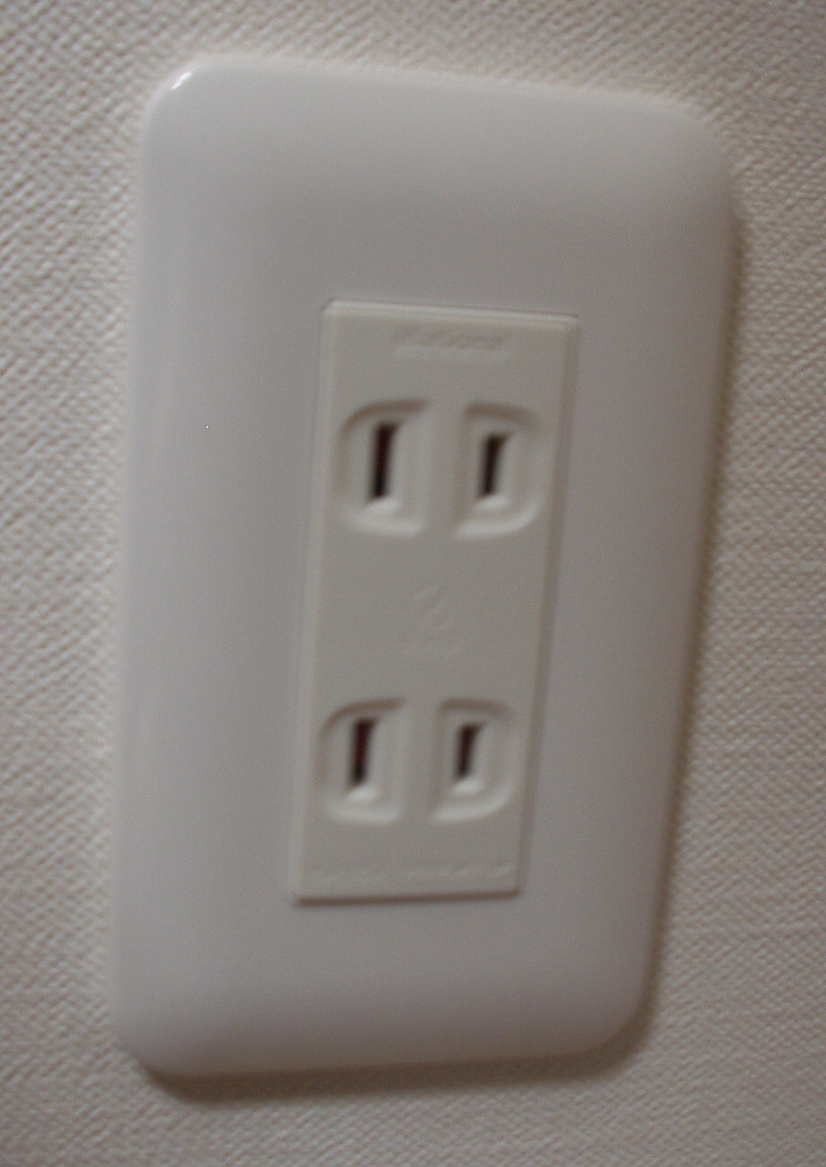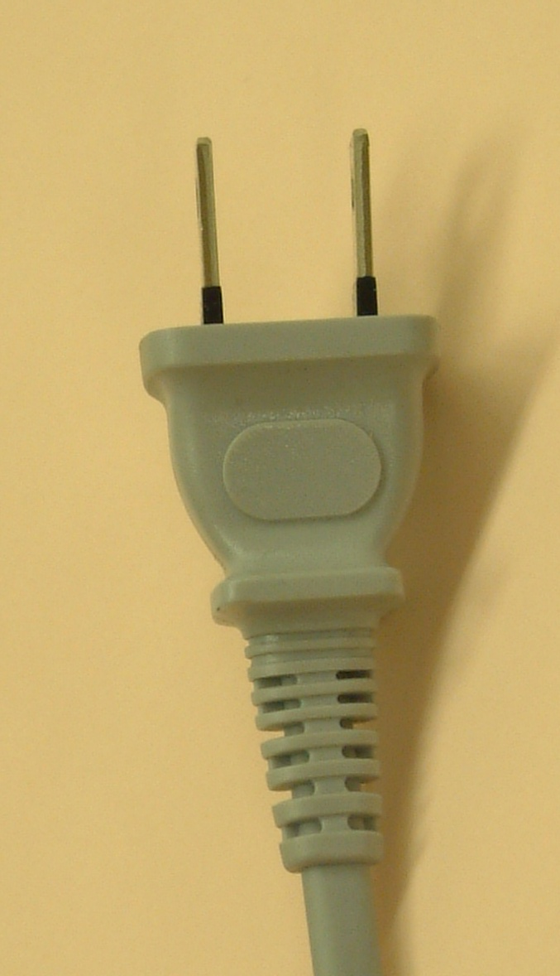
If your appliances operate on a different voltage, please bring your own transformers.

5.2 Passports and Visas
All foreign visitors entering Japan must have a valid passport. Participants who require a visa should, well in advance, apply for a visa to a Japanese consulate or diplomatic mission in their respective country prior to departure. Participants are also advised to contact their local travel agents or carriers. For more information please visit the web site of the Ministry of Foreign affairs of Japan at: http://www.mofa.go.jp/j_info/visit/visa/index.html.
Participants who need an invitation letter and/or a visa supporting letter for entering Japan are advised to get in touch with the contact person in Japan whose detailed information is as follows:
Mr. Masao MASUGI
NTT corp.
3-9-11 Midori-cho, Musashino-shi
Tokyo 180-8585, Japan
Tel: +81 422 59 2904
Fax: +81 422 59 3314
E-mail: masugi.masao@lab.ntt.co.jp

6. Additional information

Location map near meeting spot.

- Visit Japan page: http://www.vjc.jp/
- Sunrise tour (for Osaka, Kyoto & Tokyo): http://www.jtbgmt.com/sunrisetour/
- Osaka tour guide: http://www.tourism.city.osaka.jp/en/index.html
http://www.tourism.city.osaka.jp/ja/index.html
http://www.octb.jp/cb/english/index_e.html
- Kyoto tour guide: http://www.kyotojoho.co.jp/english/index.html
http://raku.city.kyoto.jp/sight.phtml
- Nara tour guide: http://www.pref.nara.jp/nara_e/
- Tokyo tour guide: http://www.tourism.metro.tokyo.jp/english/index.html
http://www.hatobus.com/(Bus tour)
annex 4
(to TSB Collective-letter 3/5)

Meeting of Working Parties 1 and 2 of Study Group 5
(Osaka, Japan, 22-26 May 2006)
HOTEL RESERVATION CONFIRMATION FORM for Miyako Hotel Osaka
This reservation form can be used till 18 April 2006 JPT. to FAX: +81 422 59 3314

Name of the hotel: Miyako Hotel Osaka

Your name and first name:

Name and address of your Company:
Phone #: | Fax #:

E-mail address:

RESERVATION:
12000 JPN per night (one person)  Single room | 20000 JPN per night (two people)  Twin room

The Type of room: Single or Twin ?

If you select the twin room, please describe the name of your partner:

Credit card (as a guarantee of your reservation):

Number:

Expiration date:

ARRIVAL and DEPARTURE
Date of arrival: | Date of departure:
Time of arrival: | Time of departure:

CONFIRMATION:
Date: | Signature:

annex 5
(to TSB Collective-letter 3/5)

 | ITU-TSB | Working Parties 1 and 2 of Study Group 5 Meeting  (Osaka, 22-26 May 2006)
 | REGISTRATION FORM
 | To be returned to TSB (Fax: +41 22 730 5853 / tsbreg@itu.int) by 21 April 2006
 |  |  |  | WP1 | WP2
I participate in the following Working Parties :

Mr. Mrs. Ms. Miss |  |  |  |  | _______________________________________________  Country
____________________________________________  Family Name |  |  |  |  | ______________________________________________  Name of Administration of Member State*
____________________________________________  First Name |  |  |  |  | ______________________________________________  Name of Sector Member / Associate / Other
Complete address of Administration or Organization:
______________________________________________ |  |  |  | Tel: _____________________________________________
______________________________________________ |  |  |  | Fax: _____________________________________________
______________________________________________ |  |  |  | E-mail: __________________________________________
*For delegates of Member States: Function at the meeting |  |  |  |  | Hotel/Address in Osaka
 |  |  |  |  | Hotel: __________________________________________
(C) Head of delegation |  |  |  |  | Address: ________________________________________
(CA) Deputy Head |  |  |  |  | ___________________________________________
(D) Delegate |  |  |  |  | Tel: ____________________________________________
Important Note:
Paper copies of meeting documents will be provided only upon request.
I need paper copies for Delayed Contributions:
I need paper copies for Temporary Documents:
Date: ___________________________ | Signature: ______________________________________
For TSB Secretariat use only
 |  |  |  |  |  | Pigeon-hole

