INTERNATIONAL TELECOMMUNICATION UNION |  |  |  | Focus Group On IPTV
TELECOMMUNICATION  STANDARDIZATION SECTOR  STUDY PERIOD 2005-2008 |  |  | FG IPTV-IL-0009
 |  |  | English only
WG(s): All |  | 2nd FG IPTV meeting:  Busan, 16-20 October 2006
INCOMING LIAISON STATEMENT
Source: | IEC TC 100
Title: | Request to establish the liaisonship between ITU-T FG IPTV and IEC TC 100
International Electrotechnical Council Technical Committee 100 (IEC TC 100) for audio, video and multimedia systems and equipment met on September 29, 2006 in Berlin and decided to send the liaison letter to ITU-T FG IPTV to establish the liaisonship between two groups.
Annex 1 to this document is the liaison statement from IEC TC 100 to ITU-T FG IPTV especially WG 1 for architecture.

Shuji Hirakawa, Ph.D., IEEE Fellow
--------------------------------------------------
IEC TC100 Secretary
(Audio, Video and Multimedia Systems and Equipment) Vice Chairman of ITU-R WP 6M (Interactive and Multimedia Broadcasting)
---
Fellow Specialist (Corporate Standardization) Technology Planning Division, Toshiba Corporation
Office: Toshiba Building, 36B Zone
1-1, Shibaura 1-Chome, Minato-Ku, TOKYO 105-8001 Japan.
Phone: +81-3-3457-2480, Facsimile: +81-3-5444-9210 Mobile Phone: +81-90-8494-2606 (3G/GSM)
E-mail: shuji.hirakawa@toshiba.co.jp (Office)

______________
Annex
Liaison Statement from IEC TC 100 to ITU-T FG IPTV

 | 100(Berlin/Secretariat)26a  For IEC use only  2006-09

INTERNATIONAL ELECTROTECHNICAL COMMISSION

TECHNICAL COMMITTEE N° 100: AUDIO, VIDEO AND MULTIMEDIA SYSTEMS AND
EQUIPMENT

Agenda 7: Liaisons Request to establish liaisonship between IEC TC 100 and ITU-T FG IPTV

Based on Recommendation 3 of AGM, the Secretary prepared the liaison document to ITU-T FG IPTV requesting the establishment of the liaisonship between ITU-T FG IPTV and IEC TC 100.

The liaison document is in the following pages.
Note: This text was approved at TC 100 PL on September 29, 2006

------
The AGM (Advisory group for management), which met on September 26, examined the output of the first meeting of ITU-T FG IPTV, especially the documents FGIPTV-MR-0007, OD-0001 and OD-0027, and advised TC 100 to establish the liaisonship with FG IPTV due to the following reasons:
- Definition of IPTV
The document FGIPTV-OD-0001 provides the definition of IPTV in the following.
Considering the title of IEC TC 100, it has a term ‘multimedia’ already. TC 100 is responsible for international standards for ‘audio, video and multimedia systems and equipment including digital TV receivers,’ those may be taget receivers of some IPTV services.
---Quoted from FGIPTV-OD-0001---
Definition of IPTV
Begin: further discussion needed at 2nd FG IPTV meeting
Definition of IPTV
IPTV is defined as multimedia services such as television/video/ audio/text/graphics/data delivered over IP based networks managed to provide the required level of QoS/QoE, security, interactivity and reliability.

Key features of IPTV
- Supportable by NGN
- Bi-directional networks
- Real time and Non-real time service delivery
Note: Definition of IP based networks, NGN and services exist in ITU-T documentations.
End: further discussion needed at 2nd FG IPTV meeting
----End of Quotation----

The following are the scope of TC 100 and the definition of multimedia in IEC for your information:
To prepare international publications in the related fields of audio, video and multimedia systems and equipment. These publications include specifications for consumer and professional systems and equipment including methods of measuring performance, interactive applications of audio, video and data for production, processing, display, transmission and storage, and network protocols for interconnecting these systems and equipment.
Note: Multimedia is the integration of any form of audio, video, graphics, data and telecommunication and integration includes the production, storage, processing, transmission, display and reproduction of such information.

- TC 100 established a new Technical Area 9 for ‘Audio, video and multimedia applications for end-user network.’
The scope of this Technical Area (TA) is in the following:
To develop International Standards for the requirements, functions and protocols of audio, video and multimedia applications for end-user networks, as well as specifications addressing the total system connected in the network for this purpose. The scope includes e.g. system interfaces, application programming interfaces, modeling for the system structure, system functionality specifications and services provided by protocol processors. End-user networks include all personal networks, e.g., home networks, vehicular networks and other networks controlled by an individual for audio, video and multimedia applications.
TA 9 has three Projects already including DLNA Ver. 1.5 specifications as PT 62481-1 and -2.
TC 100 considered that IEC is the international standardization body beyond User Network Interface (UNI) points between (an) access network(s) and end-use premises.

- TC 100 has two Technical Areas 1 and 8.
The titles of these TAs are ‘Terminals for audio, video & data services and content’ and ‘Multimedia home server systems,’ respectively.
Recent digital TV receivers have already an RJ-45 connector (or connecters) for high-speed IP connection on the back panel as shown in Figure 1.
Figure 1.
Typical Back Panel of a recent digital TV receiver in Japan.
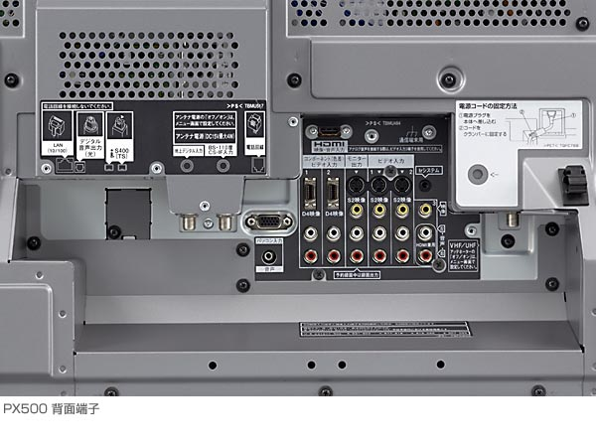
HDMI
IEEE1394
Ethernet
D Audio
DVI
___________________

