INTERNATIONAL TELECOMMUNICATION UNION |  |  |  | Focus Group On IPTV
TELECOMMUNICATION  STANDARDIZATION SECTOR  STUDY PERIOD 2005-2008 |  |  | FG IPTV-DOC-0166
 |  |  | English only
WG(s): 6 |  | 6th FG IPTV meeting:  Tokyo, Japan, 15-19 October 2007
OUTPUT DOCUMENT
Source: | Editor
Title: | Working Document: Standards for IPTV Multimedia Application Platforms

Table of Contents

1 Scope 3
2 References 3
3 Definitions 5
3.1 Terms defined elsewhere 5
3.2 Terms defined in this document 5
4 Abbreviations and Acronyms 6
5 Standards for Declarative Application Platforms 6
5.1 Binary Format for Scene (BIFS) 6
5.2 Broadcasting Markup language (BML) 8
5.3 CEA-2014 9
5.4 CSS TV Profile 10
5.5 Document Object Model (DOM) 10
5.6 ECMAScript 10
5.7 JavaScript 11
5.8 Lightweight Application Scene Representation (LASeR) & Simple Aggregation Format (SAF) 11
5.9 MHEG-5 11
5.10 Nested Context Language (NCL) 12
5.11 Scalable Vector Graphics (SVG) 12
6 Standards for Procedural Application Platforms 12
6.1 GEM based Application Platforms 12
7 Other Related Standards 14
7.1 MPEG Multimedia Middleware (M3W) 14

Standards for IPTV Multimedia Application Platforms

1 Scope
This working document identifies and analyzes the relevant standards for IPTV multimedia application platforms.

2 References
The following ITU-T Recommendations and other references contain provisions, which, through reference in this text, constitute provisions of this working document. At the time of publication, the editions indicated were valid. All Recommendations and other references are subject to revision; users of this working document are therefore encouraged to investigate the possibility of applying the most recent edition of the Recommendations and other references listed below. A list of the currently valid ITU-T Recommendations is regularly published.
The reference to a document within this document does not give it, as a stand-alone document, the status of a Recommendation.

[ITU-T J.200] ITU-T Recommendation J.200 (2001), Worldwide common core - Application environment for digital interactive television services
ITU-T Recommendation J.200 Corrigendum (2004), Worldwide common core - Application environment for digital interactive television services
[ITU-T J.201] ITU-T Recommendation J.201 (2004), Harmonization of declarative content format for interactive television applications Additional media types
ITU-T Recommendation J.201 Amendment 1 (2005), Harmonization of declarative content format for interactive television applications Additional media types
[ITU-T J.202] ITU-T Recommendation J.202 (2005), Harmonization of procedural content formats for interactive TV applications
[ITU-T J.203] ITU-T Recommendation J.203 (2006), Common core for digital video recorder platform
[ITU-T T.171] ITU-T Recommendation T.171 (1996), Protocols for interactive audiovisual services: Coded representation of multimedia and hypermedia objects
[ITU-T T.172] ITU-T Recommendation T.172 (1998), MHEG-5 support for base-level interactive applications
[ITU-T T.173] ITU-T Recommendation T.173 (1997), MHEG-3 script interchange representation
[ITU-T T.174] ITU-T Recommendation T.174 (1996), Application Programming Interface (API) for MHEG-1
[ITU-T T.175] ITU-T Recommendation T.175 (1998), Application Programming Interface (API) for MHEG-5
[ITU-T T.176] ITU-T Recommendation T.176 (1998), API for Digital Storage Media Command and Control (DSM-CC)
[ITU-R BT.1699] ITU-R Recommendation BT.1699 (2005), Harmonization of declarative content format for interactive TV applications
[ITU-R BT.1722] ITU-R Recommendation BT.1722 (2005), Harmonization of procedural content formats for interactive TV applications
[ISO/IEC 14496-11] ISO/IEC 14496-11 (2005), Information technology — Coding of audio-visual objects —Part 11: Scene description and application engine (BIFS)
[ISO/IEC 14496-20] ISO/IEC 14496-20 (2006), Information technology — Coding of audio-visual objects —Part 20: Lightweight Scene Representation (LASeR) and Simple Aggregation Format (SAF)
[ISO/IEC 23004-1] ISO/IEC 23004-1 (2007), Information technology -- Multimedia Middleware — Part 1: Architecture
[ISO/IEC 23004-2] ISO/IEC 23004-2 (2007), Information technology -- Multimedia Middleware — Part 2: Multimedia application programming interface
[ISO/IEC 23004-3] ISO/IEC 23004-3 (2007), Information technology -- Multimedia Middleware — Part 3: Component Model
[ISO/IEC 23004-4] ISO/IEC 23004-4 (2007), Information technology -- Multimedia Middleware — Part 4: Resource and Quality Management
[ETSI TS 102 819] ETSI TS 102 819 V1.3.1, Digital Video Broadcasting (DVB); Globally Executable MHP version 1.0.2
[ETSI TS 102 812] ETSI TS 101 812-v1.1.1 (2003), Digital Video Broadcasting (DVB) - Multimedia Home Platform (MHP) Specification 1.0 (FOREIGN STANDARD)
[ETSI TS 102 812] ETSI TS 102 812-v1.2.1 (2000), Digital Video Broadcasting (DVB) - Multimedia Home Platform (MHP) Specification 1.1.1
[ETSI TS 101 154] ETSI TS 101 154, Digital Video Broadcasting (DVB); Implementation guidelines for the use of Video and Audio Coding in Broadcasting Applications based on the MPEG 2 Transport Stream
[ISO/IEC 23000-5] ISO/IEC FCD 23000-5, Multimedia application format (MPEG-A) — Part 5: Media Streaming Player
[ANSI/SCTE 90-1] ANSI/SCTE 90-1(2004), SCTE Application Platform Specification OCAP 1.0 Profile
[A/101] ATSC Document A/101, ATSC Standard: Advanced Common Application (ACAP)
[ARIB STD-B23] ARIB STD-B23 ver.1.1, Application Execution Engine Platform for Digital Broad Casting
[ARIB STD-B24] ARIB STD-B24 Ver5.1, Data coding and Transmission Specification for Digital Broadcasting
[CEA-2014] CEA-2014 (2006), Web-based Protocol and Framework for Remote User Interface on UPnPTM Networks and the Internet (Web4CE)
[CSS TV Profile] CASS TV Profile 1.0(2003), W3C Recommendations: CSS TV Profile 1.0
[DOM2] DOM Level 2 Core Specification, W3C Recommendation: Document Object Model (DOM) Level 2 Core Specification
[ECMA-262] Standard ECMA-262 3rd Edition (1999), ECMA Standardizing Information and Communication Systems
[XHTML 1] XHTML™ 1.0 Second Edition, W3C Recommendation: XHTML™ 1.0 The Extensible HyperText Markup Language (Second Edition)
[NCL] Editor's note: Reference needed

3 Definitions

3.1 Terms defined elsewhere
This document uses the following terms defined elsewhere:
TBD

3.2 Terms defined in this document
This document defines the following terms:
ARIB-AE Refers to the standard “ARIB STD-B23 ver.1.1, Application Execution Engine Platform for Digital Broad Casting”

4 Abbreviations and Acronyms
This working document uses the following abbreviations and acronyms.

ACAP Advanced Common Application Platform
API Application Programming Interface
ARIB Association of Radio Industries and Businesses (Japan)
BIFS Binary Format for Scene
BML Broadcast Markup Language
CE Consumer Electonics
CSS Contents Scramble System
DASE Digital television Application Software Environment
DOM Document Object Model
DSM-CC Digital Storage Media - Command and Control
ECMA European Computer Manufacturers Association
EE Execution Engine
GEM Globally Executable MHP
LASeR Lightweight Application Scene Representation
MHEG Multimedia and Hypermedia information coding Experts Group
MHP Multimedia Home Platform
M3W MPEG Multimedia Middleware
NCL Nested Context Language
OCAP Open Cable Application Platform
PE Presentation Engine
SAF Simple Aggregation Format
SVG Scalable Vector Graphics
UI User Interface
VCR Video Cassette Recorder
VM Virtual Machine
XHTML Extensible HyperText Markup Language
XML eXtensible Mark-up Language

Standards for Declarative Application Platforms
This section describes the standards for declarative application platforms without implying any specific order or preferences but in an alphabetical order.

Binary Format for Scene (BIFS)
BIFS is the scene description language standardized by ISO as a part of MPEG-4 standard, ISO/IEC 14496-11. It is designed to allow for the efficient representation of dynamic and interactive presentations, comprising two and three dimensional (2D & 3D) graphics, images, text and audiovisual material. The representation of such a presentation includes the description of the spatial and temporal organization of the different scene components as well as user-interaction and animations.
The main features of MPEG-4 BIFS are the following:
- Seamless embedding of audio/video content. MPEG-4 BIFS allows integration and control of different audio/video objects seamlessly in a scene.
- Rich set of 2D/3D graphical constructs: MPEG-4 BIFS provides a rich set of graphical constructs which enable 2D and 3D graphics. BIFS also provides tools that enable easy authoring of complex Face and Body Animation, tools for 3D mesh encoding, and representation of 2D and 3D natural and synthetic sound models.
- Local and Remote Interactivity: BIFS defines elements that can interact with the client-side scene as well as with remote servers. Interactive elements allow for text input, mouse events, and other input devices that can trigger a variety of behaviors.
- Local and Remote Animations: Scene properties, such as object positions, colors, and even shapes, etc., can be animated using either predefined scene descriptions or via streams sent from a server.
- Reuse of Content: MPEG-4 scenes can contain references to streamed sub-scenes. That means that content can easily be reused, a powerful way to create a very rich user experience from relatively simple building blocks.
- Scripted Behavior: MPEG-4 scenes can have two types of scripted behavior. A Java API can control and manipulate the scene graph, as well as built-in ECMA script (javascript) support that can be used to create complex behaviors, animations, and interactivity.
- Streamable scene-description: the spatial and temporal graphic layout is carried in a BIFS-Command stream. Such a stream operates on the scene-graph through commands which replace, delete and insert elements in the scene-graph. .
- Accurate synchronization. Audio/visual content can be tightly synchronized with other A/V content, client-side, and server-driven scene animation, due to the underlying MPEG-4 Systems layer.
- Compression: the scene description is converted to binary data and compressed in an efficient way.
The diagram below summarizes the different components of BIFS.
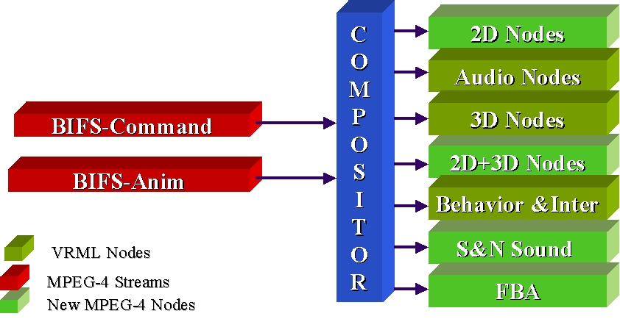
Figure 5-1: MPEG-4 Scene Description

Broadcasting Markup language (BML)
BML is a declarative application specification for multimedia broadcasting in Japan standardized by Association of Radio Industries and Businesses (ARIB). It is defined in [ARIB STD-B24]. BML consists of XHTML, Contents Scramble System (CSS), Document Object Model (DOM) and ECMAScript. [ARIB STD-B24] was revised to include additional functionalities for receivers with digital storage and for terrestrial digital broadcasting including mobile reception.
The specification of Terrestrial Integrated Services Digital Broadcasting (ISDB-T) multimedia coding scheme was first based on that of Multimedia and Hypermedia information coding Experts Group (MHEG). But since March 1999, Association of ARIB started developing an XML specification for multimedia coding scheme based on the functionalities of MHEG. This contributed to the development of an XML application language, BML that enables the presentation of an XML file on BML browsers. The ARIB data broadcasting system standards were enacted as [ARIB STD-B24] in October 1999.
BML application can be based on synchronization and spatial-temporal relationships of multiple media formats, structural composition, event-action associations, navigation, and user interaction capabilities just as MHEG (see 5.9). BML defines additional API and object for broadcasting using ECMAScript.
The semantics of BML is based on the following minimum set of MHEG classes:
- Application Class
- Scene Class
- Link Class
- Action Class
[ARIB STD-B24] is applied to reference model for data broadcasting service that is carried out as part of the digital broadcasting. The following figure shows the structure of BML.
- Data Coding
- Coding mono-media (1): Coding system for character string and bit map etc. used in multimedia is specified.
- Coding of subtitle, superimpose(2): Coding system for subtitle and superimpose is specified.
- XML-based Multimedia Coding Scheme
- Multimedia Coding (3): Coding system of XML based system adopted as multimedia coding system and its profile is specified.
- Data Transmission Specification
- Content transmission format (4): Content transmission format of data carousel transmission method etc. to transmit content is specified.
- Subtitle and superimpose transmission format (5): Independent PES transmission format to transmit subtitle and superimpose is specified.
Figure 5-2: System Structure of BML

CEA-2014
CEA-2014 is a Remote User Interface specification that allows a user interface to be remotely displayed on devices. It is based on existing web rendering technologies for CE browser with W3C tags, [XHTML 1], [ECMA-262], [CSS TV profile] and [DOM 2]. [CEA-2014] is a web based protocol and framework for Remote UI on UPnP Home Network and over Internet. It defines two service domains of [CEA-2014] as in the following figure.
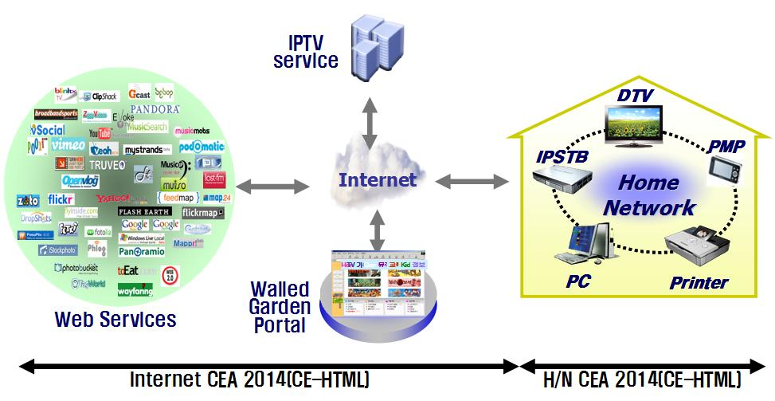
Figure 5-3: Service Model of CEA-2014 (Remote User Interface)
[CEA-2014] defines the mechanisms allowing a user interface to be remotely displayed on and controlled by devices or control points other than the one hosting the logic. The basic device operations are based on the UPnP Device Architecture v1.0 for UPnP networks and UPnP devices in the home. The standard also allows the remote display of user interfaces provided by third party internet services on UPnP devices in the home, and covers UI capabilities for TVs, mobile phones and portable devices.
A major component of CEA-2014 is the CE-HTML profile that uses XHTML content to define user interfaces that can be rendered on screens with different resolutions and sizes ranging from HDTV screens to mobile-phone displays.

CSS TV Profile
[CSS TV Profile] specification defines a subset of Cascading Style Sheets Level 2 and CSS3 Module: Color specifications tailored to the needs and constraints of TV devices.

Document Object Model (DOM)
[DOM2] defines the Document Object Model Level 2 Core, a platform- and language-neutral interface that allows programs and scripts to dynamically access and update the content and structure of documents. The Document Object Model Level 2 Core builds on the Document Object Model Level 1 Core.
The DOM Level 2 Core is made of a set of core interfaces to create and manipulate the structure and contents of a document. The Core also contains specialized interfaces dedicated to XML

ECMAScript
ECMAScript is a scripting programming language, standardized by Ecma International in the [ECMA-262] specification. The language is widely used on the web, and is often referred to as JavaScript or JScript, after the two primary implementations of the specification. There are three editions of [ECMA-262] published, and the most recent one is [ECMA-262] 3rd. edition, though some implementations claim to be [ECMA-262] 4th edition.
ECMAScript is supported in many applications. ECMAScript is also included as a component in many PE such as BML, DVB-HTML and OCAP HTML, which are used for digital data broadcasting. Some implementations have a completely different set of libraries; making applications written in one dialect of ECMAScript will not necessarily work in another.
ECMAScript is an object-oriented programming language for performing computations and manipulating computational objects within a host environment. It was originally designed to be a Web scripting language, providing a mechanism to enliven Web pages in browsers and to perform server computation as part of a Web-based client-server architecture. ECMAScript can provide core scripting capabilities for a variety of host environment.
A web browser provides an ECMAScript host environment for client-side computation including, for example, objects that represent windows, menus, pop-ups, dialog boxes, text areas, anchors, frames, history, cookies, and input/output. Further, the host environment provides a means to attach scripting code to events such as change of focus, page and image loading, unloading, error and abort, selection, form submission, and mouse actions. Scripting code appears within the HTML and the displayed page is a combination of user interface elements and fixed and computed text and images. The scripting code is reactive to user interaction and there is no need for a main program.
A web server provides a different host environment for server-side computation including objects representing requests, clients, and files; and mechanism to lock and share data. By using browser-side and server-side scripting together, it is possible to distribute computation between the client and server while providing a customised user interface for a Web-based applications.
Each Web browser and server that supports ECMAScript supplies its own host environment, completing the ECMAScript execution environment.

JavaScript
JavaScript 1.5 is identical to ECMAScript.

Lightweight Application Scene Representation (LASeR) & Simple Aggregation Format (SAF)
[ISO/IEC 14496-20] (MPEG-4 Part 20) is a specification designed for representing and delivering rich-media services to resource-constrained devices such as mobile phones. It defines two binary formats: LASeR, a binary format for encoding 2D scenes, including vector graphics, and timed modifications of the scene; and SAF, Simple Aggregation Format, a binary format for aggregating in a single stream LASeR content with audio/video streams.
The LASeR specification has been designed to allow the efficient representation of 2D scenes describing rich-media services for constraint devices. A rich-media service is a dynamic and interactive presentation comprising 2D vector graphics, images, text and audiovisual material. The representation of such a presentation includes describing the spatial and temporal organization of its different elements as well as its possible interactions and animations.
The SAF specification defines tools to enable the transport of LASeR content along with its attached audiovisual material according to these requirements. The SAF specification defines a binary format for a SAF stream, made of a LASeR stream with any type of media stream. SAF streams are low overhead multiplexed streams which can be successfully delivered using any delivery mechanism: download-and-play, progressive download, streaming or broadcasting. To achieve reactivity, the SAF specification defines the concept of cache unit which allows sending in advance sub-content which will be used later on in the presentation.

MHEG-5
A multimedia application can be conceived as a set of self-contained objects based on synchronization and spatial-temporal relationships of multiple media formats, structural composition, event-action associations, navigation, and user interaction capabilities. Controlling the playback of time-dependent contents, like streams of multiplexed audiovisual data requires specific support. These streams demand video cassette recorder (VCR) control functions (play, pause, fast forward, and so on), as well as the capability to manage events generated during their presentation. For example, rendering text subtitles can be synchronized with timecode events generated during the playback of a stream. MHEG-5 represents an application, as a set of scenes, which contain objects common to all scenes. A scene supports the spatially and temporally coordinated presentation of audiovisual content consisting of graphics, bitmaps, text, and streams (based on the multiplex of audio and video components). Interaction can be performed via graphic elements like buttons, sliders, text entry boxes, and hypertext selections. Every scene, as well as an entire application, is a self-contained entity that can represent its localized behaviour by links that are event-action associations. Events can be generated by users, expiration of timers, playback of streams, and other conditions within the RTE.
The global scope of MHEG-5 is to define the syntax and semantics of a set of object classes that can be used for interoperability of multimedia applications across minimal-resources platforms. The developed applications will reside on a server, and as portions of the application are needed, they will be downloaded to the client. In a broadcast environment, this download mechanism could rely, for instance, on cyclic rebroadcast of all portions of the application. It is the responsibility of the client to have a runtime that interprets the application parts, presents the application to the user, and handles the local interaction with the user.

Nested Context Language (NCL)
TBD

Scalable Vector Graphics (SVG)
SVG is a language for describing two-dimensional graphics and graphical applications in XML. SVG allows for three types of graphic objects: vector graphic shapes (e.g., paths consisting of straight lines and curves), images and text. Graphical objects can be grouped, styled, transformed and composited into previously rendered objects. The feature set includes nested transformations, clipping paths, alpha masks, filter effects and template objects.
SVG drawings can be interactive and dynamic. Animations can be defined and triggered either declaratively (i.e., by embedding SVG animation elements in SVG content) or via scripting. Sophisticated applications of SVG are possible by use of a supplemental scripting language which accesses SVG DOM), which provides complete access to all elements, attributes and properties.
SVG Basic and SVG Tiny are targeted to resource-limited devices and are part of the 3GPP platform for third generation mobile phones. SVG Print is a set of guidelines to produce final-form documents in XML suitable for archiving and printing.

Standards for Procedural Application Platforms
This section describes the standards for procedural application platforms without implying any specific order or preferences but in an alphabetical order.

GEM based Application Platforms
GEM stands for “Globally Executable MHP” and it specifies the core of Blu-ray’s BD-J, OCAP and MHP. For broadcast, it can best be thought of as the overlap between the MHP and OCAP standards for interactive television. It’s a formally standardised Java-based platform for interactive content and applications. GEM has been standardised by DVB, and adopted by ETSI, the ITU, CableLabs, ARIB, ACAP, and the Blu-ray Disc Association.
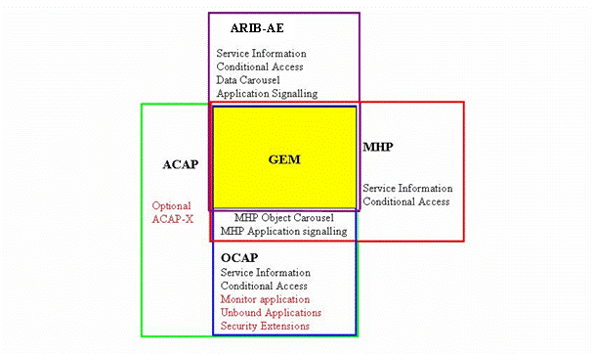
Figure ‎6-1: GEM based Standards for Multimedia Application Platforms

ACAP
ACAP is applicable for specifications and standards based on the ACAP APIs, content formats, and semantic guarantees.
ACAP Applications are classified into two categories depending upon whether the initial application content processed is of a procedural or a declarative nature. These categories of applications are referred to as a procedural (ACAP-J) and declarative (ACAP-X) applications, respectively. An example of an ACAP-J application is a Java TVTM Xlet composed of compiled JavaTM byte code in conjunction with other multimedia content such as graphic, video, and audio. An example of an ACAP-X application is a multimedia document composed of Extensible HyperText Markup Language (XHTML) markup, style rules, scripts, and embedded graphics, video, and audio.
Application environments are similarly classified into two categories depending upon whether they process procedural or declarative applications. These categories are referred to as ACA-J and ACAP-X environments, respectively. An example of an ACAP-J environment is a Java Virtual Machine and its associated API implementation. An example of an ACAP-X environment is an XHTML multimedia document browser, also known as a user agent.
The architecture and facilities of the ACAP standard are intended to apply to broadcast systems and receivers for terrestrial (over-the-air) broadcast and cable TV systems.
ACAP is primarily based on GEM and Digital Television Application Software Environment (DASE), and includes additional functionality from OCAP. The followings are the relevant specifications which ACAP includes:
- Globally Executable MHP (GEM): ACAP includes GEM 1.0.2 in its entirety, except as explicitly modified by the ACAP.
- Open Cable Application Platform (OCAP): ACAP includes OCAP 1.0 in its entirety, except as explicitly modified by the ACAP for ACAP terminal operating in a terrestrial broadcast environment.
- Addition on Non-ACAP Interfaces: Terminal Specifications based on ACAP may add public interfaces, provided that they are added in a namespace that does not conflict with ACAP. ACAP terminal specifications and ACAP terminals shall not require that such extension interfaces be called by ACAP applications in order to enable behaviour that is normatively required by ACAP standard.

ARIB AE
TBD

GINGA
TBD

ITU-R BT.1699, BT.1722
TBD

Multimedia Home Platform (MHP)
MHP is the set of specifications for multimedia broadcasting that has been developed by the DVB Project. MHP has two functional categories. The version 1.0 series covers the execution engine (EE) environment and the version 1.1 series covers the presentation engine (PE) environment in addition to version 1.0. The PE portion of the version 1.1 series is not standalone; it mandates the existence of the EE environment. The first release of the DVB MHP version 1.0 series was May 2000. The MHP 1.0 specification employs Java technology for an EE environment.

Open Cable Application Platform (OCAP)
OCAP is the set of specifications for the interactive multimedia services of digital CATV that has been developed by the OpenCable project managed. OCAP 1.0 is based on MHP 1.0.2, and includes the extensions for the cable system in USA.

Other Related Standards

MPEG Multimedia Middleware (M3W)
ISO/IEC 23000 M3W provide two sets of APIs, Multimedia platform APIs and Support platform APIs. M3W Multimedia platform APIs defines mainly audio and video processing APIs handling front-end, decoders and post-processing of A/V and trust management APIs handling Key Management, Signature Management, License Management, and Certificate Management. The M3W Multimedia APIs offer a high-level API that is independent of the target hardware. By standardizing things that are common, the Multimedia APIs let developers focus on innovation and reduce time to market without limiting product differentiation. It simplifies the work of middleware and application developers because it is designed from what they need, rather than simply reflecting how a particular product’s hardware and software happens to be implemented.
M3W Support platform provides APIs to manage the lifetime of, and interaction with, realization entities, which enables management of extra-functional (‘support’) properties as follows;
- Resource Management: enabling the optimisation of the (perceived) Quality of Service for the user of the appliance. In practice this will usually mean the optimisation of the Quality of Service delivered by the functional part;
- Download: enabling the transfer (download as well as upload) and management of new components to permanent storage of an M3W system;
- Integrity Management: enabling the maintenance of a consistent software configuration for M3W. M3W systems have the ability to download and remove components, and also to register and un-register executable components. The Integrity Management framework enables the verification of the consistency of the current configuration, and when necessary, it can adapt the configuration in order to make the configuration consistent;
Fault Management: enabling the transparent insertion of fault tolerance mechanisms in order to increase the dependability of an M3W system. In this context, ‘transparent’ means transparent for developers of M3W services as well as for the clients of these services
Appendix

Comparison of Data Broadcasting Methods
 | Presentation Engine (PE) |  | Execution Engine(EE) | Mono-media
MHEG | TBD |  | TBD | TBD
ARIB-BML | Spec. | BML | Java  (Under Study) | Video | Graphics | Audio | Character
ARIB-BML | Components | XHTML1.0  CSS1/2  DOM1/2  ECMAScript | Java  (Under Study) | MPEG-2  MPEG-1  MPEG-4 | JPEG  MPEG-2 I(Intra)  PNG  MNG | MPEG-2  AIFF-C | EUC-JP  (8bit)
ATSC-ACAP | Spec. | XDML | Java | MPEG-2  MNG | JPEG  PNG | AC-3  PCM | UTF-8
ATSC-ACAP | Components | XHTML1.0  CSS2  DOM2
DVB-MHP | Spec. | DVB-HTML | DVB-J | MPEG-2 | JPEG  MPEG-2 I(Intra)  PNG | MPEG-1 | UTF-8
DVB-MHP | Components | XHTML1.0  CSS2, DOM2  ECMAScript | Java
OpenCable-OCAP | Spec. | OCAP HTML | Java | MPEG-2 | JPEG  MPEG-2 I(Intra)  PNG, GIF  AnimatedGIF  SWF | MPEG-1  AC3  WAVE  MS-PCM  Format | UTF-8
OpenCable-OCAP | Components | HTML1.0  CSS2  DOM1/2  ECMAScript

________________

