INTERNATIONAL TELECOMMUNICATION UNION |  |  |  | Focus Group On IPTV
TELECOMMUNICATION  STANDARDIZATION SECTOR  STUDY PERIOD 2005-2008 |  |  | FG IPTV-DOC-0162
 |  |  | English only
WG(s): 6 |  | 6th FG IPTV meeting:  Tokyo, Japan, 15-19 October 2007
OUTPUT DOCUMENT
Source: | Editor
Title: | Working Document: Toolbox for content coding

Contact: | Mr. Richard Nicholls  Dolby Laboratories  UK | Tel: +44-1793-842100  Fax: +44-1793-842101  Email rzn@dolby.co.uk
Attention: This is a document submitted to the work of ITU-T and is intended for use by the participants to the activities of ITU-T's Focus Group on IPTV, and their respective staff and collaborators in their ITU-related work. It is made publicly available for information purposes but shall not be redistributed without the prior written consent of ITU. Copyright on this document is owned by the author, unless otherwise mentioned. This document is not an ITU-T Recommendation, an ITU publication, or part thereof.
Table of Contents
1 Scope 4
2 References 4
3 Definitions 7
4 Abbreviations and Acronyms 7
5 Available Codecs 7
6 Audio Codecs 8
6.1 AC-3 (Dolby Digital) 8
6.1.1 Overview of AC-3 8
6.1.2 Transport of AC-3 10
6.2 Enhanced AC-3 (Dolby Digital Plus) 10
6.2.1 Overview of Enhanced AC-3 10
6.2.2 Transport of Enhanced AC-3 11
6.2.3 Storage of AC-3 and Enhanced AC-3 Bitstreams 11
6.3 Extended AMR-WB (AMR-WB+) 15
6.3.1 Overview of AMR-WB+ codec 15
6.3.2 Transport and storage of AMR-WB+ 16
6.4 MPEG-4 High Efficiency AAC v2 (HE AAC v2) 17
6.4.1 Overview of HE AAC v2 17
6.4.2 Transport and storage of HE AAC v2 19
6.4.3 HE AAC v2 Levels and Main Parameters for DVB 20
6.4.4 Methods for signalling of SBR and/or PS 21
6.5 MPEG-1 Layer 2 Audio 21
7 Speech Codecs 22
7.1 ITU-T G.722.1 and G.722.1 Annex C 22
7.2 ITU-T G.729.1 - An 8-32 kbit/s scalable wideband coder bitstream interoperable with G.729 25
7.2.1 Overview of Encoder 26
7.2.2 Overview of Decoder 26
7.2.3 RTP payload 27
7.3 ITU-T G.722 28
7.3.1 Overview of main functional features 28
7.3.2 Overview of G.722 SB-ADPCM encoder 28
7.3.3 Overview of G.722 SB-ADPCM decoder 29
7.4 ITU-T G.722.2 (3GPP AMR-WB) 31
7.4.1 Overview of AMR-WB codec 31
7.4.2 Transport and storage of AMR-WB 33
8 Video codecs 34
8.1 H.264/AVC Video 34
8.1.1 Network Abstraction Layer 34
8.1.2 Video Coding Layer 35
8.2 MPEG-2 Video 36
8.2.1 Technical Solution 36
8.3 VC-1 video 37
8.3.1 Explanation of VC-1 Profiles and Levels 38
8.4 AVS Video 39
8.4.1 AVS encoding tools 39

Requirements and toolbox for content coding

Scope
This document addresses the use of video and audio coding in services delivered over Internet Protocols (IP). It describes the use of H.264/AVC video as specified in [ITU-T H.264] and [ISO/IEC 14496-10], VC-1 video as specified in [SMPTE 421M] , AVS video as specified in [GB/T 20090.2], HE AAC v2 audio as specified in [ISO/IEC 14496-,HE AAC v2 audio as specified in [ISO/IEC 14496-3], Extended AMR-WB (AMR-WB+) audio as specified in [ETSI TS 126 290] and AC-3 and Enhanced AC-3 audio as specified in [ETSI TS 102 366] . In addition this document also describes the use of Speech codecs within an IPTV environment and the specified codecs for thus use.
This document adopts a "toolbox" approach for the general case of IPTV applications delivered directly over IP and MPEG2 -TS. This document is not a specification for the use of Audio and Video Codec’s for use in IPTV Services.

References
The following ITU-T Recommendations and other references contain provisions, which, through reference in this text, constitute provisions of this working document. At the time of publication, the editions indicated were valid. All Recommendations and other references are subject to revision; users of this working document are therefore encouraged to investigate the possibility of applying the most recent edition of the Recommendations and other references listed below. A list of the currently valid ITU-T Recommendations is regularly published.
The reference to a document within this document does not give it, as a stand-alone document, the status of a Recommendation.

[ITU-T H.264] ITU-T Recommendation H.264 (2005), Advanced video coding for generic audiovisual services
[ISO/IEC 14496-3] ISO/IEC 14496-3 (2005), Information technology - Coding of audio-visual objects - Part 3: Audio
ISO/IEC 14496-3: ISO/IEC 14496-3:2005 / AMD.2:2006, Audio Lossless Coding (ALS), new audio profiles and BSAC extensions
All relevant corrigenda related to ISO/IEC 14496-3 (2005)
[ISO/IEC 14496-10] ISO/IEC 14496-10 (2005), Information technology -- Coding of audio-visual objects -- Part 10: Advanced Video Coding
[IETF RFC 3550] IETF RFC 3550(2003), RTP, A Transport Protocol for Real-Time Applications
[IETF RFC 3640] IETF RFC 3640 (2003), RTP payload for transport of generic MPEG-4 elementary streams
[IETF RFC 3984] IETF RFC 3984 (2005), RTP payload for transport of H.264
[IETF RFC 2038] IETF RFC 2038 (1996), RTP Payload Format for MPEG1/MPEG2 Video
[ETSI TS 101 154] ETSI TS 101 154 V1.8.1 (2007): Digital Video Broadcasting (DVB); Specification for the use of Video and Audio Coding in Broadcasting Applications based on the MPEG-2 Transport Stream
[1] EBU Recommendation R.68: "Alignment level in digital audio production equipment and in digital audio recorders".
[ETSI TS 126 234] ETSI TS 126 234 (2007), Universal Mobile Telecommunications System (UMTS); Transparent end-to-end Packet-switched Streaming Service (PSS); Protocols and codecs (3GPP TS 26.234 version 6.11.0 Release 6)
[ISO/IEC 14496-14] ISO/IEC 14496-14 (2003), Information Technology - Coding of Audio-Visual Objects - Part 14: MP4 file format
[ETSI TS 126 244] ETSI TS 126 244 (2007), : Universal Mobile Telecommunications System (UMTS); Transparent end-to-end packet switched streaming service (PSS); 3GPP file format (3GP) (3GPP TS 26.244 version 6.7.0 Release 6)
[ETSI TS 126 290] ETSI TS 126 290 V7.0.0 (2007), Digital cellular telecommunications system (Phase 2+); Universal Mobile Telecommunications System (UMTS); Audio codec processing functions; Extended Adaptive Multi-Rate - Wideband (AMR-WB+) codec
[IETF RFC 4352] IETF RFC 4352 (2006), RTP Payload Format for the Extended Adaptive Multi-Rate Wideband (AMR-WB+) Audio Codec
[ETSI TS 126 273] ETSI TS 126 273 (2006), Digital cellular telecommunications system (Phase 2+); Universal Mobile Telecommunications System (UMTS); ANSI-C code for the fixed-point Extended Adaptive Multi-Rate - Wideband (AMR-WB+) speech codec (3GPP TS 26.273 version 6.5.0 Release 6)
[ETSI TS 126 304] ETSI TS 126 304 (2006), Digital cellular telecommunications system (Phase 2+); Universal Mobile Telecommunications System (UMTS); Extended Adaptive Multi-Rate - Wideband (AMR-WB+) codec; Floating-point ANSI-C code (3GPP TS 26.304 version 6.6.0 Release 6)
[SMPTE 421M] SMPTE 421M (2006), Television - VC-1 Compressed Video Bitstream Format and Decoding Process
[IETF RFC 4425] IETF RFC 4425 (2006), RTP Payload Format for Video Codec 1 (VC-1)
[ETSI TS 102 366] ETSI TS 102 366 V1.1.1 (2005), Digital Audio Compression (AC-3, Enhanced AC-3) Standard
[IETF RFC 4184] IETF RFC 4184 (2005), RTP Payload Format for AC-3 Audio

[IETF RFC 4598] IETF RFC 4184 (2006), RTP Payload Format for Enhanced AC-3 (E-AC-3) Audio

[GB/T20090.2] GB/T20090.2 (2006), Information technology - Advanced coding of audio and video - Part 2: Video
[ISO/IEC 13818-1] ISO/IEC 13818-1(2000), Information technology — Generic coding of moving pictures and associated audio information: Systems
ITU-T Rec. G.722.1, Coding at 24 and 32 kbit/s for hands-free operation in systems with low frame loss", May 2005.
ITU-T Rec. G.191, "Software tools for speech and audio coding standardization", September 2005.
ITU-T WP3/SG16 AC-05-17, "Characterization Listening Test Plan of the 14kHz Low-Complexity Audio Coding Algorithm at 24, 32 and 48 kbps Extension to ITU-T G.722.1", April 2005.
ITU-T WP3/SG16 AC-05-16, "Processing Test Plan of the 14kHz Low-Complexity Audio Coding Algorithm at 24, 32 and 48 kbps Extension to ITU-T G.722.1", April 2005.
ITU-T WP3/SG16 AC-05-29, "Characterization test results of the 14 kHz low-complexity audio coding algorithm at 24, 32, and 48 kbit/s extension to ITU-T G.722.1: phase 1", April 2005.
ITU-T WP3/SG16 AC-05-30, "Characterization test results of the 14 kHz low-complexity audio coding algorithm at 24, 32, and 48 kbit/s extension to ITU-T G.722.1: phase 2", April 2005.
IETF RFC 3047: "RTP Payload Format for ITU-T Recommendation G.722.1".
IETF Document draft-ietf-avt-rfc3047-bis-04: "RTP Payload Format for ITU-T Recommendation G.722.1".
ITU-T Rec. G.729.1: “G.729 based Embedded Variable bit-rate coder: An 8-32 kbit/s scalable wideband coder bitstream interoperable with G.729”, 2006.
IETF RFC 4749: “RTP payload format for G.729.1 Audio codec”, 2006
3GPP TS 26.171: “AMR Wideband Speech Codec; General Description".
3GPP TS 26.190: “AMR Wideband Speech Codec; Transcoding functions".
3GPP TS 26.173: “AMR Wideband Speech Codec; ANSI-C code".
3GPP TS 26.204: “ANSI-C code for the Floating-point Adaptive Multi-Rate Wideband (AMR-WB) speech codec”
3GPP TS 26.194: “AMR Wideband Speech Codec; Voice Activity Detection (VAD)".
3GPP TS 26.192: “AMR Wideband Speech Codec; Comfort Noise Aspects".
3GPP TS 26.191: “AMR Wideband Speech Codec; Error Concealment of Lost Frames.
ITU-T Recommendation G.722.2: “Wideband coding of speech at around 16 kbit/s using Adaptive Multi-rate Wideband (AMR-WB)”
3GPP TS 26.976: “Performance characterization of the Adaptive Multi-Rate Wideband (AMR-WB) speech codec”.
3GPP TS 26.935: “Packet Switched (PS) conversational multimedia applications; Performance characterization of default codecs”.
IETF RFC 3267, “Real-Time Transport Protocol (RTP) Payload Format and File Storage Format for the Adaptive Multi-Rate (AMR) and Adaptive Multi-Rate Wideband (AMR-WB) Audio Codec,”
3GPP TS 26.234: “Transparent end-to-end Packet-switched Streaming Service (PSS); Protocols and codecs”.
3GPP TS 26.346: “Transparent end-to-end Packet-switched Streaming Service (PSS); 3GPP SMIL language profile”.
3GPP TS 26.244: “Transparent end-to-end packet switched streaming service (PSS); 3GPP file format (3GP)”.
IETF RFC 2250: "RTP Payload Format for MPEG1/MPEG2 Video".

ISO/IEC 11172-3: "Information technology — Coding of moving picture and associated audio for digital storage media at up to about 1.5 Mbit/s — Part 3: Audio", 1993

Definitions
This working document defines the following terms:
Bitstream: Coded representation of a video or audio signal.
Multi-channel audio: Audio signal with more than two channels

Abbreviations and Acronyms
This working document uses the following abbreviations and acronyms:
AC-3 Dolby AC-3 audio coding
AMR-WB+ Extended AMR-WB
AOT Audio Object Type
ASO Arbitrary Slice Ordering
AU Access Unit
AVS Audio and Video coding Standard
DRC Dynamic Range Control
E-AC-3 Dolby Enhanced AC-3 audio coding
IRD Integrated Receiver-Decoder
H.264/AVC H.264/Advanced Video Coding
HDTV High Definition Television
HE AAC High-Efficiency Advanced Audio Coding
IP Internet Protocol
IP-IRD Internet Protocol Integrated Receiver-Decoder.
LC Low Complexity
LATM Low Overhead Audio Transport Multiplex
MBMS Multimedia Broadcast/Multicast Service
MPEG Moving Pictures Experts Group (ISO/IEC JTC 1/SC 29/WG 11)
MPEG-2 TS MPEG-2 Transport Stream
NAL Network Abstraction Layer
NTP Network Time Protocol
PS Parametric Stereo
PSS Packet switched Streaming Service
QCIF Quarter Common Interchange Format
QMF Quadrature Mirror Filter
SBR Spectral Band Replication
RTP Real-time Transport Protocol
RTCP Real-time Transport Control Protocol
RTSP Real Time Streaming Protocol
S/PDIF Sony/Philips Digital Interconnect Format
SBR Spectral Band Replication
SMPTE Society of Motion Picture and Television Engineers
TCP Transmission Control Protocol
UDP User Datagram Protocol
VCL Video Coding Layer
VUI Video Usability Information

Contributor’s note: Since it is indicated that the following clause is not part of the document, it is moved to the end of the document. Decision should be made at this meeting on where is the proper place for its relocation.

Available Codecs
Table 5-1 lists a number of currently available codecs without implying any individual preference. However in the spirit of unification and harmonization the FG IPTV encourages the ITU-T to use its best efforts to reduce duplication or proliferation in its recommendations for codecs use in IPTV Services

Table 5-1: Available Codecs
 | Codec | Delivery directly over IP | MPEG-2 TS
Audio | MPEG-1 Layer II | ✓ | ✓
 | AC-3 | ✓ | ✓
 | MPEG-4 HE AAC | ✓ | ✓
 | MPEG-4 HE AAC v2 | ✓ | ✓
 | Enhanced AC-3 | ✓ | ✓
 | AMR-WB+ | ✓ | X
Video | MPEG-2 | ✓ | ✓
 | H.264 / AVC | ✓ | ✓
 | VC-1 | ✓ | ✓
 | AVS | ✓ | ✓

Audio Codecs

AC-3 (Dolby Digital)
The AC-3 digital compression algorithm can encode from 1 to 5.1 channels of source audio from a PCM representation into a serial bit stream, at data rates from 32 kbit/s to 640 kbit/s. The 0.1 channel refers to a fractional bandwidth channel intended to convey only low frequency signals.
The AC-3 audio codec is specified in ETSI TS 102 366 V1.1.1 (2005), Digital Audio Compression (AC-3, Enhanced AC-3) Standard

Overview of AC-3
The AC-3 algorithm achieves high coding gain by coarsely quantizing a frequency domain representation of the audio signal. Figure 6-1 and Figure 6-2 respectively show block diagrams of the AC-3 encoder and decoder. The first step in the encoding process is to transform the representation of audio from a sequence of pulse code modulation (PCM) time samples into a sequence of blocks of frequency coefficients. This is done in the analysis filter bank. Overlapping blocks of 512 time samples are multiplied by a time window and transformed into the frequency domain. Due to the overlapping blocks, each PCM input sample is represented in two sequential transformed blocks. The frequency domain representation may then be decimated by a factor of two so that each block contains 256 frequency coefficients. The individual frequency coefficients are represented in binary exponential notation as a binary exponent and a mantissa. The set of exponents is encoded into a coarse representation of the signal spectrum which is referred to as the spectral envelope. This spectral envelope is used by the core bit allocation routine which determines how many bits to use to encode each individual mantissa. The spectral envelope and the coarsely quantized mantissas for 6 audio blocks (1536 audio samples per channel) are formatted into an AC-3 frame. The AC-3 bit stream is a sequence of AC-3 frames.
Figure 6-1: The AC-3 encoder
The actual AC-3 encoder is more complex than indicated in Figure 6-1. The following functions not shown above are also included:
- A frame header is attached which contains information (bit-rate, sample rate, number of encoded channels, etc.) required to synchronize to and decode the encoded bit stream.
- Error detection codes are inserted in order to allow the decoder to verify that a received frame of data is error free.
- The analysis filterbank spectral resolution may be dynamically altered so as to better match the time/frequency characteristic of each audio block.
- The spectral envelope may be encoded with variable time/frequency resolution.
- A more complex bit allocation may be performed, and parameters of the core bit allocation routine modified so as to produce a more optimum bit allocation.
- The channels may be coupled together at high frequencies in order to achieve higher coding gain for operation at lower bit-rates.
- In the two-channel mode, a rematrixing process may be selectively performed in order to provide additional coding gain, and to allow improved results to be obtained in the event that the two-channel signal is decoded with a matrix surround decoder.
The decoding process is basically the inverse of the encoding process. The decoder, shown in Figure 6-2, must synchronize to the encoded bit stream, check for errors, and de-format the various types of data such as the encoded spectral envelope and the quantized mantissas. The bit allocation routine is run and the results used to unpack and de-quantize the mantissas. The spectral envelope is decoded to produce the exponents. The exponents and mantissas are transformed back into the time domain to produce the decoded PCM time samples.
Figure 6-2: The AC-3 decoder
The actual AC-3 decoder is more complex than indicated in Figure 6-2. The following decoder operations not shown above are included:
- Error concealment or muting may be applied in case a data error is detected.
- Channels which have had their high-frequency content coupled together must be de-coupled.
- Dematrixing must be applied (in the 2-channel mode) whenever the channels have been rematrixed.
- The synthesis filterbank resolution must be dynamically altered in the same manner as the encoder analysis filter bank had been during the encoding process.

Transport of AC-3
To transport AC-3 audio, over RTP [IETF RFC 3550], the RTP payload [IETF RFC 4184] is used. Carriage of multiple AC-3 frames in one RTP packet, as well as fragmentation of AC-3 frames in cases where the frame exceeds the Maximum Transmission Unit (MTU) of the network, is supported. Fragmentation may take into account the partial frame decoding capabilities of AC-3 to achieve higher resilience to packet loss by setting the fragmentation boundary at the "5/8ths point" of the frame.

Enhanced AC-3 (Dolby Digital Plus)
Enhanced AC-3 is an evolution of the AC-3 coding system. The addition of a number of low data rate coding tools enables use of Enhanced AC-3 at a lower bit rate than AC-3 for high quality, and use at much lower bit rates than AC-3 for medium quality.
The Enhanced AC-3 audio codec is specified in ETSI TS 102 366 V1.1.1 (2005), Digital Audio Compression (AC-3, Enhanced AC-3) Standard

Overview of Enhanced AC-3
Enhanced AC-3 uses an expanded and more flexible bitstream syntax which enables a number of advanced features, including expanded data rate flexibility and support for variable bit rate (VBR) coding. A bitstream structure based on sub-streams allows delivery of programs containing more than 5.1 channels of audio to support next-generation content formats, supporting channel configuration standards developed for digital cinema (D-Cinema) and support for multiple audio programs carried within a single bit-stream, suitable for deployment of services such as Hearing Impaired/Visual Impaired. To control the combination of audio programs carried in separate sub-streams or bit streams, Enhanced AC-3 includes comprehensive mixing metadata, enabling a content creator to control the mixing of two audio streams in an IP-IRD (Internet Protocol Integrated Receiver-Decoder.) To ensure compatibility of the most complex bit stream configuration with even the simplest Enhanced AC-3 decoder, the bit stream structure is hierarchical – decoders will accept any Enhanced AC-3 bit stream and will extract only the portions that are supported by that decoder without requiring additional processing. To address the need to connect IP-IRDs that include Enhanced AC-3 to the millions of home theatre systems that feature legacy AC-3 decoders via S/PDIF, it is possible to perform a modest complexity conversion of an Enhanced AC-3 bit stream to an AC-3 bit stream.
Enhanced AC-3 includes the following coding tools that improve coding efficiency when compared to AC-3.
- Spectral Extension: recreates a signal’s high frequency amplitude spectrum from side data transmitted in the bit stream. This tool offers improvements in reproduction of high frequency signal content at low data rates.
- Transient Pre-Noise Processing: synthesizes a section of PCM data just prior to a transient. This feature improves low data rate performance for transient signals.
- Adaptive Hybrid Transform Processing: improves coding efficiency and quality by increasing the length of the transform. This feature improves low data rate performance for signals with primarily tonal content.
- Enhanced Coupling: improves on traditional coupling techniques by allowing the technique to be used at lower frequencies than conventional coupling, thus increasing coder efficiency.

Transport of Enhanced AC-3
To transport Enhanced AC-3 audio over RTP [IETF RFC 3550], the RTP payload [IETF RFC 4598] is used. Carriage of multiple Enhanced AC-3 frames in one RTP packet, as well as fragmentation of Enhanced AC-3 frames in cases where the frame exceeds the MTU of the network, is supported. Recommendations for concatenation decisions which reduce the impact of packet loss by taking into account the configuration of multiple channels and programs present in the Enhanced AC-3 bit stream are provided.

Storage of AC-3 and Enhanced AC-3 Bitstreams
This section describes the necessary structures for the integration of AC-3 and Enhanced AC-3 bitstreams in a file format that is compliant with the ISO Base Media File Format. Examples of file formats that are derived from the ISO Base Media File Format include the MP4 file format and the 3GPP file format.

AC-3 and Enhanced AC-3 Track definition
In the terminology of the ISO Base Media File Format specification (ISO/IEC 14496-12), AC-3 and Enhanced AC-3 tracks are audio tracks. It therefore follows that these rules apply to the media box in the AC-3 or Enhanced AC-3 track:
- In the Handler Reference Box, the handler_type field shall be set to ‘soun’.
- The Media Information Header Box shall contain a Sound Media Header Box.
- The Sample Description Box shall contain a box derived from AudioSampleEntry. For AC-3 tracks, this box is called AC3SampleEntry, and has a box type designated ‘ac-3’. For Enhanced AC-3 tracks, this box is called EC3SampleEntry, and has box type designated ‘ec-3’. The layout of the AC3SampleEntry and EC3SampleEntry boxes is identical to that of AudioSampleEntry defined in ISO/IEC 14496-12 (including the reserved fields and their values), except that AC3SampleEntry ends with a box containing AC-3 bitstream information called AC3SpecificBox, and EC3SampleEntry ends with a box containing Enhanced AC-3 information called EC3SpecificBox.
- The value of the timescale parameter in the Media Header Box, and the value of the SamplingRate parameter in the AC3SampleEntry Box or EC3SampleEntry Box shall be equal to the sample rate (in Hz) of the AC-3 or Enhanced AC-3 bitstream respectively.

AC-3 and Enhanced AC-3 Sample definition
An AC-3 Sample is defined as follows:
- Exactly one AC-3 syncframe, as defined in [ETSI TS 102 366].
An Enhanced AC-3 Sample is defined as follows:
- The number of Enhanced AC-3 syncframes required to deliver six blocks of audio data from each substream present in the Enhanced AC-3 bitstream, beginning with independent substream 0.
An AC-3 or Enhanced AC-3 Sample is equivalent in duration to 1536 samples of PCM audio data. Consequently the value of the sample_delta field in the Decoding Time to Sample Box shall be 1536.
AC-3 and Enhanced AC-3 Samples shall be byte-aligned. If necessary, up to 7 zero-valued padding bits shall be added to the end of an AC-3 or Enhanced AC-3 Sample to achieve byte-alignment. The Padding Bits Box (defined in section 8.23 of ISO/IEC 14496-12) need not be used to record padding bits that are added to a Sample to align its size to the nearest byte boundary.

AC3SpecificBox
The AC3SpecificBox is defined as follows:
Syntax No. of bits | Identifier
AC3SpecificBox (){  BoxHeader.Size 32  BoxHeader.Type 32  fscod 2  bsid 5  bsmod 3  acmod 3  lfeon 1  bit_rate_code 5  reserved 5  } | uimsbf  uimsbf  uimsbf  uimsbf  uimsbf  uimbsf  uimsbf  uimsbf  uimbsf
Semantics
BoxHeader.Type: The value of the Box Header Type for the AC3SpecificBox shall be ‘dac3’.
fscod: This field has the same meaning and is set to the same value as the fscod field in the AC-3 bitstream
bsid: This field has the same meaning and is set to the same value as the bsid field in the AC-3 bitstream
bsmod: This field has the same meaning and is set to the same value as the bsmod field in the AC-3 bitstream
acmod: This field has the same meaning and is set to the same value as the acmod field in the AC-3 bitstream
lfeon: This field has the same meaning and is set to the same value as the lfeon field in the AC-3 bitstream
bit_rate_code: This field indicates the data rate of the AC-3 bitstream in kbit/s, as shown in Table 6-2.
Table 6-2: bit_rate_code
bit_rate_code | Nominal bit rate (kbit/s)
00000 | 32
00001 | 40
00010 | 48
00011 | 56
00100 | 64
00101 | 80
00110 | 96
00111 | 112
01000 | 128
01001 | 160
01010 | 192
01011 | 224
01100 | 256
01101 | 320
01110 | 384
01111 | 448
10000 | 512
10001 | 576
10010 | 640

EC3SpecificBox
The EC3SpecificBox is defined as follows:
Syntax No. of bits | Identifier
EC3SpecificBox (){  BoxHeader.Size 32  BoxHeader.Type 32  data_rate 13  num_ind_sub 3  for(i = 0; i < num_ind_sub; i++)  {  fscod 2  bsid 5  bsmod 5  acmod 3  lfeon 1  reserved 3  num_dep_sub 4  if num_dep_sub > 0  {  chan_loc 9  }  else  {  reserved 1  }  }  } | uimsbf  uimsbf  uimsbf  uimsbf  uimsbf  uimsbf  uimsbf  uimsbf  uimbsf  uimsbf  uimbsf  uimsbf  uimsbf
Semantics
BoxHeader.Type: The value of the Box Header Type for the EC3SpecificBox shall be ‘dec3’.
data_rate: This value indicates the data rate of the Enhanced AC-3 bitstream in kbit/s. If the Enhanced AC-3 stream is variable bit rate, then this value indicates the maximum data rate of the stream.
num_ind_sub: This field indicates the number of independent substreams that are present in the Enhanced AC-3 bitstream. The value of this field is one less than the number of independent substreams present.
fscod: This field has the same meaning and is set to the same value as the fscod field in the independent substream
bsid: This field has the same meaning and is set to the same value as the bsid field in the independent substream.
bsmod: This field has the same meaning and is set to the same value as the bsmod field in the independent substream.
acmod: This field has the same meaning and is set to the same value as the acmod field in the independent substream.
lfeon: This field has the same meaning and is set to the same value as the lfeon field in the independent substream.
num_dep_sub: This field indicates the number of dependent substreams that are associated with the independent substream
chan_loc: If there are one or more dependent substreams associated with the independent substream, this bit field is used to identify channel locations beyond those identified using the acmod field that are present in the bitstream. For each channel location or pair of channel locations present, the corresponding bit in the chan_loc bit field is set to “1”, according to Table 6-3. This information is extracted from the chanmap field of each dependent substream.
Table 6-3: chan_loc field bit assignments
Bit | Location
0 | Lc/Rc pair
1 | Lrs/Rrs pair
2 | Cs
3 | Ts
4 | Lsd/Rsd pair
5 | Lw/Rw pair
6 | Lvh/Rvh pair
7 | Cvh
8 | LFE2

Extended AMR-WB (AMR-WB+)
The AMR-WB+ audio codec can encode mono and stereo content, up to 48 kbit/s for stereo. It supports also downmixing to mono at a decoder. The AMR-WB+ codec has been specified in [ETSI TS 126 290] and includes error concealment and also contains a user’s guide. The source code for both encoder and decoder has been fully specified in TS 126 304 [ETSI TS 126 304] and [ETSI TS 126 273]. The transport has been specified in [IETF RFC 4352].

Overview of AMR-WB+ codec
The input signal is separated in two bands. The first band is the low-frequency (LF) signal, which is critically sampled at Fs/2. The second band is the high-frequency (HF) signal, which is also down sampled to obtain a critically sampled signal. The LF and HF signals are then encoded using two different approaches: the LF signal is encoded and decoded using the "core" encoder/decoder, based on switched ACELP and Transform Coded eXcitation (TCX). In ACELP mode, the standard AMR-WB codec is used. The HF signal is encoded with relatively few bits using a Band Width Extension (BWE) method.
The parameters transmitted from encoder to decoder are the mode selection bits, the LF parameters and the HF parameters. The codec operates in super frames of 1 024-samples. The parameters for each of them are decomposed into four packets of identical size.
When the input signal is stereo, the left and right channels are combined into mono signal for ACELP/TCX encoding, whereas the stereo encoding receives both input channels.
Figure 6-3: High-level structure of AMR-WB+ encoder
Figure 6-4 presents the AMR-WB+ decoder structure. The LF and HF bands are decoded separately after which they are combined in a synthesis filterbank. If the output is restricted to mono only, the stereo parameters are omitted and the decoder operates in mono mode.

Figure 6-4: High-level structure of AMR-WB+ decoder

Transport and storage of AMR-WB+
To transport AMR-WB+ over RTP [IETF RFC 3550], the RTP payload [IETF RFC 4352] is used. It supports encapsulation of one or multiple AMR-WB+ transport frames per packet, and provides means for redundancy transmission and frame interleaving to improve robustness against possible packet loss. The overhead due to payload starts from three bytes per RTP-packet. The use of interleaving increases the overhead per packet slightly. That payload format includes also parameters required for session setup.
In many application scenarios there is the probability that packets will be lost due to network problems. Because the RTP is running over User Datagram Protocol (UDP), the lost packets are not automatically retransmitted and applications do not need to wait for a retransmission of those lost packets and thus annoying interruptions of the playback is avoided. Instead, applications can utilize forward error correction (FEC) and frame interleaving to improve robustness against possible packet loss, however doing so increases the bandwidth requirement and increase the signal delay.
The AMR-WB+ RTP payload enables simple FEC functionality with low packetization overhead. In this scheme each packet also carries redundant copy (copies) of the previous frame(s) that can be used to replace possibly lost frames. The cost of this scheme is an increased overall bit rate and additional delay at the receiver to allow the redundant copy to arrive. On the other hand, this approach does not increase the number of transmitted packets, and the redundant frames are also readily available for re-transmission without additional processing. Furthermore, this mechanism does not require signalling at the session setup.
Frame interleaving is another method which may be used to improve the perceptual performance of the receiver by spreading consecutive frames into different RTP-packets. This means that even if a packet is lost then is only lost frames that are not time-wise consecutive to each other that are lost and thus a decoder may be able to reconstruct the lost frames using one of a number of possible error concealment algorithms. The interleaving scheme provided by the AMR-WB+ RTP payload allows any interleaving pattern, as long as the distance in decoding order between any two adjacent frames is not more than 256 frames. If the increases end-to-end delay and higher buffering requirements in the receiver are acceptable then interleaving is useful in IPTV applications.
The AMR-WB+ audio can be stored into a file using the ISO-based 3GP file format defined in [ETSI TS 126 244], which has the media type “audio/3GPP”. Note that the 3GP structure also supports the storage of many other multimedia formats, thereby allowing synchronized playback.

MPEG-4 High Efficiency AAC v2 (HE AAC v2)
The MPEG-4 High Efficiency AAC v2 audio codec is specified in ISO/IEC 14496-3: "Information technology - Generic coding of moving picture and associated audio information - Part 3: Audio" including ISO/IEC 14496-3:2005 / AMD.2:2006 and all relevant Corrigenda
The transport has been specified in ISO/IEC 14496-3: "Information technology - Generic coding of moving picture and associated audio information - Part 3: Audio" including ISO/IEC 14496-3:2005 / AMD.2:2006 and all relevant Corrigenda

Overview of HE AAC v2
The principle problem with traditional perceptual audio codecs operating at low bit rates is, that they would need more bits to encode the whole spectrum accurately than there are available. The results are either coding artefacts or the transmission of a reduced bandwidth audio signal. To resolve this problem, MPEG decided to add a bandwidth extension technology as a new tool to the MPEG-4 audio toolbox. With SBR the higher frequency components of the audio signal are reconstructed at the decoder based on transposition and additional helper information. This method allows an accurate reproduction of the higher frequency components with a much higher coding efficiency compared to a traditional perceptual audio codecs. Within MPEG the resulting audio codec is called MPEG-4 High Efficiency AAC (HE AAC) and is the combination of the MPEG-4 Audio Object Types AAC-Low Complexity (LC) and Spectral Band Replication (SBR). It is not a replacement for AAC, but rather a superset which extends the reach of high-quality MPEG-4 Audio to much lower bitrates. HE AAC decoders will decode both, plain AAC and the enhanced AAC plus SBR. The result is a backward compatible extension of the standard.
The basic idea behind SBR is the observation that usually there is a strong correlation between the characteristics of the high frequency range of a signal (further referred to as "highband") and the characteristics of the low frequency range (further referred to as "lowband") of the same signal is present. Thus, a good approximation of the representation of the original input signal highband can be achieved by a transposition from the lowband to the highband. In addition to the transposition, the reconstruction of the highband incorporates shaping of the spectral envelope. This process is controlled by transmission of the highband spectral envelope of the original input signal. Additional guidance information for the transposing process is sent from the encoder, which controls means, such as inverse filtering, noise and sine addition. This transmitted side information is further referred to as SBR data.
In June 2004 MPEG extended its toolbox with the Audio Object Type Parametric Stereo (PS), which enables stereo coding at very low bitrates. The principle behind the PS tool is to transmit a mono signal coded in HE AAC format together with a description of the stereo image. The PS tool is used at bit rates in the low bit rate range. The resulting MPEG profile is called MPEG-4 HE AAC v2. Figure 6-5 shows the different MPEG tools used in the MPEG-4 HE AAC v2 profile. A HE AAC v2 decoder will decode all three profiles, AAC-LC, HE AAC and HE AAC v2.
Figure 6-5: MPEG Tools used in the HE AAC v2 Profile
Figure 6-6 shows a block diagram of a HE AAC v2 Encoder. At the lowest bitrates the PS tool is used. At higher bitrates, normal stereo operation is performed. The PS encoding tool estimates the parameters characterizing the perceived stereo image of the input signal. These parameters are embedded in the SBR data. If the PS tool is used, a stereo to mono downmix of the input signal is applied, which is then fed into the aacPlus encoder operating in mono. SBR data is embedded into the AAC bitstream by means of the extension_payload() element Two types of SBR extension data can be signalled through the extension_type field of the extension_payload(). For compatibility reasons with existing AAC only decoders, two different methods for signalling the existence of an SBR payload can be selected. Both methods are described below.
Figure 6-6: HE AAC v2 Encoder
The HE AAC v2 decoder is depicted in Figure 6-7. The coded audio stream is fed into a demultiplexing unit prior to the AAC decoder and the SBR decoder. The AAC decoder reproduces the lower frequency part of the audio spectrum. The time domain output signal from the underlying AAC decoder at the sampling rate fs_{AAC} is first fed into a 32 channel Quadrature Mirror Filter (QMF) analysis filterbank. Secondly, the high frequency generator module recreates the highband by patching QMF subbands from the existing low band to the high band. Furthermore, inverse filtering is applied on a per QMF subband basis, based on the control data obtained from the bit stream. The envelope adjuster modifies the spectral envelope of the regenerated highband, and adds additional components such as noise and sinusoids, all according to the control data in the bit stream. In case of a stream using Parametric Stereo, the mono output signal from the underlying HE AAC decoder is converted into a stereo signal. This processing is carried out in the QMF domain and is controlled by the Parametric Stereo parameters embedded in the SBR data. Finally a 64 channel QMF synthesis filter bank is applied to retain a time-domain output signal at twice the sampling rate,
i.e. fs_{out} = fs_{SBR} = 2 × fs_{AAC}.
Figure 6-7: HE AAC v2 Decoder

Transport and storage of HE AAC v2
To transport HE AAC v2 audio over RTP [IETF RFC 3550], the RTP payload [IETF RFC 3640] is used. [IETF RFC 3640] supports both implicit signalling as well as explicit signalling by means of conveying the AudioSpecificConfig() as the required MIME parameter "config", as defined in [IETF RFC 3640]]. The framing structure defined in [IETF RFC 3640] does support carriage of multiple AAC frames in one RTP packet with optional interleaving to improve error resiliency in packet loss. For example, if each RTP packet carries three AAC frames, then with interleaving the RTP packets may carry the AAC frames as given in Figure 6-8.
Figure 6-8: Interleaving of AAC frames
Without interleaving, then RTP packet P1 carries the AAC frames 1, 2 and 3, while packet P2 and P3 carry the frames 4, 5 and 6 and the frames 7, 8 and 9, respectively. When P2 gets lost, then AAC frames 4, 5 and 6 get lost, and hence the decoder needs to reconstruct three missing AAC frames that are contiguous. In this example, interleaving is applied so that P1 carries 1, 4 and 7, P2 carries 2, 5 and 8, and P3 carries 3, 6 and 9. When P2 gets lost in this case, again three frames get lost, but due to the interleaving, the frames that are immediately adjacent to each lost frame are received and can be used by the decoder to reconstruct the lost frames, thereby exploiting the typical temporal redundancy between adjacent frames to improve the perceptual performance of the receiver.

HE AAC v2 Levels and Main Parameters for DVB
MPEG-4 provides a huge toolset for the coding of audio objects. In order to allow effective implementations of the standard, subsets of this toolset have been identified that can be used for specific applications. The function of these subsets, called "Profiles," is to limit the toolset a conforming decoder must implement. For each of these Profiles, one or more Levels have been specified, thus restricting the computational complexity.
The HE AAC v2 Profile is introduced as a superset of the AAC Profile. Besides the Audio Object Type (AOT) AAC LC (which is present in the AAC Profile), it includes the AOT SBR and the AOT PS. Levels are introduced within these Profiles in such a way, that a decoder supporting the HE AAC v2 Profile at a given level can decode an AAC Profile and an HE AAC Profile stream at the same or lower level.
Table 6-4: Levels within the HE AAC v2 Profile
Level | Max. channels/object | Max. AAC sampling rate, SBR not present [kHz] | Max. AAC sampling rate, SBR present [kHz] | Max. SBR sampling rate, [kHz] (in/out)
1 | NA | NA | NA | NA
2 | 2 | 48 | 24 | 24/48  (see note 1)
3 | 2 | 48 | 48  (see note 3) | 48/48  (see note 2)
4 | 5 | 48 | 24/48  (see note 4) | 48/48  (see note 2)
5 | 5 | 96 | 48 | 48/96
NOTE 1: A level 2 HE-AAC v2 Profile decoder implements the baseline version of the parametric stereo tool. Higher level decoders are not be limited to the baseline version of the parametric stereo tool.
NOTE 2: For Level 3 and Level 4 decoders, it is mandatory to operate SBR in a downsampled mode if the sampling rate of the AAC core is higher than 24 kHz. Hence, if SBR operates on a 48 kHz AAC signal, the internal sampling rate of SBR will be 96 kHz, however, the output signal will be downsampled by SBR to 48 kHz.
NOTE 3: If Parametric Stereo data is present the maximum AAC sampling rate is 24kHz, if Parametric stereo data is not present the maximum AAC sampling rate is 48kHz.
NOTE 4: For one or two channels the maximum AAC sampling rate, with SBR present, is 48 kHz. For more than two channels the maximum AAC sampling rate, with SBR present, is 24 kHz.

For DVB the level 2 for mono and stereo as well as the level 4 multichannel audio signals are supported. The Low Frequency Enhancement channel of a 5.1 audio signal is included in the level 4 definition of the number of channels.

Methods for signalling of SBR and/or PS
In case of usage of SBR and/or PS several ways how to signal the presence of SBR and/or PS data are possible [ISO/IEC 14496-3]. Within the context of DVB services over IP it is recommended to use backward compatible explicit signalling. Here the respective extension Audio Object Type is signalled at the end of the AudioSpecificConfig().

MPEG-1 Layer 2 Audio
MPEG-1 Layer I or II Audio is a generic subband coder operating at bit rates in the range of 32 to 448 kb/s and supporting sampling frequencies of 32, 44.1 and 48 kHz. Typical bit rates for Layer II are in the range of 128-256 kbit/s, and 384 kb/s for professional applications. MPEG 1 Layer I and II audio has been specified in [ISO/IEC 11172-3]. The transport of MPEG 1 Layer I and II audio using RTP over IP has been specified in [IETF RFC 2250]. Furthermore, MPEG 1 Layer II audio is the recommended audio coding system in DVB broadcasting applications as specified in [ETSI TS 101 154].

MPEG-1 Layers I and II (MP1 or MP2) are perceptual audio coders for 1- or 2-channel audio content. Layer I has been designed for applications that require both low complexity decoding and encoding. Layer II provides for a higher compression efficiency for a slightly higher complexity. Using MPEG-1 Layer I one can compress high quality audio CD data at a typical bitrate of 384 kb/s while maintaining a high audio quality after decoding. Layer II requires bit rates in the range of 192 to 256 kb/s for near CD quality. A Layer II decoder can also decode Layer I bitstreams.

Thanks to its low complexity decoding combined with high robustness against cascaded encoding/decoding and transmission errors, MPEG-1 Layer II is used in digital audio and video broadcast applications (DVB and DAB). It is also used in Video CD, as well as in a variety of studio applications.

Figure 6-9 shows a high level overview of the MPEG-1 Layers I and II coders. The input signal is transformed into 32 subband signals that are uniformly distributed over frequency by means of a critically sampled QMF filterbank. The critically down sampled subband signals are grouped in a so called allocation frame (384 and 1152 subband samples for Layer I and II respectively). By means of Adaptive PCM, these allocation frames are subsequently quantized and coded into an MPEG-1 bitstream. At the decoder side, the bitstream is decoded into the subband samples which are subsequently fed into the inverse QMF filterbank.
Figure 6-9: High level overview of MPEG-1 Layers II coder
Next to coding of mono and independent coding of stereo signals, also joint coding of stereo signals is supported by applying a technology called intensity stereo coding. Intensity coding exploits the property of the human auditory system that at high frequencies the perceived stereo image depends on intensity level differences.

Speech Codecs

ITU-T G.722.1 and G.722.1 Annex C
The main body of ITU-T Recommendation G.722.1 [1] describes a wideband coding algorithm that provides an audio bandwidth of 50 Hz to 7 kHz, operating at a bit rate of 24 kbit/s or 32 kbit/s. ITU-T Recommendation G.722.1 Annex C (“G.722.1C”) [1] is a doubled form of the G.722.1 main body to permit 14 kHz audio bandwidth using a 32 kHz audio sample rate, at 24, 32, and 48 kbit/s. Both G.722.1 and G.722.1 Annex C codecs feature very high audio quality, extremely low computational complexity, and low algorithmic delay compared to other state-of-the-art audio coding algorithms.
The G.722.1 algorithm is based on transform coding, using a Modulated Lapped Transform (MLT) and operates on frames of 20 ms corresponding to 320 samples at a 16 kHz sampling rate. Because the transform window length is 640 samples and a 50 per cent overlap is used between frames, the effective look-ahead buffer size is 320 samples. Hence the total algorithmic delay of the coder is 40 ms. Figure 1 shows a block diagram of the encoder.

Figure 7-10: Block diagram of the G.722.1 encoder
The MLT performs a frequency spectrum analysis on audio samples and converts the samples from the time domain into a frequency domain representation. Every 20 ms the most recent 640 audio samples are fed to the MLT and transformed into a frame of 320 transform coefficients centered at 25 Hz intervals. In each frame the MLT transform coefficients are divided into 16 regions, each having 20 transform coefficients and representing a bandwidth of 500 Hz. As the bandwidth is 7 kHz, only the 14 lowest regions are used. For each region the region power or the root-mean-square (rms) value of the MLT transform coefficients in the region is computed and scalar quantized with a logarithmic quantizer. The obtained quantization indices are differentially coded and then Huffman coded with a variable number of bits. Using the quantized region power indices and the number of bits remaining in the frame, the categorization procedure generates 16 possible categorizations to determine the parameters used to quantize and code the MLT transform coefficients. Then, the MLT transform coefficients are normalized, scalar quantized, combined into vectors, and Huffman coded. The bit stream is transmitted on the channel in 3 parts: region power code bits, 4 categorization control bits, and then code bits for MLT transform coefficients.
G.722.1C has the same algorithmic steps as the G.722.1 main body, except that the algorithm is doubled to accommodate the 14 kHz audio bandwidth. G.722.1C still operates on frames of 20 ms and has an algorithmic delay of 40ms, but due to the higher sampling frequency the frame length is doubled to 640 samples from 320 samples and the transform window size increases to 1280 samples from 640 samples. Compared to the G.722.1 main body, the specific differences in the G.722.1C encoder are as follows:
- Double the MLT transform length from 320 to 640 samples
- Double the number of frequency regions from 14 to 28
- Double the sizes of Huffman coding tables for encoding quantized region power indices
- Double the threshold for adjusting the number of available bits from 320 to 640

Figure 7-11: Block diagram of the G.722.1 decoder
Figure 2 shows a block diagram of the decoder. In each frame the region power code bits are first extracted from the received data and then decoded to obtain the quantization indices for the region powers. Using the same categorization procedure as the encoder, the set of 16 possible categorizations computed by the encoder are recovered and the categorization used to encode MLT transform coefficients is found with the received 4 categorization control bits. For each region the variable bit-length codes for MLT transform coefficients are decoded with the appropriate category and the MLT transform coefficients are reconstructed. The reconstructed MLT transform coefficients are converted into time domain audio samples by an Inverse MLT (IMLT). Each IMLT operation takes in 320 MLT transform coefficients to produce 320 audio samples.
Following are the main changes in the G.722.1C decoder when compared to G.722.1.
- Double the number of frequency regions from 14 to 28
- Double the threshold for adjusting the number of available bits from 320 to 640
- Extend the centroid table used for reconstruction of MLT transform coefficients
- Double the IMLT transform length from 320 to 640 samples

Low complexity is a major technical advantage of G.722.1 and G.722.1C compared to other codecs with similar performance in this bit-rate range. Table 1 and Table 2 present the computational complexity in units of Weighted Million Operations Per Second (WMOPS) [2] and memory requirements in bytes of G.722.1 and G.722.1C, respectively.
Table 7-5: Computational complexity in WMOPS
Codec | Bit rate  (kbit/s) | Encoder  (WMOPS) | Decoder  (WMOPS) | Encoder+Decoder  (WMOPS)
G.722.1 | 24 | 2.3 | 2.7 | 5.0
G.722.1 | 32 | 2.4 | 2.9 | 5.3
G.722.1C | 24 | 4.5 | 5.3 | 9.7
G.722.1C | 32 | 4.8 | 5.5 | 10.3
G.722.1C | 48 | 5.1 | 5.9 | 10.9

Table 7-6: Memory requirements in Bytes
Codec | RAM | Data-ROM
G.722.1 | 11 K | 20 K
G.722.1C | 18 K | 30 K

In March 2005, as a part of the G.722.1 Annex C development process in ITU-T, subjective characterization tests were performed on G.722.1C by an independent listening lab according to a test plan [3] designed by the ITU-T Q7/SG12 Speech Quality Experts Group (SQEG). More details about test design and data analysis can be found in [3][4][5][6]. A well-known MPEG audio codec was used as the reference codec in the tests [3]. Statistical analysis of the test results showed that G.722.1C met all performance requirements. For speech signal, G.722.1C was better than the reference codec at 24 and 32 kbit/s and G.722.1C at 48 kbit/s was not worse than the reference codec operating at either 48 or 64 kbit/s [5]. For music and mixed content such as film trailers, news, jingles and advertisement, G.722.1C was better than the reference codec at all bit rates and G.722.1C at 48 kbit/s was also better than the reference codec operating at 64 kbit/s [6].
The RTP payload for G.722.1 and G.722.1C is specified in ITU-T Recommendation G.722.1 Annex A [1], and also specified in IETF RFC 3047 [7] and draft-ietf-avt-rfc3047-bis-04 [8] which updates RFC 3047 adding support for G.722.1C.

ITU-T G.729.1 - An 8-32 kbit/s scalable wideband coder bitstream interoperable with G.729
The G.729.1 coder is an 8-32 kbit/s scalable wideband extension of G.729 [1]. The output of G.729.1 has a bandwidth of 50-4000 Hz at 8 and 12 kbit/s and 50-7000 Hz from 14 to 32 kbit/s. At 8 kbit/s, G.729.1 is fully interoperable with G.729, G.729 Annex A, and G.729 Annex B.
G.729.1 is recommended as optional codec for NG-DECT to provide high wideband voice quality in current "32 kbit/s" DECT channel. The main specific features are the interoperability with widely deployed G.729 based VoIP systems and the specific design for usage over packetized networks (high robustness to packet losses). Scalability can be also identified as a specific feature to easily and efficiently quality/bandwidth usage tradeoff.
The encoder produces an embedded bitstream structured in 12 layers corresponding to 12 available bit rates from 8 to 32 kbit/s. The bitstream can be truncated at the decoder side or by any component of the communication systems to adjust "on the fly" the bit rate to the desired value with no need for outband signalling. Figure 1 shows the G.729.1 bitstream format.

Figure 7-12: G.729.1 bitstream format (compliant with G.192)
The underlying algorithm of the G.729.1 coder is based on a three-stage coding structure: embedded Code-Excited Linear Predictive (CELP) coding of the lower band (50-4000 Hz), parametric coding of the higher band (4000-7000 Hz) by Time Domain Bandwidth Extension (TDBWE), and enhancement of the full band (50-7000Hz) by a predictive transform coding technique referred to as Time-Domain Aliasing Cancellation (TDAC).

Overview of Encoder
The G.729.1 encoder structure is shown in Figure 2. The coder operates on 20 ms frame and the default sampling rate is 16000 Hz. However, the 8000 Hz sampling frequency is also supported.
The input signal is first split into two subbands using a QMF filterbank and then decimated. The high-pass filtered lower band signal is coded by the 8-12 kbit/s narrowband embedded CELP encoder. The difference between the input and local synthesis signal of the CELP encoder at 12 kbit/s is processed by the perceptual weighting filter. The weighted difference signal is then transformed into frequency domain by MDCT.
The spectral folded higher band signal is pre-processed by a low-pass filter with 3000 Hz cutoff frequency. The resulting signal is coded by the TDBWE encoder and the signal is also transformed into frequency domain by MDCT. The MDCT coefficients of lower band and higher band signal are finally coded by the TDAC encoder.
In addition, some parameters are transmitted by the frame erasure concealment (FEC) encoder in order to introduce parameter-level redundancy in the bitstream. This redundancy allows improving quality in the presence of erased frames.
Figure 7-13: High-level block diagram of the encoder

Overview of Decoder
A functional diagram of the decoder is presented in Figure 3. The decoding depends on the actual number of received layers or equivalently on the received bit rate.
If the received bit rate is:
- 8 kbit/s (Layer 1): The layer 1 is decoded by the embedded CELP decoder. Then the decoded signal is post-filtered and post-processed by a high-pass filter. The QMF synthesis filterbank generates the output with a high-frequency synthesis set to zero.
- 12 kbit/s (Layers 1 and 2): The layer 1 and 2 are decoded by the embedded CELP decoder and the synthesized signal is then post-filtered and high-pass filtered. The QMF synthesis filterbank generates the output with a high-frequency synthesis set to zero.
- 14 kbit/s (Layers 1 to 3): In addition to the narrowband CELP decoding and lower band adaptive post-filtering, the TDBWE decoder produces a high-frequency synthesis which is then transformed into frequency domain by MDCT so as to zero the frequency band above 3000 Hz in the higher band spectrum. The resulting spectrum is transformed in time domain by inverse MDCT and overlap-add before spectral folding. In the QMF synthesis filterbank the reconstructed higher band signal is combined with the respective lower band signal reconstructed at 12 kbit/s without high-pass filtering.
- Above 14 kbit/s (Layers 1 to 4+): In addition to the narrowband CELP and TDBWE decoding, the TDAC decoder reconstructs MDCT coefficients, which correspond to the reconstructed weighted difference in lower band and the reconstructed signal in higher band. In the higher band, the non-received subbands and the subbands with zero bit allocation in TDAC decoding are replaced by the level-adjusted subbands of MDCT coefficients which are produced by TDBWE. The lower band and higher band MDCT coefficients are transformed into time domain by inverse MDCT and overlap-add. The lower band signal is then processed by the inverse perceptual weighting filter. To attenuate transform coding artefacts pre/post-echoes are detected and reduced in both the lower and higher band signals. The lower band synthesis is post-filtered, while the higher band synthesis is spectrally folded. The lower band and higher band signal are then combined and up-sampled in the QMF synthesis filterbank.
Figure 7-14: High-level block diagram of the decoder

RTP payload
To transmit the G.729.1 bitstream over RTP, the RTP payload format specified in RFC 4749 [2] is used. The payload consists of one byte header and zero or more consecutive audio frames at the same bit rate. The payload header consists of two fields: 4 bit MBS and 4 bit FT.
MBS (Maximum Bit rate Supported) indicates a maximum bit rate to the encoder at the receiver site. Because of the embedded property of the G.729.1 coder, the encoder can send frames at the MBS rate or any lower rate. Also, as long as it does not exceed the MBS, the encoder can change its bit rate at any time without previous notice. The MBS values from 0 to 11 represent the bit rate from 8 to 32 kbit/s, respectively. And the MBS value 15 assigned to a multicast group application.
FT (Frame Type) indicates the encoding rate of the frames in the packet. The FT values from 0 to 11, like a MBS, indicate the bit rate from 8 to 32 kbit/s. The FT value 15 indicates that there is no audio data in the payload.
Audio data of a payload contains one or more consecutive audio frames at the same bit rate. The audio frames are packed in order of time, that is, oldest first.

ITU-T G.722
The ITU-T G.722 is an audio coding system which may be used for a variety of higher quality wideband (50 to 7000 Hz) speech applications. It has been standardized in 1988 to enhance the audio quality of applications like video and audio conferencing over ISDN networks and has been used for some specific radio broadcast usage as well. G.722 usage has recently strongly increased for VoIP: it has been selected as mandatory codecs for New Generation wideband DECT terminals and is gaining momentum for enhanced wideband voice services over IP networks thanks to some attractive features like low delay, low complexity and license free status.

Overview of main functional features
G.722 has three modes of operation corresponding to the bit rates of 64, 56 and 48 kbit/s. The G.722 encoder produces an embedded 64 kbit/s bitstream structured in 3 layers corresponding to these 3 operating modes. The bits corresponding to the last 2 layers can be skipped by the decoder or any other component of the communication systems to dynamically reduce the bit rate to 56 kbit/s or 48 kbit/s which corresponds to 1 or 2 bits "stolen" from the low band.
Encoding/decoding operations are performed on a sample per sample basis which limits the algorithmic delay to 1,625ms.
Complexity is limited and can be estimated to around 10 MIPS.
Appendix III and IV of ITU-T G.722 Recommendation propose two possible standardized packet loss mechanisms to strongly increase G.722 audio quality for usage over IP networks subject to packet losses.
For usage of G.722 over IP networks, format of RTP payload is specified in RFC 3551.

Overview of G.722 SB-ADPCM encoder
The coding system uses sub-band adaptive differential pulse code modulation (SB-ADPCM). The frequency band of the input signal (sampled at 16 kHz) is split into two sub-bands by two linear-phase non-recursive digital QMF filters (Quadrature Mirror Filtors): [0, 4 kHz] for the lower band and [4, 8 kHz] for the higher band. The signals in each sub-band (now sampled at 8 Khz) are encoded using ADPCM with 6 bits per sample for the lower band and 2 bits for the higher band. The number of bits allocated to the lower band are reduced to 5 bits and 4 bits for the 56 kbit/s and 48 kbit/s modes respectively.

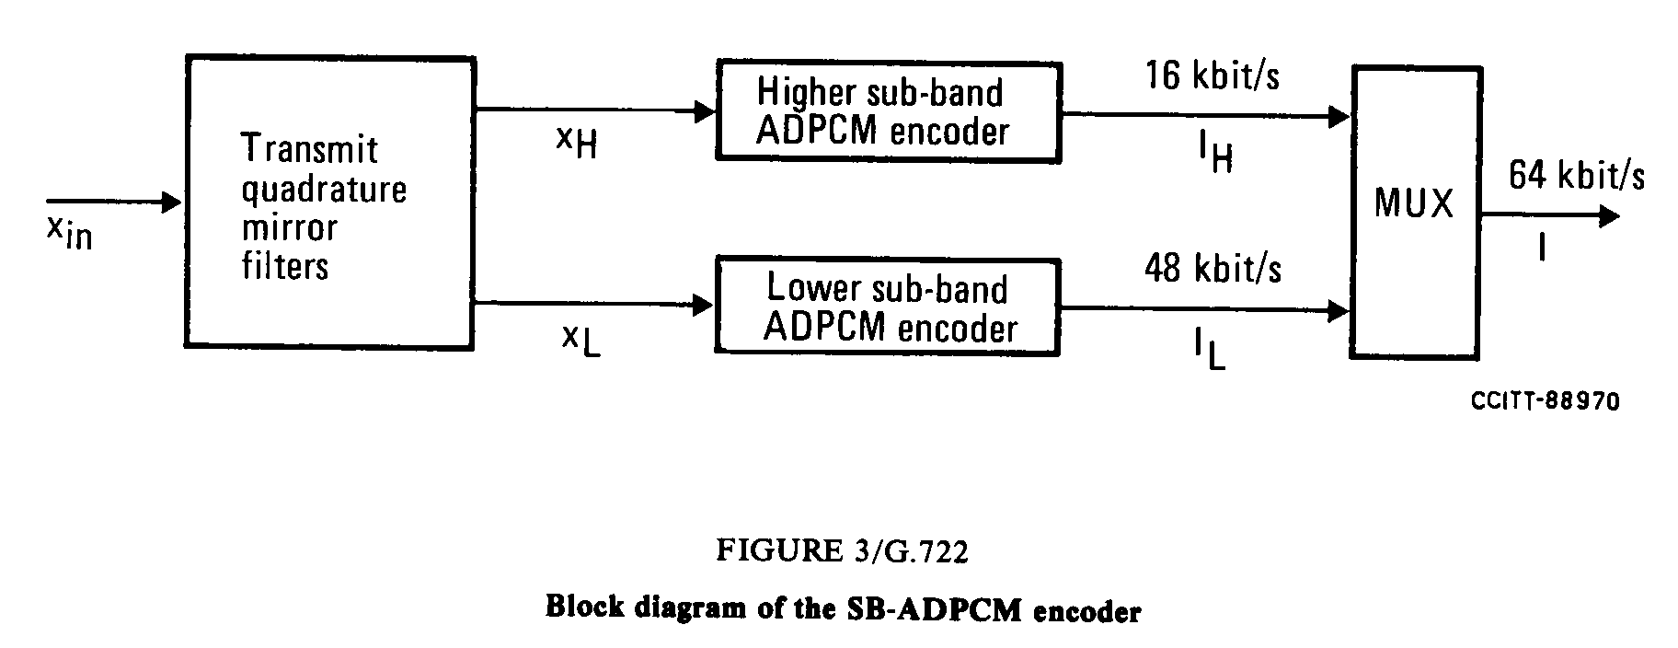

Lower sub-band ADPCM encoder
The lower sub-band input signal, x_{L} after subtraction of an estimate, s_{L} , of the input signal produces the difference signal, e_{L}. An adaptive 60-level non linear quantizer is used to assign six binary digits to the value of the difference signal to produce a 48 kbit/s signal, I_{L}. In the feedback loop, the two least significant bits of I_{L} are deleted to produce a 4-bit signal I_{Lt}, which is used for the quantizer adaptation and applied to a 15-level inverse adaptive quantizer to produce a quantized difference signal, d_{Lt}. The signal estimate, s_{L} is added to this quantized difference signal to produce a reconstructed version, r_{Lt}, of the lower sub-band input signal. Both the reconstructed signal and the quantized difference signal are operated upon by an adaptive predictor which produce the estimate, s_{L}, of the input signal, thereby completing the feedback loop.
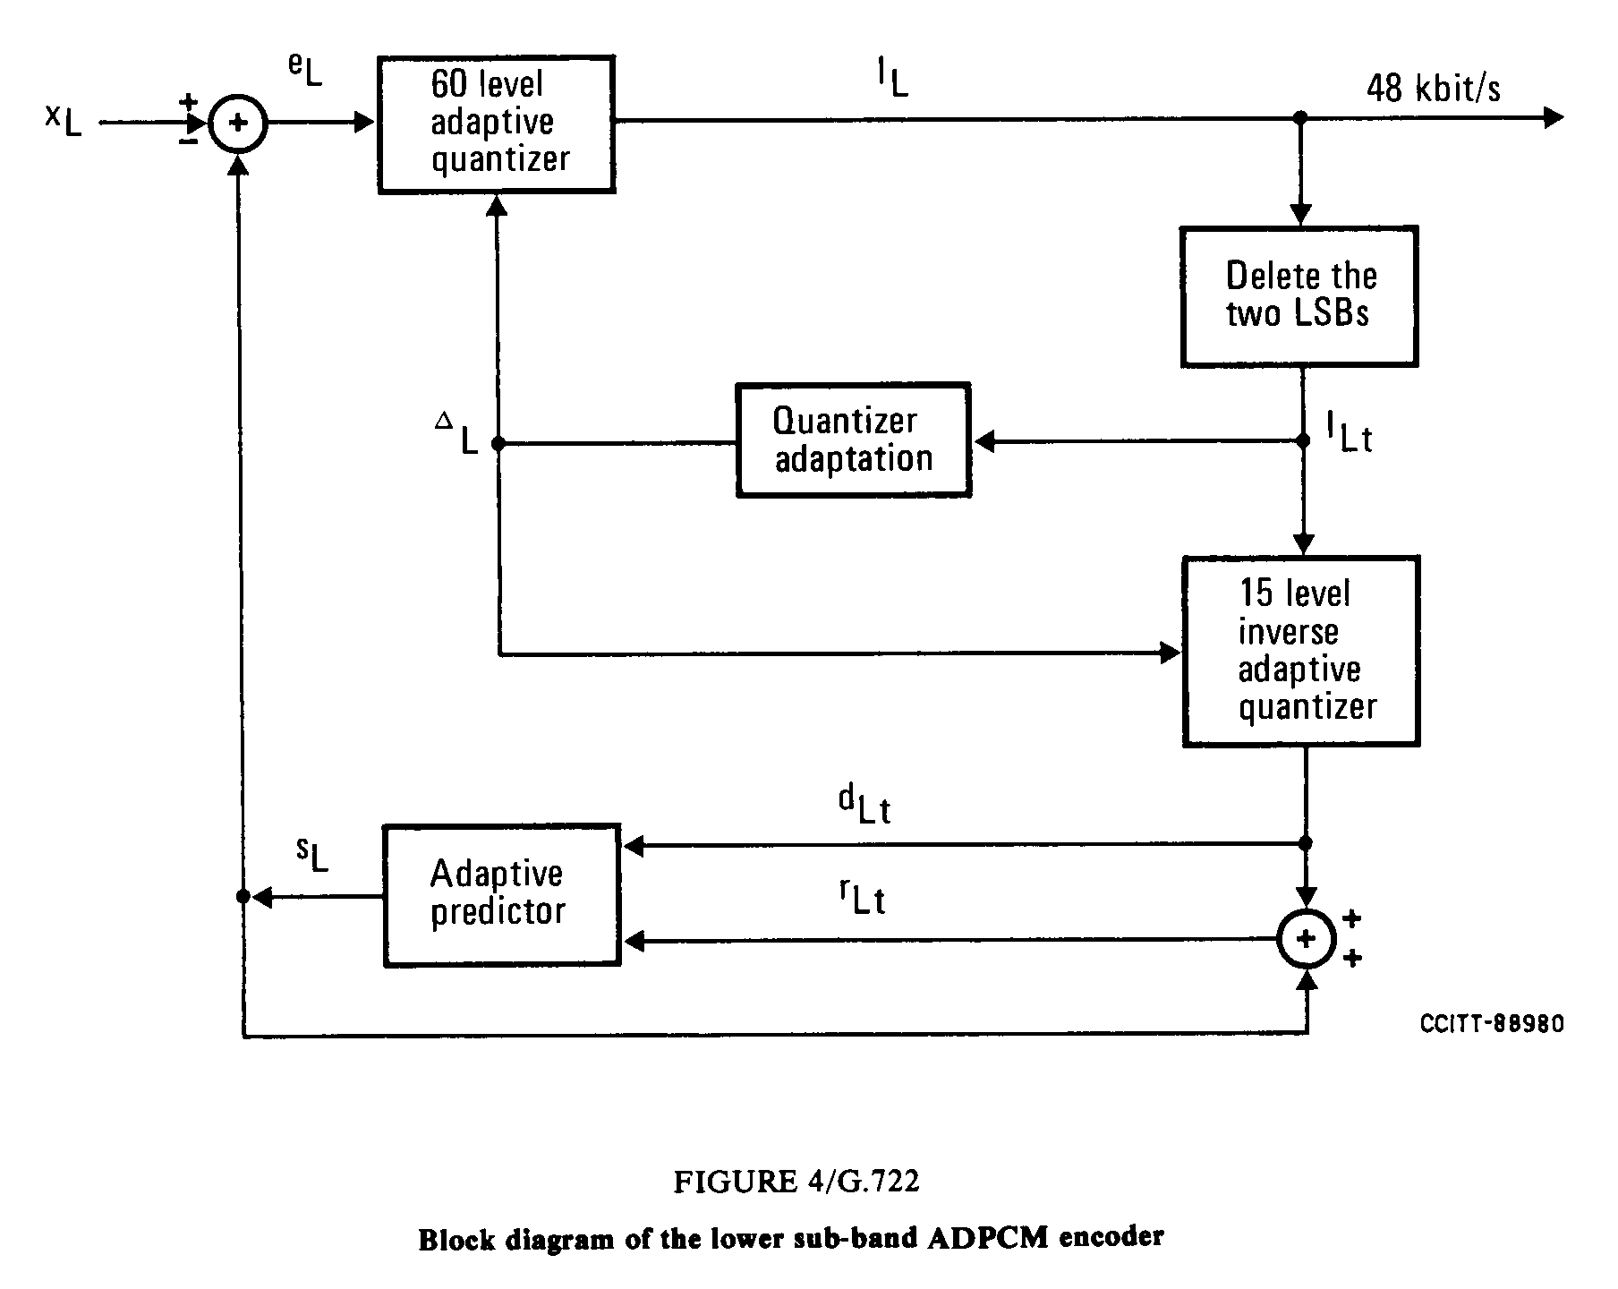
Figure 7-15 Block diagram of the lower sub-band ADPCM encoder

Higher sub-band ADPCM encoder
Same encoding scheme is used for higher sub-band with 4 level non linear quantizer, 4 level inverse adaptive quantizer and no deleted bits.

Overview of G.722 SB-ADPCM decoder
G.722 decoder can operate in any of three possible variants depending on the received indication of the mode of operation as shown in following block diagram:
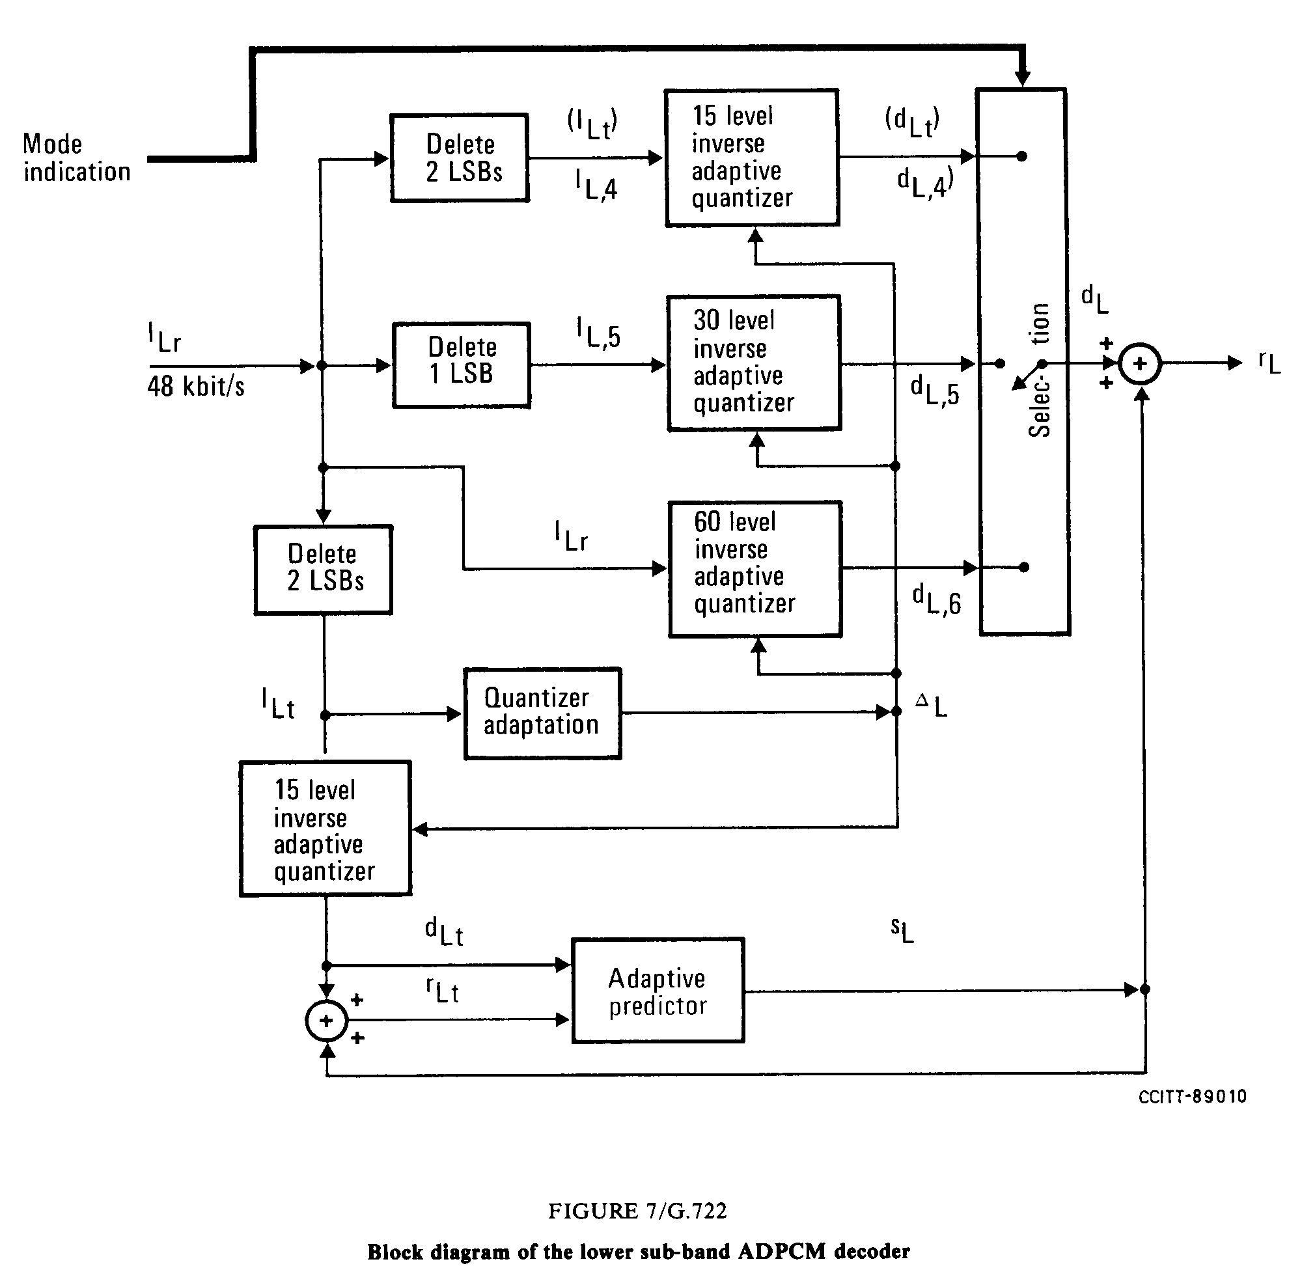
Figure 7-16: Block diagram of the lower sub-band ADPCM decoder
The path which produces the estimate, s_{L}, of the input signal including the quantizer adaptation, is identical to the feedback portion of the lower sub-band ADPCM encoder. The reconstructed signal, r_{L}, is produced by adding to the signal estimate one of three possible quantized difference signals, d_{L,6}, d_{L,5} or d_{L,4} (= d_{Lt}), selected according to the received indication of the mode of operation.
Upper band decoder has the same structure with a single 4 level inverse adaptive quantizer

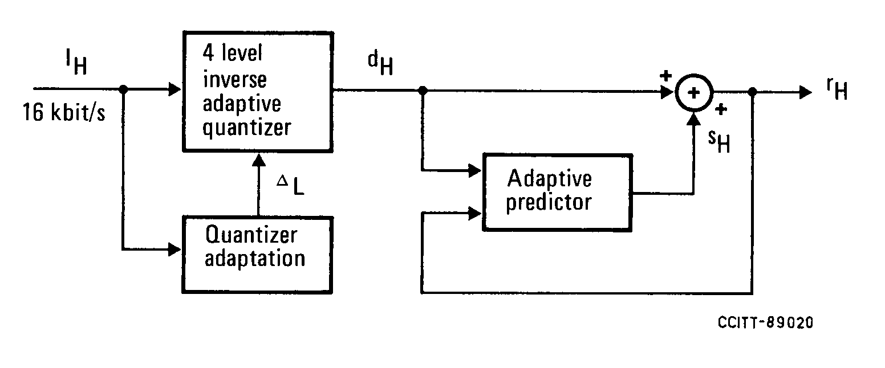
Figure 7-17: Block diagram of the higher sub-band ADPCM decoder
The output decoded signal is then reconstructed by interpolation of the decoded lower band and higher band from 8 kHz to 16 kHz. The combination of the transmit and the receive QMF filters.

ITU-T G.722.2 (3GPP AMR-WB)
The AMR-WB codec has been standardized by both the ITU-T (as Recommendation G.722.2) and 3GPP. It is a multi-rate codec that encodes wideband audio signals sampled at 16 kHz (with a signal bandwidth of 50-7000 Hz). The AMR-WB codec is also used as a part of the AMR-WB+. However, AMR-WB+ does not work as the AMR-WB codec and has a longer algorithmic delay. For supporting lower delay wideband speech applications, standalone AMR-WB is more suitable. The AMR-WB codec consists of nine modes with bit rates of 23.85, 23.05, 19.85, 18.25, 15.85, 14.25, 12.65, 8.85 and 6.6 kbps. AMR-WB also includes a 1.75 kbps background noise mode that is designed for the Discontinuous Transmission (DTX) operation in GSM and can be used as a low bit rate source-dependent back ground noise mode in other systems.
In 3GPP, the AMR-WB codec has been specified in several specifications. TS 26.171 [1] gives a general overview of the AMR-WB standards. The algorithmic detailed description is given in TS 26.190 [2], and the fixed point and floating point source code are given in TS 26.173 [3] and TS 26.204 [4], respectively. Voice Activity detection is given in TS 26.194 [5] and comfort noise aspects are detailed in TS 26.192 [6]. Frame erasure concealment is specified in TS 26.191 [7].
In ITU-T the same specifications are reproduced in Recommendation G.722.2 and its annexes [8].
In 3GPP, AMR-WB is the mandatory codec for several services when wideband speech sampled at 16 kHz is used. These services include circuit switched and packet-switched telephony, 3G-324H multimedia telephony, Multimedia Messaging Service (MMS), Packet-switched Streaming Service (PSS), Multimedia Broadcast/Multicast Service (MBMS), IP multimedia Subsystem (IMS) Messaging and Presence, and Push-to-talk over Cellular (PoC).

Overview of AMR-WB codec
The codec is based on the code-excited linear predictive (CELP) coding model. The codec operates at an internal sampling frequency of 12.8 kHz. The input signal is processed in 20 ms frames (256 samples).
The signal flow at the encoder is shown in Figure 1. After decimation, high-pass and pre-emphasis filtering is performed. LP analysis is performed once per frame. The set of LP parameters is converted to immittance spectrum pairs (ISP) and vector quantized using split-multistage vector quantization (S-MSVQ). The speech frame is divided into 4 subframes of 5 ms each (64 samples). The adaptive and fixed codebook parameters are transmitted every subframe. The quantized and unquantized LP parameters or their interpolated versions are used depending on the subframe. An open-loop pitch lag is estimated in every other subframe or once per frame based on the perceptually weighted speech signal.
Then the following operations are repeated for each subframe:
- The target signal x(n) is computed by filtering the LP residual through the weighted synthesis filter with the initial states of the filters having been updated by filtering the error between LP residual and.
- The impulse response, h(n) of the weighted synthesis filter is computed.
- Closed-loop pitch analysis is then performed (to find the pitch lag and gain), using the target x(n) and impulse response h(n), by searching around the open-loop pitch lag. Fractional pitch with 1/4th or 1/2nd of a sample resolution (depending on the mode and the pitch lag value) is used. The interpolating filter in fractional pitch search has low pass frequency response. Further, there are two potential low-pass characteristics in the adaptive codebook and this information is encoded with 1 bit.
- The target signal x(n) is updated by removing the adaptive codebook contribution (filtered adaptive codevector), and this new target, x₂(n), is used in the fixed algebraic codebook search (to find the optimum innovation).
- The gains of the adaptive and fixed codebook are vector quantified with 6or 7 bits (with moving average (MA) prediction applied to the fixed codebook gain).
- Finally, the filter memories are updated (using the determined excitation signal) for finding the target signal in the next subframe.
The signal flow at the decoder is shown in Figure 2. At the decoder, the transmitted indices are extracted from the received bitstream. The indices are decoded to obtain the coder parameters at each transmission frame. These parameters are the ISP vector, the 4 fractional pitch lags, the 4 LTP filtering parameters, the 4 innovative codevectors, and the 4 sets of vector quantized pitch and innovative gains. In the 23.85 kbit/s mode, also the high-band gain index is decoded. The ISP vector is converted to LP filter coefficients and interpolated to obtain LP filters at each subframe. Then, at each 64-sample subframe:
- The excitation is constructed by adding the adaptive and innovative codevectors scaled by their respective gains.
- The 12.8 kHz speech is reconstructed by filtering the excitation through the LP synthesis filter.
- The reconstructed speech is de-emphasized.
Finally, the reconstructed speech is upsampled to 16 kHz and high-band speech signal is added to the frequency band from 6 kHz to 7 kHz.

Figure 7-18: Detailed block diagram of the ACELP encoder

Figure 7-19: Detailed block diagram of the ACELP decoder

Transport and storage of AMR-WB
The RTP payload for AMR-WB is specified in RFC 3267 [11]. It supports encapsulation of one or multiple AMR-WB transport frames per packet, and provides means for redundancy transmission and frame interleaving to improve robustness against possible packet loss. The payload supports two formats, bandwidth-efficient and octet-aligned. The minimum payload overhead is 9 bits per RTP-packet in bandwidth-efficient mode and 2 bytes per RTP-packet in octet aligned mode. The use of interleaving increases the overhead per packet slightly. The payload also supports CRC and includes parameters required for session setup. 3GPP TS 126 234 (PSS) [12] and TS 126 346 (MBMS) [13] use this payload.
The AMR-WB ISO-based 3GP file format is defined in 3GPP TS 26.244 [14], with the media type “audio/3GPP”. Note that the 3GP structure also supports the storage of other multimedia formats, thereby allowing synchronized playback. In addition, an additional file format is specified in RFC 3267 for transport of AMR-WB speech data in storage mode applications such as email. The AMR-WB MIME type registration specifies the use of both the RTP payload and storage formats.

Video codecs

H.264/AVC Video
The part of the H.264/AVC standard referenced in the present document specifies the coding of video (in 4:2:0 chroma format) that contains either progressive or interlaced frames, which may be mixed together in the same sequence. Generally, a frame of video contains two interleaved fields, the top and the bottom field. The two fields of an interlaced frame, which are separated in time by a field period (half the time of a frame period), may be coded separately as two fields or together as a frame. A progressive frame should always be coded as a single frame; however, it can still be considered to consist of two fields at the same instant of time. H.264/AVC covers a Video Coding Layer (VCL), which is designed to efficiently represent the video content, and a Network Abstraction Layer (NAL), which formats the VCL representation of the video and provides header information in a manner appropriate for conveyance by a variety of transport layers or storage media The structure of H.264/AVC video encoder is shown in Figure 8-20.
Figure 8-20: Structure of H.264/AVC video encoder

Network Abstraction Layer
The Video Coding Layer (VCL), which is described below, is specified to efficiently represent the content of the video data. The Network Abstraction Layer (NAL) is specified to format that data and provide header information in a manner appropriate for conveyance by the transport layers or storage media. All data are contained in NAL units, each of which contains an integer number of bytes. A NAL unit specifies a generic format for use in both packet-oriented and bit stream systems. The format of NAL units for both packet-oriented transport and bit stream is identical except that each NAL unit can be preceded by a start code prefix in a bit stream-oriented transport layer. The NAL facilitates the ability to map H.264/AVC VCL data to transport layers such as:
- RTP/IP for any kind of real-time wire-line and wireless Internet services (conversational and streaming);
- File formats, e.g. ISO “MP4” for storage and MMS;
- H.32X for wireline and wireless conversational services;
- MPEG-2 systems for broadcasting services, etc.
The full degree of customization of the video content to fit the needs of each particular application was outside the scope of the H.264/AVC standardization effort, but the design of the NAL anticipates a variety of such mappings.
One key concept of the NAL is parameter sets. A parameter set is supposed to contain information that is expected to rarely change over time. There are two types of parameter sets:
- sequence parameter sets, which apply to a series of consecutive coded video pictures; and
- picture parameter sets, which apply to the decoding of one or more individual pictures.
The sequence and picture parameter set mechanism decouples the transmission of infrequently changing information from the transmission of coded representations of the values of the samples in the video pictures. Each VCL NAL unit contains an identifier that refers to the content of the relevant picture parameter set, and each picture parameter set contains an identifier that refers to the content of the relevant sequence parameter set. In this manner, a small amount of data (the identifier) can be used to refer to a larger amount of information (the parameter set) without repeating that information within each VCL NAL unit.

Video Coding Layer
The video coding layer of H.264/AVC is similar in spirit to other standards such as MPEG-2 Video. It consists of a hybrid of temporal and spatial prediction in conjunction with transform coding. Figure 11.2 shows a block diagram of the video coding layer for a macroblock, which consists of a 16x16 luma block and two 8x8 chroma blocks.
Figure 8-21: Basic coding structure for H.264/AVC for a macroblock
In summary, the picture is split into macroblocks. The first picture of a sequence or a random access point is typically coded in Intra, i.e., without using other information than the information contained in the picture itself. Each sample of a luma or chroma block of a macroblock in such an Intra frame is predicted using spatially neighbouring samples of previously coded blocks. The encoding process is required to choose which and how neighbouring samples are used for Intra prediction which is simultaneously conducted at encoder and decoder using the transmitted Intra prediction side information.
For all remaining pictures of a sequence or between random access points, typically Inter coding is utilized. Inter coding employs prediction (motion compensation) from other previously decoded pictures. The encoding process for Inter prediction (motion estimation) consists of choosing motion data comprising the reference picture and a spatial displacement that is applied to all samples of the macroblock. The motion data which are transmitted as side information are used by encoder and decoder to simultaneously provide the inter prediction signal.
The residual of the prediction (either Intra or Inter) which is the difference between the original and the predicted macroblock is transformed. The transform coefficients are scaled and quantized. The quantized transform coefficients are entropy coded and transmitted together with the side information for either Intra-frame or Inter-frame prediction.
The encoder contains the decoder to conduct prediction for the next blocks or next picture. Therefore, the quantized transform coefficients are inverse scaled and inverse transformed in the same way as at the decoder side resulting in the decoded prediction residual. The decoded prediction residual is added to the prediction. The result of that addition is fed into a deblocking filter which provides the decoded video as its output.
The new features of H.264/AVC compared to MPEG-2 Video are listed as follows: variable block-size motion compensation with small block sizes from 16x16 luma samples down to 4x4 luma samples per block, quarter-sample-accurate motion compensation, motion vectors pointing over picture boundaries, multiple reference picture motion compensation, decoupling of referencing order from display order, decoupling of picture representation methods from picture referencing capability, weighted prediction, improved "skipped" and "direct" motion inference, directional spatial prediction for intra coding, in-the-loop deblocking filtering, 4x4 block-size transform, hierarchical block transform, short word-length/exact-match inverse transform, context-adaptive binary arithmetic entropy coding, flexible slice size, FMO, ASO, redundant pictures, data partitioning, SP/SI synchronization/switching pictures.

MPEG-2 Video
ISO/IEC 11172-2 extends the specifications of MPEG-1 Video for more generic classes of video sources and applications. It supports interlaced video and more rigid display timing constraints. Encoded data rates can be up to about 40 Mbit/s for storage and transmission, or even higher for professional applications in video production. Larger frame sizes of up to HD resolution are supported.

Technical Solution
MPEG-2 is forward compatible with MPEG-1 (which means that MPEG-1 streams observing typical constraints e.g. in frame sizes and data rates can be decoded by MPEG-2 decoders). In terms of video encoding tools, specific provisions are made for interlaced video. Further, MPEG-2 defines tools for scalable video coding, e.g. to embed streams which can be used to either decode with CIF+SD, SD+HD resolution. The main technical extensions as compared to MPEG-1 can hence be summarized as follows:
- To support the properties of interlaced video, different methods for field/frame adaptive motion compensation (frame based, field based and dual prime prediction modes), as well as switching between field-/frame-wise DCT are specified. Further, it is possible to switch into a 16x8 prediction mode, where separate motion vectors can be defined for the top and bottom halves of a macroblock.
- The variable-length coding (VLC) tables were extended for better compression performance in higher data rates and resolutions.
- Methods of scalable coding are defined, which provide SNR scalability and spatial scalability over a limited number of layers each. In this context, the bitstream is sub-divided into two or three parts, which means that by retaining or receiving only core parts of the stream, it is e.g. possible to reconstruct frames at lower resolution. To encode DCT coefficients related to the different resolution levels, differently optimized variable length codes are provided in the spatial scalable mode.
- Methods to encode sequences with 4:2:2 chrominance sampling are defined by allowing additional 8x8 transform blocks to be subsumed within a macroblock.
- A method of temporal scalability is defined, which allows prediction of additional inserted frames either from a base-layer sequence or from another frame of the enhancement layer sequence. This method can also be used for encoding of stereoscopic sequences with an LRLRLR… interleaving of left and right pictures, as e.g. required for shutter-glass display.
- All scalability modes can also be used to achieve a forward and backward compatible combination of MPEG-1 and MPEG-2, when MPEG-1 syntax is exclusively used in the base layer.
- Methods of data partitioning for DCT coefficients are defined, which can improve the error resilience of video streams.
The number of application domains and necessary combinations of elementary tools is manifold for the case of MPEG-2. As it appears not to be useful for any MPEG-2 device to support all elements of the standard, MPEG-2 defines different profiles. Further, within each profile, levels are specified, which describe maximum sizes or image formats which must be decodable. Each bitstream carries information indicating which profile capability is required at the decoder, as well as the level of required support in the profile, to identify the requirements of decoder capability for the bitstream. From this information, any conforming MPEG-2 decoder can decide immediately whether it will be able to process the bitstream. Within certain application domains, specific 'profile @ level' configurations have been established as mandatory, e.g. 'Main Profile @ Main Level' is typically required for digital TV broadcast or DVD storage applications. Four levels are defined: 'Low', 'Main' (SD), 'High-1440' and 'High' (HD), where however not each level is combinable with each profile. The profiles defined by MPEG-2 video are as follows:
- Simple profile: This is for low cost and low delay applications, allowing frame sizes up to SD resolution (ITU-R Rec. BT.601) and frame rates up to 30 Hz. Usage of B frames is not allowed.
- Main profile: This is the most widely used MPEG-2 profile, defined for SD and HD resolution applications in storage and transmission, without providing compatible decoding of different resolutions. All interlaced-specific prediction modes as well as B frames are supported.
- SNR scalable profile: Similar to Main profile, but allows in addition SNR scalability invoking drift at the base layer; resolutions up to SD are supported.
- Spatial scalable profile: Allows usage of (drift free) spatial scalability, also in combination with SNR scalability.
- High profile: Similar to Spatial Scalable profile, but supporting a wider range of levels, and allowing 4:2:2 chrominance sampling additionally. This profile was primarily defined for upward/downward compatible coding between SD and HD resolutions, allowing embedded bitstreams for up to 3 layers with a maximum of two different spatial resolutions.
- 4:2:2 profile: This profile extends the Main profile by allowing encoding of 4:2:2 chrominance sampling, and allows larger picture sizes and higher data rates.
- Multiview profile: This allows encoding of stereoscopic sequences provided in a left-right interleaved multiplex, using the tool of temporal scalability for exploitation of left-right redundancies. The displacement between left and right pictures is estimated and used for disparity compensated prediction, which follows the same principles as motion-compensated prediction. In addition, camera parameters can be conveyed in the stream.

The text of the MPEG-2 Video standard is common with ITU-T Rec. H.262. Subsequent to the second edition of the standard text which was published in 2000, the following corrigenda and amendments are integral part of the MPEG-2 Video specification:
- ITU-T Rec.H.262(2000)/Cor.1 (2002)|ISO/IEC 13818-2:2000/Cor.1:2002
- ITU-T Rec. H.262(2000)/Amd.1(2000)|ISO/IEC 13818-2:2000/Amd.1:2001
- ITU-T Rec.H.262(2000)/Cor.2 (200X)|ISO/IEC 13818-2:2000/Cor.2:200X (in preparation)

VC-1 video
The VC-1 bit stream is defined as a hierarchy of layers. This is conceptually similar to the notion of a protocol stack of networking protocols. The outermost layer is called the sequence layer. The other layers are entry-point, picture, slice, macroblock and block. In the Simple and Main profiles, a sequence in the sequence layer consists of a series of one or more coded pictures. In the Advanced profile, a sequence consists of one or more entry-point segments, where each entry-point segment consists of a series of one or more pictures, and where the first picture in each entry-point segment provides random access.
In the VC-1 Advanced Profile, the sequence layer header contains the parameters required to initialize the VC-1 decoder. These parameters apply to all entry-point segments until the next occurrence of a sequence layer header in the coded bit stream. For Simple and Main Profiles, the decoder initialization parameters are conveyed as Decoder Initialization Metadata structures (see annex J of [SMPTE 421M]) carried in the SDP datagrams signalling the VC-1-based session, rather than via a sequence layer header and an entry-point segment header. Therefore, all IP IRDs supporting VC-1 must be capable of extracting this data from the SDP datagrams.

Explanation of VC-1 Profiles and Levels
As with MPEG-2 and H.264/AVC, Profiles and Levels are used to specify conformance points for VC-1. A profile defines a sub-set of the VC-1 standard which include a specific set of coding tools and syntax. A level is a defined set of constraints on the values which can be taken by key parameters (such as bit rate or video resolution) within a particular profile. A decoder claiming conformance to a specific profile must support all features in that profile. Encoders are not required to make use of any particular set of features supported in a profile but have to provide conforming bit streams, i.e. bit streams that can be decoded by conforming decoders.
Three profiles have been specified: Simple, Main and Advanced. For each profile a number of levels have been defined: two levels with Simple Profile, three levels with Main Profile and five levels with Advanced Profile. Note that VC-1 levels have been defined to be specific to particular profiles; this is in contrast with MPEG-2 and H.264/AVC where levels are largely independent of profiles.

Table 8-7 summarizes the coding tools that are included in each profile.

Table 8-7: coding tools in each profile

Feature | Simple Profile | Main Profile | Advanced Profile
Baseline intra frame compression |  |  | 
Variable-sized transform |  |  | 
16-bit transform |  |  | 
Overlapped transform |  |  | 
4 motion vector per macroblock |  |  | 
¼ pixel luminance motion compensation |  |  | 
¼ pixel chrominance motion compensation |  |  | 
Start codes |  |  | 
Extended motion vectors |  |  | 
Loop filter |  |  | 
Dynamic resolution change |  |  | 
Adaptive macroblock quantization |  |  | 
B frames |  |  | 
Intensity compensation |  |  | 
Range adjustment |  |  | 
Field and frame coding modes |  |  | 
GOP Layer |  |  | 
Display metadata |  |  | 

The Advanced Profile bit stream includes a number of fields which provide information useful to the post-decode display process. This information, collectively known as "display metadata" is output by the decoding process. Its use in the display process is optional, but recommended.

AVS Video
AVS video (Part 2) [GB/T20090.2] is a hybrid coding based on spatial and temporal prediction, integer transform and entropy coding. It has one profile, Jizhun profile. In this profile, there are 4 levels, which are level 4.0 and 4.2 for Standard Definition (SD) video with 4:2:0 and 4:2:2, level 6.0 and 6.2 for HD video with 4:2:0 and 4:2:2, respectively. The basic unit for encoding/decoding in this standard is a Macro-block, which consists of one 16x16 luma block and two 8x8 chroma blocks (for 4:2:0 format). The AVS-P2 bit stream is also defined as a hierarchy of layers. Generally a sequence consists of several GOP (group of pictures, leading by an I picture), which could be a random access point. The other layers between a GOP and a Macro-block are picture and slice. AVS-P2 has many coding tools, which are deblocking, interlace coding, forward, backward and symmetrical prediction using up to two reference pictures, or four reference fields, variable block size motion compensation down to 8x8 block size, intra prediction with 5 directions, 2D-CAVLC entropy coding, 8x8 integer transformation, as well as weighted prediction etc…

AVS-P8.2 describes an RTP Payload format for the AVS video codec specified by AVS-P2(abbreviation for AVS video (part 2)). In essence, this packetization scheme is based on the one for H.264 in order to reuse its well-defined features and to enable a unified transport platform for AVS-P2. To encapsulate an AVS-P2 syntax unit with the NALU structure, the corresponding start code prefix will be replaced by a NALU header whose fields are valued according to the start code followed. Thus, an AVS-P2 bitstream is formatted as a series of NALUs and could be further packetized or stored by using the methods proposed for H.264. AVS streams can be transported over TS by using a similar system as that of ISO/IEC 13818-1[22]. The differences between the two systems are mainly for specifying the AVS video/audio streams.

AVS encoding tools
The system architecture is illustrated in Figure 8-3.
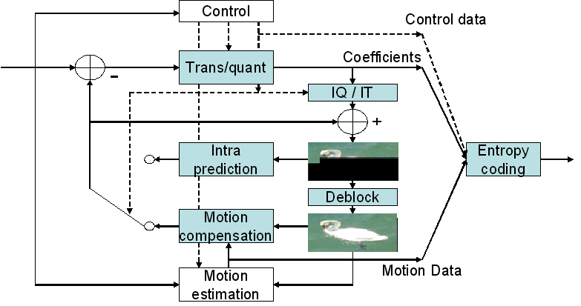
Figure 8-22: AVS video coding structure
Compared with the MPEG-2, AVS video introduces the following new features:
8x8 integer transform; 8x8 intra/inter prediction; Symmetric-prediction and direct-prediction in bi-predictive pictures; In-loop deblocking filtering; Quarter-sample-accurate interpolation and compensation; 2D-CAVLC; Up to 2 reference pictures for both P and B frames;

____________
Annex

Technical Aspects of Toolbox Codecs and Content Coding

- Video

  - Formats and Resolution
Input formats and resolutions which a terminal device may need to cope with are listed in Table 1:

Table 1: Input Formats and Resolutions
Vertical Size | Horizontal Size | Aspect Ratio | Interlaced/Progressive | Frame Rate (Hz) | Note
1080 | 1920 | 16:9 | P | 50, 59.94, 60 | 1
1080 | 1920 | 16:9 | I | 24, 25, 30 | 1
1080 | 1440 | 16:9 | I | 25, 30
720 | 1280 | 16:9 | P | 25, 50, 60 | 2
576 | 720 | 16:9 | P | 25, 50 | 3
576 | 720 | 4:3 | P | 25, 50 | 3
480 | 720 | 16:9 | P | 60 | 4
480 | 720 | 4:3 | P | 60 | 4
480 | 720 | 4:3 | I | 30 | 4
240 | 320 | 4:3 | P | 30 | 5

Note 1: [ITU-R BT.709], Under a certain condition, translating high resolution video such as 1920x1080 to lower resolution format, such as 720x483, can optionally be restricted or prohibited.
Note 2: [ITU-R BT.1543]
Note 3: [ITU-R BT.1358]
Note 4: [ITU-R BT.601] <editor’s note: in old bullet list, “720x480” was listed as “720x483”>
Note 5: Video signal with resolution of 240/320 is for common for wireless devices. <Editor’s Note: Video format for mobile device is for further study.>
<WG5 Editor’s Note: Whether 1920x1080 and 1280x720 are optional or mandatory is TBD>

Terminal devices that support high definition outputs may need to be capable of displaying video and graphics output at the resolutions listed in Table 2 on Component and HDMI outputs.

Table 2: Output Formats and Resolutions

Vertical Size | Horizontal Size | Aspect Ratio | Interlaced/Progressive | Frame Rate (Hz)
1080 | 1920 | 16:9 | I | 25, 30
1080 | 1440 | 16:9 | I | 25, 30
720 | 1280 | 16:9 | P | 25, 60
576 | 720 | 16:9 | P | 25, 50
576 | 720 | 4:3 | P | 25, 50
480 | 720 | 16:9 | P | 60
480 | 720 | 4:3 | P | 60
480 | 720 | 4:3 | I | 30
240 | 320 | 4:3 | P | 30

In addition to the formats covered here, [SCTE43] and [ETSI TR 101 154 v1.7.1] provide comprehensive lists of video formats.

The following Table 3 shows picture formats proposed for AVS

Table 3: AVS Formats and Resolutions

Maximum resolution supported by the level | Display  aspect ratio | P/I | asp_  ratio  _idc | Frame rate (Hz) | Level
1920x1152 | 4:3  16:9  2.21:1 | P | 2  3  4 | 23.976, 24, 25, 29.97, 30, 50, 59.94, 60 | 6.0, 6.1, 6.2
1920x1152 | 4:3  16:9  2.21:1 | I | 2  3  4 | 23.976, 24, 25, 29.97, 30, 50, 59.94, 60 | 6.0, 6.1, 6.2
720x576 | 4:3  16:9  2.21:1 | P | 2  3  4 | 23.976, 24, 25, 29.97, 30, | 4.0, 4.2
720x576 | 4:3  16:9  2.21:1 | I | 2  3  4 | 23.976, 24, 25, 29.97, 30, | 4.0, 4.2
352x288 | 4:3  16:9  2.21:1 | P | 2  3  4 | 23.976, 24, 25, 29.97, 30, | 2.0, 2.1
352x288 | 4:3  16:9  2.21:1 | I | 2  3  4 | 23.976, 24, 25, 29.97, 30, | 2.0, 2.1

The following tables present the encoding formats in SCTE, DVB and Japan IPTV Forum.
Editor’s note: these tables have to be in word format
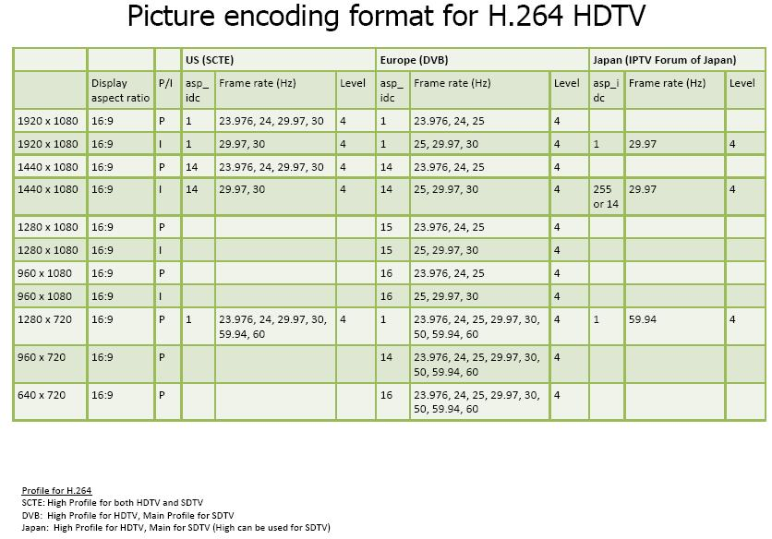
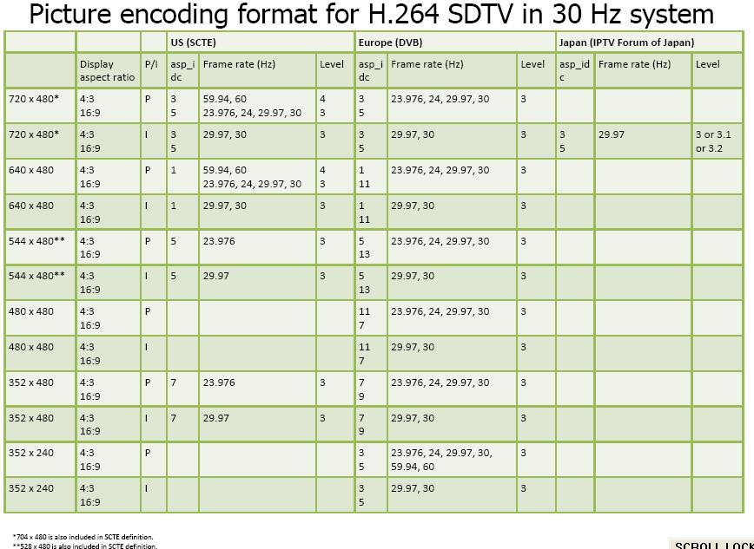
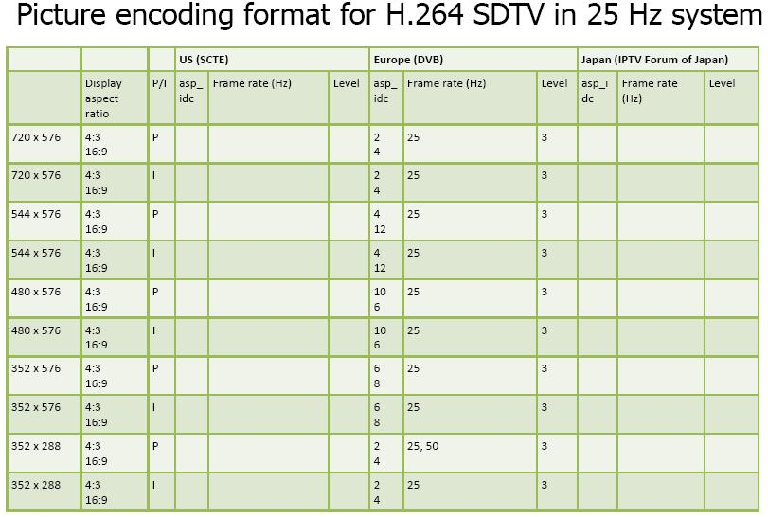
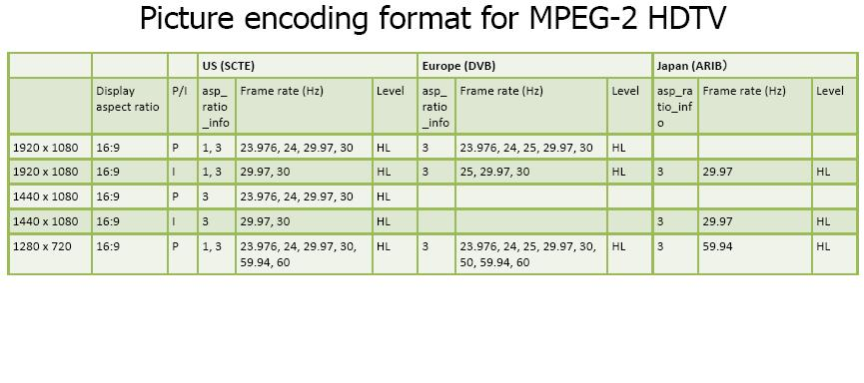
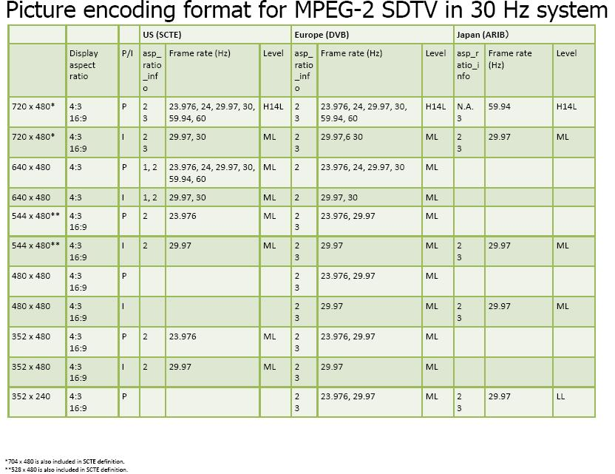

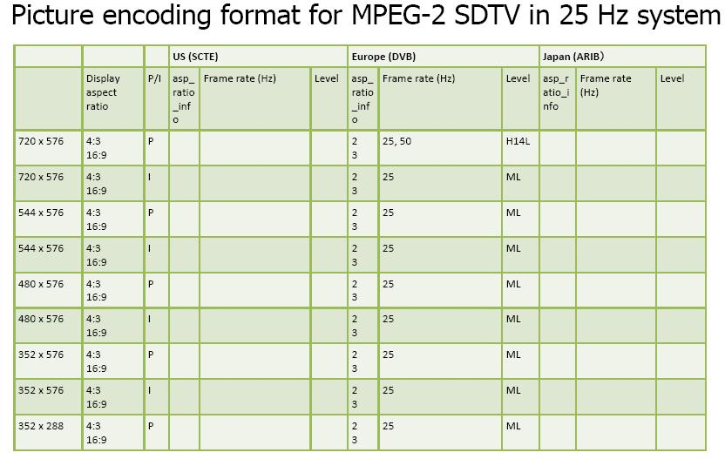
  - Implementation Aspects

To be added

- Audio

WG6 Editors note: The following list requires revision and is added for follow up purposes only.
At least one of the following audio codecs is required to be supported by IPTV Terminal Device.
- AC3 [Digital Audio Compression (AC-3) ATSC A/52MPEG-2 AAC [ISO/IEC13818-7]
- MPEG-4 AAC [ISO/IEC14496-3]
- MPEG-2 Audio BC [ISO/IEC 13818-3]
- High Efficiency-AAC (aacPlus) 2-channel program
- DTS Surround according to ETSI TS 102 114 v1.2.1.
- MPEG-1 layer 3 (MP3)
- Dolby Digital Plus (enhanced AC-3) with matrix audio (ProLogic)
- LPCM encapsulated in IP over Home Network Interface
- Non-linear PCM encapsulated in IP over Home Network Interface (for TD models that support home networking interfaces)
- Windows Media Audio (WMA)
<WG5 Editor’s Note: Codec supported by IPTV Terminal Device may be modified according to the result of WG6.>
[[WG 5 Editor’s Note: The above audio codec may become mandatory or optional according to future discussion. Contributions are expected]]

_________________-

