INTERNATIONAL TELECOMMUNICATION UNION |  |  |  | Focus Group On IPTV
TELECOMMUNICATION  STANDARDIZATION SECTOR  STUDY PERIOD 2005-2008 |  |  | FG IPTV-DOC-0098
 |  |  | English only
WG(s): 6 |  | 4th FG IPTV meeting:  Bled, Slovenia, 7-11 May 2007
OUTPUT DOCUMENT
Source: | Editors
Title: | Working Document: Service Navigation System
For the time being, this document is limited to the Web-based service navigation.
Contributions are welcome to extend this scope of this document to other solutions.

CONTENTS
1. Scope 3
2. References 3
3. Definitions 3
4. Abbreviations and acronyms 4
5. Service navigation system generic architecture and functional entity 4
5.1 Service navigation system generic architecture 4
5.2 Service navigation system generic functional entity 6
5.2.1 Service/application management Functional Entity (navigation backstage) general functional requirements: 6
5.2.2 Navigation Functional Entity (navigation front stage) general functional requirements: 7
6. Realization reference model 8
6.1 Browser-based service navigation system 8
6.2 Application/middleware-based service navigation system 9

1. Scope
This working document presents generic service navigation system architecture and its functional entity. A browser-based service navigation system is recommended and its architecture is presented.

2. References
The following ITU-T Recommendations and other references contain provisions, which, through reference in this text, constitute provisions of this working document. At the time of publication, the editions indicated were valid. All Recommendations and other references are subject to revision; users of this working document are therefore encouraged to investigate the possibility of applying the most recent edition of the Recommendations and other references listed below. A list of the currently valid ITU-T Recommendations is regularly published.
The reference to a document within this working document does not give it, as a stand-alone document, the status of a Recommendation
[xxx] TBD

3. Definitions
3.1 This working document uses the following terms defined elsewhere:
3.1.1 Application manager [J.200]: The entity that is responsible for managing the lifecycle of the applications. It manages applications running in both the Presentation engine and Execution engine if both are present.
3.1.2 Application Program Interface (API) [J.200]: Consists of software libraries that provide uniform access to system services.
3.1.3 Content [J.200]: A general term that refers to any of the following: application, application resource collection, or application resource.
3.1.4 Electronic Program Guide (EPG) [J.200]: A Program table that is presented electronically.
3.1.5 EPG provider [J.90]: The entity that collects collates and assembles the elements of information that constitute the EPG database.
3.1.6 Functional Entity [Y.2012]: An entity that comprises an indivisible set of specific functions. Functional entities are logical concepts, while groupings of functional entities are used to describe practical, physical implementations.
3.1.7 Metadata [J.98]: Metadata is descriptive data associated with a content asset package or file. It may vary in depth from merely identifying the content package title or information to populate an EPG to providing a complete index of different scenes in a movie or providing business rules detailing how the content package may be displayed, copied, or sold. Separate uses for metadata have originated from the studios, distribution networks (Cable, Satellite), down to the CPE (STBs, PVRs).
3.1.8 Service [Y.101]: A structure set of capabilities intended to support applications.
3.2 This working document defines the following terms:
3.2.1 Electronic Service Guide (ESG): Description for available services. Through the information in the ESG, the user can select the services and items he/she is interested in and find stored items on the terminal. (ETSI, DVB-CBMS)
    - Interactive Program Guide (IPG): The IPG is a service facilitated by the middleware, which provides the consumer detailed information about the content available to them. (AITS, ATIS-0800002). Ability of the ITF(Terminal Function) to display and allow user selection of program, content, and service descriptions (AITS, ATIS-0800002)
    - Lifetime/Lifecycle of an application: Characterizes the time from which the application is loaded to the time the application is destroyed. (CableLabs, OC-SP-OCAP1.0-I16-050803, Section 3.2.1)
    - Navigation: The process of selection and movement among analogue and digital services offered on the cable network. The service information tables defined in this protocol assist in the navigation process by providing physical service locations, channel names and numbers for user reference. Those tables supporting electronic program guides also assist the navigation process. (ITU-T, J.94 Amd. 1 (00), B.3.2.3)
    - Presentation: The operation of rendering the content of a document in a form perceptible to a human being. (ITU-T, T.411 (93), 3.158)

4. Abbreviations and acronyms
This working document uses the following abbreviations and acronyms.
TBD

5. Service navigation system generic architecture and functional entity
Editor’s note:
Work is needed to make it really generic

5.1 Service navigation system generic architecture

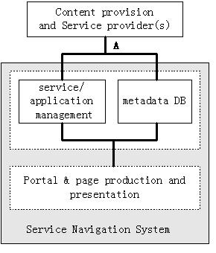
Figure 5.1: Service Navigation System generic Architecture
Interface A: An interface between CP(s)/SP(s) and service navigation system, through which service information, service metadata, content metadata etc. are sent to the service navigation system.

[Comments begin]
The “content provision and service provider(s)” have fulfilled the discovery of SP(s) and their services. In fact, in the view of operators, service discovery and selection are replaced by “content management system” and “service management system” (please see Figure 2 from IPTV-ID-0089). Here, I don’t use the two phrases because the IPTV architecture hasn’t detailed determinated. The content provision aggregate contents and extract content metadata (such as program id, program name, content_id etc.) to the metadata DB. The service provider(s) pack the contents with price, service_ID, service name etc. to provide all sorts of services or products to consumer(s). This information is transferred to service navigation system.

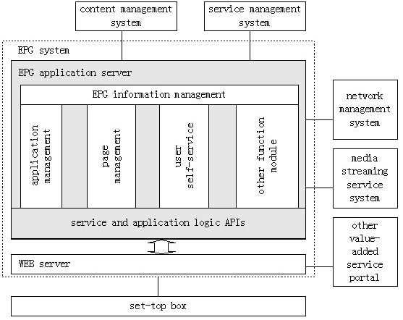
Figure 5.2: Title??
[Comments end]

5.2 Service navigation system generic functional entity
The service navigation system includes generally two parts. The first part is service/application management Functional Entity; it receives service and content metadata and account/bill data and service-order relationship information and manages them. At same time, it responds the request of the user’s VOD and live TV, time-shift TV as well as other services and application.
Mainly, service/application management Functional Entity fulfil logical processing of users’ requests. More details to see the realization method. The second part is navigation Functional Entity (Portal & page production and presentation), ant it is the man-machine interface of user interacting with the IPTV platform. Service navigation system’s generic functional requirements as following:
[Comments begin]
It is difficult to provide general functional requirements, because there are many requirements. I think the following are some basic functional requirements. They are listed simply for illustrating the service navigation system architecture and its functional entity.
[Comments end]

5.2.1 Service/application management Functional Entity (navigation backstage) general functional requirements:
(1) Service/application managements
(2) Metadata DB management
(3) Respond user’s request and accomplish service/application logical processing
(4) Live TV channel management
(5) ……

5.2.2 Navigation Functional Entity (navigation front stage) general functional requirements:
(1) Based on browser or middleware/application method
- Based on XML mechanism
- A sole(unified) entry Portal
- Permission to integrate Internet Portal and other value-added portal
- Pages presentation(including services and channel list)
- Value-added services list
- …….

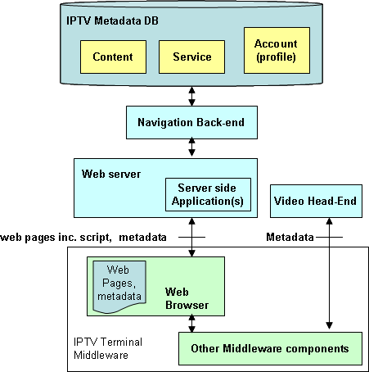
Figure 5.3: Metadata flows in Service Navigation Systems

Browser is IPTV client module that loads and renders web pages encoded in a mark-up language mostly based on HTML/XML, and a scripting language.
Navigation front-end serves navigation information (e.g. metadata) and client side scripts on requests from client side application in IPTV client.
Metadata can also be received from a video head-end and cached or processed in middleware.
Client side application is executed locally to control the navigation user interface. Client side application can retrieve metadata directly from the front-end or through middleware from local cache.

6. Realization reference model

6.1 Browser-based service navigation system
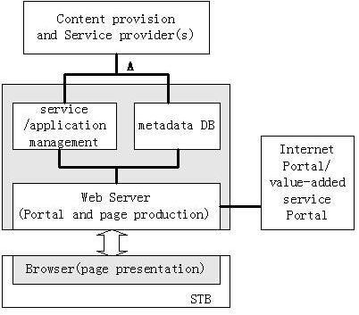
Figure 6-1: Browser-based service navigation system architecture

The service provider(s) obtain users’ service-order relationship information from the BOSS, and send them to the service navigation system. The service-order information includes user’s information and service information. Service information includes content metadata and the account/bill information of ordered content. Sometimes we call a service with price and other attribute a product. Service/application management bind user’s information (such as user’ name, password, service-order information etc.) with service information (such as price, location of content etc.) to form respondent logic when a request come. Service/application management provide some service/application logic APIs for Web server to invoke (please see figure 2).Web server obtains metadata from metadata DB, according to the service-order relationship, to produce individuality personalized pages(HTML/XML language). So, personalized pages based on user’s service-order relationship. For instance, Web server get “description for available services (ESG)” from metadata DB and put them in a customized page. Of course user could get public information and free services as others do. Operators often provide many page templates for users to choose, and these templates correspond to the order relationship.In fact, Web server could fulfill a great deal of functions as that web servers all over the world do at present. The introduction of intermediate layer (Web Server) will improve greatly the capability of service navigation system, accelerate the browsing, satisfy the requirements of distributing, extendibility and operation. Through the transition and processing of the intermediate layer (Web Server), service/application management mechanism are shielded, simultaneously, many colorful, individuality personalized pages could be produced.
The function of service/application management fulfils IPTV’s service/application management, including DVB application, mainly their logical processing.
The logic processing is independent to STB. The Web Server produces portal and pages and delivers them to STB, and the STB presents them to users by browser. The user’s requests are sent to Web Server, and the Web Server uses the backstage logic to respond user’s request or redirect to other servers. In fact, this is the C/S mode.
The typical realization system refers to FG IPTV-ID-0089(please see the figure 2). For example, users could modify their password, purchase/cancel services, and parents set the IPTV service’s type, the rank and the time to limit what children to watch by the user self-service pages.
As to the "Authentication/authorization proxy" and "The set-top box configuration and monitoring proxy", all these are the implementation requirement, so it is optional; I mean that they could be realized on browser-based.
There are many navigation realization methods such as Browser-based or application/middleware-based. I recommend browser-based for its many advantages, but I don’t oppose application/middleware method. In fact, I spent too much time on application/middleware-based method before.
Here "Internet Portal" is mainly Internet information browsering, and the "value-added service portal" is some applications portal such as downloadable application mentioned in Mr. Yasuaki’s comments.
Many applications, such as IPG, ECG, ESG, BCG and linkage to Internet, could be easier implemented. What’s more, it is consistent with the Internet navigation mechanism, and easier to realize distributed navigation system, to satisfy large scale operation requirements.

6.2 Application/middleware-based service navigation system
TBD.

_________________

