INTERNATIONAL TELECOMMUNICATION UNION |  |  |  | Focus Group On IPTV
TELECOMMUNICATION  STANDARDIZATION SECTOR  STUDY PERIOD 2005-2008 |  |  | FG IPTV-DOC-0045
 |  |  | English only
WG(s): 3 |  | 2nd FG IPTV meeting:  Busan, 16-20 October 2006
OUTPUT DOCUMENT
Source: | Acting Editors
Title: | Living list: IPTV Security Aspects
1 Scope 2
2 References 2
3 Definitions and Terms 2
4 Abbreviations and acronyms 3
5 Security Threats 3
5.1 Content Security Threat 5
5.2 Service Security Threat 9
5.3 Network Security Threat 11
5.4 Terminal Device Security Threat 13
5.5 Subscriber Security Threat 15
6 Security Requirements 16
6.1 Content Security Requirement 17
6.2 Service Security Requirement 22
6.3 Network Security Requirement 24
6.4 Terminal Device Security Requirement 26
6.5 Subscriber Security Requirement 29
7 Security Architecture 29
7.1 Security Trust Model 29
7.2 Security General Framework 29
7.2.1 Content Protection Architecture 30
7.3 Security Function Modules 33
7.4 Security Interfaces 37
8 Security Mechanisms 37
8.1 Content Security Mechanisms 37
8.1.1 Content Protection 40
8.1.2 Conditional Access 40
8.1.3 Digital Rights Management 41
8.2 Service Security Mechanisms 45
8.2.1 Service Authentication 45
8.2.2 Service Authorization 45
8.3 Network Security Mechanisms 46
8.4 Terminal Device Security Mechanisms 46
8.4.1 Terminal Device Authentication 46
8.4.2 Terminal Device Authorization 47
8.4.3 Terminal protection 47
8.5 Subscriber Security Mechanisms 48
8.5.1 Subscriber Authentication 48
8.5.2 Subscriber Authorization 49
8.5.3 Subscriber information Protection 49

Editors Note: The following BEGIN and END identifier is an internal label that designates materials boundary in this document. This label is expected to be used for internal tracking purposes.

***********************From Old output Document**********************************
------------BEGIN:

Scope
TBD.

References
The following ITU-T Recommendations and other references contain provisions, which, through reference in this text, constitute provisions of this Document. At the time of publication, the editions indicated were valid. All Recommendations and other references are subject to revision; all users of this Document are therefore encouraged to investigate the possibility of applying the most recent edition of the Recommendations and other references listed below. A list of the currently valid ITU-T Recommendations is regularly published.
….

Definitions and Terms
This Document defines the following terms:
TBD.

Abbreviations and acronyms
This Document uses the following abbreviations.
TBD.

Security Threats
Editors Note: the following materials should be considered for inclusion in security threat section of OD.

This section describes a set of identified security threats that some requirement or mechanism of this document addresses.
Editors Note: The following SEC_THREAD_0000 identifier is an internal label that designates a particular threat that is discussed by this document. This label is expected to be used for internal tracking purposes.
SEC_THREAT_0000:
The following conceptual threat model provides a classification of the related threats to the IPTV system. This threat model requires significantly more refinement to define the complete list of known risks and mitigations. This model does not include network security threats which exist in all IP networks and assumes that such threats have been mitigated.

Content Theft

Service Theft

Information
Theft
Service Disruption
System Control

Compromise IPTV Solution
Figure 1 - Compromise IPTV Solution Attack Tree
Editors Note: the following materials will not be included in OD, but replaced by material from ID-141.

SEC_THREAT_0001: Protected assets of IPTV
Editors Note: Determine level(s) and target(s) of this threat description.
Editors Note: It is felt that the description and figure below is incomplete, and does not deal with all end-to-end issues.
The service chain of an IPTV service can be divided into four parts: Content Source, Service Integration & Operations, Content Transport and Content Consumption, as illustrated in figure 2 below.
Note:
1) Content Source: The content providers that own or are licensed to sell content to IPTV service providers.
Editors Note: Convert adopted text to acceptable English.
2) Service Integration & Operation: IPTV service platform processes (e.g. marking with a watermark, programming, etc.) various contents gathered from the content source, and then presents these programs through IP network to the subscribers in some certain fashions.
3) Content Transport: Transport network is usually composed of access network metro network and core network, and often with an overlay CDN (Content Distribution Network) to enhance the IPTV service. The IPTV transport network should deliver the packets from service provider to subscribers transparently without modification.
4) Content Consumption: in this part, the packets received from the network are decoded to display on the terminal. Not only the equipment such like STB and television, handset, PC may be used for service consumption, but also a home networking of terminals and related devices can be used here.

Based on figure 2 below, the assets that need to be protected in IPTV service are:
- Content Source: the original media contents owned by content providers, such as TV programs, movies, music etc.
- Service Integration & Operation: IPTV service platform (physical equipments, system and application software), the programs, operation information (such as service log, billing information), and subscribers’ information (login, subscriber's privacy) etc.
- Content Transport: common network equipments (e.g. routers, switches), network bandwidth, packets transport through network, multicast service, CDN (e.g. server, database) etc.
- Content Consumption: terminal equipments (such as STB) or home networking (hardware and software).

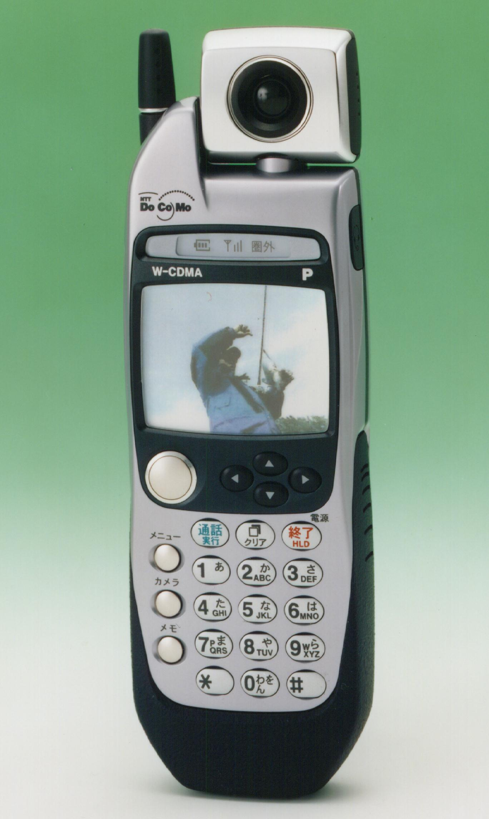
EPG based program
EPG based program
Content Transport
Service Integration & Operation
Living TV
Movie…
Content Providers
TV
Music

Movie
…
IPTV Service Platform
Content Source
Content Consumption
Service Providers
Network Operators
Subscribers
IP based Network
CDN
Figure 2 – IPTV Service chain

Content Security Threat

Editors Note: Describe category of content security threat(s).

Editors Note: Determine level(s) and target(s) of this threat description.

Editors Note: the following materials should be considered under subscriber security threats reference to ID-124, ID-125 and ID-235.

SEC_THREAT_0002: Content Source
Editors Note: The following description of a threat appears to raise a requirement on content itself that is external to commonly understood security requirements. Pass along this to WG1 for resolution then delete from next version of this document.
Here the key problem is how to ensure that the contents are compliant with law/regulatory and business requirements (e.g. observe various copyright laws, prevent the unallowable racist or sexually explicit materials, etc). Current technical and management protection systems can be used as much as possible.
-----------------END

************************from old living list*************************************
------------BEGIN:
Editors Note: the following materials should be considered under terminal security threats reference to ID-149 and ID-235.

SEC_THREAT_000x: Content consumption
- The failure of the terminal equipments (hardware and software) caused by malicious codes/viruses from the network.
- Remote theft of the subscribers’ important information (e.g. login ID and password) by malicious programs, such as Trojan horse.
- Unauthorized duplication, redistribution or any other threats to the copyrights of programs received from networks.

ID_SEC_THREAT_000x: Content Transport
Editors Note: the following materials should be considered under transport security threats.

- Accidental threats which can result in network equipments failure or transport service interruption: a threat without malicious intent, such as a power failure, a technical hitch of the equipment, etc.
- Intentional threats aim at the network equipments or resources (bandwidth): malicious attacks (e.g. denial of service attack, unauthorized access) to the transport network.
- Legitimate consumers abuse the service network resources, and result in huge garbage information which is harmful to the network.
- Security of multicast protocols: there are no security protections (such as authentication to the multicast source, control of multicast group members) in the basic IP multicast protocols, so the multicast security will be one important problem in IPTV transport network.
- Unauthorized data deletion, insertion, modification, re-ordering, replay or delay.
- Unauthorized data (i.e. the data come from the illegal IPTV program sources) transmission.
- Masquerade IPTV service nodes in the carrier network.
- Security threats to CDN.

ID-51:
Editors Note: consider the following 2 and 4 under security requirements section in OD, bullets 1,3 and 5 are excluded at this time.
ID_SEC_THREAT_000x: Security Objectives
- IPTV service should be high stable and high available.
- Only legitimate actors can access and operate on the assets of IPTV services after be authorized.
- The legitimate users’ abuse actions should be controlled to reduce garbage data.
- The IPTV service should be protected against unauthorized deletion, insertion, modification or replay attack.
- The IPTV service programs should be protected by copyrights.

ID-86:
Editors Note: consider the following under security threats section in OD.
- ID_SEC_REQ_00xx:Security requirements against abuse and threats
- There are various rights associated with content. To realize IPTV services that respect these rights, it is necessary to protect against any perceived threats to those rights. Such perceived threats can be broadly divided into three kinds, of three different levels.
  - Unintentional misuse by legitimate users
  - Intentional individual-level abuse by hackers or other illegitimate users
  - Deliberate efforts to influence or crack the overall system by groups with a certain degree of financial resources
To ensure resistance against these perceived threats, a security policy needs to be established for every IPTV system, as well as a system to implement the policy.
Furthermore, since IPTV services can include infrastructural elements that bear closely on the lives of users, it is necessary to give this point due consideration.
-----------------END

**************************From the contributions Busan meeting*********************
----------------BEGIN
Editors Note: the following description about assets from ID-141 and ID-217 can be moved to OD under architecture section or under security threats section.
ID-141:
Assets to be protected in IPTV service:
The service chain of an IPTV service can be divided into four parts: Content Source, Service Integration & Operations, Content Transport and Content Consumption.
- Content Source/Content provider: The entity that own or are licensed to sell content to IPTV service providers. Although the Service Provider is the primary source for the client at Home, a direct logical information flow may be set up between Content Provider and subscriber e.g. for rights management and protection.
- Service Integration & Operations/Service provider: the entity providing a service to the end-user. The Service Provider acquires/licenses content from Content Providers and packages this into a service. In this sense the service provider is not necessarily transparent to the application and content information flow.
- Content Transport/Delivery network: The delivery network usually is composed of access networks and core or backbone networks, using a variety of network technologies. The delivery network is transparent to the IP traffic.
- Content Consumption/Consumer: the domain where the IPTV services are consumed. In this part a single terminal may be used for service consumption, but also a network of terminals and related devices may be present for this purpose.

The assets that need to be protected in IPTV service are:
- Content: broadcast TV content, VOD content, and PVR content.
- IPTV service resource: servers such as media servers, AAA servers, DRM servers, ..., and operation information such as service logs and billing information.
- IPTV bearer network: equipments (e.g. routers, switches), bandwidth, multicast services, and CDN.
- Subscribers’ information: identity information, billing information, and information about subscriber's privacy.

ID-217:
- Content assets, which reside on transit networks controlled by IPTV businesses along the distribution chain, on networks owned by the IPTV consumer and on the IPTV terminal device.
- Network assets, which are networks operated by entities along the distribution chain, and the home network of the residential consumer.
- Service assets, which support network services and IPTV applications.
- Terminal assets, which the residential consumer uses to process and store content works and other information related to the IPTV service.
- Subscriber assets, which consist of information about the subscriber, the subscriber household, and their IPTV transactions that are processed at multiple points along the IPTV delivery chain.

Editors Note: the following materials from ID-141 and ID-217 should be considered under security threats section of OD.

ID-141:
Threats to the digital content may include:
- Interception: a breach of confidentiality of the digit content by illegal monitoring the service networks.
- Loss or corruption of the digital content: Actions to destroy the integrity of the digital content transferred, such as unauthorized deletion, insertion, modification, re-ordering …
- Unauthorized viewing.
- Unauthorized copying.

ID-217:
Table 1: Content Work ART
ASSET | RISK | SEVERITY | THREAT | LIKELIHOOD
Compressed, plaintext content work | Unauthorized copy obtained from network, network device or end system | High if the work is within the release window or deemed highly valuable by the provider; Medium to Low depending on the work. | Cracker | High
Compressed, plaintext content work |  |  | Professional | High
Compressed, plaintext content work |  |  | Insider | High
Compressed, plaintext content work |  |  | Consumer | Medium to Low
Compressed, encrypted content work | Unauthorized access | Low | Cracker | Low unless the key is obtained and High otherwise
Compressed, encrypted content work | Unauthorized access | Low | Professional | Low unless the key is obtained and High otherwise
Compressed, encrypted content work | Unauthorized access | Low | Insider | Low unless the key is obtained and High otherwise
Compressed, encrypted content work | Unauthorized access | Low | Consumer | Low
Any content work | Denial of service attack | High | Cracker | Low
Any content work | Denial of service attack | High | Professional | Low
Any content work | Denial of service attack | High | Insider | Low
Any content work | Denial of service attack | High | Consumer | Low

--------------------END

Service Security Threat

************************from old living list*************************************
------------BEGIN
TBD.
Editors Note: the following materials should be considered under service security threats section of OD.

ID-50:
ID_SEC_THREAT_000x:Service integration & Operation
- Accidental threats which result in service interruption: threats without malicious intent, such as a power failure, a technical hitch of an equipment, etc.
- Intentional threats aiming at service platform: malicious attacks (e.g. denial of service attack, unauthorized access) to the IPTV service platform or viruses infection.
- Impingement copyrights of the programs which IPTV service platform provided to the subscribers.
- Stealing/eavesdropping subscribers’ important information (e.g. login ID or password).
- Attempt to collection, spread or sale the information of subscribers’ privacy without their permission.
-----------------------END

**************************From the contributions Busan meeting*********************
----------------------BEGIN
Editors Note: the following materials should be considered under security threats section of OD.
ID-235:
Such perceived threats can be broadly divided into three kinds, of three different levels.
  - Unintentional misuse by legitimate users
  - Intentional individual-level abuse by hackers or other illegitimate users
  - Deliberate efforts to influence or crack the overall system by groups with a certain degree of financial resources
Editors Note: the following materials should be considered under service security threats section of OD.

ID-141:
Threats to IPTV service:
- Unauthorized service access: A user attempts to access IPTV service in violation of the security policy in force.
- Masquerading / spoofing IPTV service provider.
- Malicious threats aiming at the IPTV servers (AAA servers, media servers, etc…): may include the hacking aiming at security leaks in application software or communication protocol, denial of service attack, etc.
- Theft (often use malicious programs, such as Trojan horse) of the subscribers’ information (e.g. identity information, billing information, subscription information).

Editors Note: the following materials should be considered under service security threats section of OD.
ID-217:
Table 2:
ASSET | RISK | SEVERITY | THREAT | LIKELIHOOD
Domain Name Server | Denial of service attack | Medium | Cracker | High
Domain Name Server | Denial of service attack | Medium | Professional | Medium
Domain Name Server | Denial of service attack | Medium | Insider | Low
Domain Name Server | Denial of service attack | Medium | Consumer | Low
Domain Name Server | Unauthorized access | High | Cracker | High
Domain Name Server | Unauthorized access | High | Professional | Medium
Domain Name Server | Unauthorized access | High | Insider | Low
Domain Name Server | Unauthorized access | High | Consumer | Low
Electronic Program Guide | Denial of service attack | High | Cracker | High
Electronic Program Guide | Denial of service attack | High | Professional | Medium
Electronic Program Guide | Denial of service attack | High | Insider | Low
Electronic Program Guide | Denial of service attack | High | Consumer | Low
Electronic Program Guide | Unauthorized access | High | Cracker | High
Electronic Program Guide | Unauthorized access | High | Professional | Medium
Electronic Program Guide | Unauthorized access | High | Insider | Low
Electronic Program Guide | Unauthorized access | High | Consumer | Low
Media Servers and multiplexers | Denial of service attack | High | Cracker | High
Media Servers and multiplexers | Denial of service attack | High | Professional | Low
Media Servers and multiplexers | Denial of service attack | High | Insider | Low
Media Servers and multiplexers | Denial of service attack | High | Consumer | Low
Media Servers and multiplexers | Unauthorized access | High | Cracker | High
Media Servers and multiplexers | Unauthorized access | High | Professional | Low
Media Servers and multiplexers | Unauthorized access | High | Insider | Low
Media Servers and multiplexers | Unauthorized access | High | Consumer | Low
CAS and Subscriber Management | Denial of service attack | High | Cracker | High
CAS and Subscriber Management | Denial of service attack | High | Professional | Low
CAS and Subscriber Management | Denial of service attack | High | Insider | Low
CAS and Subscriber Management | Denial of service attack | High | Consumer | Low
CAS and Subscriber Management | Unauthorized use | High | Cracker | High
CAS and Subscriber Management | Unauthorized use | High | Professional | Low
CAS and Subscriber Management | Unauthorized use | High | Insider | Low
CAS and Subscriber Management | Unauthorized use | High | Consumer | Low

--------------END

Network Security Threat

************************from old living list*************************************
------------BEGIN

--------------END

**************************From the contributions Busan meeting*********************
----------------------BEGIN
Editors Note: the following materials should be considered under network security threats section of OD.

ID-141:
- Intentional threats aiming at the network equipments or resources (bandwidth): malicious attacks such as denial of service to the bearer network.
- Security threats to multicast technical used in IPTV bearer network: such as masquerading / spoofing multicast TV sources, or illegitimate multicast group members.
- Malicious attacks (like DOS, hacking) on nodes in Content Distribution Network.

Editors Note: the following materials should be considered under network security threats section of OD.

ID-217:
The following table lists assets, risks and threats for the Core Network,.
Table 3:
ASSET | RISK | SEVERITY | THREAT | LIKELIHOOD
Network bandwidth | Denial of service attack | Medium | Cracker | High
Network bandwidth | Denial of service attack | Medium | Professional | Medium
Network bandwidth | Denial of service attack | Medium | Insider | Low
Network bandwidth | Denial of service attack | Medium | Consumer | Low
Network bandwidth | Unauthorized access or use | High | Cracker | Medium
Network bandwidth | Unauthorized access or use | High | Professional | High
Network bandwidth | Unauthorized access or use | High | Insider | Low
Network bandwidth | Unauthorized access or use | High | Consumer | Low
Network Messages | Unauthorized access | High | Cracker | High
Network Messages | Unauthorized access | High | Professional | Medium
Network Messages | Unauthorized access | High | Insider | Low
Network Messages | Unauthorized access | High | Consumer | Low
Network Messages | Unauthorized modification | High | Cracker | High
Network Messages | Unauthorized modification | High | Professional | Medium
Network Messages | Unauthorized modification | High | Insider | Hlowigh
Network Messages | Unauthorized modification | High | Consumer | Low
Network Messages | Replay | High | Cracker | High
Network Messages | Replay | High | Professional | Medium
Network Messages | Replay | High | Insider | Low
Network Messages | Replay | High | Consumer | Low
Routers, intermediate systems, access servers and system hosts | Denial of service attack | High | Cracker | High
 | Denial of service attack | High | Professional | Medium
 | Denial of service attack | High | Insider | Low
 | Denial of service attack | High | Consumer | Low
 | Unauthorized use | High | Cracker | High
 | Unauthorized use | High | Professional | Medium
 | Unauthorized use | High | Insider | Low
 | Unauthorized use | High | Consumer | Low

--------------END

Terminal Device Security Threat
************************from old living list*************************************
------------BEGIN
--------------END

**************************From the contributions Busan meeting*********************
----------------------BEGIN
Editors Note: the following materials should be considered under terminal device security threats section of OD.

ID-149:
Some security threats for IPTV terminal devices are listed as follows.
- Illegally accessing clear content by tampering device hardware or software. For example, clear contents can be copied by bus data interception or DRM software cracking.
- Illegally accessing keys or other secret information in devices using software cracking or hardware tampering. Attackers can tamper the device memory or analyze the data flow to obtain the keys and other secrets. Content key exposure results in content leakage and device key leakage leads to device impersonation.
- Illegally accessing user private information stored in devices using hardware or software methods. Attackers can tap part of devices to get the users’ ID or other private information.
- Device malfunctioning by hardware methods, such as control of the device clock system to disable the functions of the DRM/CAS systems, or by software methods, such as installation of viruses to exhaust the device resources.
- Accidental threats by users’ mistakes, such as unintentional deletion of system information or sudden power off during the operation.
Editors Note: the following materials should be considered under terminal device security threats section of OD.

ID-141:
- Unauthenticated terminal devices connecting to the home network.
- The failure of the receiving terminal (hardware and software) caused by malicious attacks or a mass of unwanted traffic from the network.
Editors Note: the following materials should be considered under terminal device security threats section of OD.
ID-217:
Table 4: Terminal
ASSET | RISK | SEVERITY | THREAT | LIKELIHOOD
Locality | Fixed-location device that is outside residence is given service | Medium | Cracker | Low
Locality |  | Medium | Professional | Low
Locality |  | Medium | Insider | Low
Locality |  | Medium | Consumer | Medium
Locality | Mobile device owned by non-subscriber is given service | Medium | Cracker | Low
Locality | Mobile device owned by non-subscriber is given service | Medium | Professional | Low
Locality | Mobile device owned by non-subscriber is given service | Medium | Insider | Low
Locality | Mobile device owned by non-subscriber is given service | Medium | Consumer | Medium
Processor and Disk | Infection by malware | High | Cracker | Low unless executables downloaded from the network
Processor and Disk | Infection by malware | High | Professional | Low
Processor and Disk | Infection by malware | High | Insider | Low
Processor and Disk | Infection by malware | High | Consumer | Low
Processor and Disk | Unauthorized use | High | Cracker | Low
Processor and Disk | Unauthorized use | High | Professional | Low
Processor and Disk | Unauthorized use | High | Insider | Low
Processor and Disk | Unauthorized use | High | Consumer | Low
Interface | Subversion of content protection controls (e.g. HDCP, HDMI) | Medium | Cracker | Low
Interface | Subversion of content protection controls (e.g. HDCP, HDMI) | Medium | Professional | Low
Interface | Subversion of content protection controls (e.g. HDCP, HDMI) | Medium | Insider | Low
Interface | Subversion of content protection controls (e.g. HDCP, HDMI) | Medium | Consumer | Low
Editors Note: the following materials should be considered under terminal device security threats section of OD.
ID-235:
- Unauthorized use by subscribers
  - Attacks on the home network, unknown even to the subscriber
It is thought that attacks such as viruses are usually directed at highly diffused OSs. For this reason, in the early stages of IPTV services such attacks are not likely to be a problem. However, as the diffusion rate increases, this issue will have to be seriously considered. Particularly in the case when receivers have the capability of communicating with each other, there is a risk that virus infections will be able spread. Thus, IPTV terminals will require similar care to the PCs connected to the network.
  - Intentional attacks on receivers by subscribers
One type of external access that is envisaged is the unauthorized output of stored video from a receiver to an external recording device. Once content is output from memory/HDD, it is extremely difficult to control its copying and other manipulation, even if it is possible to implement some kind of deterrent effect.

--------------END

Subscriber Security Threat

************************from old living list*************************************
------------BEGIN
--------------END

**************************From the contributions Busan meeting*********************
----------------------BEGIN
Editors Note: the following materials should be considered under subscriber security threats section of OD.
ID-235:
- Threats to subscribers
  - Protection of personal data on the network
  - Protection of personal data maintained in receivers
  - Protection of legal minors
Editors Note: the following materials should be considered under subscriber security threats section of OD.
ID-217:
Table 5 : Subscriber ART with Severity and Likelihood of Attack
ASSET | RISK | SEVERITY | THREAT | LIKELIHOOD
Subscriber information | Unauthorized access: Disclosure to unauthorized party | High | Cracker | Medium
Subscriber information | Unauthorized access: Disclosure to unauthorized party | High | Professional | Medium
Subscriber information | Unauthorized access: Disclosure to unauthorized party | High | Insider | Low
Subscriber information | Unauthorized access: Disclosure to unauthorized party | High | Consumer | Low
Subscriber information | Unauthorized access: Modification by unauthorized party | High | Cracker | Medium
Subscriber information | Unauthorized access: Modification by unauthorized party | High | Professional | Medium
Subscriber information | Unauthorized access: Modification by unauthorized party | High | Insider | Low
Subscriber information | Unauthorized access: Modification by unauthorized party | High | Consumer | Low
Transaction information  Credit card info | Unauthorized access: Disclosure to unauthorized party | High | Cracker | Medium
Transaction information  Credit card info | Unauthorized access: Disclosure to unauthorized party | High | Professional | Medium
Transaction information  Credit card info | Unauthorized access: Disclosure to unauthorized party | High | Insider | Low
Transaction information  Credit card info | Unauthorized access: Disclosure to unauthorized party | High | Consumer | Low
Transaction information  Credit card info | Unauthorized access: Modification by unauthorized party | High | Cracker | Medium
Transaction information  Credit card info | Unauthorized access: Modification by unauthorized party | High | Professional | Medium
Transaction information  Credit card info | Unauthorized access: Modification by unauthorized party | High | Insider | High
Transaction information  Credit card info | Unauthorized access: Modification by unauthorized party | High | Consumer | Low

--------------END

Security Requirements
************************from old living list*************************************
------------BEGIN
Editors Note: consider the following under security requirements section in OD.

ID-86:
- ID_SEC_REQ_00xx:Requirements for realizing the division of roles in the business model
IPTV services are realized not just by the content provider who serves as the principal agent of the service, but rather through the coordinated efforts of multiple business players, including also the content rights holder, the network provider, and the CPE (Consumer Premise Equipment) manufacturer. Security functions need to be clear about the division of these separate roles and the realization of these various operations. It is vital to strike a balance between the distribution of content and the distribution of the money paid for it, in order to enable a backwards flow of profitability, in line with the rights that each player possesses and the costs related to service provision. The requirements for this are listed below.
- ID_SEC_REQ_00xx:Functional requirements
There are requirements other than those relating to items 1.1 and 1.2 above. IPTV services for the home use the same CPE as current broadcasting services, so it is necessary to consider the questions of sharing specifications and usability with broadcasting services. These functional requirements are enumerated below.
  - Copyright of content and related data
  - Content protection, e.g. connection of external devices to CPEs, recording controls
  - Billing controls for paid content
  - Ensuring access rights to CPEs
  - Protection against unauthorized access to servers
  - Protection of personal data, etc. relating to CPEs
--------------END

**************************From the contributions Busan meeting*********************
----------------------BEGIN

--------------END

Content Security Requirement

************************from old living list*************************************
------------BEGIN
TBD.
Editors Note: do not consider the following in OD .
ID-17:
ID_SEC_REQ_0000:
Content Security-Combined with business scenarios of network provider and service provider:
- Separation between public free materials and secured materials
- Optionally selectable depending on materials
ID_SEC_REQ_0001:
Digital Rights Management & Content protection--Various options depending on middleware and application platform
- Digital Right Management and CAS (Conditional Access System)
Editors Note: do not consider the following in OD .
ID-23:
ID_SEC_REQ_000X:
Digital Rights Management (DRM) is sometimes thought of as the “digital management of rights” or as the “management of digital rights”. In fact, DRM provides the “digital management of rights to digital assets”. DRM combines Conditional Access and Copy Protection, this combination allows the addition of richness to the policies that can be expressed and enforced on protected assets. DRM allows assets to be protected and then a variety of policies specified by the asset owner on how the asset may be used.
ID_SEC_REQ_000X:
- Conditional Access (CA) provides the restriction of content viewing to authorized users through scrambling or encryption of media.

ID_SEC_REQ_000X:

-Copy Protection (CP) prevents or limits the duplication of assets.

ID_SEC_REQ_000X:
-Digital Watermarking (DM) allows for the insertion of hidden information in digital content which allows forensic analysis to determine the source of the media if it’s copyright is violated, indicating a path of distribution.
Editors Note: do not consider the following in OD, use ID-139 material instead.
ID-51:
-Security requirements for IPTV Content Stratum
- Security requirements for content provider- Copyrights protection for contents: IPTV content provider should use digital watermark technologies to protect the copyrights of contents they owned or sold from unauthorized duplicating or any other threats.
Security requirements for service provider- Copyrights protection for contents: Service provider should use some DRM technology to prevent the under way programs being spied, copied, and redistributed illegally.
Protection for legality of contents: IPTV service providers should ensure that the media contents broadcast via their network must be compliant with law/regulatory requirements issued by national or local authorities, e.g. Acts about content rating or children’s protection.
Security requirements for subscriber- Copyrights protection for contents: Subscriber’s devices must have a DRM function module which cooperates with server side DRM system to protect the copyrights of contents.
Editors Note: do not consider the following in OD, consider content labelling requirements in ID-124, ID-125 and ID-235 instead.
ID-61:
When deploying IPTV service, it is suggested that IPTV content security should be considered, including DRM and content surveillance(?monitoring) legitimately.

Editors Note: consider the following under the content security and service security requirement sections in OD.
ID-86:
Interoperability.
The following areas represent key interoperability elements that are required in the DRM-EE, DRM-B and DRM-IX modes.

- Authentication of devices, users and DRM systems

Before content can be exchanged between entities, the identity of the receiving device and possibly its user(s) must be confidently established. Also, since content providers may not trust specific DRM systems, it is important that it be possible to authenticate the receiving DRM system(s) or implementation levels before exchanging content. This authentication should have a sound cryptographic basis and may employ various well-known digital signature techniques. Public Key cryptography in particular provides a sound mechanism for digital signatures in authentication protocols.

- Rights Expression Exchange

Different DRM systems use different rights expression languages or license formats. For DRM-B and DRM-IX modes to function, some means for a common rights expression is required. This could take the form of a common rights expression language (REL) or a rights expression translator. Another possible rights expression exchange mechanism is license negotiation.

- Common encryption algorithms for content exchange

For content to pass securely from the control of one DRM system to another or within the same DRM system but on different physical devices, content encryption is required. This renders the content unusable except for entities that possess the appropriate key or keys necessary for decryption to occur. There are many different types of encryption algorithms (e.g. block ciphers, stream ciphers, public-key-based, etc.) but generally those that use symmetric keys tend to be best suited for high-speed content exchange. For interoperability purposes, some small number of commonly agreed algorithms must be chosen. Ideally, one default algorithm would also be specified.

- Key management and/or exchange for the common encryption algorithms

Before secure content exchange can take place, keys to be used in specific instances need to be exchanged or commonly generated by the authenticated entities. Key management is usually the most difficult part of a security system to implement. Techniques such as Public Key cryptography have simplified device key distribution but require an infrastructure (PKI) to establish and maintain the validity of these keys. Such an infrastructure could be sanctioned and maintained by a license authority which has responsibility for content protection (as opposed to general network security).

- DRM Client to Receiving Device APIs

The DRM client on any given receiving device must interact with other hardware and software elements on that device. Definition of a set of standard APIs can facilitate the interoperability of the DRM client with the rest of the receiving device platform.

- Secure download of DRM client

Ideally, any receiving device would be able to exchange content obtained (legitimately) through other devices and/or using any DRM or CAS system according to the granted rights (i.e., the DRM-IX mode). However, it is not practical to pre-load at manufacture time every receiving device with every CAS and DRM system that market forces will demand. Thus, a secure mechanism for downloading and executing a selected CAS or DRM system onto a receiving device is needed. Elements such as secure bootloaders and secure download protocols play a part in this area of interoperability.
--------------END

**************************From the contributions Busan meeting*********************
----------------------BEGIN
Editors Note: consider the following under the content security and service security requirement sections in OD.
ID-225:
  - DRM/CAS technology for content security should support the interoperability.
  - We should investigate in the following elements for interoperability and for other advantages. (ID-0086)
    - Authentication of devices, users and DRM systems
    - Rights Expression Exchange
    - Common encryption algorithms for content exchange
    - Key management and/or exchange for the common encryption algorithms
    - DRM Client to Receiving Device APIs
    - Secure download of DRM client
  - IPTV devices should have a trusted architecture to support interoperability of content security.
Editors Note: consider the following under the content security and service security requirement sections in OD.
ID-139:
IPTV content security requirements may include:
- Content Access Control: Only the authorized subscribers can use the digital video content. The rights granted may include: the receiving device (one or a group), time period for viewing, watching times, output format etc. Unauthorized subscribers cannot receive the video stream, and even if they received it, they cannot decrypt it.
- Copy Protection: Protect the digit content transmitted or stored in the IPTV service network from unauthorized duplication.
- Integrity and confidentiality of the digital content: IPTV service should be able to guarantee the integrity and confidentiality of the digital content stored or delivered in the service network.
- Tracing / Non-repudiation: Digital content owner should be able to trace the illegal usage of the content by technical methods, for example forensic digital watermarking.

Editors Note: consider the following under the content security and service security requirement sections in OD.
ID-125:
IPTV system should have the ability to label contents for the filtering purposes.
(1)Mechamism should to be provided by means of which criteria for labelling
controlled contents can be defined in a flexible way.
(2)Defintion of controlled contents can vary from countries to countries
depending on local laws and cultures. And as a result, there won’t be a set
of universal criteria for identifying content contents.
(3)A general-purpose content labelling system should be able to work with
different definitions and criteria.

ID-115:
Editors Note: consider the following under the content security and service security requirement sections in OD.
Key Management System and License Issuer should be defined as two separated parts and it is proposed to add the following requirement to IPTV DRM architecture output document of WG3:
- Key Management System Requirement
- License Issuer Requirement
- Interface Requirement between Key management system and license issuer
--------------END

Service Security Requirement

************************from old living list*************************************
------------BEGIN
TBD.
Editors Note: do not consider the following in OD.

ID-17:
ID_SEC_REQ_0003:
Authentication & Authorization-
- Alignment with NGN Security requirements
- DOS Attacks, Password control or ID card, etc.

Editors Note: do not consider the following in OD, use ID-139 material instead.
ID-51:
-Security requirements for IPTV Service Stratum
- Controlled access and authorization of IPTV service: IPTV service should have the capability to identify the subscribers to prohibit illegal access. Strong authentication and strict authorization scheme are required to prevent illegal subscribers from accessing service network and servers. Strong authentication includes digital certificate, token, smartcard, fingerprint and other multi-factor authentication. IPTV service should also limit the access abilities for the legitimate subscribers by strict access policy control (for instance, to limit the access times for the same user, prevent any kind of unallowable upload and download data), in order to prevent from abusing the resource of network.
- Availability of IPTV service: The consumers are very sensitive to IPTV service failure. IPTV service should reduce attack probabilities and minimize potential damage after a violation be detected. For example, IPTV service system should have the ability to monitor the service status, and alarm in time when some security problem is detected. IPTV service system should have some emergency recovery schemes.
- Security requirements of subscriber
- Authenticity (Reliability) of IPTV service providers: Besides a service provider should authenticate the subscriber, IPTV service should provide capabilities to support the subscribers to verify the claimed identity of the IPTV servers or other entities. Many authentication methods support bi-directional authentication, such as EAP-TLS, DCE/Kerberos etc.
- Protection of subscriber’s information confidentiality: IPTV service network should have capabilities (e.g. cryptographic means) to protect subscriber’s information from being stolen or eavesdropped.
- Protection of subscribes’ right to privacy: IPTV service provider should protect subscribers’ privacy information, such as location data, identities, phone numbers, network addresses or call-accounting data.

Editors Note: do not consider the following in OD.

ID-61:
When deploying IPTV service, it is suggested that IPTV service security should be considered, including streamed audio/video and session control information security, universal policy security and network management security and service provision security.
--------------END

**************************From the contributions Busan meeting*********************
----------------------BEGIN
Editors Note: consider the following under the service security requirement sections in OD.
ID-139:
IPTV service access security requirements may include:
- Service authentication and authorization: IPTV service should have the ability to identity the users and their terminal devices in order to prohibit illegal service access. Furthermore, two-way authentication based PKI is highly recommended in order to protect the consumers from the threats of masquerading service provider. IPTV service should also limit the access abilities of the legitimate subscribers by strict access control policy to against abusing the service resource. For instance, limiting the access times of the same subscriber prevents any kind of unallowable upload and download traffic.
- Protection of subscriber’s information confidentiality: Security technologies such as encryption should be used to protect subscriber’s information (such as identity information, billing information) against theft or eavesdropping either during authenticating and authorising or in the database.
IPTV service operating security requirements are as follows:
- Service availability: The users are very sensitive to the TV service failure, so high availability is the key for a profitable IPTV service. In case of breakdown, network equipments and video service equipments must be able to recover as quickly as possible to minimise the effects on subscribers. There are two phase here:
- Firstly, failure detection: the IPTV service system should have the ability to monitor the service status. Once security problem is detected, it will set an alarm in time.
- Secondly, a failover can guarantee non-interrupted service: ensuring that the failover would not interrupt the subscriber’s viewing experience. A good redundancy scheme (such as hot backup servers and emergency switch technologies) can help to ensure a failover can guarantee seamless service delivery.
- Service reliability: the IPTV service reliability refers to the ability against attacks on IPTV servers (such as authentication servers, media servers…) and protocols.
- Non-repudiation / Accountability：An IPTV service network should provide a capability so that an entity cannot deny the responsibility for any of its performed actions as well as their effects.
- IPTV broadcasting control: the IPTV service system should have the ability to monitor the service status, and set an alarm in time when illegitimate content broadcasting is detected.

ID-229:
WG3 should discuss continuously the following features and other contributions.
  - We should define service security.
  - We should determine whether we use current CAS technologies or not.
  - If we choose to use the CAS for service security, we should consider the architecture for interoperability of CAS
  - We should consider the method of subscriber authentication.
H. We should consider the method of device authentication.

ID-247:
Subscriber Authentication: Unlike Internet services, the IPTV service can bind subscriber with his terminal device(s) to simplify the use of device(s), in which , the subscriber authentication is done once during STB installation; it can be simply implemented by providing unique user code and password. Subscriber authentication can also use smartcard or SIM card, where subscriber’s identifier is securely stored.

--------------END

Network Security Requirement

************************from old living list*************************************
------------BEGIN
TBD.
Editors Note: do not consider the following in OD.
- ID-17:
ID_SEC_REQ_0003:
Authentication & Authorization-
- Alignment with NGN Security requirements
- Security models according to information value chain

Editors Note: do not consider the following in OD, use ID-139 material instead.
ID-51:
ID_SEC_REQ_000x: Security requirements for IPTV Transport Stratum
- Security requirements for network operator
- Access control and authentication: It should be implemented on the access network to prevent unauthorized access and utilization of resources. Two kinds of resources should be controlled in the access: the network and the services over the network. In network access, the subscriber/subscriber terminal should be identified and authenticated.
- Authenticity of network entities: IPTV network should have the ability to verify the identity of each network entity participating in the IPTV service, to establish the trust relationship among the network entities.
- Protection of data integrity and availability: IPTV carrier network should guarantee the integrity, availability of data stored or delivered in the network.
- Accountability of data packets: Prevention of all bad behaviours is infeasible. A promising alternative approach is to use incentives to reward good behaviours and punish bad behaviours. If participants face a significant risk of punishment for improper actions, rational participants will have an incentive to behave for better. Source traceability is the basis of incentives.
- Multicast security protection: Either IP multicast or application layer multicast (an overlay multicast network) should achieve the following requirements: availability of the key equipments (such as the multicast source, key nodes running multicast protocols etc), verification of identities of the multicast source, the control of the multicast group members, etc.
- Security requirements about CDN: Two aspects should be considered: the protection of the CDN nodes and the protection of distributed streaming in the CDN network.
- Security requirements for subscribers
- Authenticity of subscribers’ devices: It is possible that there are more than one devices sharing one subscriber’s account. In this case, subscribers should have the ability to verify the authenticity of home devices. Authorization and accountability are also required.
ID-61:
When deploying IPTV service, it is recommended that IP-based bear network security should be considered, including access network security, concentrated network security, bone and/or core network security.
--------------END

**************************From the contributions Busan meeting*********************
----------------------BEGIN
Editors Note: consider the following under the network security requirement sections in OD.
ID-139:
- Multicast protocol security: IP multicast protocol used in IPTV bearer network should at least achieve the following requirements: verification of identities of the multicast source, control of the multicast group members, etc.
- Availability and Reliability of Content Distribution Network: The nodes in the Content Distribution Network should be resilient to malicious attacks (like DOS, leak hack). Furthermore, it also should have a good redundancy scheme to meet an emergency.

--------------END

Terminal Device Security Requirement

************************from old living list*************************************
------------BEGIN
TBD.
Editors Note: do not consider the following in OD.
ID-17:
ID_SEC_REQ_000X:
Authentication & Authorization-
- With helps of NACF for user/terminal identifications and service profiles
- Proprietary STB system information and crypto key distribution
Editors Note: do not consider the following in OD.
ID-61:
When deploying IPTV service, it is recommended that Terminal Security should be considered.
--------------END

**************************From the contributions Busan meeting*********************
----------------------BEGIN
Editors Note: consider the following under the terminal device security requirement section in OD.
ID-139:
- Authenticity of subscriber’s devices within consumer domain: It is possible that there are more than one device sharing one subscriber’s account. In this case, the subscriber should have the ability to verify the authenticity of home devices. Authorization and accountability should also be required.
- Reliability of the software in IPTV receiving terminal: The IPTV receiving terminal should have the ability to against attacks and viruses.

Editors Note: consider the following under the terminal device security requirement section in OD.
ID-149:
Terminal devices shall satisfy following security requirements.
- Content protection
The final goal of device hacking is to steal or copy clear contents. Although content protection systems such as CAS and DRM are used to protect the contents, they still have limitation. DRM/CAS systems protect contents by cryptographic techniques, and the contents must be decrypted for consumption. The contents are no more protected by DRM/CAS systems after decryption. Then, devices should protect the decrypted contents.
Terminal devices shall meet the following requirements.
  - Clear contents shall not be transmitted through user accessible buses or stored into user accessible storage or memory.
  - Devices shall not retransmit contents to output or display ports without the permission of content protection systems such as DRM/CAS systems.
- Content key protection
The leakage of content keys means the leakage of clear contents. Therefore, content keys should be safely stored in devices.
  - Devices shall provide methods to protect content keys from unauthorized access. Only DRM/CAS systems shall access their contents keys.
- Device secret protection
IPTV devices will contain some values such as device secret keys. In addition to secret keys, devices may have other secret or trust values such as secure clock state and device ID. Malicious users can copy or modify these values to use contents illegally. For example, they can use time expired contents by modifying clock state. Any secret values used in IPTV devices shall be protected from unauthorized access.
  - Device secret keys shall be accessible only by a built-in device cryptographic module, and all cryptographic operation with the keys shall be done through the cryptographic module. Users and system components other than the cryptographic module shall not be able to access the device secret keys directly. The cryptographic module and keys shall be packaged into a tamper resistant hardware such as silicon chip so that the device key cannot be accessed from outside.
  - Devices shall store secret or trust values securely so that they cannot be accessed and modified in unauthorized way.
- User information protection
Hackers can try to steal other users’ information such as ID and password. The stolen information can be used for impersonation.
- Devices shall store user information securely so that unauthorized users or software cannot access them.
- Software protection
There are many kinds of software in IPTV devices from system software to application software. System software such as operating system, and content protection system software, such as DRM and CAS software, are important in security aspect. Tampering these software can cause device failure or contents leakage.
- Devices shall be designed to frustrate attempts to tamper system software and content protection system software.
- Devices shall have methods to verify the integrity of system software and content protection system software.
- Hardware tamper resistance
Malicious users may replace or modify hardware components to steal clear contents, secret information or circumvent content protection systems.
- Attempts for removing, replacing, or modifying any hardware components shall cause system failure.
- Providing secure communication method and authentication
IPTV devices normally communicate with other components in the network such as content servers to use contents. During the communication, secure channels should be established between server and IPTV devices to exchange secure information. Mutual authentication between device and server is also required.
- Devices shall support secure communication protocols.
- Devices shall support mutual authentication method.
- Protection from malicious code
Malicious codes can be installed and cause various problems in the IPTV devices. Worms can reduce device performance by occupying system resources such as CPU and RAM. Trojan horse viruses can be installed so that hackers can manage the device or steal secret information. IPTV devices shall provide countermeasures against the malicious codes.
- During software installation, devices shall check the possibility of the danger of the software. For example, devices can perform software authentication process before installation.
- Devices shall provide hardware or software mechanisms to detect, isolate and remove malicious codes or viruses.
- Interoperability and renewability support for content protection system.
Content protection systems should be interoperable and renewable. Downloadable DRM/CAS can be a possible solution for both requirements. New DRM/CAS software can be downloaded from servers when it is required to use a new type of content or when existing DRM/CAS software is compromised. For this purpose, devices shall meet the following requirements.
- Devices shall support secure download protocol for DRM/CAS software.
    - Devices shall have the ability to authenticate the DRM/CAS software and servers providing the software.

--------------END

Subscriber Security Requirement

************************from old living list*************************************
------------BEGIN
TBD.
Editors Note: do not consider the following in OD.
ID-17:
Authentication & Authorization-
- With helps of NACF for user/terminal identifications and service profiles
--------------END

**************************From the contributions Busan meeting*********************
----------------------BEGIN

--------------END

Security Architecture
TBD.

Security Trust Model
TBD.

Security General Framework

************************from old living list*************************************
------------BEGIN
TBD.
Editors Note: to be discussed.
ID-95:
ID_SEC_ARCH_000X:
Here below is an entity model for the case of a CAS (Conditional Access Systems)/DRM (Digital Rights Management) system, to illustrate system architecture and, in particular, the security functions needed to realize the requirements explained above.
Figure 3

Content Protection Architecture

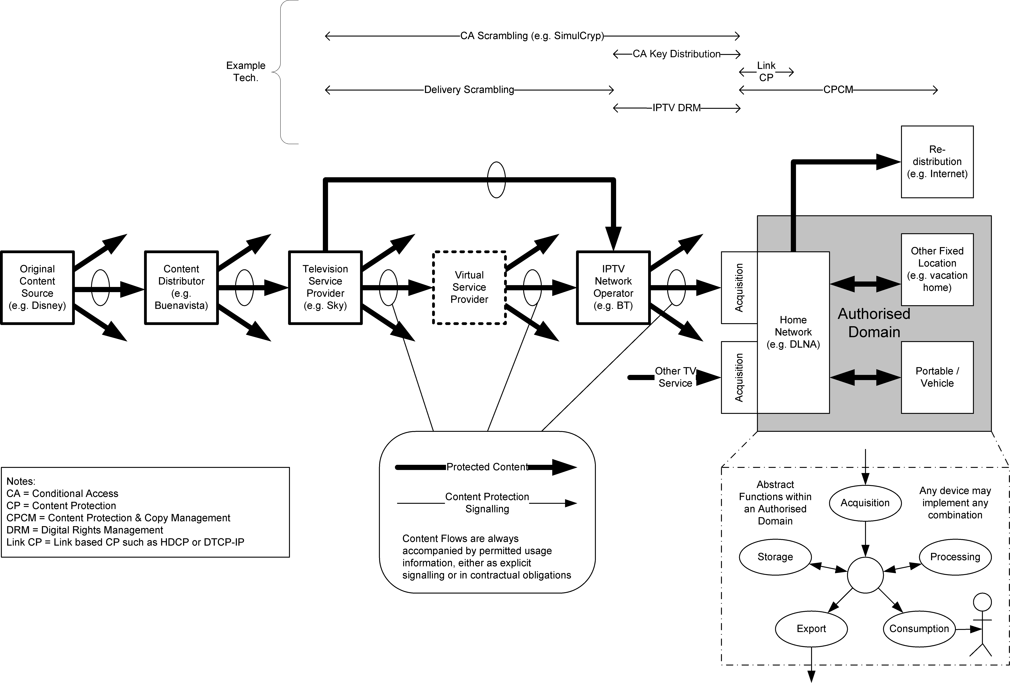

NEED TO BE DISCUSSED AND ADD THE DELINEATION OF THIS FIGURE.

Editors Note: do not consider the following figure in OD, use ID-140 material instead.
ID-51:
Transport Security
Service Security
Content Source
Service Integration&Operation
Content Transport
Content Consumption
Content Security
Content Provider
Service Provider
Network Operator
Service Provider
Subscriber
Subscriber
Subscriber
Figure 4 – IPTV security architecture
--------------END

**************************From the contributions Busan meeting*********************
----------------------BEGIN
Editors Note: consider the following under the security architecture section in OD.
ID-140:
IPTV security includes many security features, such as confidentiality, availability... All these features can be classified into 3 stratums: Transport, Service, and Content. As illustrated in figure 5, the security issues in different stratums are associated with different parts of the IPTV service chain.
Note: Figure5 only describes security features from consumer view and needs to be refined to define the complete IPTV security architecture.

Core Network
Transport Stratum Security
Service Stratum Security
Content Stratum Security
Content Source/ Content provider
Content Consumption/ Consumer
Content Transport/ Delivery Network
AN
DRM/CA Agent
DRM Server Side
Service Integration & Operation/ Service Provider
(5)
(4)
(3)
(1’)
(1) (1’) Content protection
(2) Service access security
(3) Service security
(4) Bearer network security

(2)
Network Access Client
Content Management
DRM/CAS
Service Operation& Management
(1)
User Application
(5) Network access security
(6) Consumer domain security
(6)
Figure 5 – IPTV security architecture (from consumer view)
In figure 5, six security feature groups are defined. Each of these feature groups accomplishes certain security objectives.
- (1’) Content protection: the set of security features that ensure the digital contents be transmitted, stored, transferred and consumed securely. For different purpose, the content protection technologies can be used by content providers or service providers. A good mechanism should be implemented to protect commercial digital content from interception, replacement, unauthorized viewing, or unauthorized copying.
- Service access security: the set of security features that provide subscribers with secure access to the service.The entities which involved in service access security include IPTV service providers and consumers. The security features such as the authentication and authorization to IPTV service users, the protection of subscribers’ information confidentiality should be considered here. There are two types of the service authentication & authorization, one is about multiple services (VOD, PVR, broadcast TV), and the other is about multiple service providers.
- Service operating security: the set of security features that enable the IPTV service to operate stably and securely. Main features in this group are as follows: service availability and reliability, Non-repudiation, etc.
- Bearer network security: The set of security features that enable data to be transmitted securely form IPTV service provider to receiving terminal, and protect the network against various attacks. The following security features related to bearer network security can be provided: availability and reliability of Content Distribution Network, multicast protocol security.
- Network access security: the set of security features that is implemented on the access network to prevent unauthorized access and utilization of the IPTV bearer network. Besides the network authentication and authorization, the confidentiality of the user’s ID information is needed in this feature group.
- Consumer domain security: the set of security features that ensure user devices securely access to consumer domain and to be protected against attacks. The security features such as authenticity of home network devices and reliability of the receiving terminal can be mentioned here.
--------------END

Security Function Modules

************************from old living list*************************************
------------BEGIN
Editors Note: consider the following under the security architecture section in OD.
TBD.
ID-78:
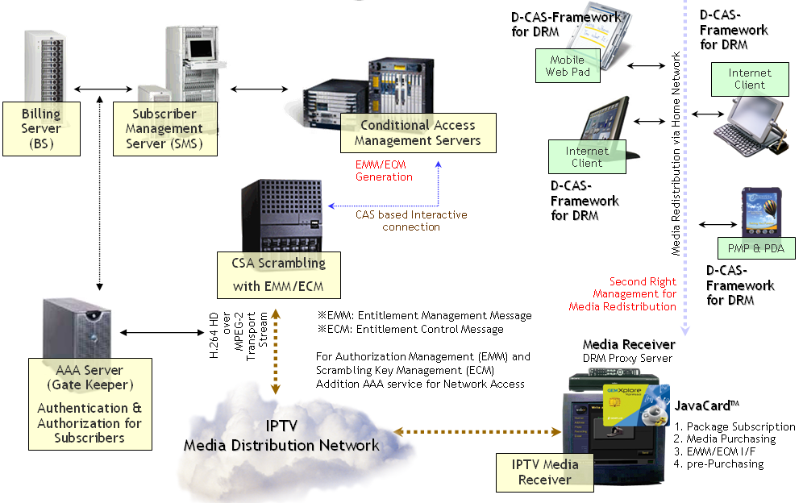
Figure 6
There are 2 categories to make this contents protection system within IPTV mechanism. First protection the network access via AAA service. Second, the media itself protection via CA or DRM method.
All access from the subscribers are connected to the SMS (Subscriber Management System) and BS (Billing Server) to request the access bill to the each subscriber of IPTV.
After receiving the media, storing and re-distribution, converting to other CODEC, transfer to the other display devices should be controlled by DRM. But for DRM control, it is needed to proxy service for faster service. So, the main receiver (we guess it might be STB with HDD) should do the role of DRM proxy server within the home.

Editors Note: to be discussed.

ID-95:

The specifications of a CAS/DRM system that implements all these security functions are shown below.
Figure 7

- CAS/Digital Rights management
The conditions below are not necessarily exclusive requirements; they can be realized through different means.

- IP channel services
If a content scrambler key is used as a method of delivery, it is desirable to use ECM (in band), which is compatible with the current streamings of the particular country question.
In the case of free channels where content protection needs to be considered, it is desirable that content is viewable only by means of multicast data transmission—a method that allows content be viewed without a subscriber contract.

- EMM/PKI (out of band)
As a delivery method of subscriber contract renewal information, utilizing the two-way nature of communication, it is desirable to deliver content by a method such as PKI—which provides a secure channel for data equivalent to EMM, an extension of current broadcasts.

- Various VOD and download services: control by license issue
While there are many conceivable types of VOD services, it is desirable in all cases to utilize a payment method for viewer conditions and licenses.

  - Content protection
- Content encryption method
In IP channel services, it is generally expected that content is viewable immediately after selecting a channel. For this reason, it is desirable to use a time-limited licensing that is compatible with broadcast methods. In the case of VOD streaming and download services, since content is delivered by unicast in response to the demand of the viewer, it is desirable to have a license key for each item of content, for encrypting the content in advance.
- Encryption algorithms
It is desirable to use encryption methods that are standardized, and widely respected. Based on links IPTV service to the broadcasting of each country, it is not essential to narrow down to one algorithm. However, when selecting new encryption algorithms, it is desirable that encryption be at least 128 bit.
  - Security
Smartcard-based “CAS” for Broadcasting are now widespread, so it is desirable to utilize smartcards. However, since technology built in to CPEs is now highly advanced, if the following conditions can be met, it is acceptable to use Download-CAS or a DRM-like implementation of CAS/DRM built in to the CPE—without the need for smartcards. Given the falling costs of building complex functionality into hardware, it is expected that in the coming years CAS/DRM systems will be increasingly implemented by way of software.
- There is compatibility between the responsibility dividing line of the service provider and the responsibility dividing line of transmission systems and CPE functions include CAS/DRM modules
- Due consideration is given software anti-tampering measures
- IPTV service is not completely interrupted, even to exchange a CAS/DRM module due to the occurrence piracy has occurred

  - Authentication/Authorization

1) PKI base
When multiple IPTV service operators share a single CPE, it is most effective if the CAS/DRM is also shared. If this is done, then in view of the frequent M&As that occur between IPTV service providers, it is preferable to use PKI (Public Key Infrastructure), whereby sharing is not necessary, instead of a common key system in which all viewers share a private key.
2) Attacks on the systems of IPTV service providers and protection of personal data
From the perspective of attacks on the systems of IPTV service providers and protection of personal data, it is preferable that the service provider implements, as far as possible, two-way authentication based on PKI.
3) Validity period and renewal of public key certificate and CRL operation
Normally, in order to limit the security risk, a validity period is set for public key certificates used for PKI. It is necessary to take care in setting validity periods, because, unlike in the case of PCs and other devices, it is not always easy to update the certificates CPEs..
Normally, CRL operation is necessary for public key certificates. For anti-piracy measures reason, it is necessary to take care in implementing CRL processing of CPEs and CAS/DRM modules.
--------------END

**************************From the contributions Busan meeting*********************
----------------------BEGIN

--------------END

Security Interfaces
TBD.

Security Mechanisms

Content Security Mechanisms

************************from old living list*************************************
------------BEGIN
TBD.
Editors Note: consider the following under the content security mechanism section in OD.
ID-78:
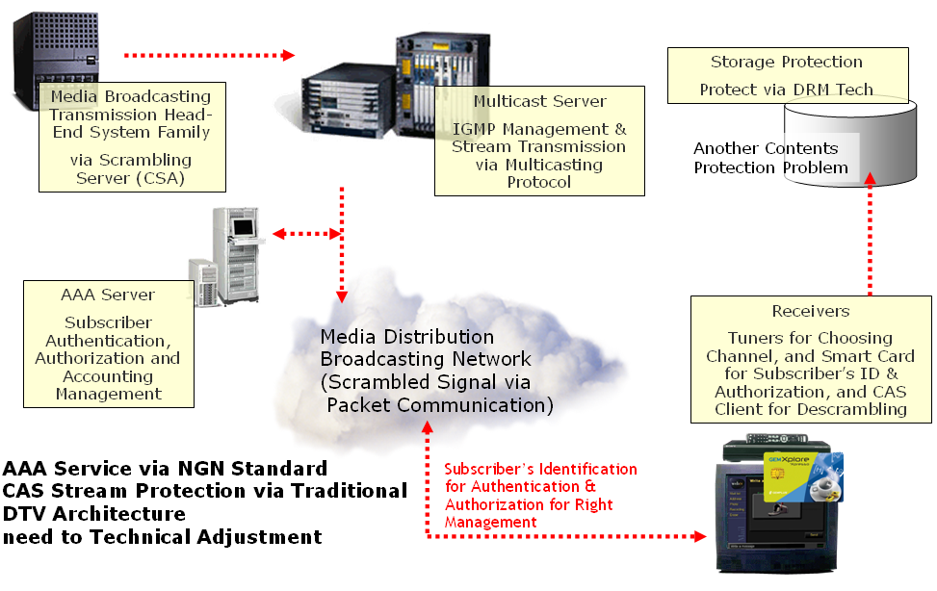
Figure 8

IPTV is based on communication technology, and always the subscriber can interchange any message with the server which would be logically located in broadcasting center. So, there are two kinds of contents protection mechanism should be considered.
First, access the IPTV broadcasting network. In many case, there is already standard mechanism for subscriber authentication, authorization and accounting, called AAA. That can do the role of toll-gate to prohibit the entrance illegal users into the IPTV network.
Second, scrambling media stream like similar mechanism of traditional can be considered. However, it is different from traditional broadcasting, because IPTV can confirm and acknowledge for each packet through open but secured protocol, like SSL. In addition, the new IPTV CA system can send to subscriber not only 2 the keywords (EMM, ECM), but also its encryption mechanism (the encryption mechanism) for each media. If it is realized we can get 3 merits.
- Each medium ((multiple) audio, video, (multiple) interactive software with data, any other information like SI) can use different encryption method according to the business model. So, the broadcaster can sell each medium through subscriber’s request.
- The encryption method can be vary according to the time goes. The encryption method can be vary even during the broadcasting is on-air. All encryption method always downloaded to the each subscriber with the keywords.
- The responsibility of contents protection should be to the contents provider, because all contents method should be transferred to the broadcasters with their A/V stream. However, if the broadcaster wants the broadcaster can install their own contents protection system like traditional broadcasting system.
Therefore, it is suggested the 2 mechanisms are all needed to IPTV for dual protection.
--------------end

**************************From the contributions Busan meeting*********************
----------------------BEGIN
Editors Note: to be discussed .
ID-217:
Table6: Content protection mechanisms
ASSET | RISK | SECURITY MECHANISM
Plaintext content work | Unauthorized modification | Integrity protection of files and streams
Plaintext content work | Unauthorized access | Encryption of files and streams  Content policy specification  Selectable security level
Encrypted content work | Unauthorized access | Strong identity and authentication  Physical security of end-systems  Documented/auditable security system
Content work | Denial of service attack | See network security mechanisms
In cases where the provider of a content work does not trust the security or practices of the recipient of the work, “content protection” mechanisms raise the bar to illegal or unauthorized uses. These mechanisms are discussed under separate points below.
- Ease and simplicity of use. According to the “Darknet” paper, cumbersome and intrusive protection mechanisms encourage circumvention of protection mechanisms and unauthorized access to content works [Darknet]. It is therefore important that Terminal applications make it very easy for works to be accessed by the consumer in the desired ways but very hard to access works in unauthorized ways. For this to have the desired effect, the types of authorized access need to meet the customer’s needs and expectations.
- Limited exposure of plaintext content works. Terminal, intermediate, and server systems should be capable of processing encrypted content works to the latest point in the rendering process. This of course is an unnecessary requirement for unencrypted works, but all systems that handle content works should be designed to send, receive, and store encrypted images of those works.
- Integrity protection. The system needs some means to distinguish an authorized copy of a digital content work from a modified or derived work.
- Stream-level encryption. Limited exposure of a content work in the form of a stream entails stream-level encryption in which the work is encrypted at the point of transport and decrypted prior to rendering at the terminal.
- File-level encryption. Limited exposure of a content-work contained in a file entails file-level encryption in which the content work can be downloaded or streamed while encrypted as done in the MPEG-4 Encryption and Authentication standard [ISMACRYP].
- Content policy specification. The types of access that the residential customer is authorized to perform needs to be specified. This may be specified per content work, such as an XrML rights specification that is bound to a particular content work. Or it can be bound to a class of content works or the entire service, as is done in Apple iTunes™.
- Protected outputs. Terminal systems that process encrypted content works must support protected outputs such as HDCP, DTCP, and other standards that are appropriate to the type of interface.
- Digital watermarking. Forensic and copy-control watermarks are two types of content-level protection mechanism that are widely used today. Systems that process a watermarked content work must preserve the watermark up to and including Terminal rendering.
- Protected key store. All keys need appropriate protection and a scalable level of protection needs to be supported. Home theatre systems that process newly-released movies, for example, may need keys stored on a secure processor or separate token card that are tamper-resistant. At the other extreme are content works that are distributed for use on PCs, such is the case for practically all music titles today and a secure co-processor is not generally available. Thus, high-value content works such as newly released movies are unlikely to be licensed for use on a PC today or in the near future. In the case of a PC, the keystore should at least be inaccessible using the facilities of the operating system such as a text editor. In general, the keys to valuable content works in the earlier phases of their release window will likely require hardware-level protections such as a co-processor that does not expose keys on the bus or system memory.
- Scalable level of protection. Not all works need to be encrypted or watermarked and not all works that are encrypted need to be encrypted in the future. The Terminal, intermediate and server systems that process content works should support a variety of policies and mechanisms for content protection including no content-protection mechanisms at all. Possibly the only mechanism that is universally desirable for digital content works is integrity protection, which is a content-security mechanism discussed above.

-----------------------END

Content Protection

Signaling Process

Interfacing
TBD.

Conditional Access
TBD.
************************from old living list*************************************
------------BEGIN
Editors Note: to be discussed.
ID-23:
Conditional Access (CA) provides the restriction of content viewing to authorized users through scrambling or encryption of media. CA has a long history in television broadcast via cable and satellite television through both proprietary (e.g. DigiCypher and Nagravision) and standard means (e.g. DVB-CA, ATSC-CA).
Common terms in CA for the control of authorization for content rights are Entitlement Control Message (ECM) which defines a protected resource and Entitlement Management Message (EMM) which grants rights to a given subscriber or their agent to view a set of content described by ECMs. Both ECMs and EMMs may be transmitted with the controlled content or through a separate channel, depending on implementation. EMMs can be delivered either through a digital communication channel or on a smart card delivered to the subscriber. The former is more relevant to the DRM discussion.

CPE
Encryptor
encrypted stream

[w/ embedded ECMs]
CA Server
keys
EMMs w/ keys
decrypted stream
Display Device
Keys for an asset are shared across all users within the CA server domain
unencrypted stream
Authentication
[ECMs]
Figure 9 - Conditional Access Logical View

ID-78:
--------------END

Digital Rights Management

************************from old living list*************************************
------------BEGIN
Editors Note: to be discussed .
ID-23:
Digital Rights Management (DRM) is sometimes thought of as the “digital management of rights” or as the “management of digital rights”. In fact, DRM provides the “digital management of rights to digital assets”. DRM combines Conditional Access and Copy Protection, this combination allows the addition of richness to the policies that can be expressed and enforced on protected assets. DRM allows assets to be protected and then a variety of policies specified by the asset owner on how the asset may be used. A DRM scheme must support the following critical attributes of rights which may be granted:
- who has access
  - a subscriber, a user, or any group or combination of these
- on which devices
  - a device or a group of devices
- to which agents
  - a DRM client implementation (“DRM agent”) or group of agents
- when do they have access
  - for what time period, how many times may access be granted
- to which features
  - e.g. a set of software features, video on demand trick modes, etc.
- with what output
  - what output formats (analogue and digital) are supported for this content, with what restriction (e.g. is 1080i digital video display allowed without HDMI/HDCP support in the display device)
  - what export formats are supported (e.g. analog output must support Macrovision, digital storage must support DVB-CPCM or digital output must support DTCP)
It must be possible to combine these attributes, such as granting the right: a particular High Definition movie may be viewed by users with a certain subscription ID, on any trusted DRM agent, for 1 week, as many times as they like, on TVs at 1080i, through digital output supporting DTCP, or through analogue output supporting CGMS-A.
It is critical that a DRM solution provides protection for both the asset owner and the asset licensee, allowing free and unencumbered use of asset within the rights of the subscriber. It is also beneficial if a DRM system can support the distribution and control of assets by “users” as well as traditional service providers – this provides for a much richer content and service exchange and engenders innovation and business.
In order to facilitate DRM, two key network services are required:
- Trust establishment and verification between the DRM rights issuer and the DRM agent
- A secure time source to facilitate time based rights expression
Additionally, the ability to facilitate forensic analysis and prosecution of breaches of key information are critical to the long term success of any content licensing model, implying the integration of Digital Watermarking technologies into DRM systems.
DRM Agent 1
Rights Issuer
unprotected
content
“unprotected”
content
Display Device
Keys for an asset are specific to a subscription
Asset Owner
Asset Provider
rights
definition
keys
(either direction)
request or distribute license
AAA /
Payment
rights request or delivery
purchase
DRM Agent 1
protected
content
request or distribute license
User
Display Device
“unprotected”
content
Figure 10 – Digital Rights Management Logical View; Rights Issuer, Asset Provider, Asset Owner, and AAA/Payment may be a single or any multiple legal or business entities

Editors Note: to be discussed .
ID-86:
Inter-working with different DRM system and
In developing interoperability specifications for CAS and DRM in the IPTV context at least three modes of high-level DRM architecture can be identified: 1) DRM End-to-End (DRM-EE), 2) DRM Bridging (DRM-B) and 3) DRM Interchange(DRM-IX). These elements are discussed below.

- DRM End-to-End (DRM-EE)

Using a single DRM system, two or more devices exchange and access content according to granted rights.

This mode should be the easiest to implement since only a single DRM system is involved and thus exchange of content and rights expression license should be the most straightforward. Note that implementation of this mode may or may not include other point-to-point security hops on the path from the content producer to the final consumption device. A disadvantage of this mode is that all participating devices and equipment must offer a single CAS or DRM system and this may not be realistic in truly global networks.

- DRM Bridging (DRM-B)

On a single device, two or more DRM systems are operative. Content acquired via one DRM or CAS system (from a network for example) can be accessed via another DRM system resident on the same device according to granted rights.

In this mode, since both DRM systems share the same storage and physical interfaces of a single hardware device, the main challenges are in the authentication of DRM clients, transfer of rights expression licenses and secure content exchange between the DRM systems.

- DRM Interchange (DRM-IX)

This case is characterized by two or more devices, each device having one or more operative DRM systems. Content acquired by one device through one of its DRM systems can be securely transferred to and accessed on another device through a different DRM system according to granted rights.

This mode presents the greatest challenges since, in addition to the interoperability issues of the DRM systems themselves, both physical and logical inter-device interfaces must be implemented in an interoperable and secure fashion.

- Authorized Output

While not a DRM mode per se, DRM systems may nonetheless need to deal with authorized output. This is content sent to a display device for direct consumer viewing or listening. Some examples of authorized output interfaces are DTCP, HDCP, CPRM, etc.
Editors Note: consider the following under the content or service security mechanism section in OD.
ID-78:
Stepwise Approach:
We need discuss on the stepwise approach for this mechanism. First step, we should make the standard only for IPTV distribution media protection.
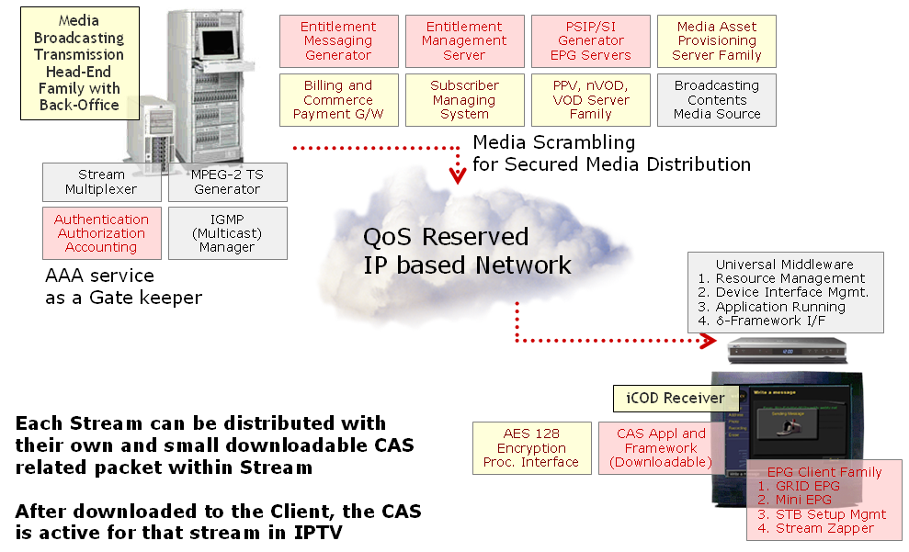
Figure 11

In this phase, we should define all downloadable mechanism for the CA system, from encryption and distribution of keywords, then decryption. However, it is more important to define all running framework on downloaded CA packets in client, because all secured keyword can be with its encryption mechanism. The following is an example of the client CA software architecture.
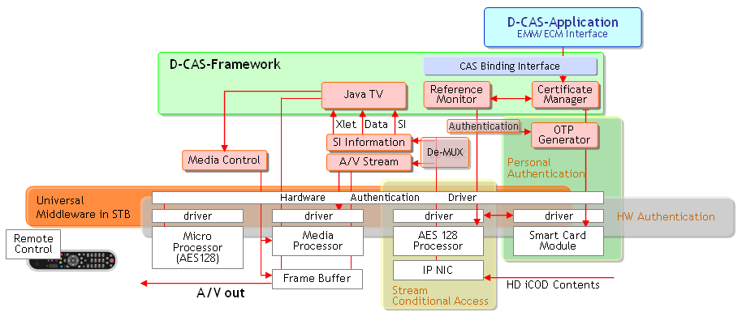
Figure 12

In second step, we should define on DRM and media life cycle management mechanism, we will call this mechanism as DRM.
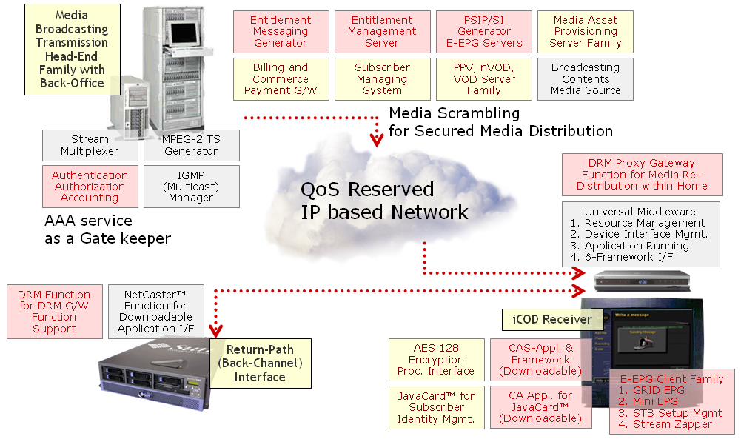
Figure 13

--------------END

**************************From the contributions Busan meeting*********************
----------------------BEGIN
Editors Note: There are some potentially useful materials in the attachment PPT in the ID-0222 and ID-0223, but we cannot include due to the copyright.

-----------------------END

Service Security Mechanisms
TBD.

Service Authentication
TBD.

Service Authorization
TBD.

Network Security Mechanisms
TBD.
**************************From the contributions Busan meeting*********************
----------------------BEGIN
Editors Note: to be discussed .
ID-217:
Table7:
ASSET | RISK | SECURITY MECHANISM
Network bandwidth | Denial of service | Firewalled perimeter
Network bandwidth | Unauthorized use | Firewalled perimeter
Network messages | Unauthorized access | Firewalled perimeter  Access Controls
Network messages | Unauthorized modification | VPN  Access Controls
Network messages | Replay | VPN
Routers and intermediate systems | Denial of Service | Firewalled perimeter  Access controls  Intrusion protection  Documented and auditable security procedures
Routers and intermediate systems | Unauthorized use
Network service information | Unauthorized disclosure | Access controls  Integrity protection  Documented and auditable security procedures
Network service information | Unauthorized modification
-----------------------END

Terminal Device Security Mechanisms
TBD.

Terminal Device Authentication
TBD.
**************************From the contributions Busan meeting*********************
----------------------BEGIN
Editors Note: to be discussed .

ID-247:
There are two phases of terminal device authentication. In the initial device installation phase, a PKI based challenge response model could be used to establish permanent key. The second phase would be subsequent power-on device authentication by using the already established permanent key after installation.

The permanent key should be generated during terminal installation. Once it is generated, it should be scrambled and stored in a permanent storage inside the terminal device with basic secured access control. The permanent key should not be changed until a new installation process is performed. Several security measures shall be considered when establishing permanent key.
- It is preferred to use PKI mechanism to secure the channel of generating the permanent key.
- Basic challenge and response method should be adopted in the process of generating permanent key.
- It is highly recommended to have certain hardware component such as secure processor and/or secured micro co-processor to facilitate the permanent key generation process, message encryption and key storage.

Instead of using permanent key to secure the service channels between the terminal devices and authentication server, a terminal device should use the permanent key to generate the session key and use it to encrypt the communication channels with authentication servers.
- And session key could be changed in operator specified interval. This will enhance the overall security of subscriber authentication system.
- A re-authentication process at a certain interval is recommended to exchange new session key.
-----------------------END

Terminal Device Authorization
TBD.

Terminal protection
TBD.
**************************From the contributions Busan meeting*********************
----------------------BEGIN
Editors Note: to be discussed .
ID-217:
Table 8
ASSET | RISK | SECURITY MECHANISM
Terminal locality | Unauthorized relocation of fixed-location device | End-system localization  Visible Fingerprinting
Terminal locality | Unauthorized sharing of mobile device | Household localization
Processor and Disk | Unauthorized access such as by malware or remote access | Signed code  Secure Bootloader  Secure Keystore  Network access controls
Terminal interface | Circumvention of content protection controls through a Terminal interface | Approved copy-protected outputs  Approved outputs to authenticated devices
-----------------------END

Subscriber Security Mechanisms
TBD.

Subscriber Authentication
TBD.
**************************From the contributions Busan meeting*********************
----------------------BEGIN
Editors Note: to be discussed.
ID-247:
The following diagram depicts a general model of the STB and subscriber authentication based the standard Kerberos token mechanism.

- STB and Authentication Server

STB communicates with the authentication server for initial terminal and subscriber device installation and authentication, as well as for subsequent power on authentications. All the service access tokens are generated by authentication server.

- STB and application servers and other resources
The communications between STB and application servers in the IPTV system are secured by access tokens that STB acquired in its authentication process with the authentication server.
STB
Service API’s
Authentication Client
Authentication Server
VoD
EPG
VAS
DRM
Billing
.
1. Installation and Authentication
2. Token Generation

Token based service verification
.

Figure 14

-----------------------END

Subscriber Authorization
TBD.

Subscriber information Protection
**************************From the contributions Busan meeting*********************
----------------------BEGIN
Editors Note: to be discussed .
ID-217:
Table 9
ASSET | RISK | SECURITY MECHANISM
Subscriber information | Unauthorized access | Terminal access control  Transaction VPN  Integrity protection of subscriber and transaction information
Subscriber information | Unauthorized modification
Transaction information | Unauthorized access
Transaction information | Unauthorized modification

As described in the previous chapter, access to the terminal over the network needs to be strictly controlled to prevent unauthorized remote access to subscriber information. Depending on the nature of the service, it may be desirable to restrict the subscriber’s information from local access to the Terminal from the console, if there is a console on the terminal device. In general, it is prudent to use encrypted and integrity-protected connections (such as a VPN) between the Terminal and the service provider’s equipment when information about the subscriber and the subscriber’s transactions is carried over the network.
-----------------------END

_________________

