Abstract
INTERNATIONAL TELECOMMUNICATION UNION |  |  |  | Focus Group On IPTV
TELECOMMUNICATION  STANDARDIZATION SECTOR  STUDY PERIOD 2005-2008 |  |  | FG IPTV-C-1100
 |  |  | English only
WG(s): 1 |  | 7th FG IPTV meeting:  Qawra, St. Paul’s Bay, Malta, 11-18 December 2007
CONTRIBUTION
Source: | France Telecom (France)
Title: | "Content Push" Scenario to be added to WD DOC-0149: IPTV service scenarios
This contribution aims at introducing a new service called "Content Push".

Proposal
In DOC-0149 there is a list of typical IPTV Services related to Content Services", in this list we can find some services more or less related to "Content Push", namely:
- 10 Download Based Video Content Distribution Services (Push VoD)
- 12 Content download service
There is no description for these services yet but there is a section "6.3.1.3. Push VoD".
What is proposed here is to have a "Content Push" section which could also be called "Content Download Service" to replace these sections.
================================================================
New "Content Push" Section
There are several cases where "Content Push" is relevant:
- In VoD when the video delivery can not be immediately satisfied, following the end-user request but will be triggered at a later stage by some wake-up mechanism.
- When an end-user has subscribed to an automatic video delivery service based on some criteria (e.g. the end-user has subscribed for the delivery of the new movies from a specific director or with a specific actor, etc.)
- When the Service Provider offers a network PVR functionality. After an end-user record request, the Network PVR waits for the event to be recorded. When the Content is available in the network PVR, then in some cases, it is of interest to deliver the content to a Customer Equipment without waiting for the end-user request.
- When the Service Provider, based on known user preferences, decides to download contents which are likely to be requested by the end-users, to a CPE having recording features, in order to avoid later network congestion.
- When the Service Provider decides to download commercials for insertion at content replay time.

This scenario is described on the following figure:
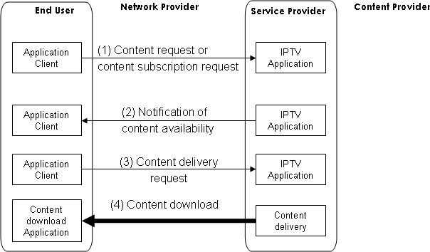
Figure 1. Push Content Scenario

(1) This scenario can start with a catalogue browsing and selection of a content. It can start also with access to an IPTV portal proposing specific content subscription (e.g. new movies, week-end football best-off, etc.).
This step does not exist in the case of contents pushed to the Terminal Device without prior end-user request. This use case is valid only when Terminal Devices are provided by the Service Provider.
(2) When a content to be delivered to the Terminal Device is available and possibly depending on other conditions (e.g. server load, subscription rate, etc.) then the Service Provider issues a Notification of Content Availability
(3) The Terminal Device will issue a content delivery request depending on end-user environment conditions (e.g. availability of storage capacity, Terminal Device activity and load, etc.)
(4) The content download starts after the reception of the content delivery request. If the content delivery request does not follow the notification of content availability, the server conditions might have changed and the server may reject the delivery request, giving a delay to reissue another delivery request.

__________________

