INTERNATIONAL TELECOMMUNICATION UNION |  |  |  | Focus Group On IPTV
TELECOMMUNICATION  STANDARDIZATION SECTOR  STUDY PERIOD 2005-2008 |  |  | FG IPTV-C-0937
 |  |  | English only
WG(s): 6 |  | 6th FG IPTV meeting:  Tokyo, Japan, 15-19 October 2007
CONTRIBUTION
Source: | ETRI
Title: | Proposal for syndication based metadata model
Summary
This contribution is to remind again for the agreed proposal of syndication capability in service navigation system during the last 5th meeting. In this document, we described how to reflect the proposed text into the origin text (FG IPTV-DOC-0130).

Background
At the last 5th meeting, syndication capability in service navigation system was discussed and agreed the necessity of metadata capability to support the enhanced EPG functionalities, e.g. customized personalized capabilities. Though the current service navigation system is specified on the web based method, syndication capability in this service navigation system also has crucial meaning. As well, syndication capability needs to further consider in application/middleware environment as well as web based mechanism.
Proposed text

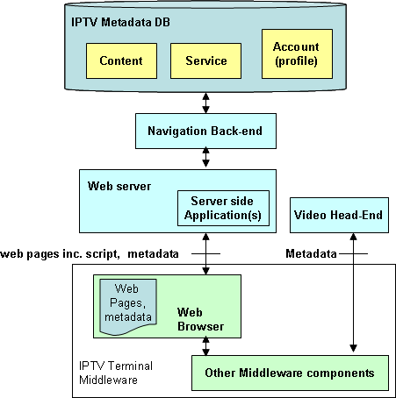

Figure 5.3: Metadata flows in Service Navigation Systems

Browser is IPTV client module that loads and renders web pages encoded in a mark-up language mostly based on HTML/XML, and a scripting language.
Navigation front-end serves navigation information (e.g. metadata) and client side scripts on requests from client side application in IPTV client.
Metadata can also be received from a video head-end and cached or processed in middleware.
Client side application is executed locally to control the navigation user interface. Client side application can retrieve metadata directly from the front-end or through middleware from local cache.

5.2.3 Syndication capability in service navigation system
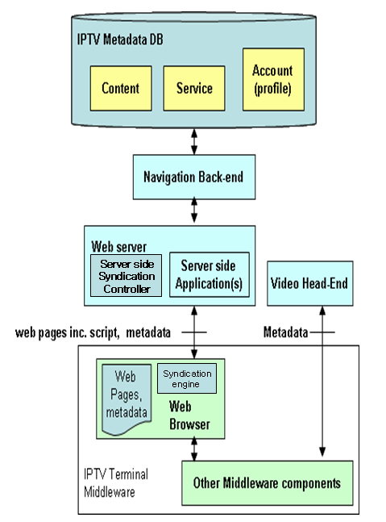
Figure 5.4: Syndication capability in Service Navigation Systems

Syndication controller provides metadata adaptation function with metadata DB and manages metadata with browser syndication engine. It classifies and customizes metadata from IPTV metadata DB for web browser in IPTV terminal. The data format between syndication controller and syndication engine could be standardized syndication format such as RSS/Atom.
Syndication engine in browser manages the metadata information from server side and it can provide the aggregated feeding and customized retrieval of metadata information.

Proposal
We hope this proposal to be included in next to figure 5.3 of service navigation system in WG6 document of FG IPTV-DOC-0130 as a new sub clause.

_______________

