INTERNATIONAL TELECOMMUNICATION UNION |  |  |  | Focus Group On IPTV
TELECOMMUNICATION  STANDARDIZATION SECTOR  STUDY PERIOD 2005-2008 |  |  | FG IPTV-C-0828
 |  |  | English only
WG(s): 3 |  | 6th FG IPTV meeting:  Tokyo, Japan, 15-19 October 2007
CONTRIBUTION
Source: | ETRI, Republic of Korea
Title: | A SCP Interoperable Architecture based on Standard Protocol

Introduction
This contribution focuses on a SCP interoperable architecture. Two kinds of possible SCP interoperable architectures are mentioned in terms of who takes the role of the interoperable function. The first one is basically the same as “the Common DRM Interoperable Architecture” described in FG IPTV-DOC-0122 at section II.4. The second one which is newly presented in this document is required to be considered as an alternative SCP Interoperable Architecture.

Discussion

Background
At the 5th meeting of the FG IPTV, WG3 discussed SCP Interoperable Architecture based on a contribution document, “A Common DRM Interoperable Architecture” proposed by Huawei Technologies Co., Ltd. It is based on mediator-based interoperability architecture like Corel’s mediator or Marlin’s gateway. This interoperability architecture needs specific system to process interoperable transmission in the middle of two security systems. However another approach which does not need specific mediator to handle interoperability issue can be considered. That is a standard protocol-based architecture instead of based on the mediator. It defines just standard interfaces and protocols to transform protected digital content and associate information between two different security systems.
This contribution paper introduces a SCP Interoperable Architecture based on standard protocol as an alternative solution of IPTV security interoperability. This newly added SCP interoperable architecture satisfies Security Interoperability requirements described at section 6.3.2 in the Working Document: IPTV Services Requirements (FG IPTV-DOC-0114)

Warming up
How do 2 people who speak in different language communicate each other?

- To use just one language of both ones. In this case, at least one person should know other party’s language. On the other hand, the other person is not required to know other party’s one. Success in this communication depends on the ability of one person’s language skill.
- To involve an interpreter. In this case, additional 3rd person should be involved in the communication. However both original parties to the communication may not know other party’s language at all. Success in this communication depends on the ability of the 3rd bilingual person’s language skill.
- To use the 3rd official or common language. In this case, it does not need additional 3rd person for interpretation and both parties to the communication may not know other party’s language at all. However both people should know the 3rd official or common language before communication. Success in this communication depends on the ability of both people’s the 3rd language skill.

The possible SCP interoperable architectures can be compared with above communication language cases. The mediator-based SCP interoperable architecture can be compared with the 2nd example, to involve an interpreter solution. And the standard protocol-based interoperable architecture can be compared with 3rd example, to use the 3rd official or common language solution.

SCP Interoperable Architectures

Mediator-based Interoperable Architecture

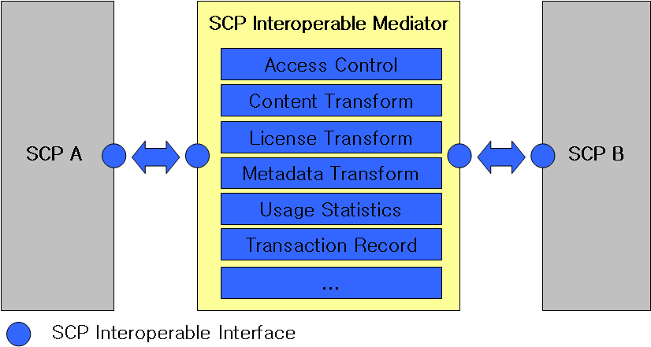
Figure 1. Mediator-based SCP Interoperable Architecture
This architecture basically same as “the Common DRM Interoperable Architecture” described in FG IPTV-DOC-0122 at section II.4, except the following:

- The scope of interoperability architecture of SCP focuses only IPTV terminal device and other device, and not involved in SCP server in head-end, service provider and network provider. ( In according to the editor’s notice at FG IPTV-DOC-0122 at section II.1 )
- The term DRM replaces with the SCP ( In according to the editor’s notice at FG IPTV-DOC-0122 at section II.4 )
- The terms ‘foreign’ and ‘native’ which were used in previous document replace with SCP A and SCP B.
- Metadata Transform function is newly added. It should output a target metadata based on the input of source metadata from SCP A realms. The target metadata should maintain the same information as the original metadata had. A set of metadata mapping (syntax and semantic mapping) may be included in the Metadata Transform. Also, Metadata Transform may be responsible for repackaging metadata information and securely delivering it to SCP B realms.

Standard Protocol-based Interoperable Architecture

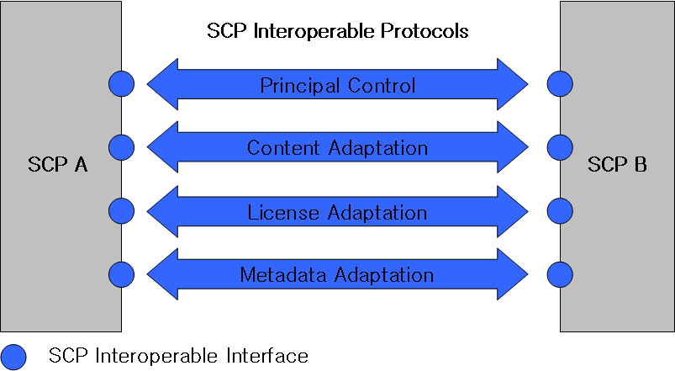
Figure 2. Standard Protocol-based SCP Interoperable Architecture

Standard Protocol-based SCP Interoperable Architecture is different from the mediator based one in that both sending and receiving SCP parties should know the interoperability protocols and do adaptation job by themselves. There exists only SCP Interoperable Protocols between two SCP realms. 4 basic functions for SCP security interoperability are accomplished through the SCP Interoperable Protocols: Principal Control, Content Adaptation, License Adaptation, and Metadata Adaptation.

- Principal Control: Since there is no mediator system in this architecture, each SCP party should judge by itself whether the other party is proper target or not based on its judgement information such as license. It is usually accompanied with mutual authentication process as a preliminary step between two SCP parties.

- Content Adaptation: Since there is no mediator system in this architecture, sending SCP party should transcript media content protected by sending-side-SCP way into the standard protection way by itself. And receiving SCP party should re-transcript the media content protected by the standard protection way into its own protection way by itself as well. Given several pre-defined encryption algorithms for the standard will facilitate these processes.

- License Adaptation: Since there is no mediator system in this architecture, sending SCP party should convert license scheme used on sending-side-SCP realm into the standard license by itself. And receiving SCP party should re-convert the standard license into its own license scheme by itself as well. The standard license should maintain the same permission behaviors (media assets & consumption permission pair) as the original license defined. A set of right mapping (rights expression mapping and semantic mapping) may be included in the License Adaptation. Also, License Adaptation protocol may be responsible for repackaging right information and securely delivering it to the other SCP party.

- Metadata Adaptation: Since there is no mediator system in this architecture, sending SCP party should convert metadata used on sending-side-SCP realm into the standard metadata by itself. And receiving SCP party should re-convert the standard metadata into its own metadata scheme by itself as well. It should output a target metadata based on the input of source metadata from SCP A realms. The standard metadata should maintain the same information as the original metadata had. A set of metadata mapping (syntax and semantic mapping) may be included in the Metadata Adaptation. Also, Metadata Adaptation protocol may be responsible for repackaging metadata information and securely delivering it to the other SCP party. SCP B realms.

Scenarios of SCP-B or SCP-IX deployed in IPTV terminal device on the protocol-based SCP interoperable architecture
This sub-clause describes 3 possible scenarios which need SCP-B or SCP-IX Protocols between Service Security and Content Security.

Scenario 1 : SCP with SCP_IX

An IPTV TD(Terminal Device) in this case has the SCP with SCP_IX to support interoperability between the IPTV TD without storage which adopts only specific service security (e.g. STB with CAS), and external device with storage which has only specific content protection (e.g. PVR with MS-DRM).
The IPTV Content protected by SCP1 is able to be displayed directly via display connection or to be done later by storing into external device via other display connection under SCP2 environment.
In order to support secure and flexible connectivity to any kind of external devices which adopts various content protection mechanisms, the IPTV TD is required to have SCP_IX better than case-by-case implementation for the security connection between two devices.

Scenario 2 : SCP with optional SCP-B and storage

An IPTV TD in this case has the SCP with SCP-B to support interoperability between service protection and content protection on a single device (e.g. STB with PVR function which adopts CAS and MS-DRM). The IPTV Content protected by SCP1 is able to be displayed directly via display connection or to be done later by storing into internal storage via the same display connection.
Manufacturer of the IPTV TD may adopt the proprietary content protection mechanism for internal storage. In that case SCP_B is not necessary.
The IPTV Content protected by SCP1 is able to be displayed directly via display connection or to be done later by storing into internal device via the same display connection under still SCP1 environment or SCP2 one.
In order to support flexible connectivity to any kind of internal storage which adopts various content protection mechanisms, the IPTV TD is recommended to have SCP_B better than case-by-case implementation for the security connection between service protection and content protection.

Scenario 3 : SCP with storage and SCP_IX

An IPTV TD in this case has the SCP with storage and SCP_IX to support interoperability between internal content protection mechanism and external one. (e.g. connection from STB with PVR function which adopts CAS and proprietary DRM to another PVR which adopts MS DRM ).
The IPTV Content protected by SCP1 is able to be displayed directly via display connection, to be done later by storing into internal storage via the same display connection, or to be also done later also by storing into external storage via other display connection.
In order to support flexible connectivity to any kind of external storage which adopts various content protection mechanisms, the IPTV TD is recommended to have SCP_IX better than case-by-case implementation for the security connection between internal content protection mechanism and external one.

Proposals
- We propose that WG3 may add the “SCP Interoperable Architecture based on Standard Protocol”. (Sub-clause 2.3.2)
- We propose that WG3 may add the “Scenarios of SCP-B or SCP-IX deployed in IPTV terminal device on the protocol-based SCP interoperable architecture” (Sub-clause 2.4)
- We propose that WG3 may update existing “A Common DRM Interoperable Architecture” which described in FG IPTV-DOC-0122 at section II.4 by referring “Mediator-based Interoperable Architecture” in this proposed document as proper one.

_______________

