INTERNATIONAL TELECOMMUNICATION UNION |  |  |  | Focus Group On IPTV
TELECOMMUNICATION  STANDARDIZATION SECTOR  STUDY PERIOD 2005-2008 |  |  | FG IPTV-C-0803
 |  |  | English only
WG(s): 1 |  | 5th FG IPTV meeting:  Geneva, 23-31 July 2007
CONTRIBUTION
Source: | Korea (Republic of)
Title: | Application support functions for IPTV
Abstract
At last meeting, some issues about applications and Application Support Functions were discussed in the IPTV Architecture Document. This contribution will introduce the standard activities related to both application and Application Support Functions. It, therefore, is proposed to divide Application Functions into two parts; Applications and ASF&SSF.

Discussion
This section will introduce the standard activities related to Application Support Functions and Service Support Functions (ASF&SSF) and Service Enabler in order to distinguish applications from ASF&SSF (or Service Enabler).

1. ITU-T Y.1201 “NGN FRA”
Through the ANI, the functional area of “Application Support Functions and Service Support Functions” offers service-enabling resources to the “Applications” area.
Figure 1 – NGN Architecture Overview

2. TISPAN “NGN Functional Architecture”
Common components (i.e. used by several subsystems) such as those required for accessing applications, charging functions, user profile management, security management, routing data bases, etc.
The NGN architecture includes a number of functional entities that can be accessed by more than one subsystem. These are:
- UPSF: It may store user profile information related to one or more service control subsystems and applications
- SLF: It can be accessed by service control subsystems and Application Server Functions to retrieve the identity of the UPSF
- ASF: It offers value added services and resides either in the user’s home network or in a third party location
- IWF: It performs the interworking between protocols used within TISPAN NGN service control subsystem and other IP-based protocols.
- IBCF: It controls the boundary between two operators’ domains
- Charging and Data Collection Functions: It includes data collection functions and mediation function to the billing systems or other management applications that may use the same data

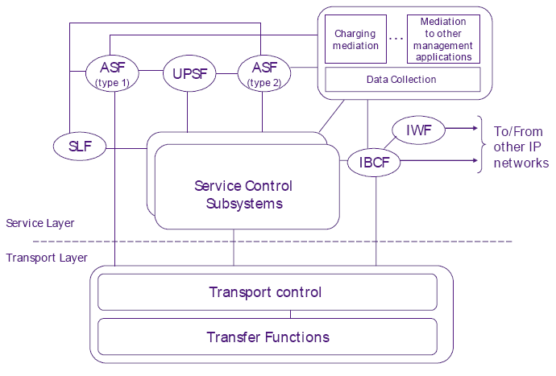
Figure 2 – Common components overview

3. ITU-T Y.2201 “NGN release 1 requirements”
Service Enabler is specified in Y.2201.
The “service enablers” category groups capabilities providing features for specific or advanced services and applications, and/or enabling access to, and/or handling of, the specific information provided by these same capabilities. For examples;
- Group management: This capability provides functionalities related to the secure and efficient management of groups of network entities (terminals, users, network nodes etc.). It may be used by applications and services for different purposes, including VPN applications, video content distribution, device management, transport and service provisioning and management, emergency (community notification) services etc. From the prospective of IPTV, this capability can be used for generating multicast group, joining/leaving a member to/from the multicast group.
- Personal information management: This capability provides management of application-specific static and dynamic information (user related and communication context related). Examples of application-specific information include user contact information, application membership (passwords, etc.), default application parameters, bandwidth/QoS preferences (e.g., according to available access networks), media preferences, user-specified data etc. Delivered by applications (e.g., notification and information services) according to pre-defined user preferences and policy attributes (e.g. across various mobile devices and access network types), this information may be stored and managed by the personal information management capability on behalf of the users. The personal information management capability, acting as user proxy with respect to applications, may also retrieve this information from applications on behalf of the users. From the prospective of IPTV, this capability can be used for providing parent control.
- Message handling: The message handling capability provides functionalities for message-based services. Functionalities include real-time and non real-time messaging service control. Examples of real-time messaging are IM and Chat, non-real time examples being electronic mail, SMS and multimedia messaging service (MMS). From the prospective of IPTV, this capability can be used for sending message to customer’s ITF.
- Multicast support: These capabilities enable applications to deliver content to multiple users at the same time using multicast mechanisms. From the prospective of IPTV, this capability can be used for supporting EPG, DRM, media adaptation, etc. Refer to OMA BCAST for more details.
- Presence: The presence capability (service) provides access to presence information and its availability to users or services. Presence is a set of attributes characterising the current properties (e.g., status, location, etc.) of an entity. An entity in this respect is any device, service, application, etc., that is capable of providing presence information. Availability, on the other hand, denotes the ability and willingness of an entity to communicate based on various properties and policies associated with that entity - e.g., time of day, device capabilities, media preferences and capabilities etc. The terms presence and availability are almost always used together to provide a complete set of presence information. From the prospective of IPTV, this capability can be used for indicating the user’s presence information such as watching TV or not.
- Location management: Location management is an enabling capability for provisioning of location based applications and services, which use information regarding the location of users and devices within networks. The location of users and devices within networks may be related to their physical positioning, hence enhancing applications with local context and relevance. From the prospective of IPTV, this capability can be used for notifying an emergency warning to the residents that live an accident location.
- Push: Push is an enabler that provides the capability to transmit data from a sender to a recipient without previous request by the recipient, e.g., via SIP-based push mechanism. From the prospective of IPTV, this capability can be used for pushing the contents to ITF, for example messaging, streaming, etc.
- Device management: Device management is an enabler that provides the network capabilities to manage and control devices. From the prospective of IPTV, this capability can be used for providing remote device management of the ITF.
- Session handling: NGN is required to provide the capabilities to setup, manage, and terminate end-to-end service sessions that involve, for example, multiple parties, a group of endpoints associated with those parties, and a description of multimedia connections among the endpoints. These session handling capabilities are required to be provided in both fixed and mobile environments in order to accommodate different service requirements, as well as to use the appropriate application servers for service operation. From the prospective of IPTV, this capability can be used for providing video communication while watching display device of the ITF.
- Web-based application support: Web-based application support capabilities provide users a consistent web environment which spans multiple network environments and multiple devices (PC, laptop, PDA, cell phone, etc.). From the prospective of IPTV, this capability can be used for providing internet surfing while watching display device of the ITF.
- Data synchronization: Data synchronization is defined as the act of establishing equivalence between two data sets. The data synchronization enabler synchronizes networked data of different terminals, including handheld computers, mobile phones, laptop PCs and desktop PCs. Applications which may utilize the data synchronization enabler include calendar, contact information management, management of enterprise data stored in databases, and management of web documents. From the prospective of IPTV, this capability can be used for supporting the synchronization of an ITF with appropriate EPG data.

4. OMA “OMA Service Environment”
Service Enabler
The enabler (or its long form Service Enabler) architecture element is pervasive in OMA because enablers are the primary products of OMA (e.g. Enabler Releases and Enabler Packages). An enabler should specify one or more public interfaces. Examples of OMA enablers include Location, Device Management, Digital Rights Management or Broadcast Services.

Enabler implementation
It literally represents an implementation of an enabler, e.g. either in a Service Provider domain or in a terminal domain. An enabler implementation can be viewed as a template that represents an implementation of any enabler (e.g. MMS) as defined by OMA. When an enabler specifies multiple entities (e.g. client and server, multiple clients or multiple servers) and their interactions, each of these entities can be implemented as separate enabler implementations (e.g. client enabler implementation and server enabler implementation).

Application
Applications are identified as an element in the OSE because they are a primary means for initiating and consuming an enabler. For example an application may directly invoke an enabler implementation to deliver a service. Applications may be located anywhere in a service environment including a mobile terminal.

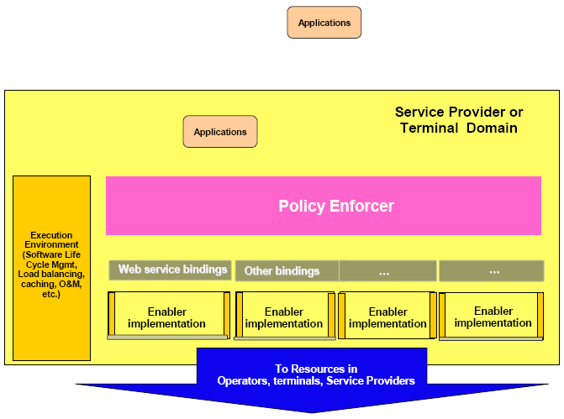
Figure 3 – OSE architecture elements

Proposal
In the previous section, we introduced the standard activities related to both applications and ASF&SSF (or service enabler). As the consequence, we know that applications completely differ from ASF&SSF (or service enabler).
This contribution proposes to divide Application Functions into two parts; Applications and ASF&SSF in the IPTV Architecture Document. Updated texts are proposed at next page.

Application Support Functions and Service Support Functions
This contains the common components for the IPTV and NGN services. The main role of this functional group is to an application to directly invoke one or more components to deliver a service. Some components are used by IPTV but other components are used by both IPTV and NGN (or IMS). Examples of components in ASF&SSF include Location, Presence, Digital Rights Management or EPG, etc.

Application Profile Function
Provides the functions for the application level storage and management of the customer’s profile.

Content Preparation
IPTV content including VOD programs, TV channel streams, metadata, EPG data, and DRM data are received from the Content Provider and prepared by the Content Preparation functions. First the content is acquired and is then managed (e.g. encrypted, etc…) before being delivered to the Content Preparation functions. Some simple content editing work may be done within the Content Preparation functions if necessary and permitted (e.g. Ad-insertion, subtitle or logo superimposing, etc.).

Applications
Applications are a primary means for initiating and consuming one or more components in ASF&SSF. Applications include IPTV application and NGN applications.

Figure 8-1 Functional Architecture for IPTV

-----------

