- Introduction
INTERNATIONAL TELECOMMUNICATION UNION |  |  |  | Focus Group On IPTV
TELECOMMUNICATION  STANDARDIZATION SECTOR  STUDY PERIOD 2005-2008 |  |  | FG IPTV-C-0794
 |  |  | English only
WG(s): 3 |  | 5th FG IPTV meeting  Geneva, 23-31 July 2007
CONTRIBUTION
Source: | Huawei Technologies Co., Ltd.
Title: | Some Updates to the Content Protection Architecture
This contribution focuses on Content Preparation component in the Content Protection Architecture. This component is originally shown in Working Document FG IPTV-DOC-0090. However, Working Document did not give a clear definition to the Content Preparation component. In this contribution, several functionalities are discussed in details. We suggest WG3 gives a definition to Content Preparation Component (or maybe some inner functions) and do some changes to the original Content Preparation Architecture.

- Discussion
  - Background
In Working Document (FG IPTV-DOC-0090) Section 9.2.1, Figure 9-2 illustrates Content Protection Architecture. A Content Preparation component is included in Service Provider Domain and interfaces to other four components (Content Source component, Content Delivery component and two watermarking components). It acts as the central point for content security enforcement.

However, there is no definition to this important component in the Working Documents. Content Preparation component has no path to acquire necessary key material from SCP server to perform content encryption. Furthermore, in some cases, Content Delivery component also perform content encryption and it also need keys supply from SCP server.

  - A General Definition to Content Preparation
ATIS IPTV High Level Architecture [1] has a same name component. The definition from ATIS is “Content Preparation – The functions required to convert the media files into their delivery format”. It may be a good starting point for the definition in WG3.

  - Who Performs Content Encryption
In general, off-line encryption is processed in Content Preparation component, while real-time encryption is processed in Content Delivery component. Off-line content is pre-encrypted with a symmetric key and packaged in some secure content container, such as OMA DRM DCF [2]. Real-time encryption is regarded as a processing function of network provider and often integrated in Content Delivery component.

  - Key Distribution Paths
As suggested in the last WG3 meeting, SCP Server plays a double role: Key Server for Conditional Access and DRM Server. SCP Server distributes keys to authenticated end users and enables them to consume content. This path is already shown in the Figure 9-2.
SCP Server should also provide keys to Content Preparation and Content Delivery components, in order to enable them to perform content encryption. However, these key distribution paths are not shown in the Figure 9-2. We suggest that WG3 modify original figure and add these key distribution paths to SCP Server.

- Proposals
- We suggest WG3 gives a clear definition to Content Preparation component or show some inner function blocks. This will be helpful to clarify its functionality and to further define its external interfaces.
- As discussed above, in general, Content Preparation and Content Delivery may both perform content encryption. SCP Server may distribute keys to these two components. We suggest WG3 adds two one-way arrows to Figure 9-2, which indicate key passing direction. They should start from SCP Server and end to Content Preparation component and Content Delivery component respectively.
- The following figure shows our modification.

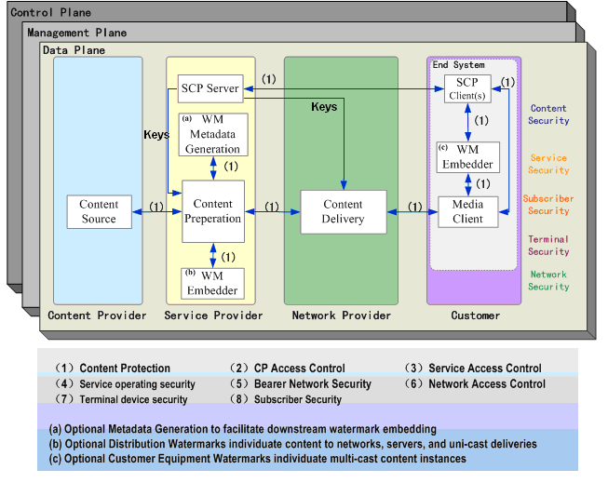

- References
[1] ATIS-0800007, IPTV High Level Architecture, ATIS-IIF, 2007
[2] OMA-TS-DRM-DCF-V2_0-20060303-A, DRM Content Format, Version 2.0, Mar 2006.

_________________

