INTERNATIONAL TELECOMMUNICATION UNION |  |  |  | Focus Group On IPTV
TELECOMMUNICATION  STANDARDIZATION SECTOR  STUDY PERIOD 2005-2008 |  |  | FG IPTV-C-0684
 |  |  | English only
WG(s): 2 |  | 5th FG IPTV meeting:  Geneva, 23-31 July 2007
CONTRIBUTION
Source: | NEC Corporation
Title: | Proposal for Modifications to FG IPTV-DOC-0088
Summary
This paper proposes two modifications to FG IPTV-DOC-0088. The first one is to mandate that a baseline decoder has a de-jittering function to absorb jitter induced by the FEC option. The second one is to clearly state to consider a CoP3 based multi-layer FEC as a low complexity FEC scheme for high bitrates and long burst losses.

- Consideration of Sending arrangement and De-jittering function
Currently WG2 agrees that FEC is an option, depending on the performance of the underlying transport network. Whether FEC is mandatory or not, it is better to mandate a baseline decoder to have a de-jittering function to absorb jitter induced by the FEC option like Annex A.1 of [1] (Figure 1(a)).
If the baseline decoder simply handles source packets at a constant rate, optional repair packets are also sent at a constant rate in order to keep the overall sending rate constant. As Annex A.2 of [1] describes, the repair packets of a current FEC block are distributed over the entire duration of the next block (Figure 1(b)). This arrangement restricts the maximum block size to one half of the latency budget. As a result, lack of the de-jittering function in the baseline decoder leads to inefficiency of FEC.
Figure 2 compares two overhead curves of the Ideal code with the A.1 and A.2 arrangements. The difference between the two shows the de-jittering function almost halves the overhead.
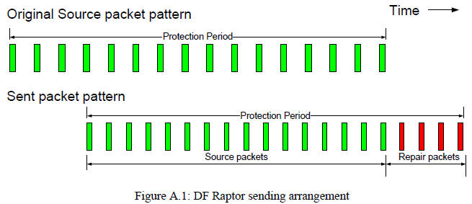 | 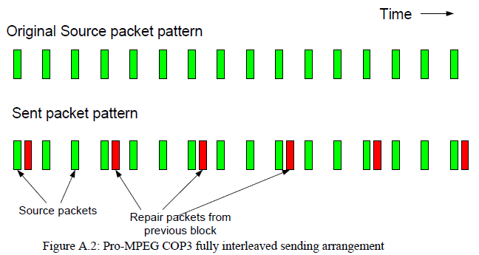
(a) Annex A.1 of [1] | (b) Annex A.2 of [1]
Figure 1: Sending arrangement
Figure 2: Minimum FEC overheads of the Ideal code with the A.1 and A.2 arrangements (6Mbps MPEG-2 Transport Stream, 400ms latency, Random Loss)

- CoP3 based multi-layer FEC
  - CoP3ML and CoP3UML
The column code of SMPTE 2022-1 [3] (CoP3) can be used as the first layer as well as subsequent layers in a multiple layered FEC like Annex E of [2]. We call this configuration as a multi-layer CoP3 (CoP3ML). In CoP3ML, the product of L and D is the same for the all layers to form a common source block. For example, when the first layer has (L, D) = (3, 30) and the second one has (L, D) = (5, 18), 8 repair packets are associated to a common source block of 90 packets. A decoder recovers lost packets with both of the layers while another lesser one does with only the first layer.
The restriction of the L-D product simply degrades the performance of CoP3ML. This document also evaluates CoP3UML as an unrestricted version of CoP3ML. CoP3UML uses CoP3 in the base layer and interleaved parity code very similar to CoP3 in subsequent layers.
Since CoP3ML and CoP3UML are based on CoP3, the computational complexity of them is still in a category of “lowest” as in B9 of [1].
  - Simulation conditions and results
Simulation conditions follow those of [1] with the following three modifications.
- 10Mbps is added to a set of bitrates, because IP retransmission of digital terrestrial broadcasting in Japan may be done at 10Mbps with MPEG-2 to H.264 transcoding.
- As the REIN model is used for DSL links in [1], a loss model of path change by routing update (PCRU) is newly introduced to evaluate FEC schemes over a dynamic routing network. The PCRU model is the same as REIN except its burst length is 30ms instead of 8ms.
- FEC minimum overhead is measured simply in terms of code performance. Since ITU can determine its packet format, overhead due to a certain format is excluded.
Simulation conditions are summarized as:
- Bitrates: 2Mbps, 6Mbps and 10 Mbps of MPEG-2 TS with 7-TS to 1-UDP packetizing
- FEC latency budget: 400ms
- Sending arrangement: Annex A.1 of [1]
- Loss models: Random, REIN and PCRU
- Simulation time: 96 hours
- Target MTBF of FEC decoding: 4 hours
- FEC schemes: Ideal, 2%-Overhead to Ideal, CoP3, CoP3r2 (2D), CoP3ML and CoP3UML
Simulation results are shown in Figure 3. Unlike CoP3 and CoP3r2, CoP3ML and CoP3UML achieve the target MTBF in most of the cases. They are good at high bitrates and at long bursts. Especially at 10Mbps with the REIN and PCRU models, CoP3UML works as well as 2%-Overhead even at high packet loss rate.

- Proposal
We propose to add the followings to WG2 Working Document: Application layer reliability solution for IPTV [4].
In 8.2 FEC, Before Table 1: AS DVB Document A115 shows, a thoughtless arrangement of source and repair packets restricts the maximum FEC block size to one half of the latency budget. In other words, lack of the de-jittering function in the baseline decoder leads to inefficiency of FEC.
In 8.2 FEC, Before Table 1: A recent contribution shows a CoP3 based multi-layer FEC works well at high bitrates and at long bursts. Its performance is comparable to 2% overhead to the Ideal code.
In 10 Conclusion: Although FEC is an option, it is mandatory that a baseline decoder has a de-jittering function to absorb jitter induced by the FEC option. The function may be called a null FEC.
In 10 Conclusion: To provide a low complexity FEC option for high bitrate applications, the CoP3 based multi-layer FEC should be considered.

- References
[1] DVB Document A115: DVB Application Layer FEC Evaluations, May 2007
[2] DVB Document A086 Rev. 4: Transport of MPEG 2 Transport Stream (TS) Based DVB Services over IP Based Networks, March 2007
[3] SMPTE Specification 2022-1: Forward Error Correction for Real-time Video/Audio Transport Over IP Networks
[4] ITU FG IPTV-DOC-0088: Working document: Application layer reliability solutions for IPTV

 | Random | REIN | PCRU
2Mbps
6Mbps
10Mbps
Figure 3: Minimum FEC overheads of the FEC schemes (MPEG-2 Transport Stream, 400ms latency)

This represents the worst case of Raptor.

