INTERNATIONAL TELECOMMUNICATION UNION |  |  |  | Focus Group On IPTV
TELECOMMUNICATION  STANDARDIZATION SECTOR  STUDY PERIOD 2005-2008 |  |  | FG IPTV-C-0545
 |  |  | Original: English
WG(s):2 |  | 4th FG IPTV meeting:  Bled, Slovenia, 7-11 May 2007
CONTRIBUTION
Source: | Korea (Republic of)
Title: | Consideration on Channel Zapping Time in IPTV Performance Monitoring
In the previous FG IPTV meetings, there was necessity of discussion for Channel Zapping Time. (Working Document #66 of WG2, performance monitoring for IPTV)
This document proposes several considerations of Channel Zapping Time in IPTV performance monitoring.

- Introduction
Channel zapping time is one of the hot issues in IPTV QoE performance because it is directly related with subscribers and service providers. In previous FG IPTV meetings, there has existed consistent necessity related channel zapping delay as a monitoring parameter in IPTV; but, actually no arrangements and descriptions except title was decided.
In this contribution, general concept of the channel zapping time is covered and elements which take part in this QoE parameter are described.

- Channel Zapping Time
Channel zapping time has strong relationship with end user experience of service quality. Generally, it is primarily determined by the time required to have a proper frame at the STB to start decode processing for the new channel. Channel zapping requests can occur when [1]:
- Meta data request in EPG or IPG
- Random selecting channel by entering channel number using remote control
- Channel Up/Down button using remote control
- Channel Up/Down button using STB front panel
- Selecting a channel on IPG application menu
- Powering on STB/TV and tuning to initial channel assigned by IPG

As the QoE parameter, channel zapping time can be described of three components: IGMP processing time, which includes join & leave process and snooping time; buffering time, which is correspond to buffering of multicast data; and decoding time, which decodes and renders given encoded one.

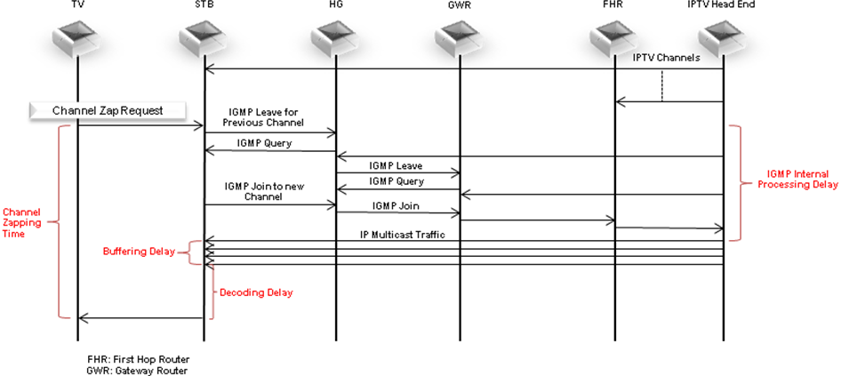
Figure 1 Overall Channel Zapping Process
  - Classification of Channel Zapping Time
    - IGMP Processing Delay
A channel zap request is triggered by a channel change which is mapped by STB to a multicast group address carried in the IGMP message. The IGMP message, which includes join message, is sent to HG (home gateway). HG, playing an IGMP proxy role, will process the IGMP message and send an IGMP request to the GWR (Gateway Router). After IGMP message is sent toward rendezvous point by GWR, corresponding the channel data is deliver to the end point.
    - Buffering Delay
During STB receives IPTV multicast traffics, it stacks those in buffer. Buffering delay is the time between the first multicast traffic arrival in buffer and the enough buffer that is capable of playing screen.
    - Decoding Delay
After STB starts to receive and buffers multicast stream, decoding delay processes buffered data and render them to TV screen. This type of delay includes both codec decoding delay, which intends to program-specific information frames in order to decide the target channel and I-frame acquisition delay, which is for reduction of bandwidth required for digital video transmission.

  - Requirements for Channel Zapping Time
To ensure interactivity and satisfactory QoE, the channel zapping delay needs to be below 2 seconds, and to guarantee the recommended MOS mapping with this delay, we can decrease this constraint below 2 seconds [3].
Typical STB de-jitter buffers can store 100-500 ms video, so network jitter must be within these limits [2]. Generally IGMP processing takes below 100 ms, and most of delay time is configured by buffering delay, because in ordinary case decoding delay has value less than 100ms. Moreover, as later two ones have trade-off relationship, the more buffer data we have, the faster decode processing is possible. In this sense, requirements for channel zapping time should be considered.

- Proposal
In the working document, FG IPTV-DOC-0066 (Performance monitoring for IPTV), section 7.1.3, “Channel Zap Time”, can be classified and has requirements for its elements based on this contribution.
Hereby we propose to compose the section 7.1.3 in the working document with contents of the section 2 in this contribution in below structure.

    - Channel Zap Time
      - IGMP Internal Processing Delay
      - Buffering Delay
      - Decoding Delay
      - Requirements of Channel Zapping Time

- Reference
[1] A Framework for QoS Metrics and Measurements Supporting IPTV Services, ATIS-0800004, ATIS
[2] Triple-play Services QoE Requirements, TR-126, DSL Forum,
[3] Perceived Quality of Channel Zapping, TNO
[4] T-Bridge, ETRI

