INTERNATIONAL TELECOMMUNICATION UNION |  |  |  | Focus Group On IPTV
TELECOMMUNICATION  STANDARDIZATION SECTOR  STUDY PERIOD 2005-2008 |  |  | FG IPTV-C-0539
 |  |  | English only
WG(s): 1 |  | 4nd FG IPTV meeting:  Bled, 7-11 May 2007
CONTRIBUTION
Source: | Korea (Republic of)
Title: | Clarification for IPTV architecture compared with NGN architecture
Abstract

This contribution proposes to update some text related Application Component Function in IPTV architecture document in order to align with Application Support Functions and Service Support Functions in NGN architecture.

Introduction

The “NGN-based IPTV architecture” means the IPTV architecture in accordance with [Y.2012] for providing IPTV services. The NGN components described in [Y.2012] are shown in Figure 6-1 in [FG IPTV-DOC-0062].
Although the above sentences show in IPTV architecture Document [FG IPTV-DOC-0062], the current IPTV architecture is not aligned with NGN architecture.
In order to maintain the consistency between two architectures, this contribution first outlines the concept of NGN architecture and then is trying to adapt the IPTV architecture to NGN architecture under consideration that IPTV service is one of the subsystems in NGN.

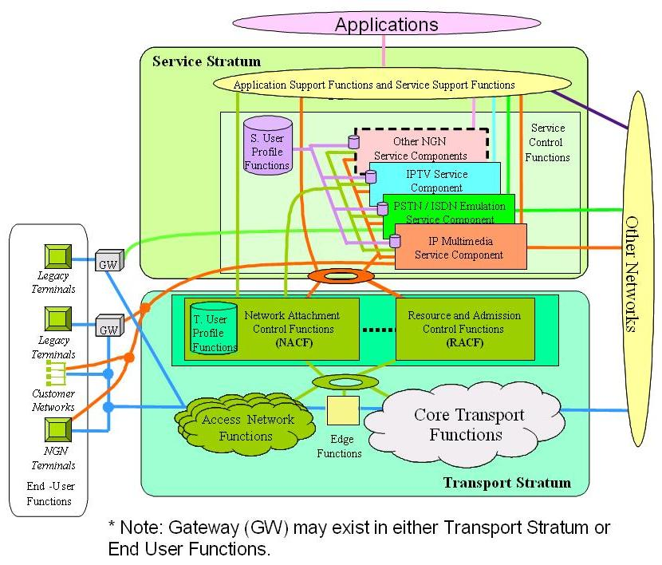
Figure 6-1: Transport and service configuration of the NGN

Discussion

1. NGN architecture Overview
NGN functions are divided into service stratum functions and transport stratum functions according to Y.2011.
The Service Control Functions in service stratum include resource control, registration, and authentication and authorization functions at the service level for both mediated and non-mediated services. The SCF includes functions for controlling media resources, i.e., specialized resources and gateways at the service-signaling level and accommodates service user profiles which represent the combination of user information and other control data into a single user profile function in the service stratum.
On the other hand, Application Support Functions and Service Support Functions in service stratum include functions such as the gateway, registration, authentication and authorization functions at the application level. ASF&SSF works in conjunction with the service control functions to provide end-users and applications with the NGN services they request.

Figure 1 NGN architecture Overview

Figure 2 illustrates NGN Functional architecture including both IMS and PES. The three CSC-FEs coloured with orange represent Core IMS to perform session control. The green colour box, AGC-FE belongs to PES. The FEs coloured with yellow, meanwhile, are common FEs used by both in IMS and PES.

Figure 2 NGN generalized functional architecture

Figure 3 shows the service stratum FEs.

Figure 3 Service stratum functional entities

The application support functions and service support functions interacts with other entities in the network as shown in Figure 4.
Application Support Functional Entity (AS-FE) supports generic application server functions including hosting and executing services. The examples of AS-FE are call feature application servers, presence servers, various messaging servers, conferences servers, home application servers, and so on.
Application Gateway Functional Entity (APL-GW-FE) serves as an interworking entity between the Application and the S-CSC-FE of the Service stratum. APL-GW-FE provides a secure open interface for the Applications to use the capabilities and resources of the NGN. The Applications connected to APL-GW-FE are usually realized by OSA Application Servers.
Application Service Coordination Manager Functional Entity (APL-SCM-FE) manages interactions between multiple application services (or servers). The functional entities of ASF&SSF might interwork with each other via APL-SCM-FE to provide convergent services to the end users.
Service Switching Functional Entity (SS-FE) provides access and interworking to a legacy IN SCP. For the IN services, the S-CSC-FE is connected through SS-FE to SG-FE to interact with a legacy IN SCP. It provides IN service switching functions including service trigger detection, service filtering, call state management, etc and the protocol adaptation function between INAP and SIP.

Figure 4 Application/service support functions

2. Adaptation of IPTV architecture to NGN architecture
In 8.1.2 Architecture Framework for IPTV, the definition of Application Components is described as follows.
Application Components: The functional components of the IPTV Application. The main role of this layer is to enable the use of the IPTV terminal to select, and purchase if necessary, and item of content. It will also contain support for content protection.
In this sentence, “to select item of content” means that a user selects a program channel which he/she wants to watch through IPG server and “content protection” indicates major role of DRM server. Application Components include DRM server as well as IPG server. In fact, Figure 8-3 shows more clearly the truth, even though the inconsistency happens between Figure 8-2 and the related text.
In addition, IPTV Application in page 16 is specified as follows.
IPTV Application - Provides the server side functions of the IPTV Application. In general, this supports selection of IPTV service and the browsing and selection of content with the service.
In this sentence, “selection of IPTV service and the browsing and selection of content with the service” indicates the functions of IPG server.

We thus can conclude that both Application Components and IPTV application represent DRM server as well as IPG server.

Considering NGN architecture, the role IPG/DRM server is similar to AS-FE in NGN in that both provide end-users and applications with the services they request.

In order to maintain the consistency between two architectures, both Application Component Functions and Service Component Functions are changed to Application Support Functions and Service Support Functions.

Proposal
This contribution proposes to update text related to Application Component Functions in IPTV architecture according to the suggestion in discussion section.

-----------

