INTERNATIONAL TELECOMMUNICATION UNION |  |  |  | Focus Group On IPTV
TELECOMMUNICATION  STANDARDIZATION SECTOR  STUDY PERIOD 2005-2008 |  |  | FG IPTV-C-0424
 |  |  | English only
WG(s): 4 |  | 3rd FG IPTV meeting:  Mountain View, USA, 22- 26 January 2007
CONTRIBUTION
Source: | Republic of Korea
Title: | Consideration on QoS and Resource Control in IPTV Multicast

1. Introduction
Multicast functions for IPTV service will not be performed in unique way with transport network as indicated another document of WG4 (Jan 22, 2007). The implementation of IPTV multicast functions will be diverse according to networking environments of IPTV service providers. Therefore, it is necessary to consider QoS and resource control in IPTV multicast in either transport stratum or service stratum, and in both. QoS and resource control in IPTV multicast approaches will affect IPTV application features and performance to support user’s requirements.
This contribution proposes some considerations to support QoS and resource control in IPTV multicast, as described below in section 2 and 3.

2. Functional Architecture of IPTV Multicast Management
For multicast function in the SCF, there consists of a session manager (SM) and a multicast agent (MA). The SM takes charge on group membership management and monitoring transport state while MA takes charge on send or receive application and forwarding function of IP multicast router. Both of MA and SM can be implemented by host or separate server.
The MA transfers resource control parameters (e.g. Flow direction, IP Address, Protocol Number, Bandwidth, MPLS Label.) to the PD-FE. The PD-FE establishes a negotiation based on these parameters.
It is necessary for session manager (SM) to provide a management functions for multicasting in wired and wireless and customer premises environment. Thus, SM interacts with multiple MAs (Multicasting Agents), for example MA-1 for wired environment, MA2 for wireless environment, and MA-3 for customer premises environment at transport stratum.
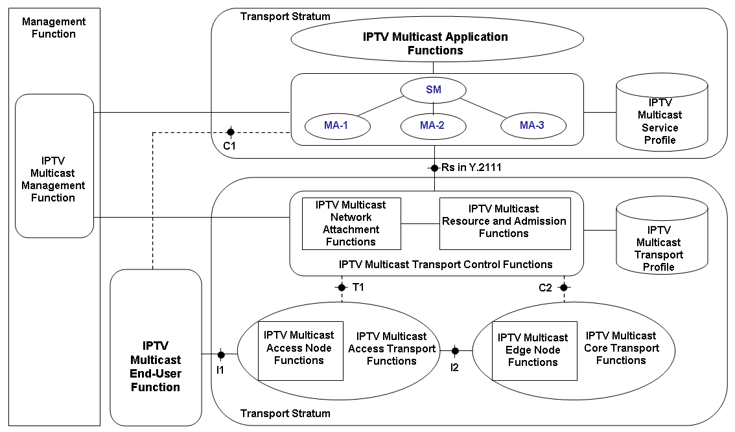
Figure 1. Interaction between service and transport stratum for Resource Control of IPTV multicast
. Each of IPTV multicast agents (MAs) in SCF can interact with PD-FE via Rs in Y.2111 reference point. Service control interface between service and the transport stratum. User profile information of IPTV multicast service and QoS parameters are delivered through Rs interface. IPTV Multicast session management provides unique group identifier in the network domain and interact with IPTV multicast transport control functions to assign group identifier. Each IPTV multicast flow is distinguished by a group identifier.
- The MAs provide information to the PD-FE to maintain the status information for multicast QoS service, performance, etc.
- Multicast agents (MAs) provide information to the PD-FE to identify media flows and their required resource (e.g. service QoS class, bandwidth) for multicast QoS service.
- The MAs may provide service information to the PD-FE to facilitate handling (e.g. wired, wireless, customer premises network).
- The MAs may request resource usage information through the PD-FE for accounting.

3. Functional Architecture for Resource/QoS Management in IPTV Multicast
It is necessary for SCF to send and receive following messages via C2 to PD-FE. For identify IPTV multicast group and service, the PD-FE may need to receive following messages from SCF.
- Application Identifier, Resource Control Session Identifier, and Transport Subscriber Identifier message can be used to uniquely identify a specific IPTV multicast group or service by PD-FE.
- Advertisements of multicast group membership may necessary Application Identifier, Media Profile messages.
- Solicitations of IPTV multicast service information could request only one multicast service information or a group of multicast services information. Application Identifier, Media Profile, and Resource Control Session Identifier messages can be used for this operation.
- IPTV Multicast session management is necessary for PD-FE to manage the IPTV multicast session information including multicast tree information. Resource Control Session Identifier and Resource Control Session Information, Media Profile messages can be used for this operation.
- Network resource controls to support QoS classes support a number of QoS levels for a IPTV multicast group while network resources are limited. Resource Reservation Mode, Media Profile messages can be used for this operation.
- In case of MAs support the interaction between wired network and wireless network.
[1] shows two main scenarios to control multicast flows in two ways, Figure 1 indicates the approach based on RACF and performing IPTV multicast resource admission control in the first transport node element (TRE-FE or PE-FE) which process the request to joint multicast tree (i.e. IGMP, MLD, …). And [1] and [3] introduce two elementary functions to handle the processing of IPTV multicast flow:
- Multicast Replication Function (MRF) which replicates packets sent to a multicast address; This Function could be localised within the TRE-FE (if packet replication occurs at layer 2) or PE-FE (if packet replication occurs at layer 3).
- IPTV Multicast Control Function (MCF), which controls and manages the requests to join and leave a IPTV multicast group. This function could be preferred to localize within the PD-FE. The MCF is within the PD-FE, and the RACF will decide if a new requested channel could be delivered or not, each time it receives a request to joint a IPTV multicast channel. If the requested channel is not present, the MCF checks if there are sufficient resources (bandwidth) in the subsequent network segment to deliver this new channel, before forwarding it to the customer. If the MCF rejects this request, it just does not forward the IPTV multicast request to the next node in the IPTV multicast tree.

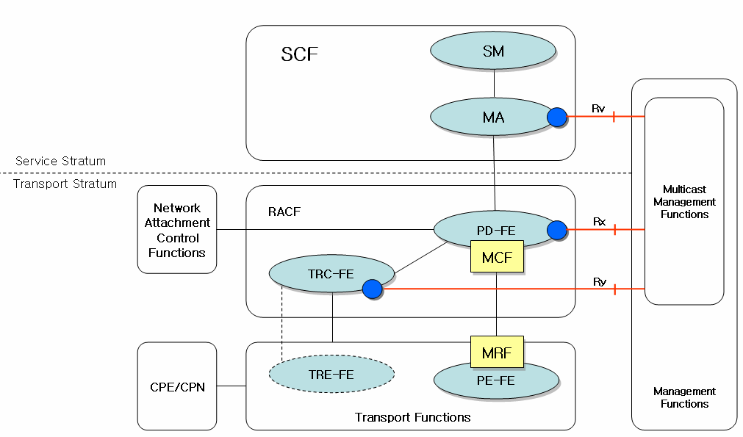
Figure 3 Architectural Scenario of Resource Management and QoS Control of IPTV Multicast

To support IPTV multicast service at the service stratum, PD-FEs may have a function that interacts with other PD-FE in other network. Between different networks, PD-FE communicates with others through Rd interface for sharing multicast QoS control received from SCF. PD-FE inspects both TRC-FEs in same network and other nearby network. This interaction may occur eventually at any time, so that PD-FEs can have information about QoS control over the different or same networks.
MA-1 can be applied existing multicasting mechanism in service stratum, but MA-2 must support following functional requirements because it must provide multicast mechanism in mobile environment.
MA-2 for mobile environment interacts with PD-FE, it is necessary considering the following.
- MA-2 should have MAID(Multicast Agent Identifier) of mobile device for smooth handover mechanism.
- This unique identifier enables the group administrator to know the location of each PD-FE.
- When MA-2 moves from one wireless network to another one, supporting smooth and fast handover is highly needed.
- PD-FE and MA-2 for wireless environment must be free from network fault such as loop and partitioning.
- When a PD-FE uses bidirectional tunnelling, mechanism, undesirable data duplication may occur inside wireless environment. To prevent this, PD-FE guarantees only one MA inside local network.

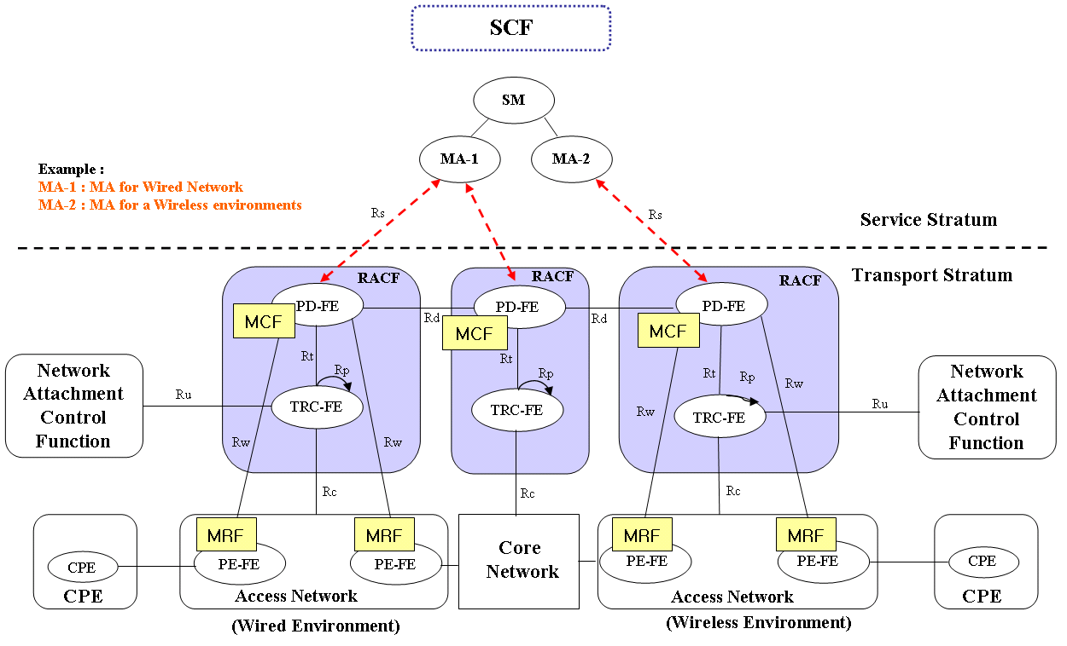
Figure 4 Global Architectural Scenario for QoS and Resource Control in IPTV Multicast

4. Conclusion
This contribution proposes some considerations to support QoS and resource control in IPTV multicast, as described before in section 2 and 3.

References
[1] France Telecom, “IPTV Multicast and Unicast in RACF”, T05-NGN-GSI/C-93, 24 Oct, 2006
[2] Huawei Technologies Co. Ltd., “NACF and RACF Consideration for Multicast”, T05-NGN-GSI/C-308, 8 Jan., 2007
[3] TISPAN, “Networking (TISPAN) Resource and Admission Control Sub-system (RACS) Functional Architecture", 2006.4
[4] ITU-T, “Functional requirements and architecture of the NGN”, T05-NGN-GSI/C-308, 8 Jan., 2007
__________________

