INTERNATIONAL TELECOMMUNICATION UNION |  |  |  | Focus Group On IPTV
TELECOMMUNICATION  STANDARDIZATION SECTOR  STUDY PERIOD 2005-2008 |  |  | FG IPTV-C-0423
 |  |  | English only
WG(s): 4 |  | 3rd FG IPTV meeting:  Mountain View, USA, 22- 26 January 2007
CONTRIBUTION
Source: | Republic of Korea
Title: | Documentation on “Multicast Requirements for IPTV Services”

1. Introduction
Considering IPTV information delivery pattern and service requirements, the multicast functions for IPTV service will not be performed in unique way with transport network. The implementation of IPTV multicast functions will be diverse according to networking environments of IPTV service providers. Therefore, it is expected that the functions to support multicast networking functions for IPTV service will be available in either transport stratum or service stratum, and in both.
Some SGs of ITU-T and other SDOs are dealing with making standards on IPTV multicast protocols and related issues. It is not necessary to handle the similar multicast issues at WG 4 of FG IPTV, but multicast approaches will affect IPTV service application features and performance criteria to support user’s requirements of IPTV services.
Since it will provide valuable roadmap in deployment of IPTV services to define multicast issues for IPTV services, this contribution stresses the importance to draft separate document with WD of WG4 of FGIPTV. And this contribution shows rationale to make another document for “Multicast networking requirements for IPTV services” and its documentation structure.

2. Functional Architecture for IPTV Multicast Control
As we understand IPTV services will provided by those with service provisioning capability, networking capability or both. Thus, it is important for multicast requirements of IPTV services to be classified at two levels, e.g., service stratum and transport stratum. And also it will be very necessary to provide a document for IPTV multicast requirements in considering IPTV service implementation and deployment. As shown in Figure 1, the functional requirements for IPTV services will be described at the transport and service Stratum.

2.1 IPTV Multicast Functions at Transport Stratum
Considering the deployment of IPTV services with multicast transport capability, the following functional requirements for multicast control at transport stratum will be necessary with existing transport networking capabilities for multicast functions in internet or NGN.
- Group management for IPTV multicast: A IPTV multicast group will be identified by the relevant mapping mechanisms with physical or logical identifiers of IPTV service users. In multicast transport control function for IPTV services, this functional entity manages the multicast sessions including multicast tree information, multicast domain, the QoS levels per multicast group and accounting information per user, etc. The multicast tree can be dynamically updated when joining and leaving IPTV customers. Depending on network topology and physical media, multicast tree path can be constructed by physical media (e.g., FTTH/PON and wireless LAN).
- Networking domain management for IPTV multicast: A multicast domain will be defined according to networking topology for IPTV service multicast, and it will be constructed with a set of multicast routing and forwarding topologies which multicast traffic goes through to the destination. That is, a multicast routing and forwarding domain will be mapped with a user’s multicast group, and the networking domain for IPTV multicast will be necessarily managed with required QoS level, security or other requirements. If its transport capability may provide many logical transport group over physical transport networks, many virtual transport networking domains will be constructed with QoS-enabled, security-enabled or particular requirements of IPTV services. The transport virtual networking mechanisms will be able to support a particular group for IPTV service. This is achieved by existing or specific group routing and forwarding capabilities in the transport network.

The multicast control functions will be applied to access network and core network differently, and the document will be necessary to consider the control functions at access transport networks and core transport networks as shown in Figure 1.
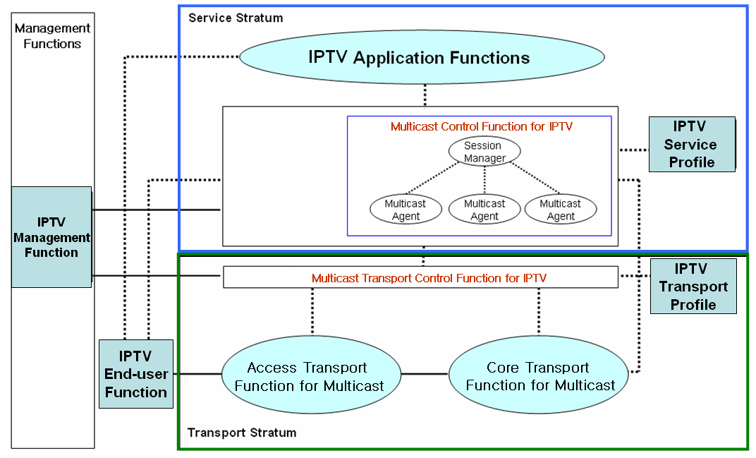
Figure 1 Functional Architecture for IPTV Multicast Control

2.2 IPTV Multicast Functions at Service Stratum
IPTV Multicast functions at service stratum will be another interesting issue in IPTV deployment by service providers. This is because IPTV service providers without transport networking capability will want to provide multicast function at service level. In deployment for IPTV multicast functions at service stratum there need to consider few requirements described below.
- IPTV service control functions include session control, session membership management and service user profile management at the service level.
- IPTV value-added applications will require various multicast control functions at service stratum. It could be controlled by specific multicast control functions dependent on the service features interaction, and requires an interface to notify the IPTV services to users.
- In order to provide dynamic topological change of IPTV service groups, multicast control functions will be performed in conjunction with registration, authentication, and authorization. at service stratum.

Some IPTV service providers may use relayed multicast mechanism through some particular application nodes, it constructs and manages relayed multicast functions to support internet group application services over the unicast-based network. Along the delivery path, real-time or reliable data transport channels are inter-connected between upstream and downstream IPTV multicast agents. After virtual data delivery channels over the transport network are established, IPTV group applications can work as if they were in a native IPTV multicast network shown in Figure 2.
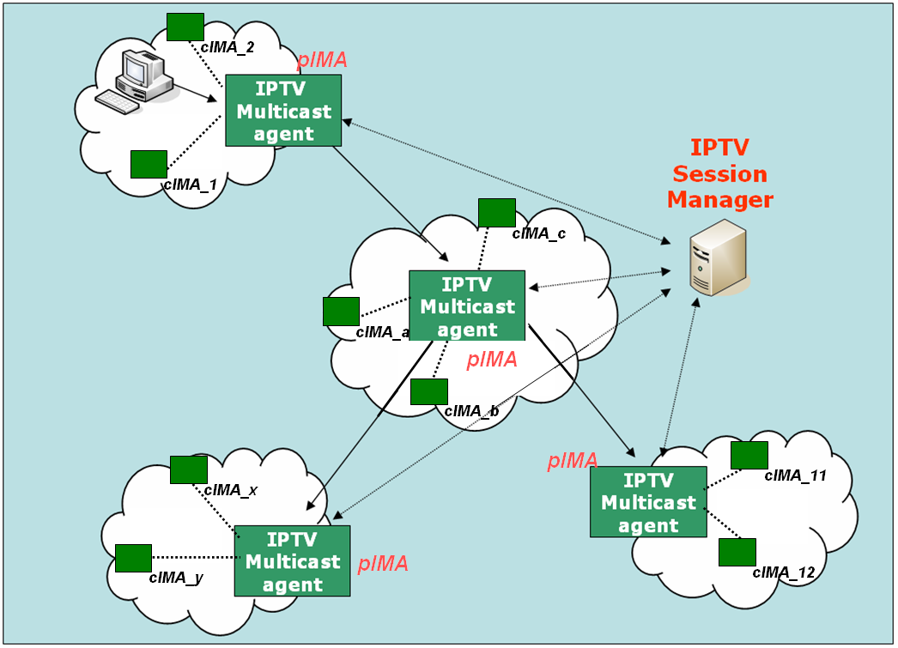
Figure 2. Functional Architecture for IPTV Multicast Capabilities at Service Stratum

IPTV session manager in Figure 2 is involved in session configuration and maintenance for IPTV service flows. It handles one or multiple sessions simultaneously, and it can provide the following functionalities:
- Session initialization: IPTV session manager allocates IPTV Session ID for new session.
- Session release: Session can be released as needed.
- Session membership management
- Session status monitoring:
- report the status of data channel
- data throughput
- multicasting protocol topology information gathering
- multicasting protocol membership management

- Overlay Multicast Control for IPTV Services
Existing reliable multicast mechanisms have unresolved problems including scalability, flow control, congestion control and etc. Until the related reliable multicast transport mechanism settles down, group communications requiring reliable data transfer are actually clinging to replicated unicast method based on servers. For example, Ethernet-based LANs and private networks such as corporate and campus networks substantially provide the multicast transport capability within their local subnet or administrative domains.
Recognizing these observations, there is a crucial need to develop an alternative multicast delivery scheme, overlay multicast approach. It makes good use of existing unicast, multicast and/or multicast tunneling schemes. In addition, overlay multicast is designed as several separate forms to support any kinds of group service type well. Overlay multicast will be controlled to provide virtual TCP or session connections over real transport network for IPTV services applications.
Figure 3 shows an architecture for “Overlay Multicast Functions for IPTV Services” The overlay multicast control function performs creation of virtual TCP or session connections and controls multicast capabilities for diverse IPTV service applications.
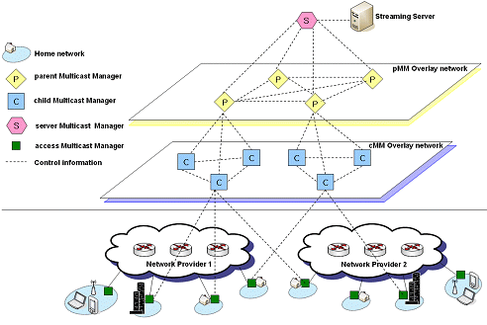
Figure 4 Overlay IPTV Service Multicast Control

3. Proposal
This contribution proposes that a documentation of Working Document for “Multicast Requirements for IPTV Services” at WG4 be necessary, and its content will be as follows.

“Multicast Requirements for IPTV Services”
Table of Contents
- Scope
- References
- Terms of Definitions
- Abbreviation, Acronyms and Conventions
- Multicast Framework for IPTV Services
- IPTV Multicast Transport Stratum Requirements
6.1 Access Transport Function
- Architectural Requirements
- Multicast Functional Entities for IPTV Services
- IPTV Multicast QoS and Performance Control
- Group/Accounting Management
- Security Issues
6.2 Core Transport Function
- Architectural Requirements
- Multicast Functional Entities for IPTV Services
- IPTV Multicast QoS and Performance Control
- Group/Accounting Management
- Security Issues
- Service Stratum Requirements
  - Control Requirements for Service Stratum
  - Multicast Functional Entities for IPTV Services
  - IPTV Multicast QoS and Performance Control
  - Group/Accounting Management
  - Security Issues
- Overlay Multicast Requiements
  - Overlay Control Requirements
  - Multicast Functional Entities for IPTV Overlay Multicast
  - IPTV Multicast QoS and Performance Control
  - Group/Accounting Management
  - Security Issues

----------------------------------------------

