INTERNATIONAL TELECOMMUNICATION UNION |  |  |  | Focus Group On IPTV
TELECOMMUNICATION  STANDARDIZATION SECTOR  STUDY PERIOD 2005-2008 |  |  | FG IPTV-C-0225
 |  |  | English Only
WG(s): 3 |  | 2nd FG IPTV meeting:  Busan, 16-20 October 2006
CONTRIBUTION
Source: | ETRI, Republic of Korea
Title: | Adhoc Results of the Content Security
- Introduction

Providing of an IPTV service is a content delivery process to the devices placed in home network via several paths and services. Content delivered to home network can be leaked out side of home by the mass storages and removable storages, so we should consider the content security to solve this problem.
In this adhoc group, we tried to analyse the input documents of FG-IPTV WG3 which was held in Geneva from 7th, September of 2006 and then we deeply deal with the requirements and architecture for content security. Therefore, this document does not include all related issues, and we welcome any requirements, contributions, additional comments, and etc.
In FG-IPTV WG3, we have classified four categories regarding the security related IPTV. First is service security, second is content security, third is network security, and last is device security. However, it is hard to have accurate classification because four securities have relationship with each other. Especially, service security and content security have very high relevancy and connectivity. Network security can be dealt with an independent issue because it deals with the security on the physical or logical network. Device security is related the content security because the device is final destination of the content for consumption.

- Definition of Content Security

In this group we defined the content security as a security to prevent the illegal copy and use of service during the process from content creation to final consumption and that content provider protects their own content.
The differentiation between service security and content security is that service security is related between a service provider and subscribers, and content security provides a security to the content itself. That is, content security can be defined as a security to protect the content where the content is.
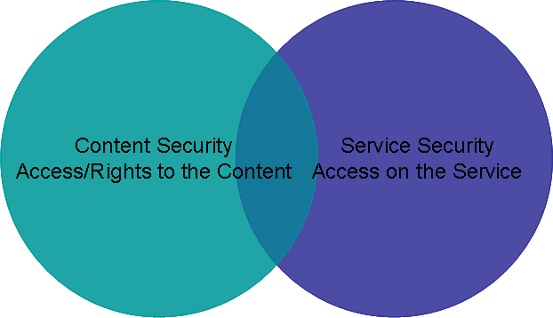
Fig 1. Service Security and Content Security (from OMA)

- Review of Input Document for Content Security

In the meeting held at Geneva, many input documents have dealt with several security issues. In this section, we would like to abstract the results of the review related content security among the input documents. If you need more detail reviews and details, please refer to Geneva Output Document of WG3 and input documents.
Although many input documents deal with the content security, the security issues have abstracted two technologies, Watermarking technology and DRM (Digital Rights Management) technology. Generally, content security also controls the delivery procedure because it controls the content usage to intervene in the procedure from content creation to content consumption. We should define the exact role of the delivery procedure, because it is duplicated by service security.
The document of ID-0063 defines the content security as a mandated technology needed in the content provider layer, and it explained that the use of technology is to protect content production, content transmission, content copy, and etc.
The document of ID-0051 deals with the digital watermarking technology as a content security to protect content copyright, and DRM technology as a service security and content security to protect in subscriber’s device.
The document of ID-0078 deals with the DRM as a content security and CAS (Conditional Access System) as a service security. They uphold the mixed architecture for CAS and DRM. The document of ID-0023 explains the CAS, DRM, and digital watermarking technology. It also suggests service and content security using DRM technology.
The document of ID-0086 deals with the possibility of service and content security using CAS and DRM. Especially they focused on how we use the several CAS and DRM technologies. For this, they introduced three concepts, DRM-EE(DRM End-to-End), DRM-B(DRM Bridging), and DRM-IX(DRM Interchange). Also it includes classifications by devices to be able to use individual DRM, and efficient DRM interoperability.
Most input documents deal with about DRM technology and they show that the technology is useful for content security and service security.
Digital Rights Management (generally abbreviated to DRM) is any of several technologies used by publishers (or copyright owners) to control access to and usage of digital data (such as software, music, movies) and hardware, handling usage restrictions associated with a specific instance of a digital work. The term often is confused with copy protection and technical protection measures (TPM). These two terms refer to technologies that control or restrict the use and access of digital media content on electronic devices with such technologies installed, acting as components of a DRM design.(by Wikipedia)
Nowadays there are many CAS and DRM technologies, and many companies and institutes that are developing their own technologies. Therefore if we choose only one technology for IPTV service it makes several problems and may suffer from an exclusive possession of the technology.
So we should consider DRM and CAS interoperability to take the advantages of IPTV service. Especially, we should solve the exclusive possession problems and give an option to the content provider.

- Conclusions

In this document, we reviewed the input documents submitted in the meeting at Geneva from the viewpoint of the content security. Similar to service security, content security is hard to clarify the technical application area. Especially, the application areas of DRM and CAS are not distinguishable because DRM can be used instead of CAS, and CAS accepts DRM function. Thus we should define the content security concept and consider supporting DRM interoperability to prevent exclusive possessions of technology.
  - DRM/CAS technology for content security should support the interoperability.
  - We should investigate in the following elements for interoperability and for other advantages. (ID-0086)
    - Authentication of devices, users and DRM systems
    - Rights Expression Exchange
    - Common encryption algorithms for content exchange
    - Key management and/or exchange for the common encryption algorithms
    - DRM Client to Receiving Device APIs
    - Secure download of DRM client
  - IPTV devices should have a trusted architecture to support interoperability of content security.
______________

