INTERNATIONAL TELECOMMUNICATION UNION |  | Focus Group on ICT&CC
TELECOMMUNICATION  STANDARDIZATION SECTOR  STUDY PERIOD 2005-2008 |  | FG ICT&CC-C-15
English only
Original: English
 |  | Geneva, 1-3 September 2008
CONTRIBUTION
Source: | Republic of Korea
Title: | USN use-cases for monitoring climate change

- Background of the proposal
FG ICT&CC has been launched to study the ICT impact against climate change, and one of its rationales is
- ICTs can also be used to monitor climate parameters (e.g. networks for environmental monitoring, Ubiquitous Sensor Networking)
As the rational mentions, USN can be a good monitoring tool against climate change in terms of both direct monitoring of climate changes and indirect learning of climate features.
This contribution introduces USN use-cases for the monitoring climate change. The use-cases will help to understand the applicability of USN in the climate change issues

- USN use-cases
“To fully appreciate the mechanisms underlying climate change, we must first understand the water cycle and its relationship to the climate. To do this, we must be able to accurately and precisely track water’s detailed movements within a given area”
The quoted sentences are from the ‘Berkely Science Review’ by Tim De Chant (in the Issue 14) on the explanation of their ‘watching the watershed’ project. It explains the importance of monitor climate changes which affect the natural phenomena. It also implies that the learning natural environment will help to understand climate change. This section introduces some of USN use-cases for monitoring climate change. It is noted that the USN use-cases in terms of monitoring and countering climate change are not limited to the listed items.

  - Sensing parameters
Sensor networks have been used to monitor environmental changes for more than decade and now it meets a new phase which the sensor networks are integrated to the network infrastructure. ITU-T uses the term Ubiquitous Sensor Network (USN) for the integrated network and service area. Sensor nodes can measure and deliver diverse environmental data such as:
- Pressure, Humidity, Temperature, Light, Chemicals, Strain and tilt, Speed and acceleration, Magnetic fields, Vibrations, Motion, Metal detection, Sound, etc.
The sensing parameters are used to measure climate change and understand climate phenomena. The issues are how to deliver the sensed data and to manage the data to make value-added information for countering climate change.

  - Direct climate change monitoring
In order to counter climate change, the most important thing is to monitor climate and natural phenomena from the climate change. Sensor networks has been studied to monitor climate for more than decade, however the techniques have been recently advancing enough to be practically used. This section will briefly introduce the examples of USN applications and services on this category. It is noted that the introduced examples do not limit the usage of USN in this category.

- Climate monitoring
Sensor networks are widely installed to the nature in order to monitor climate information. USN can enable the diverse services from the raw data as Figure 1 shows. The collected sensor data is used to understand the climate in the national meteorology centre, and also provided to the weather forecast service. The analysed data can be used for preparation or early-detection of natural emergency cases.
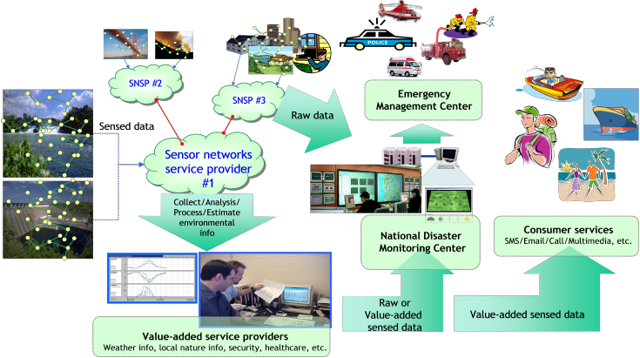
Figure 1 – An example service model for climate monitoring

- Marine environment monitoring
Jeju island, Republic of Korea has one of the biggest testbed of IP based USN. It shows the possibility to use IP enabled sensor nodes to directly connect to the IP infrastructure. The collected information from sensor nodes is delivered to the local weather station via wireless mesh networks. It helps to monitor real-time status of the seashore and marine environment.

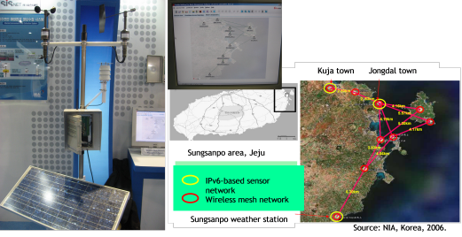
Figure 2 – A pilot project of monitoring seashore and marine environment

- Glacier monitoring
Researches to monitor glaciers are carrying out. In the 1st ITU symposium of ICT & CC, Nepal research and education network presented their study to observe glacier lakes and its danger. The technical lesson was presented: wireless network can be made work in remote areas; low-power self-sufficient devices embedded with appropriate sensors are needed to avoid big impact on fragile ecosystem; power storing technology still needs more work for remote and cold areas. This lesson fits the scope of USN which has the concept to connect sensed data to the existing infrastructure.
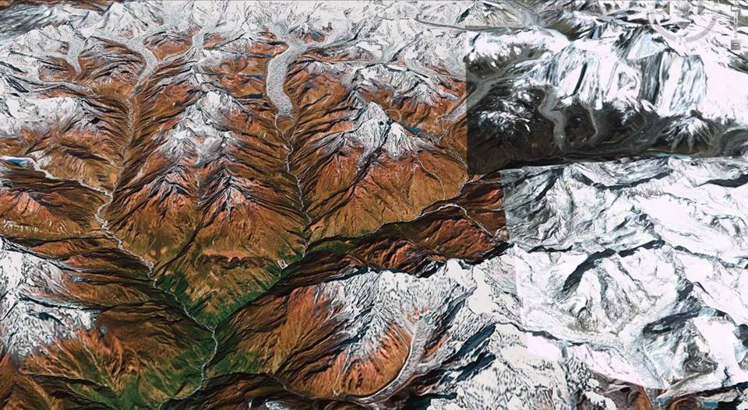
• Pangboche
• Dingboche
• Namche bazaar
• Chhukung Ri
• Kalapathar
• Quangde
• Tengboche
• Loboche (Pyramid)
• Phortse
• Everest base camp
• Imja lake
• Khumbu Glacier
• Everest
25 Km
Source: Nepal research and education network
Figure 3 – Monitoring glacier lakes in Himalaya

  - Monitoring and control of the emission of GHG
USN applications can be built up to automatically control the power consumption level to a certain threshold. In addition, the Monitoring information of the consumption of electric power and emission of air pollution can be used to alarm the users for users’ self-awareness. Various USN applications and services are in this category. The listed use-case is only to show the usage, not to limit the applications and services in this category.

- Management of city facilities:
This USN application manages city facilities like road, sewer line, or supply lines of water, electricity, or gas. Then maintenance systems can handle leakages, material fatigue, etc. The road management system captures road conditions and gives road weather information to drivers.
In terms of monitoring and control of the emission of GHG, the traffic control system can guide drivers to less crowded road based on sensed data and it will lead to emit less GHG.
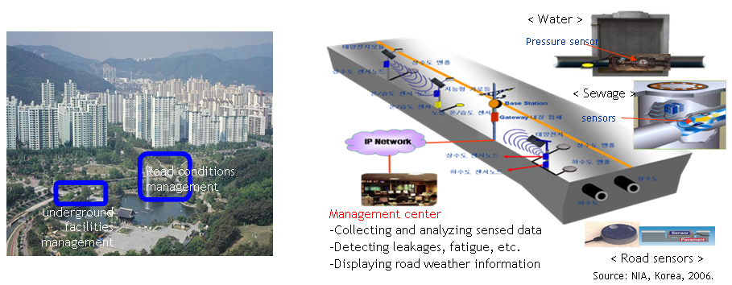
Figure 4 – u-city pilot project –Republic of Korea

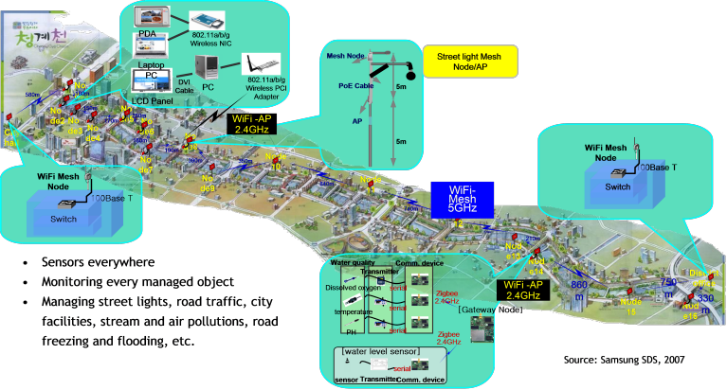
Figure 5 – Chung-gyeo-cheon streem in Seoul

- Home automation
Sensor networks are one of the key technologies for home automation. Light bulbs will be automatically control the appropriate brightness based on the information of the motion sensors. Home appliances and other electronic gadgets will save the energy when it is not used. On handheld LCD, the usage level of electricity from the collected sensed data will be shown to inform and alarm the power consumption. These monitoring and controlling systems will directly and indirectly lead less GHG emission.
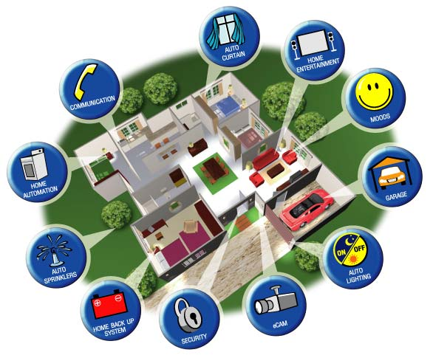picture source:CSEC solutions
Figure 6 –An example of home automation

- Industry automation and commercial building control
The level of power consumption and GHG emission of industries and commercial buildings cannot be comparable to home. In the same sense with home automation, it can be used for direct reduction of power consumption and indirect guide to reduce the power consumption.

  - Indirect monitoring to learn climate features
This category is very important to understand climate change. There are many USN applications and services in this category. The following examples do not limit the use-cases of this category.

- Watershed monitoring
“Understanding climate change is the fist step in developing strategies to deal with impending crises that could threaten global supplies for drinking, sanitation and irrigation.” The HydroWatch project in Berkley built up wireless sensor networks to more closely examine the water cycle. This is a good example to use USN to understand climate phenomena. USN can be widely deployed to monitor status and change of natural environment and help to learn the nature. The sensed results can be used to predict the future changes.
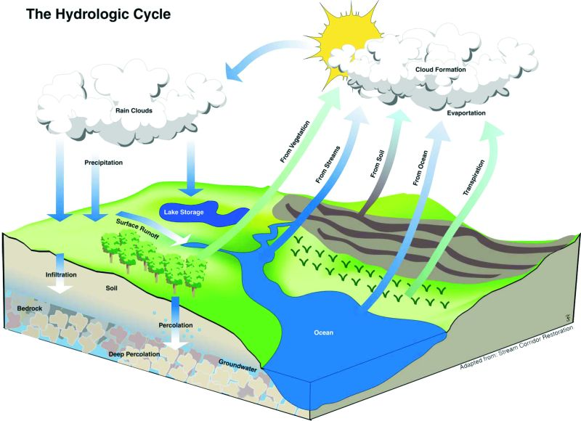Source: Berkely Science review
Figure 7 – Observation of hydrologic cycle

- Plants monitoring
Sensor nodes are installed in green houses or certain area of fields. The sensor network application monitors current cultivation environment and learn the habitant of plants based on the planting environment. Further, it can be used to manage optimal conditions for plants.

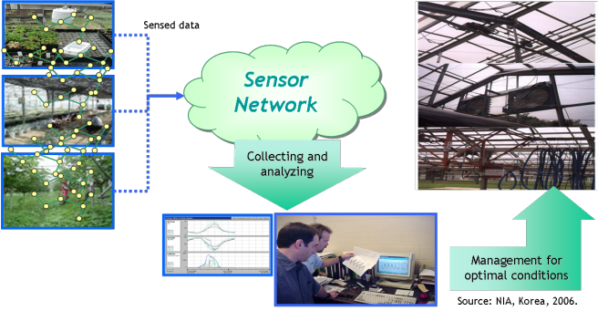
Figure 8 – Agriculture monitoring and management application

- Proposal
It proposes that appropriate FG ICT&CC deliverable includes the study of USN use-cases in a viewpoint of monitoring climate changes.

