INTERNATIONAL TELECOMMUNICATION UNION
Radiocommunication Bureau
(Direct Fax N°. +41 22 730 57 85)

Circular Letter  5/LCCE/4(Rev.1)* | 6 May 2008
To Administrations of Member States of the ITU
and Radiocommunication Sector Members participating in the work of
Working Party 5D of Radiocommunication Study Group 5

Subject: Second meeting of Working Party 5D on IMT systems

Introduction
At the kind invitation of the Administration of the United Arab Emirates, this letter is to announce that the 2nd meeting of ITU-R Working Party 5D will take place in Dubai, UAE from 24 June - 1 July 2008.

Place of the meeting
The meeting will take place at the:
Dubai Convention and Exhibition Centre
Sheikh Zayed Road
Dubai
United Arab Emirates
E-mail: itudubai@dwtc.com
Web: www.dicec.ae
For further information see Annex 2.

Programme of the meetings
A draft agenda for the meeting is contained in Annex 1. The Questions assigned may be found on:
http://www.itu.int/publ/R-QUE-SG05/en
Working Party 5D will conduct its work in English.

Contributions
Contributions in response to the work of Working Party 5D are invited*. Contributions will be processed according to the provisions laid down in Resolution ITU-R 1-5 and posted on the web.
The deadline for submission of contributions is Tuesday, 17 June 2008, 16:00 hours UTC.
According to the ITU-R patent policy (Annex 1 to Resolution ITU-R 1-5), contributions containing a proposal for a Recommendation should draw the attention to any known patent or to any known pending patent application relating to systems or technologies considered in the proposal.
Copies of each contribution should be sent to the Study Group Department, Radiocommunication Bureau, for processing, to the Chairman of the Working Party and to the Chairman and Vice-Chairmen of Radiocommunication Study Group 5. The pertinent addresses can be found on:
http://www.itu.int/cgi-bin/htsh/compass/cvc.param.sh?acvty_code=5
Participants are encouraged to submit contributions by electronic mail to:
rsg5@itu.int
Documentation
Contributions to this meeting are stored on the ITU web site at:
http://www.itu.int/md/R07-WP5D-C/en
A number of CD-ROMs containing all of the contributions will be available for participants at the start of the meeting. A CD-ROM containing all of the contributions and temporary documents will also be provided to each participant before the final plenary session.
Wireless LAN facilities will be provided in all meeting rooms and a cyber cafe facility will also be provided.
Participants are encouraged to use electronic working methods and to bring their laptops
(equipped with a CD-ROM drive and a WLAN-card) with them to the meeting. Please note that only a limited number of paper copies of the documents will be available at the meeting.

Participation
In order to make the necessary arrangements, it is requested that the intended participation of your representative(s) be advised no later than one month before the opening of the meeting by means of the annexed form (Annex 3). It is very important that participants requiring entry visas for the United Arab Emirates submit their applications at the earliest possible opportunity (see also § 5 and § 6 of Annex 2).
Valery Timofeev
Director, Radiocommunication Bureau

Annexes: 3

Distribution:

– Administrations of Members of the ITU and other members of the Radiocommunication Sector participating in the work of Working Party 5D of Radiocommunication Study Group 5
– ITU-R Associates participating in the work of Radiocommunication Study Group 5
– Chairman and Vice-Chairmen of Radiocommunication Study Group 5
– Secretary General of the ITU, Director of the Telecommunication Standardization Bureau, Director of the Telecommunication Development Bureau

ANNEX 1

Draft agenda for the 2nd meeting of Working Party 5D
(Dubai, 24 June – 1 July 2008)

1 Opening of the meeting
2 Approval of the agenda
3 Report on the 1st meeting of Working Party 5D (Doc. 5D/97)
4 Reports from Rapporteurs and Correspondence Groups
5 Working structure and document assignment
6 Any other business

S. BLUST
Acting Chairman, Working Party 5D

ANNEX 2
Additional information on the 2nd meeting of Working Party 5D

1 Introduction
The Telecommunications Regulatory Authority of the United Arab Emirates is pleased to welcome participants to the ITU-R Working Party 5D which will take place in Dubai, United Arab Emirates from the 24th June to 1st July, 2008. This annex provides information on the meeting and guidance to the delegates for their stay in Dubai.

2 Transportation and access
Dubai is a meeting point for destinations around the world with an average flying time of six hours or less from Europe, Asia, India and many parts of Africa.
Direct flights are now available to and from all of the continents of the world.
The Dubai International Airport is just 10 minutes drive from the Dubai International Convention and Exhibition Centre and within 25 minutes drive from most of the hotels.
Upon arrival at Dubai International Airport, we would recommend that you take a taxi to your hotel or the Convention Centre. The taxi fare will be approximately Dhs30.00 to Dhs50.00. For those delegates who arrive at Abu Dhabi International Airport the taxi fare will be approximately Dhs150.00 to Dhs200.00.

From the hotels to the meeting venue
The hotels are either on site or within 5 minutes walking distance of the Dubai International Convention and Exhibition Centre.

3 Meeting Venue
Dubai Convention and Exhibition Centre

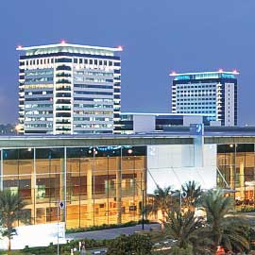

The Dubai Convention and Exhibition Centre is centrally located on the Sheikh Zayed Road.
Contact details are:
Dubai Convention and Exhibition Centre
Sheikh Zayed Road
P.O. Box 9292
Dubai
United Arab Emirates
Tel: +9714 332 1000
Fax: +9714 318 8744
E-mail: itudubai@dwtc.com
Web: www.dicec.ae

4 Hotel accommodation
TRA has booked hotels in Dubai either at the Convention Centre or within walking distance. If you wish to book a hotel room, please complete the attached form. Bookings will be made on a first-come, first-served basis. Bookings should be made by the 15th May 2008 at the latest.

5 Passports and Visas
A valid passport is required to enter Dubai. Please ensure that your passport is valid for at least 6 months beyond your intended stay.
Please note: Visas will not be processed without hotel accommodation.
Should you require a visa to enter Dubai, the visa requirements, the application form and the visa rates will be communicated by the hotel along with the room reservation confirmation. Upon receipt of the application form, please complete it and forward it to the hotel for processing together with a scanned copy of the passport, a credit card authorization form and a scanned copy of both sides of the credit card. Please ensure that the hotel receives all the required documents in time.
The visa rates applicable are between AED 180 (US$50) to AED 340 (US$94) depending on the processing time (Normal process or Urgent process). The visa fees are charged prior to processing and are non-refundable. Please allow for 7 to 10 working days after the submission of the documents for a visa to be issued, keeping in mind that the weekend in the UAE falls on Friday-Saturday.
Please note that as per the UAE regulations, all hotels charge a security deposit of AED 5000 (USD 1370) for each visa request. This deposit is refunded once the delegate has left the UAE, and the exit stamp page is faxed to the hotel. Please allow 2 weeks time to the hotel to process this refund after the receipt of the exit stamp page.
The following Nationalities do not require visa to enter Dubai and can obtain the entry permit on arrival.
GCC residents, Andorra, Australia, Austria, Belgium, Brunei, Canada, Denmark, Finland, France, Germany, Greece, Hong Kong, Iceland, Ireland, Italy, Japan, Liechtenstein, Luxembourg, Malaysia, Monaco, Netherlands, New Zealand, Norway, Portugal, San Marino, Singapore, South Korea, Spain, Sweden, Switzerland, United Kingdom, United States of America, Vatican.
For all other citizens, a visa must be obtained prior to arrival in the UAE.

6 Local contact
For any further information you may require, or if you need a personal invitation letter or official document for your visa application, please contact:
Mr. Khaled Al Kalbani
Public Relation Office
TRA
E-mail: Khaled.alkalbani@tra.ae
Tel: +97150 4440079

7 Currency and Banking
Banks
Many international banks are represented by branches in Dubai. Bank hours are 08:00 – 13:00, Saturday to Wednesday and 08:00 – 12:00, Thursday.
Credit cards
American Express, Diners Club, Visa, MasterCard, etc. are generally accepted in the main hotels and shops.
Currency
The monetary unit is the Dirham (AED), which is divided into 100 fils. It is fixed to the US dollar at a current rate of US$1 = Dhs 3.675. There are numerous currency exchanges in the shopping malls and the Convention Centre in Dubai. These are normally open from 10 am to 11 pm.

8 Language
The official language is Arabic but English is widely spoken and understood throughout the country.

9 Local Time
Gulf Standard Time: + 4 hours GMT (winter), + 3 hours (summer).

10 Tipping
Tipping practices are similar to most other parts of the world. Most restaurants include a 10% service charge, but tipping in general is at the customer’s discretion.

11 Electricity
The electricity supply in Dubai is 220/240 volts at 50 cycles. Standard, British square three-pin plugs are the norm in most hotels. US-made appliances may need a transformer.

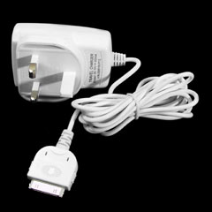

12 Climate
The UAE has a sub-tropical, arid climate with daytime temperatures ranging from a low of about 10 degrees Celsius in January to a high of 44 degrees Celsius in August. There is no rain in June or July. Whatever the month it is always pleasant as all the venues, shops and restaurants are air-conditioned year round.

13 Mobile phones
The United Arab Emirates has two operators Etisalat and Du. You can buy cards for both on arrival at the airport.

14 Tourist information
For any further information about tourism in Dubai you can visit the website www.dubaitourism.ae.

Attachment 1
Hotel accommodation for the ITU-R Working Party 5D
24 June – 01 July 2008, Dubai International Convention and Exhibition Centre, Dubai, United Arab Emirates

Dubai Congress Management (DCM) will handle all hotel accommodation for participants to the ITU-R Working Party 5D.
Dubai Congress Management
Dubai World Trade Centre
Dubai, United Arab Emirates
E-mail: itudubai@dwtc.com
Tel: +971-4-308-6634 / 6076
Fax: +971-4-318-8738

Hotel accommodation
DCM has booked hotels in Dubai at very special rates for participants to the meeting. Reservations will be made on a first-come, first-served basis. Please indicate your order of preference on the reservation form.

Hotel number | Name of Hotel | Room rate |  | Breakfast | Number of available rooms
Hotel number | Name of Hotel | Twin | Single | Breakfast | Number of available rooms
1 | Ibis – 3 star | AED 420 | AED 375 | Included | 45
2 | Novotel – 4 star | AED 535 | AED 487 | Included | 100
3 | Fairmont – 5 star | AED 1259 | AED 1067 | Included | 85

NOTES:
1. All Hotel rates include breakfast, 10% Service and 10% Municipality Fee.
2. Available rooms are valid from 23rd June to 2nd July (i.e. 3rd July, the checkout date).

Application and payment
Participants wishing to reserve hotel accommodation should complete the reservation form on the next page and return it by email or fax to DCM no later than 15th May 2008. Credit card data should be included on the form to guarantee the hotel reservation and to pay cancellation fees.
No reservation will be confirmed in the absence of this reservation form. All payment must be in AED.
The following credit cards are accepted:
1. American Express 2. MasterCard 3. VISA

Cancellation
In the event of cancellation, written notification should be sent to DCM. The following cancellation fees will be charged against your credit card, indicated on the next page.

Up to 31 days before the first night of stay - No cancellation fee
30 to 15 days before the first night of stay - 80% of total stay
14 days prior and including No-Show - 100% charge of total room nights

Changes to the accommodation dates will be accepted until 22nd May 2008.
Hotel accommodation reservation form for the meeting of
ITU-R Working Party 5D in Dubai, 24 June – 01 July 2008

Please complete and return this form by email or fax to:
E-mail: itudubai@dwtc.com
Fax: +971-4-318-8738
Deadline for room reservation: 15th May 2008

Full name: □ Prof. □ Dr. □ Mr. □ Ms. Do you require a Visa: □ Yes □ No
Family name: First name:
Organization:
Full address: □ Office □ Home

Postcode: Country:
Phone: + Fax: + E-mail:
Name of accompanying person(s), if any: □ Mr. □ Ms. Do you require a Visa: □ Yes □ No
Family name: First name:
Hotel accommodation
Please select the hotel number you wish to book from the hotel numbers 1 to 3 (see table on the previous page).
Hotel number | Number of room(s) | Date of check in and check out
1st choice . | Twin(s): .  Single(s): . | Check in June  Check out June / July
2nd choice . | Twin(s): .  Single(s): . | Check in June  Check out June / July
Credit card
□ American Express □ MasterCard □ VISA
Card number: Expiration date:
Name of card holder: Authorized signature:
Date: Signature:
NOTE:
1. All payment must be in AED.
2. This application will be valid upon receipt of confirmation from DCM.
Note: The boundaries and names shown and the designations used on this map do not imply official endorsement or acceptance by the ITU.
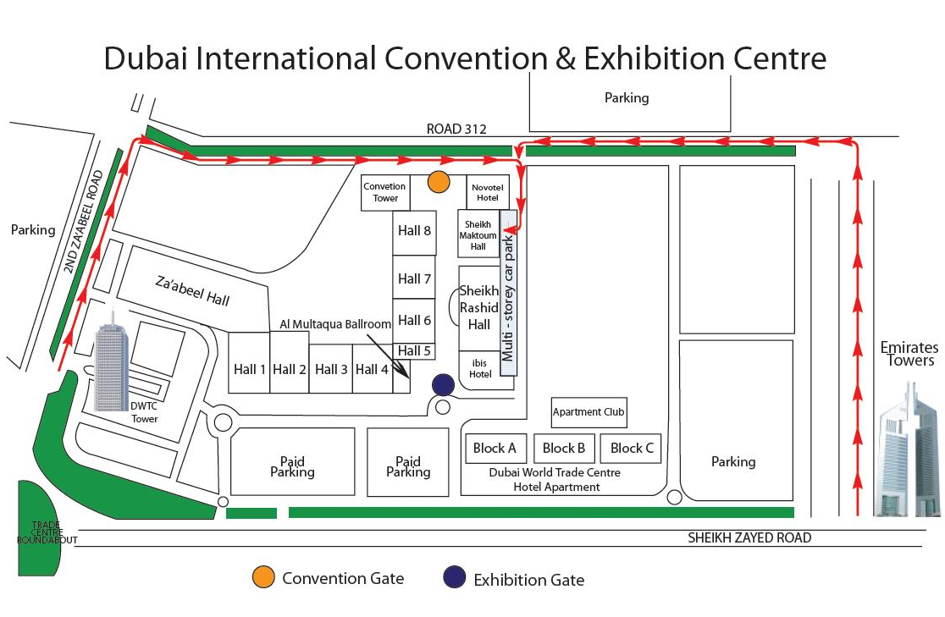

ANNEX 3  Working Party 5D  Dubai, United Arab Emirates, 24 June – 1 July 2008 | 
REGISTRATION FORM
Mr. Mrs. Ms. Miss: |  |  | ……………………………………………………………………. |  |  |  |  |  |  |  |  |  |  | ………………………………………………………………………………
 |  |  |  |  |  | (family name) |  |  |  |  |  |  |  | (first name)
Accompanied by family member(s):
 |  |  |  |  |  | (family name) |  |  |  |  |  |  |  | (first name)
1. REPRESENTATION
Name of Member State:
❒ Head of Delegation |  |  |  |  |  |  | ❒ Deputy |  |  |  |  |  |  |  |  | ❒ Delegate
(to be completed by representatives of Member States only)
Name of Sector Member:
r |  | Recognized Operating Agencies |  |  |  |  |  |  | r |  |  | Regional Telecommunication Organizations
r |  | Scientific or Industrial Organizations |  |  |  |  |  |  | r |  |  | Intergovernmental Organizations operating Satellite Systems
r |  | UN, Specialized Agencies and the IAEA |  |  |  |  |  |  | r |  |  | Other Entities dealing with Telecommunication matters
r |  | Regional and other International Organizations |  |  |  |  |  |  | r |  |  | Associates
2. OFFICIAL ADDRESS
Name of the Company:
Street Address: ……….
City/State/Code/Country:
Business tel.: ……………………………………………………………………………. |  |  |  |  |  |  |  |  |  |  |  |  | Fax: ……………………………………………………………………………
E-mail: ………………………………………………………………………………………. |  |  |  |  |  |  |  |  |  |  |  |  | In case of emergency:
3. DOCUMENTS
I wish to receive paper copies during the meeting: |  |  |  |  |  |  |  |  |  |  |  |  | r |  | Yes |  |  |  | r | No
Date: ………………………………………………………………………………… |  |  |  |  |  |  |  |  |  |  | Signature: ………………………………………………………………………….
 | For BR Secretariat use only
 | Approved (if applicable) |  |  | Personal Section |  |  |  |  |  | Meeting Section |  |  |  |  |  |  |  | Pigeonhole
 | To be returned duly completed to the Radiocommunication Bureau |  |  |  |  |  |  | Place des Nations  CH-1211 Geneva 20  Switzerland |  |  |  |  |  |  |  |  | Telephone: +41 22 730 5802  Telefax: +41 22 730 6600  Email: linda.kocher@itu.int

* English only.
* Contributors are urged to reduce the length of their contributions as much as possible. The recommended maximum length of an input document is 10 pages. Long documents should be structured as a small number of cover pages (preferably one) summarizing the document and an attachment containing the detailed information. The attachments of such long documents, when submitted as delayed contributions, would only be distributed on paper to the participants at the meeting, on request.

