INTERNATIONAL TELECOMMUNICATION UNION
Radiocommunication Bureau
(Direct Fax N°. +41 22 730 57 85)

Circular Letter  1/LCCE/66 | 24 November 2004
To Administrations of Members States of the ITU and Radiocommunication
Sector Members participating in the work of Task Group 1/8 of
Radiocommunication Study Group 1
Subject: Fifth meeting of Task Group 1/8 on compatibility between ultra-wideband devices (UWB) and radiocommunication services

Introduction
By means of this Circular Letter, we wish to announce that the fifth meeting of ITU-R Task Group 1/8 will take place in San Diego, California, at the kind invitation of the United States Administration, from 18 to 27 May 2005.

Place of the meeting
The meeting will take place at the:
Sheraton San Diego Hotel & Marina
1380 Harbor Island Drive
San Diego, CA 92101

For further information see Annex 1.

Programme of the meeting
Services directly connected with meeting activities, such as delegate registration, document distribution, etc. will be located in the vicinity of the meeting room. Registration of delegates will start at 08:00 hours on the opening day.
A draft agenda for the meeting is contained in Annex 2. The Questions assigned may be found on: http://www.itu.int/ITU-R/publications/download.asp?product=que01&lang=e. The Task Group will conduct its work in English.
Contributions
Contributions in response to the work of Task Group 1/8 are invited. These will be processed according to the provisions laid down in Resolution ITU-R 1-4, posted on: http://www.itu.int/ITU-R/study-groups/rsg1/rtg1-8/index.asp. Delegates are kindly requested to bring copies of all documentation to the meeting as duplication facilities are limited at the meeting venue. Participants will work essentially by electronic means. A CD-ROM containing all of the contributions will be provided to each participant at the start of the meeting.
One copy of each contribution should be sent to the Radiocommunication Bureau for processing. A copy should also be sent to the Chairman of the Task Group and to the Chairman and Vice-Chairmen of Study Group 1. The pertinent addresses can be found on:
http://www.itu.int/ITU-R/study-groups/index.asp (see Chairmen and Vice-Chairmen).
Participants are encouraged to submit contributions by electronic mail to:
adrienne.bonnici@itu.int
The deadline for submitting contributions is Wednesday, 11 May 2005 at 17:00 hours Geneva time. Documents received after this deadline will be forwarded to the next meeting of the Task Group.
Invitation
A copy of the invitation letter from the United States of America is reproduced in Annex 3.
Visas
Delegates are urged to apply, as soon as possible, for U.S. visas, if needed, to facilitate entrance to the United States. If a special invitation is required, please contact the meeting coordinator, Gary Anderson, indicated in Annex 1.
Participation
The intended participation of your representative(s) should be advised not later than one month before the opening of the meeting, by means of the annexed form (Annex 4) (to be photocopied as required).

Valery Timofeev
Director, Radiocommunication Bureau
Annexes: 4
Distribution:

– Administrations of Members of the ITU and other members of the Radiocommunication Sector participating in the work of task Group 1/8 of Radiocommunication Study Group 1
– ITU-R Associates participating in the work of Radiocommunication Study Group 1
– Chairman and Vice-Chairmen of Radiocommunication Study Group 1
– Secretary General of the ITU, Director of the Telecommunication Standardization Bureau, Director of the Telecommunication Development Bureau
Annex 1
(English only)
Information for participants
Meeting venue
The venue of the meeting is:
Sheraton San Diego Hotel & Marina
1380 Harbor Island Drive
San Diego, CA 92101
United States of America
Phone: +1 619 291-2900
Fax: +1 619 692-2337

The Hotel is located 5 km from centre of San Diego.
General directions
From San Diego International Airport: take the exit which becomes Harbor Island Drive and travel over the bridge. The hotel is on the right-hand side (about a 5 minute drive.)
From East: take Interstate 8 West to I-5 South. Then take the Sassafrass/San Diego Airport Exit. Turn right onto Laurel Street and then turn right onto Harbor Drive. Continue for 1.5 miles to Harbor Island.
From South: take I-5 North to the Hawthorne/San Diego Airport Exit. Turn right onto Harbor Island Drive. Continue for 1.5 miles to Harbor Island.
From North: take Interstate 5 South to the Sassafrass/San Diego Airport Exit. Turn right onto Laurel Street and then turn right onto Harbor Drive. Continue for 1.5 miles to Harbor Island.
Rates:
 | Single (in US$) | Double (in US$)
Run of House | 239.- | 239.-
Government rooms | Government prevailing rates
Club rooms | 299.- | 299.-
Suites | 450.- and up
Additional person | 20.-
The Sheraton San Diego will provide an Early Bird package for those who make their hotel reservations from contract signature date to 5 April 2005 that includes:
– a coupon for 10% off our outlets;
– complementary heath club access – valued at $10.- per day;
– complimentary guestroom telecommunications package – local, credita and 800 calls and high speed Internet access – valued at $15.- per day.
All rooms are quoted exclusive of applicable state and local taxes, which are currently at 10.545% (subject to change without notice). These rates will be offered three (3) days period and three (3) days after the meeting dates.
Cut-off rate
The “cut-off date” for accepting reservations into this room block is 26 April 2005. Reservations received after 05:00 p.m. local time at the Hotel on the cu-off date will be accepted at the Hotel’s prevailing rate, based on availability. Failure to reserve rooms before the cut-off date will not impact the enforceability of the attrition or cancellation clauses.
Early departure fee
In the event that a guest who has reserved a room within your block checks out prior to the guest’s reserved checkout date, and early departure fee of $100.- will be charged. Guests wishing to avoid this fee must advice the hotel at or before check-in of any change in the scheduled length of stay.
Additional concessions
The hotel will provide complementary airport shuttle transportation.
Room deposit
A deposit equal to one (1) night’s stay is required to hold each individual’s reservation. Such deposit shall serve to confirm the reservation for the date’s indicated, and, upon check-in, shall be applied to the first night of the reserved stay. These deposits paid by individuals are refundable if notice is received at least 72 hours prior to arrival and a cancellation number is obtained.
For more information, please contact the meeting coordinator:
Mr. Gary Anderson
URAXS Communications, Inc.
Tel.: + 1-858-964-3787
Fax: + 1-270-626-7652
E-mail: G@uraxs.com
For more information on the Sheraton San Diego Hotel & Marina
http://www.starwood.com/sheraton/index.html

Annex 2
(English only)
Draft agenda for the fifth meeting of Task Group 1/8
(San Diego, 18-27 May 2005)

1 Welcome by the Chairman and the United States of America
2 Approval of the draft agenda
3 Objectives of the fifth meeting
4 Chairman's report on the fourth meeting (Doc. 1-8/256)
5 Introduction and attribution of input documents to the Working Groups
6 Work programme, arrangements, and meetings schedule
7 Review and approval of output documents
8 Dates and venue of the sixth meeting, and its objectives
9 Any other business

S. HANNA
Chairman, Task Group 1/8
Annex 3
(English only)
Copy of the invitation letter
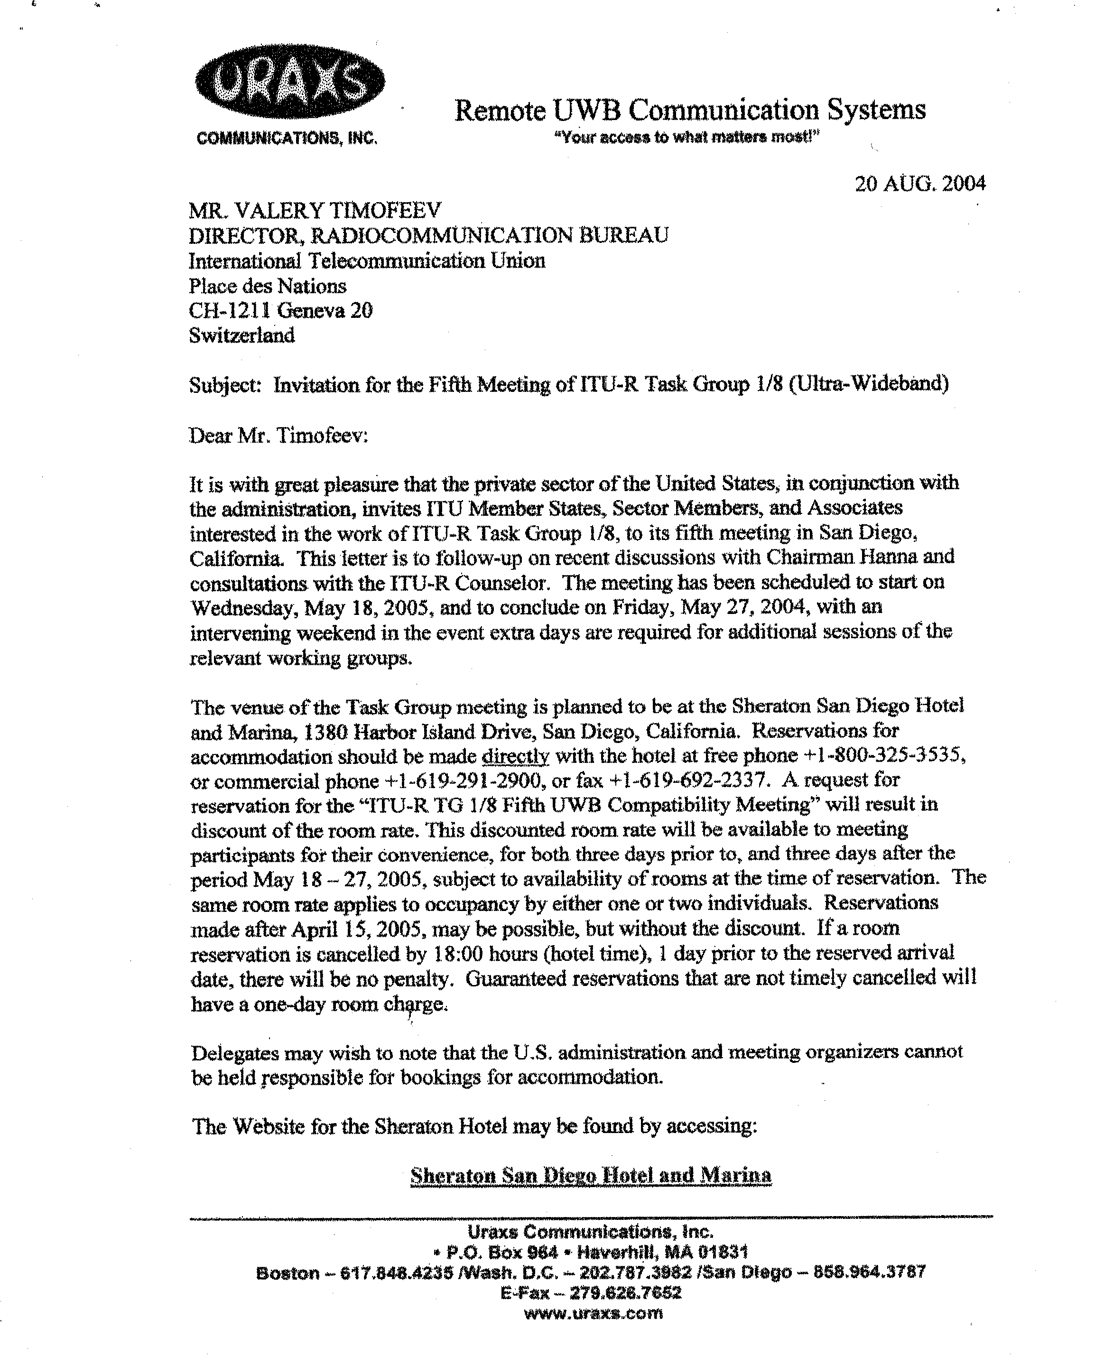

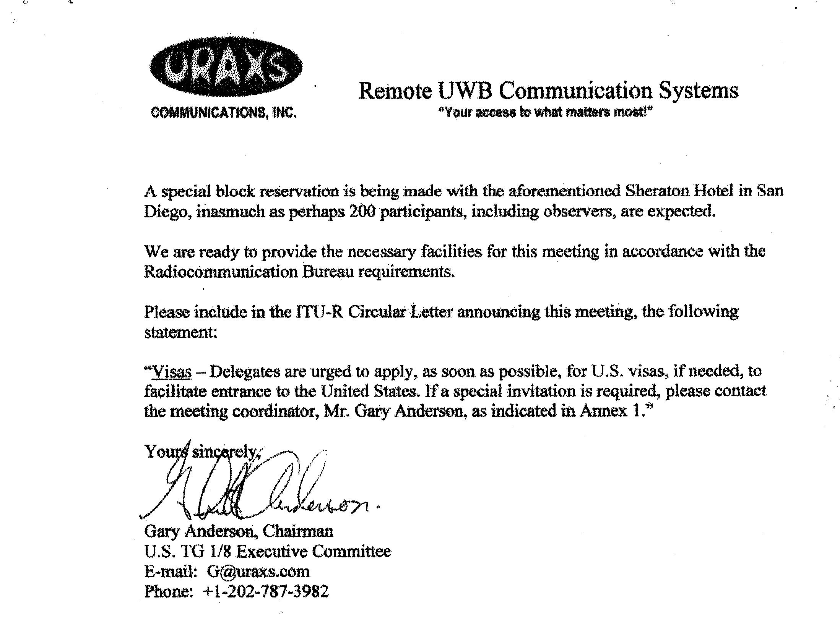
Annex 4
Registration Form
ITU-R Task Group 1/8 (UWB)
San Diego, California, 18-27 May 2005
Radiocommunication Bureau

I wish to participate in | Task Group 1/8 (UWB)
 | ✓

Mr. Mrs. Ms. Miss:
(family name) (first name)
Accompanied by family member:
(family name) (first name)

1. REPRESENTATION

Name of Member State:
❒ Head of Delegation  Deputy  Delegate
(to be completed by representatives of Member States only)
Name of Sector Member:
r Recognized Operating Agencies r Regional Telecommunication Organizations
r Scientific or Industrial Organizations r Intergovernmental Organizations operating Satellite Systems
r UN, Specialized Agencies and the IAEA r Other Entities dealing with Telecommunication matters
r Regional and other International Organizations r Associates

2. OFFICIAL ADDRESS

Name of the Company:
Street address:
City/State/Code/Country:
Business tel.: Fax:
E-mail: In case of emergency:
3. DOCUMENTS ☑ English only
Date: Signature:
For BR Secretariat use only
Approved (if applicable) | Personal Section |  | Meeting Section |  | Pigeonhole
To be returned duly completed to the Radiocommunication Bureau |  | Place des Nations  CH-1211 Geneva 20  Switzerland |  | Telephone: +41 22 7305802  Telefax: +41 22 7306600  Email: linda.kocher@itu.int

