INTERNATIONAL TELECOMMUNICATION UNION
Radiocommunication Bureau
(Direct Fax N°. +41 22 730 57 85)

Circular Letter  1/LCCE/57* | 13 January 2003
To Administrations of Members of the ITU and other members
of the Radiocommunication Sector participating in the work of
Radiocommunication Study Group 1
Subject: Third meeting of SG 1 Handbook Group on National Spectrum Management

Date and place
The third and last meeting of NSM Handbook Group will be held from 10 to 16 April 2003 in France, following the kind invitation of the French administration. The meeting will take place at the premises of THALES (THOMSON-CSF), 66 rue du Fossé-Blanc, (Room 630)
92231 GENNEVILLIERS. A copy of the invitation letter together with all practical information concerning the venue of this meeting, including hotel accommodation may be found in Annex 1.
Reservation for accommodation have to be made via the reservation form (Annex 5), which should be sent, whenever possible, before 7 March 2003 directly to the Hotel and the meeting co-ordinator.
Delegates may wish to note that THALES cannot be held responsible for bookings for accommodation.
The meeting will commence at 9:30 hours on 10 April 2003. The registration will start at 9:00 hours.
The informal meeting of Chapter Rapporteurs will take place on 9 April 2003 from 14:00 to 17:00 hours at the same premises.

For more information, please contact meeting Co-ordinator:
Mr. Philippe Mège
THALES Communications
Tel: + 33.1.46.13.21.45
Fax: + 33.1.46.13.21.33

e-mail: philippe.mege@fr.thalesgroup.com

Work programme and submission of contributions
The programme of the meeting is contained in a draft Agenda (Annex 2).
Contributions are invited along with the work programme as agreed in The Hague (Annex 3 and Attachment). These will be processed according to the provisions laid down in Resolution ITU-R 1. One copy of each contribution should be sent to the Director, Radiocommunication Bureau for processing. Contributions with indication of the contact person should also be sent to the Chairman of SG 1 and to the Coordinator/Rapporteur of the relevant Chapter. The pertinent e-mail addresses can be found in Annex 4 to this circular. Participants are encouraged to submit contributions by electronic mail to:
dusan.schuster@itu.int
Late contributions, received up to seven days prior to the meeting, are made available at the opening of the meeting in the original working language and, if possible, in English. The Secretariat cannot guarantee that documents received after the seven-day limit can be made available for the opening of the meeting. Resolution ITU-R 1 provides that contributions which are not available to participants at the opening of the meeting shall not be considered.
Documents may be found in the ITU Website:
www.itu.int/ITU-R/study-groups/sg/sg1/contribrep

Working language

The meeting will be conducted in English.

Participation
The intended participation of your representative(s) should be advised not later than one month before the opening of the meeting, by means of the annexed form (Annex 6)

Valery Timofeev
Director
Radiocommunication Bureau
Annexes: 6
Distribution:
- Administrations of Members of the ITU and other members of the Radiocommunication Sector participating in the work of Radiocommunication Study Group 1
- Secretary General of the ITU, Director of the Telecommunication Standardization Bureau, Director of the Telecommunication Development Bureau
ANNEX 1
A copy of the letter from THALES (French only)
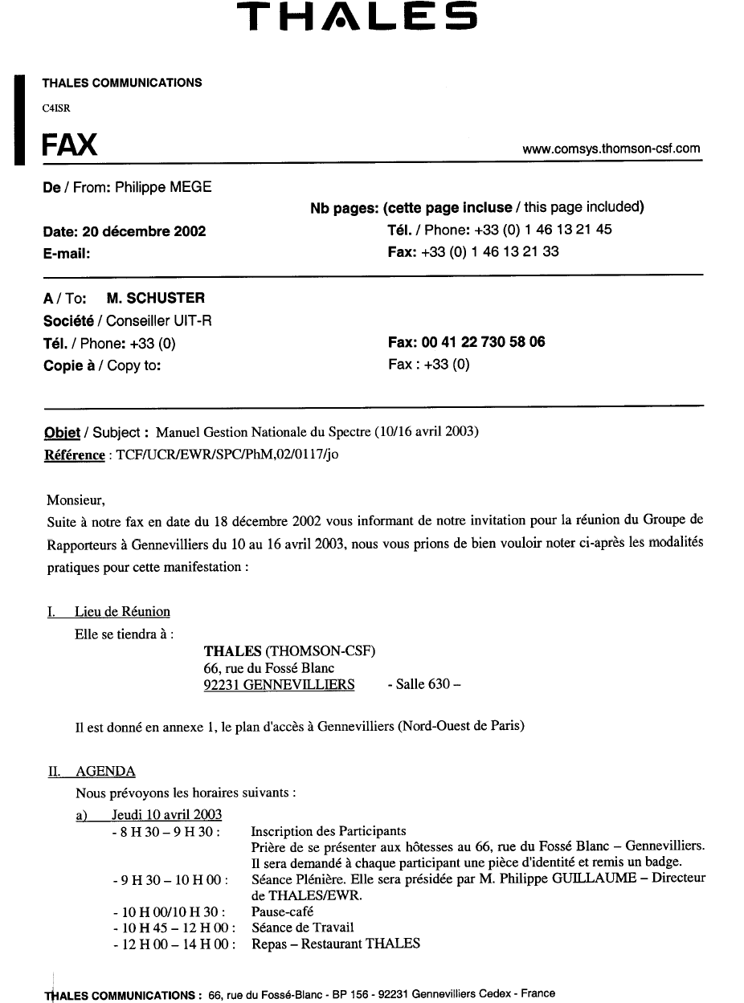
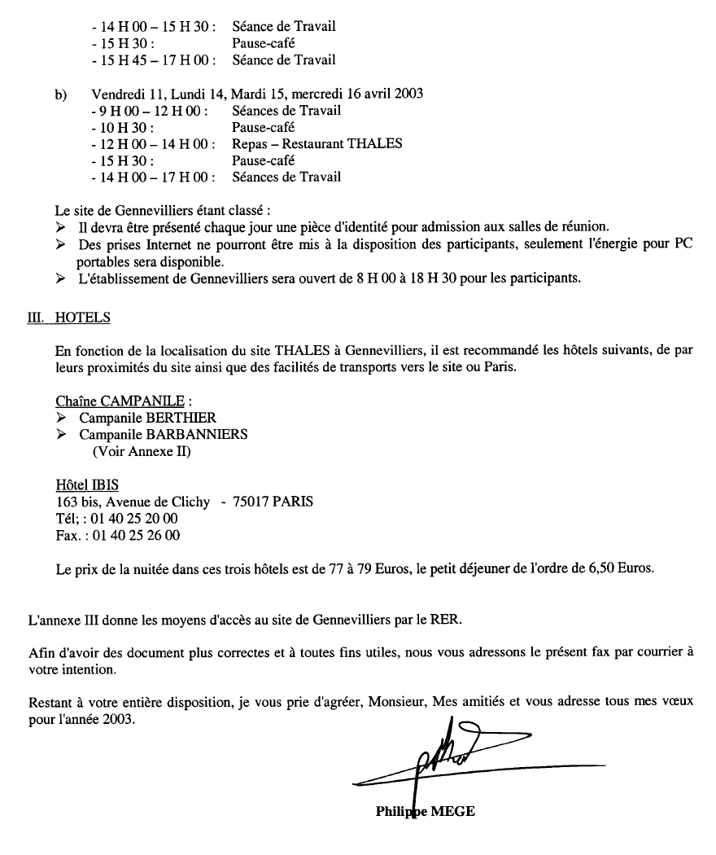

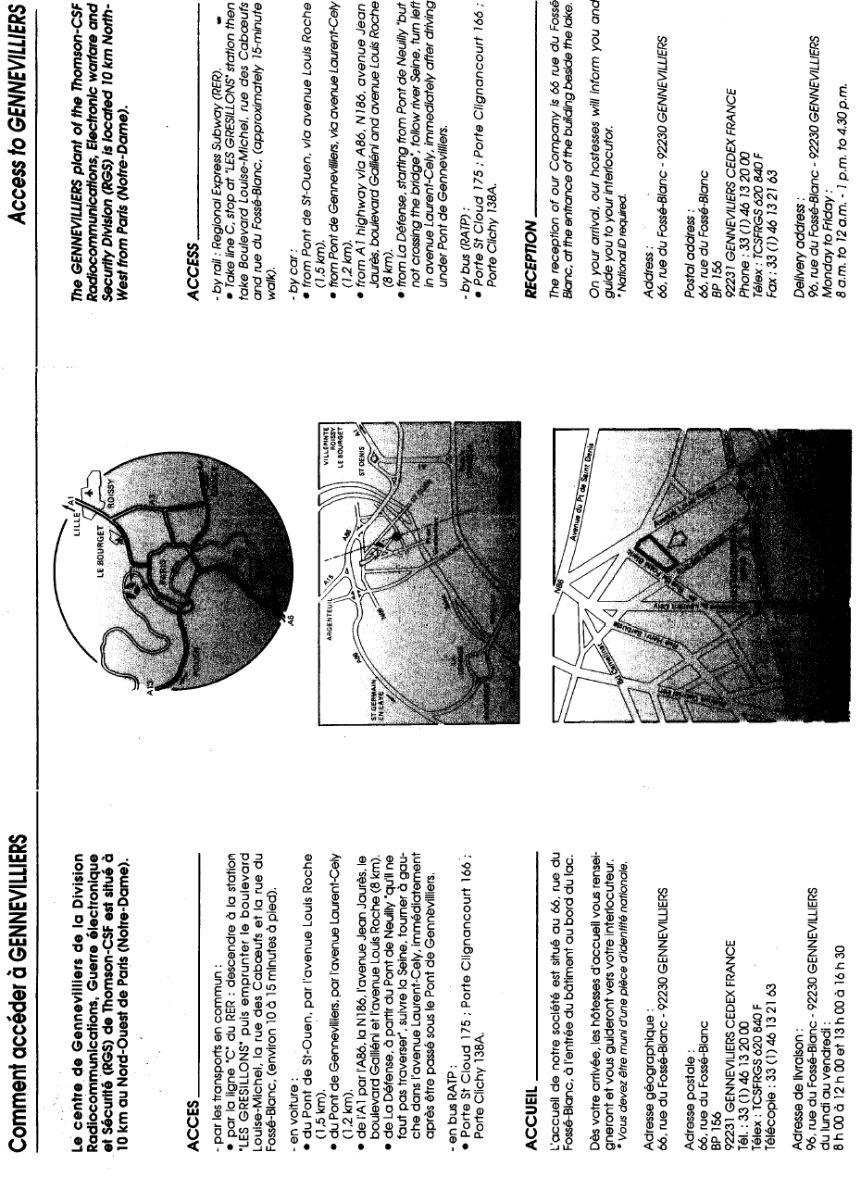

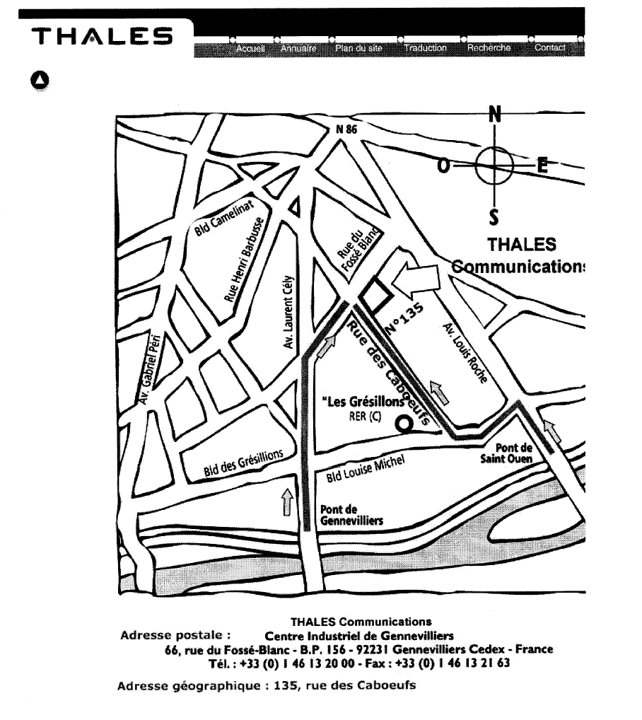

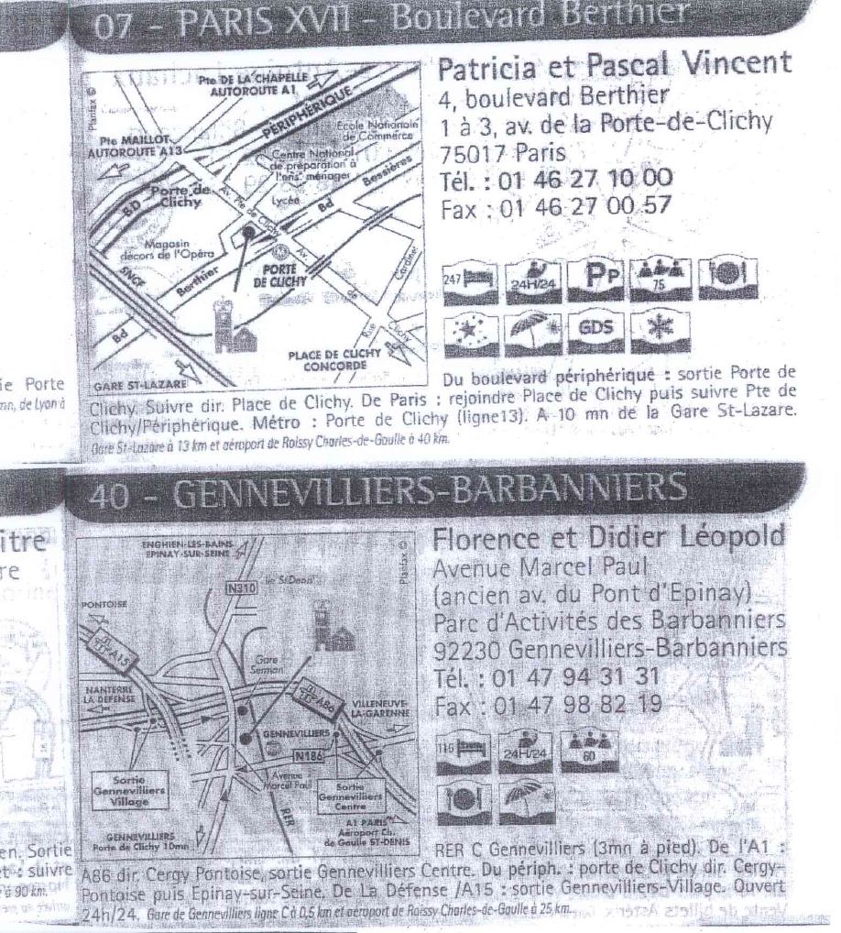

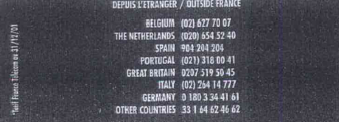
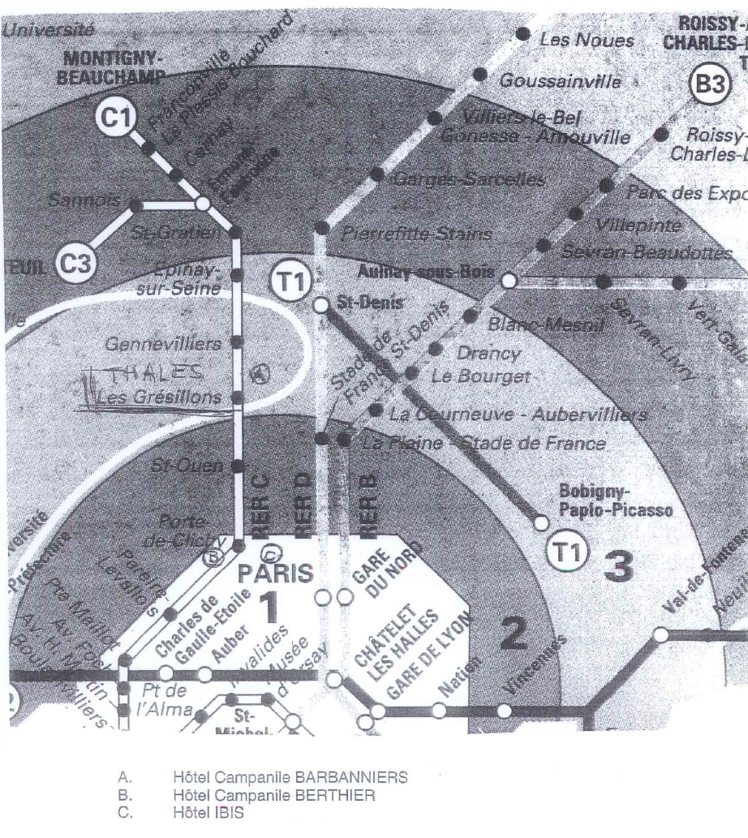

ANNEX 2

Draft Agenda for the Meeting of SM Handbook Group

(10-16 April 2003, GENNEVILLIERS, France )

1. Introductory remarks
2. Approval of Agenda
3. Consideration of the contributions by Chapters:
Introduction: Rapporteur: Mr. MAYHER R.- Chairman
Chapter 1 Rapporteur: Mr. MAYHER R.- Chairman
Chapter 2 Rapporteur: Mr. LUTHER W.
Chapter 3 Rapporteur: Mr. PAVLIOUK A., Mr. MEGE Ph.
Chapter 4 Rapporteur: Mr. VERDUIJN J.
Chapter 5 Rapporteur: Mr. BOND S.
Chapter 6 Rapporteur: Mr. BARRET D., Mr. DELMONTE H., Mr. MEGE Ph.
Chapter 7 Rapporteur: Mr. RACINE T.
Chapter 8 Rapporteur: Mr. TOPCU S.
Chapter 9 Spectrum Management Information available on the ITU-R website
Rapporteur: Mr. MAYHER R. - Chairman
ANNEX 1 Spectrum Management Training - Rapporteur: Mr. WOOLSEY R.
ANNEX 2 Spectrum practices - Rapporteur: Mr LUTHER
4. Conclusions
5. Any other business

Mr. MAYHER R.
Chairman

ANNEX 3

Source: Document 1-HNB-SM/35

HIGHLIGHTS OF THE HAGUE MEETING
(The Hague, 8-12 July 2002)

The second meeting on the HB-NSM was hosted by Mr. Jan Verduijn following the kind invitation of the Radiocommunication Agency of Netherlands. More then 25 contributions have been submitted and work progress was reported by the Rapporteurs.

In view of further harmonization of the texts and editing it was decided to hold a final meeting of this group in April 2003 in France, following the kind invitation by Thales, extended to the participants by Mr. Ph. Mège.

Following the discussion it was agreed, interalia, that:
- Chapters 2 and 5 in their consolidated versions will be submitted by the Rapporteurs to the Councillor by end September.
- Mr. Ph. Mège was appointed as co-Rapporteur on Chapter 3 (Licencing).
- Mr. S. Topcu was appointed Rapporteur for new Chapter 8 (Spectrum Efficiency).
- Mr. B. Mayher will prepare the texts for Chapter 9 (old Chapter 8).
- Glossary will be prepared for its inclusion at the end of the Handbook in a similar way as for Handbook on Spectrum Monitoring.
- Table of contents will be incorporated at the beginning of the Handbook.
- The statement and/or conclusions which the Rapporteurs consider important, should appear in BOLD print.
- Colour print should be used when preparing for final edition.

The follow up activities with associated calendar are given in Attachment 1.

Attachment 1 to annex 3
AGREED WORK PROGRAMME AND TIME MANAGEMENT
(last meeting in April 2003)

July - December
Participants at HB(2) meeting may wish to assist further the Rapporteurs in consolidating the texts following the The Hague decisions. The Rapporteurs notify in due course the Chairman and the Counsellor on the The Hague version of their Chapter. The Hague texts will be circulated to all participants by the Counsellor.

December 1, 2002
The Rapporteurs complete their Chapters on the basis of HB(2) and any other any other relevant input, as appropriate. The Rapporteurs exchange their draft texts with each other inviting comments and copying Chairman and Counsellor with this correspondence. The contributions from Administrations, if any, are posted as they are submitted to the ITU. The letter of invitation relevant to the 3rd meeting is dispatched.

January 31, 2003
The Rapporteurs are offering their respective comments directly to their colleagues Rapporteurs, with a copy to the Chairman and Counsellor.

March 6, 2003
The Rapporteurs are taking account of these comments and any new contribution by MS and SM and are submitting consolidated version of draft texts to the Counsellor. He will notify immediately all Rapporteurs and Chairman with these texts and inform them on general work progress. The texts are posted as working documents for the 3rd meeting.

March 27, 2003
The Rapporteurs who wish to make additional comments on the published texts may do so by this date. They are submitted to the Counsellor who will publish them as additional documents for the meeting.

April 3, 2003
Publishing of the CD-ROM one week before the meeting 10-16 April.

NOTE - The preparation for the 3rd meeting and consultation required will be done exclusively by using electronic means. The paper copies will not be distributed and CDROM will be offered to all participants. Participants in the final meeting are expected to download their documents from the ITU-FTP-area.
ANNEX 4
Rapporteurs and Co-ordinators HB-NSM

No | Name | Country/  Organization | E-mail address | Telephone number | Fax number
1. | Mr. R.J. Mayher | USA, Chairman | rjmayher@aol.com | +12524267169 | +12524265577
2. | Mr. T. Jeacock | United Kingdom | terence.jeacock@ties.itu.int | +442072110004 | +442072110021
3. | Mr. W. Luther | USA | wluther@fcc.gov | +12024180729 | +12024187270
4. | Mr. H. Del Monte | United Kingdom | howard.delmonte@ra.gsi.gov.uk | +442072110090 | +442072110047
5. | Mr. Ph. Mege | France, THALES | philippe.mege@fr.thalesgroup.com | +33146132145 | +33146132133
6. | Mr. A. Pavliouk | Russian Federation | pavliouk@ties.itu.int | +70952671841 | +70952611108
7. | Mr. T. Racine | Canada | racine.thomas@ic.gc.ca | +16139904767 | +16139907287
8. | Mr. D. Schuster | ITU | dusan.schuster@itu.int | +41227305216/  +41792173548 | +41227305881
9. | Mr. J.J. Verduijn | The Netherlands | jan.verduijn@at-ez.nl | +31505877405 | +31505877400
10. | Mr. R. Woolsey | USA, TCI | roy.woolsey@dielectric.spx.com | +16509415236 | +15106876101
11. | Mr. E. Tin | Turkey | isyam@bilkent.edu.tr | +903122902457 | +903122902410
12. | Mr. S. Topcu | Turkey | topcu@ee.bilkent.edu.tr | +903122902457 | +903122902410
13. | Mr. S. Bond | United Kingdom | stephenbond1@compuserve.com | +442072110001 | +442072110021

ANNEX 5
Hotel reservation form

ITU-R Handbook Group on National Spectrum Management
10-16 April, GENNEVILLIERS, France

Hôtel IBIS
163 bis, Avenue de Clichy
75017 PARIS
Tél : 01 40 25 20 00
Fax : 01 40 25 26 00

Name  ........................................ | Initials  ........................................

Company/Organisation
........................................

Business address
........................................

Postcode and City
........................................

Country
........................................

Credit card number  ........................................ | Exp. date  ........................................

Telefax  ........................................ | Telephone  ........................................
E-mail

Date of arrival  ........................................ | Approximate time of arrival at hotel  ........................................................

Date of departure
........................................

Signature

Hotel reservation form must be returned before 7 March 2003 directly both to the hotel and the meeting co-ordinator (Mr. Philippe Mège).

annex 6
Registration Form
SG 1 Handbook Group
10-16 April 2003, Gennevilliers
Radiocommunication
Bureau

I wish to participate in | SG 1 HNB Group
 | ✓

Mr. Mrs. Ms. Miss:
(family name) (first name)

Accompanied by:
(family name) (first name)

Name of Member State:
(to be completed by representatives of Member States only).
Name of Sector Member: ..
❒ Recognized Operating Agencies
❒ Scientific or Industrial Organizations
❒ Regional and other International Organizations
❒ Regional Telecommunication Organizations
❒ Intergovernmental Organizations Operating Satellite Systems
❒ Other Entities Dealing with Telecommunication Matters
❒ United Nations and its Specialized Agencies

Name of the Company:
Street address:
City/State/Code/Country:
Business tel.: Fax:
E-mail: In case of emergency:
Date: Signature:

For BR Secretariat use only
Approved (if applicable) | Personal Section |  | Meeting Section |  | Pigeonhole
To be returned duly completed to the Radiocommunication Bureau |  | Place des Nations  CH-1211 Genève 20  Switzerland |  | Telephone: +41 22 730 5815  Telefax: +41 22 730 5806  Telex: 421000 UIT
_________________________

* English only

