 | INTERNATIONAL TELECOMMUNICATION UNION
 | RADIOCOMMUNICATION  ADVISORY GROUP  GENEVA, 27 - 31 JANUARY 2003 | Delayed Contribution  Document RAG03-1/28-E
 |  | 17 January 2003
 |  | French and English only
France
wrc-03 preparation
improving logistics for e-working
This contribution could be examined under agenda item 4.2 of the RAG draft agenda.

1 Introduction
WRC-03 will take place in June-July 2003 in the same premises as CPM02-2 in November 2002. So it is of special relevance to take advantage of this experiment so as to improve the Conference effectiveness.

2 Proposals to improve logistic and working methods at WRC-03
a) Electronic access to contributions and conference documents:
It is to be noted that timely access to electronic documentation is not only an improvement in working methods, but is also a prerequisite before giving up request for paper documentation. In addition, working methods should be revised to allow for postponement of the review of a document if it is not available in electronic form, as it is currently the case when it is not available in paper form…
Timely posting on the web: with a few exceptions, posting on the web of electronic documents during CPM was without delay when compared with the availability in paper form. This was a great improvement when compared to PP-02, and allowed effective work on electronic documentation. However, there should be no exceptions and the procedure of putting documents into the system should ensure that. In addition, administrative documents (ADMs), DTs and DLs should also be put on the web for more effective work.
− Proposal for WRC-03: to review the procedure in order to assure that all relevant documents (including ADMs, DTs and DLs, work schedules …) be posted without delay on the web.
Access to the web: since the beginning of 2002, a new radio-LAN access has been introduced in ITU. This allows a much greater number of people to have access to the web and to e-documentation, with no limitation due to the number of wire connections. Although, if access through radio-LAN was easy at the beginning of the CPM meeting, it very soon became crowded, and during meetings of the second week, data rate transfer was often less than 1 kbit/s, in lieu of tens of kbits/s as it should have been.
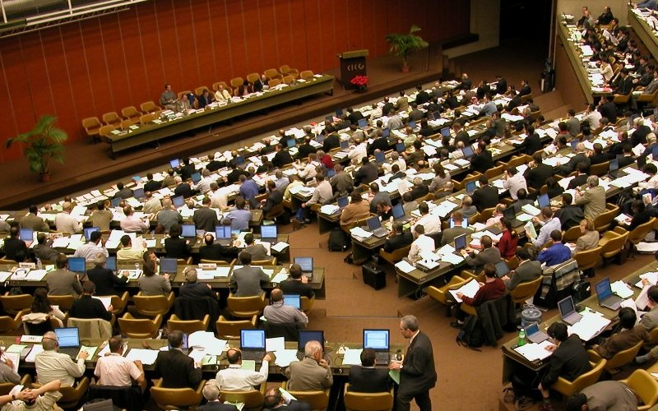
Laptop and radio-LAN access flourished during meetings at CPM-02

So, something in the network is not well-dimensioned, and it will certainly be worse for WRC-03. Moreover, the number of connections was said to be limited to 480. Though it was perhaps enough for CPM, it could be under-dimensioned for the attendance foreseen at WRC-03.
− Proposal for WRC-03: that the structure of the network be analysed and reinforced where needed in order to accommodate the greater number of electronic document users expected at WRC-03, in all meeting rooms.
Easy access to newly posted documents: at present, the new system for multiple download allows to select documents according to some defined criteria, and to download them in a zip file. This procedure allows one to save a lot of time. Although, during a conference or a meeting, when the number of documents is great, it is currently cumbersome to select only the last posted documents. So, even if selecting only one type of document (word for instance) and one language, one has to either download the whole stack of document (and even in a zip file, it was quite impossible during the second week of CPM due to their huge number), or to spend a very long time checking documents and selecting them one after the other. It is to be feared that this procedure will be overwhelming during WRC-03, due to the high number of documents, and will prevent people from having up-to-date documentation.
− Proposal for WRC-03: to implement a better document "synchronization" mechanism, for instance by adding a new criterion to the multiple download procedure, giving the possibility to choose documents posted after a date defined by the user.
b) Structure of documents:
Some documents deal with a lot of items, and are very big. In particular, contributions issued in the name of a number of administrations from regional organizations' preparation usually deal with most of the agenda items in a single document. In such cases, it is difficult to find the relevant pages (and for those using paper documents, it is hard to carry a big document of which only some pages are relevant). A good solution has been implemented at CPM in the case of the draft CPM report, with one electronic document for each chapter, the whole of them being bulked in a zip file.
− Proposal for WRC-03: to encourage regional organizations to submit documents in an electronic form structured so that proposals for each agenda item be a separate file.
c) Equipment in meeting rooms:
A lot of work is to be anticipated in different working, ad hoc or drafting groups during WRC-03, and it will be critical to be as efficient as possible in order to achieve the best results in spite of the overloaded agenda. To have adequate instruments at disposal to take the best of electronic documents has proved to be an effective way to work.
Video projectors: the use of video projectors during working, ad hoc or drafting groups is the natural complement of the use of laptops and electronic documents. They have been provided during CPM, and proved very useful. For WRC-03, it can be anticipated a greater number of groups working in parallel, nevertheless the availability of video projectors should not be less.
− Proposal for WRC-03: to ensure that the number of video projectors will match the anticipated number of working groups.
Printers: though printers are quite common in ITU tower and Montbrillant building, in the premises of CICG a lonely printer was available for laptops to connect. This is a single point failure and very inefficient since a lot of people have laptops and should not need to queue and lose ten or fifteen minutes to print a document. Moreover, when working in a meeting group, it is sometimes needed to print documents for people that work without laptop, or who are not able to get the file back on their computer.
− Proposal for WRC-03: to add printers in the Cyber-Café with possibilities for connection to laptops (by wire or IR), and to put printers in meetings rooms.
Power points: RAG has already noted in former sessions the need for an adequate number of power points in meeting rooms for WRCs. During the CPM, the situation was excellent in the largest meeting rooms, but very poor in the smaller ones, leading to difficulties when the meeting lasted a little bit, or when different meetings were in sequence in these rooms.
− Proposal for WRC-03: to add adaptors and extension leads in meeting rooms where power points are too few.

______________

