Plenipotentiary Conference (PP-14)  Busan, 20 October – 7 November 2014 | 
PLENARY MEETING | Document 10-E
PLENARY MEETING | 4 November 2013
PLENARY MEETING | Original: Chinese
Note by the Secretary-General
CANDIDACY FOR THE POST OF SECRETARY-GENERAL
Further to the information published in Document 3, I have pleasure in transmitting to the Conference, in annex, the candidacy of:
Mr Houlin ZHAO (People's Republic of China)
for the post of Secretary-General of the International Telecommunication Union.

Dr Hamadoun I. TOURÉ
Secretary-General

Annex: 1

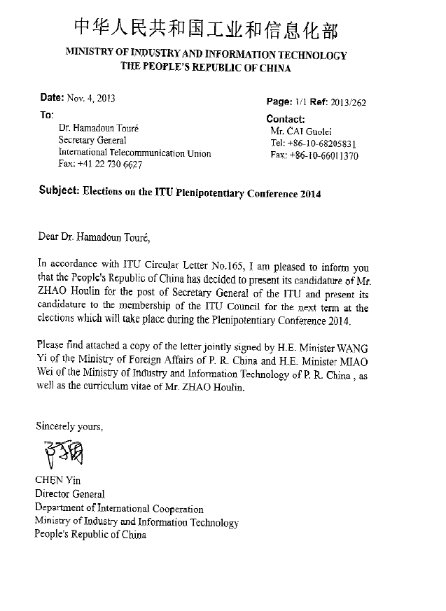

4 November 2013
To: Dr. Hamadoun I. TOURE
Secretary-General of the International Telecommunication Union
Geneva, Switzerland
Your Excellency,
Further to your letter concerning the preparations for the ITU Plenipotentiary Conference to be held in 2014 (Ref. CL-165), we have the honour to inform you officially that the Government of the People’s Republic of China has decided to present the candidature of Mr Houlin Zhao for the post of Secretary-General of the International Telecommunication Union for the period 2015 to 2018, and the candidature of China once again for membership of the ITU Council.
Mr. Zhao has worked in ITU for over two decades. Since 1998, he has served as Director of the ITU Telecommunication Standardization Sector and is currently Deputy Secretary-General of this prestigious organization. He is widely recognized for his professionalism, rich experience, able leadership and outstanding performance. As Deputy Secretary-General of ITU, he has assisted you effectively in recent years in facilitating the organization’s diverse tasks with his unwavering spirit of cooperation and collaboration. With his excellent grasp of ITU’s mission and of the challenges it faces, his competence and qualities of leadership, Mr. Zhao will undoubtedly, if elected to the post of Secretary-General, lead ITU in playing an even more important role in the worldwide development of information and communication technologies (ICTs).
As a Member State of ITU, China has long participated actively in the organization’s work and is committed to its objectives. We greatly appreciate the very effective work carried out and successes achieved by ITU in recent years in the field of ICTs under your distinguished leadership. Together with other ITU Member States, China will continue to give its full support to the organization so as to enhance its contribution to the worldwide development of ICTs.
It is our sincere hope that you will support Mr Zhao in his candidature for the post of Secretary-General of ITU, and China in its efforts to seek re-election as a Member of the ITU Council.
Please accept, Sir, our highest compliments,
WANG YI MIAO WEI
Minister of Foreign Affairs Minister of Industry and Information Technology
People’s Republic of China People’s Republic of China
Attachment: CV of Mr. Houlin Zhao

Candidate for the post of

Secretary-General, 2015-2018

Houlin ZHAO
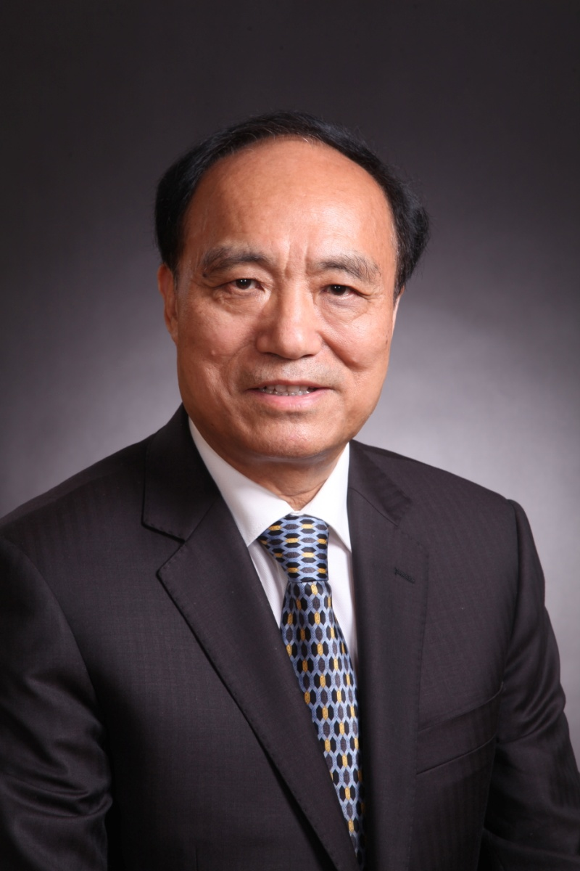

General
Date of Birth: 7 March 1950 (Jiangsu, China)
Nationality: Chinese
Marriage Status: Married with one son, two grand-children
Languages: Chinese, English and French
Current Post: Deputy Secretary-General of ITU
Education
1975: Graduated from Nanjing University of Posts and Telecommunications, China.
1985: Master of Science in telematics, University of Essex, United Kingdom.
Professional Experience
2007-2010, 2011-2014: Deputy Secretary-General (two terms)
- Assisted the Secretary-General, in coordination with Elected Officials, in successful management of ITU’s activities and strategies, maintaining good contacts with Members, facilitating promotion of ITU worldwide.
- Contributed to the good teamwork of the Elected Officials and to the transparent and efficient functioning of the Union.
- Contributed to strengthening the relationship between Members and ITU, to increasing Union’s openness, and to enhancing partnership with all stakeholders concerned.
Internally, among other roles:
- Acting Chief of “Personnel Department” and later “Administration and Finance Department” in 2007, Acting Head of “Procurement Unit” in 2007; Acting Manager of “ITU Telecom” during May 2008-October 2009, and Acting Chief of the “Conference and Publications Department“ in 2007 and 2013 during the recruitments for the posts.
- Supervised Departments of General Secretariat: “Conference and Publications Department”, “Information Services Department”, “Human Resource Management Department”, and “Finance Resource Management Department”.
- Chair of cross-sector projects and teams: “WSIS Task Force”, “Task Force on Emergency Communications and Climate Change”, “ICT Funds”, “ITU Publication Policy Committee (IPPC)”, and “Appointment and Promotion Board (APB) for P staff”.
1999-2002, 2003-2006: Director of the Telecommunication Standardization Bureau (two terms)
- Successfully organized WTSA-2000 in Montreal, Canada, and WTSA-2004 in Florianopolis, Brazil.
- Improved the ITU-T’s environment in a timely manner, e.g.: Associate Members created, free online access of ITU-T Recommendations offered to public, the Alternative Approval Procedures (AAP) developed; established the NGN Focus Group in 2004 and the IPTV Focus Group in 2006.
- Closely worked with industry members, e.g.: organized “Informal Consultation Meetings (Martigny meetings)” in 2000 and 2001, the “Chief Technical Officers (CTOs) meetings” two times during 2003-2006, and “the Informal Forum Summits” in 2001 and 2003.
- Closely cooperated with ISO/IEC, e.g.: MoU on e-business signed in 2000, the “Common Patent Policy of ITU-T/ITU-R/ISO/IEC” adopted in 2006.
- Cooperated with ICANN, IETF and RIRs, e.g.: signed the MoU with ICANN, W3C, ETSI on PSO in July 1999; organized the first joint management meeting of ITU-T Study Group Chairmen and IETF Area Directors in November 1999; cooperated with RIPE NCC on management of ENUM in 2002.
- Encouraged the developing countries to participate at standardization work, e.g.: organized a plenary meeting of ITU-T Study Group 12 in Senegal in 2001, and many workshops in the regions.
1986-1998: ITU Staff Member
- Engineer/Counsellor of CCITT/TSB, responsible for ITU-T SG 7 (Data networks and open system communications) and SG 8 (Terminals for telematics services).
- ITU-T coordinator with ISO, IEC and ISO/IEC JTC 1, developed common texts between ITU-T and ISO/IEC; promoted effective cooperation between ITU-T and ISO, IEC, ISO/IEC JTC 1 in many areas.
- Member of the ITU Appointment and Promotion Board for G-level staff.
1975-1986: Engineer of the Ministry of Posts and Telecommunications, China
- Engineer for national projects and for developing national standards on telecommunication services and networks.
- Chinese delegate to various CCITT Study Group meetings.
- Published a number of technical articles in China.
- Awarded a Prize for science and technology achievements from the Ministry of Posts and Telecommunications, China, 1985.

Commitment
Over the last two decades, modern telecommunication services have developed rapidly everywhere with the remarkable result of having 6.8 billion mobile phone subscriptions and 2.7 billion Internet connections by the end of 2013. However, there are still many challenges and difficulties in connecting all human beings on the planet and ensuring equal benefits of those services for every individual. Based on its achievements and successes, ITU should continue to work closely with its Member States, which are the Union’s solid foundation, and further strengthen its partnership with the private sector, which plays a very important role in global ICT business. ITU should aim to retain its place as a pre-eminent organization responsible for the development and harmonization of telecommunications/ICT services in the global information society.
The visionary leadership, energy and dedication of Mr Zhao during his period in office as Director of the Telecommunication Standardization Bureau and Deputy Secretary-General have been highly appreciated by ITU Members. His consistently outstanding performance and his transparent, efficient, fair and pragmatic management style have received wide recognition and praise. His deep understanding of the Members, strategic vision, excellent spirit of teamwork, superior communication skills, firm willingness to take on responsibility, and tireless efforts to create confidence and trust, will all assure his work as Secretary-General. He is fully committed to leading ITU in carrying out its core missions more efficiently and successfully and to introducing innovative and effective measures to make ITU more adaptive in the fast-changing telecommunication/ICT environment of the 21st century. He is the ideal leader to act as the bridge to the future.
______________

