Radiocommunication Study Groups | 
INTERNATIONAL TELECOMMUNICATION UNION
Source: Document 5A/TEMP/312 (Rev. 1)  Subject: Question ITU-R 205-5/5 | Annex 10 to  Document 5A/736-E
 | 17 July 2015
 | English only
Annex 10 to Working Party 5A Chairman’s Report
WORKING DOCUMENT TOWARDS A PRELIMINARY
DRAFT NEW REPORT ITU-R M.[RAIL.LINK]
Systems for [public] mobile communications with [train][railways]

1 Scope
This Report deals with the general principles, technical characteristics and operational features of terrestrial systems for [public] mobile communications with train.

2 General technical and operational considerations
2.1 The system requires full compatibility and capability of interfacing with the international public data network, the Internet, the control network, or any combinations thereof.
2.2 The system requires adequate bandwidth to meet the foreseeable demand for the services.
2.3 The Quality of Service (QoS) is to be considered to meet the objectives of the system. For example, if the objective is to provide high quality voice service, then the QoS should be comparable to that of the public switched network (voice and data). If the objective is to provide best-effort Internet type traffic, then typically there are no QoS mechanisms being used, at least for the best-effort traffic.
2.4 The radioequipment installed in the train needs to be electromagnetically compatible with other wireless train systems in accordance with appropriate regulatory requirements and have minimal impact on these systems.
2.5 The system requires indicating the applied category of trains. [Trains are classified and designed according to particular purposes. For the passenger train, it divides inter-city train and inner-city train (long distance train and short distance train). The inter-city train contains the regional train, high-speed train, etc. The inner-city train includes metro also called subway, underground or tube, light rail, tram, monorail, etc.]
[Note: the above sentences will be deleted if no contributions related the above content at the following meetings]
[2.6 The deployment of the system should consider the scenarios, e.g., viaducts, cuttings, tunnels and station. The detailed category of scenarios is given in Annex 3.]
[Note: The 2.6 subsection will be discussed in the following meeting.]

3 System technical characteristics and operational features
As example analyses, propagation characteristics of wireless communication links between train and ground stations are given in Annex 1.
Technical characteristics and operational features of the system for public mobile communications with train in some countries are given in Annex 2.
Annexes: 3
Annex 1
Propagation characteristics between train and ground stations
in the millimetre wave frequency range

1 Introduction
Considering future demand of mobile phone and wireless local area network (LAN) access, wireless link between ground station and train should be broadband and require more bandwidth, e.g. the order of 40-500 MHz. Meanwhile, the millimetre wave band, such as the over-30 GHz band, is not used heavily in commercial mobile applications and is expected to facilitate the broadband communication systems.
Figure 1 shows a conceptional image of the broadband wireless transmission system between moving trains and the backbone network using over-40 GHz band where the situations of the communication links include open area site and tunnel channel. The propagation characteristics are generally critical for establishing the wireless communication link. Therefore, this section deals with the characteristics of millimetre wave propagation for public mobile communications with train, focusing on wireless links between ground station and train.
Figure 1
Conceptional image of the broadband wireless transmission system
Backhaul network

2 Propagation data in open-site

2.1 Measurements of millimetre wave propagation on a line-of-sight link

2.1.1 Descriptions of test conditions
A propagation measurement was conducted between two train stations, which was a 2 km long typical line-of-sight (LoS) straight section as shown in Figure 2.
FigUre 2
Sectional view of line-of-sight straight section
(a) Horizontal view, (b) Vertical view
A transmitter with a horn antenna on the train transmitted a signal with beam width of 17 degrees in vertical polarization and the transmitted signal was received by a Cassegrain antenna at the ground station placed beside the railway line. The train moved at a velocity of 310 km/h on the rail. The height of the receiving antenna was set at 2 m above the ground. Table 1 shows the other measurement conditions.
Table 1
Measurement conditions
Station | Parameter | Value | Note
 | Frequency | 50 GHz
 | Polarization | Vertical
Train station  (transmitting side) | On-board transmitter power | 12 dBm | 15 mW
Train station  (transmitting side) | Antenna gain | 40 dBi | 30 cm diameter Cassegrain,  1.5 degrees beam width
Train station  (transmitting side) | Antenna gain | 20 dBi | 2.5 cm diameter conical horn,  17 degrees beam width
Train station  (transmitting side) | Velocity | 310 km/h
Ground station  (receiving side) | Threshold input level | -70 dBm | BER = 10⁻⁷ [2 Mbit/s,]
Ground station  (receiving side) | Antenna gain | 40 dBi | 30 cm diameter Cassegrain,  1.5degrees beam width

2.1.2 Measurement results
Figure 3(a) shows the results of the obtained propagation behaviour in this measurement, and Figure 3(b) shows the result of theoretical calculations using a 2-wave interference model under the same conditions as this measurements.
FigUre 3
Propagation behaviour in line-of-sight link
(a) measurement results, (b) calculated result using 2-wave interference model
Comparison of Figs. 3(a) and (b) show that the results of the reception level obtained in this measurements give close agreement with the calculated regular fading pattern. A deep drop in the receiving level described by “↓” in Figure 3(a) is thought to be the effect of the null pattern of the antenna mounted on the train due to the meandering path of the railway track. Figure 4 shows relationship between fade duration and burst error. The trend of relationship between fade duration and burst error is almost same whether the train speed is high or not¹.
FigUre 4
Relationship between fade duration and burst error

2.2 Measurements of millimetre wave propagation on an non line-of-sight link

2.2.1 Descriptions of measurement conditions
Propagation over curved sections or in situations when there is an obstruction (like mountain, etc.) between the transmitter and receiver, are typical cases of non line-of-sight (NLoS) links. A propagation measurement was conducted on a railway track including a slope change as shown in Figure 5. The other measurement conditions were same as Table 1¹.
FigUre 5
Sectional view of non line-of-sight area

2.2.2 Measurement Results
Figure 6 shows the results of the obtained propagation behaviour in this measurement. This result shows that the reception level in this measurement agrees with the calculated values with knife-edge diffraction propagation at the 800 m mark or farther from the receiver, described by “↑” in Figure 6.
A large amount of propagation loss at the area indicated by the point “∗ “ in Figure 6 was thought to be the effect of diffracted waves¹.
FigUre 6
Measurement results of propagation behaviour in out-of-sight link

2.3 Measurements of millimetre wave propagation on curved line

2.3.1 Descriptions of measurement conditions
On the curved sections, diffraction and reflectance are major factors in considering the propagation. The propagation measurement was conducted in a curved section with side walls, as shown in Figure 7. The other measurement conditions were same as Table 1.
FigUre 7
Sectional view of curved line

2.3.2 Measurement results
Figure 8 shows the results of the obtained propagation behaviour in this measurement. This result shows that the reception level in this measurement are still enough for establishing the communication link over line-of-sight condition. This is because diffraction by electrical poles and reflectance by the ground and the side walls prevented the propagation loss.
FigUre 8
Measurement results about propagation behaviour in out-of-sight link

2.4 Summary of measurement results
[This part is subject to further review]
The results of these measurements mainly present propagation characteristics of millimetre wave, which are important elements for system design of railway mobile communication.
In considering keeping the quality, further efforts would be required against the deep drops, such as use of diversity for transmit and received antenna, optimized arrangement of distance between base stations, increasing transmit power, etc.
In the case of non line-of-sight link with gradient changed points and/or curved line, diffraction propagation over curved sections or slope changed sections and reflection by side-wall should be considered for the arrangement of base station. In curved section, there is little influence of line-of-sight because of those reflectance. However, in the case of gradient changed section, drop of received power by diffraction loss can’t be negligible for link quality. In order to avoid this phenomena, base station should be located on the gradient changed points.

3 Propagation data in tunnel

3.1 Measurements of millimetre wave propagation

3.1.1 Descriptions of system architecture and communication equipment
A propagation measurement was conducted in a tunnel site. The deep fading effects are expected due to the multipath signals in tunnel. Therefore, in order to mitigate the deterioration of transmitting and receiving signals from this multipath effects, antenna diversity or similar techniques are required. Therefore, two-antenna arrays were used for both the transmitter (Tx) and receiver (Rx) in these measurements in tunnel in order to evaluate antenna diversity effect.
Figure 9 shows the configuration of the measurements. The antenna units of Tx and Rx were oriented to be faced each other. The Tx was mounted on a road-rail vehicle and moved in the broadside direction linearly. Between Tx and Rx, 100 Mbit/s signals were consecutively transmitted. The measurement conditions are shown in Table 2.
FigUre 9
Measurement setup of Tx and Rx
Table 2
Measurement parameters
Station | Parameter | Value | Note
 | Frequency | 46.8 GHz
 | Polarization | Circular
 | Modulation scheme | 64QAM-OFDM
 | Maximum throughput | 100 Mbit/s
Train station  (transmitting side) | On-board transmitter power | 10 dBm | 10 mW
Train station  (transmitting side) | Antenna gain | 32 dBi | Cassegrain,  1.0~1.5 degrees beam width
Ground station  (receiving side) | Antenna gain | 32 dBi | Cassegrain,  1.0~1.5 degrees beam width

The measurements in a tunnel scenario were carried out in Iiyama Tunnel of Hokuriku Shinkansen, Nagano, Japan, of which the sectional view is shown in Figure 10. The Tx (transmitter on a road-rail vehicle) moved at a velocity of 15 km/h on the rail, and received signal strength indicator (RSSI) and bit error ratio (BER) were measured at the Rx (receiver at a side of the rail). The distance between the Rx and the Tx was measured by Radio-Frequency Identification (RFID) tags uniformly located alongside the rail and pulse signals from an axle shaft of the vehicle per one wheel rotation. Two antennas at the BS were installed vertically. On the other hand, two antennas at the MS were set vertically or horizontally depending on the measurement case, where the former and the latter are hereafter referred to as "vertical case" (Fig. 11) and "horizontal case" (Fig. 12), respectively. The test parameters for the tunnel scenario was shown in Table 3.
Figure 10
Sectional view of Iiyama tunnel
Figure 11
Antenna setup in tunnel scenario (vertical case)
Figure 12
Antenna setup in tunnel scenario (horizontal case)
Table 3
Test parameters (tunnel scenario)
Parameter | Value
Carrier frequency | 46.8 GHz
Number of antennas | Tx: 2, Rx: 2
Moving range | 3,500 m from Rx
Velocity | 15 km/h
How to get Tx’s location | RFID and pulse signals from an axle shaft

3.1.2 Measurement results
This subsection shows the results in the tunnel scenario.

3.1.2.1 Performance of Diversity Effect
Figs. 13-16 show the results of RSSI and BER performance for the vertical case depending on the number of antennas; the performance without any diversity schemes (1 TX & 1 RX) in Figure 13, that with transmit diversity (2 TX & 1 RX) in Figure 14, that with receive diversity (1 TX & 2 RX) in Figure 15, and that with both transmit diversity and receive diversity (2 TX & 2 RX) in Figure 16, respectively. As a reference, the free-space propagation loss is also shown in each RSSI figure. Here, the Tx moved away from the Rx. It can be seen that in the tunnel scenario all RSSI performances are similar to or less than the free-space propagation loss within transmission distance of 3 500 m. Furthermore, it can also be seen that BER performance is drastically improved with
an increase of the number of antennas, because of the alleviation of received power degradation by diversity effect.
Figure 13
The RSSI and BER performance for the vertical case depending on
the number of antennas in the tunnel scenario (Tx = 1, Rx = 1)
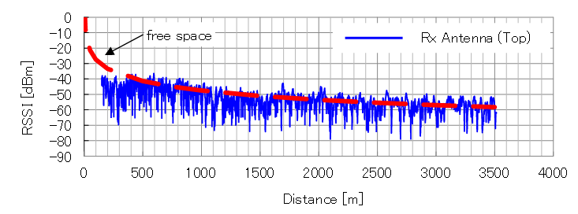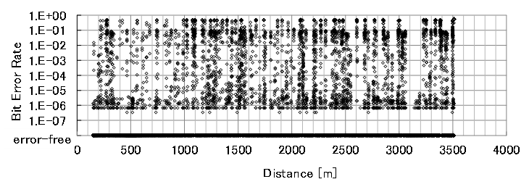
Figure 14
The RSSI and BER performance for the vertical case depending on
the number of antennas in the tunnel scenario (Tx = 2, Rx = 1).
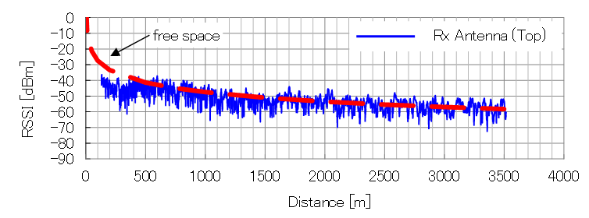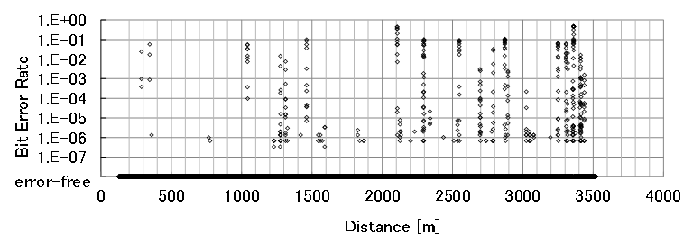
FigURE 15
The RSSI and BER performance for the vertical case depending on
the number of antennas in the tunnel scenario (Tx = 1, Rx = 2)
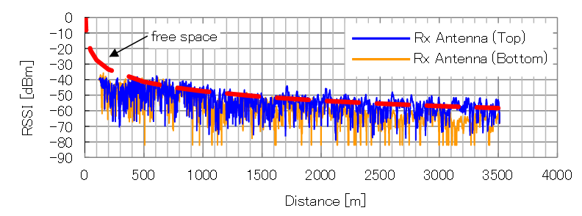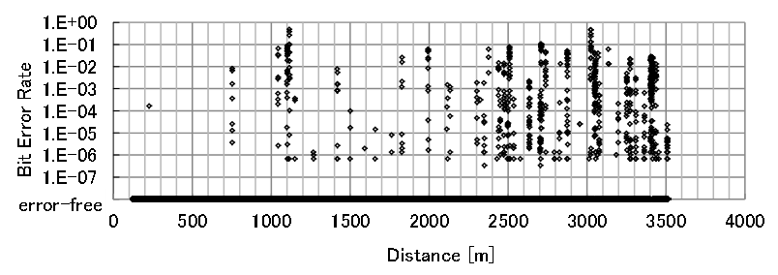
Figure 16
The RSSI and BER performance for the vertical case depending on
the number of antennas in the tunnel scenario (Tx = 2, Rx = 2)
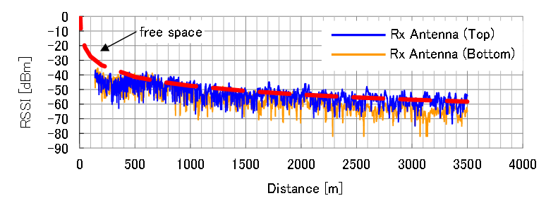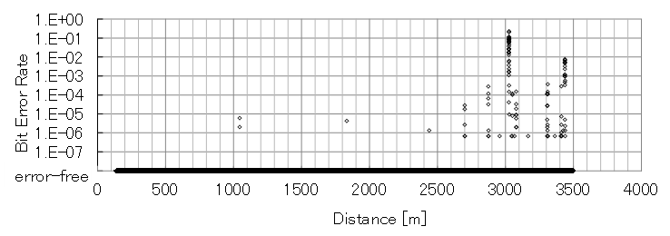

3.1.2.2 Comparison between vertical and horizontal cases
The performance for the different installations of Tx antennas is evaluated. Here, the number of antennas at the Rx and the Tx is commonly set to 2. Figure 17 shows the RSSI and BER performance of the horizontal case (Fig. 12) while the performance of the vertical case is already shown in Figure 16. It can be noticed that the performance of both the cases are similar despite the difference in antenna configurations. This tendency irrespective of the antenna configuration may be due to rich multipath and a wave-guide phenomenon in the tunnel.
Figure 17
Measurement results (horizontal case) in the tunnel scenario
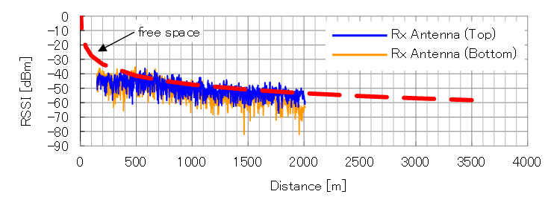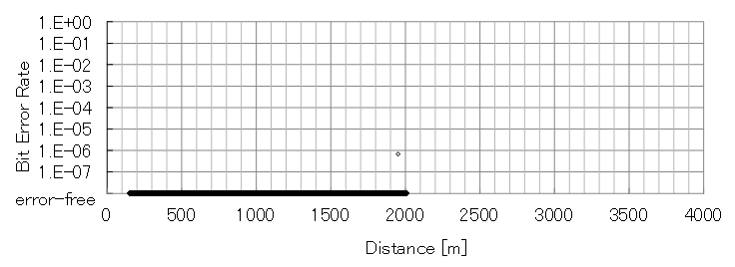

3.2 Summary of measurement results
These results present that it has been verified that the maximum throughput of 100 Mbit/s in almost all the measurement area of the tunnel can be achieved and been exploiting transmit and receive diversity effects. The transmit distance with keeping enough link quality was over 3 500 m distance from base station, which is longer than the distance in similar case in open area. This shows the millimetre wave propagation is suit for condition of tunnel. Moreover, the use of antenna diversity technique can mitigate the deep drop of received power from interference and/or multipath effects.

4 Data transmission trial by high speed train

4.1 Descriptions of trial conditions
The trial was conducted in an open-site curve section (R = 4 000 m) of Tohoku-Shinkansen near Ninohe station in Japan, using a high-speed bullet train known as Shinkansen train. The train with receivers moved at a velocity of 320 km/h on the rail. The measurement conditions are shown in Table 4.
TABLE 4
Measurement conditions (high speed train)
Parameter | Value
Frequency | 40 GHz Band
Number of antenna | Ground Station: 2(TX)  Train Station: 2(RX)
Modulation scheme | 64QAM-OFDM
Data transmission speed | 100 Mbps
Transmitter power | 10 mW
Antenna gain | 32 dBi
Beam width | ±1.0～1.5 deg
Vehicle | Shinkansen train
Vehicle speed | Approx. 320 km/h
Propagation environment | Open-site

4.2 Measurement results
Figure 18 shows the measured RSSI and the corresponding Frame Error Rate, where “E.F.” at the vertical axis means Error Free, providing both 100 Mbit/s transmission and error-free connection. The Error Free can be achieved when enough RSSI level is obtained.
Figure 18
Measurement results (high speed case) in curved area
Under the restricted measurement conditions that the location of ground station was installed apart from track, the desired measurement scenario, that main lobes of ground-side and train-side antennas faced directly each other, could not be configured. Furthermore, because the train-side antennas were experimentally installed in driver’s room for this measurement, the received signal was attenuated by the front glass of the room. Due to these unfavourable conditions, the range of communication distance was limited. Considering practical use case that the train-side antennas are installed outside, the communication range is expected to be longer than this measurement result.

Annex 2
Systems for [public] mobile communications with train in some countries

1 Introduction
In some countries, there are public mobile communication systems with [train][railways] currently in operation. These are described in the sections below.

2 Communication systems in Japan

2.1 Introduction
Demand has increased for mobile phone and wireless local area network (LAN) access for passengers on trains in particular for broadband applications. In general, the telecommunication infrastructure for public network for broadband cellular phones and Wi-Fi network has not been sufficiently equipped in tunnels, and the more high speed communication links between ground and trains would be required for adapting various types of wireless communications. Now, many kinds of radio communication systems with train have been used in Japan, as shown in Figure 19.
Figure 19
Various radio communication systems used in railway systems in Japan
ATS
ATS-P, Wireless card system, RF-ID
Train radio
Millimeter wave communication system, Rader system
Microwave fixed radio communication system, satellite communications, WLAN, etc.
Train radio, Train protection radio, Route control system, Various private radio, private PHS system, WLAN, Mobile WiMax, etc.
300MHz
3MHz
30MHz
300kHz
30kHz
3
kHz
300GHz
3GHz
30GHz
3THz
1m
100m
10m
1km
EHF
SHF
UHF
VHF
HF
MF
LF
VLF
10km
THz
100
km
1mm
10cm
1cm
0.1mm
Frequency
Wave length
ATS, Inductive Radio
ATC(ATP)
In Japan, radio communication systems with train are generally categorized into two types based on application; train operation and passenger service. Several train companies have started Wi-Fi network service inside the train cabin in order to provide stable and high-speed network service for the passengers. Furthermore, LCX operated in Shinkansen has been used for not only train operation but also passenger service, which can be defined as integrated system.
The following sections address the existing and planned public communication systems between ground and trains in Japan for each of three systems; integrated system, train operation, and passenger services

2.2 Integrated systems

2.2.1 Shinkansen LCX train radio system
The Shinkansen train radio system equipped with leaky coaxial cables (LCX) as shown in Figure 20, which is laid at each side of railway tracks all along the Shinkansen line, is used for direction call, direction message, train monitoring information, character-based news, and travel information by radio transmission. Tokaido Shinkansen provides internet access as well for passengers via LCX. A high-quality communication between high speed train and ground with reliable handover connection, is the most distinctive feature of the system.
A Central Unit in Control Center accommodates Ground Communication Controllers which are located in the key stations. The Ground Communication Controllers take handover through accommodated Base Stations. Base Stations are located in almost every station and repeaters which compensate for LCX propagation loss, are sided at every 1.3 km intervals along track between Base Stations (2.6 km intervals only at Sanyo Shinkansen). Four antennas which are installed at body side of the front vehicle, receive radio waves from LCX.
LCX which was developed in 1967 as a type of coaxial cable, has holes called “slot”, to gradually leak radio waves to outside of the cable. Information is transmitted by 400 MHz band radio waves propagated between the slots and antennas installed at the “skirt” of the vehicle. LCS method allows the distance between LCX and antennas on board to be so close constantly that the affection of interference or noise can be so smaller and it is possible to maintain stable communication regardless of the location of train, open-site or inside of tunnels. Applying the whole LCX method to train radio systems makes it possible to achieve more than 99.99% connections throughout the entire line even when trains are running at high speed (above 300 km/h).
Figure 20
Total system of LCX along Shinkansen tracks

2.2.2 Millimetre wave
In Japan, the 50 GHz band has been used for convenience radio stations of the Shinkansen systems, and the 60 GHz band was examined in some measurements for the operation of Shinkansen. On the other hand, recently verification measurements of mass volume wireless communication using
40 GHz band for high speed train has been conducted considering public mobile communication for passengers in the near future. These measurements verified high connectivity in the range of over 3 500 m from base station in 100 Mbit/s in tunnel. This millimetre communication system can have high degree of expectation for application in Japan, which has many tunnel area on the line of high speed trains because there are many uphills, downhills, and mountains all over Japan.

2.3 Train operation communication systems

2.3.1 Train radio system for conventional lines
The train radio system for conventional lines is the private communication tool between train operators on the ground and crews on board for safety and stable train transportation. In the past, the analogue radio system is used mainly for direction call. Recently the digital radio system is deployed in order to meet the needs of direction message transmission or train monitoring information transmission.
The system consists of a Central Unit in Control Center, base stations located at each 2~3 km distance along the track, and mobile stations on board. The coverage area of each radio zone is 20~30 km. Since all base stations in a zone transmit a same frequency radio it causes a beat interference occurs at Mobile Stations when RSSI of the front base station and RSSI of the rear base station are almost same. It is considered to be a demerit of the analogue radio system. This problem was solved in the digital radio system.
In the digital radio system, the base station transmit two types of waves; the preceding and delayed. The transmission timing of delayed wave is delayed by one-symbol compared to the preceding wave. Base stations transmit these two types of waves one after another and mobile stations demodulate waves by using adaptive equalizer to suppress a beat interference and realize high quality radio communications.

2.3.2 Radio communication based train control system
Radio communication based train control system is an automatic train control system that makes use of the telecommunications between trains and base stations for traffic management and infrastructure control. In Japan, from the latter of 1980s to the 1990s, a system called “CARAT” (Computer and Radio Aided Train control system) had been developed for Shinkansen system experimentally. At the trial running of CARAT by Shinkansen train, a part of the Shinkansen LCX train radio system described in 2.2.1, had been utilized for telecommunications of train control commands. As a result of the trial running, it was confirmed that the safe and flexible train control could be achieved by the system. Based on some essential techniques developed in CARAT, a new system called “ATACS” (Advanced Train Administration and Communication System) has been developed for conventional lines. ATACS has been in practical use since October 2011, as the first train control system based on radio communications without using whole LCX along the track. These systems developed in Japan, are called “JRTC” (Japan Radio Train Control system) as shown in Figure 21, and requirements of basic function and system construction have been defined in Japanese Industrial Standards as JIS E 3801. JRTC corresponds to the train control system of ERTMS/ETCS Level 3 in Europe.
The basic architecture of JRTC consists of 3 sub-systems, i.e. wayside sub-system, on-board sub-system, and train to way side communication sub-system. The train detects its own location and the location information is transmitted to the Ground Controller. With the location information, condition of electric switch machine, and condition of level crossing, the Ground Controller calculates the limit in which the train could run safely and sends the stopping limit to the train. The Ground Controller controls the ground equipments as well, such as electric switch machines, level crossings, etc.
On the train, the on-board controller calculates a brake pattern and an upper limit speed curve, by using its own brake performance to stop at the running limit directed by the Ground Controller. The on-board controller directs adequate train-speed to the train-driver and if train-speed exceeds the brake pattern, the on-board controller makes the train slow-down or stop by controlling the brake automatically.
Figure 21
Basic architecture of JRTC system
In ATACS, base stations are located at every 3 km intervals along the track. In the system, FDD method is used and four pairs of radio frequencies for ground-to-train communications and rain-to-ground communications are prepared. These frequency pairs are assigned to each base station one by one repeatedly to prevent interference at any place along the track. Therefore 8 radio frequencies, a pair of frequencies x4, are used in each railway section. The bandwidth of the radio wave is 6.25 kHz and transmission speed is 9 600 bit/s. TDMA method is used in the system and each base station can control 12 trains at a time. Location information of the train is used for handover between base stations. The base station communicates with each train every 1 second in own radio zone and the train will make an emergency stop automatically if communications between a base station and the train stopped for more than 3 seconds. Emergency stop caused by malfunction of radio communication, has never happened since 2011 in practical use.

2.3.3 Train protection radio system
The train protection radio system is used to notify the approaching trains of emergency, and in order to prevent a secondary accident. When train crews are confronting an emergency situation on track such as line blocked objects, a train derailment, a fire, the crews should use the train protection radio system and the emergency radio signal is which are directly transmitted to approaching trains. The system started operating in the later 1980s in Japan as an analogue system and now the systems have been replaced with the digitalized systems in many railways in the nationwide.
The protection radio equipment on board consists primarily of private radio equipment, a transmission button, and an antenna. When the transmission button is pressed, the emergency radio of 150/400 MHz band is transmitted to the approaching trains. When the approaching train receives the emergency signal, the crew hears alarm and should take necessary actions such as stopping the train. The emergency radio signal reaches nominally within 1 km radius. If it is difficult to reach the emergency to approaching train according to geographical conditions, such as in tunnels, repeaters are installed on trackside in order to expand the coverage of radio propagation.
The followings are some extended examples of the system.
1 The emergency radio signal is transmitted to other trains through the network via Base Stations and Central Unit.
2 The emergency radio signal is also triggered by input signal from other equipments on board.
3 The train protection radio equipments are installed at stations, or railroad crossings in order to notify the approaching trains of the emergency satiation.
4 The train protection radio equipments are set up in the equipment room on the ground. It may send signal to other systems such as power cut-off system when it receives the emergency signal from the train. The other system utilizes the signal to improve safety.

2.4 Passenger service systems

2.4.1 WiMAX
Narita Express trains connecting between Narita international airport and the Tokyo metropolitan areas provides Internet access service that communicates with WiMAX base stations using antennas on the train roof and converts data into that for Wi-Fi at on-board repeaters to communicate with passengers’ terminals. WiMAX already has many base stations in operation along railway lines in the greater Tokyo area, and small base stations and relay station are installed in railway stations. On the other hand, use of WiMAX on Shinkansen trains faces the issues of transmission in tunnels and the number of base stations required along the lines. The transmission speed is 40 Mbit/s in the 2.5 GHz band, and the transmission range is 1 km.

2.4.2 WiFi access for travelling train
Tsukuba Express railway line connecting Tokyo and Tsukuba, Ibaraki prefecture at 130 km/h uses Wi-Fi access system inside the car. A base station installed in each compartment of the train provides internet services to passengers, and a base station at each end of the train communicates with relay base stations installed at stations or along the railroad. The detailed information on this system is provided in Report ITU-R F.2086-1. Figure 22 shows the overview of this Wi-Fi access system.
Figure 22
Wireless LAN services for train

2.4.3 Contents Transmission
Recently, digital signage in cabin, which displays advertisements, news, etc., is becoming popular. Millimetre waves are used for contents transmission. The contents transmission system consists of Ground Stations and On-Vehicle Stations. 60 GHz band radio is used for 100 Mbit/s transmission. Contents are transmitted to the train when it stops near the Ground Station.
It becomes possible to renew instantaneously large-volume information of contents such as the latest news and advertisement with video by using large-capacity communication by a millimetre wave. Figure 23 shows the image of the millimetre wave system.
Figure 23
Millimetre wave system of contents transmission

3 Communication systems in Korea

3.1 Introduction
The Republic of Korea has been running high speed railway systems, so called KTX, whose speed is about 300 km/h and conventional railway. Mobile internet services such as mobile video on demand, internet broadcasting, and social networking are steadily increasing and expanding. According to a recent survey, one of the most preferred places to use mobile internet is the moving vehicle, such as subway and train. The passengers in the subway trains and high speed trains called KTX can use Wi-Fi access points (APs) as well as 3G/4G cellular networks. Specifically, to make use of the Wi-Fi APs, the backhaul lines between tracksides and trains are important. In this regards, this section describes an existing mobile wireless backhaul based on WiBro and on-going development work that expands the existing backhaul capacity per train with a millimetre-wave-based system. Additionally, it describes the present and near future railway communication systems related to a couple of signal control systems.

3.2 WiBro
WiBro is the service name for IEEE 802.16e international standard. In Korea, the WiBro systems have been widely deployed at tracksides of subways in Seoul and Busan for the mobile wireless backhauls. The passengers can access the Internet through Wi-Fi APs inside the train cars, and their aggregated data are pipelined into the WiBro backhauls. The maximum capacity of the deployed WiBro-based backhauls is less than 10 Mbit/s where 2.4 GHz bands are utilized. On the other hand, the passengers inside the carriages can directly access 3G/4G networks of three operators. Therefore, the WiBro backhauls play the key role in performing offloading for these networks on rush hours in the carriers’ point of view. However, the backhaul capacity limitation is still too low to accommodate the ever-increasing demands for data. In the meantime, the Korean bullet trains, KTX provide the passengers with some limited free Wi-Fi services by using 4G-network-based backhauls.

3.3 Train communication system using millimetre wave
In Korea, a communication system for fast moving vehicles, named as mobile hotspot network (MHN), is under development. One of millimetre-wave bands, 30 GHz carrier frequency band has been used. Figure 24 shows an overall system architecture where backhaul links with the millimetre waves and user access links inside the car are drawn. A goal of backhaul capacity is 1 Gbit/s using 250 MHz bandwidth, which corresponds to 100 times larger than that of the currently deployed WiBro based backhaul in Seoul. However, the service scenarios are likely to be expanded into normal and high-speed trains, and even route-unpredictable fast moving transportations. Particularly, the expected mobility supported by the MHN system is up to 500 km/h. A prototype of the MHN system will emerge soon. The capability of supporting ultra-high data capacity and mobility will enable the MHN system to be deployed widely in Korea and even all over the world. And this can make it an alternative evolutional path to the high-speed region of upcoming 5G systems.
Figure 24
Overview of MHN system
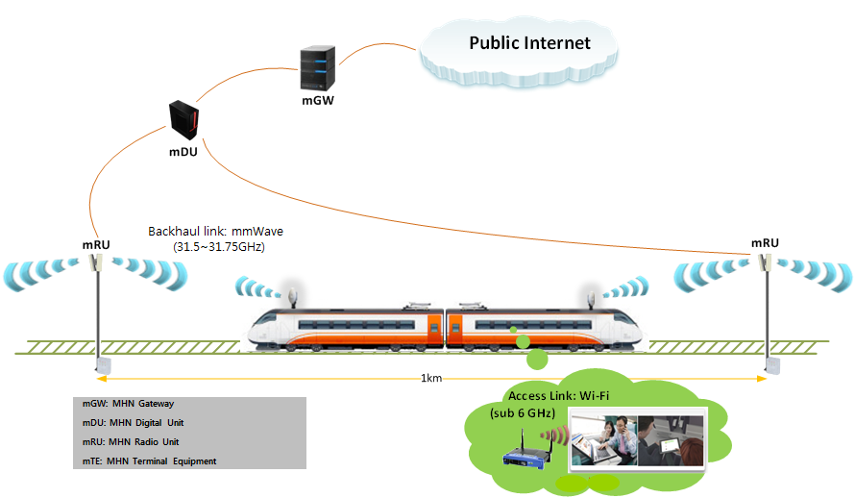

3.4 Train communication system for conventional railways

3.4.1 VHF
VHF (Very High Frequency) provides point-to-point communication scheme between control center/base station and a train crew or inter-mobile station communications in conventional train. UHF uses 4 channels for exchanging data at the 153 MHz frequency band. Since the communication is established by voice call depending on propagation range, appointment for intercommunication is required. Due to point-to-point scheme, various communication functions such as group communication, priority communication are not supported. Furthermore, the main requirement for railway wireless networks, i.e., safety, reliability, and security, is not guaranteed. Table 5 represents Frequency band allocation for VHF.

Table 5
Frequency band allocation for VHF
Item | CH | Broadband |  | Narrowband |  | Remarks
Item | CH | Tx | Rx | Tx | Rx | Remarks
Portable terminal | 1(Normal) | 153.440 | Same as Tx | 150.4250 | Same as Tx
Portable terminal | 2(emergency) | 153.250 | Same as Tx | 150.4500 | Same as Tx
Portable terminal | 3(Work) | 153.280 | Same as Tx | 150.4625 | Same as Tx
Portable terminal | 4(Work) | 153.660 | Same as Tx | 150.4375 | Same as Tx
Portable terminal | 1(Normal) | 153.440 | Same as Tx | 150.4250 | Same as Tx
Portable terminal | 2(emergency) | 153.340 | Same as Tx | 150.4875 | Same as Tx
Portable terminal | 3(Work) | 153.740 | Same as Tx | 150.4125 | Same as Tx
Portable terminal | 4(Work) | 153.660 | Same as Tx | 150.4375 | Same as Tx
Mobile terminal | 1(Normal) | 153.440 | Same as Tx | 150.4250 | Same as Tx
Mobile terminal | 2(emergency) | 153.520 | Same as Tx | 150.4500 | Same as Tx
Mobile terminal | 3(Work) | 153.590 | 153.110 | 150.4750 | 150.3750
Mobile terminal | 4(Work) | 153.620 | 153.200 | 150.5000 | 150.4000
Base station | 1(Normal) | 153.440 | Same as Tx | 150.4250 | Same as Tx
Base station | 2(emergency) | 153.520 | Same as Tx | 150.4500 | Same as Tx
Base station | 3(Work) | 153.110 | 153.590 | 150.9750 | 150.4750
Base station | 4(Work) | 153.200 | 153.620 | 150.4000 | 150.5000

3.4.2 TRS
Korea is using two TRS (Trunked Radio System) schemes, i.e., TRS-ASTRO and TRS-TETRA.TRS-ASTRO is developed two stages where the 1st stage adopts FDMA (Frequency Division Multiple Access) which uses one channel per 12.5 kHz, and the 2nd stage increases frequency efficiency by adopting TDMA (Time Division Multiple Access) and modifying modulation scheme. Table 6 represents TRS-ASTRO technology depending on the development stage.
Table 6
Comparison of TRS-ASTRO depending on the development stage
Property | Stage 1 | Stage 2
Channel access | FDMA | TDMA(including FDMA)
Bandwidth | 12.5 kHz | 6.25 kHz
Data rate | 9.6 kbit/s | 9.6 kbit/s
Modulation scheme | C4FM | CQPSK

TRS-TETRA has two schemes, i.e., Release 1(R1) and Release 2(R2). R1 provides 4 channels with 25 kHz bandwidth in 1995, and R2 enhances data service function of R1 in 2006. R2 is designed to upgrade R1 without changing of network architecture to maintain backward compatibility. Table 7 compares two schemes. R2 enhances data rate by applying various modulation scheme and adopting R1’s bandwidth and channel access scheme.
Table 7
Comparison of TRS-TETRA depending on the release version
Property | Release 1 | Release 2
Frequency range | 380 MHz, 800 MHz | Muli-band(up to 1 GHz)
Channel access | TDMA | TDMA
Data rate | 7.2~36 kbit/s | 54~690 kbit/s
Modulation scheme | π/4 DQPSK | π/4 DQPSK, 4QAM, 16QAM, 64QAM

TRS-TETRA provide voice service such as one-to-one call, one-to-multi call, group call, emergency call, and direct call as well as data service such as message and packet transmission. R1 and R2 support 300 km/h and 400 km/h mobility, respectively. TRS-TETRA has versatile availability for railway wireless network compare with TRS-ASTRO and VHF. However, TRS-TETRA does not apply railway control system. In addition, TRS-TETRA has limitation of localization due to technology proprietary and high speed data transmission.

3.5 LTE-R
UIC (International Union of Railway) starts to consider LTE based railway system (LTE-R) for the evolutions technology of GSM-R in 2011. To overcome the disadvantage of existing railway wireless communications and support high speed transmission and functionality (group communication, data service, quality of service), various wireless communication technologies are considered for railway communications, and it is reported that LTE based railway system is the best communication scheme. Some parts of LTE based railway system has been developed and demonstrated in Korea.
Busan Metro will install LTE systems for railway communications in 700 MHz band next year. This frequency arrangement 718-728/773-783 MHz is allocated for public safety also.

[Annex 3
Deployment scenarios of systems for public mobile communication with trains
[Note: Annex 3 will be modified and discussed at the following meetings]

1 Viaducts
Viaduct is one of the most common scenarios in railway. This scenario is a long bridge-like structure, typically a series of arches, carrying a railway across a valley or other unevenground, as shown in Figure 25.
FIGURE 25
Viaducts scenario
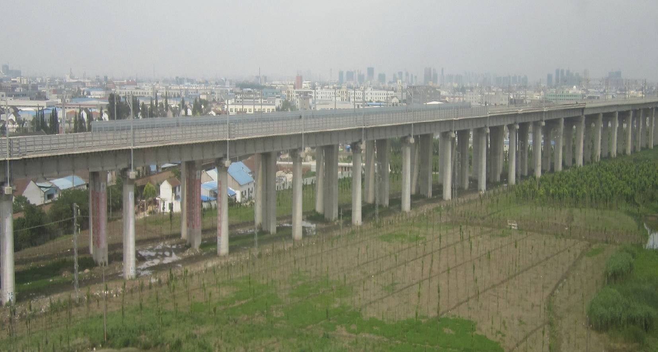

2 Cuttings
Cutting is a common scenario in railway environments. The cutting sides are usually covered with vegetation and reinforced concrete in case of subsidence. The forms of cutting can be either regular, where the steep walls on both sides of the railway have almost the same depths and slopes, or irregular owing to the locations of irregular hills or mountains along the line. This special structure of cutting creates a big “container”, with rich reflection and scattering.
FIGURE 26
Cutting scenario
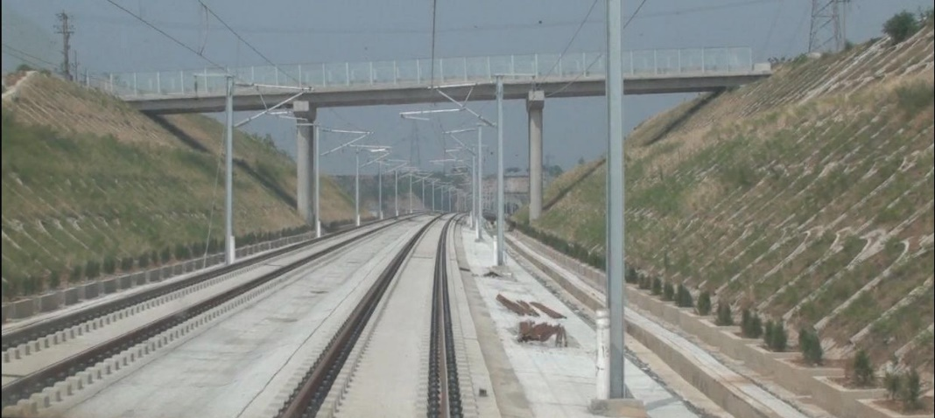
Cutting usually can be described with three parameters: crown width, bottom width, and depth of cutting. The most common cutting is the regular deep cutting, where the steep walls on both sides of the railway have almost the same depths and slopes, as is shown in Figure 26.

3 Tunnels
Tunnel is an artificial underground passage, especially one built through a mountain in railway environment, as is shown in Figure 27. The sectional view of tunnel in railway is usually vaulted or semicircle, with a height of 5–10 m and a width of 10–20 m. The length of the tunnel in railway mostly ranges from several to dozens of kilometres.
FIGURE 27
Tunnel scenario
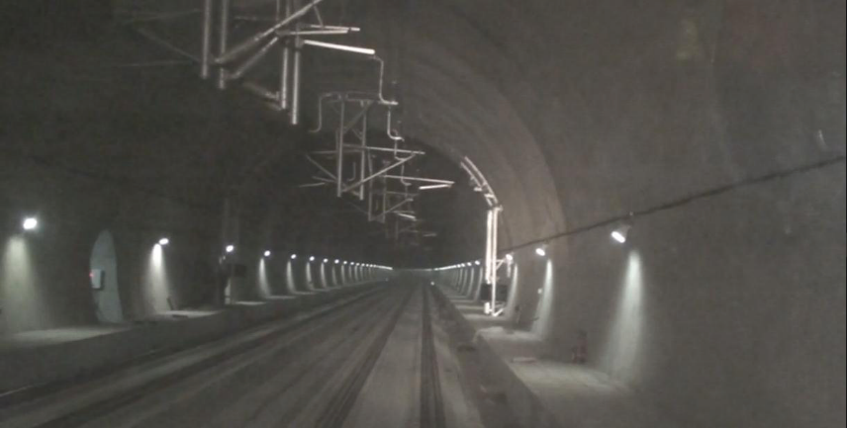

4 Railway stations
Railway station is a railway facility where trains regularly stop to load or unload passengers. It generally consists of a platform next to the tracks and a depot providing related services such as ticket sales and waiting rooms. Due to the large number of users, high traffic requirements are expected in this environment. Moreover, the big awnings are usually utilized in stations to stop the rain from reaching the passengers and the trains. Based on the capacity of the transportation, stations in railway can be divided into three categories: medium- or-small-sized station (Fig. 28a), large station (Fig. 28b), and marshalling station and container depot (Fig. 28c).
FIGURE 28
(a) Medium- or small-sized station scenario
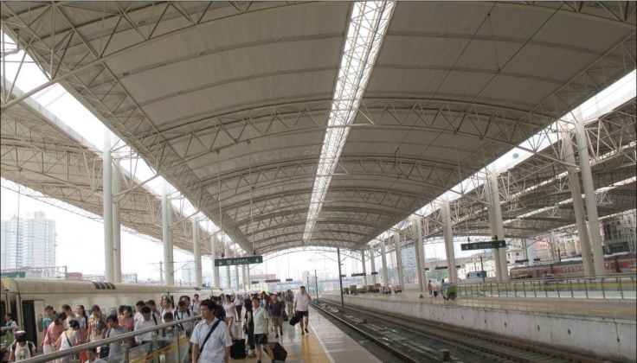
(b) Large station scenario
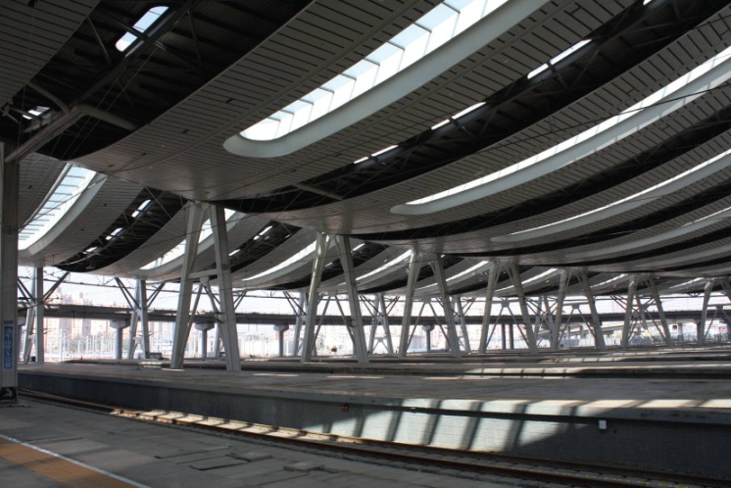
(c) Marshaling station and container depot scenario
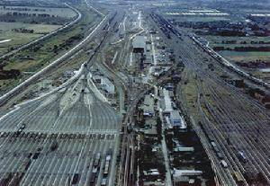

______________]

H. Yamamura, T. Kawamura and S. Sasaki, “Millimeter-Wave Propagation Characteristics and Applications in Railway Radio Systems”, Quarterly Report of RTRI, Vol. 32, No. 3, pp.182-189, Railway Technical Research Institute, 1991.
K. Tsukamoto et al., “Field-test Results of Mobile Communication Systems over 40 GHz Frequency Band”, IEEE VTS APWCS2014, Taiwan (China), Aug. 2014.
T.Hattori et al., “Propagation Test on Millimeter Wave Communication for Railway Trains”, IEICE Technical Report, vol. 114, no. 295, RCS2014-210, pp. 79-84, Nov. 2014.
M.Atsuzawa et al., “Development and Introduce of Digital Train Radio System for Conventional lines”, JR EAST Technical Review-No.20, summer 2007.
M. Kato and K. Terada, “Development of an Evolution Type Train Protection System to Prevent Secondary Accident”, Dublin Conference, 2006
T. Takashige, “Signaling systems for safe railway transport”. Japan Railway and Transport Review 21 (1999): 44-50.
Communication Technology on Milli-Meter Wave and Its Application Systems, MITSUBISHIELECTRIC Technical Report (Vol.80・No.9・2006).

