Radiocommunication Study Groups | 
Source: Document 5A/TEMP/192(Rev.1)  Subject: Question ITU-R 241-2/5, Resolution ITU-R 58 | Annex 20 to  Document 5A/421-E
 | 2 December 2013
 | English only
Annex 20 to Working Party 5A Chairman’s Report
PRELIMINARY DRAFT NEW REPORT ITU-R M.[LMS.CRS2]
[Cognitive radio systems [(CRS) applications] in the land mobile service]
(Question ITU-R 241-2/5)

[Editor’s note: Since sections 5 and 6 are considered to be stable they may only need editorial modifications. As for other sections, contributions are invited to improve them with the aim of completion of the report at the WP 5A meeting in May 2014.]
[Editor’s note: The title of the [LMS.CRS2] Report will be considered in the next meeting.]
TABLE OF CONTENTS
1 Scope 6
2 Introduction 6
3 Related documents 7
3.1 ITU-R Recommendations 7
3.2 ITU-R Reports 7
3.3 Other references 7
4 Definitions and terminology 11
4.1 Definitions 11
4.2 Terminology 11
4.3 Abbreviations 12
5 Applications 14
5.1 Existing and emerging applications employing CRS capabilities 16
5.1.1 5 GHz RLANs utilizing dynamic frequency selection (DFS) 16
5.1.2 Use of TV White Space 16
5.2 Potential applications 17
5.2.1 Cognitive networks exploiting reconfigurable nodes 17
5.2.2 Cognitive mesh networks 19
5.2.3 Heterogeneous system operation using CRS technology 20
5.2.3.1 Intra-system inter-RAT handover 20
5.2.3.2 Inter-system handover 22
5.2.3.2.1 Inter-system handover using cognitive radio terminals 22
5.2.3.2.2 Inter-system handover using CRS supporting network entities 24
5.2.4 Coordinated spectrum access in heterogeneous radio environment 25
[5.2.5 Cognitive networks using vertical and horizontal spectrum sharing 26
6 CRS capabilities and enabling technologies 27
6.1 Obtaining knowledge 28
6.1.1 Listening to a wireless control channel 28
6.1.1.1 Cognitive Control Channel (CCC) 29
6.1.1.1.1 CCC operation procedure 30
6.1.1.1.2 Main functionalities of the CCC 31
6.1.1.2 Cognitive Pilot Channel (CPC) 32
6.1.1.2.1 CPC operation procedure 33
6.1.1.2.2 Main functionalities of the CPC 36
6.1.1.2.3 Geography-based implementations of the CPC 36
6.1.1.3 Challenges of CCC and CPC 37
6.1.2 Spectrum sensing 37
6.1.2.1 Sensing methods 38
6.1.2.2 Implementation of sensing methods 38
6.1.2.3 Challenges of spectrum sensing 39
6.1.3 Databases 40
6.1.3.1 Geolocation and access to databases 40
6.1.3.2 Multi-dimension cognitive database 42
6.1.3.3 Challenges of geo-location/database 42
6.2 Decision making and adjustment of operational parameters and protocols 43
6.2.1 Decision making methods 44
6.2.1.1 Centralized decision making 44
6.2.1.2 Distributed decision making 44
6.2.1.3 Examples of possible criteria to be used for decision making 45
6.2.1.3.1 Frequency channel selection based on channel usage 45
6.2.1.3.2 Frequency channel handover 45
6.2.2 Adjustment methods 46
6.2.2.1 Cognitive network management 46
6.3 Learning 47
6.4 Implementation and use of CRS technologies 48
6.4.1 Dimensions of flexibility 49
6.4.1.1 Time 49
6.4.1.2 Space 49
6.4.1.3 Frequency 49
6.4.1.4 Other operational parameters 49
7 High level characteristics and operational and technical requirements 50
7.1 High level characteristics 50
7.2 High level operational and technical requirements 51
8 CRS performances and potential benefits 52
8.1 Performance evaluation of CRSs 52
8.1.1 Aspects related to the performance of the CRS radio operations 52
8.1.2 Metrics for evaluation of spectrum use 54
8.1.2.1 Metrics for performance evaluation in the context of sharing 54
8.1.2.2 Metrics for performance evaluation in the context of coexistence 55
8.2 Potential benefits of CRSs 55
8.2.1 Benefits related to vertical and horizontal spectrum sharing 55
8.2.2 Optimization of the system operator network 55
9 Factors related to the introduction of CRS technologies and corresponding migration issues 56
9.1 Factors related to the introduction of CRS to current radiocommunication systems 56
9.2 Migration issues when introducing CRS 57
10 Conclusion 57
Annex A Examples of implementations of the CPC 58
A.1 Organization of geographical related information 58
A.1.1 Mesh-based approach 58
A.1.2 Coverage area approach 59
A.1.2.1 Link with subdivision of meshes 60
A.2 Out-band and in-band characteristics 61
Annex B Conceptual relationship between SDR and CRS 61
Annex C Examples of improved spectrum usage efficiency enabled by cognitive networks 63
Example 1 63
Example 2 63
ANNEX D Sensing methods 64
[ANNEX E An example of geolocation database operation 66

1 Scope
This Report addresses cognitive radio systems (CRSs) in the land mobile service (LMS) above 30 MHz (excluding IMT). This Report presents the existing, emerging and potential applications employing CRS capabilities and the related enabling technologies, including the impacts of CRS on the use of spectrum from a technical perspective. The description of such technologies, operational elements and their challenges are also presented. This Report also provides high level characteristics, operational and technical requirements related to CRS technology, their performances and potential benefits. Finally, factors related to the introduction of CRS technologies and corresponding migration issues are discussed.

2 Introduction
[Editor’s note: Check the plurality of CRS in the Report.] Cognitive radio systems (CRSs) have attracted growing interest in the development of future wireless systems as a solution to address growing traffic demand. CRSs could allow more efficient use of radio resources including limited spectrum resources, compared with conventional radiocommunication systems.
Report ITU-R M.2225 gives an introduction to CRSs in the land mobile service addressing technical features and capabilities, potential benefits and challenges. A description of deployment scenarios for CRSs was also introduced. The key technical features and capabilities of a CRS as identified in Report ITU-R M.2225 and Report ITU-R SM.2152 are:
– the capability to obtain knowledge of its radio operational and geographical environment, its internal state and established policies, as well as to monitor usage patterns and users’ preferences;
– the capability to dynamically and autonomously adjust its operational parameters and protocols according to the knowledge in order to achieve predefined objectives; and
– the capability to learn from the results of its actions to further improve its performance.
Due to rapidly increasing wireless traffic and the need for a larger amount of spectrum, studies in LMS have identified important aspects related to the use of CRS. Cognitive technologies could be an enabler for spectrum sharing and radio resource management on a more dynamic basis, thus providing increased spectral efficiency and mitigating the problem of congestion, e.g., through enhancing capacity.
As described in Report ITU-R M.2225, CRSs may provide several benefits to both system operators and end users, however, the extent of the benefits and suitability of CRS technologies depends on the deployment scenarios and use cases of CRS as well as the technical conditions of CRS operation.
In principle, the introduction and deployment of CRS can take place without the need for any changes tothe Radio Regulations. CRS is not a radiocommunication service, but a collection of technologies that in the future may be implemented in a wide range of applications in the land mobile service. However the deployment of CRS in the LMS may require identification of unique and detailed characteristics to ensure appropriate operation which can be achieved by future studies and further technical analysis. One example of such a characteristic is the provision of appropriate security mechanisms in the adaptation of radio operations.
[Editor’s note: introduction should also cover other parts of the Report.] This Report focuses on the applications of CRSs in the land mobile service. It provides a detailed description of the key technical features and capabilities of CRSs as enablers for enhanced sharing and coexistence as well as more efficient use of resources. It also discusses the impact of CRSs on the use of spectrum from a technical perspective.

3 Related documents

3.1 ITU-R Recommendations
ITU-R M.1652 Dynamic frequency selection (DFS) in wireless access systems including radio local area networks for the purpose of protecting the radiodetermination service in the 5 GHz band.
ITU-R F.1110 Adaptive radio systems for frequencies below about 30 MHz.
ITU-R F.1337 Frequency management of adaptive HF radio systems and networks using FMCW oblique-incidence sounding.
ITU-R F.1611 Prediction methods for adaptive HF system planning and operation.
ITU-R M.1739 Protection criteria for wireless access systems, including radio local area networks, operating in the mobile service in accordance with
Resolution 229 (WRC-03) in the bands 5 150-5 250 MHz, 5 250-5 350 MHz and 5 470-5 725 MHz.
ITU-R F.1778 Channel access requirements for HF adaptive systems in the fixed service.
ITU-R SM.1266 Adaptive MF/HF systems.

3.2 ITU-R Reports
ITU-R M.2117 Software-defined radio in the land mobile, amateur and amateur satellite services.
ITU-R M.2034 Impact of radar detection requirements of dynamic frequency selection on 5 GHz wireless access system receivers.
ITU-R M.2225 Introduction to cognitive radio systems in the land mobile service.
ITU-R M.2242 Cognitive radio systems specific for IMT systems.
ITU-R SM.2152 Definitions of software-defined radio (SDR) and cognitive radio system (CRS).
[Editor’s note: Add other related ITU-R documents as necessary.]

3.3 Other references
- Unlicensed operation in the TV broadcast bands and additional spectrum for unlicensed devices below 900 MHz and in the 3 GHz band, Third Memorandum Opinion and Order, FCC 12-36 (rel. 5 Apr. 2012) available at http://transition.fcc.gov/Daily_Releases/Daily_Business/2012/db0405/FCC-12-36A1.pdf
- Public Notice, Office of Engineering Announces the Opening of Public Testing for Google Inc.’s TV Band Database System, DA 13-297 (rel. 27 Feb. 2013) available at http://transition.fcc.gov/Daily_Releases/Daily_Business/2013/db0227/DA-13-297A1.pdf
- Office of Communications (Ofcom), “TV white spaces - A consultation on white space device requirements”, November 2013, accessible at: http://stakeholders.ofcom.org.uk/consultations/whitespaces, accessed August 2013
- Office of Communications (Ofcom), “TV White Spaces Pilot”, November 2013, accessible at: http://stakeholders.ofcom.org.uk/spectrum/tv-white-spaces/white-spaces-pilot, accessed August 2013
- European Telecommunications Standards Institute (ETSI), “White Space Devices (WSD); Wireless Access Systems operating in the 470 MHz to 790 MHz frequency band; Harmonized EN covering the essential requirements of article 3.2 of the R&TTE Directive”, July 2013, accessible at: http://www.etsi.org/deliver/etsi_en/301500_301599/301598/01.00.00_20/en_301598v010000a.pdf, accessed August 2013
- Y.A. Gromakov, V.V. Rodionov and K. Nastasin, “Increasing the data transmission rate in GSM networks through the use of cognitive radio”, “Elektrosviaz”, No. 1, 2012.
- ETSI TR 102 838 v1.1.1 Reconfigurable Radio Systems (RRS); Summary of feasibility studies and potential standardisation topics, 2009.
- IEEE P1900.4, “Architectural Building Blocks Enabling Network-Device Distributed Decision Making for Optimized Radio Resource Usage in Heterogeneous Wireless Access Networks,” http://grouper.ieee.org/groups/scc41/4/index.htm.
- IEEE 802.21, “IEEE Standard for Local and Metropolitan Area Networks - Part 21: Media Independent Handover Services,” http://www.ieee802.org/21/.
- H. Harada et al “A software-defined cognitive radio system: Cognitive wireless cloud,” IEEE Global Telecommunications Conference, pp. 29 -299, Nov. 2007.
- G. Miyamoto, M. Hasegawa, and H. Harada, “Information collecting framework for heterogeneous wireless networks,” International Symposium on wireless personal multimedia communications, Sep. 2008.
- K. Ishizu et al “Design and implementation of cognitive wireless network based on IEEE P1900.4,” IEEE SDR Workshop, Jun. 2008.
- M. Inoue et al “Context-based network and application management on seamless networking platform,” Wireless personal communications, Vol. 35, No. 1-2, pp. 53-70, Oct. 2005.
- G. Wu et al “MIRAI Architecture for heterogeneous network,” IEEE Communications Magazine, Vol. 40, No. 2, Feb. 2002.
- K. Ishizu et al “Radio map platform for efficient terminal handover in cognitive wireless networks,” International Symposium on wireless personal multimedia communications, Sep. 2008.
- H. Harada, “A feasibility study on software-defined cognitive radio equipment,” IEEE Symposium on new frontiers in dynamic spectrum access networks, Oct. 2008.
- H. Harada et al “Research and development on heterogeneous type and spectrum sharing type cognitive radio systems,” International Conference on cognitive radio oriented wireless networks and communications, June 2009.
- E3 Deliverable D4.4, “Final solution description for autonomous CR functionalities”, September 2009.
- E3 Deliverable D4.5: “Final system specification for autonomous CR functions”, December 2009.
- E3 Deliverable D4.7, “Final performance and complexity analysis for autonomous CR functionalities”, Public dissemination, September 2009.
- E3 Deliverable D4.8: “Empirical feasibility evaluations of autonomous functionalities”, December 2009.
- E3 Deliverable D2.4 “Cognitive Function, Mapping to Network Infrastructures, Standard Engineering and Software Technologies for Cognitive Radios”, December 2009.
- IEEE P802.19.1, “System Design Document”, IEEE 802.19-10/0055r3, March 2010.
- ETSI TR 102 907, Reconfigurable Radio Systems (RRS); Use Cases for Operation in White Space Frequency Bands, V1.1.1, October 2011.
- P. Cordier et al., “E2R Cognitive Pilot Channel Concept”, IST Mobile and Wireless Communications Summit 2006, Kylonos, Greece
- Oliver Holland et al., "Development of a Radio Enabler for Reconfiguration Management within the IEEE P1900.4 Working Group," IEEE DySPAN 2007, Dublin, Ireland, April 2007
- E3 Whitepaper, “Support for heterogeneous standards using CPC”, June 2009.
- ETSI TR 102 683 V1.1.1 (2009-09) - Reconfigurable Radio Systems (RRS); Cognitive Pilot Channel (CPC).
- Z. Feng, P. Zhang, B. Lang, Q. Zhang, Cognitive Wireless Network Theory and Key Technology, Posts and Telecom Press, P31-P32, 2011,Beijing.
- Z. Feng, Q. Zhang, F. Tian, L. Tan and P. Zhang, “Novel Research on Cognitive Pilot Channel in Cognitive Wireless Network”, Wireless Personal Communications, 2010.
- X. Jing, D. Raychaudhuri, “Global Control Plane Architecture for Cognitive Radio Networks”, 2007.IEEE International Conference on Communications (ICC´07), 24-28 June 2007.
- K. Kalliojärvi, J. Pihlaja, A. Richter, P. Ruuska, Cognitive Control Radio (CCR) – Enabling Coexistence in Heterogeneous Wireless Radio Networks. ICT Mobile Summit 2009 Conference Proceedings. 2009.
- E3 Deliverable D3.3, “Simulation based recommendations for DSA and self-management”, July 2009.
- ETSI TR 102 684 v1.1.1 Reconfigurable Radio Systems (RRS); Feasibility Study on Control Channels for Cognitive Radio Systems, 2012.
- T. Yücek and H. Arslan, “A Survey of Spectrum Sensing Algorithms for Cognitive Radio Applications”, IEEE Communications Surveys & Tutorials, vol. 11, pp. 116–130, March 2009.
- Radio Spectrum Policy Group of European Commission Report on, “Cognitive Technologies”, RSPG10-306, February 2010. Available online: http://www.ictregulationtoolkit.org/en/Publication.3902.html.
- M. Nekovee, “A Survey of Cognitive Radio Access to TV White Spaces”, Ultra-Modern Telecommunications & Workshops, 2009. ICUMT '09, October 2009.
- M. López-Benítez and F. Casadevall, “On the Spectrum Occupancy Perception of Cognitive Radio Terminals in Realistic Scenarios”, 2nd IAPR International Workshop on Cognitive Information Processing (CIP 2010), June 2010.
- A. Ghasemi, E. S. Sousa, “Spectrum Sensing in Cognitive Radio Networks: Requirements, Challenges and Design Trade-offs”, IEEE Communications Magazine, April 2008.
- Dr B. Sayrac, “Cognitive Radio Activities at Orange Labs: Challenges and Opportunities”, CROWNCOM 2010, June 2010. http://www.crowncom2010.org/keynote.shtml
- ECC Report 159 “Technical and Operational Requirements for the Possible Operation of Cognitive Radio Systems in the ‘White Spaces’ of the Frequency Band 470-790 MHz”, January 2011.
- FCC 10-174, “Second memorandum opinion and order”, September 2010.
- Yngve Selén and Jonas Kronander, “Cooperative detection of programme making special event devices in realistic fading environments”, IEEE DySPAN 2010.
- Y. Xu, Z. Feng, P. Zhang, “Research on Cognitive Wireless Networks: Theory, Key Technologies and Testbed”, 6th International Conference on Cognitive Radio Oriented Wireless Networks and Communications, June 2011.
- E. Hossain, D. Niyato and Z. Han ”Dynamic Spectrum Access and Management in Cognitive Radio Networks”, Cambridge University Press, 2009.
- R.O. Duda, P. E. Hart and D. G. Stork ”Pattern Classification”, 2nd ed. John Wiley & Sons, 2001.
- James Neel, R. Michael Buehrer, Jeffrey Reed, Robert P. Gilles, Game theoretic analysis of a network of cognitive radios, Virginia Tech, Blacksburg, Virginia 24061 USA. http://ieeexplore.ieee.org/iel5/8452/26621/01187060.pdf?isnumber=26621&prod=CNF&arnumber=1187060&arSt=+III-409&ared=+III-412+vol.3&arAuthor=Neel%2C+J.%3B+Buehrer%2C+R.M.%3B+Reed%2C+B.H.%3B+Gilles%2C+R.P
- Q.H. Mahmoud, cognitive networks, Wiley & Sons, 2007, West Sussex England.
- C. Clancy, J. Hecker, E. Stuntebeck, and T. O’Shea, “Applications of machine learning to cognitive radio networks,” IEEE Wireless Communications, vol. 14, pp. 47–52, August 2007.
- Q. Zhang, Z. Feng, G. Zhang, “A Novel Homogeneous Mesh Grouping Scheme for Broadcast Cognitive Pilot Channel in Cognitive Wireless Networks”, IEEE International Conference on Communications, 2010.
- D. Čabrić et al., “Spectrum sharing radios,” IEEE Circuits and Systems Magazine, vol. 6, pp. 30–45, July 2006.
- Yunlin Xu Hongshun Zhang Zhaohui Han, “The performance analysis of spectrum sensing algorithms based on wavelet edge detection,” IEEE International Conference on Wireless Communications, Networking and Mobile Computing, 24-26 Sept. 2009, pp. 1-4.
- [CR Policy and Regulation: Techno-Economic Studies to Facilitate Dynamic Spectrum Access. Springer, London [February 2014, in press]]
- ETSI TR 102 802, “Reconfigurable Radio Systems (RRS); Cognitive Radio System Concept”, V1.1.1, February 2010.
- ETSI TR 103 063, “Use Cases definition for Reconfigurable Radio Systems (RRS) operating in IMT bands and GSM bands”, V1.1.1, July 2011.
[Editor’s note: To be checked by the BR: NOTE: According to the references reported above, it is acknowledged that some material contained in this Report is in the copyright of the relevant organizations who produced the specific publications. ]

4 Definitions and terminology
The following definition and terms are used in the Report.

4.1 Definitions
Cognitive radio system (CRS): A radio system employing technology that allows the system to obtain knowledge of its operational and geographical environment, established policies and its internal state; to dynamically and autonomously adjust its operational parameters and protocols according to its obtained knowledge in order to achieve predefined objectives; and to learn from the results obtained. (See Report ITU-R SM.2152.)
Software-defined radio (SDR)
A radio transmitter and/or receiver employing a technology that allows the RF operating parameters including, but not limited to, frequency range, modulation type, or output power to be set or altered by software, excluding changes to operating parameters which occur during the normal pre-installed and predetermined operation of a radio according to a system specification or standard. (See Report ITU-R SM.2152.)
Further information on SDR can also be found in Report ITU-R M.2117. The conceptual relationship between SDR and CRS is described in Annex B.

4.2 Terminology
For the purpose of this report, the following terms have the meanings given below. However, these terms do not necessarily apply for other purposes.
Coexistence
Coexistence refers to the situation where two or more systems operate in adjacent frequency bands.
Node
Node refers to a generic network element (e.g. a base station, an access points, radio terminals, core network element) that is involved in the related network operations.
Policy
a) A set of rules governing the behavior of a system,
b) A machine interpretable instantiation of policy as defined in (a).
NOTE 1 – Policies may originate from regulators, manufacturers, network and system operators. A policy may define, for example, waveforms, radio resource control, and power levels.
System users may also be able to define preferences as long as they are consistent with the operator and regulatory policies.
NOTE 2 – Policies are normally applied post manufacturing of the radio as a configuration to a specific service application.
NOTE 3 – b) recognizes that in some contexts the term “policy” is assumed to refer to machine-understandable policies.
Sharing
Sharing refers to the situation where two or more radio systems use the same frequency band.
TV White space
A portion of spectrum in a band allocated to the broadcasting service and used for television broadcasting that is identified by an administration as available for wireless communication at a given time in a given geographical area on a non-interfering and non-protected basis with regard to other services with a higher priority on a national basis.

4.3 Abbreviations
A/D Analogue to Digital
AC Alternating Current
AI Artificial Intelligence
ASM Advanced Spectrum Management
BAN Basic Access Network
BS Base Station
CBS Cognitive Base Station
CCC Cognitive Control Channel
CCN Cognitive Control Network
CDMA Code Division Multiple Access
CMN Cognitive Mesh Network
CPC Cognitive Pilot Channel
CR Cognitive Radio
CRS Cognitive Radio System
CSMA Carrier Sense Multiple Access
CWN Composite Wireless Network
CPU Central Processing Unit
D/A Digital to Analogue
DFS Dynamic Frequency Selection
DNP Dynamic Network Planning
DSA Dynamic Spectrum Allocation
ETSI European Telecommunications Standards Institute
EUTRA Evolved UMTS Terrestrial Radio Access
FFT Fast Fourier Transform
FH Frequency Hopping
FSM Flexible Spectrum Management
FSU Flexible Spectrum Use
GPS Global Positioning System
GSM Global System for Mobile Communications
HW Hardware
IEEE The Institute of Electrical and Electronics Engineers
IETF Internet Engineering Task Force
IMT International Mobile Telecommunications
IM Information Manager
JRRM Joint Radio Resource Management
LAN Local Area Network
LMS Land Mobile Service
LTE Long Term Evolution
MAC Medium Access Control
MIHF Media Independent Handover Function
MUE Multi-radio User Equipment
MWR Mobile Wireless Router
NAT Network Address Translation
NRM Network Reconfiguration Manager
O&M Operation & Maintenance
OSM Operator Spectrum Management
PAWS Protocol to Access White Space databases
PMSE Programme Making and Special Events
PSD Power Spectrum Density
QoS Quality of Service
RAN Radio Access Network
RAT Radio Access Technology
RBS Reconfigurable Base Station
RF Radio Frequency
RLAN Radio Local Area Network
RMC RAN Measurement Collector
RRC RAN Reconfiguration Controller
RRM Radio Resource Management
RRS Reconfigurable Radio Systems
SDR Software-Defined Radio
SHA Signalling Home Agent
SINR Signal to Interference and Noise Ratio
SNR Signal to Noise Radio
SOR Service-Oriented Radio
TMC Terminal Measurement Collector
TPC Transmit Power Control
TRC Terminal Reconfiguration Controller
TRM Terminal Resource Manager
TV Television
UHF Ultra High Frequency
UMTS Universal Mobile Communications System
VHF Very High Frequency
VoIP Voice over IP
WiMAX Worldwide Interoperability for Microwave Access
WRAN Wireless Regional Area Network.

5 Applications
The CRS capabilities encompass a number of techniques that can be applied to different wireless systems. The CRS can offer several benefits to system operators and end users, such as improved efficiency of spectrum use, additional flexibility, self-correction and potential for new mobile communication solutions as discussed in Report ITU-R M.2225.
The CRS applications introduced in this section could be mapped to the deployment scenarios given in ITU-R Report M.2225. These deployment scenarios and an example mapping to applications (both paraphrased) are depicted in Figure X1. It is noted that in some cases a particular application might map to more than one scenario.
[Editor’s note: The links between the scenarios and applications need to be reviewed and modified if needed.]
[FIGURE [X1]
Example mapping between CRS deployment scenarios and applications
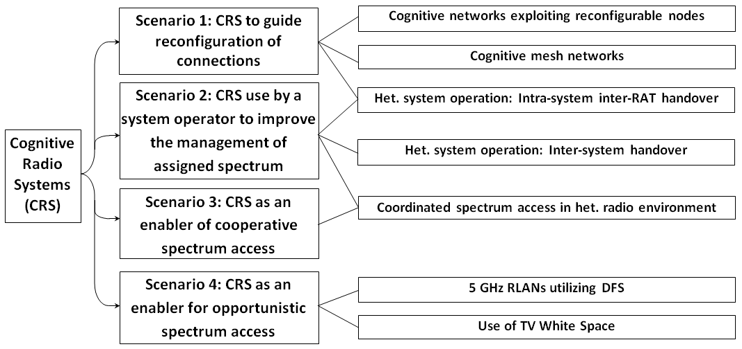
]
Actually, there are already existing applications (i.e. RLANs using Dynamic Frequency Selection) or planned applications (i.e. radio systems using TV White Space) that employ some of the CRS capabilities in order to obtain knowledge of their radio environment. Based on the obtained knowledge they are able to select parameters such as their frequencies and/or adjust their transmit power to enhance coexistence and sharing with the aim to avoid causing harmful interference.
CRSs may share spectrum with other radio systems that are not necessarily CRSs, as well as with other CRSs. In this context pertaining only to sharing involving CRSs, sharing as referenced in section 4.2 can be described as follows:
– Vertical spectrum sharing: The case where one or more CRSs share the band of another radio system that is not necessarily a CRS. The CRSs are only allowed to utilise frequencies within the band as long as the other radio system is not affected by harmful interference from the CRSs.
– Horizontal spectrum sharing: The case where multiple CRSs are accessing the same shared spectrum band.
A graphical illustration of vertical and horizontal spectrum sharing is given in Figure 1 below. In this illustration, vertical sharing refers to situation where CRS(s) with lower level of spectrum usage rights share spectrum band with radio systems having higher spectrum usage rights. One example of this kind of sharing is the use of TV white spaces as discussed in section 5.1.2. It should be noted that radio systems with higher spectrum usage rights may also possess CRS capabilities. As well the figure illustrates the horizontal sharing that could also take place between radio systems with/without CRS capabilities at the same level of spectrum usage rights.
FIGURE 1
Vertical and horizontal spectrum sharing involving CRSs
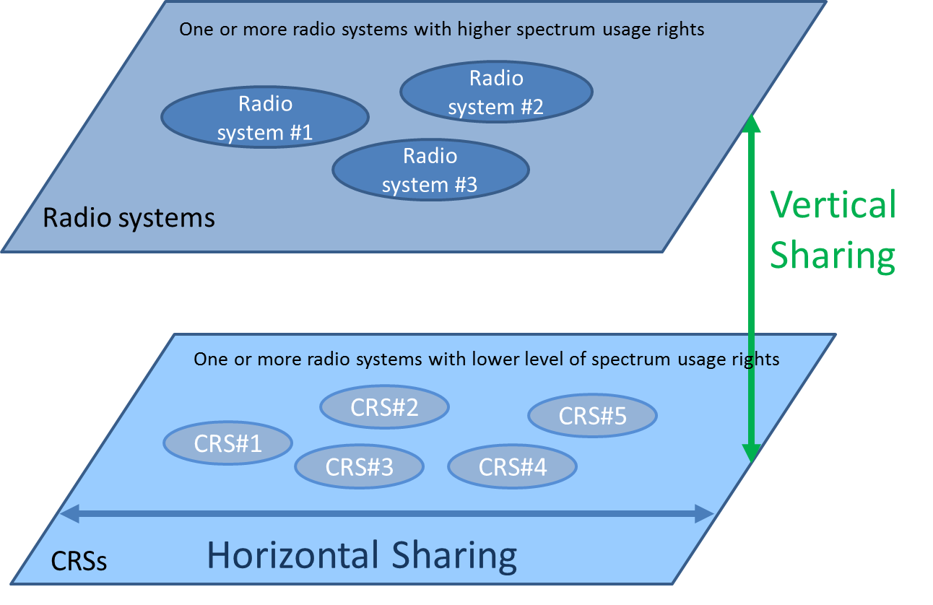

Vertical and horizontal spectrum sharing are not mutually exclusive and both of them are present in the examples of applications employing CRS capabilities that will be given in this section. Vertical and horizontal spectrum sharing can also exist separately.
Coexistence essentially refers to the interference issues that a CRS operating in a certain band may imply on another radio system (that is not necessarily CRS) that operates in the adjacent bands.
The technical description of sharing and coexistence may find specific applications according to the deployment scenarios described in Report ITU-R M.2225. Each application may have different implications on sharing and coexistence aspects.
In addition to existing and emerging applications, this section also reviews potential applications for the future.

5.1 Existing and emerging applications employing CRS capabilities
There are already examples of existing or emerging applications employing CRS capabilities, such as spectrum sensing and geo-location with access to database. These example applications can also make decisions and adjust their operational parameters based on the obtained knowledge.
Both examples that are introduced in this section represent opportunistic use of spectrum: an existing example is the radio local area network (RLAN) using 5 GHz band and the emerging application is the TV White Space usage.

5.1.1 5 GHz RLANs utilizing dynamic frequency selection (DFS)
RLANs can operate in the 5,250-5,350 MHz and 5,470-5,725 MHz bands on a co-primary basis with radiolocation systems and radars. RLANs operate within the mobile service allocation and radars in the radiolocation service allocation, both having a co-primary status. In this band, Radio Regulations have been adopted by the ITU (cf. Resolution 229 (WRC-03)) to facilitate sharing between the two systems with the aid of a dynamic frequency selection (DFS) protocol (cf. Recommendation ITU-R M.1652). This protocol specifies the sensing/detection and operational techniques to be used by the RLANs to avoid interference to the radar systems. Recommendation ITU-R M.1739 provides the protection criteria. Prior to operation, RLANs are required to use DFS to ensure that radiolocation systems are not operating in the same channel they intend to use. The mobile systems must also vacate channels when new radiolocation systems come into operation.

5.1.2 Use of TV White Space
Due to various reasons some channels have had to be left unused by TV applications to provide guard bands between the active broadcast channels. The guard bands have been needed to accommodate TV receiver characteristics for strong or weak signals and adjacent channel performance. Some channels have also been left unused as there has been limited TV service deployment in some geographic areas.
Recently, some administrations have allowed or are considering to allow license-exempt devices to operate on a non-interfering basis within these TV white spaces. To facilitate spectrum sharing and to protect incumbent services from interference, a variety of technical approaches for the operation in these bands have been considered. These approaches include:
– geo-location capability with access to a database;
– sensing capability.
With respect to the capabilities of CRS to obtain knowledge of its environment, in the case of TV white spaces the key capability is geo-location coupled with access to a database which in this application is referred to as the TV white space database approach. One administration adopted rules in April 2012 in ‎[1] to allow license-exempt devices employing the TV white space database approach to access available channels in the UHF television bands. That administration has selected several private-sector database managers and announced in the first half of 2012 the public availability of several databases, which were coordinated with local stakeholders. TV white space database functionality for TV white space usage is now available nationwide. The TV white space databases identify channels available for transmission of radio signals from license-exempt devices, register radio transmitting facilities entitled to protection, and provide protection to authorized services and registered facilities as required by the administration, see ‎[2]. Additionally, in late 2012, that administration launched a nationwide registration system for unlicensed wireless microphones. That registration system enables qualifying entities across the nation to register with the TV white space database managers so that the wireless microphones will be protected at specified times from other license-exempt devices operating on unused broadcast TV channels.
Other administrations are also considering defining requirements for the operation of the devices using TV White Spaces. One such administration has developed an approach for license-exempt TV white space access, again, based on the database approach (see ‎[3], as well as links referred to therein), and at the time of writing is undertaking a pilot test of license-exempt devices under these rules ‎[4]. Moreover, this approach has been adopted by ETSI into a European Harmonised Standard, aiming to converge to common approach for TV white space access on a European level ‎[5]. One key difference between this approach and another approach developed in ‎[1] by another non-European administration is that there is a more flexible approach to the transmit power limit of license-exempt devices based on the actual interference caused at the edge to the primary coverage area. This is a different approach to using a fixed transmit power limit irrespective of distance/loss to the edge of primary coverage.
[Editor’s note: check the terminology of license-exempt/TV white space device etc.]

5.2 Potential applications
The following subsections address the potential applications of CRS. Each of them uses either one or combinations of the deployment scenarios identified in Report ITU-R M.2225.

5.2.1 Cognitive networks exploiting reconfigurable nodes
Cognitive networks are networks in which CRS capabilities are implemented at the infrastructure level. This includes, for example, network elements such as O&M (Operation & Maintenance) and base stations. In particular, a cognitive network is a network that could dynamically adapt its parameters, functions and resources on the basis of the knowledge of its environment.
In the context of this section, cognitive networks are intended to be deployed using reconfigurable nodes. In principle, the application of such cognitive networks includes the following functionalities and entities (see Figure 2):
− cognitive network management;
− reconfigurable base stations;
− reconfigurable terminals.
The cognitive network management functionality spans different radio access technologies (RATs), managing and controlling the nodes inside the network, with the goal of self-adapting towards an optimal mix of supported RATs and frequency bands. This functionality could act on the basis of some input parameters, for example the available resources, the traffic demand, the capabilities of the mobiles within the network (supported RATs, frequency bands, etc.), the requested bearer services (bandwidth, quality of service (QoS), etc.), etc. In addition, this functionality could exploit a collaborative cognitive radio resource management scheme, where the decision making functions are shared among different network nodes.

In this approach, the reconfigurable base stations (RBSs) are the nodes establishing the cognitive network. The hardware resources of a reconfigurable base station could be dynamically reconfigured in order to be used with different RATs, frequencies, channels, etc., and they could support multi-RAT operation with dynamic load-management.
The reconfigurable terminals are the nodes connecting to the base station in the cognitive network. The software and hardware of a terminal could be reconfigured dynamically. Thus it could support operating on different RATs, frequencies, resource utilization modes, etc. Therefore, the reconfigurable terminals could facilitate the flexible and efficient adaptation of the cognitive network to the dynamic environment. For example, they could support multi-RAT operation, such as joint admission control and vertical handovers to balance the load of different RATs more efficiently.
In addition, cognitive networks enable the introduction of the CRS concepts and technologies in a multi-RAT environment.
The availability of reconfigurable base stations in conjunction with cognitive network management functionalities could give the network operators the means for managing the radio and hardware resource pool with better overall efficiency. This enables the adaption of the network to dynamic variations of network traffic.
The main features of cognitive networks can be summarized as follows:
− the dynamic self-adaptation of the network configuration towards an optimal mix of supported RATs and frequency bands can be achieved by the exploitation of the reconfigurable nodes and the application of cognitive network management functionalities;
− the dynamic self-adaptation (e.g. network configuration) can be based on the traffic patterns variations in time and space for the different deployed RATs;
− ability to provide sufficient information to the terminals for initiating a communication session appropriately in a dynamic context (e.g. wireless control channels).
The potential application of cognitive networks described in this section refers to the scenario outlined in section 5.2 of Report ITU-R M.2225.
An example of cognitive network application could be the enhancement of spectrum efficiency and high data rate provision based on GSM system frequency reuse. For cellular systems like GSM, in order to ensure that the mutual interference among cells remains below a defined threshold, adjacent cells use different frequencies. However in cells that are separated by a certain distance, frequencies can be reused. On this basis, a cognitive network management could efficiently reuse appropriate GSM frequencies to activate micro cells within the coverage area of a GSM macro cells by using a low transmission power in order to avoid harmful interference to the GSM system. Such micro cells can be deployed using a different radio access technology to provide high date rate transmission [6].
Other examples of higher efficiency of spectrum usage enabled by cognitive networks are reported in Annex C.
FIGURE 2
Cognitive networks functionalities and entities
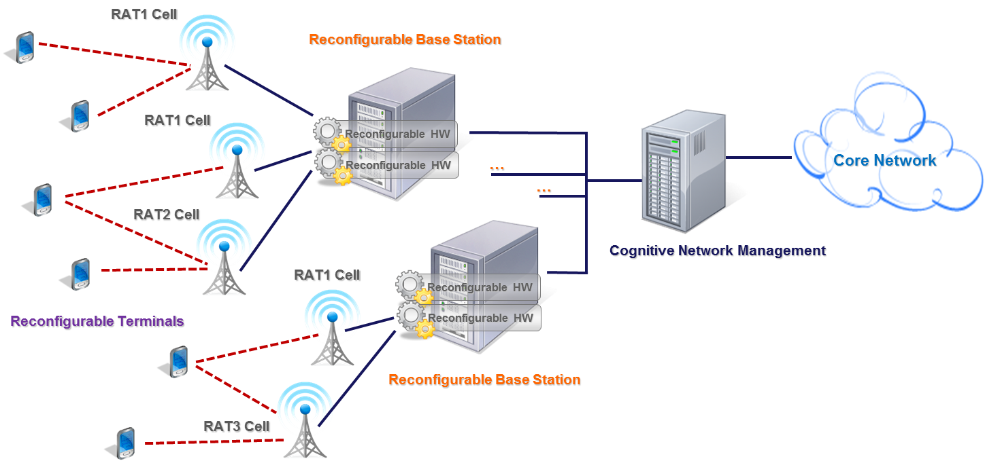

5.2.2 Cognitive mesh networks
In addition to the centralized concept described in the above section, decentralized CRS concept may also be considered as illustrated in the left part of Figure 3 ‎[7].
FIGURE 3
Centralized and decentralized CRS concepts
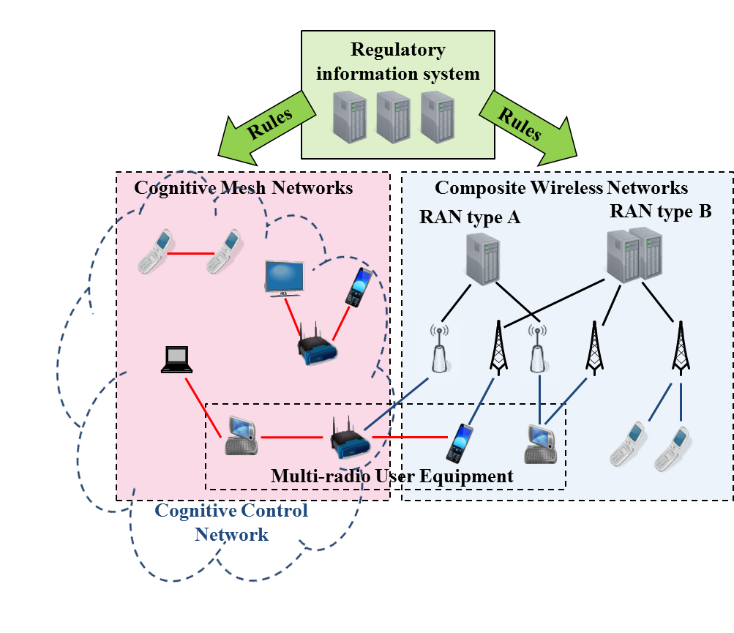
In Figure 3, Multi-radio User Equipment (MUE) represents a user device with reconfigurable radio capabilities and able to have connections to multiple radio networks at the same time. Such radio networks can be identified as i) Composite Wireless Network (CWN) representing a set of radio networks operated by a network operator using a common network management system that may also have cognitive capability (see Section 6.2.1), and ii) Cognitive Mesh Networks (CMNs). In general, mesh networks can be seen as a group of nodes which all communicate with each other creating a mesh typically using short-range radios. Every node can send and receive messages, but the nodes may also function as routers. CMNs introduce the possibility to use opportunistic spectrum access in collaborative manner so that different CMNs active in the same geographical area can coordinate their use of radio frequencies. Interworking between CMNs may be arranged in a decentralized manner by using logically separate Cognitive Control Network (CCN) to exchange information between CMNs. CCN may be implemented with the Cognitive Control Channel (CCC) which is described in section 6.1.1.1.
It should be noted that a MUE could be simultaneously connected to both CMN and CWN, however, the CMN domain is separated by the CWN domain, in terms of used radio frequencies and RATs. Inside CMN domain, MUEs do not act as relay entities towards CWN for others MUEs, while each of them may connect directly to CWN by the appropriate RAT ‎[7].

5.2.3 Heterogeneous system operation using CRS technology
In a heterogeneous network environment, CRS technology provides users with the optimal wireless access that best suits the users’ needs as well as operators’ objectives towards efficient use of radio resource and spectrum. CRS technology can be utilized for handover across different RATs and across different systems. In the following, the use of the CRS technology to enhance the handover operations within an operator’s networks is considered first, followed by a multi-operator situation.

5.2.3.1 Intra-system inter-RAT handover
Intra-system handover is considered within heterogeneous radio environment, where multiple RATs are deployed by a single operator on one or different frequency bands assigned to it, for example an operator deploys two different radio interface technologies within a single Radio Access Network (RAN) of a cellular system. In order to implement such intra-system handover functionality, the technical characteristics and capabilities of CRS described in Section 6 should be exploited by the system.
When a terminal in connected mode moves close to the cell edge of a RAT, it needs to handover to another cell. The candidate cell to handover may be the same type of RAT, or may also be different types of RATs. Therefore, the intra-system handover functionality may consist of RAT discovery, RAT selection, and terminal reconfiguration. For example, a terminal discovers available RATs and selects an optimal RAT among them by obtaining knowledge of its operational and geographical environment, its internal state and the established policies provided by the network operator. After an optimal RAT is selected, the terminal adjusts its parameters and protocols dynamically and autonomously according to its obtained knowledge and the network policies by reconfiguration procedure and executes the handover to the selected RAT. There may be cooperation between terminals and wireless networks for the universal access functionality to find an optimal wireless access.
A possible functional architecture for the intra-system handover based on IEEE P1900.4 ‎[8] and IEEE802.21 ‎[9] is reported in Figure 4. Entities described IEEE P1900.4, for examples Network Resource Manager (NRM), Terminal Resource Manager (TRM) and Cognitive Base Station (CBS), are applied for the optimization of radio resource management including dynamic spectrum use and an entity from IEEE802.21, i.e. entity which has Media Independent Handover Function (MIHF), is used as a toolbox for handover between heterogeneous radio access networks. A terminal may have various kinds of RATs through software-defined radio (SDR) technology and it reconfigures its parameters in order to access an optimal RAT determined by the universal access functionality. Context information of the core network is transferred to terminals through cognitive pilot channels (CPC), which are used for RAT discovery and selection procedures whenever terminals require context information of access networks as described in more detail in Section 6.1.1.2.
Another example of intra-system handover application is shown in Figure 5, where one operator deploys multiple radios systems on different frequency bands. These systems have different coverage areas from small to large cell. The resource manager collects the radio operational environment information from the base stations and user terminals on the geo-location basis, which is one of CRS functionalities (obtaining knowledge). The radio environment information may include the information of signal strength, throughput, and transmission delay. The resource manager provides the information to the control equipment. Based on this information, the control equipment selects the appropriate connectivity for the user terminal, which is another CRS functionality (decision and adjustment).
Figure 4
Functional architecture for Inter-RAT handover
FIGURE 5
Network configuration consisting of multiple RATs


medium cell

Internet
Application
Server
Resource Manager
(collection of radio circumstance information)

Heterogeneous radio network

large cell

small cell

Control Equipment
Base Station
User
terminal

5.2.3.2 Inter-system handover
Inter-system handover is considered within heterogeneous radio environment, where multiple operators operate multiple RATs on different frequency bands assigned to them, for example one operator operates a radio interface technology in a single RAN, i.e. a cellular system while another operator operates an RLAN technology as a public RLAN system. There are many ways to utilize CRS capabilities for inter-system handover, e.g. implementing the capabilities to terminals, base stations, and core networks.

5.2.3.2.1 Inter-system handover using cognitive radio terminals
An example of inter-system handover using cognitive radio terminals is shown in Figure 6 ‎[10] ‎[11] ‎[12]. Some terminals may also have reconfiguration capability. The terminals in this application have capability to support several simultaneous connections with different radio access networks. The green solid lines show the data paths and the orange dotted lines show the signalling. In this example reconfigurable terminal performs an inter-system handover.
The terminal utilizes multiple wireless networks concurrently so that communication bandwidth for applications becomes large. Following terminal movement and/or change of radio environment, suitable wireless link(s) are adaptively and actively utilized in order to keep stability.
Another example is shown in Figure 7 ‎[13]. In this example reconfigurable terminal performs inter-system handover. Decision making is being supported by selecting the appropriate parameters. A common signalling channel between ubiquitous networking server and the terminal, drawn in orange solid line in the figure, is used in order to obtain knowledge in addition to the sensing performed by the terminal. On the other hand, Figure 8 ‎[14] shows the same potential application with different implementation of CRS features. The example implements a dedicated radio system as the common signalling channel shown in an orange arrow, named Basic Access Network (BAN) in ‎[14], between BAN-BS and BAN-component. Terminals exchange information with management entity on network, named Signaling Home Agent (SHA), for adjusting its parameter and selection of RANs.
FIGURE 6
Inter-system handover using cognitive radio terminals
FIGURE 7
Inter-system handover using in-band signaling
FIGURE 8
Dedicated radio system for signalling
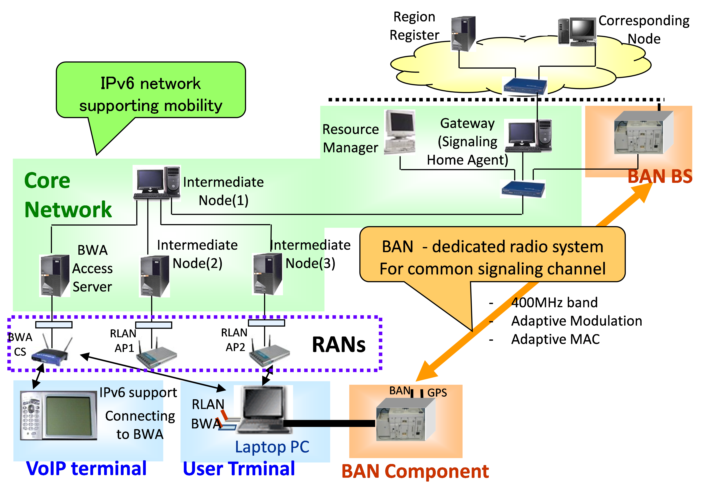

5.2.3.2.2 Inter-system handover using CRS supporting network entities
Compared to potential applications in the previous subsection, the applications in this subsection can address terminals without cognitive capabilities. Instead of using CRS terminals, the CRS capabilities are provided by CRS supporting network entities, e.g. mobile wireless router (MWR) which has CRS capability itself and resource manager which realizes CRS capabilities with existing base stations.
An example of MWR application is shown in Figure 9 ‎[15] ‎[16] ‎[17]. In this example MWR reconfigures itself to provide the best suitable service application for its terminals. A mobile wireless router serves as a bridge between multiple radio systems and terminals. Such MWR is required to have a CRS capability to obtain knowledge which RANs (and mobile networks) are available at its location, and also to adjust its operational parameters and/or switch the attaching radio access systems. The thresholds are configured by the obtained users’ preferences and they are used for RAN’s selection.
The MWR conducts Network Address Translation (NAT) routing between the Internet and local wireless network to which terminals are connected. When the MWR is turned on, the best frequency channel is selected, e.g. based on the lowest interference level. Then the MWR selects and conducts the various RAN authentication procedures according to the selected RAN.
FIGURE 9
Mobile wireless router

5.2.4 Coordinated spectrum access in heterogeneous radio environment
Coordinated spectrum access is here considered within a heterogeneous radio environment, where particular frequency band(s) can be shared by several radio systems in order to optimize spectrum usage. Improvement in spectrum usage is based on the fact that different radio systems in the same geographic area at some time intervals may have different levels of spectrum usage.
One possibility in this scenario is that one radio system is not a CRS while another radio system is a CRS. Another possibility is that both radio systems are CRSs.
One example of coordinated spectrum access is shown in Figure 10 ‎[16] ‎[17] based on the example 2 of use case of “Use of CRS technology as an enabler for opportunistic spectrum access in bands shared with other systems and services” described in section 6.4 in Report ITU-R M.2225 combined with “centralized decision making” described in section 6.2.1.1. In this example base station and terminals with CRS capabilities of obtaining knowledge can sense the spectrum usage at their location. The sensing information of base station and terminals are gathered to Network Reconfiguration Manager (NRM) ‎[8], which has a CRS capability of decision making. The NRM analyzes the measurements and detects temporary vacant frequency bands. Then, the NRM instructs the base station to reconfigure correspondingly. After the base station reconfigures itself to use these vacant frequency bands and starts its operation, NRM notifies the terminals of the operation frequencies of the base stations.
FIGURE 10
Coordinated spectrum access in heterogeneous radio environment
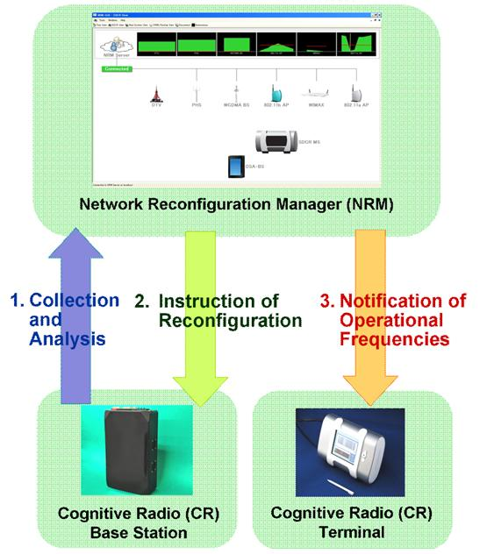

[5.2.5 Cognitive networks using vertical and horizontal spectrum sharing
[Editor’s note: Clarification is needed regarding the use of the terms existing users and incumbents as well as the use of the terms new wireless terrestrial broadband users and mobile broadband highlighted in yellow below,]
[Editor’s note: Clarification is needed as to what differentiates the other wireless terrestrial broadband users (highlighted in blue below) versus the new wireless terrestrial broadband users.]
As an example of vertical and horizontal spectrum sharing, one administration has proposed using a spectrum access system which includes a geo-location database and spectrum management function/agent to promote sharing between various radio systems. The proposal is intended to make spectrum available for the operations of wireless terrestrial broadband/mobile broadband while imposing restrictions to protect existing users of spectrum/incumbents. Further, the proposal is intended to protect existing users of the spectrum, and to allow use for wireless terrestrial broadband as well as opportunistic access where and when the spectrum is otherwise not in use. To accomplish this, both vertical and horizontal spectrum sharing are used (see Figure 1).
It is envisioned that a spectrum access system would take dynamic inputs from existing users regarding their spectrum utilization. Based on such inputs and other factors, the spectrum access system could communicate with existing and potential users of the spectrum about the availability of spectrum and certain operational parameters.
It is assumed that infrastructure nodes, like Radio Access Networks Operation and Maintenance, eNode B/Base Stations, or Access Points would interact with the spectrum access system and provides User Equipment/Mobile Stations/Access Terminals with operational parameters and updates.

Under the administration’s proposal existing users of the spectrum would be protected from harmful interference from all other systems by the spectrum access system using vertical spectrum sharing. In some cases, existing users of the spectrum may also be protected in certain areas through the establishment of exclusion zones.
Likewise, some new wireless terrestrial broadband users with quality-of-service needs would be granted exclusive access with respect to other wireless terrestrial broadband users but not with respect to existing incumbent users of spectrum. New wireless terrestrial broadband users with exclusive access in this proposal would have a measure of interference protection from opportunistic wireless terrestrial broadband access users but not with respect to existing incumbent users of spectrum. These opportunistic access users would be required to accept interference from existing users of spectrum new wireless terrestrial broadband users with exclusive access and using horizontal sharing, with other opportunistic access users.
This approach is intended to allow existing users of spectrum to operate on a fully protected basis. It is also intended to allow for flexible spectrum sharing between existing users and mobile broadband.]

6 CRS capabilities and enabling technologies
This section describes examples of enabling technologies, which are part of the CRS capabilities of obtaining knowledge, decision and adjustment, and learning. The deployment scenarios described in Report ITU-R M.2225 as well as the specific applications described in the previous section of this report, rely on these capabilities. The relationship between these technologies and the CRS capabilities are illustrated in Figure 14. The section further identifies and describes technical features related to these technologies.
Figure 14
Example of enabling technologies for CRS capabilities
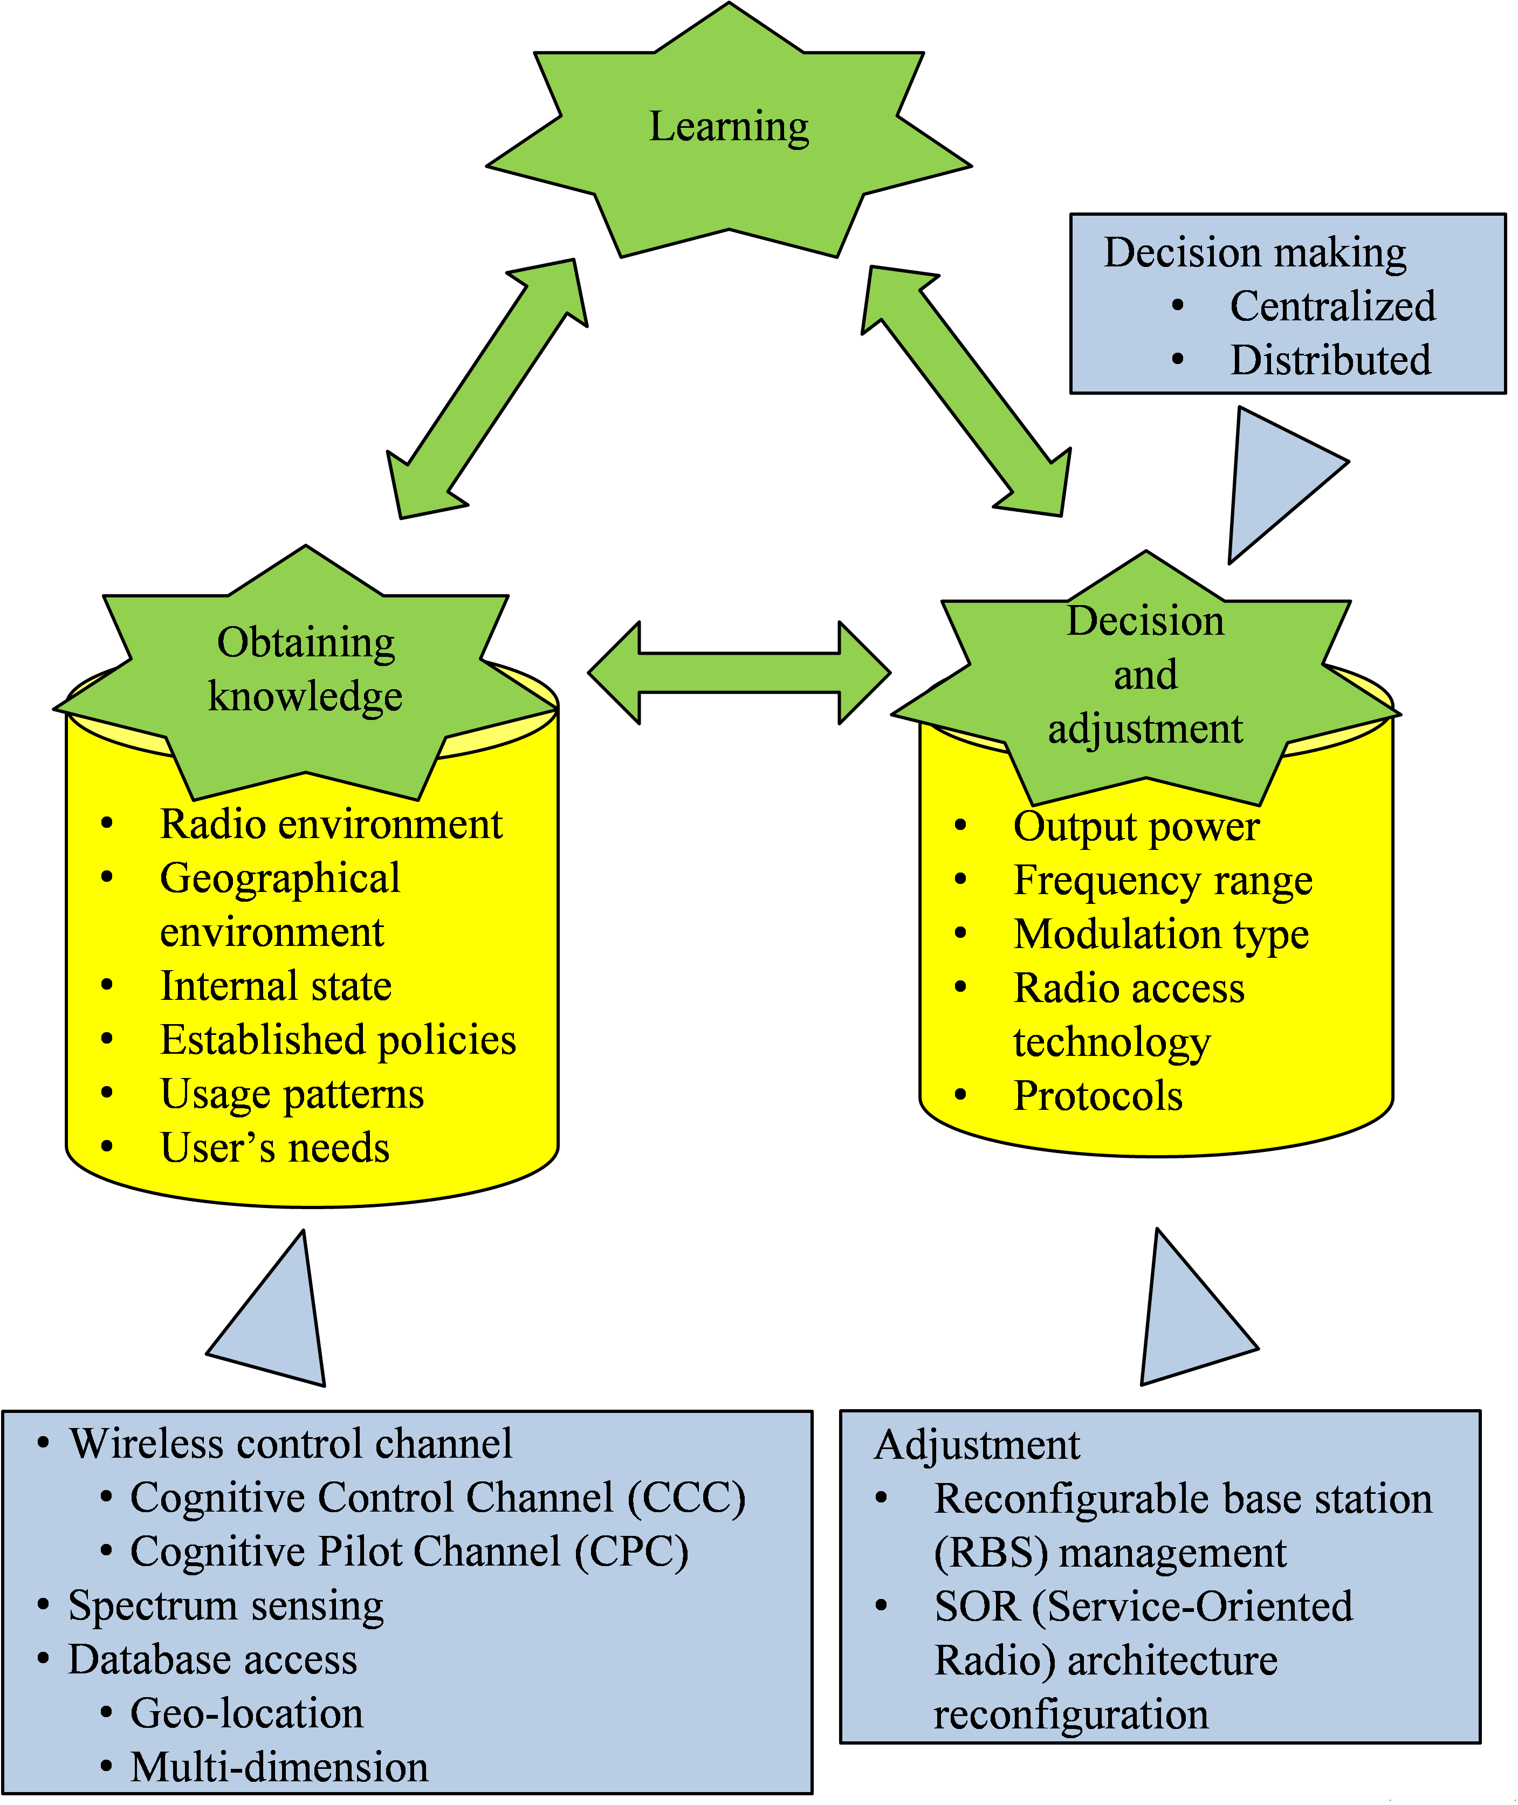

6.1 Obtaining knowledge
The first key capability of a CRS node is to obtain knowledge of its operational and geographical environment, established policies and its internal state.
Three most commonly suggested methods for obtaining knowledge in CRS are listening to a wireless control channels, spectrum sensing and access to databases. They are covered in detail in the following sections. Also combinations of the methods can be considered.

6.1.1 Listening to a wireless control channel
Control channels could be used for transmitting control information between two or more entities belonging to the systems which use the same spectrum resources. They facilitate more efficient CRS operation, spectrum use and coexistence of different radio systems. One of the key challenges with control channels is to decide how much and what control information should be exchanged to find the balance between the increased overhead and the gain achieved from exchanging that information. There also needs to be a way to ensure the reliability and accuracy of the control information sent on the channel. Following we have two examples of such control channels including Cognitive Control Channels (CCC), and Cognitive Pilot Channels (CPC). CCCs may enable different CRSs to exchange information related to the local spectrum between each other. The CRS can use the CPC to obtain knowledge of radio operational environment and by doing this the CPC facilitates the efficient operation and spectrum use. It may be possible to use or extend control channels already defined for the existing radio systems operation for cognitive control information exchange.
The purpose of CCC is to enable distributed information exchange directly between the CRS entities which have operation in the same area, whereas CPC conveys elements of the necessary information to let the mobile terminal know e.g. operators, policies, and access technologies and their associated assigned frequencies in a given region to enable efficient RAT discovery and selection. CPC covers the geographical areas using a cellular approach. The focus of CCC is on enhancing coexistence between secondary systems which are using the same available spectrum resources, i.e. the networks operating in the same area and frequency band.

6.1.1.1 Cognitive Control Channel (CCC)
The Cognitive Control Channel (CCC) is a suggested approach for a real time communication channel between different distributed CRS nodes in a specific geographical area. The CCC has been introduced and studied in EU FP7 Project E3 as the Cognitive Control Radio (CCR). In deliverables ‎[18] and ‎[19] the CCR concept and its functions as an awareness signalling mechanism are described, while analysis and comparison to other awareness signalling mechanisms are reported in ‎[20], ‎[21], and ‎[22]. The CCC is based on the CCR definitions and it is further considered as a coexistence solution in IEEE P802.19.1 ‎[23] and ETSI RRS ‎[24].
The CCC is primarily targeted for enhancing the coordination of the CRS devices. The CCC enables different CRS entities to exchange information related to the sharing and coexistence, spectrum usage rules or policies and/or specific capabilities and needs of different entities. The CCC may be used for:
– Sharing and coexistence – Exchanging the information on the network capabilities and characteristics, network’s spectrum need and use, and agreeing spectrum use with other networks in the area.
– Cooperative sensing – Agreeing on the common quiet periods for sensing the signal from other radio nodes which are not connected to the CCC, and exchanging spectrum sensing outcomes between the other networks in the area.
– Network access – Discovering the networks or devices to connect to, their capabilities and provided services.
– Access local policy and etiquette information, e.g. sharing rules for accessing specific bands and local availability of the bands.
The CCC may be implemented with a physical or a logical channel approach ‎[22]:
– In the physical channel implementation approach a specific physical radio channel targeted for CCC operation is included in the entities exchanging cognitive control information. This enables direct communication between any entities within range on the used physical radio channel.
– In the logical channel implementation approach the CCC operates over any physical radio channel using a transport networking protocol such as Internet Protocol. If the entities, which need to exchange cognitive control information, do not support the same physical radio channel, direct communication between the entities is not possible. Thus, the communication is routed through the other entities, e.g. through internet servers or wireless router nodes. As an example IEEE 802.19.1 assumes logical channel implementation approach for coexistence communication ‎[23].
The CCC can be applied e.g. in a context of heterogeneous networks, consisting of centralized and decentralized CRS concepts, operating in the same area ‎[24]. The CCC enables the networks to share and exchange various information directly with each other to enhance simultaneous operation.
The information which a network may exchange on the CCC can be collected by a combination of means, e.g.:
– Querying a local database for spectrum availability.
– Spectrum sensing, e.g. estimating spectrum availability or recognizing other spectrum users by evaluating the detected radio waves.
– Information received from other CRS entities e.g. over CCC or CPC.

6.1.1.1.1 CCC operation procedure
Typical applications of the CCC in an environment of independent and/or heterogeneous networks are illustrated in Figure 15. The nodes exchange cognitive control information to each other over the illustrated CCC physical or logical connections. In the physical implementation option, direct CCC connections may be formed over low power local connectivity technology between the networks. In the logical channel implementation option of the CCC, internet servers supporting the logical CCC communication facilitate the connections between the nodes operating in the same geo-location area.
Figure 15
Cognitive control channel used for enhancing coexistence between heterogeneous networks

Based on ‎[23] and ‎[24], which introduce requirements and information flows for sharing and coexistence communication, the CCC operations can be organized in four phases:
– initiate CCC;
– discover other nodes;
– connect to the relevant nodes;
– exchange and receive information with the relevant nodes.
The CRS behaviour in each of the different phases depends on whether the physical or logical implementation option is used for CCC.
In the “Initiate CCC” phase the CCC entity in the CRS node starts the CCC operations. In the physical implementation option it switches on the physical radio channel which is used for CCC. In the logical implementation option, the CCC entity in the network registers to the CCC entity in the internet server. The geo-location area of the network is provided to the CCC entity in the registration.
In the “Discover other nodes” phase the CCC entity acquires information of other nodes in the area. The CCC entity may regularly enter the “Discover other nodes” phase to discover for example if new nodes have started operation in the same geo-location area. If the physical implementation option is used, the CCC entity scans or broadcasts messages from/to other CCC entities. This phase includes evaluation of the signal strength and content of the broadcast messages which are received from other CCC entities. In the logical implementation option, the CCC entity requests discovery information from the CCC entity in the internet server that provides a list of the nodes which are registered to operate in the same geo-location area. The list contains also information on how to connect to the CCC entities of those nodes, e.g. internet protocol address, or address specific to CCC system. The discovery mechanisms with different approaches are evaluated in ‎[19].
In “Connect to the relevant nodes” phase the CCC entity determines with which nodes to exchange cognitive control information, and creates connection to the CCC entities of those networks. In physical implementation option, the CCC entity responds to the broadcast messages to request connection, and performs the required authentication procedures. Alternatively, the option to broadcast the cognitive control information may be used. This option does not require separate connection creation. In logical implementation option, the CCC entity connects to the CCC entities of the relevant nodes using the addressing information provided by CCC entity in the internet server in the “Discover other nodes” phase.
In the “Exchange and receive information with the relevant nodes” phase the CCC entity exchanges cognitive control information over the connections which were created in the “Connect to the relevant nodes” phase. The connections remain until they are terminated. A CCC entity may actively terminate the connection to another CCC entity. The connection may also be terminated passively if no messages have been exchanged before a pre-defined connection timeout.

6.1.1.1.2 Main functionalities of the CCC
In terms of functionality, the CCC may:
1) enable information exchange between independent and/or heterogeneous CRSs which operate in the same area;
2) provide support for sharing and coexistence of the CRSs by enabling networks to exchange information of the network capabilities and characteristics, and spectrum use and;
3) provide support for efficient spectrum use by enabling CRSs to exchange information about spectrum use, and to share policies, etiquettes, and spectrum sensing outcome;
4) enable collaborative spectrum sensing. The networks operating in the same area may agree on a common quite period when they can sense the interferences e.g. from primary spectrum users or other CRSs which are not connected to the CCC. Exchanging the sensing outcome enables a network to gain more, and more reliable, information on the radio environment;
5) provide support for self-configuring networks by enabling CRSs to exchange and access information about radio environment, use the information to identify optimal spectrum resources, and agree on the spectrum sharing with other networks;
6) provide support for efficient discovery of networks or devices to connect to.
The messages and the protocols to discover other independent and/or heterogeneous networks in the area and to exchange the information with them should be defined.

6.1.1.2 Cognitive Pilot Channel (CPC)
The CPC is a pilot channel (physical or logical) that broadcasts radio environment information intended to aid the decision processes of a cognitive terminal in a dynamic and flexible heterogeneous environment, as also described in ‎[7], ‎[27]‎[25], ‎[26], ‎[27], and ‎[28]‎[28]. The radio environment information includes information with regard to operators, frequency bands, available RATs, services, and load situation etc. This information can be used to aid a variety of different usage including:
– initial camping;
– network association;
– policy distribution;
– simplify inter-system handovers;
– spectrum brokering;
– pre-emptive access;
– real-time adaptations;
– migration to new standards.
In some proposed radio environment, the cognitive capability of the terminal (or possibly, base station) appears to be a crucial point to enable optimisation of radio resource usage.
Indeed, in order to obtain knowledge of its radio environment, a cognitive radio system may need to obtain information of the parts of the spectrum within the considered operable frequency range of its radio hardware: it is important that this action is reliable and would be carried out within an acceptable time and with acceptable power-consuming performance. On this basis, the CPC concept consists of conveying the necessary information to let the terminal or base station know the status of radio channel occupancy through a kind of common pilot channel.
In addition, the CPC is anticipated to be conveyed by two approaches: the “out-band” CPC and the “in-band” CPC. The first one, out-band CPC, considers that a channel outside the bands assigned to component RATs provides CPC service. The second one, in-band CPC, uses a transmission mechanism (e.g. a logical channel) within the technologies of the heterogeneous radio environment to provide CPC services. Out-band and in-band CPC approaches are considered to be used jointly by broadcasting the general information over out-band CPC and detailed information over in-band CPC. The characteristics of out-band and in-band parts of the CPC are summarized in Table A.7.1.
Taking into account the description of spectrum use database as described in section 6.1.3, used to store information of spectrum use indicating vacant or occupied frequencies and the rules related to the use of the frequencies in certain locations, the CPC may be used for providing such information to CRS nodes.

6.1.1.2.1 CPC operation procedure
The typical application of the CPC in a heterogeneous or multi-RAT context is depicted for out-band and in-band CPC deployment in Figures 16 and 17, respectively. When turned on, the mobile communication terminal or base station may not be aware of which is the most appropriate RAT in that geographic area where it is located, or which frequency ranges the RATs existing in that specific geographic area exploit.
Figure 16
Out-band CPC
The multi RAT environment context

Figure 17
In-band CPC
RAT m
RAT j
RAT k
RAT n
CPC in RAT m
CPC in RAT j
CPC in RAT n
CPC in RAT k
Indeed, in the case where Dynamic Spectrum Allocation (DSA) and Flexible Spectrum Management (FSM) schemes are applied, the mobile terminal or base station will have to initiate a communication in a spectrum context which is completely unknown due to dynamic reallocation mechanisms.
In this case, if information about the service areas of deployed RATs within the considered frequency range communicable from a radio terminal is unavailable, it would be necessary to scan the whole frequency range in order to know the spectrum constellation. This may be a power- and time-consuming effort and sometimes the search may not even be effective, as for example in the “hidden-node” case.
In this context, a CPC should provide sufficient information to components of the CRS, including a mobile terminal, so that it can initiate a communication session optimised to time, situation and location. The CPC broadcasts relevant information with regard to frequency bands, RATs, load situation etc. in the terminal location.
In principle, the CPC covers the geographical areas using a cellular approach for out-band deployment. While for in-band deployment case, CPC is carried in system resource, e.g. as an extended system information message on broadcast channel of RATs or other resource partition part. With CPC, information related to the spectrum status in the cell's area is broadcast, such as:
– indication on bands currently assigned to cellular-like and wireless systems; additionally, also pilot/broadcast channel details for different cellular-like and wireless systems could be provided;
– indication on current status of specific bands of spectrum (e.g. used or unused).
The envisaged CPC operation procedure is organized into two main phases, namely the “start-up” phase and the “ongoing” phase:
– For the “start-up” phase: after switching on, the node of the CRS (e.g. terminal) detects the CPC and optionally could determine its geographical information by making use of some positioning system. The CPC detection will depend on the specific CPC implementation in terms of the physical resources being used. After detecting and synchronizing with the CPC, the node of CRS (e.g. terminal) retrieves the CPC information corresponding to the area where it is located, which completes the procedure. Information retrieved by the node of CRS (e.g. terminal) is sufficient to initiate a communication session optimised to time, situation and location. In this phase, the CPC broadcasts relevant information with regard to operators, frequency bands, and RATs in this geographical location (e.g. terminal location).
– For the “ongoing” phase: once the terminal is connected to a network or CRS base station is on operation, a periodic check of the information forwarded by the CPC may be useful to rapidly detect changes in the environment due to either variations of the mobile position or network reconfigurations. In this phase, the CPC broadcasts the same information of the “ongoing” phase and additional data, such as services, load situation, etc.
Figure 18 presents the two main phases in the CPC operation taking into account the main steps of the overall CPC operation procedure described above. Both out-band CPC and in-band CPC are jointly used (see ‎[25], ‎[26], ‎[29] and ‎[30]).
Figure 18
CPC operation procedure
use of the Outband CPC
Start-up information
Ongoing information
use of the Inband CPC
Listen to out-band CPC in order to obtain basic parameters (e.g. available networks at that location)
Select and connect to a network using information from the out-band CPC; stop listening to the out-band CPC
Connect to the in-band CPC within the registered network
Listen to ongoing information using the in-band CPC
To broadcast data allowing a terminal to select a network in an environment where several technologies, possibly provided by several operators, are available
e.g. much more detailed context information, policies for reconfiguration management

6.1.1.2.2 Main functionalities of the CPC
In terms of functionality, the CPC:
1) enables the nodes of a CRS (e.g. mobile terminal) to properly select network depending on the specific conditions like for example RATs' operating frequency bands, established policies, desired services, RAT availability, interference conditions, etc. This provides support to Joint Radio Resource Management (JRRM), enabling a more efficient use of the radio resources;
2) provides support for an efficient use of the radio resource by forwarding radio resource usage policies from the network to the terminals;
3) provides support to reconfigurability by allowing the terminal to identify the most convenient RAT to operate with and to download software modules to reconfigure the terminal capabilities if necessary;
4) provides support to context awareness by helping the terminal identify the specific frequencies, operators and access technologies in a given region without the need to perform long time and energy consuming spectrum scanning procedures;
5) provides support to the network provider to facilitate dynamic changes in the network deployment by informing the terminals about the availability of new RATs/frequencies, thus providing support to dynamic network planning (DNP) and advanced spectrum management (ASM) strategies, providing information of the current status of specific spectrum bands (e.g. used or unused).
By considering such a CPC, the following advantages are pointed out:
– simplifying the RAT selection procedure;
– avoiding a large band scanning, therefore simplifying the terminal implementation (physical layer) for manufacturers;
– the CPC concept seems particularly relevant for the implementation of DSA/FSM;
– the CPC concept as a download channel could be useful to the operator and user where it is necessary to download a new protocol stack to connect to the network.
The deployment of CPC may require information also from the existing technology. The format of the frequency usage information as well as the spectrum band for the CPC needs to be realised in a way that CRSs are able to access it and understand the information.

6.1.1.2.3 Geography-based implementations of the CPC
There is a need to organize the information delivered over the CPC according to the geographical area where this information applies.
A difference can be made between two options differing on how they provide geographical related information:
− Mesh-based approach: The geographical area is divided into small regions, called meshes. In that case the CPC should provide network information for each one of these meshes, being possibly transmitted over a wide area and therefore including a lot of meshes. Initial requirements evaluations seem to conclude that this solution could require a very high amount of bandwidth.

− Coverage area approach: In this approach, the coverage area is provided for the different RATs, thus the concept of mesh is not needed any more. For example, the following items could be provided in this approach: operator information, related RATs and for each RAT, corresponding coverage area and frequency band(s) information.
Implementations of these two approaches are given in Annex A.

6.1.1.3 Challenges of CCC and CPC
Some challenges arise when considering listening to a wireless channel for obtaining knowledge of the operational environment.
Various sources in literature have proposed the use of a predetermined common coordination channel for spectrum etiquette, network establishment and adaptation to changing interference environments, see ‎[31] ‎[18] ‎[32]. Local coordination and exchange of information provides low delay and accurate sharing limited to the involved networks.
The CCC usage may increase the power consumption of the devices. The power consumption should be considered carefully and particularly if the nodes are mobile. In such case the challenges related to the power consumption are to limit the signalling overhead and to enable efficient power save mode which still enables low latency information exchange. Thus, it is important to find the optimal amount of exchanged information and the latency for the information exchange. In addition, in the case the nodes have to connect over the internet, the appropriate network access to be used should be selected.
Further challenges of CCC such as the synchronization between the involved nodes, the contention resolution mechanisms when accessing the spectrum band, and the reliability of the exchanged information should be investigated.
According to ‎[33], the CPC concept could provide the necessary support for obtaining knowledge of the spectrum occupancy. However, also the use of CPC would require further investigations on some technical challenges before being considered as a mature approach, such as: the CPC delivery should strictly satisfy the timing requirements coming from the opportunistic spectrum use; the CPC content should be updated in a proper timeframe, according to the one related to opportunistic spectrum use.
Setting arise on the above consideration, it can be concluded that further research and development in order to improve the maturity of both CCC and CPC are needed e.g. in ETSI RRS and IEEE 802.19.1. For this purpose a feasibility study on different approaches and implementation options of control channels for cognitive radio systems has been carried out in the scope of ‎[34].

6.1.2 Spectrum sensing
Spectrum sensing is a capability to detect other signals around the CRS node and is one method to determine unused spectrum bands. Spectrum sensing is usable in particular in cases where the level of the detected signal is sufficiently strong, and/or the signal type/form is known beforehand.
Considerable research is focused on sensing techniques, which has resulted in a number of sensing methods, which are described in the following sections.

6.1.2.1 Sensing methods
Currently different spectrum sensing methods are considered for CRSs. These methods include energy detection, matched filtering, cyclostationary feature detection and waveform based detection etc. These existing sensing methods differ in their sensing capabilities, requirements for a priori information, and also their computational complexities. The choice of a particular sensing method can be made depending on sensing requirements, available resource such as power, computational resource and application/signal to be sensed. These sensing methods can also be used in a cooperative way where several CRS nodes do sensing and reporting.
Performance indicators which are related to the impact of different spectrum sensing techniques to other users of the spectrum include e.g. the following:
– Detection threshold for the signals of the existing system
The minimum signal-to-noise ratio (SNR) which is needed by a spectrum sensing method to achieve a certain probability of detection.
– Pre-determined detected signal intensity
The minimum detected signal intensity which is needed by a spectrum sensing method to achieve a certain probability of detection.
– Detection time for the signals of the existing system
The duration which is used by each spectrum sensing method to detect the signals of existing system.
– Detection probability
Probability that the signal is correctly detected when it is present.
– False alarm probability
Probability that the signal is detected when it is not present.
– Time between failures in detection
Average time period between failures in signal detection (i.e. signal is not detected when it is present).
– The lost spectrum opportunity ratio
The expected fraction of the OFF state (i.e., idle time) undetected by CRS nodes.
– The interference ratio
– The expected fraction of the ON state (i.e., the transmission time of the networks of the existing systems) interrupted by the transmission of CRS nodes.
In Annex D, the description of different sensing methods can be found.

6.1.2.2 Implementation of sensing methods
Currently several implementations of sensing methods are studied. Besides incorporating the sensor directly into the user device, the following implementations are under consideration:
– Dedicated listening devices: A dedicated listening device could be used to detect incumbent systems at a distance if mounted outside such as on a tower or rooftop. CRSs communicate with the dedicated listening device to follow its instructions when the listening device detects the channels that incumbent systems are using. A dedicated listening device could also be used in conjunction with a database as well.
– Community sensor networks: A network of sensors may be used either alone or in conjunction with a database to identify and communicate the presence of incumbent transmissions and the availability of particular frequencies to end-user devices.

6.1.2.3 Challenges of spectrum sensing
Some challenges arise when considering spectrum sensing for obtaining knowledge of the operational environment. One of them is the hidden node problem. The hidden node problem occurs when a CRS node cannot sense another node transmitting (for example, due to radio propagation conditions) or not sense the presence of a receive only node and therefore incorrectly assumes that the frequency channel is not in use (Report ITU-R M.2225).
Furthermore, spectrum sensing requires high sensitivity, sampling rate, resolution analogue to digital (A/D) converters with large dynamic range, and high speed signal processors. When wideband sensing is considered terminals are required to capture and analyse a wide band, which imposes additional requirements on the radio frequency (RF) components. Wideband sensing also means that a wide range of signals with different characteristics needs to be detected which adds to the complexity of sensing since it needs to adapt to e.g. different energy levels or cyclostationary features of the primary signal ‎[35].
Therefore it might be useful to utilize sensing technologies in a limited frequency range in which the range of technologies used by the other existing systems in the band is limited ‎[36]. Moreover, considering the constrained energy and limited processing capacity of some CRS nodes, the power consumption and complexity of spectrum sensing algorithms should also be considered. For example, the order of channels to be sensed, sensing interval, and complexity should be optimized while maintaining sensing accuracy.
An important issue that has to be considered is the reliability of sensing, that is how much reliable is the information obtained sensing the spectrum band. Indeed, in case of unreliable information, there could be consequences for the primary system (and even for the secondary system). Several recent studies and statements as the ones reported in ‎[37], ‎[38], ‎[39], ‎[40], ‎[41] and ‎[42], show that the reliability of sensing is one of the most critical challenge to spectrum sensing.
Reference ‎[33] reports a study focused on the reliability of a spectrum sensing technique as a way to obtain the knowledge of the 2G system spectrum occupancy. As a result of the study, it is possible to conclude that the considered spectrum sensing techniques may suffer of a very low reliability in the evaluation of the spectrum occupancy and this aspect could be really critical in an opportunistic spectrum use context as decisions should be made in a strict timeframe. Similar results are also reported in ‎[38], where it is concluded that the dependence of the perceived spectral activity with the user location along with the presence of external noise sources (e.g. man-made noise sources like AC power systems, electric motors, etc.) altering the observed spectrum occupancy suggest the need for sophisticated spectrum sensing methods as well as some additional techniques in order to guarantee an accurate spectrum occupancy detection.
Thus, it does appear clear that the implementation of opportunistic spectrum access mechanisms could not rely simply on the spectrum sensing techniques, in particular in case of terminal-side only approaches. Indeed, when exploiting spectrum sensing in case of failure to obtain knowledge or in case of unreliable information of radio environment, CRS using spectrum sensing approach needs to have alternative methods to cope with the situation.
In ‎[41] it is stated that sensing is not a preferred solution to protect the broadcast service in the UHF TV bands and that the potential benefit of using sensing in addition to the geo-location database needs to be further considered. When sensing is implemented, testing procedures would need to be developed by standardization bodies to assess the efficiency and the reliability of the sensing process/device. In addition, to protect emerging systems of the broadcast service, sensing algorithm would require continuous developments, which may raise legacy issues. Research on sensing ‎[43] has shown that PMSE services can be very difficult to detect under realistic conditions, even by cooperative sensing.
When spectrum is used opportunistically, the primary system has the priority to use its frequency bands anytime. Therefore, CRSs should be able to identify the presence of primary user and vacate the band as required within a certain time depending on the requirements of the specific primary user. For example if the CRS is exploiting opportunities at the public safety band, there may be a sudden need for more spectrum by the primary use, the tolerance time will be very small and if the opportunistic spectrum use is based on sensing, it needs to be done frequently. Also the temporal characteristics of the primary user affect how frequently the sensing should be done. For example the presence of a TV station does not usually change frequently in a geographical area, but the use of wireless microphones may change rapidly ‎[32].
It can occur that the primary user receiver is in the transmission range of the CRS but the primary user transmitter is not. This could be the case e.g. with wireless microphones. There are also receive-only users, such as passive radio astronomy services which cannot be detected by sensing ‎[35] ‎[36].
In addition to the challenges reported above, in general, also the following ones should be addressed while investigating the sensing approach:
– Algorithm complexity may be related with power and processing consumptions.
– The complexity of each spectrum sensing method (in terms of power and processing consumptions) related to the observed bandwidth.
– Sensing signalling cost (e.g. including cost in sensing measurement and sensing reporting).
– For cooperative sensing, the cost of aggregating and processing the sensing reports as well as synchronization issues.
Based on the current studies that have been referred, the sensing techniques are not mature enough and further research effort is needed on spectrum sensing in order to understand how such a technique can be implemented and what would be the sensing requirements in each band and with relevant primary services.

6.1.3 Databases

6.1.3.1 Geolocation and access to databases
The objective of databases is to provide information about the locally usable frequencies and thus to provide protection to incumbent services from harmful interference. The database can protect a wide range of radio services, including passive services which cannot be covered by sensing.
Databases can deliver information of vacant spectrum bands and the rules related to the use of those frequencies in certain locations, such as information on the allowed maximum transmit power. By knowing the locations and having access to the database, the CRS nodes can check available frequencies from the database to be used for their own transmissions. The information on the
database can be obtained either by the CRS itself or the information can be provided by another system. The CRS nodes can access the database in several ways and for example CPC could be used for providing the information contained in the database to CRS nodes.
Database approach is especially useful to protect primary usage where the locations of the stations are known and remain stable and spectrum use does not change frequently ‎[36].
Several approaches to databases can be possible. The approach can vary e.g. on the time frame on which the information on the spectrum band is gathered.
In UHF TV bands, as stated in ‎[42], the geo-location and database access method provides adequate and reliable protection for broadcast services, so that spectrum sensing is not necessary.
Furthermore, in one country industry has set up a voluntary database for recording RLAN systems operating in the 5 470-5 725 MHz band outdoors if they are within 35 km of a Terminal Doppler Weather Radar (TDWR) that is operating in the 5 600-5 650 MHz band. In other bands the geolocation databases may become a key tool of enabling other forms of vertical as well as horizontal spectrum sharing.
Any database could contain and utilize information on all services the administrations want to protect in the bands to be accessed by the CRS nodes. This could include information on protected receive sites or operational areas of those protected services, as well as on any registered devices.
The operation of the database can also be organized in different ways, and there are several proposed architectures. ‎[41]
[Editor’s note: Make reference to newly proposed Annex E.]
It is possible to have one or more databases and they could be provided by the regulator or third parties authorized by the Regulator. If there are multiple databases they all need to provide the same minimum information about the available frequencies to the cognitive device.
– Single open database: One option is to have a single database for the entire country or for a region. All CRS nodes consult this database using a pre-defined and standardized message format. The database would be open to all users. In practice a regional database may not be practical due to differences in national approaches.
– Multiple open databases: A second option is to have multiple databases. In this case, CRS nodes could select their preferred database but there would be no difference between them in the information related to the allowed frequencies. One benefit could be an improved availability as a result of the redundancy of databases. In addition, if some of the databases are operated by third parties, they could offer also other information and value-added services to the CRS nodes, in addition to the mandatory interference protection related information.
– Proprietary closed databases: A third option is to have “closed” databases corresponding to different types of devices. For example, a manufacturer of CRS nodes might also establish a database for those devices it had made. Multiple manufacturers might work together to share a single closed database or one manufacturer might “open up” its protocols and database for others to use if they wish.
– “Clearinghouse” model: The “clearing house” model partitions the process of providing information on available channels to CRS nodes, in order to facilitate the development of multiple database service providers. The key element is the clearing house, which aggregates and hosts the raw data needed to perform database calculations.

Since there would be only one of these per country or region, it would need to be carefully regulated to ensure equitable access conditions as well as integrity of data handling and distribution.
Open interfaces and protocols should be defined between the devices and the database so that different types of CRS nodes can access a database-based on those interfaces and protocols.
Geolocation is an important part of the database access approach as the location of the CRS node needs to be known to retrieve correct information from the database for the specific location. There are several ways to implement the geo-location. Fixed CRS devices such as access points can be professionally installed and their location then programmed into the device. Personal computers and other portable devices can use geo-location technologies such as GPS chips. Also triangulation using radio towers or any other location determination method provided those methods provide sufficient accuracy to determine the location of devices at a given point and time. Once the device determines its location, or it is determined by the access point acting as a master device, it can be communicated to the database to determine the frequencies available for use in its area ‎[41].

6.1.3.2 Multi-dimension cognitive database
An important characteristic of CRS is its capability of making decisions and adaptations based on past experience, on current operational conditions, and also possibly on future behavior predictions. An underlying aspect of this concept is that CRS must efficiently represent, store and manage environmental and operational information.
Cognitive database ‎[44] is a promising module in CRS architecture by storing and managing cognitive information to support the functions implemented in cognitive cycle. This database is a logical entity which can be organized flexibly in both centralized and distributed manner.
The cognitive information in cognitive radio systems is comprehensive, including information of space, time, frequency, user, network and different layers of system. The cognitive database should be divided into several dimensions in terms of its nature, and the cognitive information in which should be managed based on the dimension division, such as:
– Radio dimension
• Parameters of radio transmission characteristics
– Network dimension
• Information reflecting the network status
– User dimension
• Information related to users or concerned by users
– Policy dimension
• Guideline of radio resource management, spectrum policies, operator policies.

6.1.3.3 Challenges of geo-location/database
CRS nodes may need to be capable of knowing their locations and accessing the database. Using databases to present fast varying spectrum use is challenging as the information stored in the database can become outdated fast.
Furthermore, database approach may not be suitable in cases where the location of the protected stations is not known or they cannot be registered in the database.
The management of database includes also security and privacy aspects that need to be considered.
The sensitivity of the information stored in the database could be very high, and should be carefully managed in the network, in order to avoid any unauthorized or unexpected access to the data. As a basic principle for addressing the security of the information, two categories of information could be introduced: a first category related to non-sensitive information, and a second category related to sensitive information. Any information related to the available RATs and related frequency bands in a certain area should be included in the first category, since this kind of information needs to be sent freely to any mobile device. On the other side, any information related to some specific actions, decisions and operations in the networks should be included in the second category.
The information that the database provides to the devices may depend on the regulation and the database implementation. The CRS may be able to operate in various countries and frequency bands, and thus it may need to access to various databases. For providing global interoperability for CRS, a unified and flexible interface, which enables access to various databases globally, should be defined. Such interface may be defined e.g. in IETF PAWS.

6.2 Decision making and adjustment of operational parameters and protocols
The design of future CRSs will face new challenges as compared to traditional wireless systems. Future CRSs need take into account the underlying policies in the different spectrum bands that determine the rules for using the bands and transform the policies into adjustment actions. The operational environment will be heterogeneous consisting of several RATs with diverse sets of terminals to support a wide range of services. In addition, the operational environment will be more dynamic as the number of users and the applications they are requesting vary in time leading to changing requirements for resource management. As a result the resource management in a dynamic and complex environment becomes a multivariable optimisation problem with conflicting requirements where optimal solutions are difficult to find.
The decision making in CRSs including e.g. the resource allocations among the CRS nodes such as frequency channels, output power levels, RAT, transmission timing and modulation types, can be done with mathematical or heuristic methods. Mathematical algorithms have good performance and reliability, but they can be complex and their applicability depends on the characteristics of the target system. In dynamic environment mathematical models may not be suitable for the target problem leading to performance degradations. Heuristic methods could be based on mathematical understanding and statistical knowledge, human-kind thinking or artificial intelligence (AI) applied to problem to solve. Techniques like rule-based expert systems, fuzzy logic, neural networks, genetic algorithms, or combinations of them may be attractive to tackle problems that hinder using mathematical algorithms. With heuristic methods the decision making system can be designed to handle such unusual, or even unpredictable, cases that are difficult to implement using mathematical methods.
For decision making in CRSs, the nodes may use various parameters, which can be categorized into radio link quality and network quality parameters. Radio link quality parameters include metrics such as received signal strength and signal to interference-plus-noise ratio (SINR). Network quality parameters include traffic load, delay, jitter, packet loss, and connection drop/block statistics. This two-level information covering both physical level and network level can be used for the decision making. For instance, network congestion cannot be observed at the physical layer, while its effects will be shown on network level monitoring as decreased throughput and/or increased delays and packet losses. Another example is that if packet losses start to increase, they might be caused by low or alternating signal strength, which will be shown immediately at the physical layer. Then again, high overall SINR combined with packet losses is an indication that there could be sporadic shot noise interference, problems with link layer delivery, or problems somewhere behind the radio link. All this information, taken together, can contribute to the decision making process of the CRS.

6.2.1 Decision making methods
Centralized and distributed decision making methods are hereafter described. In general, their specific application depends on the considered scenario and the trade-off between the two methods should be studied case by case. Sometimes hybrid solution may bridge the gap between the two extremes ‎[45].

6.2.1.1 Centralized decision making
A simple architecture to support the dynamic adaptation of the operational parameters in CRS is to have a centralized entity for decision making, which could coordinate the operational parameters and resources and consequently realize and issue decisions for utilizing the spectrum resources or channels.
The central entity obtains the knowledge of its radio operational and geographical environment, its internal state and the established policies, and monitors spectrum usage patterns and users’ needs, for instance, by sensing the spectrum use, using a database and/ or receiving control and management information through listening to a wireless control channel. Based on all obtained information, the central entity makes a decision on the adaptations of its operational parameters including e.g. spectrum resources to CRS nodes in the area it manages.
The centralized architecture is simple and easy to control from the operator’s view. However, when the amount of components increases greatly, a single centralized entity would not be able to cope with the coordination, decisions making and management for a large number of CRS nodes’ resources. This will not only lead to scalability issues, but will also introduce significant delays in the resource management decisions being conveyed. Besides, the centralized entity may not be easy to collect dynamic information from all involved network entities and make fast decision.

6.2.1.2 Distributed decision making
A distributed approach is based on localized decisions of distributed CRS nodes. Distributed decision making approach could be used when a set of ad hoc CRS nodes operates in the same area, and in the same frequency band using dynamic access. In this case, each CRS node would have to gather, exchange, and process the information about the wireless environment independently. The decisions on the actions would be carried autonomously based on the available information.
The delay is substantially shorter to facilitate dynamic change of situations when compared with centralized approach. However, there may be an issue with stability (especially when entities act independently without coordination) as it is difficult to prove that the proposed solution will always behave in a predictable manner. Distributed decision making can be useful in networks employing relay transmission schemes which help to avoid interference by selecting appropriate transmission power levels and paths.
There is a wide range of techniques for distributed decision making including e.g. game theory, metaheuristics (e.g. genetic and search algorithms), Bayesian networks and neural networks. Different decision making techniques are more suitable depending on the operational environment, network conditions and the use of coordinated or non-coordinated mechanisms. The main aspects of the coordinated and non-coordinated mechanisms are reported in the following.
In general, in the coordinated mechanisms a CRS nodes will make a decision on e.g. spectrum access to achieve the best overall performance of the network whereas in the non-coordinated mechanisms CRS nodes will make a decision only to maximize its own benefits. In both mechanisms CRS nodes have to collect information such as information on RATs, operating parameters, capabilities and measurement results to make the decision.
In the non-coordinated mechanisms such information are gathered and processed locally by each of the CRS nodes that can make the decision independently by choosing the actions that optimize their own performance while fulfilling the given constraints arising e.g. from policies. If the nodes decide independently e.g. their channel and power allocations, the overall performance of the network in terms of e.g. throughput may not be good. Examples of non-coordinated mechanisms are, CSMA, frequency hopping, and adapting transmission power based on interference level.
In the coordinated mechanisms, the actions can be optimized to obtain better overall network performance. The CRS nodes can collaborate using e.g. control channels or databases to optimize the operation of the network based on policies to ensure fairness and effectiveness taking into account the different CRS nodes characteristics and other aspects e.g. load balance between CRS.

6.2.1.3 Examples of possible criteria to be used for decision making

6.2.1.3.1 Frequency channel selection based on channel usage
The CRS may be able to recognize the utilization probability of different frequency channels, the state transition probability from idle to busy of different channels, the usage model of different channels from periodically-collected statistical information though out-of-band and in-band spectrum sensing. In order to select most suitable channel that improves the utilization of available spectrum, the CRS needs to identify the opportunity utilization quality of the different channels by integrally considering the information obtained by the CRSs. The considered information could include e.g. the following aspects:
1) utilization of channel probability;
2) state transition probability from idle to busy of channels;
3) the usage model of different channels;
4) traffic pattern in different channels;
5) bandwidth as well as traffic requirements of the cognitive radio users;
6) channel collision problem for the scenario of multi-cognitive radio users.

6.2.1.3.2 Frequency channel handover
Frequency channel handover occurs when a CRS user changes frequency e.g. in case the frequency is reclaimed or, due to the channel conditions, the communication cannot be maintained. Frequency channel handover may cause delay and packet loss to the CRS user. Frequency channel handover strategy is trying i) to maintain the seamless connectivity of CRS users and ii) to guarantee the QoS requirements of the CRS user.
The considered information may include e.g. the following aspects:
1) usage model of different channels;
2) predicted vacant time of channels;
3) quality of channels, such as SNR and path loss;
4) bandwidth as well as traffic requirements of the cognitive radio users;
5) handover delay.

6.2.2 Adjustment methods
A CRS node could dynamically and autonomously adjust its operational parameters, protocols, and configurations according to the obtained knowledge and past experience based on appropriate decision methods. This section reports an example of cognitive network management.

6.2.2.1 Cognitive network management
Based on the knowledge of its environment, a cognitive network (as described in section 5.2.1) can dynamically adjust its parameters, functions and resources by means of appropriate methods. To accomplish such tasks, appropriate management functions need to be identified.
The availability of reconfigurable nodes in the networks (i.e. nodes whose hardware and processing resources can be reconfigured in order to be used with different RATs, frequencies, channels, etc.), coupled with appropriate Cognitive Network Management functions, will give the network operators the means for managing in a globally efficient way the radio and processing resource pool, with the aim to adapt the network itself to the dynamic variations of the traffic offered to the deployed RATs and to the different portions of the area. In some cases cognitive network management could be used for energy saving purposes.
As an example of self-adaptation on the basis of traffic load, it could be considered to deploy RAT1 and RAT2 systems in a geographical area with a network built with reconfigurable base stations, thus having reconfigurable hardware shared between RAT1 and RAT2 functionalities. During the daily life of the network, it could be needed, for instance due to different traffic loads on the two RATs, to increase the percentage of processing resources devoted to the over-loaded system while decreasing the resources given to the other (supposed under-loaded). In Figure 19, a reconfiguration example increasing RAT2 resources is depicted.
Figure 19
Reconfiguration example
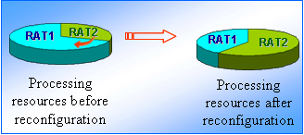

As another example, sometimes the traffic loads of a RAT could be low so that such RAT could be switched into dormant mode for energy saving. The dormant mode operation saves power by allowing the CRS to power down part of the reconfigurable hardware shared between the two RATs, while all residual resources are allocated to the active system.
As anticipated before, in order to perform such network reconfigurations, an appropriate cognitive network management function need to be introduced. Such function is devoted to:
− monitor periodically the current activity status of the cells (for each supported RAT) in terms of measurement of the number of the requests and rejects (if any) from the different systems;
− execute a reconfiguration algorithm that decides which base station(s) are to be reconfigured, e.g. with the aim to adapt the percentages of processing resources devoted to each supported RAT and to dynamically shape the active radio resources to the behaviour of the traffic;
− control the network reconfiguration by sending appropriate reconfiguration commands to the reconfigurable base stations in order to perform the appropriate actions (e.g. to activate/deactivate processing resources and/or radio resources – such as frequency carriers – for each supported RAT).
It is worth noting that the Cognitive Network Management function can reside in any radio network control node, a core network or O&M node as well as inside each reconfigurable node (e.g. in case of flat-architecture) supposing that it can opportunely interact with the other network management functions e.g. RRM (Radio Resource Management) and the reconfigurable node entities. Distributed solutions of the cognitive network management function are also possible.

6.3 Learning
Learning can enable performance improvement for the CRS by using stored information both of its own actions and the results of these actions and the actions of other users to aid the decision making process. The learning process creates and maintains knowledge base where the data is stored.
Learning techniques can be classified into three major learning schemes such as supervised learning, unsupervised learning, and reinforcement learning. Supervised learning is a technique which uses pairs of input signals and known outputs as training data so that a function that maps inputs to desired outputs can be generated. Case-based reasoning is an example of supervised learning technique where the knowledge base contains cases that are representations of past experiences and their outcomes. Reinforcement learning uses observations from the environment in learning. Every action has an impact in the environment and this feedback is used in guiding the learning algorithm. Q-learning is an example of this class. Unsupervised learning techniques aim at determining how the data are organized. Clustering is an example of unsupervised learning technique ‎[46]. Also aspects of “game theory” and “policy engines” are among the techniques under investigation for CRS management ‎[47].
Major learning schemes can include several specific learning techniques such as genetic algorithms, neural networks, pattern recognition, and feature extraction. Neural networks provide a powerful tool for building classifiers. Pattern recognition and classification can be seen as crucial parts of an intelligent system that aims at observing its operating environment and acting based on observations. Feature extraction and classification are complementary functions. A very important task is to find good distinguishing features to make classifier perform efficiently.
Learning makes the operation of CRSs more efficient compared to the case where only information available at the design time is possible. For example, learning enables use of traffic pattern recognition. A CRS can learn the traffic patterns in different channels over time and use this information to predict idle times in the future. This helps to find channels offering long idle times for secondary use, increasing throughput for secondary users and simultaneously decreasing collisions with primary users. Moreover, a CRS could also be able to recognize the type of the application generating the traffic by looking at the statistical features of the traffic. This would help the management of the network since different applications have different QoS requirements, e.g., VoIP and media downloading.

Learning helps also in fault tolerance since patterns of faults can be identified as logical sets that can be interconnected as a constraint network or a reactive pattern matching algorithm. This approach can enable a more efficient fault isolation technique as it identifies multiple potential causes concurrently and then chooses the most likely based on precedence and weighting factors.
A major challenge in learning is the maintenance of knowledge base which is a key requirement for efficient learning and reasoning. The knowledge base should be able to adapt to the possible changes in the environment to offer relevant information to the decision making. The size of the knowledge base is not allowed to grow uncontrollably. Rather the size should remain at the reasonable level. Thus, a management element might be needed in the system to take care of these tasks. All the unnecessary information should be taken away from the database on a regular basis. Management element might be also needed to restrict the amount of changes in the knowledge base to avoid chaotic situations. Moreover, the knowledge base could be tailored to operate efficiently with the specific learning techniques used in the system ‎[48] ‎[49] ‎[50].

6.4 Implementation and use of CRS technologies
The implementation and use of CRS technologies in the different applications in LMS would depend on the particular application and the band where certain radiocommunication services are used and the particular CRS technologies for obtaining knowledge such as sensing and access to database that are required.
As described in section 5, applications that are employing CRS technologies would have an implication on sharing and coexistence issues.
In the following some examples are given of how the use of CRS technologies could enhance sharing and coexistence, specifically when the existing radio systems undergo technical upgrades and technology evolution. These and other technical solutions for sharing and coexistence are subject to study before they can be implemented. It should be noted that sensing and database are examples of CRS technologies with potential for technical suitability in the applications of CRS as addressed in Section 5. However, this does not preclude that other CRS technologies can also be applicable.
Use of sensing allows the CRS nodes to detect changes of the existing radio systems around them and to act accordingly, based on the appropriate policy. The changes can usually be related to change of frequencies used by the existing radio system around the CRS nodes. But also technical changes of the signals to be detected may be handled as the sensing method may be sufficiently flexible or broad to cover a range of signals or technical changes in the signals of the existing radio systems. More fundamental technical changes of the radio systems, due to technology evolution and technology upgrades, can be handled through reconfiguration of the CRS nodes. It should be noticed, that also policy updates can be delivered to the CRS nodes.
Use of access to database by CRS nodes can ensure no harmful interference to the existing radio system practically under any changes and evolution of the radio systems. CRS nodes are following the updated orders from the database, where the changed protection requirements have been taken into account. Thus dealing with evolution of the existing radio system is more straightforward when the database approach is in use. The valid policies are implemented in this case by the database and the CRS nodes just continue to follow the orders, even if they are changed.]
Therefore, particular sets of CRS capabilities and related technical solutions may be needed to allow spectrum sharing and radio resource management on more dynamic basis, depending on particular bands and applications.

In addition, there is a need to utilize appropriate policies and condition under which CRSs could operate. For example, in the case where CRSs would share spectrum bands with other radio systems (in particular for the vertical sharing approach presented in Section 5), such policies and conditions could be set under a framework defined by the rights of spectrum usage. The framework should describe the condition of use and provide possible mechanisms for sharing.
In the horizontal spectrum sharing arrangement where several CRS(s) share the same spectrum band, there is a need to define some rules of accessing the shared spectrum band such that all CRS(s) have an equal chance to access the spectrum band, i.e. the CRS capabilities are used to ensure fair access to the spectrum.
In order to exploit the opportunities of CRS in the land mobile service to its fullest harmonized technical solutions could be beneficial. However, it should be noted that CRS is a technology that can be applied to the various systems for the various applications. Harmonised technical solutions would be useful to address possible CRS applications in various bands.

6.4.1 Dimensions of flexibility
The CRS technology may offer flexibility in following dimensions: space, time, frequency and other operational parameters. Each of them is discussed in the following:

6.4.1.1 Time
– CRS can receive guidance about the time validity of the available frequencies from the database or from some other source. If sensing is used, it may also provide some information about the instantaneous changes in the environment around the CRS nodes.
– Another approach may be that the CRS operates according to policies that define the timing of the transmit/receive signals.
The CRS itself can be able to make the timely changes rapidly.

6.4.1.2 Space
– CRS operation may be location specific. For example if geo-location database is used, it can instruct the CRS in a manner that facilitates flexibility in the space domain. Thus the CRS may operate differently in different locations.
– The spectrum occupancy and the resulting spectrum availability can vary significantly depending on the location indicating that different frequency channels can be available in different locations. CRS can exploit the spatial variations in the spectrum availability by adapting its operations according to the local situation.

6.4.1.3 Frequency
– CRS can obtain knowledge of the available frequencies based on its own observations, through sensing, or by receiving the information from other sources, such as geo-location database. It can then change its operation to available frequencies.

6.4.1.4 Other operational parameters
– The CRS nodes may need to adjust various other operational parameters, like the transmit power (TPC), modulation, coding, used RAT, protocols, etc. Especially if the CRS is implemented using SDR, the CRS node characteristics can be changed flexibly.
– Ability to change the operational parameters improves the ability of CRS to ensure avoidance of harmful interference and can improve its operational capabilities.

7 High level characteristics and operational and technical requirements

7.1 High level characteristics
Land mobile radio systems are characterized by physical characteristics as discussed in ITU reports (e.g. in Report ITU-R M.2116-1 on wireless broadband access) as well as other system characteristics. The characteristics of a land mobile radio system that includes CRS technology consists of the characteristics associated with a land mobile radio system and additional characteristics associated with CRS technology which are applied to it as shown in Figure 7.1.
Figure 7.1
The characteristics of a land mobile radio system and its CRS technology
The characteristics of a conventional land mobile radio system are operating and technical parameters such as frequency band, modulation type, data rate, access method, channelization, transmit power, transmit spectrum mask, spurious emission, antenna gain and receiver sensitivity. CRS have not yet reached the maturity for discussing in detail additional characteristics that are unique to land mobile radio systems employing CRS technology. Therefore, in this document CRS characteristics are discussed at a high level based on the features that characterize CRS listed in [M.2225].
CRS characteristics that differ from characteristics of most other radiocommunication systems are:
1) the capability to obtain the knowledge of the established policies;
2) the capability to autonomously adjust its operational parameters and protocols;
3) the capability to learn from the results of its actions.
[Editor’s note: the following paragraph needs enhancement.]
[Parameters related to CRS specific characteristics include, but are not limited to reliability of information, decision delay and control delay for quick and precise adjustment of the radio parameters. These parameters may be commonly found across land mobile radio systems with CRS technology, but the values of the parameters vary depending on the radiocommunication system themselves and the system(s) that they share or coexist. It is needed to determine the characteristics of a CRS together with those of its base radiocommunication system.]

7.2 High level operational and technical requirements
This section introduces some high level operational and technical requirements for CRS. In general, requirements can be categorized into two main sets: i) requirements that focus on the CRS operations itself in order to guarantee a certain level of performances in its operations, and ii) requirements related to the interaction with the other systems that operate in the same band and/or in the adjacent bands. The requirements are strictly related to the different scenarios and applications of CRS. In addition, CRS operations may rely e.g. on the technical features and functionalities such as the ones described in Section 6 of this Report that may impact the requirements.
Some high level operational and technical requirements related to the CRS operations only are as follows:
- Scalability and insensitivity to network topology changes ‎[54]: the CRS should react in an appropriate manner to the changes in network topology (e.g. some nodes may go out-of-service). The connectivity between the CRS nodes should be maintained in a robust manner, and advanced protocols are required to reconnect nodes via different channels.
- Power efficiency ‎[54]: some CRS operations may require high power consumptions. Such consumptions should be optimized in each CRS node, taking into account the new functions that the nodes need to perform such as sensing, coordinated and non-coordinated approaches in the decision making mechanism, etc.
- Network discovery ‎[54]: the protocols and procedures of a CRS should be designed in such a way that the network discovery from the user perspective meet specific delays restrictions (e.g. defined through network policies).
- Robust control plane ‎[54]: the control planes both within a single CRS as well as between different CRS should be robust and able to continue to provide connectivity in the context of different radio environments that changes dynamically during time.
- Reconfigurability of the radio nodes ‎[54]: the radio part of CRS nodes should be capable of adjusting to different radio frequency environments. This kind of dynamic adaptability means that the transmission parameters and resource allocation can be easily adjusted to the needs of the system operator and/or the user, or the interference environment in a particular band.
- Context, policies and information provisioning support ‎[54]: for the purpose of supporting CRS nodes in their selection of radio technology and frequency band as well as radio link configuration, context provision needs to provide the radio context information such as e.g. available frequencies and radio technology selection constraints (policies) in the appropriate manner.
- Efficient use of spectrum: The CRS should support functionalities that improve the efficiency of overall spectrum use. This could be assessed by using for example spectrum occupancy metric, see Section 8.1.4.
- Spectrum coordination: The CRS should be able to release a spectrum band on demand e.g. in the case of appearance of another, radio system (or another CRS) with higher level of spectrum usage rights. In order to provide continuous service to its user (if required), the CRS should support changing its operating channel.
- Support for designated method(s) to obtain knowledge: The CRS should support method(s) to obtaining knowledge on e.g. spectrum availability information.
- Location knowledge: The CRS should support geo-location functions to be aware of its location to the level and accuracy required by its capabilities e.g. to obtain knowledge.
- Security and privacy: The CRS should ensure the security of its interfaces and data transmission, as well as data privacy.
The requirements reported above are related to some of the CRS applications depicted in this document. For example, the requirements on reconfigurability of the radio nodes and on context, policies and information provisioning support, are both valid for the cognitive network application ‎[55].
The following are two examples of high level requirements related to the interaction with the other systems which are very important in the context of applications that involve horizontal and vertical sharing as well as coexistence issues with other radio systems:
- Harmful interference and QoS degradation avoidance: a CRS should support specific technical features and functionalities to avoid any harmful interference and QoS degradation to the other radio systems operating in the same band and/or in the adjacent bands.
- Sharing and coexistence: The CRS should support functionalities that facilitate sharing and coexistence with other CRS as well as other radiocommunication systems according to the operating environment.

8 CRS performances and potential benefits

8.1 Performance evaluation of CRSs
In this section, general performance criteria and metrics are presented to help the performance evaluation of LMS radio systems employing CRS technology. Aspects to characterise the CRS operations are given in Section 8.1.1. Spectrum related performance metrics are captured in Section 8.1.2.

8.1.1 Aspects related to the performance of the CRS radio operations
CRS technology introduces additional dynamic radio operations and functionalities whose performances may require the introduction of new metrics. For example, metrics for the CRS to respond to dynamic availability of spectrum in time domain in addition to geographical domain. The impact of learning as one of the key characteristics of CRS is not straight forward to o quantify with metrics used for conventional radio systems. In fact, LMS radio systems employing the CRS technology can function in a more dynamic radio operational environment and adjust their operations accordingly, which calls for new metrics to measure this dynamic behaviour.
For CRS radio operations, performance metrics can be categorized into two levels: radio link level and radio access network level.
[Editor’s note: Unconventional CRS related radio link level metrics could be added.]
From the conventional radio link level metrics, the following metrics could be used to evaluate radio link level quality:
– Received signal strength indicator (RSSI).
– Signal-to-interference plus noise ratio (SINR).
[While radio link level quality represents physical characteristics and performances of CRS transmission, radio access network level quality provides a quantified overview of CRSs performance.] Radio access network level metrics can be divided into system performance metrics and user performance metrics. System performance metrics refer to overall operation of the radio network, while user performance metrics refer to the Quality of Service (QoS) and Quality of Experience (QoE) of the end user.
The radio access network level system performance metrics include, but are not limited to:
– Base station reconfiguration time
It refers to the duration from the time when a reconfigurable base receives a particular reconfiguration command to the time when it starts to operate again with the new configuration.
– Time-scales related to CRS specific characteristics
Delays caused by the cognitive cycle including e.g. responsiveness to changes.
– System capacity
It refers to of the peak throughput that can be achieved over a communications system under certain conditions.
– System spectral efficiency
System capacity divided by the overall system bandwidth per link direction, calculated for the maximum load that still allows fulfilling the satisfied-user criterion of a selected service in terms of data rate and delay.
– Successful communication establishment probability
It refers to the probability of successfully establishing communications links.
– Frequency channel handover time
It refers to the time for a CRS device to handover from current frequency channel to another frequency channel.
– Security
Measures taken to protect the usability, reliability, integrity, and safety of the system and data.
Radio network level’s user performance metrics include:
– Delay and Jitter
Communications delay and delay variation of the end user traffic.
– Connection setup times
Connection setup times indicate how long it takes to establish an application level connection.
– Connection reliability
Connection reliability measures the probability that the user session will be maintained during a session. Connection failure can occur even though RSSI and SINR would be high if e.g. data traffic is jammed.
– Percentage of users with lowered quality
Defines the percentage of network user’s whose selected user performance metric(s) indicator(s) have remained below the set threshold(s) for predetermined duration of time.

8.1.2 Metrics for evaluation of spectrum use
The CRS aims at enabling more efficient use of spectrum. This may be evaluated e.g. in terms of:
– Spectrum occupancy [Report ITU-R SM.2256]
The utilization rate of the frequency channel, thus, the fraction of time that the power in a frequency channel exceeds a certain threshold. Measurements of the spectrum occupancy enable monitoring on how efficiently the current spectrum allocations are being used in reality. Measurements are influenced by detection method, measurement channel bandwidth, number of channels, observation time per channel, revisit time and duration of monitoring.
– Spectrum utilization efficiency (SUE) [Rec. ITU-R SM.1046]
Considering a CRS that operates at a particular frequency, at a given location, and at a particular time, the spectrum utilization is defined as the product of the bandwidth, the geographic space, and the time denied to other potential users. SUE is defined as the ratio of information transferred to the amount of spectrum utilization.
First measure describes how efficiently a spectrum band is used in the course of time by all radiocommunication systems that are allowed to use it. The second metric describes the spectral efficiency of CRS but it may not be valid for all applications.

8.1.2.1 Metrics for performance evaluation in the context of sharing
[Editor’s note: the metrics from Section 8.1.1 can also be applied to the context of sharing. Situation awareness is not considered to be a metric and needs to be refined. Check Rec. ITU-R M.1652 for metrics.]
– SINR degradation
Reduction in SINR in the radio systems involved in sharing.
[– Shared frequency channel acquisition time
The time it takes for a CRS device to negotiate and acquire an available shared frequency channel.]
– Channel release time
The time that it takes for CRS to release a spectrum band on demand.
[– Channel closing transmission time
The time is the aggregate duration of all transmissions in the channel release time.]
[– Situation awareness
Awareness of operational and geographical environment including sharing radio systems and policies for sharing.]
[– Non-occupancy time:
The time is defined as the time during which the CRS device shall not make any transmissions on a channel after signal from other radio system was detected on that channel.]

8.1.2.2 Metrics for performance evaluation in the context of coexistence
[Editor’s note: Performance metrics in the context of coexistence need further elaboration. Possible examples of performance metrics are spectrum utilization/spectral efficiency and adjacent channel interference among others that can evaluate the performance of the CRS in the context of coexistence].
Performance in the context of coexistence may be evaluated e.g. in terms of:
– SINR degradation
Reduction in the SINR in the coexisting radio systems.
[– Situation awareness
Awareness of operational and geographical environment, including coexisting radio systems and policies for coexistence.]

8.2 Potential benefits of CRSs
[Editor’s note: contributions are invited to address additional benefits of CRS and their classification.]
In Report ITU-R [M.2225] an initial set of CRS benefits have been identified. This section further expands and develops on the potential benefits.
Cognitive radio systems are expected to increase the efficiency of the overall radio resources (e.g. including spectrum) usage by offering new and enriched radio resource management mechanisms and also to provide more flexibility to applications as a result of their ability to adapt their operations e.g. to external and internal factors. CRS appears to be a promising vehicle for technological evolution of wireless technologies and is likely to become a key means for future innovation of land mobile radio systems.

8.2.1 Benefits related to vertical and horizontal spectrum sharing
CRS could be an enabler for vertical and horizontal sharing to allow more flexible access to spectrum.

8.2.2 Optimization of the system operator network
In general, the main challenge from system operator perspective is to answer user needs in a timely and adapted manner satisfying the requirements in terms of capacity and QoS. CRS having the potential to obtain knowledge from and analyse the radio operational environment, can make the system operator's network react accordingly by optimizing the choice of radio access technologies and associated radio resources. Some of the potential benefits that CRS may introduce are the following ‎[54]:
- [Dynamic spectrum reconfiguration: a particular situation is that of spectrum reconfiguration in the context of technology evolution and periodical emergence of new families of standards. This implies their progressive introduction/coexistence in the legacy "bands" rather than a simple and quick switchover which is not appropriate due to the large amount of legacy equipment and the corresponding investments. CRS may allow a smooth spectrum transition period in this case taking into account the traffic constraints and user requirements.]

- Radio Resource optimization: considering a cell set in a certain area, the traffic of different services on a specified RAT may change from one sub-area to another according to the day period. Moreover, in case of deployment of different RATs in the same area, the offered traffic of different services may vary depending on the RAT in both time and space domains. In such contexts, CRS may provide to the network operator the means for managing in an efficient and dynamic way the radio resources (e.g. reducing of radio access blocking percentages, redistributing resources among different RATs and/or minimizing system interference problems).
- Enabler for dynamic device context provision: considering a heterogeneous or multi-RAT context managed by an operator in which radio resource management mechanisms could be performed dynamically in time (e.g. spectrum refarming, radio resource optimization, etc.), solutions to provide appropriate information for the mobile devices operations are needed. In this context, CRS may provide the tools to achieve such objective in an efficient manner e.g. through the utilization of an in-band control channel.
- [Energy Saving [53]: related to network side radio resource optimization, another important issue for the system operator is energy consumption. This issue becomes more relevant in the case of dense base stations deployments. In this context, CRS may facilitate energy saving based on obtained knowledge and learning of spatial and temporal variations in traffic demand, making decision to put base stations into dormant mode at appropriate times and locations. Hand-overs to other base stations and/or other RATs may be performed to maintain the connections and/or the QoS/QoE. Different means for planning for the resulting spatial and temporal traffic and coverage changes, as well as means for handovers, are already available or under study [53].]

9 Factors related to the introduction of CRS technologies and corresponding migration issues
In this section, factors related to the introduction of CRS technologies are discussed followed by related migration issues. Some the factors being introduced are currently under practice in today’s LMS networks, i.e., pre-cognitive features already exist in current practice. On the other hand some other factors are not yet introduced and still subject to further study and investigations.

9.1 Factors related to the introduction of CRS to current radiocommunication systems
In Report ITU-R M.2225, four different deployment scenarios for CRS were identified. Each of these four scenarios described below have different factors related to the introduction of CRS in the land mobile service.
[Scenario 1: Reconfiguration of connections between terminals and radio systems.
Multiple radio systems employing different radio access technologies (RATs) are deployed on different frequency bands to provide wireless access. For this scenario terminals should be reconfigurable, able to obtain knowledge and able to adjust operational parameters and protocols dynamically. However, other possible enabling factors to improve the performance of the CRS in scenario 1 that may still need to be considered include radio interface enhancements, network architectural changes and on the terminal side:
– learning capability;
– dynamic and autonomic adjustment of operational parameters and protocols.]
Scenario 2: An operator of a radiocommunication system improving the management of its spectrum.
A network operator managing two or more RATs can dynamically and jointly manage the resources of the deployed RATs. For this scenario operator benefits from techniques such as traffic pattern recognition and prediction, load balancing algorithms between RATs and RAT reforming. These techniques are currently under discussion in standardization bodies e.g. in 3GPP, and some deployment of techniques are foreseen in the near future.
Scenario 3: An enabler of cooperative spectrum access.
Utilizing parts of the spectrum remaining unused due to variations in the spectrum occupancy using CRS technology. Enabling factors for the scenario include:
– exchange of spectrum use information among systems;
– prediction of spectrum occupancy variations;
– sharing agreements from a technical perspective.
Scenario 4: An enabler for opportunistic spectrum access.
The CRS accesses parts of unused spectrum in bands shared with other radio systems and services without causing harmful interference. Enabling factors for the scenario include:
– methods to obtain knowledge e.g. a real-time radio environment analysis;
– sharing mechanisms between CRS and non-CRS or between CRSs.

9.2 Migration issues when introducing CRS
[Editor’s note: Some more analysis is needed when looking at the impact of migration with scenario 3. Other scenarios could also be considered.]
Traditionally in the development of LMSs, backwards compatibility has been an important design criterion and continues to be important along with the introduction of CRS technology. It is likely that intelligence by using the CRS technology will be added to the systems in a step-by-step fashion by gradually enhancing conventional systems with new features of CRS technology.
An impact to conventional LMS systems is visible especially when considering spectrum sharing scenarios for CRS. Particularly in scenario 3, mechanisms for the exchange of spectrum use information between systems need to be supported either directly or by using database.

10 Conclusion
This Report has presented the cognitive radio system (CRS) concept within the land mobile service (LMS) continuing the work of Report ITU-R M.2225 that provided an introduction of CRSs in the LMS. The focus has been on providing an in-depth analysis of the application areas and technical features of CRSs in the LMS excluding IMT but many of the findings may also be applicable to IMT systems.
This Report has presented several applications of the CRS capabilities that consist of obtaining knowledge, decision making and adjustment and learning. Existing, emerging and potential future applications of the CRS capabilities have been presented to show that there already exist CRS applications within the LMS and there is potential for new application areas.
This Report has also presented a detailed description of the CRS capabilities and related enabling technologies. Particular sets of CRS capabilities and technical solutions may be needed to enhance spectrum sharing, coexistence and radio resource management on more dynamic basis, depending on particular bands and applications.
The introduction of the CRS capabilities into the LMS may offer improvements in the system performance and increased flexibility to respond to the operational environment. For example, the CRS capabilities may facilitate spectrum sharing.

Annex A
Examples of implementations of the CPC
As described in section 6.1.1.2, the CPC is a pilot channel that broadcasts radio environment information in CRS to facilitate the efficient operation and spectrum use. To implement CPC, the radio environment information is organized and delivered according to the geography area. Moreover, to achieve the operational efficiency, the main steps of the overall CPC operation procedure have been taken into account.

A.1 Organization of geographical related information
There is a need to organize the information delivered over the CPC according to the geographical area where this information applies.
A difference can be made between two options, the mesh based approach and the coverage area approach, differing on how they provide geographical related information as described below.

A.1.1 Mesh-based approach
The CPC operates in a certain geographical area that could be imagined as subdivided into meshes, as shown in Figure A.1. A mesh is defined as a region where certain radio electrical commonalities can be identified (e.g. a certain frequency that is detected with power above a certain level in all the points of the mesh etc.). The mesh is uniquely defined by its geographic coordinates, and its adequate size would depend on the minimum spatial resolution where the above mentioned commonalities can be identified ‎[50].
Figure A.1
Geographical area of the CPC divided into meshes
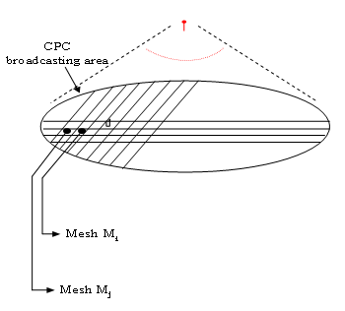
The coverage area of the heterogeneous networks could be divided into several meshes in geographical area. Each mesh can have different operational state, such as RATs, traffic load and etc. CPC could deliver information based on mesh-division. In the mesh division-based approach, there are mainly three CPC information delivering approaches: broadcast CPC, on-demand CPC and multicast CPC mode.
The multicast CPC mode is an evolution of on-demand CPC delivery mode, which adopts point-to-multipoint information delivery approach. In this mode, the network should wait the requests of users from the same mesh for a period time before sending the request of this mesh into the scheduling system which would arrange the requests.
The multicast CPC utilizes the scheduling system to manage the information delivering. The multicast CPC functionality would send the information to the scheduling system first, and then the scheduling system would deliver the information to the terminals according to certain scheduling policies.
The out-band CPC-cells can be divided as meshes to improve the accuracy and efficiency of the information delivered via CPC. And the mesh division scheme provide guidelines for how to divide meshes appropriately, in which the factors that are related to the mesh division size and have significant effects on the accuracy and efficiency of the information delivered via CPC should be considered, such as user density, information representation in multi-RATs overlapped meshes, dynamic mesh division size in multi-RATs overlapped deployment. Furthermore, the transmission delay of information delivery via CPC and the efficiency of overall procedure of CPC should also be considered.

A.1.2 Coverage area approach
The CPC content for a given geographical area is organised considering the region, under-laying CPC umbrella, where such information has to be considered valid.
For instance, in case the CPC information is related to availability of operator/RAT/frequency the CPC information will be organised e.g. per coverage area of each RAT.
Knowing the position of the mobile terminal is not a strict requirement for the CPC operation using this approach, but a capability that enables higher efficiency in obtaining knowledge:
− in case positioning is not available, as long as the mobile terminal is able to receive the CPC information, the information about the different regions in that area are available;
− in case positioning is available, a subset of the information at the actual position could be identified. The mobile terminal could then use that information.
The structure of the CPC message includes at least the following fields:
− Operator information: operator identifier. This information is repeated for each operator to be advertised by the CPC.
− RAT list: for each operator, provide information on available RATs. This information is repeated for each RAT of i-th operator.
• RAT type: could be for instance “GSM”, “UMTS”, “CDMA2000”, “WiMAX”, “LTE”, etc.
• Frequency information: provide the list of frequencies used by the RAT, i.e. the operating band(s).

The information above is assumed to be valid wherever the CPC is received. Nevertheless, optionally additional information related to the local geographical deployment could be provided.
In the case of CPC In-band solution, other fields could be added to the reported ones. Such fields could include e.g. Policies, Context Information, etc.

A.1.2.1 Link with subdivision of meshes
The coverage area approach might be achieved through dedicated transmissions each associated with a reference point (e.g., coordinate) and specification of the coverage area with respect to that reference point, or alternatively might be incorporated into the mesh-based approach. If such a capability were incorporated into the mesh-based approach, the information load (e.g., in order to specify each coordinate reference point and associated relative coverage area) could be significant.
One alternative solution could be to develop a scheme for sub-division of meshes, whereby a small number of bits could indicate at the start of a mesh whether it is subdivided or not, thereby allowing for a very large base mesh size (hence, a small information load for the CPC), while also allowing for the subdivision of that in locations where the information is varying more densely such as urban areas. Figure A.2 depicts one such possible scheme for the subdivision of meshes, where 2 bits are used in each mesh to indicate whether it is subdivided or not. This Figure also shows the order in which the information on the CPC would be transmitted under such a scheme (black arrows).
Figure A.2
An approach to the subdivision of CPC meshes

A.2 Out-band and in-band characteristics
The characteristics of out-band and in-band parts of the CPC are summarized in the following Table A.1 (see also ‎[26]).
Table A.1
Characteristics of out-band and in-band parts of the CPC
Characteristics | Outband CPC | Inband CPC
Information conveyed | Start-up information, e.g. context information on available networks at that location | Ongoing information, e.g. much more detailed context information, policies for reconfiguration management, etc.
Channel bit rate requirements | Initial requirements evaluations seem to conclude that relatively low bit rate is required in case of coverage area approach, while mesh-based approach could require a very high amount of bandwidth.
Data direction | Downlink.  Optionally uplink | Downlink and Uplink
Bearer | Most likely a harmonized frequency band, wide-area coverage. Might be a novel RAT, or a legacy technology of appropriate characteristics (e.g. GSM channel) | A bearer in a operator’s network (e.g. a logical channel mapped on a UMTS bearer)

Annex B
Conceptual relationship between SDR and CRS
Software-defined radio is recognized as an enabling technology for the cognitive radio system. SDR does not require characteristics of CRS for operation. One can be deployed/implemented without the other.
In addition, SDR and CRS are at different phases of development, i.e., radiocommunication systems using applications of SDR have been already utilized and CRS are now being researched and applications are under study and trial.
Furthermore, SDR and CRS are not radiocommunication services but are technologies that can be implemented in systems of any radiocommunication service. Moreover, it is seen that SDR and CRS are two technologies which can be combined.
From the viewpoint of the progression in the development of the Software Defined Radio (SDR), the signal processing technology has played major role, because it enhanced the digitalization of the communication equipment. Therefore, several kinds of signal processing become to be possible, which are not attainable by the analogue devices. At the initial stage of the SDR development, analogue devices are replaced to signal processor and A/D and D/A converters. Then, signal processing can be controlled by the CPU (Central Processing Unit) with intelligence.

Considering these development steps, the SDR may be the basis of the CRS, although it is also said that the SDR and CRS are not dependent with each other. The SDR is one of the tools for realization of the reconfiguration functions.
One example of conceptual relationship is depicted in Figure B.1. The SDR is the composite entity of the hardware, software and processing capability, which provide the capability of adjustment for the CRS to achieve the predefined objectives. For such objectives the cognitive radio system (CRS) will obtain knowledge regarding the operational and geographical environment, learn from the results obtained, and furthermore adjust its operational parameters and protocols, e.g. modulation scheme.
Figure B.1
Example of conceptual relationship between cognitive radio system (CRS)
and software defined radio (SDR)
Processor (CPU + memory, et al.)
hardware and software (reconfigurable device, et al.)
CRS
(function)
SDR
(entity)

adjustment
learning
obtaining
knowledge
predefined objectives of radiocommunication system
SDR provides a capability of “adjustment”

Annex C
Examples of improved spectrum usage efficiency enabled by cognitive networks
This Annex provides examples to illustrate the importance of the CRS technology employed by the operators to improve spectrum utilization and traffic load distribution.
An operator today must manage a heterogenic radio environment due to its multiple services, different network architectures, various multiple access techniques and multiple frequency bands. Intra-operator spectrum pooling enabled by a CRS is becoming essential in order to balance the load of the different networks that represent different technologies and different generations. Spectrum pooling also can increase the utilization of the scarce resources available.
The continuing growth of mobile radio systems is driving demand for more efficient use of spectrum. Spectrum pooling is a novel approach to radio resource management enabled by a CRS. A simple example to show the benefits of spectrum pooling enabled by a CRS is shown below.
In this calculation the resource needed for each call is assumed to be one channel. It is assumed that there are two different groups of spectrums available. Each spectrum group has 18 channels. It is also assumed that the performance criterion is not to exceed 1% probability of blocking.

Example 1
Two groups of spectrum that are completely partitioned. Each spectrum group is assumed to support 10 identical calls at 1% probability of blocking:

Spectrum are not shared: each group is fully utilized |  |  | Spectrum are pooled
Group 1 | Group 2 | Group 1 + Group 2 | Group 1 + Group 2
10 calls | 10 calls | 20 calls | 25 calls
18 channels | 18 channels | 36 channels | 36 channels
Utilization = 55% | Utilization= 55% | Utilization = 55% | Utilization = 69%

Example 2
Two groups of spectrum that are completely partitioned. It is assumed that the first group is not fully utilized, where the number of calls serviced is = 2 calls; and group 2 is overloaded (more than 10 calls) which resulted in unacceptable probability of blocking (higher than 1%)
Each group is assumed to support 10 identical calls at 1% probability of blocking.

Resources are not shared: group 1 is not fully utilized |  |  | Resources are pooled
Group 1 | Group 2 | Group 1 + Group 2 | Group 1 + Group 2
2 calls | 10 calls | 12 calls | Can support up to 25 calls (2 calls from group 1 and 23 calls from the overloaded group 2)
18 channels | 18 channels | 36 channels | 36 channels
Utilization = 11% | Utilization = 55% | Utilization = 33% | Utilization = 69%

ANNEX D
Sensing methods
This Annex provides a non-exhaustive list of different sensing methods that are actually under study.
Matched filter detection
The optimal detector in stationary Gaussian noise is the matched filter since it maximizes the received SNR. The main advantage of matched filtering is the short convergence time to achieve a certain probability of misdetection or false alarm. However, the problem with this approach is that the perfect prior information of the signal to be detected (modulation type, order, pulse shape and packet format, etc.) is needed. Radio networks with pilot, preambles and synchronization words and spreading codes can use this matched filter detection. Since the CRS needs receivers for several different signal types, the implementation complexity of sensing unit is impractically large and various receiver algorithms also lead to large power consumption. The matched filter is also not suitable for spectrum sensing in very low SNR regions since synchronization is difficult to achieve ‎[35].
Energy detection
If there is no information of the primary user signals to be detected, the optimal detection is an energy detector. Its generic nature as well as low computational and implementation complexity are attractive features for this case. The energy detector simply measures the energy of the received signals and compares it to a threshold which depends on the noise floor. However, the problem with the energy detection is that the noise floor might be unknown to the detector, thus, finding a proper threshold is challenging though training can be done with pilot signals. Because the energy detector is unable to distinguish between noise and interference from primary user false detection might be triggered by unintended signals. The energy detector does not perform well in low SNR regions or in detecting spread spectrum signals ‎[35]. One method for using information from the energy detector is noise floor based method where the receiver measures the cumulative RF energy from multiple transmissions over a particular frequency spectrum and set a maximum cap on their aggregate level. As long as a CRS node does not exceed this limit by their transmissions, it can use that frequency spectrum.
Cyclostationary feature detection
This type of detector operates based on the cyclostationary feature of the signals. Cyclostationary features are caused by the periodicity in the signal or in its statistics like mean and autocorrelation or they can be intentionally induced to assist spectrum sensing. Cyclostationary feature detector can differentiate between noise and primary users signal because noise has no correlation. It can also classify different types of transmission and primary users ‎[35]. It performs better than the energy detection in terms of probability of detection particularly in low SNR region. However, the computation complexity is relatively high and it also requires longer sensing time than energy detector ‎[51].
Self-correlation detection
In self-correlation detection, the decision statistic for the binary hypothesis is derived from signal autocorrelation sequence instead of the received signal itself. The correlation lag/delay is chosen in accordance with the maximum bandwidth of the signal involved. The decision statistic is obtained after converting the correlation sequence to frequency domain through FFT. The scheme improves the probability of detection compared to the energy detection in the presence of noise power uncertainty with less complexity compared to cyclostationary property detection. However, if multiple primary users are present, unwanted signal due to the non-linearity of the correlation operation arises. This would affect the performance especially if the primary users are many and have weak signals.
Waveform based detection
Known patterns, for example, preambles, mid-ambles, regularly transmitted pilot pattern, spreading sequences, are usually operated in wireless systems to assist synchronization or for other purposes. In the presence of a known pattern, waveform based detection can be performed by correlating the received signal with a known copy of itself. Compared with energy detection, this method requires shorter measurements time and outperforms in reliability. Furthermore, the performance of the sensing algorithm increases as the length of the known signal pattern increases ‎[35].
Distributed sensing
Distributed sensing systems have been employed in the past for both commercial and military services. Due to multiple factors like noise and interference, shadowing, fading and limitation of the sensing method, it may be very difficult to use a single standalone sensor to obtain high quality of sensing. In this case, distributed sensing can be used where each individual sensor can either be located inside or outside the CRS node. As the name implies, the distributed spectrum sensing is executed using multiple sensors distributed spatially. These distributed sensors may have the ability to exchange sensing information, making decisions and relay the sensing information to the CRS nodes. The sensing information could include sensing outcome, accuracy of results, location of sensors, etc. The sensing information is supplied to the CRS node in a cooperative manner where the data from all sensors is aggregated to obtain the final sensing information. Such implementation method can dramatically improve the sensing quality of the CRS. This would relax the sensing requirements and choice of the sensing method at each sensor. Note, however, that relaying the sensing information requires a channel free from primary users.
Edge detection for wideband spectrum sensing
In some cases, CRS may identify used spectrum over wide frequency bands. For spectrum sensing over wideband channels, the edge detection approach offers advantages in terms of both implementation cost and flexibility in adapting to the dynamic spectrum, as opposed to the conventional use of multiple narrow-band bandpass filters. The edge detection techniques ‎[52] can be used to effectively detect the channel borders in power spectrum density (PSD). Therefore, the edge detection techniques for wideband spectrum sensing can effectively scan over a wide bandwidth to simultaneously identify all subbands, without prior knowledge on the number of subbands within the frequency range of interest.

[ANNEX E
An example of geolocation database operation
[Editor’s note: This Annex needs to be revisited at May 2014 meeting. The compliance of this approach with European TV white space approaches needs to be checked. Terminology and architecture needs to be checked.]
Geolocation databases (GDBs) for TV white space operation can be implemented under various proposed architectures ‎[41]. One general example approach for GDB implementation, also considering its interaction with notional WSDs, is depicted in Figure [X3].
Figure [X3]
Geo-location database (GDB) example ‎[53]
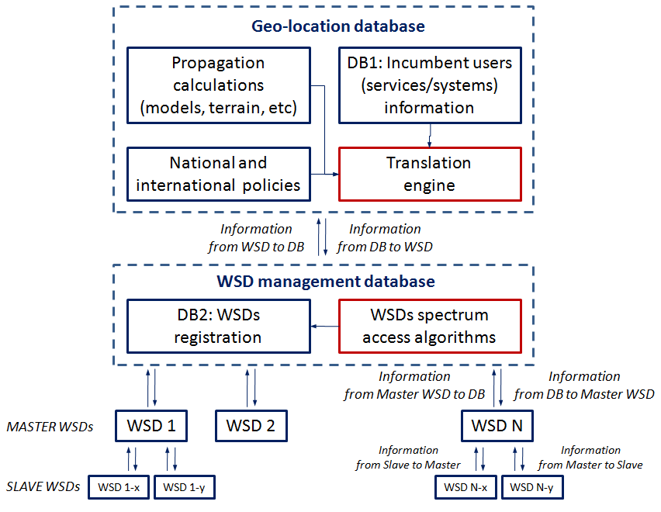

The goal of the GDB is to provide WSDs access to the spectrum of incumbent spectrum users, while protecting the incumbent users from interference. There are a number of key elements associated with GDB operation ‎[53].
In order to ensure protection of incumbent spectrum users, the GDB is provided with information on those users, including their locations, and technical parameters which can be used to derive their acceptable interference characteristics. WSDs also provide information to the GDB as part of their registration process, this information comprising their locations and RF characteristics among other details. Given other knowledge such as geographical and frequency-dependent path loss characteristics, the GDB uses the information from incumbent users and WSDs to derive a lists of available channels for the WSDs. Under the currently proposed European approach to TV White Spaces operation in Europe [X ETSI harmonised standard ref?], associated maximum permitted radiated power levels for WSDs in each available channel are also provided.
A generic implementation of the GDB is required to take into account international and national policies in deriving appropriate responses to the WSDs. Moreover, the GDB may be implemented in a hierarchical fashion, with core sets of information originating from a higher-level management entity such as may be run by a national administration, and direct interactions with the WSDs being implemented through lower-level database implementations. These lower level implementations may also feedback information to the higher-level GDB, in order to assist decisions at that level. Moreover, a translation process may be implemented between the information as structured and used at the lower level databases, and the structured/used information at the higher-level database.
More than one WSD may seek spectrum access in a given geographical area. Additional algorithms or considerations might therefore be implemented to ensure that different WSDs can access the spectrum in a coordinated manner (e.g., without causing mutual interference), and that aspects of aggregate interference are taken into account. Such algorithms might again be governed by national and international policies.
Finally, depending on implementation, WSDs might operate in “master” or “slave” modes. “Slave” mode WSDs aren’t required to communicate and receive authorisation directly from the geolocation database, but can operate merely based on an enabling signal transmitted by a “master” WSD. Typically, such “slave” WSDs may be limited to a lower transmission power. The allowance for “slave” WSDs is important to serve those devices that might not already have the means for achieving a link with the geolocation database, such as mobile devices operating solely under service provision in TV White Space.]

Initial camping identifies the procedure followed by a terminal at the start-up in order to select an appropriate network cell.
In this case, there is no core band for the network operation.
Programme Making and Special Events (PMSE) is a term that denotes equipment that is used to support broadcasting, news gathering, theatrical productions and special events, such as culture events, concerts, sport events, conferences and trade fairs. PMSE devices use low power.
There is standardization effort by Internet Engineering Task Force (IETF) to standardize a Protocol to Access White Space databases (PAWS).

