July 5, 2002

Subject: Invitation to the ITU-T SSG Q.2/Q.6 and Q.7 Rapporteurs Meetings, September 9 – 13, 2002
Seoul, Korea

Dear ITU-T SSG Members,

Samsung Electronics (Korea) is pleased to invite you to the Q.2/Q.6 and Q.7 Rapporteurs meetings, which will take place September 9 – 13, 2002 at TTA, Seoul, Korea.

Venue of the meeting | numbers
TTA Head office  267-2 Seohyeon-dong, Bundang-gu, Seongnam-City, Kyonggi-do, 463-824 Korea  http://www.tta.or.kr | Jeong-sik Park  Manager, IMT-2000 Team  Phone: +82 31 724 0093  Mobile:+82 19 209 0232

The meeting will start on Monday 9 September at 0900 and will end on Friday 13 September at 1800.

HOTEL RESERVATION

We reserved a block of 20 rooms in New-Town Tourist Hotel with special discounted room rates for participants. Recommended hotel reservation should be made preferably through Jimmy Dho via e-mail by 24 August 2002.

NEW-TOWN TOURIST Hotel  157 Kumgok-dong, Bundang-gu,  Seongnam-City, Kyonggi-do, Korea  KRW 82,600/night (Breakfast included)  for the single bedroom  KRW 88,900/night (Breakfast included)  for the Double bedroom | Phone: +82 31 279 5121  Fax: +82 31 279 5130  (Fax is preferable)  Mobile: +82 16 9530 5121  jimmy_dho@samsung.com
**1,203KRW is about 1 USD

CANCELLATION POLICY:

48 hours before the arrival: no penalty
Cancellation within 48 hours of the arrival time will be charged the full cost of one night. For this reason, I invite the guests to inform as soon as possible in case of cancellation.

Welcoming Reception: on Wednesday night (12th of September) the Welcoming Reception will be hosted by Samsung Electronics.

Proposed Meeting Schedule

SSG activities | Mon  9 | Tue  10 | Wed  11 | Thu  12 | Fri  13
Joint Opening/Closing Rapporteur meeting | - |  |  |  | - -
Joint Q.2/Q.6 | - . - - | - - . - - | - - . - - | - - . - - | - -
Q.7/SSG | - . - - | - - . - - | - - . - - | - - . - - | - -

Terms of Reference for Q.2/Q.6 and Q.7 are attached.

PRACTICAL INFORMATION

In order to ensure smooth access from Incheon International Airport to the hotel, here are some practical information.

- Arrival at Incheon International Airport  When you’re arrived at the airport, please pick up some useful information, e. g., City Maps, Tourist Information booklet at Information Center located inside of the airport building, please see the right picture. | 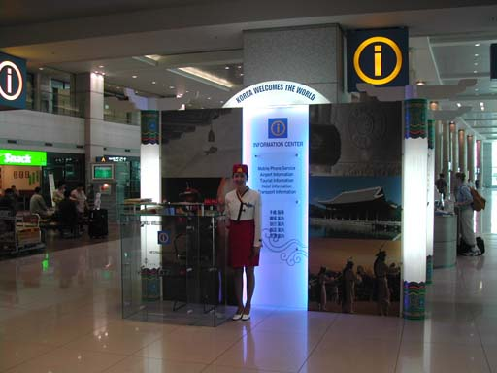
- At near to Exit Number #5, you can buy the Ticket for Airport Limousine Bus from the Airport to Bundang (or Seohyoen Station), the fare is 12,000Won. Please also see the right picture.  ※ Please Note; Using the TAXI from the Airport to TTA or to Downtown is not recommended due to high cost. (50,000Won/85,000Won for Deluxe Taxi) | 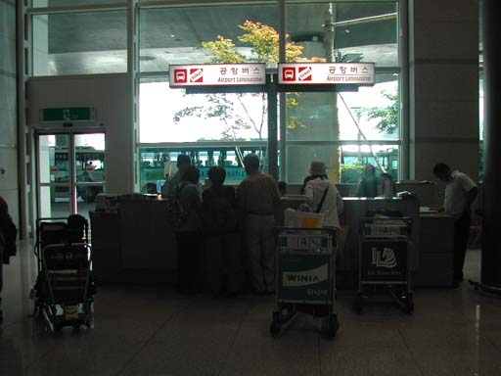
- If you are sure to get the Ticket, then you can move to Airport Limousine BUS STOP #7A or #7B with getting out the Airport building through the Exit Number #7. | 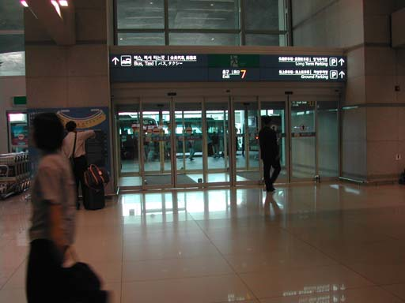
- As soon as you’re getting out from the Airport Building, you can find the Bus Stop #7A or #7B. The Interval of the Bus operation is about 20 minutes. Please wait there for moments when you’re middle of the Interval. | 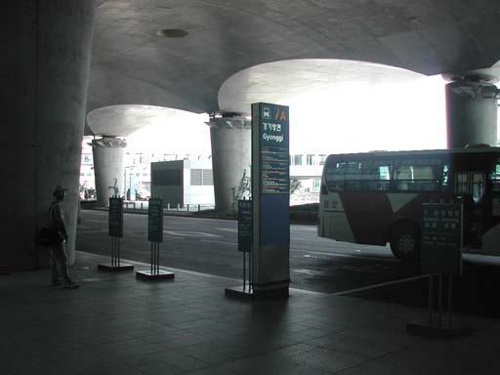
- When you’re in time, you’ll get right Airport Limousine Bus to Bundang (or Seohyoen Station). Please check the picture on your right. | 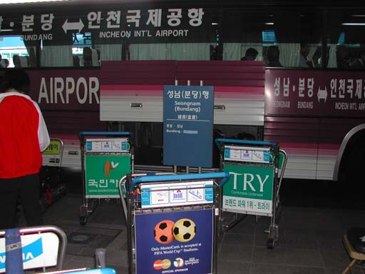
- Another picture of Airport Limousine Bus to Bundang (or Seohyoen Station). From the Airport to Bundang will takes about an hour. Please remember the name of Bus Stop, Bundang, first stop after departure from the Airport. | 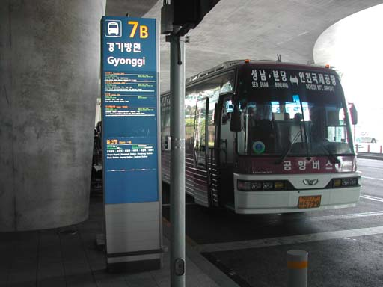
- After you get off, take a taxi and ask driver to hotel (just ‘New town hotel’). It will take about 10 – 15 mins and requires Korean currency (about 2,500 – 3,000 Won).
Climate
In September, the daytime temperatures in the Seoul metropolitan area generally range from + 10° C and + 25° C.
Electricity
In Korea major hotels use 220 volts. Some hotels have two outlets for both 110 and 220 volts. Be sure to check the power supply before using equipment.
Time
Plus 9 GMT (same as Tokyo time)

Visa
Any foreign visitor wishing to enter the Republic of Korea should have a valid passport and a visa.
Visitors for sightseeing or transit with confirmed outbound tickets may stay in Korea up to 30 days without visas, except for the following.
- Stateless Persons
- Nationals of such countries or regions as follows:
Albania, Cambodia, Cuba, Laos, Russia, Ukraine, Belarus, Moldova, Aremenia, Azerbaijan, Kazakhstan, Turkmenistan, Uzbekistan, Tajikistan, Kyrgyzstan, Georgia, Macedonia, Bosnia-Hercegovina, China P.R, Mongolia, Vietnam, Ghana, India, Iran, Myanmar, Nepal, Nigeria, Philippines, Sri Lanka, Palestine
- For further information, contact Korean Embassies or consulates.
http://www.mofat.go.kr/en/visa/e_visa.mof

Terms of Reference:

Interim Q.2/SSG and Q.6/SSG Joint Rapporteurs' Meeting

- To progress work under Task Objective 1 of Q.2/SSG on mobility management aspects – in particular, to refine the emerging Q.2/SSG draft deliverable;
see Temporary Document 1-014r2.doc at:
http://ties.itu.int/u/imt2000/imt2000/td/RiodeJaneiro-30-08-2001/wp1/
- To progress work under Task Objectives 1 and 2 of Q.6/SSG on harmonization – in particular, to discuss how best to establish co-operative working arrangements with various external organization and to refine the existing draft for a Q.6/SSG output document (Ottawa TD WP3/SSG-5);
- To discuss documents carried forward from the Ottawa meeting (see section 5 of Ottawa TD WP3/SSG-16r1).
- To contribute and progress on the following topics from a global perspective and from the standpoint of end users, operators, regulators, or vendors of equipment:
- Regulatory aspects: emergency services, lawful intercept, etc.
- Security aspects: authentication, privacy and integrity requirements, etc
- Mobility schemes: inter-system mobility scenarios (i.e. IS-41, UMTS, Wireless IP), mobility over IP versus cellular mobility protocol analysis, etc.
- Harmonization and inter-working aspects
- To discuss the possible output document types for the deliverables under these Questions.

________________________________________

Interim Q.7/SSG Joining Rapporteurs' Meeting

The global objective of Q.7/SSG is to study network aspects for the convergence of fixed networks and existing IMT-2000 systems: this would provide the foundation for migration paths to interoperable and harmonized network architectures to support services transparently to users across different network access arrangements (subject to regulatory agreements).

Suggested topics for consideration in the preparation of the upcoming meeting :
- The recent development of WLAN-3G systems interworking issues in 3GPP: WLAN is initially a radio technology, for private networks. It can also be connected to fixed public access, and it is now considered as mobile accesses as well. 3GPP developed TR 22.934, with a wide range of possible implementation scenarios, beyond the current 3G systems. In particular, some scenarios enable the development of services for different access types (WLAN, UTRAN, etc.) in a convergent way.
- This topic relevant for the scope of Q.7 and some implementation scenarios are the first step of fixed-mobile convergence.
- The "fixed wireless access" was highlighted as an important topic during our Rio meeting, and contributions are therefore expected on the basic requirements for FWA, in particular for interconnection the network evolutions required to support such access technologies.
- The user profile developments in the context of mobility in fixed and mobile environments and in the context FWA. This has been identified as a topic for Q.7 and is a key issue for the development of network solutions for mobility management.

Draft Terms of reference for interim Q.7/SSG rapporteur's meeting :

To progress work on
- Principles and requirements for convergence of fixed and existing IMT-2000 systems :
  - Define the scope for carrying out the work assigned to the question , including Fixed Wireless Access
  - Analyse the fixed systems to be converged
  - Analyse existing IMT-2000 systems to be converged
- Requirements for mobility across fixed and mobile networks
  - What network capabilities (high level functional view) are needed?
  - What network capabilities in fixed and mobile networks should we consider for convergence?
- Q.7 documentation
  - Baseline document and definition of Q.7 output type.

