Geneva, 23 June 2000
INTERNATIONAL TELECOMMUNICATION UNION
Telecommunication
Standardization Bureau

Ref: | TSB Collective Letter 13/2
Tel:  Fax: | +41 22 730 5887  +41 22 730 5853 | - To the Administrations of the Member States of the Union and to ITU-T Sector Members participating in the work of Study Group 2

Subject: | Meeting of Working Party 1/2 (Numbering,  Routing, Global Mobility and Service  Definition), Berlin, Germany  19-26 October 2000

Dear Sir/Madam,
1 As proposed by Study Group 2 at its meeting in Geneva, 7-17 March 2000 and with my agreement, I would like to inform you that Working Party 1/2 (Numbering, Routing, Global Mobility and Service Definition) will meet in Berlin, Germany from Thursday 19 to Thursday 26 October 2000, thanks to the kind invitation of Deutsche Telekom. The meeting will open at 0930 hrs, with registration commencing at 0830 hrs on Thursday, 19 October 2000.
2 The discussions will be held in accordance with decisions taken with reference to the provisions in force.
3 The draft agenda for the Working Party, as prepared by the WP 1/2 Chairperson, is contained in Annex 1.
4 The meeting will take place at:
T-Nova Deutsche Telekom Innovationsgesellschaft mbH
Berkom
Goslarer Ufer 35
10589 Berlin
Germany
(Meeting Room 055, see Attachment 1 to Annex 2)
In Annex 2, you will find information on practical arrangements for the meeting, including hotel reservation details (see Attachment 3 to Annex 2).
5 Pursuant to the provisions of Recommendation A.1 of the WTSC (Geneva, 1996), contributions to the work of the Study Group shall be submitted to the Director of the Telecommunication Standardization Bureau (TSB).
a) Contributions received at least two months before the meeting shall be published and mailed to the Administrations of the Member States of the Union and to ITU-T Sector Members registered in this Study Group who have requested paper copies.
b) Contributions received by the Director less than two months but not less than seven working days before the date set for the opening of the meeting shall be published as "delayed contributions", shall be posted to the Study Group 2 website and shall be distributed at the beginning of the meeting to only the participants present. Therefore, such contributions must be received by the TSB not later than 9 October 2000.
With a view to settling any questions which might arise concerning contributions, the name, the fax and telephone numbers and the e-mail address of the person to be contacted should be indicated on contributions. Accordingly, please give those details on the cover page of all documents.
You are encouraged to submit documents electronically. For detailed instructions please refer to Annex A to TSB Circular 182 of 7 April 1999. For e-mail submission, please use the Internet address: tsbedh@itu.int.
6 In order to enable the TSB to make the necessary arrangements concerning the documentation and organization of the meeting, I should be grateful if you would send me, by letter or fax (No.: +41 22 730 5853), as soon as possible, but not later than 22 September 2000, the list of people who will be representing your Administration, recognized operating agency, scientific or industrial organization, other entity dealing with telecommunication matters, or regional and/or international organization. The registration form in Annex 3, duly completed (one per participant), should be attached to the above-mentioned list.
7 The principal aim of this meeting is to determine the texts of draft Recommendations, for approval by the January 2001 meeting of Study Group 2.
Yours faithfully,
H. Zhao
Director of the Telecommunication
Standardization Bureau
Annexes: 3
ANNEX 1
(to TSB Collective Letter 13/2)
Draft agenda, WP 1/2, Berlin, 19-26 October 2000

1 Opening of the meeting - welcome and introduction
2 Approval of the agenda
3 Objectives of the meeting
4 Review of progress since March 2000
Report of March 2000 meeting
Questions 1, 2 and 3/2: COM 2-R 73
5 Study Questions approved by WTSA-2000
6 Working methods and guidance for Rapporteurs
7 Rapporteur progress reports and updated work programmes
Questions 1, 2 and 3/2
8 Determination(s) for Resolution No. 1 approval at the Study Group 2
meeting in 2001
9 Future work programme
10 Any other business
11 Closure of meeting

Annex 2
(to TSB Collective Letter 13/2)
Meeting of WP 1/2, Berlin, 19-26 October 2000
Practical information for participants

1 Conference venue: T-Nova Deutsche Telekom Innovationsgesellschaft mbH
Berkom
Goslarer Ufer 35
10589 Berlin
Germany
Meeting Room 055 (see picture in Attachment 1)
2 Schedule: The meeting commences at 0930 hrs, Thursday, 19 October with
registration from 0830 hrs, and is expected to close at 1600 hrs,
Thursday 26 October
3 Participation: The registration form in Annex 3 to this collective letter should be
faxed to the TSB by 22 September 2000
4 Secretariat: The secretariat will operate from 0900 hrs 19 October to 1600 hrs
26 October.
E-mail: Martina.Bonitz@telekom.de
Fax: + 49 30 3497 4993
5 Hotel: See enclosed list. The participants have to make their hotel reservation
directly to the hotel of their choice (see Attachment 2 list of hotels and Attachment 3 reservation form).
6 Air Travel: The international airport in Berlin is Tegel airport
7 Public transport Please see Attachment 4 to this Annex
system:
8 Taxi: Please see Attachment 4 to this Annex
9 Lunch: Lunches will not be provided during the meeting. There are lots of
restaurants around the conference place
10 Contact points Tel: + 49 30 3497 3741 Meeting Room Nr. 0055
for delegates: Fax: + 49 30 3497 3333 Codeword "Konferenzraum 0055"
11 Berlin Infos: http://www.berlin.de
Attachment 1 to Annex 2
(to TSB Collective Letter 13/2)

Picture of Berkom building

Attachment 2 to Annex 2
(to TSB Collective Letter 13/2)

Hotels near to Berkom

ECONTEL
Soemmeringstr. 24
10589 Berlin
Phone: +49 30 34 68 10
Fax: +49 30 34 68 11 63
http://www.econtel.de

ParkConsul
Alt-Moabit 86a
10555 Berlin
Telefon: 030 · 39 07 80
Fax: 030 · 39 07 89 00

Sorat Hotel Spree-Bogen
Alt-Moabit 99,
10559 Berlin
Telefon: 030/39 92 00
Fax: 030/39 92 09 99
E-mail: SORAT.Hotel.Spree-Bogen@t-online.de

Hotel in the City (exclusive)

Berlin Excelsior Hotel "Berlin Zoologischer Garten"
Hardenbergstr. 14
10623 Berlin
Phone: +49 30 31 55 -0
Fax: +49 30 31 55 -0
http://www.hotel-excelsior.de

There are plenty of hotels in Berlin, for other hotels please ask the tourist information.

Attachment 3 to Annex 2
(to TSB Collective Letter 13/2)
ITU SG 2 Working Party 1/2 meeting, Berlin, Germany
19-26 October 2000

Hotel Reservation Form

Family Name:________________________________________________________

First Name:___________________________________________________________

Company:____________________________________________________________

Address:______________________________________________________________

_____________________________________________________________________
______________________________________________________________________

Telephone:_____________________________________________________________

Facsimile:______________________________________________________________

Date & approx. time Date & approx. time
of arrival at hotel:_____________________ of departure from hotel:___________________

Single room:__________________________Double room:________________________

Credit card type:_____________No.:__________________________Expiry date:_______

Hotel reservations should be sent directly to the hotel as soon as possible.

Attachment 4 to Annex 2
(to TSB Collective Letter 13/2)

From the airport to Berkom

Arrival from airport Berlin-Tegel
Please take the bus X9 in direction to Zoologischer Garten until the bus stop U- und S-Bahnhof Jungfernheide. There you should take bus 227 in direction to Pankow. After three stations you arrive at Goslarer Platz directly opposite to the Berkom building.
More convenient and faster is it if you take a taxi. The price from the airport Tegel to Goslarer Ufer 35 is about 15,- to 20,- DM due to the traffic.

Arrival from airport Tempelhof
Please take the underground U6 in direction to Tegel until the underground station Mehringdamm. Change then to the underground U7 in direction to Spandau and drive until the underground station Mierendorffplatz. There you should take bus 340 in direction to the main railway station and get out after two stops at Goslarer Platz directly opposite to the Berkom building.
More convenient and faster is it if you take a taxi. The price from the airport Tempelhof to Goslarer Ufer 35 is about 30,- to 35,- DM due to the traffic.

Arrival from airport Berlin-Schönefeld
Please take the S-Bahn 9 (fast train) in direction to Westkreuz until the S-Bahn station Lehrter Stadtbahnhof. There you should change into the bus 340 in direction to the underground station Mierendorffplatz and drive until the bus stop Goslarer Platz- You arrive directly in front of the Berkom building.
More convenient and faster is it if you take a taxi. The price from the airport Berlin-Schönefeld to Goslarer Ufer 35 is about 50,- to 65,- DM due to the traffic.

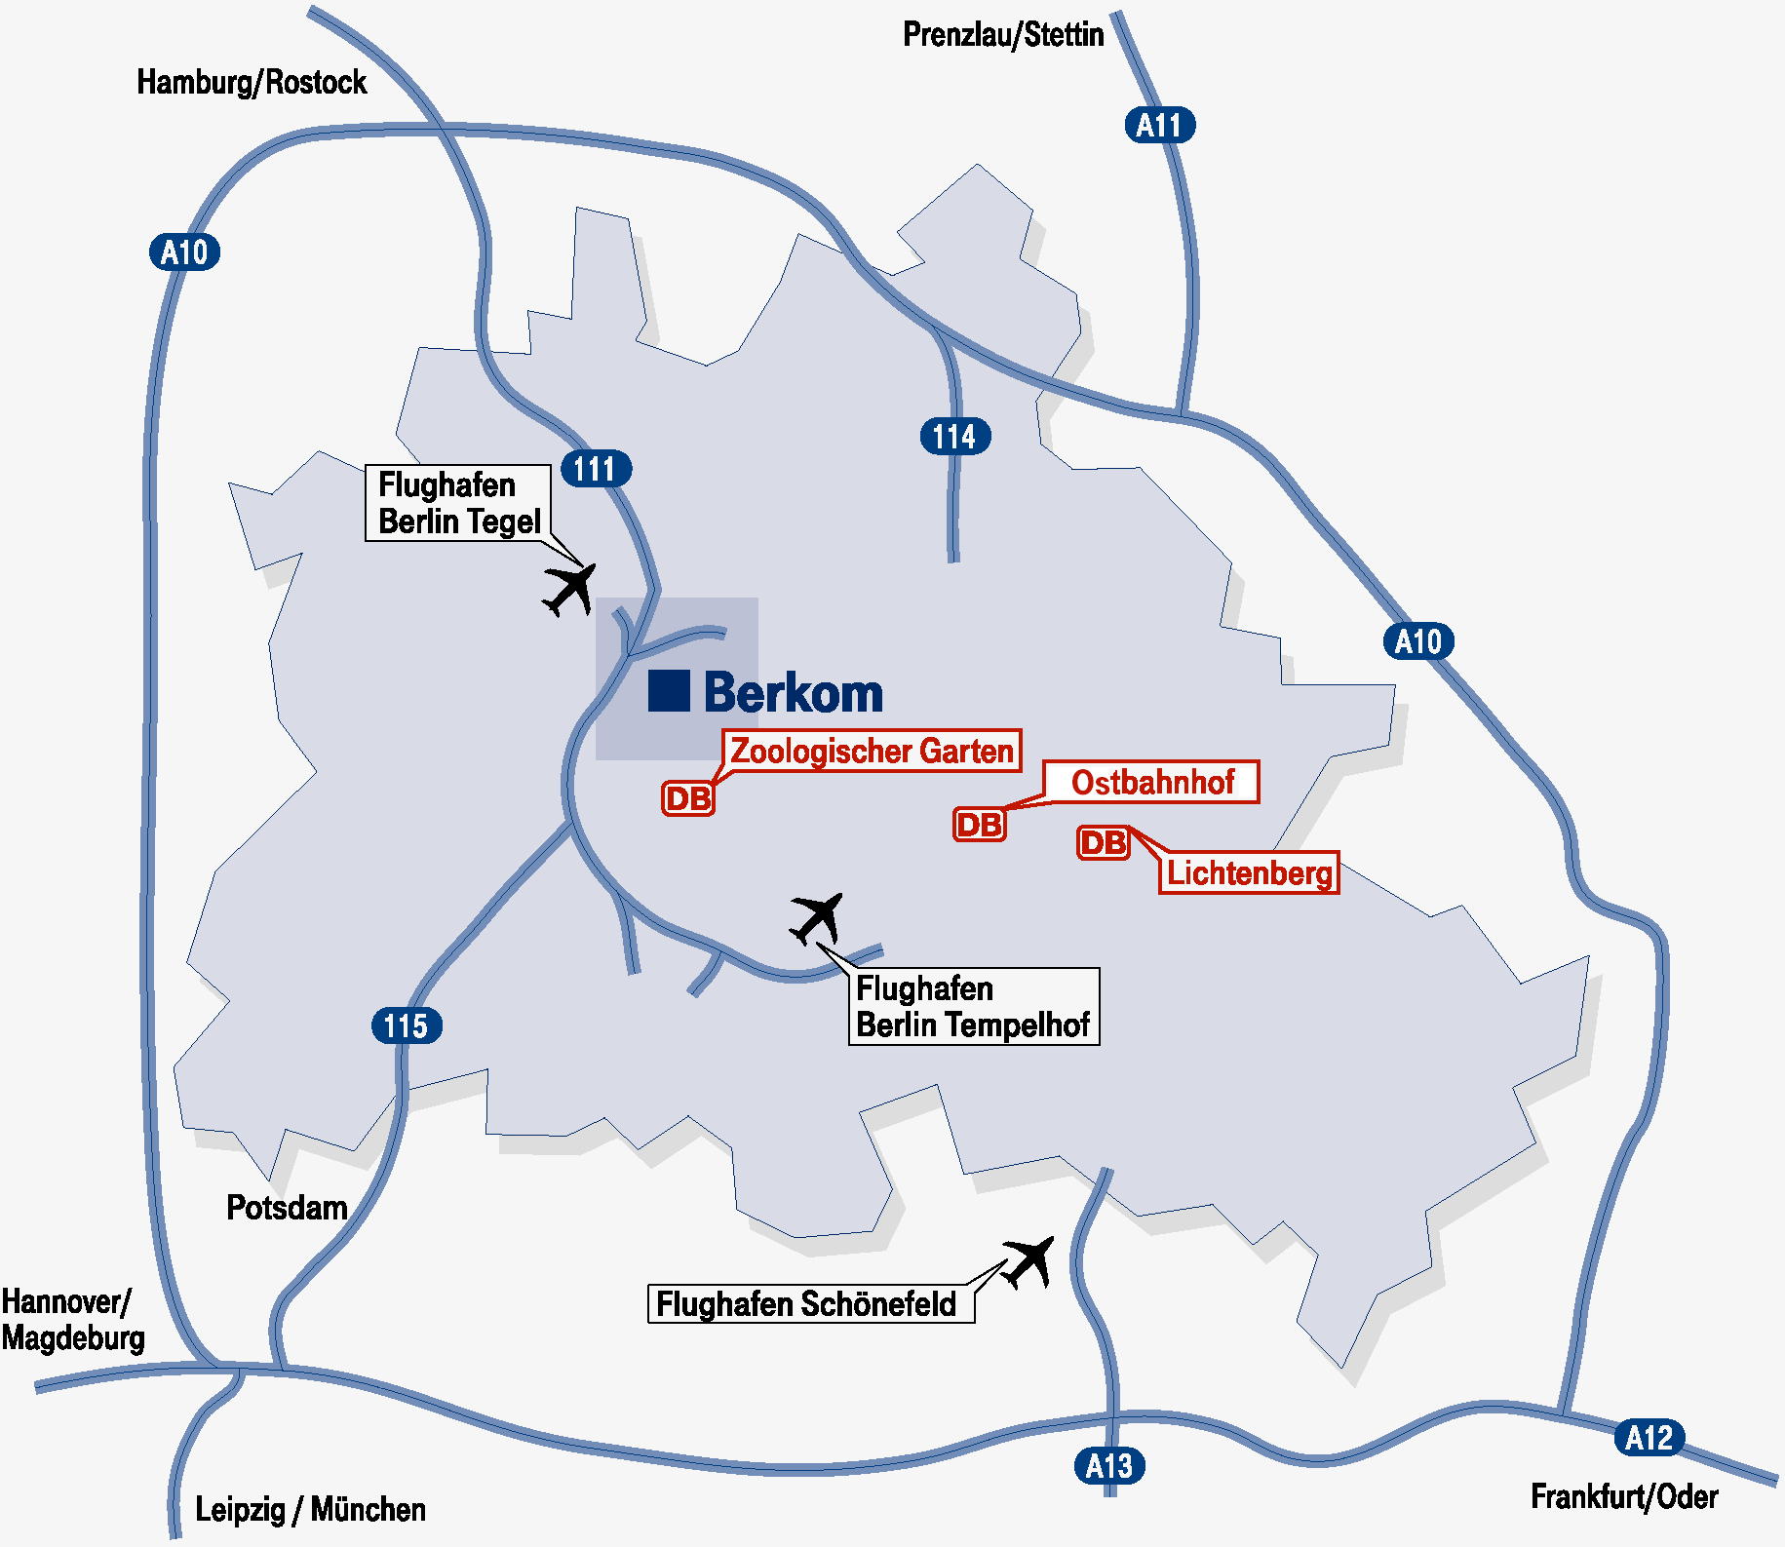

ITU - TSB | ANNEX 3  (to TSB Collective Letter 13/2) | To be returned  by 22 September 2000  TSB Fax: +41 22 730 58 53

Working Party 1/2 Meeting (Berlin, Germany, 19-26 October 2000)

Formule de participation - Registration Form - Formulario de inscripción

Je participe aux Groupes de travail suivants | GT/WP 1/2
I participate in the following Working Parties
Participo en los siguientes Grupos de Trabajo

1. M. Mme Mlle
Mr. Mrs. Miss ________________________________________ ___________________________________
Sr. Sra. Srta. (nom / family name / apellidos) (prénom / first name / nombre)

2. | Pays / Country / País | ________________________________________________________________

3. |  | Administration / Administración | ________________________________________________________________

 |  |  | Chef de délégation |  |  | Adjoint |  |  | Délégué
 |  |  | Head of delegation |  |  | Deputy |  |  | Delegate
 |  |  | Jefe de delegación |  |  | Suplente |  |  | Delegado

ou - or - o
 |  | Exploitation reconnue
 |  | Recognized operating agency | ___________________________________________________________
 |  | Empresa de explotación reconocida

 |  | Organisme scientifique ou industriel
 |  | Scientific or industrial organization | ___________________________________________________________
 |  | Organismo científico o industrial

 |  | Autre entité s'occupant des questions de télécommunication
 |  | Other entity dealing with telecommunication matters | ________________________________________
 |  | Otra entidad que se ocupe de cuestiones de telecomunicaciones

 |  | Organisation régionale et/ou internationale
 |  | Regional and/or International organization | ________________________________________________________
 |  | Organización regional y/o internacional

4. | Adresse officielle | ______________________________________________________________________________
 | Official address
 | Dirección oficial | ______________________________________________________________________________

 | TEL. (office) __________________________ | FAX _____________________________ | TX _________________
 | TEL. (private) _________________________ | E-mail _____________________________________________________

5. Adresse privée pendant la réunion ____________________________________
Private address during the meeting TEL. _____________________
Dirección privada durante la reunión ____________________________________

6. | Je désire recevoir les documents en
 | I wish to receive the documents in |  | Français |  |  | English |  |  | Español
 | Deseo recibir los documentos en idioma

Signature / Firma _________________________________ Date / Fecha__________________________

Réservé au TSB / For TSB use only / Para uso exclusivo de la TSB

Franchise |  |  | Section |  |  | Casier

