INTERNATIONAL TELECOMMUNICATION UNION
Telecommunication
Standardization Bureau

 |  | Geneva, 16 December 1999
Ref. | TSB Collective-letter 12/2
Tel:  Fax: | +41 22 730 5887  +41 22 730 5853 | - To the Administrations of the Member States of the Union and to ITU-T Sector Members participating in the work of Study Group 2
Email: | John.tar@itu.int
Subject: | Meeting of Study Group 2  Geneva, 7-17 March 2000

Dear Sir/Madam,
1 In accordance with the schedule of ITU Telecommunication Standardization Sector meetings for 2000 (see TSB Circular 203 of 3 August 1999), I would like to inform you that Study Group 2 (Network and service operation) is to meet at ITU headquarters, Geneva, from 7 to 17 March 2000 inclusive.
The meeting will open at 0930 hours on the first day. Detailed information concerning the meeting rooms will be displayed on screens at the entrances to ITU headquarters.
2 An interpretation service will be provided for the meeting in accordance with the provisions in force.
3 The draft agenda, as prepared by the Chairperson of Study Group 2, is set out in Annex 1 hereto.
4 The draft timetable of the meeting, prepared in consultation with the Study Group 2 Management Team, is contained in Annex 2.
5 Pursuant to the provisions of Recommendation A.1 of the WTSC (Geneva, 1996), contributions to the work of the Study Group shall be submitted to the Director of the Telecommunication Standardization Bureau (TSB).
a) Contributions received at least two months before the meeting shall be published and mailed to the Administrations of the Member States of the Union and to ITU-T Sector Members registered in this Study Group who have requested paper copies.
b) Contributions received by the Director less than two months but not less than seven working days before the date set for the opening of the meeting shall be published as "delayed contributions", shall be posted to the Study Group … website and shall be distributed at the beginning of the meeting to only the participants present. Therefore, such contributions must be received by the TSB not later than 24 February 2000.
With a view to settling any questions which might arise concerning contributions, the name, the fax and telephone numbers and the e-mail address of the person to be contacted should be indicated on contributions. Accordingly, please give those details on the cover page of all documents.
You are encouraged to submit documents electronically. For detailed instructions please refer to Annex A to TSB Circular 182 of 7 April 1999. Your attention is drawn to the possibility of submitting documents over the Web, which is being tested on a trial basis. Details are included in Annex 3.
6 For your information, a hotel confirmation form is enclosed as Annex 4 (see TSB Circular 180 of 10 March 1999 for the list of hotels).
7 In order to enable the TSB to make the necessary arrangements concerning the documentation and organization of the meeting, I should be grateful if you would send me, by letter or fax (No.: +41 22 730 5853), as soon as possible, but not later than 7 February 2000, the list of people who will be representing your Administration, recognized operating agency, scientific or industrial organization, other entity dealing with telecommunication matters, or regional and/or international organization. The registration form in Annex 5, duly completed (one per participant), should be attached to the above-mentioned list.
8 With a view to rationalizing document distribution during meetings, working party members are reminded that they will receive only the documents which concern them. You are therefore requested to indicate carefully, in the registration form, the different working parties you wish to attend.
9 On Monday, 6 March 2000 there will be a Study Group Management Coordination meeting of the Study Group Management Team and the TSB. Details will be advised to those concerned prior to the meeting.
10 Please note that delegates may register and pick up temporary documents and delayed contributions on the day before the start of the meeting; i.e. from 1600 to 1700 hours on Monday, 6 March 2000 in the second basement level of the ITU Tower Building.
Yours faithfully,

H. Zhao
Director of the Telecommunication
Standardization Bureau
Annexes : 5
ANNEX 1
(to TSB Collective-letter 12/2)
Draft Agenda, ITU-T Study Group 2 meeting, 7-17 March 2000

1 Opening of the meeting
2 Approval of agenda
3 Review of “Guidance Document”, including:
- activities since May 1999 meeting of SG2, including WPs 1/2 and3/2 meetings;
approval of Reports COM 2-R 53 to R 71
- results of meetings relevant to SG2 work
- report on numbering issues
- IP-Telecoms interworking Workshop, 25-27 January 2000
- practical logistic guidance

4 Review of Recommendations under provisions of WTSC-96 Resolution No. 1
5 Study issues for the 2001-2004 study period
6 Timetable and room allocation

7 Meeting Working Parties and other Groups

8 Approval and deletion of Recommendations under the provisions of WTSC-96 Resolution No. 1

9 Study Group level activities:
- Year 2000 Task Force actions and report to WTSA-2000
- IP related activities
- EDH (TSB Circular 182)
- Review of TSAG meeting, 25-29 October 1999
- Review of ITU Reform Group, 15-17 December 1999

10 Review of WP meeting results:
- Identification of Recommendations for future approval under the provisions of Resolution No. 1
- Work programme
- Study issues for the 2001-2004 period (proposed new Questions)

11 Future meetings
12 Other business
13 Closure of the meeting

Attachment to Annex 1: Notes to the Agenda
Attachment
(to Annex 1)
Notes to the Agenda

1) You will recall that at the November 1998 meeting of Study Group 2, a review was made of its working practices and procedures, as contained in COM 2-40 and reproduced in Annex 10 of Report
COM 2-R 41.

It was agreed that the following practices and procedures would be implemented on a trial basis, at the May 1999 meeting (based on §3 of COM 2-40 or §3 of Annex 10 to COM 2-R 41):

P.1 Opening SG2 plenary session to commence at 09:30 hrs on Tuesday, 7 March 2000 for a duration of approximately 45 minutes. Interim SG2 plenary session of approximately two hours (maximum) on Monday morning, 13 March 2000. Closing SG2 plenary session on Friday, 17 March 2000, at the conclusion of the Working Party plenaries.

P.2 Opening plenary session of the Working Parties will be held in series (permit small delegations to participate in all WP opening plenaries) with the first of the three Working Parties to commence at 10:15 hrs on the opening day and all to be completed at the end of the day.

P.3 Delegates are strongly encouraged to pre-register, either by EDH or fax, and to pick up their badges and documents on Monday, 6 March 2000 between 16:00 and 17:00 hrs, thus minimizing the registrations required on Tuesday morning, 7 March, commencing at 08:30 hrs.

P.4 You are reminded to use the electronic facilities available to you to study the documents available for the meeting (Reports, White Contributions and Delayed Contributions on the SG2 Web site; incoming liaisons and other Temporary Documents on the SG2 iFTP area. Please refer to TSB Circular 182 for details).

Also, as already mentioned in P.3 above, you can pick up your badges, Temporary Documents and Delayed Contributions between 16:00 and 17:00 hrs on Monday, 6 March 2000.

P.5 The TSB will assist the SG2 Management Team to prepare a “Guidance Document”, which will be available on the opening day.

2) Agenda items 1-6 will be dealt with in the opening plenary on Tuesday, 7 March. Items 8-9 are foreseen to be handled in the middle plenary, Monday, 13 March. Everything else will be dealt with in the closing plenary, Friday, 17 March.

For any proposals or questions referring to the agenda or the draft timetable, please contact the Chairman, or the Vice-Chairmen, or the TSB Counsellor before the coordination meeting to be held on Monday, 6 March 2000. Depending on the progress made, some minor changes in the timetable might be possible, mainly at the end of the meeting.

To be able to make reliable planning it is essential that all inputs, delayed contributions, etc. to the meeting should be sent in due course to all interested parties and not only to the TSB. Delayed contributions will also be placed on the SG2 Web site.
Because of the considerable workload of the Study Group it is unlikely that the plenary meeting scheduled for Friday afternoon, 17 March, can be held earlier the same day.

ANNEX 2
(to TSB Collective-letter 12/2)
Draft Timetable, Study Group 2, Geneva, 7-17 March 20001

Tues. 7.3 |  | Wed. 8.3 |  | Thurs. 9.3 |  | Fri. 10.3 |  | Mon. 13.3 |  | Tues. 14.3 |  | Wed. 15.3 |  | Thurs. 16.3 |  | Fri.17.3
a.m. | p.m. | a.m. | p.m. | a.m. | p.m. | a.m. | p.m. | a.m. | p.m. | a.m. | p.m. | a.m. | p.m. | a.m. | p.m. | a.m. | p.m.
SG2→WP1, WP2 |  | Q.1 | Q.1 | Q.1 | Q.1 | Joint WPs on IP | Q.1 | SG2  ↓  WP3 | Joint Q.1 & Q.2 | Q.1 | Q.1 | Q.1 | Q.1 | Q.1 | Q.1 prog. Report | WP1 | SG2
 |  | WP3 IP issues |  |  |  |  |  |  | Project 6M  7M  8M | Hand-book (WP 3) | Project 7N | Project 6M  7M  8M | Hand-book (WP 3) | Project 7N | WP 3
 |  |  |  |  |  |  |  |  | IP Issues | Project 8B | IP Issues | Project 8S | IP issues | Project 8S
 |  |  |  |  |  |  | Fraud Preven-tion |  | Q.10 |  | Q.10 |  | Q.10
 | Q.3 | Q.3 | Q.5 | Q.3 | Q.3 | Q.5 | WP2 |  | Q.16 | Q.17 | Q.16 | Q.17
 | Q.4 | Q.4 | Q.4 |  | Q.4
 |  |  | Q.10 | Q.2 | Q.2 |  | Q.2
Q.11→
Q.12
 |  |  |  | Joint Qs. 13 & 15 | Joint Qs. 13 & 15 |  | Joint Qs. 13 & 15 |  |  | Joint Qs. 13 & 15 | Joint Qs. 13 & 15 | Joint Qs. 13 & 15 | Joint Qs. 13 & 15

ANNEX 3
(to TSB Collective-letter 12/2)
Electronic Document Submission over the Web
Participants may now submit documents to the TSB using a new, user-friendly interface utilizing a form-based Web page. Submitters are requested to fill in the information to facilitate the processing of the document. It is recommended that documents for submission be prepared using the standard ITU document templates. These templates may be downloaded from the Web page. Guidelines and helpful hints on the document submission are also available online.
This method of document submission is accessible from the Study Groups’ EDH home page by selecting the option “Submit a document to the TSB”. The address of Study Group 2 EDH home page is:
http://www.itu.int/ITU-T/com2/edh/index.html
Procedures:
- An Information Envelope Form (known as “Envelope”) with the document attributes and contact information should be filled in (see Attachment 1 for an example). A red asterisk indicates that input to the field is mandatory.
- After the Envelope has been completed, click on the “ Create Envelope ” button. If necessary, click on the “Reset” to erase the information on the form.
- Click on “ Choose a File to Upload ”.
- Select the “ File Format ” or word-processing software from the drop-down list.
- Click on the “ Browse ” button to search for the file on your computer or type the filename including the full path.
- Click on the “ Submit File ” button to start the upload.
- Upon successful submission of the file, there are three options to choose from:
- File Upload button: to upload another file using the same Envelope information. Select this option when the document you are submitting has been split into several files or if you are sending the same document but in a different file format. For example, a submitter may send the same document in different file formats: Word 2000, Word 97, Word 95, RTF and PDF.
- Report button: to end submission and view or download the submission report. The Submission Activity Report contains the Acknowledgement Number, Envelope Information and Uploaded File Information and is available in ASCII or text format. It is recommended that submitters save this report as a ‘receipt’.
- New submission button: to submit a new document with a different Envelope. Upon clicking this button, the Envelope will appear. Most of the information from the previous Envelope will be carried over except for the information on title, approval by national authorities and revision marks.
- A message will automatically be sent to the TSB-EDH (tsbedh@itu.int) informing them of the submission.
Attachment 1
Sample Information Envelope For Document Submission over the Web

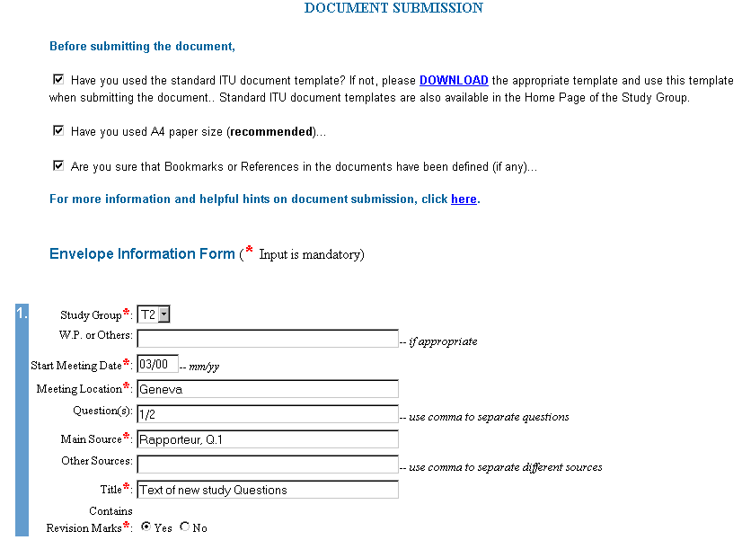
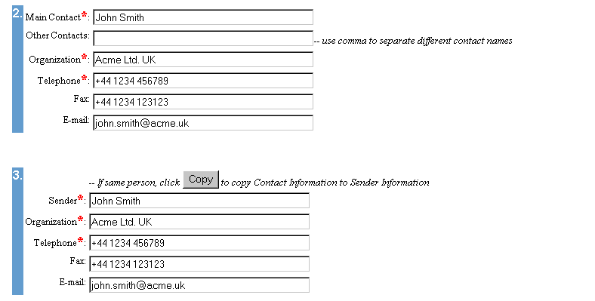

ANNEX 4
(to TSB Collective-letter 12/2)

Ce formulaire de confirmation est à adresser directement à l'hôtel de votre choix (voir la Circulaire TSB 180)
This confirmation form should be sent directly to the hotel of your choice (see TSB Circular 180)
Dirija directamente este formulario de confirmación al hotel que elija (véase la Circular TSB 180)

UNION INTERNATIONALE DES TELECOMMUNICATIONS
INTERNATIONAL TELECOMMUNICATION UNION
UNIÓN INTERNACIONAL DE TELECOMUNICACIONES

SECTEUR DE LA NORMALISATION DES TELECOMMUNICATIONS
TELECOMMUNICATION STANDARDIZATION SECTOR
SECTOR DE NORMALIZACION DE LAS TELECOMUNICACIONES

Réunion CE/GT du au Genève
SG/WP meeting -------------------------------------- from 7 to 17 March 2000, Geneva
Reunión CE/GT desde el al Ginebra

Confirmation de la réservation faite le A l'hôtel
Confirmation of the reservation made on ---------------------------- To hotel -------------------------------
Confirmación de la reserva efectuada el Al hotel

au prix préférentiel offert à l'UIT / at ITU preferential tariff / al precio preferencial ofrecido a la UIT

chambre simple/double du heure d'arrivée au
------------- single/double room from --------------- time of arrival ------------- to ------------
habitación indiv./doble desde el hora de llegada al

Nom / Name / Apellido ----------------------------------------------

Prénom / First name / Nombre -----------------------------------------------

Adresse / Address / Dirección ------------------------------------------------- Tel : -----------------------------

----------------------------------------------------------------------------------------- Fax : -----------------------------

-----------------------------------------------------------------------------------------

Carte de crédit en garantie de la réservation
Credit card to guarantee this reservation: AX/VISA/DINERS/EC -----------------------------------------------
Tarjeta de crédito que garantiza la reserva autre/other/otras

No ---------------------------------------------- validité/validity/validez ---------------------------------------------------

Date/Date/Fecha -------------------------- Signature/Signature/Firma ------------------------------------------------
ITU - TSB | - 11 -  ANNEX 5  (to TSB Collective-12/2) | To be returned  by 7 February 2000  TSB Fax: +41 22 730 58 53

Study Group 2 Meeting (Geneva, 7-17 March 2000)

Formule de participation - Registration Form - Formulario de inscripción

Je participe aux Groupes de travail suivants | CE/SG Plen | GT/WP 1 | GT/WP 2 | GT/WP 3
I participate in the following Working Parties
Participo en los siguientes Grupos de Trabajo

1. M. Mme Mlle
Mr. Mrs. Miss ________________________________________ ___________________________________
Sr. Sra. Srta. (nom / family name / apellidos) (prénom / first name / nombre)

2. | Pays / Country / País | ________________________________________________________________

3. |  | Administration / Administración | ________________________________________________________________

 |  |  | Chef de délégation |  |  | Adjoint |  |  | Délégué
 |  |  | Head of delegation |  |  | Deputy |  |  | Delegate
 |  |  | Jefe de delegación |  |  | Suplente |  |  | Delegado

ou - or - o
 |  | Exploitation reconnue
 |  | Recognized operating agency | ___________________________________________________________
 |  | Empresa de explotación reconocida

 |  | Organisme scientifique ou industriel
 |  | Scientific or industrial organization | ___________________________________________________________
 |  | Organismo científico o industrial

 |  | Autre entité s'occupant des questions de télécommunication
 |  | Other entity dealing with telecommunication matters | ________________________________________
 |  | Otra entidad que se ocupe de cuestiones de telecomunicaciones

 |  | Organisation régionale et/ou internationale
 |  | Regional and/or International organization | ________________________________________________________
 |  | Organización regional y/o internacional

4. | Adresse officielle | ______________________________________________________________________________
 | Official address
 | Dirección oficial | ______________________________________________________________________________

 | TEL. (office) __________________________ | FAX _____________________________ | TX _________________
 | TEL. (private) _________________________ | Email _____________________________________________________

5. Adresse privée pendant la réunion ____________________________________
Private address during the meeting TEL. _____________________
Dirección privada durante la reunión ____________________________________

6. | Je désire recevoir les documents en
 | I wish to receive the documents in |  | Français |  |  | English |  |  | Español
 | Deseo recibir los documentos en idioma

Signature / Firma _________________________________ Date / Fecha__________________________

Réservé au TSB / For TSB use only / Para uso exclusivo de la TSB

Franchise |  |  | Section |  |  | Casier

1 The opening plenary of SG2 starts at 0930 hours, followed by Working Parties 1/2 and 2/2 in series and then to Questions if time permits. Please note that WP 2/2 meets only during the first week and WP 3/2 meets only during the second week.

