INTERNATIONAL TELECOMMUNICATION UNION
Telecommunication
Standardization Bureau

Geneva, 22 May 2000
Ref: | TSB Circular 271 | - To the Administrations of the Member States of the Union;  - To ITU-T Sector Members;  - To the ITU-T Study Group Chairpersons and Vice-Chairpersons
Tel: | +41 22 730 5972
Fax: | +41 22 730 5853
E-mail: | tsbmail@itu.int
Subject: | Availability of ITU-T documents in electronic form
Dear Sir/Madam,
In view of reducing the cost of printing and dispatch of paper documentation, a more widespread use of Electronic Document Handling facilities (EDH) is encouraged.
In accordance with the guidelines provided in letter DM 1013 sent by the Secretary-General of the ITU on 27 January 2000, ITU Member States and ITU-T Sector Members can gain electronic access to and download ITU-T documents via the ITU Telecommunication Information Exchange System (TIES). At present the TSB dispatches circulars, collective-letters, contributions and reports by mail to those Administrations of Member States and ITU-T Sector Members that have requested them. Since these documents are all available electronically, Administrations and Sector Members are kindly requested to consider whether they still wish to receive paper versions of these documents or whether they prefer to download them from the ITU-T Website (http://www.itu.int/ITU-T).
In order to access and download ITU-T documents, the concerned staff of Administrations and Sector Members must request a TIES account, if they do not have one already, to the ITU TIES Registration Service at ties.registration@itu.int. Information on TIES and letter DM 1013 can be found at http://www.itu.int/TIES .
After having obtained a TIES account, users can subscribe to the E-mail Notification System which will inform them each time a document is posted on the ITU-T Website and is thus available for download. Information on the E-mail Notification System can be found in Annex 1, or on the ITU-T Website at http://www.itu.int/ITU-T/itu-t_email.htm .
Administrations of Member States and ITU-T Sector Members are reminded that once they have a TIES account they can also access the study group informal FTP areas which contain temporary documents and liaison statements, and associated e-mail mailing lists available to the study groups for their correspondence work. Requests for access to study group informal FTP areas and subscriptions to e-mail mailing lists can be made directly from the Study Group EDH homepage on the ITU-T Website, http://www.itu.int/ITU-T or by sending a message to the TSB Electronic Document Handling (EDH) Service at tsbedh@itu.int .
Please refer to TSB Circular 182 for information on the EDH facilities provided by the TSB and for a detailed list of the information and type of documents available on the ITU-T Website. Updates on EDH facilities can be found on the EDH Frequently Asked Questions (FAQ) Page on the ITU-T Website.
In view of the above, I kindly invite the Administrations of ITU Member States and ITU-T Sector Members who wish to renounce receiving paper copies of ITU-T documents, to inform the TSB Documents Service by returning the annexed questionnaire (Annex 2) to fax number +41 22 730 58 53.
Yours faithfully,
H. Zhao
Director of the Telecommunication
Standardization Bureau
Annexes : 2
ANNEX 1
(to TSB Circular 271)

E-mail Notification System
This service is available to TIES users only

With the new E-mail Notification System you will receive an e-mail message whenever new or updated ITU-T documents and Recommendations are available on the web.

How to subscribe to the E-mail Notification System
1) Log in to your TIES account (http://www.itu.int/tiesutils/asp/login.asp)
2) From Account Options, select Update Notifications (see Figure 1)

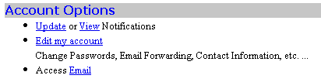
Figure 1

3) Once you have reached the “Update your Notifications” page, select areas for which you want to be notified for new ITU-T documents updates (see Figure 2)

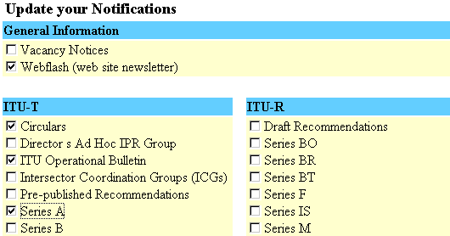
Figure 2

4) To unsubscribe, unselect the areas you do not want to be notified for

The notification e-mail will be sent to the e-mail address listed in the Contact Information of your TIES account. To update your contact e-mail address :

1) Log in to your TIES account ( http://www.itu.int/tiesutils/asp/login.asp )
2) From the Account Option, select Edit my Account
3) Under Contact Information, update your contact e-mail address
ANNEX 2
(to TSB Circular 271)

Renounce receiving paper copies of ITU-T

Please tick

YES, this organization renounces receiving paper copies of ITU-T documents

Administration of Member State __________________________________________

or

Sector Member/Organization __________________________________________

Address ____________________________________________________________

____________________________________________________________

____________________________________________________________

____________________________________________________________

Telephone ____________________________________________________________

Fax ____________________________________________________________

E-mail ____________________________________________________________

Kindly return to the TSB Documents Service, fax + 41 22 730 58 53

