INTERNATIONAL TELECOMMUNICATION UNION
Radiocommunication Bureau
(Direct Fax N°. +41 22 730 57 85)

Circular Letter  8/LCCE/94 | 7 March 2001
To Administrations of Member States of the ITU and
Radiocommunication Sector Members participating in the
work of Working Party 8F of Radiocommunication Study Group 8
Subject: Fifth meeting of Working Party 8F
on IMT-2000 and systems beyond IMT-2000

Introduction
The fifth meeting of Working Party 8F was foreseen in the programme of the Radiocommunication Study Groups by the meeting of Study Group Chairmen and Vice-Chairmen in June 2000.

Date and place of the meeting
Following the kind invitation from the National Post and Telecom Agency of Sweden, the meeting will take place in the München-Bryggeriet Building in Stockholm , from 27 June to 3 July 2001.
Services directly connected with meeting activities, such as delegate registration, document distribution, etc., will be located at the meeting place. Registration will commence at 08:30 hours on the opening day. The opening session will commence at 10:00 hours.
Information concerning the venue of the meeting and accommodation is provided in Annex 2.

Programme of the meeting
In accordance with Resolution ITU-R 1-3, § 2, the meeting agenda (see Annex 1) will comprise the examination of the Questions assigned to the Working Party.

Working language
Working Party 8F conducts its work in English.
Contributions
Contributions in response to the work of Working Party 8F assigned to this meeting are invited*. Contributions will be processed and dispatched in accordance with Resolution ITU-R 1-3 and posted on TIES/ITUDOC. In view of the meeting taking place outside Geneva, the deadline for submitting contributions will be Monday, 11 June 2001. Documents received after this deadline and which cannot be processed by the Secretariat in time for the opening of the meeting will be forwarded to the next meeting of the Working Party.
According to the ITU-R patent policy (Annex 1 to Resolution ITU-R 1-3), contributions containing a proposal for a Recommendation should draw the attention to any known patent or to any known pending patent application relating to systems or technologies considered in the proposal.
Copies of each contribution should be sent to the Study Group Department, Radiocommunication Bureau, for processing, to the Chairman of the Working Party and to the Chairman and Vice-Chairmen of Radiocommunication Study Group 8. The pertinent addresses can be found in Annex 3 to this Circular. Participants are encouraged to submit contributions by electronic mail as outlined in Administrative Circular CA/17 (Revision 2) of 16 April 1999 (http://www.itu.int/itudoc/itu-r/ac/ca/ca-17-r2.html) to:
brsgd@itu.int

Documentation
New arrangements for documentation are envisaged for this meeting (see Annex 5).

Participation
In order to make the necessary arrangements, it is requested that the intended participation of your representative(s) be advised no later than one month before the opening of the meeting by means of the annexed form (Annex 6) (to be photocopied as required).

Robert W. Jones
Director, Radiocommunication Bureau
Annexes: 6
Distribution:
- Administrations of Member States and Radiocommunication Sector Members participating in the work of Working Party 8F of Radiocommunication Study Group 8
- Chairman and Vice-Chairmen of Radiocommunication Study Group 8
- Secretary General of the ITU, Director of the Telecommunication Standardization Bureau, Director of the Telecommunication Development Bureau
ANNEX 1

Draft agenda for the fifth Meeting of Working Party 8F

(Stockholm, 27 June – 3 July 2001)

1 Opening of the meeting
2 Approval of the agenda
3 Report on the 4th meeting of Working Party 8F Doc. 8F/268
4 Reports from Liaison and Special Rapporteurs
5 Proposed method of work
6 Introduction and assignment of input documents*
7 Consideration of input documents
8 Future work
9 Other business

S. BLUST
Chairman, Working Party 8F
ANNEX 2
INFORMATION FOR PARTICIPANTS
Conference venue: München-Bryggeriet
S. Mälarstrand 29
SE-104 62 STOCKHOLM
Secretariat: Telefax, photocopiers, printers, IBM compatible PCs (Word 7.0) and Internet connections will be made available.
Hotel reservations: A block reservation of 250 rooms has been made at the following hotels so please return the hotel booking form given Annex 4 as soon as possible and in no case later than May 15, 2001 to:
BOKA (Hotel agency)
Telephone: +46 8 54 59 10 10
Telefax: +46 8 673 06 25
Email: info@bokahotell.se

No* | Name and address |  | Price, SEK
1 | Conference Venue,  S. Mälarstrand 29 |  | Single room incl. breakfast
2 | Långholmen Sweden Hotel, Långholmsmuren 20, (Hotel in an ex-prison from the 18th century on an island) | A short walk to bus no 66 at Långholmsgatan (in the direction of Sofia) to Krukmakargatan and a 2-3 minutes walk. | 695.--
3 | Aston Hotel, Mariatorget 3 | At a walking-distance of less than 10 minutes | 830.--
4 | Rica City Hotel Gamla Stan, Lilla Nygatan 25 | Subway from Gamla Stan to Mariatorget (2 stations). Exit Torkel Knutssonsgatan and then 3 minutes walk. | 990.--
5 | Mälardrottningen,Riddarholmskajen (a ship, earlier owned by the actress Barbara Hutton) | 5 minutes walk to the subway Gamla Stan to Mariatorget  (2 stations). Exit Torkel Knutssonsgatan and then 3 minutes walk | 1000.--
6 | Comfort Hotel Stockholm, Kungsbron 1 | 5 minutes walk to T-Centralen Subway to Mariatorget (3 stations). Exit Torkel Knutssonsgatan and then 3 minutes walk. | 1305.--
7 | Hotel Stockholm, Norrmalmstorg 1 | Bus no 55 (in the direction of Sofia) to Krukmakargatan.  Then 5 minutes walk | 1100 – 1300
8 | Hotel Terminus, Vasagatan 20 (just opposite the Central Station) | Subway just close to the hotel to Mariatorget 3 stations away. Exit Torkel Knutssonsgatan and then 3 minutes walk. | 940 - 1480
It is very difficult to get additional rooms therefore it is highly recommended to make an early reservation as all hotels in Stockholm are fully booked due to a session by the Swedish Presidency of the European Union.
The room will be allocated in the order of reservation (first-come-first-served).
A full day will be charged, if the reservation is cancelled less than ten days before your scheduled date of arrival at the hotel. Two full days will be charged for “no shows”.
Air travel: The international airport in Stockholm is Arlanda airport. Arlanda is situated about 45 kilometres north of the city. The hotels and the conference venue are located in the city centre.
Airport bus service: There are airport buses, which depart from the terminal to the city centre every 10 minutes, approximately time 40 minutes. The price is SEK 60. There is also a direct train, “Arlanda Express” to the Central Station in Stockholm, approximately time 20 minutes. The price for the train is SEK 150. Taxis are available from there.
Taxi: You can use a ”shared taxi”. Please call at the desk ”FLYGTAXI” in the arrival hall at the airport, price approx. SEK 310. An ordinary taxi, ask for fixed price, from/to the airport should not exceed SEK 500.
Currency: The Swedish currency unit is krona (SEK), divided into 100 öre.
1 Euro (EUR) = SEK 9.05 (2000-03-01)
1 USD = SEK 9.67 (2000-03-01)
Weather: Summer usually begins in June and by Midsummer’s Eve (22 June) it should definitely have arrived. Normally the temperatures in Stockholm during this period are 20-25C (68 to 77F) degrees or warmer.
Banks: Banks are open Monday through Friday 9.30 - 15.00 and are closed on Saturdays and Sundays. Traveller’s cheques and foreign currency can also be exchanged at the airport and at the central railway station. There are also several currency exchanges offices in the centre of Stockholm.
Credit cards: Major credit cards (American Express, Diners Club, Euro Card, Master Card and Visa) are accepted by most Swedish hotels, restaurants, car rental agencies, department stores, shops and taxis..
Shopping hours: The most common opening hours are 09.00. – 18.00 during weekdays and 9.00 – 15.00 on Saturdays.
Post offices: Post offices are open Monday through Friday 09.00 – 18.00 and on Saturdays 09.00 - 13.00. The nearest post office is located at Rosenlundsgatan 11, Stockholm.
Yellow mailboxes are for collections daily. Stamps can be bought at post offices, most stations, hotels and kiosks.
Electrical appliances: The mains power voltage in Sweden is 220V. Plugs are two-round-pin European continental size.
Emergency: Should medical or dental assistance be required during your visit, please contact the secretariat during working hours and at other times the hotel receptionist.
All Emergencies: Dial 112 (SOS)
Tourist information: Turist Center, Sverige huset
Hamngatan 27
103 93 Stockholm
Telephone: +46 8 789 24 00
Web sites to visit: www.ericsson.com/wp8f
http://www.aos.se/Stockholm/Tourist_Time/
http://www.stockholmtown.com/pages/271/index.asp
http://cityguide.se/stockholm/turism/index_e.phtml
http://www.axi.americanexpress.com/wg/Europe/Sweden/P2631.asp
http://www.gulasidorna.se
Lunch: Lunches will not be provided during the meeting. There are several restaurants around the conference place.
Social event:
Wednesday June 27: Ericsson will invite you to a buffet at The Museum of National Antiquities in Stockholm. You will have a chance to tour the museum, visit the Gold Room with ancient Swedish gold treasures and the newly inaugurated Viking exhibition. Additional information about the museum can be found at: http://www.historiska.se
Sunday July 1 - "Ericsson-day in Dalarna" - Excursion northwest of Stockholm to the province of Dalarna, famous for its beauty, its history, and its role in the creation of the Kingdom of Sweden. Visit the sites of Sweden’s earliest industry, including the world’s oldest corporation still in operation, experience Dalarna´s local culture, its colorful costumes and music, and enjoy a dinner with guaranteed special flavor. Top off the day with a very special exotic experience - a Tjaikowsky concert performed by Peter Jablonski and the Gävle Symphony Orchestra in an open limestone mine under the special blue sky of a Nordic midsummer night!

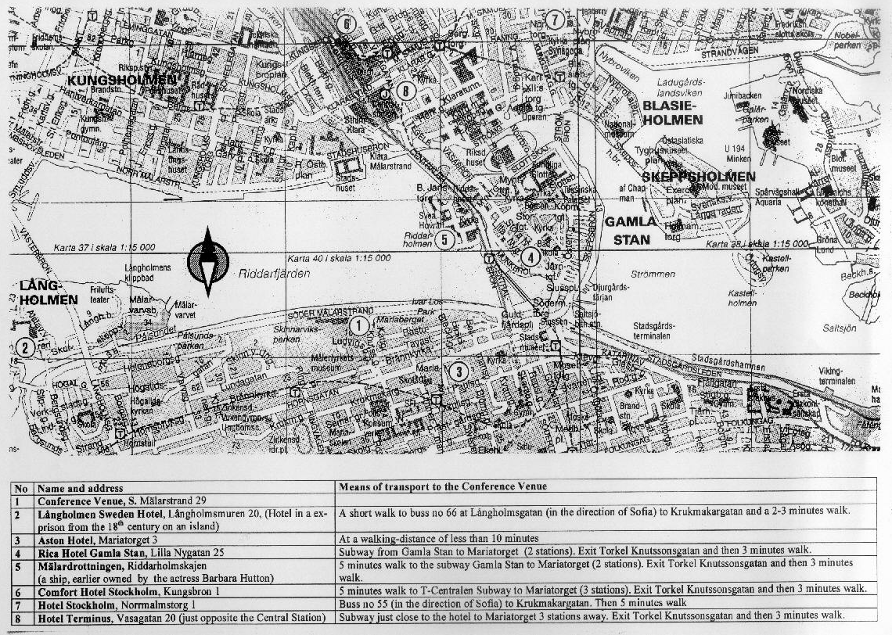

ANNEX 3
List of Chairmen and Vice-Chairmen

Chairman, Study Group 8
Mr. C. VAN DIEPENBEEK
Radiocommunications Agency
DGTP/RDR
P.O. Box 450
9700 AL GRONINGEN
Netherlands (Kingdom of the)
Tel: +31 505 877130
Fax: +31 505 877400
Internet: chris-van.diepenbeek@rdr.nl

Vice-Chairmen, Study Group 8
Mr. T. MIZUIKE
KDD Corporation
2-1-15 Ohara
Kamifukuoka
SAITAMA 356-8502
Japan
Tel: +81 492 787810
Fax: +81 492 787318
Internet: mizuike@lab.kdd.co.jp
Mr. V. STRELETS
General State Supervisory Department
for Communications
in the Russian Federation
6, 2nd Spasonalivkovsky per.
117909 MOSCOW
Russian Federation
Tel: +7 095 2389498
Fax: +7 095 2003230
Internet: strelets@podlipki.ru

Mr. R.L. SWANSON
Federal Communications Commission (FCC)
445 12th Street S.W.
WASHINGTON, D.C. 20554
United States of America
Tel: +1 202 4180732
Fax: +1 202 4187270
Internet: rswanson@fcc.gov

Chairman, Working Party 8F
Mr. S. BLUST
Cingular Wireless
1100, Peachtree Street NE
Room 803
ATLANTA GA 30309-4599
United States of America
Tel: +1 404 2495058
Fax: +1 404 2495157
Email: stephen.blust@cingular.com

annex 4
ITU-R Working Party 8F on IMT-2000 and systems beyond IMT-2000,
Stockholm, Sweden June 27 –July 3, 2001
Hotel Reservation Form

Family name:

First name:

Company:

Address:

Telephone:

Facsimile:
Date & approx. time of arrival at hotel
Date & approx. time of departure from hotel:
Single room:  Double room: 
Credit card type: ………….No.: ………………………… Expiry date:…………………

HOTEL RESERVATIONS SHOULD BE SENT DIRECTLY TO BOKA (Hotel agency) AS SOON AS POSSIBLE

BOKA (Hotel agency)
Telephone: +46 8 54 59 10 10
Telefax: +46 8 673 06 25
Email: info@bokahotell.se
ANNEX 5
Documentation*

In order to reduce the costs of reproducing documents and the wastage of paper, participants are kindly requested to make use of, to the maximum practical extent, electronic access to the meeting documentation.
- Before the meeting, input documents are made available to TIES registered users through the ITU web site at http://www.itu.int/itudoc/itu-r/sg8/docs/wp8f/2000-03/contrib/index.html
The first input document for this meeting is document 8F/266.
Information about TIES registration is available at http://www.itu.int/TIES/
- During the meeting, a reasonable number of IBM compatible PCs, printers and local area network connections (10BaseT) for individual delegate’s computers will be provided. Access to all of the meeting documents is provided via the local area network. A limited number of “loaner” CD-ROMS will also be produced on a regular basis.
To this end, paper copies of the input documents will not be distributed to each delegate’s pigeon hole; sufficient paper copies of all input documents will be made available on a document table. Delegates are responsible for individually collecting from the document table paper copies of any particular input document they may need.
To assist delegates to identify which input documents may be of interest, document 8F/ADM/3 will be prepared and distributed in each delegate’s pigeon hole at the start of the meeting. Document 8F/ADM/3 details the input document numbers, sources, contents and a provisional indication of which Working Groups within WP 8F will address the document. The final assignment of input documents to Working Groups will be decided during the first Plenary meeting.
To enable the Secretariat to estimate the correct number of copies, please indicate in which areas of interest you expect to require paper copies of the input documents by placing a tick under the relevant working groups in the table below.

Plenary | Working Group
 | Circulation | Developing | R-Tech | Sat-Coord | Spectrum | Vision
Documents produced during the meeting (ADM and TEMP documents) will be distributed to each delegate’s pigeon hole.
Please advise the Secretariat if you cancel your registration.

ANNEX 6

Registration Form
ITU-R Meeting
Stockholm - Sweden, 27 June – 3 July 2001
Radiocommunication Bureau
I wish to participate in |  | Working Party 8F
 |  | ✓

Mr. Mrs. Ms. Miss:
(family name) (first name)

Accompanied by:
(family name) (first name)

1. REPRESENTATION
Name of Member State:
❒ Head of Delegation  Deputy  Delegate
(to be completed by representatives of Member States only)
Name of Sector Member: ..
❒ Recognized Operating Agencies
❒ Scientific or Industrial Organizations
❒ Regional and other International Organizations
❒ Regional Telecommunication Organizations
❒ Intergovernmental Organizations Operating Satellite Systems
❒ Other Entities Dealing with Telecommunication Matters
❒ United Nations and its Specialized Agencies

2. OFFICIAL ADDRESS
Name of the Company:
Street address:
City/State/Code/Country:
Business tel.: Fax:
E-mail: In case of emergency:
3. DOCUMENTS (see Annex 5) □ English
Date: Signature:
For BR Secretariat use only
Approved (if applicable) | Personal Section |  | Meeting Section |  | Pigeonhole
To be returned duly completed to the Radiocommunication Bureau |  | Place des Nations  CH-1211 Geneva 20  Switzerland |  | Telephone: +41 22 730 5802  Telefax: +41 22 730 6600  Telex: 421000 UIT

* Contributors are urged to reduce the length of their contributions as much as possible. The recommended maximum length of an input document is 10 pages. Long documents should be structured as a small number of cover pages (preferably one) summarizing the document and an attachment containing the detailed information. The attachments of such long documents, when submitted as delayed contributions, would only be distributed on paper to the participants at the meeting, on request.
* Discussions on the use of spectrum outside the frequency bands identified for IMT-2000 in the Radio Regulations (see provisions Nos. S5.388, S5.384A, S5.388A, and S5.317A) will be pursued at the 5th meeting; therefore, contributions are invited with respect to the technical and commercial advantages which there might be in also using the range 450-470 MHz, recognizing the potential coverage advantages at lower frequencies for sparsely populated areas.
* The numbers refer to the map on page 8.
* Please return to the Secretariat with the registration form.

