INTERNATIONAL TELECOMMUNICATION UNION
Radiocommunication Bureau
(Direct Fax No. +41 22 730 57 85)
Circular Letter 21 October 1999
7/LCCE/23
To Administrations of Members States of the ITU and
Radiocommunication Sector Members participating in the work
of Working Parties, 7B, 7C, 7D and 9D of Radiocommunication Study Groups 7 and 9

Subject: Meetings of Working Parties 7B, 7C and 7D and Joint Rapporteur Group 7D-9D
Working Party 7B Space radio systems
Working Party 7C Earth exploration satellite systems and meteorological elements
Working Party 7D Radio astronomy
Joint Rapporteur Frequency sharing between space science services and
Group 7D-9D the fixed service

Introduction
The meetings of Working Parties 7B, 7C and 7D and the meeting of Joint Rapporteur Group 7D-9D have been decided by Radiocommunication Study Group 7.

Date and place of the meetings
The Administration of the United States of America on behalf of NASA (National Aeronautics and Space Administration) has kindly offered to host the meetings of Working Parties 7B, 7C and 7D from 24 to 28 January and the meeting of JRG 7D-9D from 31 January to 3 February 2000 (see Annex 1).
The meetings will take place at the Adam’s Mark Hotel, 1500 Sand Lake Road, Orlando, Florida 32809, USA (see Annex 3). Services directly connected with meeting activities, such as delegate registration, document distribution, etc. will be located in the same building. Registration will commence at 08:30 hours on the opening day. A joint meeting of all the Working Parties will commence at 09:30 hours on 24 January 2000. The Joint Rapporteur Group 7D-9D will start at 09:30 hours on 31 January 2000.
Programme of the meetings
Preliminary draft agendas for these meetings are contained in Annex 2.
Working language
The Working Parties and Joint Rapporteur Group will conduct their work in English.
Contributions
Contributions in response to the work of Working Parties 7B, 7C and 7D and to JRG 7D-9D are invited. These will be processed according to the provisions laid down in Resolution ITU-R 1-2, and posted on TIES/ITUDOC.
One copy of each contribution should be sent to the Director, Radiocommunication Bureau for processing. Contributions should also be sent to the Chairmen of the relevant Working Party and to the Chairmen and Vice-Chairmen of Study Groups 7 and 9. The pertinent addresses can be found in Annex 4 to this circular. Participants are encouraged to submit contributions on magnetic diskettes along with paper copies, or by electronic mail as outlined in Revision 2 to Administrative Circular CA/17 of 16 April 1999. Contributions by electronic mail can be sent to:
renata.zecha@itu.int
Contributions received up to six weeks in advance of the meeting are dispatched, as far as possible, before the meeting in their original language. Later contributions, received up to seven days in advance of the meeting, are made available at the opening of the meeting. The Secretariat cannot guarantee that documents received after the seven-day limit can be made available to participants at the opening meeting. Resolution ITU-R 1-2 provides that contributions which are not available to participants at the opening of the meeting shall not be considered.

Participation
In order to make the necessary arrangements, it is requested that the intended participation of your representative(s) be advised not later than one month before the opening of the meeting, by means of the annexed form (Annex 5) (to be photocopied as required).

Robert W. Jones
Director, Radiocommunication Bureau

Annexes: 5

Distribution:

- Administrations of Member States of the ITU and Radiocommunication Sector Members participating in the work of Working Parties 7B, 7C and 7D of Radiocommunication Study Groups 7 and Working Party 9D of Radiocommunication Study Group 9
- Chairmen and Vice-Chairmen of Radiocommunication Study Groups 7 and 9
- Secretary-General of the ITU, Director of the Telecommunication Standardization Bureau, Director of the Telecommunication
Development Bureau
ANNEX 1

ANNEX 2

Preliminary Draft Agenda for the meetings of
Working Parties 7B, 7C and 7D
(Orlando, 24-28 January 2000)

1 Introduction by the Chairman
2 Approval of the agenda
3 Status of Questions assigned to the Working Party and related work
4 Chairman's progress report
5 Work programme for the meeting
6 Introduction of input documents
7 Establishment of drafting groups and attribution of documents
8 Preparation of output documents
9 Discussion of the future work plan
10 Venue of the next meetings
11 Any other business

S. TAYLOR L. RUIZ
Chairperson, Working Party 7B Chairman, Working Party 7C

- B. WHITEOAK
Chairman, Working Party 7D

Preliminary Draft Agenda for the Meeting of
Joint Rapporteurs Group 7D-9D
(Orlando, 31 January -3 February 2000)

1 Introduction by the Chairman
2 Approval of the agenda
3 Chairman's progress report
4 Work programme for the meeting
5 Introduction of input documents
6 Establishment of drafting groups and attribution of documents
7 Preparation of output documents
8 Discussion of the future work plan
9 Venue of the next meeting
10 Any other business

J.E. MILLER
Principal Rapporteur, JRG 7D-9D

ANNEX 3

PRACTICAL INFORMATION FOR PARTICIPANTS
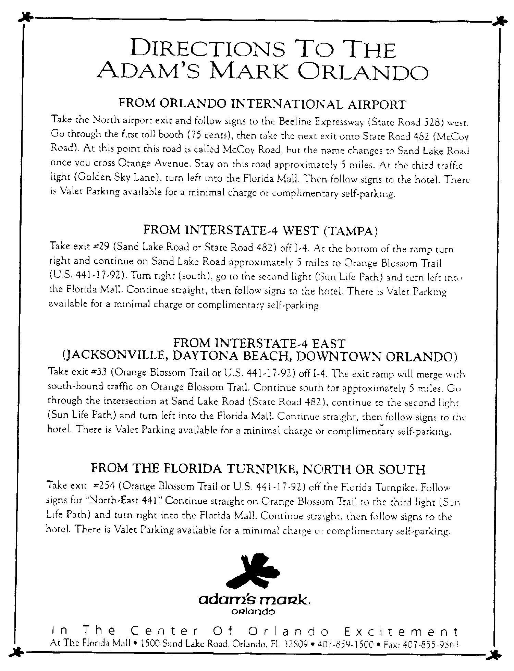

ANNEX 4
List of Chairmen and Vice-Chairmen
Chairman, Study Group 7
Mr. R. M. TAYLOR TEL: +1 409 285 9263
TT&C FAX: +1 409 285 0256
103 Oyster Creek Drive E-mail: robert@teleregs.com
Suite I.
LAKE JACKSON, TX 77566
United States of America
Vice-Chairmen, Study Group 7
Mr. G. DE JONG TEL: +31 15 2691 623
NMi Van Swinden Laboratorium FAX: +31 15 2612 971
P.O. Box 654 E-mail: gdejong@NMi.nl
2600 AR DELFT
Netherlands (Kingdom of the)
Mr. V. MEENS TEL: +33 5 612 73 808
CNES - DSO/RC/BF FAX: +33 5 612 81 574
BPI 2511 E-mail: vincent.meens@cnes.fr
18, avenue Edouard Belin
31401 TOULOUSE Cedex 04
France
Mr. J.B. WHITEOAK TEL: +61 2 9372 4110
Deputy Director FAX: +61 2 9372 4444
Australia Telescope National Facility E-mail: jwhiteoa@atnf.csiro.au
CSIRO, P.O. Box 76
EPPING, NSW 1710
Australia
Chairperson, Working Party 7B
Mrs. S. TAYLOR TEL: +1 281 483 0122
NASA Johnson Space Center FAX: +1 281 483 5200
Mail Code GT Email: shayla.e.taylor1@jsc.nasa.gov
HOUSTON, TX 77058
United States of America
Chairman, Working Party 7C
Mr. L. RUIZ TEL: +33 1 447 67614
CNES FAX: +33 1 447 67579
DP/RC E-mail: luis.ruiz@cnes.fr
2, place M. Quentin
75039 PARIS Cedex 01
France

Chairman, Working Party 7D
Mr. J. B. WHITEOAK
(see address above)

Chairman, Study Group 9
Mr. M. MUROTANI
Mitsubishi Electric Corporation Tel: +81 467 412401
Corporate Research and Development Fax: +81 467 411050 or
1-1, Ofuna 5-Chome +81 467 412419
KAMAKURA 247-8501 E-mail: murotani@isl.melco.co.jp
Japan

Vice-Chairmen, Study Group 9
Mr. G.F. HURT Tel.: +1 202 4824107
NTIA, Room 6725 Fax.: +1 202 4824595
U.S. Department of Commerce E-mail: ghurt@ntia.doc.gov
14th and Constitution Ave., N.W.
Washington, D.C. 20230
United States of America
Mr. V.M. MINKIN Tel: +7 095 2619307
Radio Research & Development Institute (NIIR) Fax: +7 095 2610090 or
16 Kazakova Street +7 095 2619307
103064 MOSCOW E-mail: minkin@niir.pvt.msu.su
Russian Federation
Chairman, Working Party 9D
Mr. G.F. HURT
(see address above)
Principal Rapporteur (JRG 7D-9D)
Mr. John E. MILLER Tel.: +1 301 809 2272
Stanford Telecommunications, Inc. Fax: +1 301 262 2642
7501 Forbes Blvd., Suite 105 E-mail: john.miller@itu.int or
Seabrook, MD 20706 jemiller@cpcug.org
United States of America

ANNEX 5
Registration Form
ITU-R Meetings
Orlando, Florida
24 January - 3 February 2000
Radiocommunication
Bureau
I wish to participate in | WP 7B  24-28 Jan. | WP 7C  24-28 Jan. | WP 7D  24-28 Jan. | JRG 7D-9D  31 Jan.- 3 Feb.
Mr. Mrs. Ms. Miss:
(family name) (first name)
Accompanied by:
(family name) (first name)
1. REPRESENTATION
Name of Member State:
❒ Head of Delegation  Deputy  Delegate
(to be completed by representatives of Member States only).
Name of Sector Member: ..
❒ Recognized Operating Agencies
❒ Scientific or Industrial Organizations
❒ Regional and other International Organizations
❒ Regional Telecommunication Organizations
❒ Intergovernmental Organizations Operating Satellite Systems
❒ Other Entities Dealing with Telecommunication Matters
❒ United Nations and its Specialized Agencies
2. OFFICIAL ADDRESS
Name of the Company:
Street address:
City/State/Code/Country:
Business tel.: Fax:
E-mail: In case of emergency:
Date: Signature:

For BR Secretariat use only
Approved (if applicable) | Personal Section |  | Meeting Section |  | Pigeonhole
To be returned duly completed to the Radiocommunication Bureau |  | Place des Nations  CH-1211 Genève 20  Switzerland |  | Telephone: +41 22 730 5802  Telefax: +41 22 730 6600  Telex: 421000 UIT

