TRENDS IN TELECOMMUNICATION
REFORM 2004/05
Licensing in an era
of convergence

Summary

December 2004

Table of Contents

Page
1 Introduction 1
2 What’s going on in the ICT sector? 3
3 Selected regulatory developments 9
4 Licensing in an era of convergence 12
5 Towards a converged licensing framework 17

TRENDS IN TELECOMMUNICATION
REFORM 2004/05
Licensing in an era of convergence
Summary

1 Introduction
ITU/BDT is pleased to present the sixth edition of the International Telecommunication Union’s Trends in Telecommunication Reform, which is part of our ongoing, global dialogue with policy-makers and regulators of information and communication technologies (ICTs). This year’s edition of Trends focuses on licensing in an era of convergence. The ICT sector is undergoing a radical transformation from an industry based on “plain old telecommunication service” (POTS) to one that provides voice, data and multimedia applications, on both wireline and wireless networks, accessible from a full range of end-user devices. As a result, countries around the world are in the process of updating their licensing and regulatory frameworks to address the increasing reality of convergence. Their goal is to better promote affordable access to the entire range of communication services, from voice to high-speed Internet access. This report spotlights the global trend towards reducing licensing requirements and adopting converged licensing regimes that will enable service providers to offer any and all services using the technology of their choice in a more competitive market environment.
Increasingly, policy-makers are revamping licensing frameworks to make them more flexible and more “converged”. At this juncture, there are various approaches – and it is good to let a thousand flowers bloom. Some approaches favour a “generic” or “converged” licence for all providers of telecommunication services, regardless of what technology they deploy or what specific service niche they target. Other governments have developed new, functional categories, establishing
different licences for network operation and service provision. Still others have questioned whether licencing, as we traditionally knew it, is necessary at all in a liberalized environment. Some services are being provided under class licences or general authorizations. Operators may be asked to simply notify regulators or register their services. In some cases, previously licensed services are subject to no licensing requirements at all.
All of this change, of course, raises issues that policy-makers and regulators will have to address. Can they completely de-regulate the licensing of spectrum and other scarce network inputs? How can they move to a converged licensing framework without unduly benefiting either incumbents or new market entrants? If new and existing participants in the market are less tightly licensed, how can regulators ensure that the public interest is appropriately served? Can governments pull back on licensing and still push operators to attain societal objectives such as universal access?
These questions are explored in this edition of Trends to launch a global dialogue on this key ICT sector development issue. That process has begun with pioneering governments that have implemented far-reaching revisions of their licensing and regulatory frameworks – efforts that are spotlighted in this report. This process will continue to develop over time, guided and empowered by the needs of consumers to benefit from convergence and competition, and the responses of service providers, the world over.

2 What’s going on in the ICT sector?

Basic services opened to competition, at last
The year 2004 marks a major milestone in the opening up of basic telecommunication services to competition. Many countries had been reluctant to do so until now. The term “basic services” is defined as local, long distance and international services. As stated in Trends 2004/2005, basic services are today being provided under competitive conditions in 54 per cent of countries worldwide. However, some important regional differences remain. The majority of Arab States, for example, retain monopoly status for local (90 per cent), long distance (80 per cent) and international (86 per cent) services. The reverse is true for Europe where competition is the norm, with 85 per cent of local, 73 per cent of long distance and 74 per cent of international markets now open to competition (see Figure 1).
Recent announcements from around the world point to further liberalization. The Former Yugoslav Republic of Macedonia plans to end its fixed-line monopoly by year-end 2004. Jordan has announced full liberalization of its telecommunication market in 2005. And Tanzania plans to open its fixed-line market by the end of February 2005.
For many countries, their initial phase of market reform involved opening mobile services to competition, along with certain value-added and Internet services. This often was implemented by issuing service-specific licences for each category of service as it became liberalized.
Trends 2004/2005 explores the move to technology- and service-neutral licences, and indicates that this shift would bring more robust competition in all service segments. It further underlines that the information and communication technology (ICT) market would be treated in a more unified manner, allowing all service segments and technologies to compete in an open framework.
Figure 1 – The Status of Competition
The legal status of competition in different global telecommunication
market segments in 2004 (top chart); and level of competition in basic
services, by region, in 2004 (bottom chart)
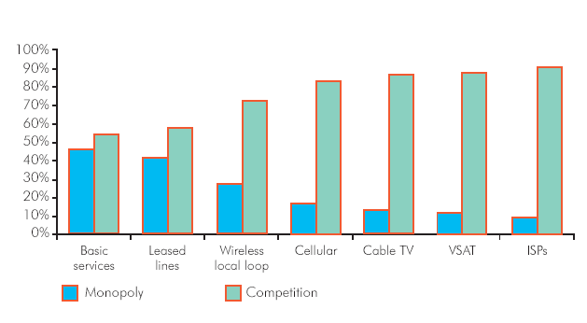
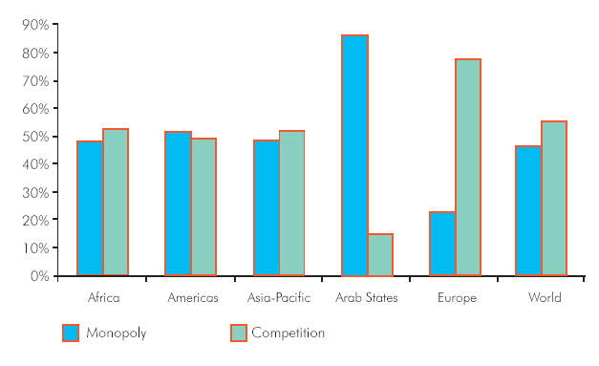
Source: ITU World Telecommunication Regulatory Database.

Regulatory authorities on the rise
The number of regulatory authorities around the world had risen to 132 by mid-2004, reflecting the general pattern of growth that has continued to mark the ICT sector for over a decade (see Figure 2). As well, the trend towards institutional convergence continued into 2004, as existing regulatory authorities merged and new, converged ones were established from scratch. For example, in the United Kingdom, five separate agencies merged to form the Office of Communications (OFCOM) that became operational at year-end 2003. These were the Office of Telecommunications (Oftel), the Broadcasting Standards Commission, the Independent Television Commission (ITC), the Radio Agency and the Radiocommunications Agency. In Brunei Darussalam, the Authority for Info-communications Technology (AiTi) was created and entrusted with responsibilities in both telecommunication regulation and ICT industry development. This trend towards institutional convergence is commensurate with the expanding role regulators are expected to play in developing national ICT markets. To achieve their tasks, a number of regulatory authorities have become ICT enablers and promoters, supporting the development of new technologies, new services and new business models. For many regulators, ICT capacity-building and consumer outreach have become key mandates.

The rise of Internet exchange points
Many developing countries are grappling with the challenge of the high cost of international Internet backbone capacity, often directly related to the state of competition for connectivity. Backbone access in many countries is still very much a monopoly of the national public operator. True, a number of developing countries have liberalized this market by allowing local Internet service providers (ISP) to have direct access to the international Internet backbone. However, the costs that these local ISPs incur in doing so still remain high. High prices for connectivity to the points of presence of international Internet backbone providers are often attributed to factors that range from the need to use expensive transmission media (for example, satellite links) to the lack of competition in the market for such connectivity.

Figure 2 – The Number of Regulators Continues to Rise
(1990-2004)
Total number of regulatory agencies worldwide between 1990 and 2004 (top
chart); and percentage of regulators by region in 2004 (bottom chart)
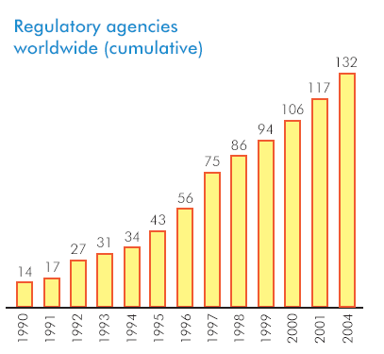
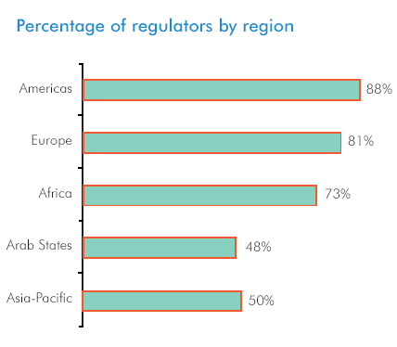
Source: ITU World Telecommunication Regulatory Database.
To overcome these problems, local ISPs, particularly in countries with high domestic demand for Internet services, are being encouraged to own their own links to international Internet backbones. For developing countries, one of the more promising solutions is the use of Internet exchange points (IXP) to aggregate and keep traffic local. In this regard, some African countries are now establishing national IXPs to route Internet traffic locally and reduce dependencies on expensive international links. An expansion of this approach is under way to interconnect national IXPs into regional African IXPs to further reduce costs. Figure 3 shows the number of IXPs per region as of September 2004.
Network access point (NAP) is a term that can also be used to refer to IXPs. A typical NAP or IXP consists of one or more cabinets that contain routing equipment belonging to the participants, plus a central switch to which all of the routers are connected. Each network operator installs a connection to the IXP and exchanges traffic with other networks through a central switch. Redundant equipment is installed in case of a failure. Internet exchange operators include many different types of organizations such as industry associations, independent non-governmental organizations (for example, academic institutions) or companies. Each ISP connecting to the IXP pays its own connection costs, and the IXP’s operating costs are recovered from all participants, usually in the form of access fees.
The cost benefits to a country with one or more IXPs can be significant. Without an in-country exchange point, traffic between two local networks often will transit through an Internet backbone operator in the United States or Europe. Consequently, both local operators have to place heightened demands on the capacity of their international connections, which are the single largest cost component for ISPs in most developing countries. South Africa’s Johannesburg Internet Exchange (JINX) is reported to have saved participants USD 5.7 million annually. An estimated USD 2.5 million of that amount would have, in the absence of JINX, left the country through payments to US backbone operators, according to Trends 2004/2005.

Figure 3 – Internet Exchange Points (IXP) Around the World
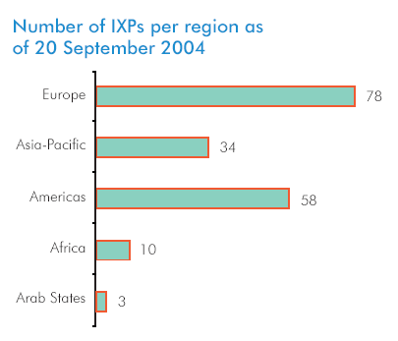
Source: The Internet Exchange Points Directory: A TeleGeography Resource at:
http://www.telegeography.com/ix/; http://www.fact-index.com/i/in/internet_
exchange_point.html; and ITU.

3 Selected regulatory developments

Local loop unbundling
Some countries place a higher level of regulatory oversight on operators that control access to essential facilities, such as local loops. This is the approach in the European Union, where operators deemed to have significant market power in a given market may be subject to additional regulatory oversight – at least until competition in that market has matured.
In October 2004, Switzerland’s National Council voted to require the country’s incumbent telephone company to give its competitors unbundled access to its local loops. This legislation reflects a wider trend in many areas of the world towards requiring local loop unbundling as a means of fostering competition in the provision of broadband Internet access and other services. By late 2004, 65 ITU Member States had required local loop unbundling, up from just 23 in 2000 (see Figure 4).
Figure 4 – Countries Requiring Local Loop Unbundling
Percentage of countries requiring local loop unbundling by region, 2004

Source: ITU World Telecommunication Regulatory Database.
In the United States, the Federal Communications Commission (FCC) in October 2004 relieved incumbent local telephone companies of most unbundling requirements for fibre-to-the-curb (FTTC) loops. This move reflected arguments that local loop unbundling requirements were a disincentive to infrastructure investment. By allowing incumbent telephone companies to retain all the benefits of their investment, the arguments held, the incumbents could be expected to invest more heavily in expanding high-speed, last-mile infrastructure.
However, if past history is anything to go by, it does not provide much encouragement for that view. In the early stages of broadband deployment, incumbent telephone companies were hesitant to introduce broadband services. This may have stemmed mostly from fear of cannibalizing revenues from established services, such as leased lines and dial-up Internet access. This was especially true in countries where there was very little inter-modal competition (that is, competition between operators using different network platforms or technologies) from cable companies or other facilities providers. Countries with the most extensive broadband penetration have generally achieved it through strong competition either from a healthy cable television industry, such as in Canada, or from new market entrants that have enjoyed easy access to facilities through strict unbundling requirements, such as in Japan and the Republic of Korea.

Foreign mobile termination rates: The next challenge?
Old challenges are poised to resurface in new forms in 2005. Trends 2004/2005 predicts that high foreign mobile termination rates may be one such challenge. While many regulators have taken steps to remedy high mobile termination rates over the past few years, significant differences in mobile termination rates between countries still remain.
In the United States, for example, the Federal Communications Commission (FCC) issued a “Notice of Inquiry” on 14 October 2004 that seeks to further develop FCC’s understanding of the possible effects of foreign mobile termination rates on the country’s customers and competition in the US international telecommunication services market.
The Notice of Inquiry fulfils a commitment that FCC made in March 2004 in the “ISP Reform Order” to develop a record on foreign mobile termination rates. The Notice solicits comment on foreign mobile termination payment arrangements and on payment flows between carriers that terminate mobile calls in certain foreign countries. It also requests data and information on foreign mobile termination rates, on the actions taken by foreign regulators with respect to these rates, and on competitive concerns raised in the FCC’s ISP Reform proceeding.
Finally, the Notice seeks comment and information on the appropriate framework for evaluating whether foreign mobile termination rates are unreasonably high.

4 Licensing in an era of convergence

Rethinking the basic tenets of telecommunication regulation, licensing and spectrum management
As a technological, market and regulatory trend, convergence is rasing a dizzying array of regulatory and legislative issues that policy-makers and regulators will have to address, particularly in the area of licensing. This sixth edition of Trends in Telecommunication Reform explores many of these issues in a bid to launch a global dialogue on licensing and convergence in the ICT sector. For example, can policy-makers and regulators completely deregulate the licensing of spectrum? How can they move to a converged licensing framework without unduly benefiting either incumbents or new market entrants? If new and existing participants in the market are less tightly licensed, how can regulators ensure that the public interest is served appropriately? Can governments pull back on licensing and still push operators to attain societal objectives such as universal access?
What is clear is that a number of pioneering governments are revamping their licensing and regulatory frameworks with the goal to better promote affordable access to the entire gamut of communication services from voice to high-speed Internet access.

Convergence: A rose by any other name
Historically, service providers have used different types of networks to deliver voice, video and data offerings. And end-users typically used different equipment to receive these services. But all of this has changed with technological developments now blurring the boundaries between different wire-line and wireless transmission technologies, including those using the Internet Protocol (IP). Old copper networks are being upgraded and re-fitted as digital subscriber line (DSL) broadband networks, enabling high-speed Internet access for multimedia applications such as video clips and music downloads.
Increasingly, the voice traffic carried on these retooled networks is shifting to voice over IP, or VoIP and voice over broadband (VOB). As shown in Figure 5, there just under 170 billion minutes of international voice traffic in 2003, of which 87 per cent travelled over traditional switched networks and 13.1 per cent (or 22 billion minutes) was routed using VoIP.
Cable television (CATV) systems, formerly used simply to convey broadcast content to subscribers, are also being re-fitted as interactive networks offering video-on-demand content, broadband Internet access and voice telephony. CATV operators now can compete head-to-head with telecommunication operators across a range of market segments. The new paradigm for service providers is to offer bundles of ICT services – a “triple play” of voice, broadband Internet access and broadcast services – all in one monthly price package.
So, with a full array of services and applications now available from multiple network operators and service providers, it is difficult to distinguish between voice, data and broadcast networks. From the consumer perspective, all of these previously different networks are beginning to look the same, because they can deliver virtually the same services and content. Manufacturers are beginning to respond with wireless devices that can transmit multimedia data around the house, so that video downloaded on a desktop computer may be viewed on the family television.
Add to this mix the rapid rise of mobile cellular voice services, the advent of third-generation mobile services (3G or IMT-2000), the emergence of new fixed wireless broadband technologies such as Wi-Fi and Wi-MAX, and it is not surprising that regulators and policy-makers in many countries are in the process of completely re-thinking some of the basic tenets of telecommunication regulation, licensing and spectrum management.
Figure 5 – What is Happening to International Voice Traffic?
Trends in international voice traffic on public switched telephone networks
(PSTN) and Voice over IP (VoIP), in billions of minutes (1997-2003)
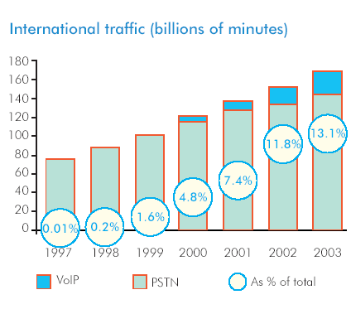
Source: ITU/TeleGeography “Direction of Traffic” database, and ITU World Tele-
communication Indicators Database. TeleGeography is now part of PriMetrica Inc.
(see www.primetrica.com).

A new era in licensing
In the early days of telecommunication sector reform in the 1980s and 1990s, many countries initially used licensing as a vehicle to control market entry and to impose regulatory obligations. But even after the initial stage of market liberalization, the licensing process in some countries still provides a means of gatekeeping to control market entry. Nevertherless, in this new era of convergence, more and more policy-makers are questioning the utility of licensing and demanding that licences be adapted to achieve policy goals without hindering market development and technological advancement. These concerns have been translated into two significant trends: an expansion in the number of services subject to minimal or even no licensing and the development of converged licensing frameworks that break down traditional service and
technology-based licensing distinctions. Some examples of the various forms of converged licensing regimes being implemented around the world are shown in Table 1.
Table 1 – Converged Licensing Around the World
Selected countries
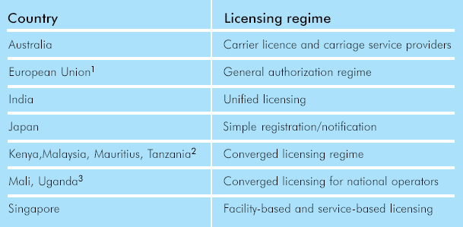
¹ Directive 2002/20/EC of the European Parliament and the Council of 7 March 2002 requires all 25 European Union Member States to implement a general authorization regime applicable to all electronic communications (see http://europa.eu.int/
information_society/topics/telecoms/regulatory/new_rf/index_en.htm). The Directive was being implemented throughout the EU at the time of the publication of the ITU report: Trends in Telecommunication Reform 2004/05.
² Kenya and Tanzania are in the process of introducing a converged licensing regime. For more information on Tanzania’s proposed licensing regime, see http://www.itu.int/ITU-D/treg/Case_Studies/Index.html
³ More information on Uganda’s licensing regime is available at http://www.itu.int/
ITU-D/treg/Case_ Studies/Index.html

Is licensing really necessary?
Licences do not have the same importance in all countries. In a few countries where monopoly operators have been privately owned – particularly in the United States and Canada – telecommunication licensing is not widely used as a regulatory instrument. Instead, regulatory rules are enacted through the regulations, codes, decisions or orders made by the regulator.
Given the widespread availability of alternative regulatory instruments to regulate the behaviour and activities of operators in the market, the need to impose licensing requirements in general has been questioned. One example of reduced licensing can be found, nearly worldwide, in the growth of Internet service providers (ISP). Typically, ISPs do not own extensive transmission facilities and instead rely upon lines leased from underlying network providers. The economic barriers to entry into the ISP market are low, and robust competition is possible even in smaller geographic markets. Consequently, some countries have established “open entry” policies for ISPs. New providers do not need to obtain individual licences or other formal approvals from the government before entering the market – nor do they even have to notify the regulator before beginning operation. Other countries require notification, but not before operations begin. Research suggests that countries requiring formal regulatory approval for ISPs have fewer Internet users and hosts than countries that do not require such approval. Even with open-entry or simple notification policies, ISPs may still be subject to government oversight in areas such as consumer protection. They often come under general business regulation that applies to all commercial entities – or at least a certain group or “class” of companies. Specific groups or classes may be singled out for general authorization requirements or “class licences”. Or, specific rules or regulations may be applied to that narrow group.

Spectrum for licence-exempt use
The allocation of spectrum for licence-exempt use is increasingly viewed as a catalyst for the development of more efficient and cost-effective wireless technologies. By late 2004, 55 countries had allocated spectrum for unlicensed use. The United States is one of the countries that allows unlicensed spectrum to be used for any lawful purpose, including broadband access to the Internet. In such an environment, companies and organizations have emerged to provide broadband Internet access in areas not served previously. One example that is often cited is the Southern California Tribal Digital Village, which uses the unlicensed Wi-Fi (wireless fidelity) technology to provide broadband access to more than 12 000 Native Americans in 17 different tribal communities spread over an isolated and vast geographic area.

5 Towards a converged licensing framework

From individual licensing to general authorizations
In a number of countries today, licensing requirements for many services are being eased in order to remove barriers to market entry and boost competition. Instead of requiring individual licensing and lengthy application procedures, general authorizations are increasingly used for a growing number of services. A prime example of this trend can be found in the Member States of the European Union (EU), which has taken a major step to create a single licensing classification for all electronic communications. Through its Authorization Directive, the EU wants to create more consistent licensing throughout its 25 Member States.
With the exception of assigning radio frequencies and numbers, the EU has replaced individual licences with a general authorization to provide all electronic communication networks and services under a new regulatory framework for electronic communications. This new regulatory framework that entered into force in July 2003 is also technology neutral, and aims to be sufficiently flexible to deal with converging markets. The authorization rules lay down an administratively simple, “light-touch” procedure allowing companies to enter markets quickly. But despite its flexibility, the new regulatory framework still requires constant evaluation and review. The European Commission must conduct such a review not later than 2006 to discuss issues related to authorization and convergence.

From service-specific to generic licences
Malaysia’s Communications and Multimedia Act (CMA), enacted in 1999, has established a regulatory framework designed explicitly to reflect and accommodate convergence. In particular, the CMA introduced a technology- and service-neutral licensing regime for telecommunications and broadcasting that reduced that country’s thirty-one service-specific licences to four generic categories of licences as follows:
• Network facility providers: Infrastructure including satellite earth stations, fibre-optic cables, communication lines and exchanges, radio communication and transmission equipment,
mobile communication base stations and broadcasting towers and equipment.
• Network service providers: Basic connectivity and bandwidth to support a variety of applications and connect different networks. This includes cellular, broadcasting distribution and mobile satellite services.
• Application service providers: This category is for licensees that provide specific functions such as voice, data and electronic commerce services. It also includes Internet access, IP telephony, radio paging and audiotext.
• Content applications service providers: This classification covers a special subset of applications and includes traditional broadcast services, online publishing and information services.
The Malaysian Commission for Multimedia and Communications, the national regulatory authority, began migrating telecommunication and broadcasting providers to the new licensing regime in 1999. Under the previous licensing regime, 220 licences had been granted (of which 180 were active) in the 31 service categories. Licensees were encouraged to migrate to the new regime, and 135 of them agreed to obtain new licences. The others had either gone out of business, were no longer interested in providing service or were offering services that no longer required a licence. This migration process was completed in 2002, and could offer some lessons.

Unified licensing framework
Going a step further, some countries have begun to introduce measures to create a unified licensing model. India’s move towards a unified licensing regime provides some insights into this trend. In a consultation paper issued in March 2004, the Telecom Regulatory Authority of India (TRAI) proposed several unified licensing models. Already, in October 2003, TRAI had recommended implementing a unified licensing regime in a two-stage process. And as a first step, a unified access regime for basic (fixed) and cellular services was established in November 2003. Under the unified access licensing regime, both fixed and mobile service providers are free to offer their services using any technology.
The next stage was to define guidelines and rules for a comprehensive, fully unified licensing regime for all services. On 6 August 2004, TRAI issued detailed draft recommendations on this new regime (www.trai.gov.in), following a consultation process.
The creation of a simplified, single licensing classification has been touted as ideal in terms of simplicity and neutrality. However, it is important to note that there are limits to such an approach. Spectrum management, in particular, presents a challenge to the implementation of a single licensing classification. Under the present approach to spectrum management, frequencies are divided into bands and then allocated to specific services on a global and national level. The aims of this process are to minimize interference and promote harmonization and economies of scale in equipment manufacturing. Consequently, most countries assign spectrum usage rights on a technology- or service-specific basis. Notable exceptions include Australia, Guatemala and New Zealand, where flexibility of spectrum use is allowed.

Technology and service neutrality
One of the key goals in moving to a converged licensing framework is to achieve technology neutrality. This term is intended to convey the meaning that a licensee retains the ability to choose the technology and equipment he or she will use to provide the licensed service. So, for example, a rural universal access project that subsidizes a payphone service can be considered technology neutral if the operator is left to choose which technology or architecture is economically optimal to deliver the service. That choice could be a VSAT (very small aperture terminal) system, use of a mobile cellular architecture or spectrum, or a fibre network – or, in fact, a combination of all those approaches.
Yet technology-neutral licensing is not necessarily synonymous with a single, umbrella licence that covers all ICT services. Perhaps the best example of technology neutrality without service neutrality is when a government issues mobile service licences but allows the operators to choose whether to employ GSM or CDMA technology.
A technology-neutral licensing regime provides a fair and predictable regulatory regime flexible enough to embrace technological and market developments.
In addition to experimenting with technology neutrality, governments are increasingly moving to service-neutral licensing. This allows licence holders to take cues from the market as to which services are most in demand or most cost-effective. A generic licence then empowers operators to offer a variety of different services and applications, tailored to fluctuations in market demand. Converged licensing frameworks that incorporate technology and service neutrality increase the scope of applications and services that any operator can provide, using its choice of technologies. Many countries such as Australia, the EU Member States and Malaysia have adopted converged licensing regimes (see Table 1 above for more examples).

Conclusion
While the introduction of more flexible and straightforward licensing regimes is clearly the trend today, regulators are nevertheless confronted with a large number of challenges and choices in their progress towards this ideal. Beyond the adoption of a converged licensing model, issues such as spectrum management, the setting of licence fees, ensuring a level playing field and the pursuit of public policy goals, including universal access, also have to be dealt with as part of the process. Left unchanged, the licensing process can be an obstacle to the development of a telecommunication market.
Trends 2004/2005 will be presented in Geneva at ITU’s Global Symposium for Regulators, scheduled for 8-10 December 2004. This symposium will be the fifth annual gathering of regulators from around the world, attracting regulators and policy-makers from every region. The authors of each chapter will present their findings and discuss key issues with regulators during panel discussions on the topic of licensing in an era of convergence.
For more information on this report and other regulatory activities of ITU, consult http://www.itu.int/ITU-D/treg/
For ordering information, contact:
Sales and Marketing Division
Place des Nations, 1211 GENEVA 20, Switzerland
Fax: +41 22 730 5194 E-mail: sales@itu.int

