INTERNATIONAL TELECOMMUNICATION UNION

Geneva, 5 December 2003
Publication Notice No. 190-03-corr-04

Final Acts of the World Radiocommunication  Conference (WRC-03)  Geneva, 9 June-4 July 2003 |  |  |  |  | 
 |  |  | via ITU Website
The Final Acts record the decisions taken at the World Radiocommunication Conference, 2003 (WRC-03). They include the new and revised provisions of the Radio Regulations and associated Appendices, as well as the new and revised Resolutions and Recommendations adopted by the Conference. Statements made by Member States at the time of signing the Final Acts are also included.
Date of publication: | November 2003
Language: | Printed version and Electronic Bookshop: Separate editions in English, French or Spanish  CD-ROM: Trilingual edition
Paper format: | About 600 pages – A5 (14.8 × 21 cm)
Electronic format: | MS Word for WindowsTM – Adobe AcrobatTM PDF
Article number:  Paper version | English  24404 | French  24405 |  | Spanish  24406
CD-ROM | 24407 – Trilingual edition
ISBN number:  Paper version | English  92-61-10561-0 | French  92-61-10562-9 |  | Spanish  92-61-10563-7
CD-ROM | 92-61-10577-7 – Trilingual edition
Price in Swiss francs: | Paper version or CD-ROM single user  Catalogue Price: CHF 120.–  Member States and Sector Members: –15%  Administrations of Least Developed Countries and  libraries of educational institutions (CD-ROM only): – 80%  Electronic Bookshop: CHF 120.– (No discount)

Price in Swiss francs for user(s) at the same location
Number of authorized users | 1 | 2-10 | 11-25 | 26-50 | 51-100 | Other
Price | 120.– | 240.– | 480.– | 720.– | 1 080.– | on request

Final Acts of the World Radiocommunication Conference
(WRC-03)
Geneva, 9 June-4 July 2003

Contents
Explanatory note
Preamble
Signatures
Final Protocol
Articles
Appendices
List of Resolutions and Recommendations agreed for deletion by WRC-03
Resolutions
Recommendations

GENERAL CONDITIONS OF SALE

■ Prices
The prices quoted in Publication Notices, as well as in the ITU Catalogue of Publications and in the Lists of ITU-T and ITU-R Recommendations (distributed free of charge and visible on the ITU website at the following address: www.itu.int/publications) are in Swiss francs (CHF), and are subject to change without notice.
Discounts of 15% are granted to Member States and Sector Members participating in the work of ITU. A discount of 80% of the catalogue price on all ITU publications is granted to Administrations of the Least Developed Countries (LDCs), as well as to libraries of educational institutions (for online subscriptions and CD-ROM publications only). Please note that the minimum price for a publication bought from the Electronic Bookshop is twenty Swiss francs (CHF 20.–) and that there is no discount via this service.
All additional information concerning CD-ROMs, online Recommendations and the ITU Electronic Bookshop can be found in the Catalogue of Publications and its associated Lists of ITU-R and ITU-T Recommendations.

■ Methods of payment
All publications ordered from ITU must be paid for in advance. Payments can be made:
a) by credit card: American Express, Eurocard/Mastercard, Visa;
b) by bank transfer to the UBS SA, Geneva, Account ITU Geneva, No. CH 96 0024 0240 C876 5565 0;
c) by cheque made payable to ITU;
d) by international postal order;
e) to the ITU postal cheque account: ITU Geneva, No. 12-50-3 (from within Switzerland);
f) or by UNESCO coupon.
Payments normally should be made in Swiss francs (CHF). Payments may also be made in other currencies, freely convertible into CHF, provided that, when converted by the bank, the price of the service in CHF is covered. ITU does not accept Letters of Credit.
For faster order processing, we invite you to either pre-pay by credit card or take advantage of a new service by opening an ITU deposit account.

■ Forms of dispatch
The catalogue price includes the cost of dispatch by non-registered economy-class mail or the means of carriage most advantageous to ITU. Dispatch can be requested in other forms: i.e. airmail, DHL, Federal Express, TNT, UPS or diplomatic pouch. If one of these alternative methods is chosen, the dispatch cost will be added to the quote. As from 1 February 2003, the costs of shipping via registered mail have been added to the economy-class costs. You may, if you wish, refuse these conditions but, in this case, ITU will not be held responsible for the replacement of any undelivered orders dispatched by mail that has not been registered. Customs duties and other taxes or dues levied on imported goods are not borne by ITU. ITU accepts no responsibility for delay, loss or damage in shipment. Any discrepancy or claim must be communicated to ITU within one year of dispatch of the publication(s).

■ Return of publications
Where a publication found to be faulty is returned to ITU, the latter’s responsibility shall be limited to replacement of the publication and payment of the costs arising from such replacement. Any publication returned to ITU as unwanted must reach it within one (1) month from the date of its dispatch to the customer, subject to ITU’s prior agreement. A minimum charge of fifty Swiss francs (CHF 50.–) will normally be invoiced to the customer by ITU for return of the publication to stock.
No exchange or refund is available for purchases made directly at the ITU Bookshop.
In the case of electronic publications (CD-ROM and online), these general conditions shall apply, subject to the specific derogation provisions contained in the Licence Agreements. The placing of an order implies full acceptance of these general conditions of sale.
None of the provisions of these general conditions of sale shall be interpreted as constituting a derogation or renunciation of the privileges, immunities and facilities enjoyed by ITU in accordance with the international agreement applicable to it, in particular the Headquarters Agreement concluded with the Swiss Federal Council on 22 July 1971, as well as the Swiss law or any other relevant national legislation.
Please note that orders cannot be taken over the telephone.
They should be sent by telefax or electronic mail.

Article number: q 24404 paper version  q 24407 CD-ROM  Number of users | No. 190-03-corr-04
Final Acts of the World Radiocommunication Conference (WRC-03)
Geneva, 9 June-4 July 2003
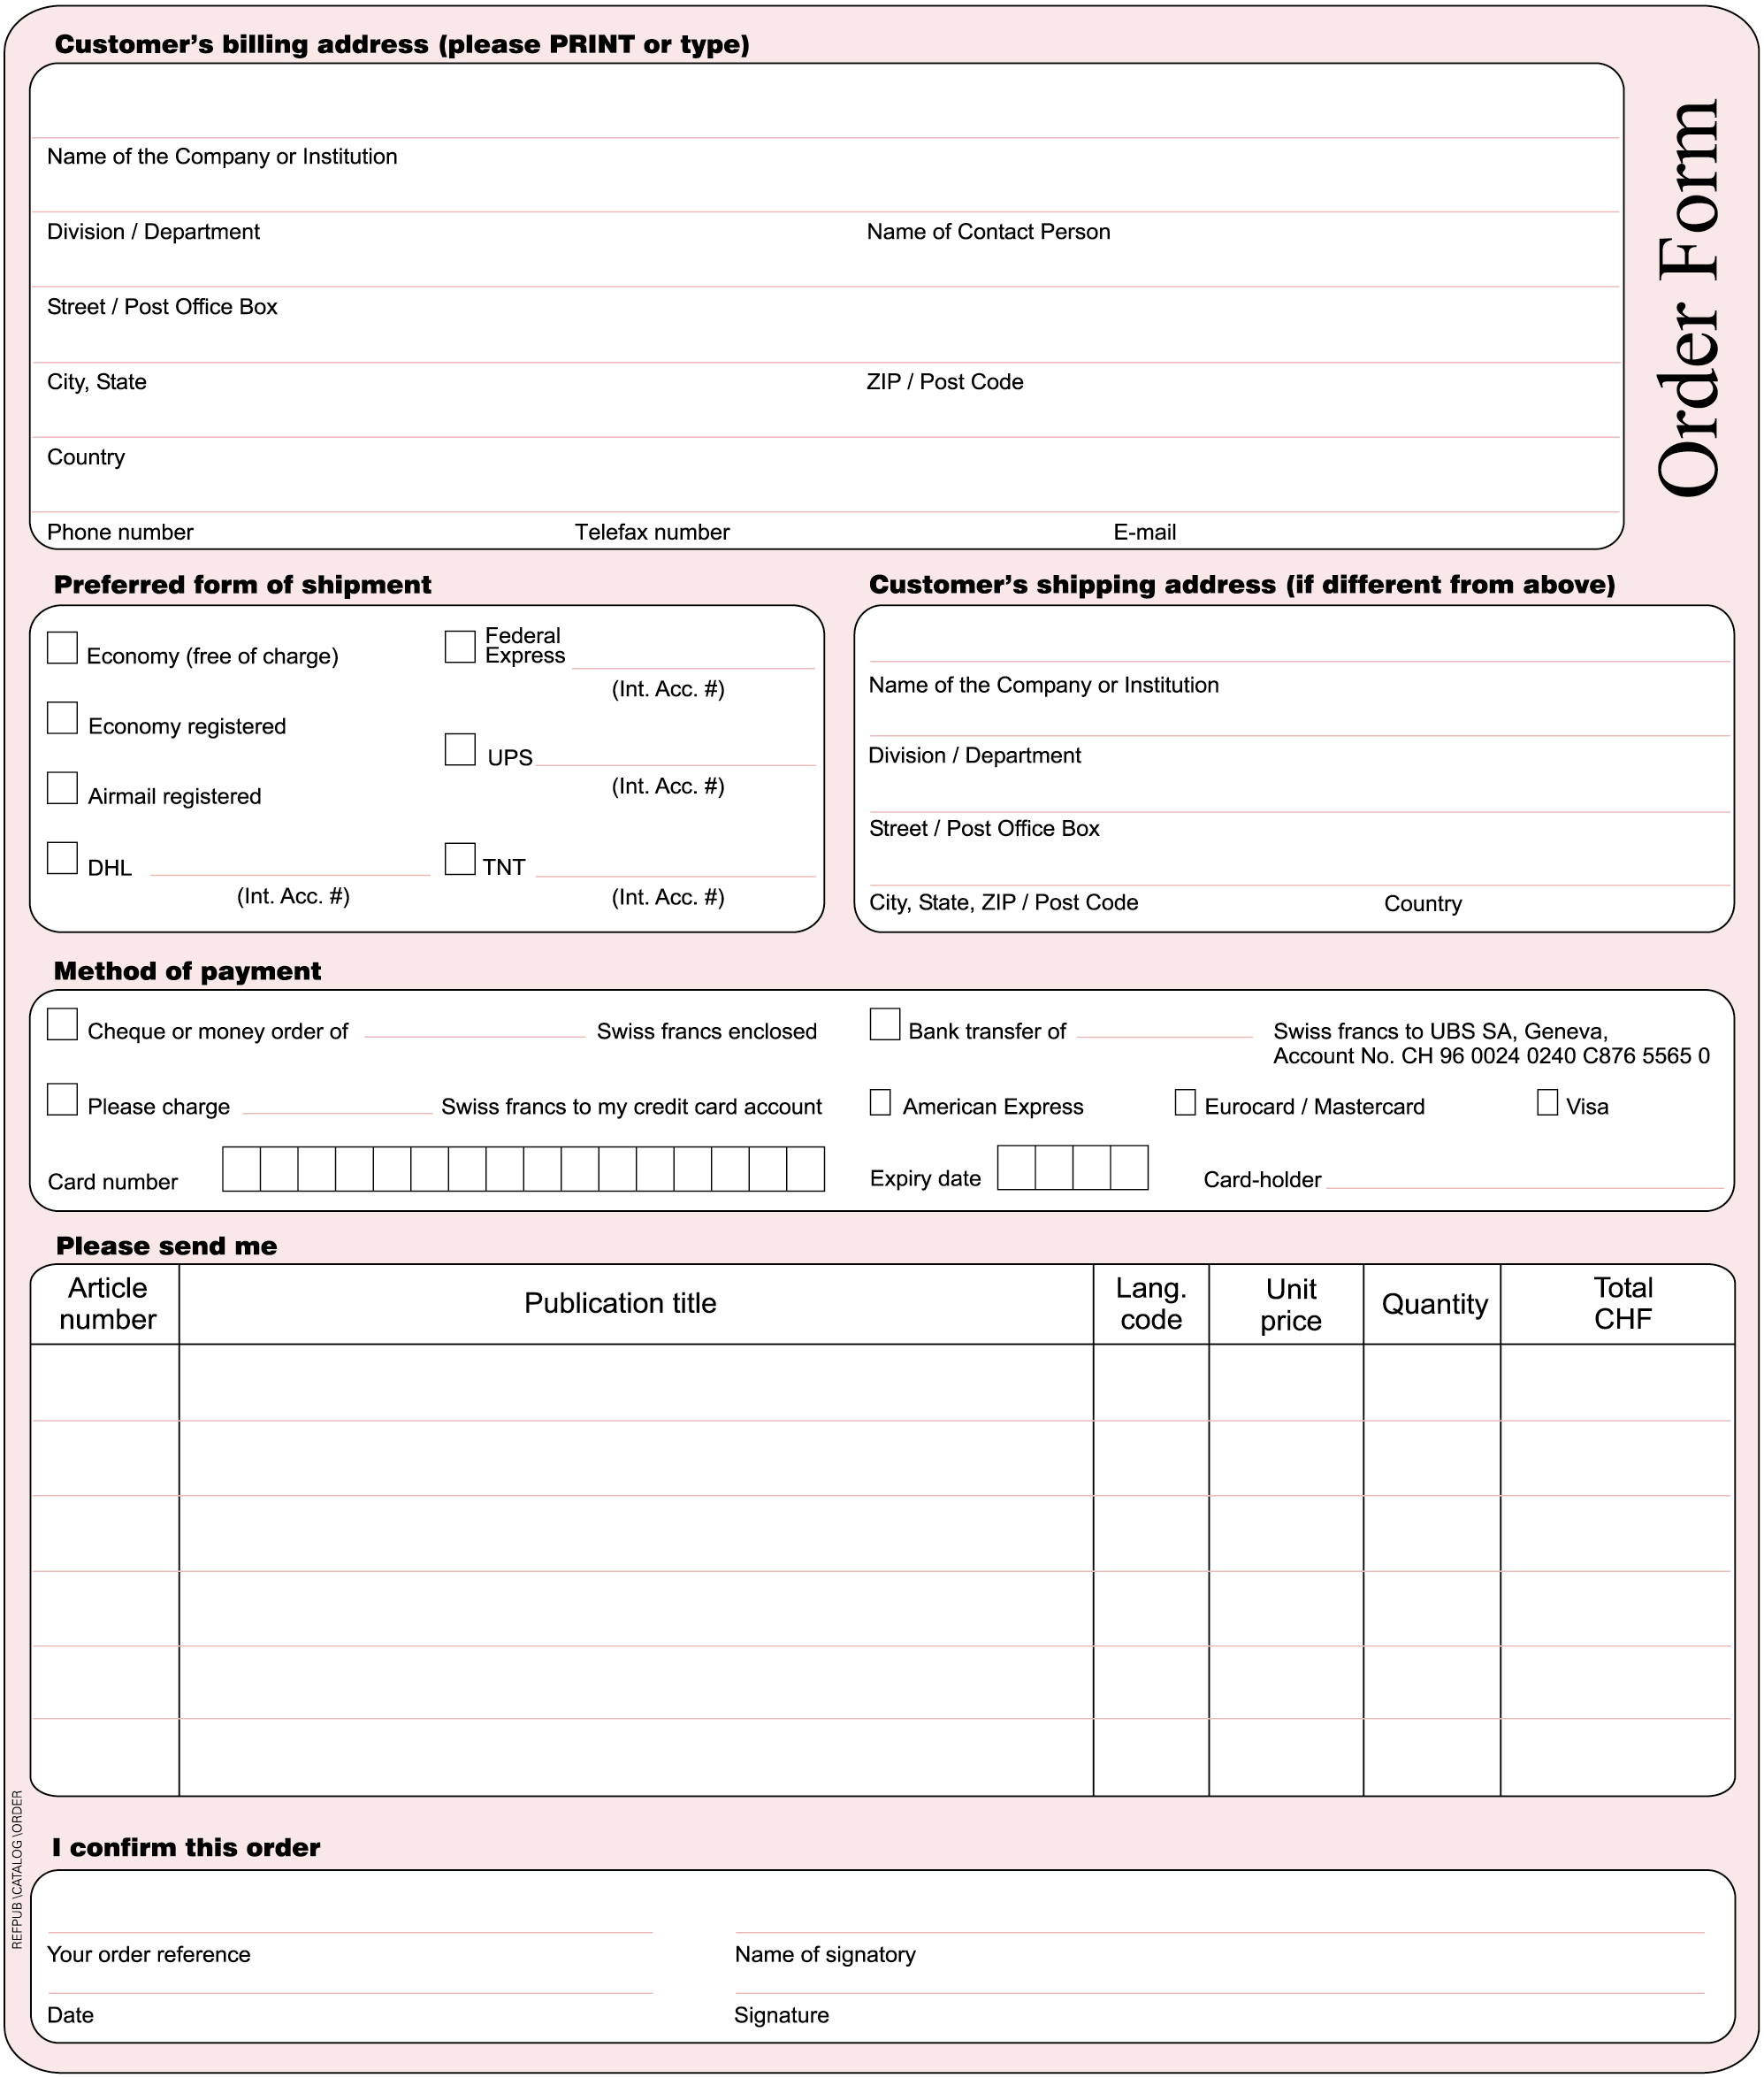
* Please note that ITU will not be held responsible for the replacement of any undelivered orders dispatched by mail which has not been registered. ITU accepts no responsibility for loss, delay or damage in shipment.
Please sign and return the completed Order Form to:
ITU  Sales and Marketing Division  Place des Nations  CH-1211 Geneva 20 – Switzerland | Telefax: +41 22 730 51 94  E-mail: sales@itu.int

