INTERNATIONAL TELECOMMUNICATION UNION

Geneva, 26 January 2004
Publication Notice No. 283-04

BR International Frequency Information Circular
(BR IFIC) Space Services
(Inclusive of Terrestrial Services – See also 282-04)
BR IFIC Space Services is a service document on CD-ROM in Adobe Acrobat PDF format published every two weeks by the Radiocommunication Bureau in accordance with provision No. 20.13 and No. 20.15 of the Radio Regulations, as well as former Resolution 30 (WRC-97).
It contains information on the frequency assignments to space stations, earth stations or radioastronomy stations submitted by Administrations to the Radiocommunication Bureau for recording in the Master International Frequency Register, as well as those that are submitted under the relevant provisions of the Radio Regulations or which are subject to the Appendices 30, 30A and 30B Plans. The information published corresponds to the recorded assignments as well as the notifications still being processed.

Date of publication: | Once every two weeks, from 13 January 2004
Language: | Trilingual: English, French and Spanish
Hardware and software requirements: | PC i486TM or Pentium®-based processor or compatible with 64 MB of RAM (minimum) and CD-ROM drive running Microsoft® Windows® 98, Windows® Me, Windows NT®, Windows XP® Professional or Home Edition and Adobe Acrobat Reader with Search  (For more details, see page 2)
Electronic format: | CD-ROM
Price in Swiss francs: | CD-ROM single user  Catalogue Price: Yearly subscription CHF 3500.–  Per issue: CHF 300.–  Member States and Sector Members: –15%  Administrations of Least Developed Countries and  libraries of educational institutions: – 80%

BR International Frequency Information Circular
(BR IFIC) Space Services
(Inclusive of Terrestrial Services – See also 282-04)

The BR IFIC Space Services CD-ROM contains, in Adobe Acrobat® PDF format, all the information which corresponds to transactions so far published in Parts IS, IIS and IIIS as well as in Special Sections related to Space Services of the former Weekly Circulars (WIC).
The BR IFIC Terrestrial Services CD-ROM is published at the same time. Please refer to Publication Notice No. 282-04.

Software and hardware requirements
When you insert this CD-ROM into your CD reader, the BR IFIC Space Services Menu page opens automatically if you have not de-activated the AutoStart option. For manual start you should open the menu.pdf file found in the root directory of the CD-ROM.
The BR IFIC Space Services in PDF format on CD-ROM is designed to be used with Microsoft WindowsTM 95, 98, NT, 2000 or XP on computers equipped with a CD-ROM reader using Adobe Acrobat® Reader 4.0 with Search. This reader allows PDF files contained in the BR IFIC Space Services CD-ROM to be viewed, searched, navigated and printed.
The Acrobat® Reader must have the Search option installed to enable the full-text search contained in the CD-ROM.

Acrobat® reader 4.0 basic system requirements:

Windows
• i486TM or Pentium® processor-based personal computer.
• Microsoft Windows® 95, Windows 98, or Windows NT® 2000 with Service Pack 3, XP or later.
• 10 MB of available RAM on Windows 95 and Windows 98 (16 MB recommended).
• 16 MB of available RAM on Windows NT (24 MB recommended).
• 10 MB of available hard-disk space.

For more detailed information, please visit http://www.adobe.com

GENERAL CONDITIONS OF SALE

■ Prices
The prices quoted in Publication Notices, as well as in the ITU Catalogue of Publications and in the Lists of ITU-T and ITU-R Recommendations (distributed free of charge and visible on the ITU website at the following address: www.itu.int/publications) are in Swiss francs (CHF), and are subject to change without notice.
Discounts of 15% are granted to Member States and Sector Members participating in the work of ITU. A discount of 80% of the catalogue price on all ITU publications is granted to Administrations of the Least Developed Countries (LDCs), as well as to libraries of educational institutions (for online subscriptions and CD-ROM publications only). Please note that the minimum price for a publication bought from the Electronic Bookshop is twenty Swiss francs (CHF 20.–) and that there is no discount via this service.
All additional information concerning CD-ROMs, online Recommendations and the ITU Electronic Bookshop can be found in the Catalogue of Publications and its associated Lists of ITU-R and ITU-T Recommendations.

■ Methods of payment
All publications ordered from ITU must be paid for in advance. Payments can be made:
a) by credit card: American Express, Eurocard/Mastercard, Visa;
b) by bank transfer to the UBS SA, Geneva, Account ITU Geneva, No. CH 96 0024 0240 C876 5565 0,
SWIFT UBSWCHZH12A – Clearing No. 240;
c) by cheque made payable to ITU;
d) by international postal order;
e) to the ITU postal cheque account: ITU Geneva, No. 12-50-3 (from within Switzerland);
f) or by UNESCO coupon.
Payments normally should be made in Swiss francs (CHF). Payments may also be made in other currencies, freely convertible into CHF, provided that, when converted by the bank, the price of the service in CHF is covered. ITU does not accept Letters of Credit.
For faster order processing, we invite you to either pre-pay by credit card or take advantage of a new service by opening an ITU deposit account.

■ Forms of dispatch
The catalogue price includes the cost of dispatch by non-registered economy-class mail or the means of carriage most advantageous to ITU. Dispatch can be requested in other forms: i.e. airmail, DHL, Federal Express, TNT, UPS or diplomatic pouch. If one of these alternative methods is chosen, the dispatch cost will be added to the quote. As from 1 February 2003, the costs of shipping via registered mail have been added to the economy-class costs. You may, if you wish, refuse these conditions but, in this case, ITU will not be held responsible for the replacement of any undelivered orders dispatched by mail that has not been registered. Customs duties and other taxes or dues levied on imported goods are not borne by ITU. ITU accepts no responsibility for delay, loss or damage in shipment. Any discrepancy or claim must be communicated to ITU within one year of dispatch of the publication(s).

■ Return of publications
Where a publication found to be faulty is returned to ITU, the latter’s responsibility shall be limited to replacement of the publication and payment of the costs arising from such replacement. Any publication returned to ITU as unwanted must reach it within one (1) month from the date of its dispatch to the customer, subject to ITU’s prior agreement. A minimum charge of fifty Swiss francs (CHF 50.–) will normally be invoiced to the customer by ITU for return of the publication to stock.
No exchange or refund is available for purchases made directly at the ITU Bookshop.
In the case of electronic publications (CD-ROM and online), these general conditions shall apply, subject to the specific derogation provisions contained in the Licence Agreements. The placing of an order implies full acceptance of these general conditions of sale.
None of the provisions of these general conditions of sale shall be interpreted as constituting a derogation or renunciation of the privileges, immunities and facilities enjoyed by ITU in accordance with the international agreement applicable to it, in particular the Headquarters Agreement concluded with the Swiss Federal Council on 22 July 1971, as well as the Swiss law or any other relevant national legislation.
Please note that orders cannot be taken over the telephone.
They should be sent by telefax or electronic mail.

No. 283-04

BR International Frequency Information Circular
(BR IFIC) Space Services
(Inclusive of Terrestrial Services – See also 282-04)

Important – Please indicate one of the following
❑ This order is for an annual subscription of the BR IFIC CD-ROM for 12 consecutive months.
❑ This order if for one single edition of the BR IFIC CD-ROM (most recently available edition).

Price multiplier for user(s) at the same location, per edition
Quantity | Number of authorized users | 1 | 2-10 | 11-25 | 26-50 | 51-100 | Other
 | Price multiplier | 1 | 2 | 4 | 6 | 9 | on request
The total number of Authorized Users is (please check one box):
q 1 | q 2-10 | q 11-25 | q 26-50 | q 51-100 | q Other

Mr / Ms/Name of the company (please print or type)
Name Title
declares that he/she is authorized to sign this agreement on behalf of the Customer and that his/her signature is binding upon the Customer.

Date: Authorized signature:

Please complete and send, duly signed, this Subscription Form, together with the Order Form overleaf, to the ITU Sales and Marketing Division.
No. 283-04
BR International Frequency Information Circular (BR IFIC) Space Services
(Inclusive of Terrestrial Services – See also 282-04)

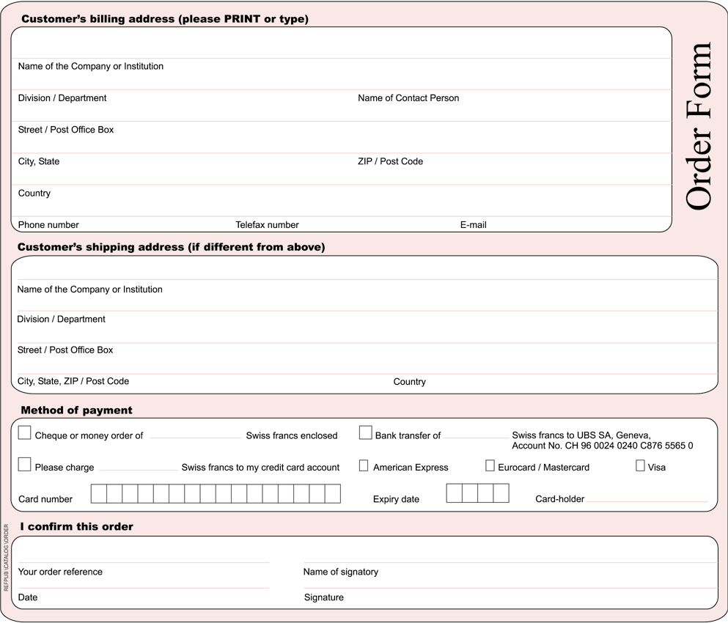

* Please note that ITU will not be held responsible for the replacement of any undelivered orders dispatched by mail which has not been registered. ITU accepts no responsibility for loss, delay or damage in shipment.

Please sign and return the completed Order Form with the Subscription Form to:
ITU  Sales and Marketing Division  Place des Nations  CH-1211 Geneva 20 – Switzerland | Telefax: +41 22 730 51 94  E-mail: sales@itu.int

