INTERNATIONAL TELECOMMUNICATION UNION

Geneva, 23 January 2004
Publication Notice No. 282-04

BR International Frequency Information Circular (BR IFIC) Terrestrial Services only
The BR International Frequency Information Circular (BR IFIC) Terrestrial Services is a consolidated regulatory publication, in CD-ROM format, published once every two weeks by the Radiocommunication Bureau, pursuant to the Radio Regulations (Nos. 20.2 to 20.6 and No. 20.15) and various Regional Agreements.
It contains information on the frequency assignments/allotments submitted by Administrations to the Radiocommunication Bureau for recording in the Master International Frequency Register and in the various regional or worldwide Plans/Agreements.
The information published corresponds to the recorded assignments/allotments as well as the notifications still being processed.

Date of publication: | Once every two weeks, from 13 January 2004 onwards
Language: | Trilingual: English, French and Spanish
Hardware and software requirements: | Pentium-based Windows NT version 4.0, Windows 2000, Windows XP or higher, with CD-ROM drive  Microsoft Access 2000 (For more details, see page 2)
Electronic format: | CD-ROM
Price in Swiss francs: | CD-ROM single user  Catalogue Price: Yearly subscription CHF 1750.–  Per issue: CHF 150.–  Member States and Sector Members: –15%  Administrations of Least Developed Countries and  libraries of educational institutions: – 80%

BR International Frequency Information Circular (BR IFIC) Terrestrial Services only

The BR IFIC (Terrestrial Services) on CD-ROM represents a reference publication which contains the following information that is relevant for frequency management purposes:
• the complete and permanently updated International Frequency List, in Access database format;
• the complete and permanently updated versions of terrestrial frequency assignments/allotment Plans, in Access database format;
• particulars of notices still being processed, under the provisions of the procedures of Article 11 of the Radio Regulations;
• particulars of notices still being processed, under the provisions of the various regional Agreements.
The BR IFIC also incorporates a continuously updated version of the inquiry software TerRaQ, the software package TerRaNV, used to validate the electronic notice files generated by the notifying Administrations, and the latest version of the Preface.
The software package TerRaQ associated with the query, display, printing and exporting of the data will allow Administrations to identify easily and extract to file particulars of assignments which are included in the latest publication (Parts I, II and III) and the associated Special Sections (Parts A, B and C).
The BR IFIC (Space Services) CD-ROM is published at the same time. Please see Publication Notice No. 283-04.

Software and hardware requirements
The BR IFIC (Terrestrial Services) is designed to be used on a personal computer running on Windows NT, Version 4.0 or higher, on Windows 2000, or Windows XP, or higher, and requires Microsoft Access (Version 2000 or higher). Generally speaking, such a workstation configured with Microsoft’s minimum requirements (mouse, CD-ROM reader, etc.) is sufficient for use with this publication. However, in addition to Microsoft’s minimum requirements, this publication requires a minimum of 24 megabytes of memory (RAM), with 32 megabytes recommended, and a minimum of 3.5 gigabytes of disk space reserved for this publication. Although it will work properly with a VGA monitor, as defined in Microsoft’s minimum requirements, the software associated with this publication provides for detailed graphics (such as maps showing the locations of selected assignments), and obtaining the full benefit of these detailed graphics will require a monitor with higher resolution.
It is to be noted that the disk space estimate is based on the current size of the Bureau’s databases containing existing assignments and pending notices to add, modify and suppress assignments. The required disk space will, of course, change as a function of the size of the database, which depends on the number of notices received by the Bureau. It is to be further noted that these are requirements for typical users of this publication, and that requirements specific to individual users may be different. For example, if one wishes to extract many sub-sets of the data, additional disk space will be required to store these sub-sets. On the other hand, if one wishes to install the publication on a network server, then the disk space requirements apply once (to the server) rather than to each client that connects to the server to use the publication. In this regard, please take note that the publication can be installed either in a stand-alone configuration on a single workstation, or in a client-server configuration.
Although the TerRaQ software does not run under Windows 95/98 platforms, it is possible to make your own queries to the database using MS Access.

GENERAL CONDITIONS OF SALE

■ Prices
The prices quoted in Publication Notices, as well as in the ITU Catalogue of Publications and in the Lists of ITU-T and ITU-R Recommendations (distributed free of charge and visible on the ITU website at the following address: www.itu.int/publications) are in Swiss francs (CHF), and are subject to change without notice.
Discounts of 15% are granted to Member States and Sector Members participating in the work of ITU. A discount of 80% of the catalogue price on all ITU publications is granted to Administrations of the Least Developed Countries (LDCs), as well as to libraries of educational institutions (for online subscriptions and CD-ROM publications only). Please note that the minimum price for a publication bought from the Electronic Bookshop is twenty Swiss francs (CHF 20.–) and that there is no discount via this service.
All additional information concerning CD-ROMs, online Recommendations and the ITU Electronic Bookshop can be found in the Catalogue of Publications and its associated Lists of ITU-R and ITU-T Recommendations.

■ Methods of payment
All publications ordered from ITU must be paid for in advance. Payments can be made:
a) by credit card: American Express, Eurocard/Mastercard, Visa;
b) by bank transfer to the UBS SA, Geneva, Account ITU Geneva, No. CH 96 0024 0240 C876 5565 0,
SWIFT UBSWCHZH12A – Clearing No. 240;
c) by cheque made payable to ITU;
d) by international postal order;
e) to the ITU postal cheque account: ITU Geneva, No. 12-50-3 (from within Switzerland);
f) or by UNESCO coupon.
Payments normally should be made in Swiss francs (CHF). Payments may also be made in other currencies, freely convertible into CHF, provided that, when converted by the bank, the price of the service in CHF is covered. ITU does not accept Letters of Credit.
For faster order processing, we invite you to either pre-pay by credit card or take advantage of a new service by opening an ITU deposit account.

■ Forms of dispatch
The catalogue price includes the cost of dispatch by non-registered economy-class mail or the means of carriage most advantageous to ITU. Dispatch can be requested in other forms: i.e. airmail, DHL, Federal Express, TNT, UPS or diplomatic pouch. If one of these alternative methods is chosen, the dispatch cost will be added to the quote. As from 1 February 2003, the costs of shipping via registered mail have been added to the economy-class costs. You may, if you wish, refuse these conditions but, in this case, ITU will not be held responsible for the replacement of any undelivered orders dispatched by mail that has not been registered. Customs duties and other taxes or dues levied on imported goods are not borne by ITU. ITU accepts no responsibility for delay, loss or damage in shipment. Any discrepancy or claim must be communicated to ITU within one year of dispatch of the publication(s).

■ Return of publications
Where a publication found to be faulty is returned to ITU, the latter’s responsibility shall be limited to replacement of the publication and payment of the costs arising from such replacement. Any publication returned to ITU as unwanted must reach it within one (1) month from the date of its dispatch to the customer, subject to ITU’s prior agreement. A minimum charge of fifty Swiss francs (CHF 50.–) will normally be invoiced to the customer by ITU for return of the publication to stock.
No exchange or refund is available for purchases made directly at the ITU Bookshop.
In the case of electronic publications (CD-ROM and online), these general conditions shall apply, subject to the specific derogation provisions contained in the Licence Agreements. The placing of an order implies full acceptance of these general conditions of sale.
None of the provisions of these general conditions of sale shall be interpreted as constituting a derogation or renunciation of the privileges, immunities and facilities enjoyed by ITU in accordance with the international agreement applicable to it, in particular the Headquarters Agreement concluded with the Swiss Federal Council on 22 July 1971, as well as the Swiss law or any other relevant national legislation.
Please note that orders cannot be taken over the telephone.
They should be sent by telefax or electronic mail.

No. 282-04

BR International Frequency Information Circular (BR IFIC)
Terrestrial Services only

Important – Please indicate one of the following
❑ This order is for an annual subscription of the BR IFIC (Terrestrial Services only) for 12 consecutive months.
❑ This order is for one single edition (most recently available) of the BR IFIC (Terrestrial Services only).

CD-ROM – Price multiplier for user(s) at the same location, per edition
Quantity | Number of authorized users | 1 | 2-10 | 11-25 | 26-50 | 51-100 | Other
 | Price multiplier | 1 | 2 | 4 | 6 | 9 | on request
The total number of authorized users is (please check one box):
q 1 q 2-10 q 11-25 q 26-50 q 51-100 q Other

Mr / Ms/Name of the company (please print or type)
Name Title
declares that he/she is authorized to sign this agreement on behalf of the Customer and that his/her signature is binding upon the Customer.

Date: Authorized signature:

Please complete and send, duly signed, this Subscription Form, together with the Order Form overleaf, to the ITU Sales and Marketing Division.
No. 282-04
BR International Frequency Information Circular (BR IFIC) Terrestrial Services only

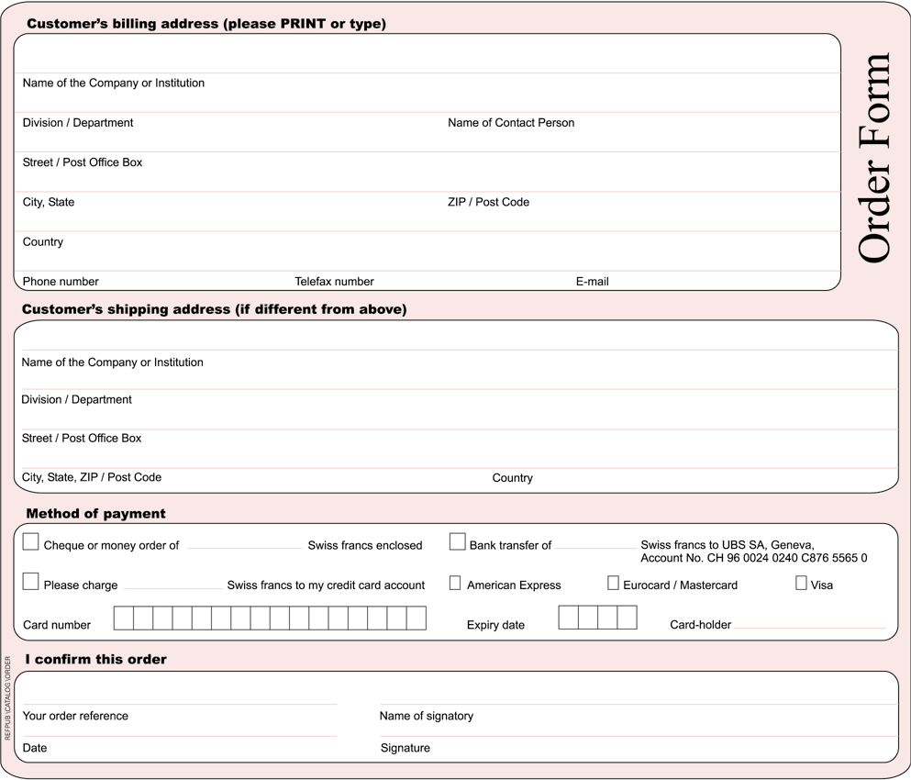

* Please note that ITU will not be held responsible for the replacement of any undelivered orders dispatched by mail which has not been registered. ITU accepts no responsibility for loss, delay or damage in shipment.

Please sign and return the completed Order Form with the Subscription Form to:
ITU  Sales and Marketing Division  Place des Nations  CH-1211 Geneva 20 – Switzerland | Telefax: +41 22 730 51 94  E-mail: sales@itu.int

