INTERNATIONAL TELECOMMUNICATION UNION

Geneva, 23 January 2004
Publication Notice No. 220-04

Space Radiocommunications Stations on CD-ROM
(SRS on CD-ROM)
2004 Edition: March and September 2004
The Space Radiocommunications Stations on CD-ROM is a service document published in electronic format by the Radiocommunication Bureau (BR) pursuant to the pertinent provisions of Article 20 of the Radio Regulations (edition of 2001). It contains alphanumeric and graphical information on satellite networks and earth stations, which are provided to and maintained by BR.
Date of publication: | March and September 2004
Language: | English – Booklet: trilingual
Hardware and software requirements: | PC with Intel Pentium processor or compatible with 32 Mbytes memory (or higher) running MS Windows 9x, ME, NT 4.0, 2000. or XP, a hard disk with at least 10 Mbytes free space, a CD-ROM drive with ISO 9660 compatible device driver.
Format: | 2 CD-ROMs
Article number: | Trilingual edition  24114 March 2004  24115 September 2004  24117 Collection of the two CD-ROMs (March and September 2004)
ISBN number: | Trilingual edition  92-61-10647-1 March 2004  92-61-10657-9 September 2004
Price in Swiss francs: | Catalogue Price for a single user:  per edition CHF 450.–  for two editions CHF 900.–  Member States and Sector Members: –15%  Administrations of the Least Developed Countries and  libraries of educational institutions: – 80%

Price multiplier for user(s) at the same location, per edition
Quantity | Number of authorized users: | 1 | 2-10 | 11-25 | 26-50 | 51-100 | Other
 | Price (CHF): | 450.– | 900.– | 1800.– | 2700.– | 4050.– | on request
Space Radiocommunications Stations on CD-ROM
(SRS on CD-ROM)
2004 Edition: March and September 2004

March 2004 and September 2004
The Space Radiocommunications Stations on CD-ROM is a service document published in electronic format by the Radiocommunication Bureau (BR) pursuant to the pertinent provisions of Article 20 of the Radio Regulations. It contains alphanumeric and graphical information on satellite networks and earth stations, which are provided to and maintained by BR.
The software (SPACEQRY) allows the user to access the data (in an MS-Access Version 97 database) by such criteria as space station/earth station name, orbital position (or range of orbital positions), space station/earth station administration, country, geographical coordinates, class of station, assigned frequency (or range of assigned frequencies) and category (coordination/notification). It permits the user to navigate within the set of data retrieved, to print some or all of the data and to export an extracted subset to an MS-Access database. The related graphical data (consisting of diagrams for the antenna gain contours, service area and the gain towards the geostationary orbit) can be viewed through GIMS, either through the alphanumeric information retrieval software or independently.
The CD also contains software developed by BR for the electronic notification and validation of satellite networks/earth stations; SPACECAP allows the capture of satellite networks/earth stations parameters which can be validated via the “SPACE VALIDATION” software, SPACEPUB allows for the printing of satellite networks and earth station, GIMS allows the capture of the related graphical data (mentioned above) and the carrying out of power-flux density calculations, SPS is used to analyze the Space Plans (Appendices 30, 30A and 30B), GIBC to carry out Appendix 8 (29) and power-flux density calculations, SPACECOM for assisting administrations commenting on CR/C special sections and software to determine the coordination area around an earth station according to Appendix 7.

GENERAL CONDITIONS OF SALE

■ Prices
The prices quoted in Publication Notices, as well as in the ITU Catalogue of Publications and in the Lists of ITU-T and ITU-R Recommendations (distributed free of charge and visible on the ITU website at the following address: www.itu.int/publications) are in Swiss francs (CHF), and are subject to change without notice.
Discounts of 15% are granted to Member States and Sector Members participating in the work of ITU. A discount of 80% of the catalogue price on all ITU publications is granted to Administrations of the Least Developed Countries (LDCs), as well as to libraries of educational institutions (for online subscriptions and CD-ROM publications only). Please note that the minimum price for a publication bought from the Electronic Bookshop is twenty Swiss francs (CHF 20.–) and that there is no discount via this service.
All additional information concerning CD-ROMs, online Recommendations and the ITU Electronic Bookshop can be found in the Catalogue of Publications and its associated Lists of ITU-R and ITU-T Recommendations.

■ Methods of payment
All publications ordered from ITU must be paid for in advance. Payments can be made:
a) by credit card: American Express, Eurocard/Mastercard, Visa;
b) by bank transfer to the UBS SA, Geneva, Account ITU Geneva, No. CH 96 0024 0240 C876 5565 0,
SWIFT UBSWCHZH12A – Clearing No. 240;
c) by cheque made payable to ITU;
d) by international postal order;
e) to the ITU postal cheque account: ITU Geneva, No. 12-50-3 (from within Switzerland);
f) or by UNESCO coupon.
Payments normally should be made in Swiss francs (CHF). Payments may also be made in other currencies, freely convertible into CHF, provided that, when converted by the bank, the price of the service in CHF is covered. ITU does not accept Letters of Credit.
For faster order processing, we invite you to either pre-pay by credit card or take advantage of a new service by opening an ITU deposit account.

■ Forms of dispatch
The catalogue price includes the cost of dispatch by non-registered economy-class mail or the means of carriage most advantageous to ITU. Dispatch can be requested in other forms: i.e. airmail, DHL, Federal Express, TNT, UPS or diplomatic pouch. If one of these alternative methods is chosen, the dispatch cost will be added to the quote. As from 1 February 2003, the costs of shipping via registered mail have been added to the economy-class costs. You may, if you wish, refuse these conditions but, in this case, ITU will not be held responsible for the replacement of any undelivered orders dispatched by mail that has not been registered. Customs duties and other taxes or dues levied on imported goods are not borne by ITU. ITU accepts no responsibility for delay, loss or damage in shipment. Any discrepancy or claim must be communicated to ITU within one year of dispatch of the publication(s).

■ Return of publications
Where a publication found to be faulty is returned to ITU, the latter’s responsibility shall be limited to replacement of the publication and payment of the costs arising from such replacement. Any publication returned to ITU as unwanted must reach it within one (1) month from the date of its dispatch to the customer, subject to ITU’s prior agreement. A minimum charge of fifty Swiss francs (CHF 50.–) will normally be invoiced to the customer by ITU for return of the publication to stock.
No exchange or refund is available for purchases made directly at the ITU Bookshop.
In the case of electronic publications (CD-ROM and online), these general conditions shall apply, subject to the specific derogation provisions contained in the Licence Agreements. The placing of an order implies full acceptance of these general conditions of sale.
None of the provisions of these general conditions of sale shall be interpreted as constituting a derogation or renunciation of the privileges, immunities and facilities enjoyed by ITU in accordance with the international agreement applicable to it, in particular the Headquarters Agreement concluded with the Swiss Federal Council on 22 July 1971, as well as the Swiss law or any other relevant national legislation.
Please note that orders cannot be taken over the telephone.
They should be sent by telefax or electronic mail.

Article number: q 24114 March 2004 q 24115 September 2004  q 24117 Collection of the two CD-ROMs   Number of users | No. 220-04
Space Radiocommunications Stations on CD-ROM (SRS on CD-ROM)
2004 Edition: March and September 2004
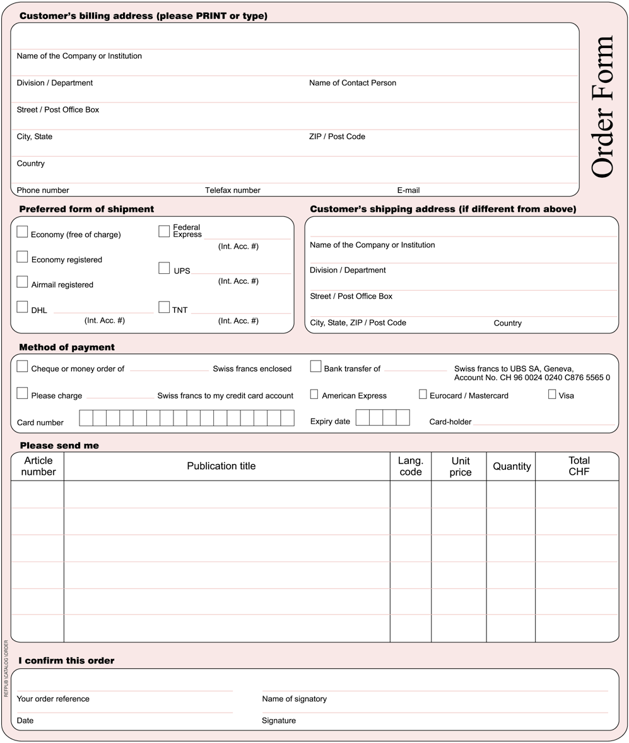
* Please note that ITU will not be held responsible for the replacement of any undelivered orders dispatched by mail which has not been registered. ITU accepts no responsibility for loss, delay or damage in shipment.
Please sign and return the completed Order Form to:
ITU  Sales and Marketing Division  Place des Nations  CH-1211 Geneva 20 – Switzerland | Telefax: +41 22 730 51 94  E-mail: sales@itu.int

