INTERNATIONAL TELECOMMUNICATION UNION

Geneva, 27 January 2004
Publication Notice No. 178-04-corr-04

List of Coast Stations (List IV)  (19th Edition, 2004) |  | 
The List is a service publication prepared by ITU in pursuance of Article 20 of the Radio Regulations. The List shall be provided to all ship radiotelegraph stations as prescribed in Appendix 16 to the afore-mentioned Regulations.

Date of publication: | April 2004  Supplement No. 1: October 2004  Supplement No. 2: April 2005  Supplement No. 3: October 2005
Language: | Trilingual Edition (English, French, Spanish)
Pages: | Edition: about 1000  Supplements: about 500
Format: | A4 (21 × 29.7 cm)
Article number: | Edition 24675  Supplement No. 1: 24676  Supplement No. 2: 24677  Supplement No. 3: 24678
ISBN number: | Edition 92-71-13031-6  Supplement No. 1: 92-71-13131-2  Supplement No. 2: 92-71-13231-9  Supplement No. 3: 92-71-13331-5
Price in Swiss francs:  (supplements included) | Catalogue price: CHF 63.–  Etats Membres et Membres des Secteurs: –15%  Administrations des pays les moins avancés: – 80%

List of Coast Stations (List IV)
(19th Edition, 2004)

This List contains particulars of coast stations and coast earth stations providing a public correspondence service with their charges and accounting authorities. The List also contains an annex with particulars on different categories of stations participating in the GMDSS (e.g. particulars of stations transmitting maritime safety information that participate in the NAVTEX services coordinated by the International Maritime Organization).
As prescribed in Appendix 16 to the afore-mentioned Regulations, this List is required to be carried in stations on board ships for which a radiotelegraph installation is required by international agreement. It is also required to be carried in stations on board ships for which a radiotelephone is required by international agreement, and in stations on board ships for which a GMDSS installation is required by international agreement, unless these stations are sailing only within range of VHF coasts stations.

Contents
Preface
Part I Symbols and abbreviations used in the List.
Part II Alphabetical index of stations found in Part III of the List.
Part III Particulars of coast stations providing a public correspondence service.
Part IV Charges and accounting.
Annex I Maritime mobile-satellite systems.
Annex II Particulars of stations participating in the Global Maritime Distress and Safety System including stations of the NAVTEX services that have been coordinated by the International Maritime Organization (IMO).
Annex III Allotment plans for national channels in the digital selective calling system in the bands 435-526.5 kHz and 1 606.5-2 160 kHz in Region 1.

GENERAL CONDITIONS OF SALE

■ Prices
The prices quoted in Publication Notices, as well as in the ITU Catalogue of Publications and in the Lists of ITU-T and ITU-R Recommendations (distributed free of charge and visible on the ITU website at the following address: www.itu.int/publications) are in Swiss francs (CHF), and are subject to change without notice.
Discounts of 15% are granted to Member States and Sector Members participating in the work of ITU. A discount of 80% of the catalogue price on all ITU publications is granted to Administrations of the Least Developed Countries (LDCs), as well as to libraries of educational institutions (for online subscriptions and CD-ROM publications only). Please note that the minimum price for a publication bought from the Electronic Bookshop is twenty Swiss francs (CHF 20.–) and that there is no discount via this service.
All additional information concerning CD-ROMs, online Recommendations and the ITU Electronic Bookshop can be found in the Catalogue of Publications and its associated Lists of ITU-R and ITU-T Recommendations.

■ Methods of payment
All publications ordered from ITU must be paid for in advance. Payments can be made:
a) by credit card: American Express, Eurocard/Mastercard, Visa;
b) by bank transfer to the UBS SA, Geneva, Account ITU Geneva, No. CH 96 0024 0240 C876 5565 0,
SWIFT UBSWCHZH12A – Clearing No. 240;
c) by cheque made payable to ITU;
d) by international postal order;
e) to the ITU postal cheque account: ITU Geneva, No. 12-50-3 (from within Switzerland);
f) or by UNESCO coupon.
Payments normally should be made in Swiss francs (CHF). Payments may also be made in other currencies, freely convertible into CHF, provided that, when converted by the bank, the price of the service in CHF is covered. ITU does not accept Letters of Credit.
For faster order processing, we invite you to either pre-pay by credit card or take advantage of a new service by opening an ITU deposit account.

■ Forms of dispatch
The catalogue price includes the cost of dispatch by non-registered economy-class mail or the means of carriage most advantageous to ITU. Dispatch can be requested in other forms: i.e. airmail, DHL, Federal Express, TNT, UPS or diplomatic pouch. If one of these alternative methods is chosen, the dispatch cost will be added to the quote. As from 1 February 2003, the costs of shipping via registered mail have been added to the economy-class costs. You may, if you wish, refuse these conditions but, in this case, ITU will not be held responsible for the replacement of any undelivered orders dispatched by mail that has not been registered. Customs duties and other taxes or dues levied on imported goods are not borne by ITU. ITU accepts no responsibility for delay, loss or damage in shipment. Any discrepancy or claim must be communicated to ITU within one year of dispatch of the publication(s).

■ Return of publications
Where a publication found to be faulty is returned to ITU, the latter’s responsibility shall be limited to replacement of the publication and payment of the costs arising from such replacement. Any publication returned to ITU as unwanted must reach it within one (1) month from the date of its dispatch to the customer, subject to ITU’s prior agreement. A minimum charge of fifty Swiss francs (CHF 50.–) will normally be invoiced to the customer by ITU for return of the publication to stock.
No exchange or refund is available for purchases made directly at the ITU Bookshop.
In the case of electronic publications (CD-ROM and online), these general conditions shall apply, subject to the specific derogation provisions contained in the Licence Agreements. The placing of an order implies full acceptance of these general conditions of sale.
None of the provisions of these general conditions of sale shall be interpreted as constituting a derogation or renunciation of the privileges, immunities and facilities enjoyed by ITU in accordance with the international agreement applicable to it, in particular the Headquarters Agreement concluded with the Swiss Federal Council on 22 July 1971, as well as the Swiss law or any other relevant national legislation.
Please note that orders cannot be taken over the telephone.
They should be sent by telefax or electronic mail.

Article number: 24674 | No. 178-04
List of Coast Stations (List IV)
(19th Edition, 2004)

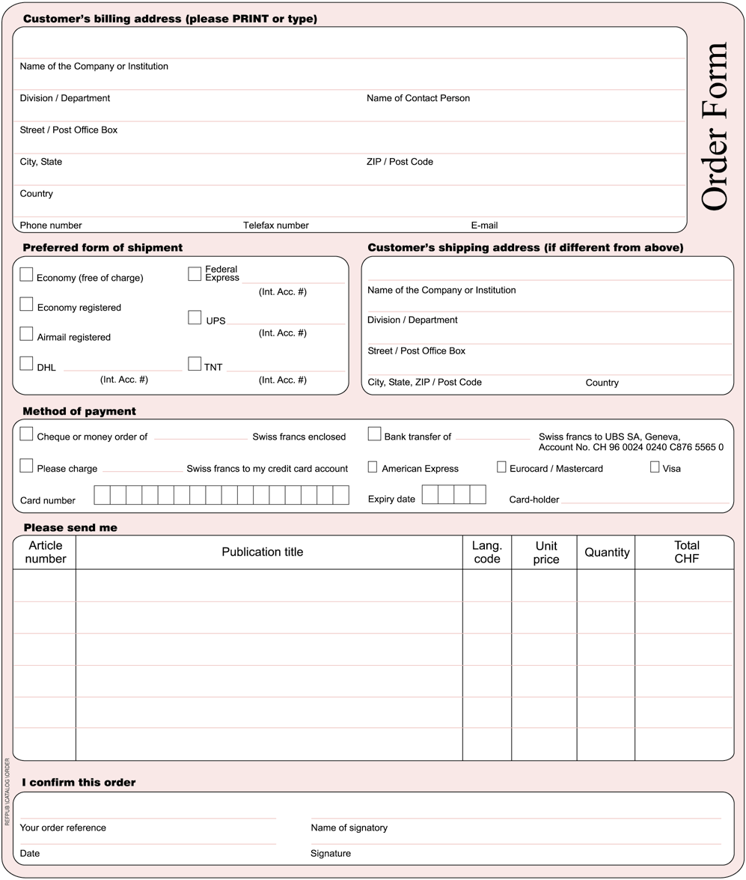
* Please note that ITU will not be held responsible for the replacement of any undelivered orders dispatched by mail which has not been registered. ITU accepts no responsibility for loss, delay or damage in shipment.
Please sign and return the completed Order Form to:
ITU  Sales and Marketing Division  Place des Nations  CH-1211 Geneva 20 – Switzerland | Telefax: +41 22 730 51 94  E-mail: sales@itu.int

