INTERNATIONAL TELECOMMUNICATION UNION

Geneva, 18 December 2003
Publication Notice No. 361-03

Investing in Telecommunications and ICTs in Developing Markets:  Shifting the Paradigm  Edition 2003 |  |  | 
via ITU Website
Telecommunications and ICTs have become a key infrastructure necessary for human development. As the sector has transformed into one driven by commercial interest, one question begs to be answered: what actions can be taken to stimulate private investment in the sector, particularly in countries and regions where the opportunities are less obvious? This report provides insight into answers to this question by analysing trends, examining risk factors facing potential investors and by identifying specific investment opportunities in developing markets. Finally, the report makes specific recommendations to the various stakeholders on actions that can be taken to "shift the paradigm" so that investment will be attracted to those markets most in need.

Date of publication: | English: December 2003  French and Spanish available in 2004
Language: | English, French, Spanish
Paper format: | About 250 pages – A4 (21 × 29.7 cm)
Electronic format: | MS Word for WindowsTM – Adobe AcrobatTM PDF
Article number: | English:  French:  Spanish: | 24629  24630  24631
ISBN number: | English:  French:  Spanish: | 92-61-10611-0  92-61-10612-9  92-61-10613-7
Price in Swiss francs: | Catalogue Price: CHF 90.–  Member States and Sector Members: –15%  Administrations of Least Developed Countries: –80%  Electronic Bookshop: CHF 90.– (No discount)

Investing in Telecommunications and ICTs in Developing Markets:
Shifting the Paradigm
Edition 2003

Table of contents
Introduction
Executive Summary and Findings
1 Methodology
2 The Role of Telecommunications and ICTs in Enhancing Human Development
3 Global Investment Trends
4 Regional Trends
5 Factors Influencing Investment
5.1 Overarching Civil/Governmental/Institutional Factors
5.2 Macroeconomic Factors
5.3 Infrastructure Factors
5.4 Human Capital
5.5 Intellectual Property Protection
5.6 Supply and Distribution Channels
5.7 Sector Dynamics
6 Overcoming Investment Risk Factors In Developing Markets
6.1 Roles of International and Regional Organizations in Mitigating Investment Risk Factors
6.2 Investors’ Technology Choices for Mitigating Risk Factors
6.3 Financial Considerations
7 Country Investment Climates
7.1 Country Grouping Analysis
7.2 Identification of Country Groupings
7.3 Large Urbanized Countries
7.4 Large Rural Countries
7.5 Small Urban Countries
7.6 Small Rural Countries
7.7 Small Low-income Island Nations
8 Conclusions
9 Recommendations for National Governments
10 Recommendations for Investors
11 Follow-up Action Items
Appendix I – Selected Regional Analysis: Africa Region
Appendix II – Selected Regional Analysis: Americas Region
Appendix III – Selected Regional Analysis: Asia-Pacific
Appendix IV – Country Profile Data
Appendix V – Data Sources
Appendix VI – Bibliography
Appendix VII – Universal Access and Universal Service Funding Mechanisms

GENERAL CONDITIONS OF SALE

■ Prices
The prices quoted in Publication Notices, as well as in the ITU Catalogue of Publications and in the Lists of ITU-T and ITU-R Recommendations (distributed free of charge and visible on the ITU website at the following address: www.itu.int/publications) are in Swiss francs (CHF), and are subject to change without notice.
Discounts of 15% are granted to Member States and Sector Members participating in the work of ITU. A discount of 80% of the catalogue price on all ITU publications is granted to Administrations of the Least Developed Countries (LDCs), as well as to libraries of educational institutions (for online subscriptions and CD-ROM publications only). Please note that the minimum price for a publication bought from the Electronic Bookshop is twenty Swiss francs (CHF 20.–) and that there is no discount via this service.
All additional information concerning CD-ROMs, online Recommendations and the ITU Electronic Bookshop can be found in the Catalogue of Publications and its associated Lists of ITU-R and ITU-T Recommendations.

■ Methods of payment
All publications ordered from ITU must be paid for in advance. Payments can be made:
a) by credit card: American Express, Eurocard/Mastercard, Visa;
b) by bank transfer to the UBS SA, Geneva, Account ITU Geneva, No. CH 96 0024 0240 C876 5565 0;
c) by cheque made payable to ITU;
d) by international postal order;
e) to the ITU postal cheque account: ITU Geneva, No. 12-50-3 (from within Switzerland);
f) or by UNESCO coupon.
Payments normally should be made in Swiss francs (CHF). Payments may also be made in other currencies, freely convertible into CHF, provided that, when converted by the bank, the price of the service in CHF is covered. ITU does not accept Letters of Credit.
For faster order processing, we invite you to either pre-pay by credit card or take advantage of a new service by opening an ITU deposit account.

■ Forms of dispatch
The catalogue price includes the cost of dispatch by non-registered economy-class mail or the means of carriage most advantageous to ITU. Dispatch can be requested in other forms: i.e. airmail, DHL, Federal Express, TNT, UPS or diplomatic pouch. If one of these alternative methods is chosen, the dispatch cost will be added to the quote. As from 1 February 2003, the costs of shipping via registered mail have been added to the economy-class costs. You may, if you wish, refuse these conditions but, in this case, ITU will not be held responsible for the replacement of any undelivered orders dispatched by mail that has not been registered. Customs duties and other taxes or dues levied on imported goods are not borne by ITU. ITU accepts no responsibility for delay, loss or damage in shipment. Any discrepancy or claim must be communicated to ITU within one year of dispatch of the publication(s).

■ Return of publications
Where a publication found to be faulty is returned to ITU, the latter’s responsibility shall be limited to replacement of the publication and payment of the costs arising from such replacement. Any publication returned to ITU as unwanted must reach it within one (1) month from the date of its dispatch to the customer, subject to ITU’s prior agreement. A minimum charge of fifty Swiss francs (CHF 50.–) will normally be invoiced to the customer by ITU for return of the publication to stock.
No exchange or refund is available for purchases made directly at the ITU Bookshop.
In the case of electronic publications (CD-ROM and online), these general conditions shall apply, subject to the specific derogation provisions contained in the Licence Agreements. The placing of an order implies full acceptance of these general conditions of sale.
None of the provisions of these general conditions of sale shall be interpreted as constituting a derogation or renunciation of the privileges, immunities and facilities enjoyed by ITU in accordance with the international agreement applicable to it, in particular the Headquarters Agreement concluded with the Swiss Federal Council on 22 July 1971, as well as the Swiss law or any other relevant national legislation.
Please note that orders cannot be taken over the telephone.
They should be sent by telefax or electronic mail.

Article number: 24629 | No. 361-03
Investing in Telecommunications and ICTs in Developing Markets:
Shifting the Paradigm
Edition 2003
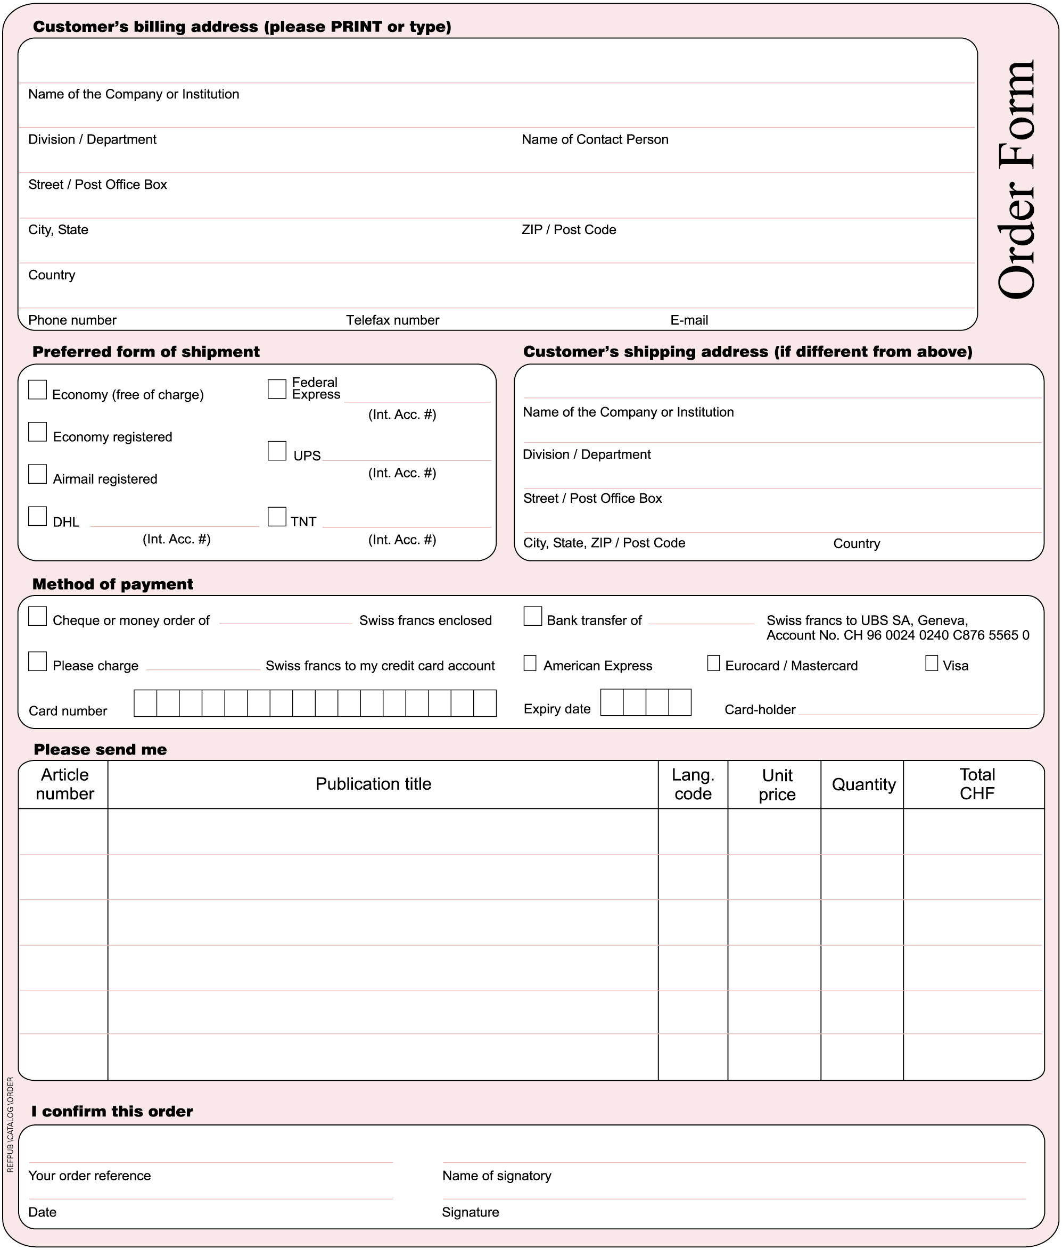
* Please note that ITU will not be held responsible for the replacement of any undelivered orders dispatched by mail which has not been registered. ITU accepts no responsibility for loss, delay or damage in shipment.
Please sign and return the completed Order Form to:
ITU  Sales and Marketing Division  Place des Nations  CH-1211 Geneva 20 – Switzerland | Telefax: +41 22 730 51 94  E-mail: sales@itu.int

