INTERNATIONAL TELECOMMUNICATION UNION

Geneva, 11 July 2003
Publication Notice No. 347-03

COSITU Version 1.0 SP1 –
Software for the Calculation of Costs,
Tariffs and Rates for Telephone Services
Edition 2003
Cost-based pricing, in particular calculation of interconnection rates, has been one of the most high-profile challenges facing both operators and regulators. Negotiating tariffs or rates is a delicate matter, whether it is for a new operator entering a liberalized market or a regulator wishing to set affordable tariffs for national calls without compromising competitiveness among operators. Now, ITU’s Market, Economics and Finance Unit has released COSITU, a practical tool which automates the calculation of costs, taxes, tariffs and rates. This new and powerful tool will permit network operators, service providers, regulators and policy-makers in developing countries to efficiently calculate costs, taxes related to trade in international traffic (accounting, settlement and termination rates), interconnection rates between local operators and tariffs for national and international telephone services, both fixed and mobile.
This version of COSITU SP1 includes, among other improvements, a new tool to estimate equivalent installed capacity of mobile communication networks with a view to evaluating the efficiency of their operation
COSITU is a bilingual software package (software on CD-ROM + user manual: English/French). The English/Spanish version will be available soon.

Date of publication: | July 2003: English and French  September 2003: English and Spanish
Languages: | English and French  English and Spanish
Hardware and software requirements: | PC i486TM or Pentium®-based processor or compatible; running Microsoft® Windows® 98, Windows® Me, Windows NT® 2000, Windows XP® Professional or Home Edition; with 64 MB of RAM (minimum) and CD-ROM drive.
Article number: | 23686 Bilingual version: English and French  21961 Bilingual version: English and Spanish
ISBN number: | 92-61-10417-7 Bilingual version: English and French  92-61-10427-4 Bilingual version: English and Spanish
Price in Swiss francs: | Catalogue Price: CHF 400.– (for a single workstation)  Member States and Sector Members: –15%  Administrations of Least Developed Countries and  libraries of educational institutions: – 80%

COSITU Version 1.0 SP1 – Software for the Calculation of Costs, Tariffs and Rates for Telephone Services
Edition 2003

COSITU makes cost-oriented principles easier to incorporate into tariff-calculation and rates-setting, thereby facilitating the decision-making process.

What’s In It For You?
Operators and Service Providers can streamline management of costs by assessing:
– the cost of provision of each service;
– the level of distribution rates;
– the level of profit and losses with current interconnection rates;
– which services are profitable and which are subsidized;
– the impact of “Universal Service Obligations” (USO) on their business.
Regulators and Policy-Makers can use it to help evaluate:
– the global cost of USO policies;
– whether interconnection rates are calculated on the basis of incurred costs;
– what impact USO strategy has on the attractiveness of the market in the eyes of potential investors;
– regulatory questions linked to telephony on the Internet;
– whether competition is biased or not as a result of regulatory arbitrage.
COSITU is a handy companion to the ITU publication Trends in Economics and Finance Volume I: Cost, Tariff and Interconnection Rate Calculation Methodology and Application to Case Studies.

GENERAL CONDITIONS OF SALE

■ Prices
The prices quoted in Publication Notices, as well as in the ITU Catalogue of Publications and in the Lists of ITU-T and ITU-R Recommendations (distributed free of charge and visible on the ITU website at the following address: www.itu.int/publications) are in Swiss francs (CHF), and are subject to change without notice.
Discounts of 15% are granted to Member States and Sector Members participating in the work of ITU. A discount of 80% of the catalogue price on all ITU publications is granted to Administrations of the Least Developed Countries (LDCs), as well as to libraries of educational institutions (for online subscriptions and CD-ROM publications only). Please note that the minimum price for a publication bought from the Electronic Bookshop is twenty Swiss francs (CHF 20.–) and that there is no discount via this service.
All additional information concerning CD-ROMs, online Recommendations and the ITU Electronic Bookshop can be found in the Catalogue of Publications and its associated Lists of ITU-R and ITU-T Recommendations.

■ Methods of payment
All publications ordered from ITU must be paid for in advance. Payments can be made:
a) by credit card: American Express, Eurocard/Mastercard, Visa;
b) by bank transfer to the UBS SA, Geneva, Account ITU Geneva, No. CH 96 0024 0240 C876 5565 0;
c) by cheque made payable to ITU;
d) by international postal order;
e) to the ITU postal cheque account: ITU Geneva, No. 12-50-3 (from within Switzerland);
f) or by UNESCO coupon.
Payments normally should be made in Swiss francs (CHF). Payments may also be made in other currencies, freely convertible into CHF, provided that, when converted by the bank, the price of the service in CHF is covered. ITU does not accept Letters of Credit.
For faster order processing, we invite you to either pre-pay by credit card or take advantage of a new service by opening an ITU deposit account.

■ Forms of dispatch
The catalogue price includes the cost of dispatch by non-registered economy-class mail or the means of carriage most advantageous to ITU. Dispatch can be requested in other forms: i.e. airmail, DHL, Federal Express, TNT, UPS or diplomatic pouch. If one of these alternative methods is chosen, the dispatch cost will be added to the quote. As from 1 February 2003, the costs of shipping via registered mail have been added to the economy-class costs. You may, if you wish, refuse these conditions but, in this case, ITU will not be held responsible for the replacement of any undelivered orders dispatched by mail that has not been registered. Customs duties and other taxes or dues levied on imported goods are not borne by ITU. ITU accepts no responsibility for delay, loss or damage in shipment. Any discrepancy or claim must be communicated to ITU within one year of dispatch of the publication(s).

■ Return of publications
Where a publication found to be faulty is returned to ITU, the latter’s responsibility shall be limited to replacement of the publication and payment of the costs arising from such replacement. Any publication returned to ITU as unwanted must reach it within one (1) month from the date of its dispatch to the customer, subject to ITU’s prior agreement. A minimum charge of fifty Swiss francs (CHF 50.–) will normally be invoiced to the customer by ITU for return of the publication to stock.
No exchange or refund is available for purchases made directly at the ITU Bookshop.
In the case of electronic publications (CD-ROM and online), these general conditions shall apply, subject to the specific derogation provisions contained in the Licence Agreements. The placing of an order implies full acceptance of these general conditions of sale.
None of the provisions of these general conditions of sale shall be interpreted as constituting a derogation or renunciation of the privileges, immunities and facilities enjoyed by ITU in accordance with the international agreement applicable to it, in particular the Headquarters Agreement concluded with the Swiss Federal Council on 22 July 1971, as well as the Swiss law or any other relevant national legislation.
Please note that orders cannot be taken over the telephone.
They should be sent by telefax or electronic mail.

Article number: q 23686 English and French  q 21961 English and Spanish | No. 347-03

LICENCE AGREEMENT

COSITU Version 1.0 SP1 – Software for the Calculation of Costs,
Tariffs and Rates for Telephone Services
Edition 2003

1. This Licence Agreement applies to version 1.0 of the software product called “COSITU” (hereinafter the “Software”). This Licence Agreement will terminate automatically if the licensee designated below (hereinafter the “Licensee”) fails to comply with the terms and limitations contained herein. On termination, the Licensee must destroy all copies it has of the Software.
2. ITU hereby grants the Licensee a non-exclusive licence to use the Software, subject to the terms and limitations contained in this Licence Agreement. This Software may be installed on one personal computer used by a single person or, by paying the appropriate licence fees, installed on multiple workstations used by several individuals. The Licensee agrees to pay to ITU the corresponding licence fee mentioned in the table below (choose language and number of workstations):

Price for software installed on a single or multiple workstation(s)
Language |  | Number of workstations | 1 | 2-5 | 6-10 | 11-25 | Other
E/F | E/S | Licence fee (in Swiss francs)* | 400 | 800 | 1,600 | 2,700 | On request
* Please circle the appropriate box.

This Software is not intended for use on a network. Such use could cause loss of confidentiality, and malfunctioning of the Software leading to problems ranging from the loss of data to the publishing of erroneous results. ITU declines all responsibility in the case of such use.
3. The Licensee may not rent, lease, sell, sublicense, assign or otherwise transfer the Software to third parties. It is not permitted to modify, reverse engineer, disassemble or decompile the Software, or create derivative works based on the Software. The Licensee may copy this Software for archival purposes only.
4. Ownership of and copyright on this Software belong to ITU. The Licensee does not acquire any rights in respect of this Software except as specifically provided in this Licence Agreement. This Software is further protected by copyright laws and treaties. Any unauthorized reproduction or distribution of this Software is strictly prohibited.
5. Although this Software has been prepared using reasonable standards of care, and while ITU has no reason to believe that there exist defects in the Software, ITU hereby disclaims all warranties, express or implied, including but not limited to, warranties of merchantability and fitness for a particular purpose. In particular, ITU does not warrant that the operation of the Software will be error-free or uninterrupted. In no event shall ITU be liable for any damages whatsoever (including, without limitations, damages for loss of profits, business interruption, loss of information or any other pecuniary loss) arising out of, or related to the use of, or inability to use the Software.
6. Nothing in this Licence Agreement shall constitute a waiver of the privileges, immunities and facilities which ITU enjoys by virtue of the international agreements and national laws applicable to it.
7. Any dispute between ITU and the Licensee (hereinafter collectively referred to as the “Parties”) arising from or in connection with this Licence Agreement shall be settled directly and amicably by the Parties through mutual negotiations. In the case of failure of such negotiations, the dispute shall be settled by a sole arbitrator to be nominated at the request of either of the Parties by the Court of Arbitration of the International Chamber of Commerce. The place of arbitration shall be Geneva. The language of arbitration shall be English. The arbitration shall be carried out in accordance with the Rules of Arbitration of the International Chamber of Commerce. The applicable law shall be Swiss law. The arbitrator’s ruling shall be final upon the Parties and any recourse to any court or tribunal against the arbitrator’s ruling shall be excluded.

Please complete this Licence Agreement (pages 5 and 6), and send it, duly signed, together with the Order Form (page 8), to the ITU Sales and Marketing Division.
The Licensee hereby declares that it is fully aware of the Terms and Limitations of this Licence Agreement and accepts them without any reservation:
(please print or type)
Mr/Ms Name of the Licensee: …………………………………………………………………………………………
Name and title of duly
authorized representative Officer: ………………………… …………………………………………………………
Date: Signature:

Article number: q 23686 English and French  q 21961 English and Spanish | No. 347-03
COSITU Version 1.0 SP1 – Software for the Calculation of Costs,Tariffs and Rates for Telephone Services
Edition 2003

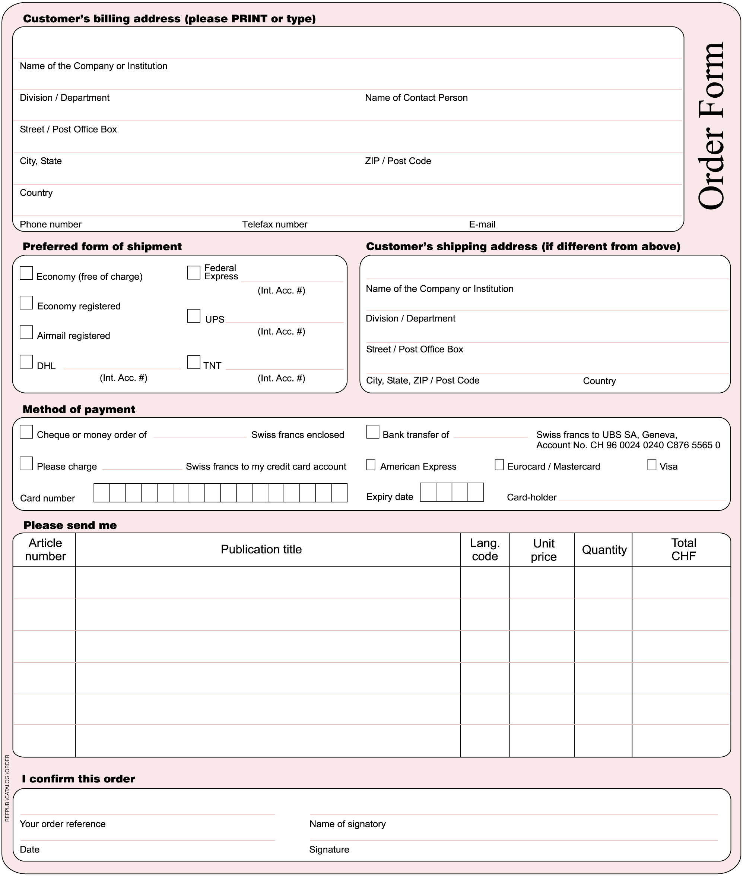
Please sign and return the completed Order Form, together with the Licence Agreement, to:
ITU  Sales and Marketing Division  Place des Nations  CH-1211 Geneva 20 – Switzerland | Telefax: +41 22 730 51 94  E-mail: sales@itu.int

