INTERNATIONAL TELECOMMUNICATION UNION

Geneva, 26 May 2003
Publication Notice No. 191-03-cor-03

World Telecommunication Indicators Database
(7th Edition 2003)
 |  | via ITU Website
The World Telecommunication Indicators Database contains time series data for the years 1960, 1965, 1970 and annually from 1975-2002 for around 80 communications statistics covering telephone network size and dimension, other services, quality of service, traffic, staff, tariffs, revenue and investment. Selected demographic, macro-economic and broadcasting statistics are also included. Data for over 200 economies are available.

Date of publication: | April 2003
Language: | English only
Hardware and software requirements: | PC with Pentium processor (or compatible) with 32 MB RAM running MS Window 9x, NT, 2000 or XP, hard disk with at least 50 MB free space and CD-ROM drive. WINSTARS v4.2.
Conditions: | This product is not sold, but leased and licensed according to the annexed Licence Agreement for a single user or multi-user (networked) environment.

 | CD-ROM |  | Online  Yearly subscription  for a single user | Single access  through ITU  Electronic Bookshop
 | Swiss  francs | Article Number | Swiss  francs | Swiss  francs
Catalogue price | 200.– |  | 750.– | 200.–
Member States and Sector Members | –15% | 23269 | –15% | (No discount)
Least Developed Countries  and libraries of educational institutions  (online service) | – 80% |  | – 80%

World Telecommunication Indicators Database
(7th Edition 2003)

The World Telecommunication Indicators Database contains time series data for the years 1960, 1965, 1970 and annually from 1975-2002 for around 80 communications statistics covering telephone network size and dimension, mobile services, quality of service, traffic, staff, tariffs, revenue and investment. Selected demographic, macro-economic, broadcasting and information technology statistics are also included. The attached list shows which statistics are contained. Data for over 200 economies are available. Notes explaining data exceptions are also included.
The data are collected from an annual questionnaire sent out by the Telecommunication Development Bureau (BDT) of ITU. Additional data are obtained from reports of telecommunication ministries, regulators and operators and from ITU staff reports. In some cases, estimates are made by ITU staff; these are noted in the database.
This electronic database uses the latest version of the World Bank’s Socio-economic Time series Access and Retrieval System (WINSTARS v4.2). WINSTARS v4.2 has sophisticated features including mapping and charting, a choice of data selection techniques, versatile display options and several data export formats (Access, ASCII, dBASE, Excel, and SAS). A user guide is included with the database as are the definitions of the time series.
The database is available either for one-time purchase (single issue) or as an annual subscription. The one-time purchase is available either on CD-ROM or via the Internet through ITU’s Electronic Bookshop. The annual subscription is available only via the Internet and can be accessed for a period of one year starting from delivery of the access key. The subscription service is available for single-user or multi-user licences.
Subscribers to the annual subscription will receive 2002 data as it becomes available throughout the year. Updates and revisions of the data will be posted to the ITU website approximately every three months. Subscribers are entitled to BDT Telecommunication Data and Statistics reference services such as clarification of data, sources and methodology used.
Note: Related statistical and market analysis publications are also available. For details of these reports, please consult our website at
http://www.itu.int/ITU-D/ict

ANNUAL TIME-SERIES INCLUDED IN THE DATABASE

TELEPHONE NETWORK | DEMOGRAPHY, MACRO-ECONOMY
Main telephone lines in operation | Population
Main lines per 100 inhabitants | Population of largest city
Main telephone lines in largest city | % urban population*
% of digital main lines | Households
% of households with a telephone | Gross Domestic Product (GDP)***
% of residential main lines | Gross Fixed Capital Formation (GFCF)***
% of main lines in urban areas | Consumer Price Index (1990 = 100)
Total telephone subscribers | Average annual exchange rate (local currency per USD)
Total telephone subscribers per 100 inhabitants
Connection capacity of local exchanges | TARIFFS***
Telephone sets* | Residential telephone connection charge
Public pay phones | Business telephone connection charge
International telephone circuits | Residential telephone monthly subscription
Waiting list for main lines | Business telephone monthly subscription
 | Price of three minute local call (peak)
TELEPHONE TRAFFIC** | Price of three minute local call (off-peak)
Local | Cellular connection charge
National long distance | Cellular monthly subscription charge
International outgoing | Cellular 3 minute call (peak)
 | Cellular 3 minute call (off-peak)
QUALITY OF SERVICE
Telephone faults per 100 main lines | TELECOM FINANCE***
 | Total telecommunication service revenue
TELEX | Telephone service revenue
Telex subscribers* | Mobile telecommunication revenue
 | Total telecommunication investment
DATA
ISDN subscribers | MOBILE
ISDN channels | Cellular mobile telephone subscribers
Leased circuits | Digital cellular subscribers
Internet users | Cellular subscribers per 100 inhabitants
Number of Internet hosts
Number of personal computers | BROADCASTING
 | Television receivers
EMPLOYMENT | Television households
Total full-time telecommunications staff | Cable television subscribers
 | Home satellite antennas

* indicates series that are included for historical purposes but are no longer regularly updated or verified.
** indicates series whose units (i.e. calls, minutes or charging units) vary depending on the convention used in the country to measure telephone traffic. Therefore comprehensive comparison of telephone traffic data between countries is not possible.
*** indicates series that are in national currency and in United States dollars.

UNION INTERNATIONALE DES TÉLÉCOMMUNICATIONS
INTERNATIONAL TELECOMMUNICATION UNION
UNIÓN INTERNACIONAL DE TELECOMUNICACIONES

PROTECTION OF RIGHTS, LICENCE AGREEMENT
AND DISCLAIMER OF WARRANTY
1. The publications of the International Telecommunication Union (“ITU”) are protected by copyright law. ITU fully retains all titles and rights on its publications and does not sell any rights related thereto.
2. By the present licence, ITU hereby grants you a non-exclusive right to use the copy of the publication indicated in your order (“Publication”), your use thereof constituting your agreement with the terms and conditions of the present licence.
3. Unauthorized copying of the Publication is expressly forbidden. You may make one copy of the ITU Publication solely for backup purposes. You must reproduce and include the copyright notice on the backup copy. This Publication is for the number of authorized users indicated in your order.
4. In no event may you transfer, assign, rent, lease or otherwise dispose of the Publication.
5. The CD-ROM and the Publication (“Product”) are provided “as is” without warranty of any kind. In particular, ITU does not warrant or make any representations regarding the use, or the results of use, of the Product in terms of correctness, reliability, currentness, or otherwise. ITU shall not be held liable for any direct, indirect, consequential or incidental damages arising out of the use of or inability to use this Product.

© ITU 2003
All rights reserved

Publication Notice No. 191-03-cor-03 – Annex
World Telecommunication Indicators Database
(7th Edition 2003)
Licence Agreement
ITU Online – Subscription Service
1. Parties
The Parties to this Licence Agreement (“Agreement”) are the “Customer”, as licensee, and the International Telecommunication Union (“ITU”), as licenser. This Agreement, once received by ITU with the Customer’s signature, shall become effective between the Parties on the day the access key(s) is (are) provided to the Customer by ITU.
2. Service
The Online Service (“Service”) provided by ITU to the Customer is subject to the terms and conditions of this Agreement and includes:
a) online access to the “World Telecommunication Indicators” for the Authorized User(s);
b) an “Access Key” which protects access to the Service; and
c) a “Helpdesk” service that can be contacted by the Customer for assistance if required.
3. Definitions
3.1 Customer and Authorized User
In the context of this Agreement, the following meaning shall be attributed to the following terms:
a) Customer is either a natural person or an entity with its own legal status of whatsoever nature, having signed this ITU Licence Agreement.
b) Authorized User is a person designated by the Customer to access the Service, during the subscription period.
3.2 Types of Licence
The Licence Agreement may be established for a single-user, multi-user or network licence, in conformity with the terms and conditions of this Agreement.
a) Single-User Licence: access to the “World Telecommunication Indicators” online is authorized using a single access key.
b) Multi-User Licence: access to the “World Telecommunication Indicators” online is authorized for multiple users with access keys provided for each Authorized User. The names and addresses of the Authorized Users must be specified in the Subscription Form at the end of this Agreement of which it forms part.
c) Multi-User Network Licence: “World Telecommunication Indicators” is authorized for multiple users via an organization’s internal network.
4. Licence coverage
The Customer receives from ITU a non-exclusive and non-transferable licence for use of the Service by each Authorized User, subject to the terms and conditions set forth in this Agreement. The Customer acquires no copyright or ownership rights to the Service or its contents whatsoever, or any portions thereof, and all such rights remain with ITU.
a) The Customer may use the Service until the Termination of this Agreement (see Article 9 below).
b) The Customer may permit each Authorized User to download and print copies, or any portion thereof, within the physical premises where the Authorized User has his office, for use as stipulated in the Copyright Notice (see Article 5 below).
c) Any use of the Service is limited to the Authorized User(s) and does not extend to subsidiary/parent corporations or sub-contractors, or to any other related or affiliated entities.
d) Downloading or posting the information into a public access network database is strictly prohibited.
e) The Customer shall not sell, sub-license, rent, or lease the Service or any portion thereof.
5. Copyright notice
The publications of the International Telecommunication Union (ITU) are protected by international copyright and trade law. Their contents or parts thereof may not be duplicated for sale or outside distribution by the Customer, but may be used by the Customer:
a) to further the work of ITU; or
b) to further the work of any standards body developing related standards; or
c) to provide guidance for the Customer’s product or service development and implementation; or
d) to serve as support for documentation associated with a product or service of the Customer.
Consequently, the foregoing provisions of this Copyright Notice apply to the Service under this Agreement. They shall, however, within the framework of this Agreement, automatically be replaced by any new Copyright Notice that ITU may publish, in which event ITU shall immediately provide the Customer with a copy of such new Notice.
6. Limited warranty
ITU warrants that the “World Telecommunication Indicators” are properly available by means of the Service.
ITU does not warrant that the operation of the Service, or the chosen method of access by the user, will be uninterrupted or error free.
If the Customer is unable to use the Service, it must provide ITU with a detailed description of the problems encountered as soon as possible after receiving the access key(s).
Although the Service has been prepared using reasonable standards of care, and while there are no indications or reasons to believe that there exist inaccuracies or defects in the Service, itu formally disclaims hereby all other warranties, either express or implied, including but not limited to implied warranties of merchantability and fitness for a particular purpose, with respect to the service.
7. No liability for consequential damages
In no event shall ITU be liable for any damages whatsoever (including, without limitation, damages for loss of profits, business interruption, loss of information, or other pecuniary loss) arising out of the use of this Service, even if ITU has been advised of the possibility of such damages.
8. Subscription period
The subscription period and thus the duration of this Agreement are for one year starting from the date on which ITU provides the access key(s) to the Customer by mail. Access key(s) will be provided by ITU only after receipt of this signed Licence Agreement and payment of the price of the subscription.
9. Termination
The Service automatically terminates at the expiration of the subscription period. However, ITU has the right, at its discretion, not to renew this Agreement and shall inform the Customer accordingly. ITU also reserves the right to terminate unilaterally this Agreement at any time if, in its judgement, the Customer has failed to comply with any of its material provisions; it shall inform the Customer of such termination.
10. Settlement of disputes
Any dispute between the Parties arising from or in connection with this Agreement, which cannot be settled amicably by them through direct negotiations, shall, at the request of either of the Parties, be submitted for settlement to a sole arbitrator to be nominated by the President of the Court of Arbitration of the Chambre de commerce internationale de Paris (France), the current Rules of Arbitration of which shall apply.
The place of arbitration shall be Geneva and the language of arbitration shall be English. Besides, and only supplementary to the provisions of this Agreement, the applicable law shall be the Swiss substantive law, with the exception of Article 190 of the Swiss Federal Law on Private International Law of 18 December 1987. The arbitrator’s ruling shall be final and binding upon the Parties hereto and any recourse to any court or tribunal against the arbitrator’s ruling shall be excluded.
11. Status, privileges, immunities and facilities enjoyed by ITU
ITU is a specialized agency of the United Nations and, as such, enjoys all of the privileges, immunities and facilities that are associated with that status and recognized as being enjoyed by ITU under the international agreements applicable to it, the Headquarters Agreement concluded between ITU and the Swiss Federal Council on 22 July 1971, and Swiss law.
No provision of this Agreement may be interpreted as constituting a derogation or renunciation of the privileges, immunities and facilities enjoyed by ITU pursuant to the provisions referred to in this Agreement.

12. Price due for the online service
The Customer hereby declares that it has taken full notice of the pricing arrangements in the Service description of this Publication Notice.
The Customer hereby declares that it is (please tick where appropriate):
❑ from one of the Least Developed Countries (LDCs) or a library of an educational institution;
❑ an ITU Member State Administration; or an ITU Sector Member;
❑ other.
The Customer hereby chooses (please tick where appropriate):
❑ Single user licence;
❑ Multi-user licence for users at the same location;
❑ Multi-user licence for users at multiple sites or network.

Price in Swiss francs for multi-users
Number of Authorized Users | 2-10 | 11-25 | 26-50 | 51-100 | Other
Price for same location | 1500.– | 3000.– | 4500.– | 6750.– | on request
Price for multiple sites or network | 15 000.–

Please circle the appropriate box.

The Customer agrees that the total price due under this Agreement does not include any telecommunication line charges incurred by the Customer in browsing or downloading and recognizes that no additional connection charges are levied by ITU.

13. Payment

❑ | Cheque or money order of |  |  |  |  |  |  | ………………………..….......... |  |  |  |  |  |  |  |  |  |  | Swiss francs enclosed
❑ | Bank transfer of |  |  |  |  |  |  | ………………………..….......... |  |  |  |  |  |  |  |  |  |  | Swiss francs to the UBS SA in Geneva;  ITU Account No. CH 96 0024 0240 C876 5565 0
❑ | Please charge |  |  |  |  |  |  | ………………………................ |  |  |  |  |  |  |  |  |  |  | Swiss francs to my credit card account
 |  | ❑ American Express |  |  |  |  |  | ❑ Eurocard/Mastercard |  |  |  |  |  |  |  |  |  |  | ❑ Visa
Card number |  |  |  |  |  |  |  |  |  |  |  |  |  |  |  |  |  |  |  |  |  |  |  | Expiry date |  |  | /

Card-holder’s name

Card-holder’s signature:

14. Customer’s address

 | Contact address  (please print or type) | Billing address  (if different)
Company/Organization | ........................................................................ | ......................................................................
Division/Department | ........................................................................ | ......................................................................
Address/Postal code | ........................................................................ | ......................................................................
 | ........................................................................ | ......................................................................
City, State/Country | ........................................................................ | ......................................................................
 | ........................................................................ | ........................................................................
Contact point | ........................................................................ | ......................................................................
Telephone/Telefax number | ........................................................................ | ......................................................................
E-mail | ........................................................................ | ......................................................................

15. Acceptance and signature
The Customer hereby declares that it has read and understood the terms and conditions of this Licence Agreement, which it hereby accepts as binding upon itself and recognizes ITU’s right not to execute this Agreement if ITU does not agree with the Customer’s information provided in Articles 12 and/or 13 above and informs the Customer accordingly, by stating the reasons for such refusal, within 30 working days from ITU’s receipt of the signed Agreement. After the expiration of such period and/or upon provision by ITU of the access key(s) to the Customer, ITU shall be bound by this Licence Agreement.
Customer’s reference:
The Customer hereby declares that it has read and understood the terms and conditions stipulated in Articles 1 to 15 of this Licence Agreement and will comply with them.
Mr/Ms:
represents that he/she is authorized to sign this Licence Agreement on behalf of the Customer and that his/her signature is binding upon the Customer.
Date: Authorized signature:

Please mail or fax the completed Licence Agreement or the Order Form duly completed and signed, to:

International Telecommunication Union  Sales and Marketing Division  Place des Nations  CH-1211 Geneva 20  Switzerland | Telefax: +41 22 730 51 94  E-mail: sales@itu.int  www.itu.int/publications

16. List of Authorized Users (additional pages may be added)

Surname, first name  of each Authorized User  (in capital letters) | Full mail address of each Authorized User  (street, town, postal code, country) | Telephone number  Telefax number  E-mail
................................................  ................................................  ................................................ | .............................................................................  .............................................................................  .............................................................................. | .......................................  .......................................  .......................................
................................................  ................................................  ................................................ | ..............................................................................  ..............................................................................  .............................................................................. | .......................................  .......................................  .......................................
................................................  ................................................  ................................................ | ..............................................................................  ..............................................................................  .............................................................................. | .......................................  .......................................  .......................................
................................................  ................................................  ................................................ | ..............................................................................  ..............................................................................  .............................................................................. | .......................................  .......................................  .......................................
................................................  ................................................  ................................................ | ..............................................................................  ..............................................................................  .............................................................................. | .......................................  .......................................  .......................................
................................................  ................................................  ................................................ | ..............................................................................  ..............................................................................  ............................................................................. | .......................................  .......................................  .......................................
................................................  ................................................  ................................................ | ..............................................................................  ..............................................................................  .............................................................................. | .......................................  .......................................  .......................................
................................................  ................................................  ................................................ | .............................................................................  .............................................................................  .............................................................................. | .......................................  .......................................  .......................................
................................................  ................................................  ................................................ | ..............................................................................  .............................................................................  .............................................................................. | .......................................  .......................................  .......................................
................................................  ................................................  ................................................ | ..............................................................................  ..............................................................................  .............................................................................. | .......................................  .......................................  .......................................
................................................  ................................................  ................................................ | ..............................................................................  ..............................................................................  .............................................................................. | .......................................  .......................................  .......................................

Article number: q 23269 CD-ROM | No. 191-03-cor-03

SUBSCRIPTION FORM
CD-ROM

World Telecommunication Indicators Database
(7th Edition 2003)

Price in Swiss francs for user(s) at the same location, per edition
Quantity | Number of authorized users | 1 | 2-10 | 11-25 | 26-50 | 51-100 | Other
 | Price* | 200.– | 400.– | 800.– | 1200.– | 1800.– | on request
 | Network Price | 15 000.–
* Please circle the appropriate box.

I acknowledge that I have read and understood the enclosed “Protection of rights, licence agreement and disclaimer of warranty” notice, and agree to be bound by its terms and conditions.
Mr / Ms/Name of the company (please print or type)
Name Title
declares that he/she is authorized to sign this agreement on behalf of the Customer and that his/her signature is binding upon the Customer.

Date: Authorized signature:

Please complete and send, duly signed, this Subscription Form, together with the Order Form overleaf, to the ITU Sales and Marketing Division.

Article number: q 23269 CD-ROM | No. 191-03-cor-03
World Telecommunication Indicators Database
(7th Edition 2003)

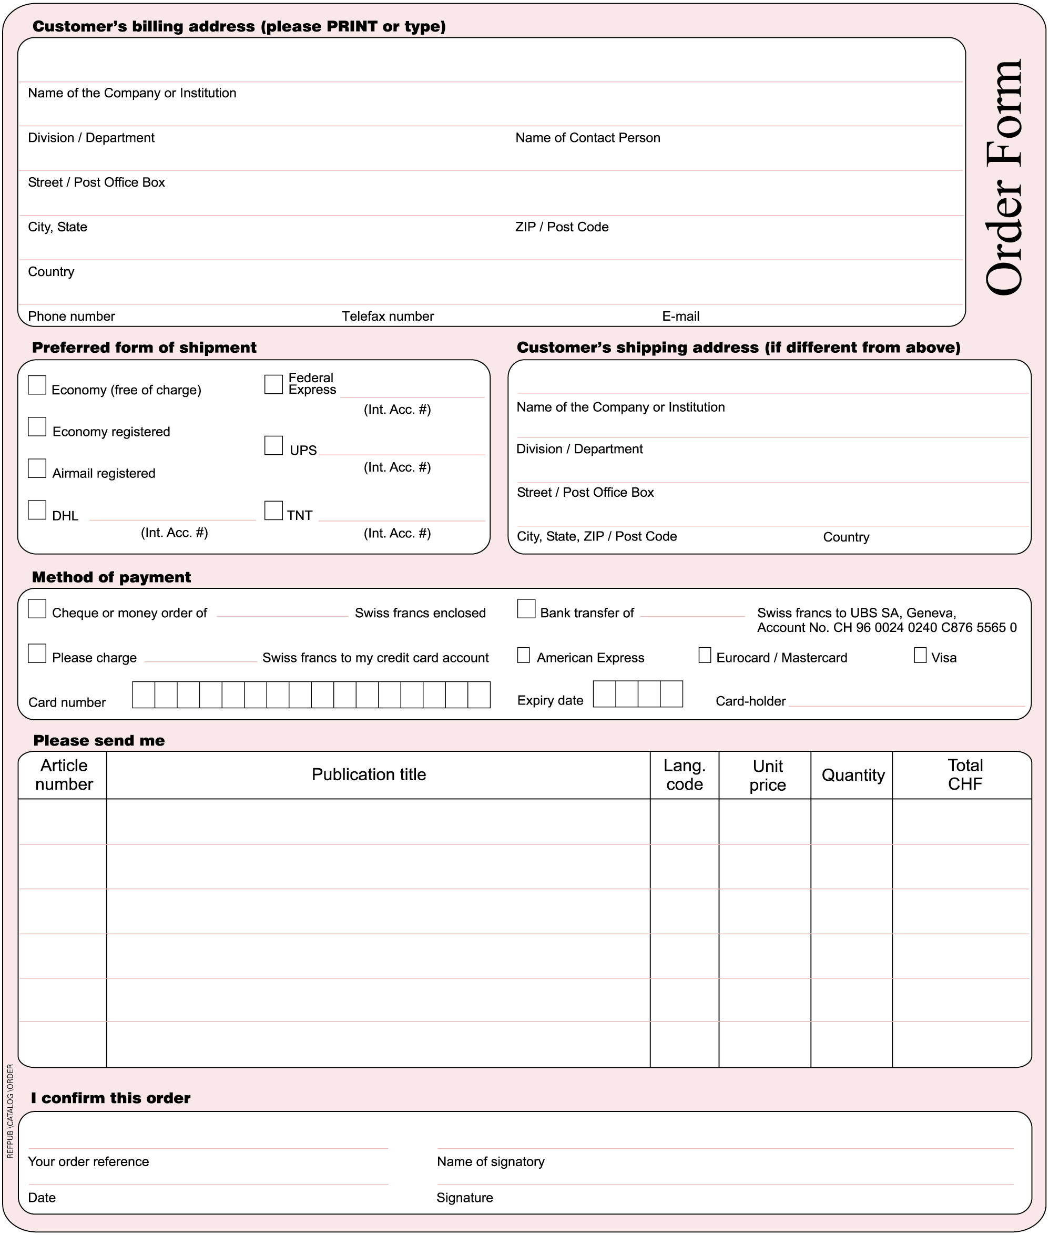
Please sign and return the completed Order Form with the Subscription Form to:
ITU  Sales and Marketing Division  Place des Nations  CH-1211 Geneva 20 – Switzerland | Telefax: +41 22 730 51 94  E-mail: sales@itu.int

