 | World Telecommunication Development Conference 2025 (WTDC-25)  Baku, Republic of Azerbaijan, 17–28 November 2025 |  | 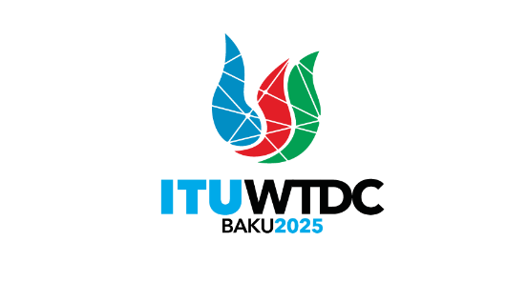
PLENARY MEETING |  | Document WTDC-25/xx-E
 |  | [Date]
 |  | Original: [English]
[Source]
[Title]
Priority area: - Declaration
- Action Plan, Regional Initiatives and ITU-D Study Group Questions
- ITU-D Resolutions and Recommendations
- Other proposals
Summary:
[Maximum 100 words]
Expected results:
[Maximum 100 words]
References:

_______________

